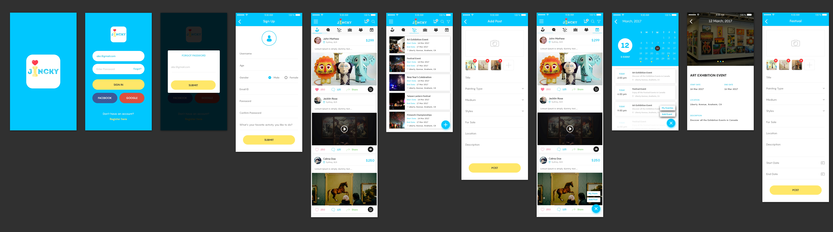

Task – SQL ShowCase-2 in
Databse name: db_showcase2

For the following relation schema:
1- tbl_user(Structure create base of all question)
2-tbl_add_post(Structure create base of all question)
3- tbl_img(Structure create base of all question)
4-tbl_event(Structure create base of all question)

1.Insert Query in table of user

-->INSERT INTO `tbl_user`(`user_id`, `name`, `email`, `password`, `profile_image`, `age`, `gender`, `about`, `role`, `social_id`, `login_type`, `is_active`, `created_at`, `updated_at`) VALUES (6,'SRk','srk@gmail.com','srk123456','26.jpeg',25,'M','ok','User','srk1213','S',1,'2022-07-23','2022-07-26');

2.Insert Query in table of add post

INSERT INTO `tbl_add_post`(`post_id`, `user_id`, `title`, `painting_type`, `medium`, `styles`, `for_sale`, `location`, `description`, `is_active`, `created_at`, `updated_at`) VALUES (8,5,'imagination','chinese style','oil paints','Realism','60000','Vadodra','ok',1,'2022-06-22','2022-07-22')

3.Insert Query in table of image

INSERT INTO `tbl_img`(`img_id`, `post_id`, `image`, `created_at`, `updated_at`) VALUES (8,6,'61.jpeg','2022-05-22','2022-06-22');

4.Insert Query in table of event

INSERT INTO `tbl_event`(`event_id`, `name`, `img_id`, `start_date`, `end_date`, `location`, `description`, `is_active`, `created_date`, `updated_at`) VALUES (8,'Exhibition',2,'2022-04-04','2022-05-05','Surat','ok',1,'2022-04-04','2022-05-05');

5.Update Query in table of user

UPDATE `tbl_user` SET `name`='abc',`email`= 'abc@gmail.com',`password`= 'abc1234',`age`= 25,`social_id`='abc_13',`login_type`='S' WHERE user_id = 2;

6.Delete Query in table of user
DELETE FROM `tbl_user` WHERE name = 'Srk';

7.select Query in table of add post

SELECT `post_id`, `user_id`, `title`, `painting_type`, `medium`, `styles`, `for_sale`, `location`, `description`, `is_active`, `created_at`, `updated_at` FROM `tbl_add_post` WHERE post_id = 8;

8.Display the recorde of user whose email id is VarunDhavan@gmail.com and password is VarunDhavan186

select * from tbl_user where email="VarunDhavan@gmail.com" and password ="VarunDhavan186" and is_active='1'

9.Display the records of user who activate

select * from tbl_user where is_active='1';

10.Find the users who role is User.

select * from tbl_user where role='User';

11.Find the user details who login in gmail

select * from tbl_user where login_type='G';

12.count users who login using gmail and activate

select count(login_type ) from tbl_user where login_type='S' And is_active='1';

13.Need Email and Password for login

SELECT email, password FROM tbl_user WHERE email = email;

14.Count of post which user is posted

SELECT COUNT(u.user_id), u.name
FROM tbl_user as u
JOIN tbl_add_post as p ON u.user_id = p.user_id
GROUP BY u.name;

15.Count of total like where is active = 1

Select Count(*)
As total_like from tbl_add_post Where is_active = 1;

// Post
Select user_name, rs, description, img, loaction, total_likes, total_cmt From tbl_img
JOIN tbl_user ON tbl_img.user_id = tbl_user.user_id
JOIN tbl_post ON tbl_img.post_id = tbl_post.post_id;

// Total Active post
Select Count(*)
As Total_Post from tbl_post Where is_active = 1;

