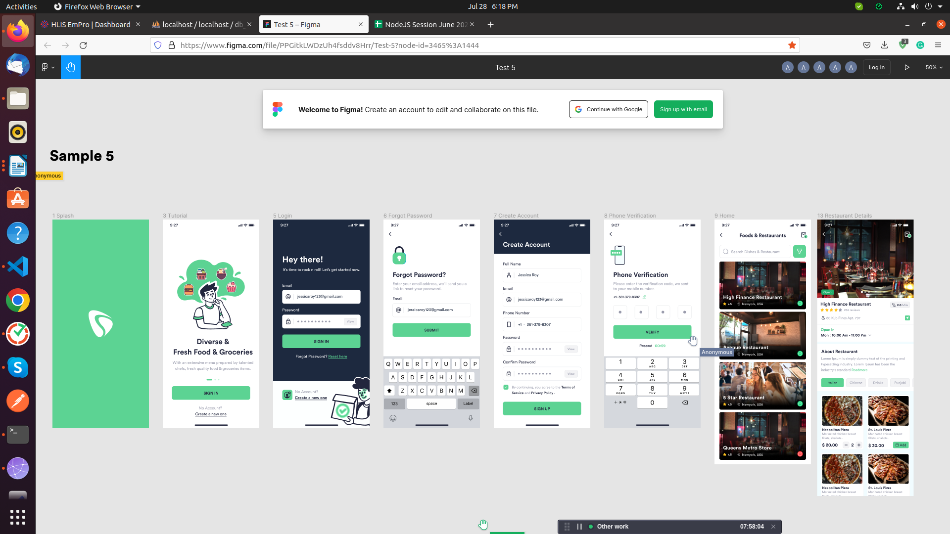

Task – SQL ShowCase-3 in
Databse name: db_showcase3

For the following relation schema:
1- tbl_user(Structure create base of all question)
2-tbl_restaurant_details(Structure create base of all question)
3- tbl_review(Structure create base of all question)
4-tbl_order(Structure create base of all question)
5- tbl_order_details(Structure create base of all question)
6-tbl_dish(Structure create base of all question)
7- tbl_time(Structure create base of all question)
8- tbl_cuisine(Structure create base of all question)
9-tbl_phone_verification(Structure create base of all question)

1.Insert Query in table of user

-->INSERT INTO `tbl_user`(`user_id`, `name`, `email`, `mobile_no`, `password`, `role`, `is_active`, `created_at`, `updated_at`) VALUES (6,'Yuvraj','Yuvraj@gmail.com','9998887770','Yuvraj123','User',1,'2022-07-01','2022-07-01')

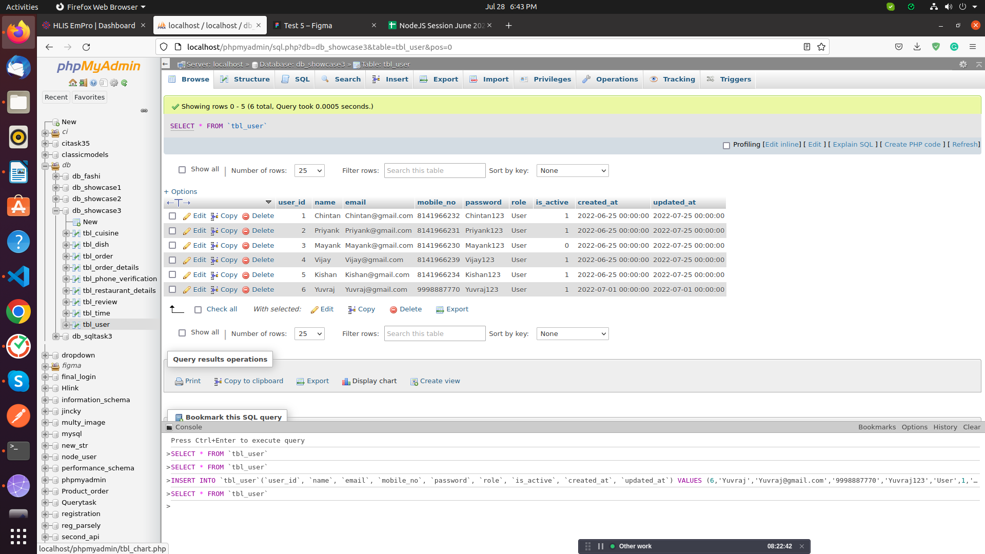
2.Insert Query in table of Restaurant Details

-->INSERT INTO `tbl_restaurant_details`(`restaurent_id`, `name`, `location`, `image`, `avg_rating`, `total_review`, `about`, `latitude`, `longitude`, `is_active`, `created_at`, `updated_at`)
VALUES (8,'BinyBeats','Surat','2.png',5,10,'Very Nice Restaurants','-80 to 80','-90 to 90',1,'2022-07-01','2022-07-01');

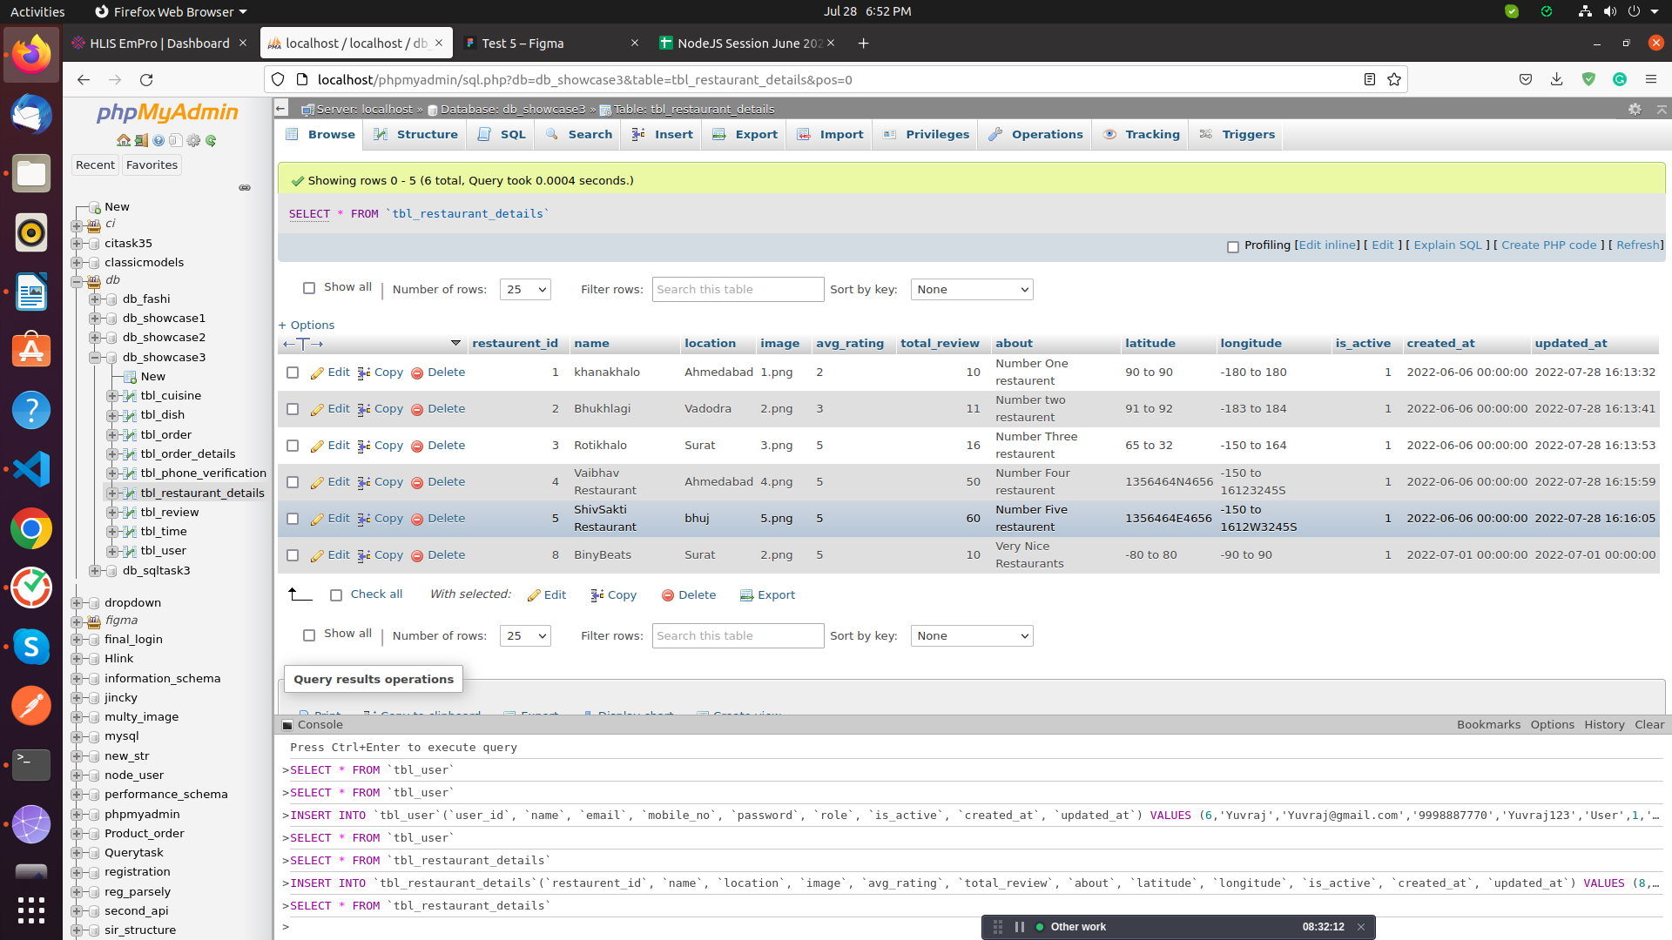

3.Insert Query in table of Order

-->INSERT INTO `tbl_order`(`order_id`, `order_no`, `restaurant_id`, `dish_id`, `user_id`, `quantity`, `total`, `discount_amount`, `service_charge`, `sub_total`, `grand_total`, `promocode`, `status`, `payment_method`, `transaction_Id`, `rating`, `is_active`, `created_at`, `updated_at`)
VALUES (6,555656,5,1,1,10,500,200,20,320,320,'HSOHOSHSHS','Prepared','Online','HDIHOIDHID1','5.1',1,'2022-07-02','2022-07-02');

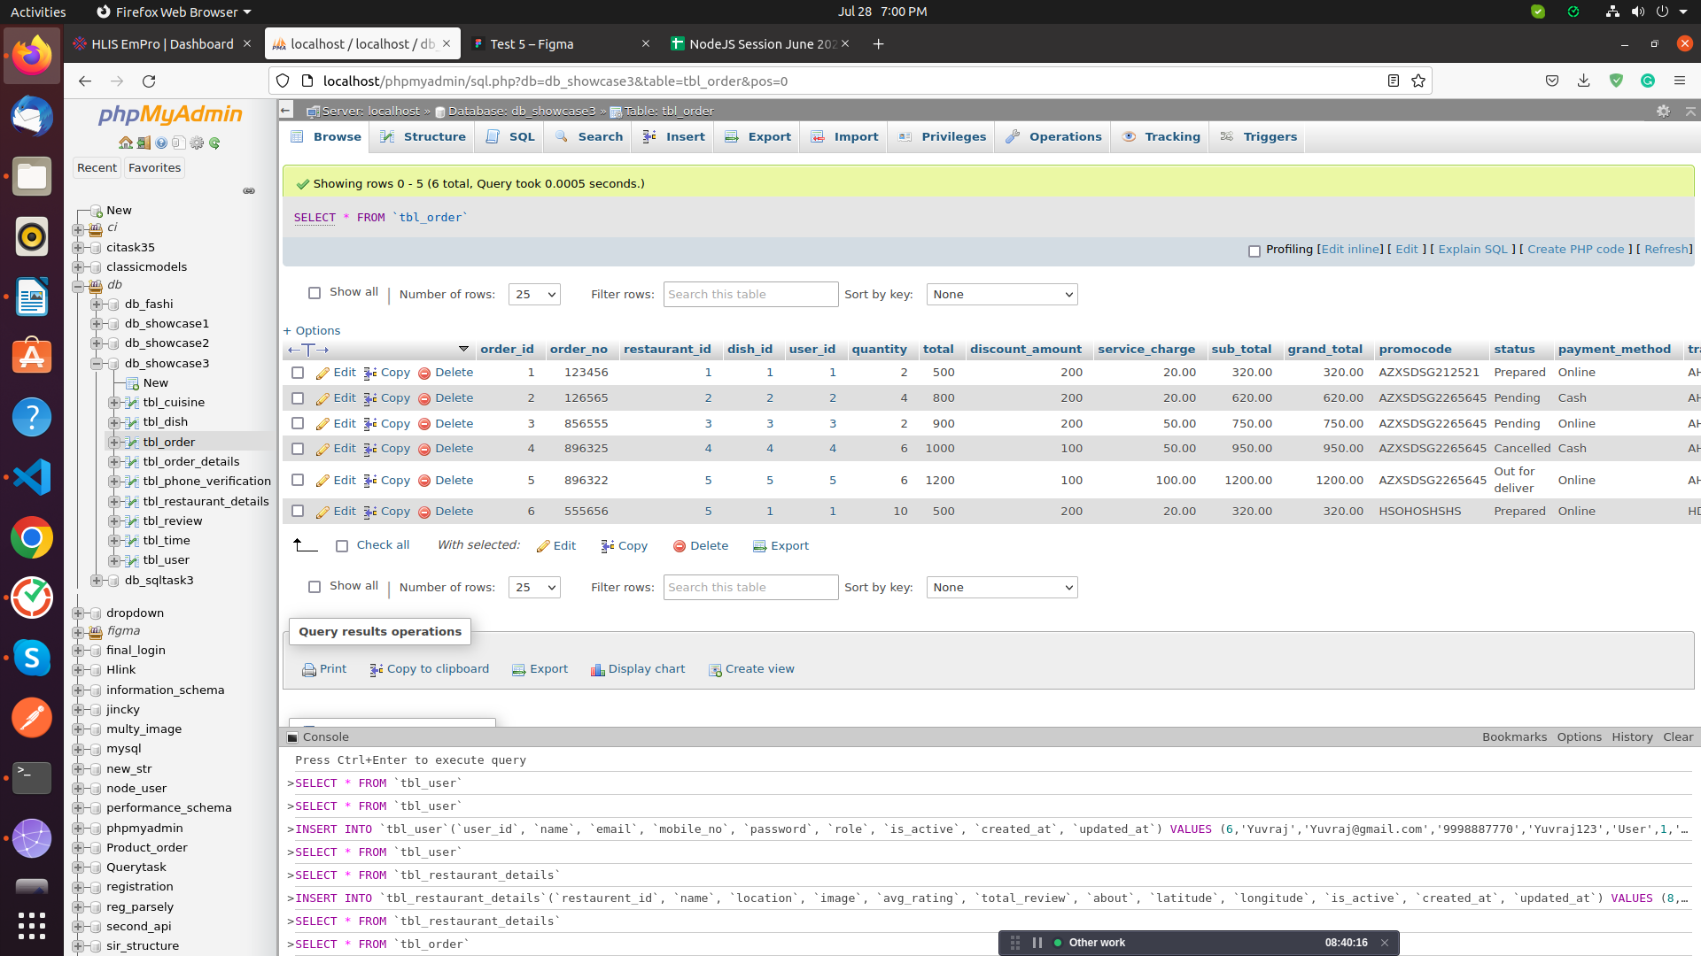

4.Insert Query in table of dish

-->INSERT INTO `tbl_dish`(`dish_id`, `restaurant_id`, `cuisine_id`, `image`, `name`, `price`, `about`, `is_active`, `created_at`, `updated_at`)
VALUES (7,1,1,'56.png','SouthIndian',600,'SO Delicious',1,'2022-07-05','2022-07-05');

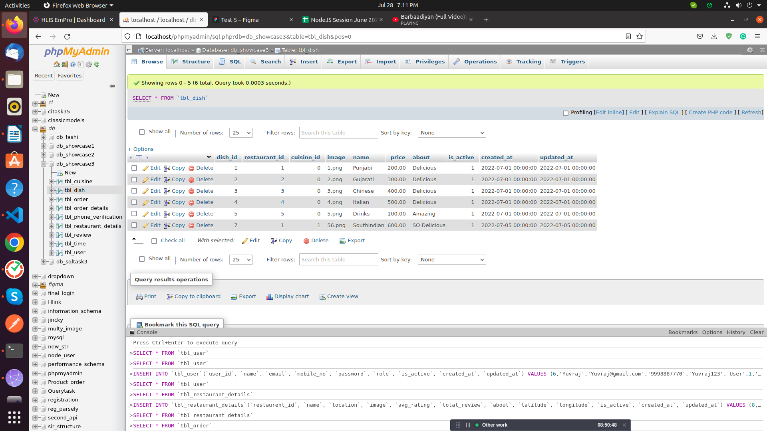

5.Update Query in table of dish

->UPDATE `tbl_dish` SET `image`='vn.png' WHERE dish_id = 1;

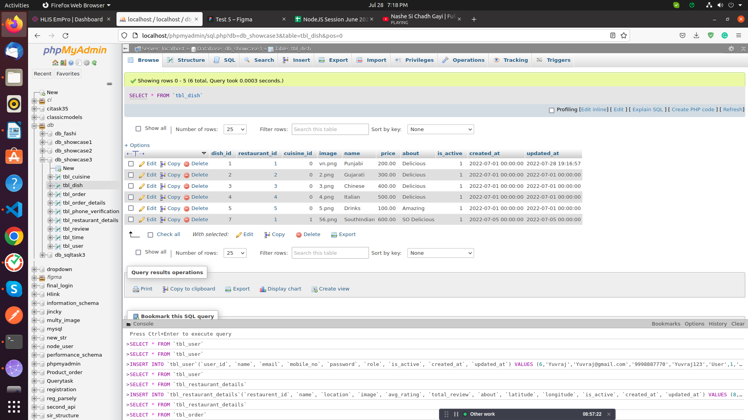
6.Delete Query in table of order

-->DELETE FROM `tbl_order` WHERE order_id = 6;

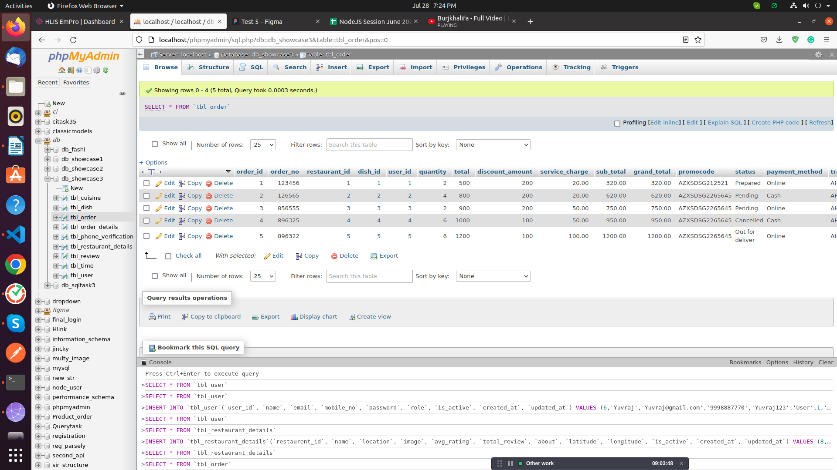

7.Select Query in table of order Deatails

-->SELECT `order_details_id`, `order_id`, `dish_id`, `quantity`, `price`, `sub_total`, `created_at`, `updated_at` FROM `tbl_order_details` WHERE order_details_id = 1;

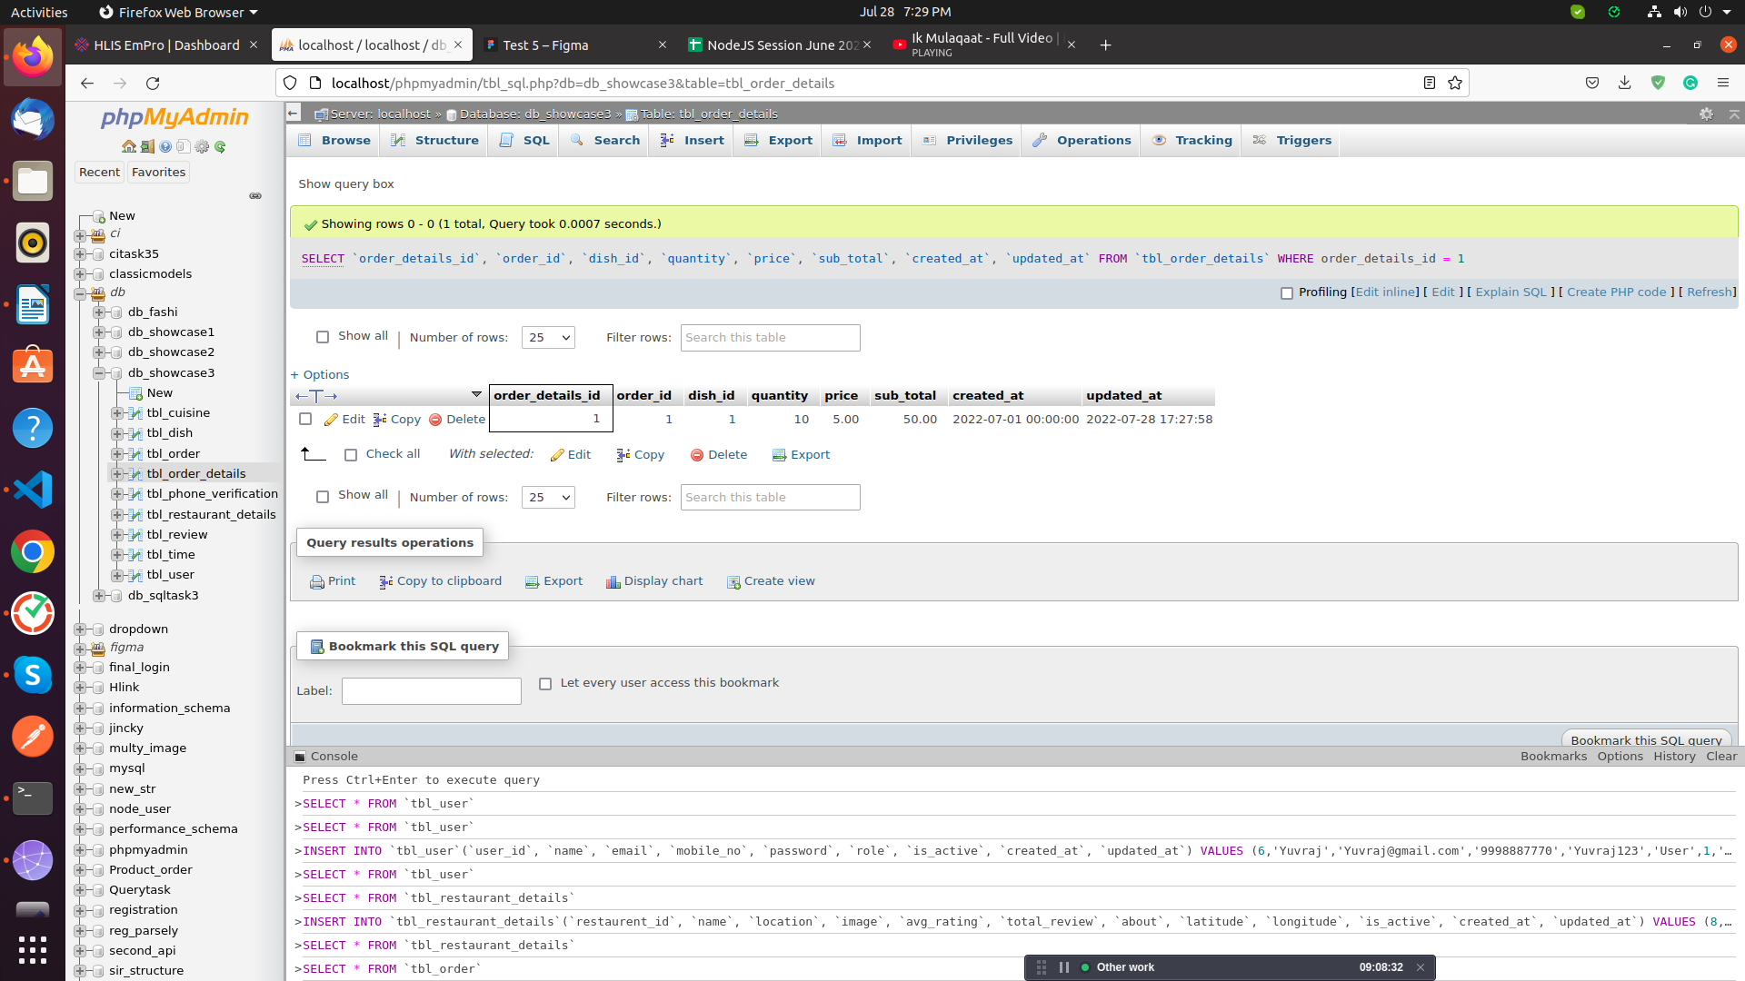

8.Display the recorde of user whose email id is Chintan@gmail.com and password is Chintan123
-->select * from tbl_user where email="Chintan@gmail.com" and password ="Chintan123" and is_active='1'

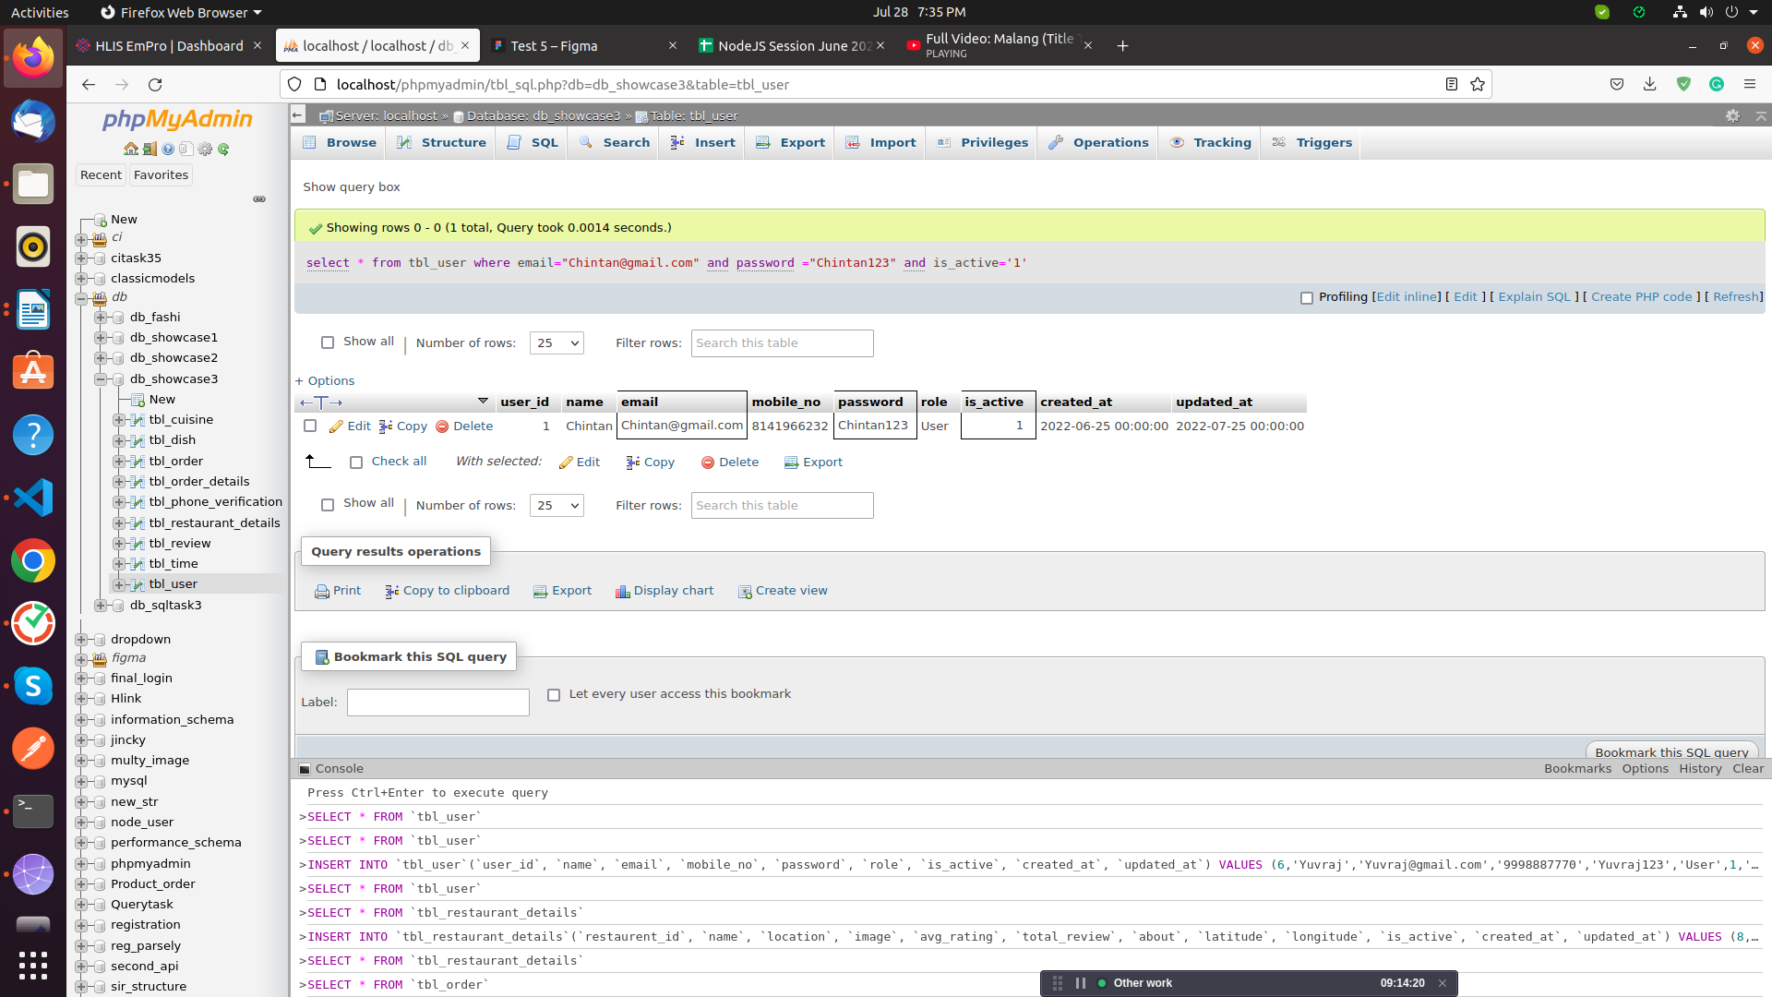

9. login :
-->SELECT email, password FROM tbl_user WHERE user_Id = user_Id;

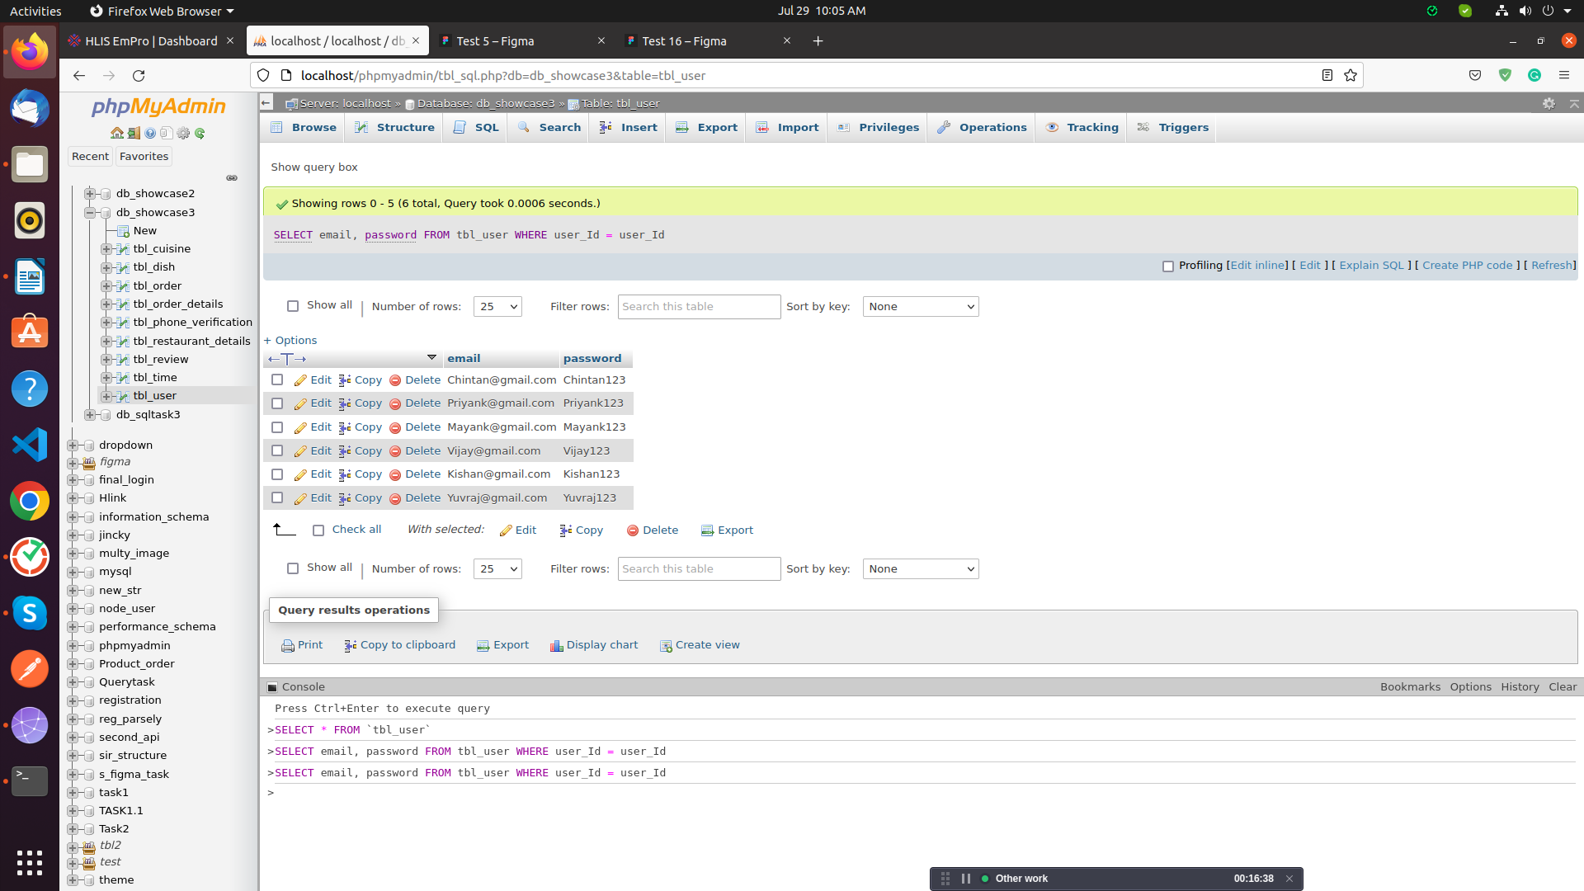

10. active user :
--> SELECT name, is_active
FROM tbl_user
WHERE is_active=1;

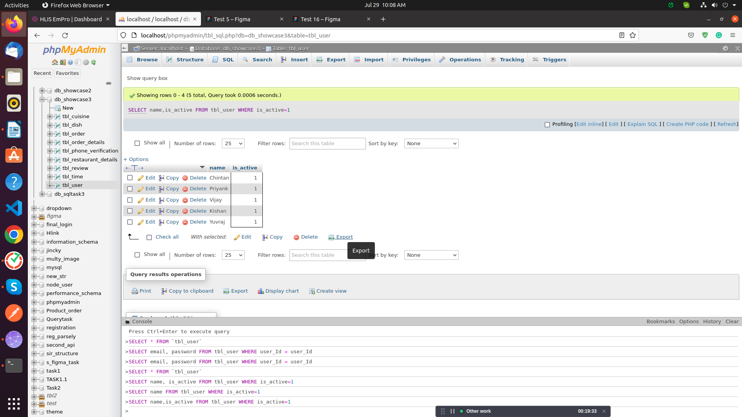

11. forgot password :
-->UPDATE `tbl_user` SET `password`='Chintan56' WHERE email = "Chintan@gmail.com";

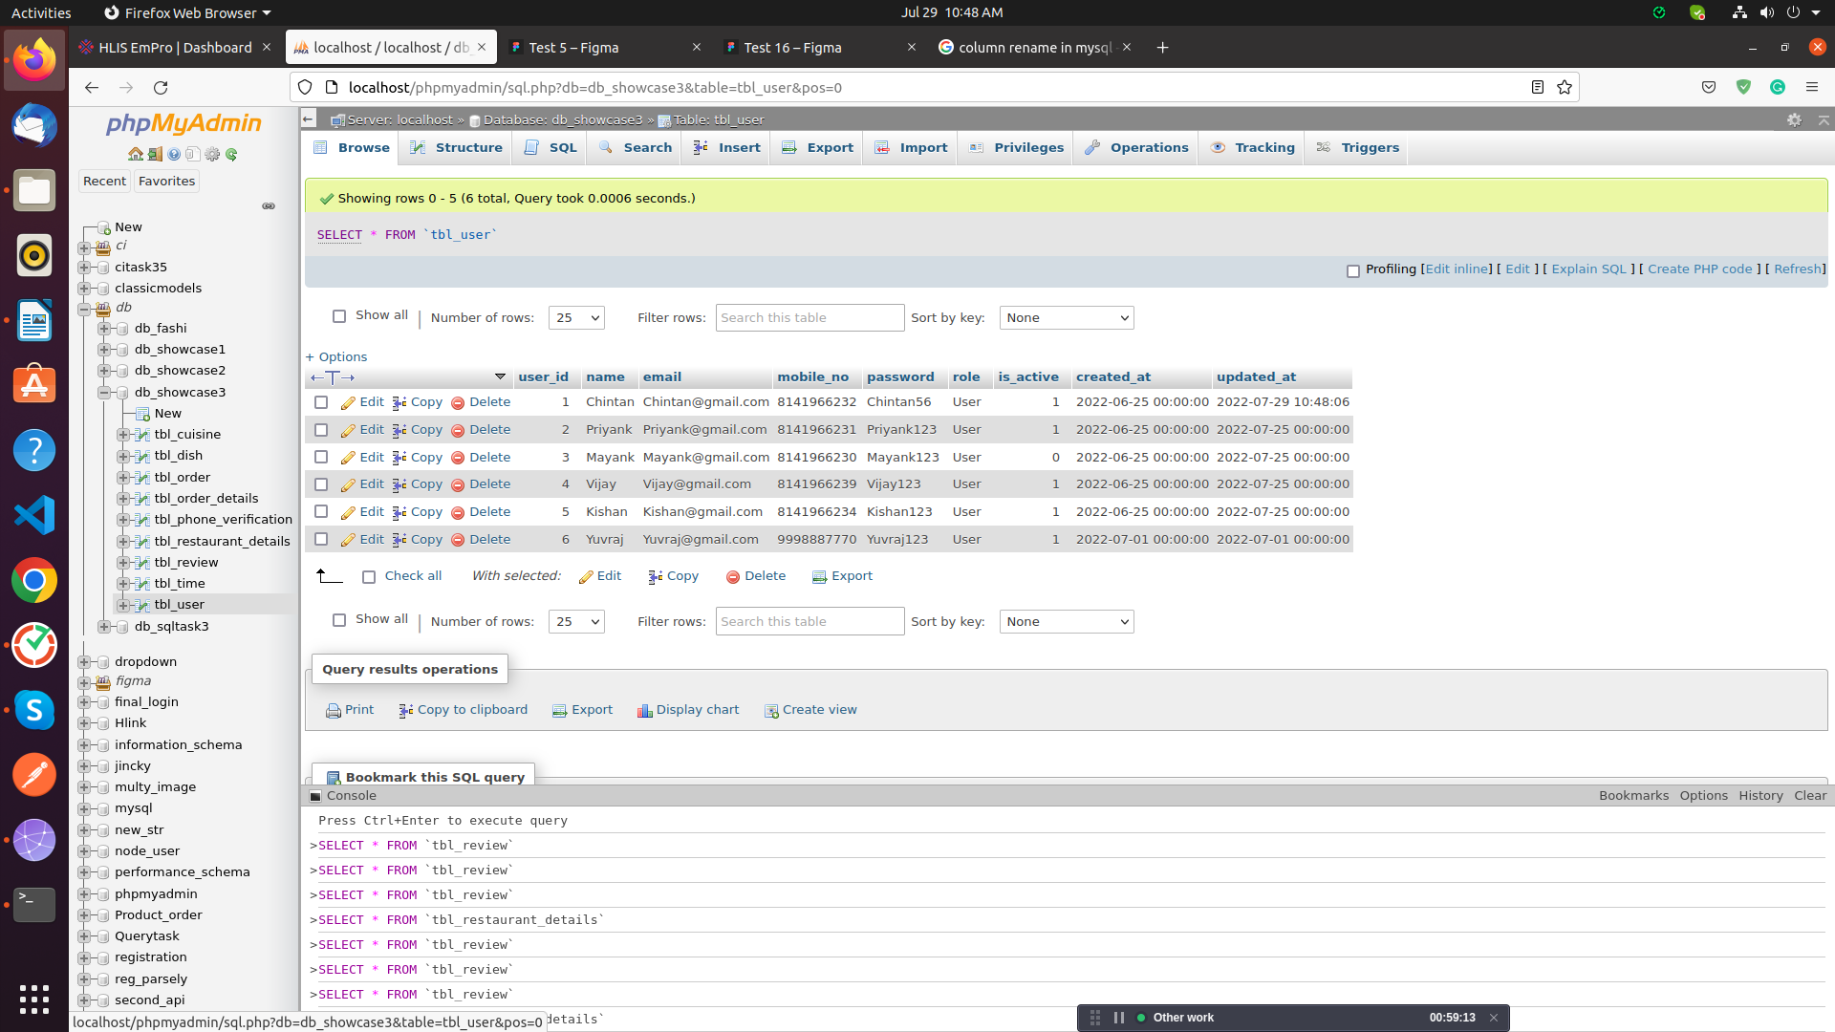

12. fetch restaurant all details.
-->select * from tbl_restaurant
where is_active=1;
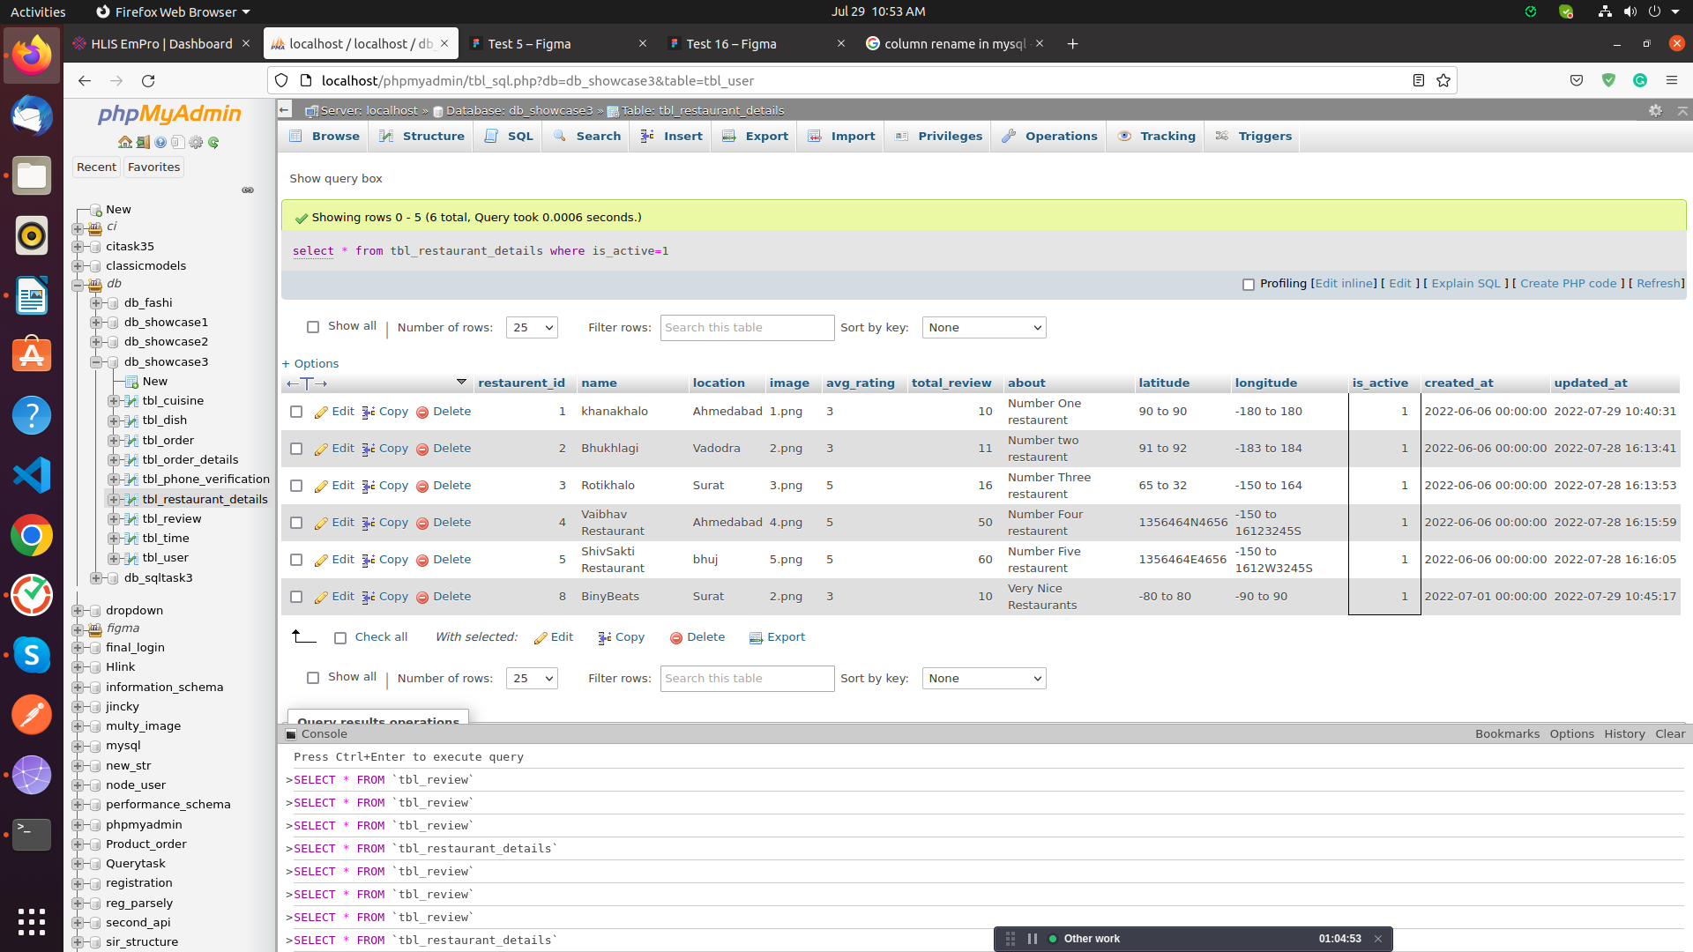

13. Restaurant details with Time, Category, Dish name if restaurant is active

-->select tbl_restaurant_details.name, tbl_restaurant_details.total_review,
tbl_restaurant_details.location, tbl_time.restaurant_id, tbl_time.opning_time, tbl_time.closing_time,
tbl_restaurant_details.about, tbl_cuisine.quesing_name, tbl_dish.name, tbl_dish.about,
tbl_dish.price
from tbl_restaurant_details
join tbl_time on tbl_time.timing_id = tbl_restaurant_details.restaurent_id
join tbl_dish on tbl_restaurant_details.restaurent_id = tbl_dish.dish_id
join tbl_cuisine on tbl_cuisine.cuisine_id = tbl_dish.dish_id

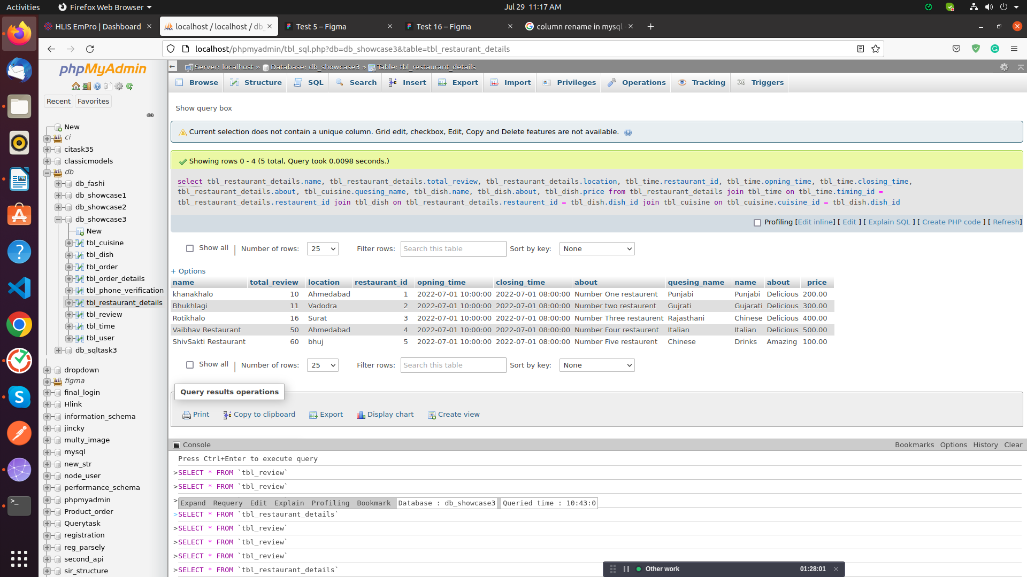

14. Apply trigger AFTER INSERT Review On tbl_review to tbl_restaurant_details

-->UPDATE tbl_restaurant_details SET avg_rating=(SELECT AVG(rating) FROM tbl_review WHERE tbl_review.restaurent_id=tbl_restaurant_details.restaurent_id) WHERE restaurent_id=NEW.restaurent_id

14. Apply trigger AFTER INSERT Review On tbl_review to tbl_restaurant_details for both trigger
1 is avg_rating
2 is total review

-->UPDATE tbl_restaurant_details SET
total_review = total_review + 1,
avg_rating = (SELECT AVG(rating) FROM tbl_review WHERE tbl_review.restaurent_id=tbl_restaurant_details.restaurent_id)
WHERE restaurent_id=NEW.restaurent_id

#Sahil Kanet
1. login :
SELECT email, password FROM tbl_user WHERE user_Id = user_Id;
2. active user :
SELECT full_name, is_active
FROM tbl_user
WHERE is_active=1;
3. forgot password :
UPDATE `tbl_user` SET `password`='sahil2211' WHERE email = "mailto:sahil@gmail.com";
4. Insert data in user table :
insert into tbl_user(full_name, email, phone, password, role)value
('Kenil Donga', 'mailto:kenil.donga@gmail.com', '9865327418', 'kenilD123', 'User');
5. fetch restaurant all details.

select * from tbl_restaurant
where is_active=1;
6. Restaurant details with Time, Category, Dish name if restaurant is active
select tbl_restaurant.r_name, tbl_restaurant.total_rating, tbl_restaurant.total_review,
tbl_restaurant.address, tbl_r_time.days, tbl_r_time.open_time, tbl_r_time.close_time,
tbl_restaurant.about, tbl_category.category_name, tbl_dish.dish_name, tbl_dish.about,
tbl_dish.price
from tbl_restaurant
join tbl_r_time on tbl_r_time.r_time_Id = tbl_restaurant.r_Id
join tbl_dish on tbl_restaurant.r_Id = tbl_dish.dish_Id
join tbl_category on tbl_category.category_Id = tbl_dish.dish_Id
where tbl_restaurant.is_active=1;
7. Order details with order number, restaurant name, dish name, payment type, credit number, bank ac number, quantity, total, service charge, sub total, grand total and order status fetch all data.
select order_no, r_name, dish_name, payment_type, credit_card, bank_ac, quantity, total,
service_charge, sub_total, grand_total, status
from tbl_order
join tbl_restaurant on tbl_restaurant.r_Id = tbl_order.order_Id
join tbl_dish on tbl_restaurant.r_Id = tbl_dish.dish_Id
join tbl_payment on tbl_payment.payment_Id = tbl_restaurant.r_Id
where tbl_dish.is_active=1;
8. If payment method is credit card then show
select order_no, r_name, dish_name, payment_type, credit_card, bank_ac, quantity, total,
service_charge, sub_total, grand_total, status
from tbl_order
join tbl_restaurant on tbl_restaurant.r_Id = tbl_order.order_Id
join tbl_dish on tbl_restaurant.r_Id = tbl_dish.dish_Id
join tbl_payment on tbl_payment.payment_Id = tbl_restaurant.r_Id
where tbl_dish.is_active=1 and tbl_payment.payment_type='Credit';
9. Review and Rating average trigger
CREATE DEFINER=`root`@`localhost`
TRIGGER `tbl_review_AFTER_INSERT`
AFTER INSERT ON `tbl_review`
FOR EACH ROW
BEGIN
update `db_food`.`tbl_restaurant`
set total_review = total_review + 1 ,
total_rating = (select avg(rating) from tbl_review where tbl_review.r_Id = tbl_restaurant.r_Id)
where r_Id = new.r_Id;
END

#Varsha
Login Screen

1. SELECT * FROM db_foodapp.tbl_user where email = 'varsha123@gmail.com' && password = 'Abc@123' && is_active = '1';

Signup Screen

2. INSERT INTO `db_foodapp`.`tbl_user` (`name`, `email`, `password`, `profile_pic`, `c_code`, `phone`, `role`, `is_active`)
VALUES ('nisarg', 'nisarg123@gmail.com', 'Abc2123', 'nisarg.png', '+91', '9638521471', 'user', '1');

otp verify

3. SELECT * FROM db_foodapp.tbl_otp where phone = '8787985858' && otp = '5678';

Forgot password

4. SELECT id FROM db_foodapp.tbl_user where email = 'varsha123@gmail.com';
5. UPDATE db_foodapp.tbl_user SET `password` = 'Xyz@123' WHERE `id` = '1';
and then send new password to user in sms then check new password login query when user enter new credentials.

Restaurant

Search Restaurant and Dish Using Like

6. Select * from tbl_restaurant where `name` LIKE '%Avenue%';
Select * from tbl_dish where `name` LIKE '%Punjabi%';

Display All Active Restaurant

7. SELECT distinct r.id,r.name,r.image,r.avg_rating,r.location,
(select count(id)
from db_foodapp.tbl_timing where is_open = '1' && res_id = r.id) As is_open
FROM db_foodapp.tbl_restaurant as r
LEFT JOIN db_foodapp.tbl_timing as t ON r.id = t.res_id
order by r.id DESC;

DIsplay Details of Restaurant which is clicked by user

Display all details of Restaurant with distance and is_open
8. SELECT distinct r.id,r.image,r.name,r.total_review,r.location,r.about,
concat(round((((acos(sin(("r.latitude"*pi()/180)) sin((`Latitude`*pi()/180))+cos(("r.latitude"*pi()/180)) cos((`Latitude`*pi()/180)) *
cos((("r.longitude"- `Longitude`)*pi()/180))))*180/pi())*60*1.1515)),' ','Mile') as distance,
(select count(id)
from db_foodapp.tbl_timing where is_open = '1' && res_id = r.id) As is_open
FROM db_foodapp.tbl_restaurant as r
where r.id = '1';

Display Restaurant Todays Timing
9. select day,open_time,close_time from db_foodapp.tbl_timing where res_id = '1' && is_open = '1';

Display All Category
10. SELECT * FROM db_foodapp.tbl_category where is_active = '1';

Display Restaurant's All Dishes

11. SELECT name,image,about,price FROM db_foodapp.tbl_dish where res_id = '1' && is_active = '1';

Display Dishes Restaurant and Clicked Category Wise
12. SELECT name,image,about,price FROM db_foodapp.tbl_dish where cat_id = '1' && res_id = '1' && is_active = '1';

Add Data into order and order Details table when User place the order.

13. INSERT INTO `db_foodapp`.`tbl_order` (`res_id`, `user_id`, `address_id`, `order_no`, `total_qty`, `total`, `sub_total`, `service_charge`, `grand_total`)
VALUES ('1', '3', '9', 'order14', '1', '200', '200', '50', '250');

order id 3 creted now add order details
14. INSERT INTO `db_foodapp`.`tbl_order_details` (`order_id`, `dish_id`, `qty`, `price`, `sub_total`) VALUES ('3', '5', '1', '200', '200');

AkashBhai Trigger 2

CREATE DEFINER=`root`@`localhost` TRIGGER `tbl_reviews_AFTER_INSERT` AFTER INSERT ON `tbl_reviews` FOR EACH ROW BEGIN
update `db_food`.`tbl_restaurant`
set total_reviews = total_reviews + 1 , total_ratings =(SELECT avg(ratings) FROM tbl_reviews
WHERE tbl_reviews.r_id = tbl_restaurant.id)
where id = NEW.r_id;
END

