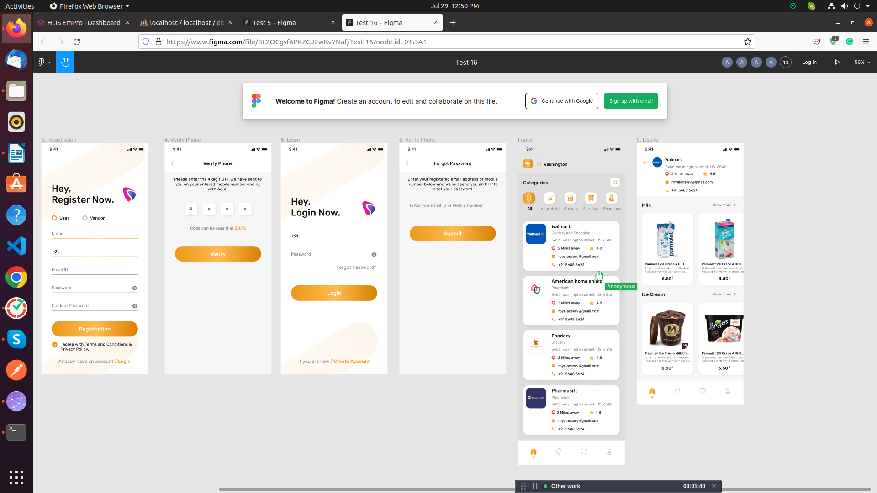

Task – SQL ShowCase-4 in
Databse name: db_showcase4

For the following relation schema:
1- tbl_user(Structure create base of all question)
2-tbl_verify(Structure create base of all question)
3-tbl_store_categories(Structure create base of all question)
4- tbl_store(Structure create base of all question)
5-tbl_rating(Structure create base of all question)
6- tbl_product_categories(Structure create base of all question)
7- tbl_product_item(Structure create base of all question)

1.Insert Query in table of user

-->INSERT INTO `tbl_user`(`user_id`, `name`, `phone_no`, `email`, `password`, `role`, `is_active`, `created_at`, `updated_at`)
VALUES (1,'Mahesh','1234567890','Mahesh@gmail.com','Mahesh@123','User',1,'2022-07-29','2022-07-29'),
(2,'Virat','1234567891','Virat@gmail.com','Virat@123','User',1,'2022-07-29','2022-07-29'),
(3,'Akshay','1234567892','Akshay@gmail.com','Akshay@123','Vendor',1,'2022-07-29','2022-07-29'),
(4,'Rishabh','1234567893','Rishabh@gmail.com','Rishabh@123','Vendor',0,'2022-07-29','2022-07-29');

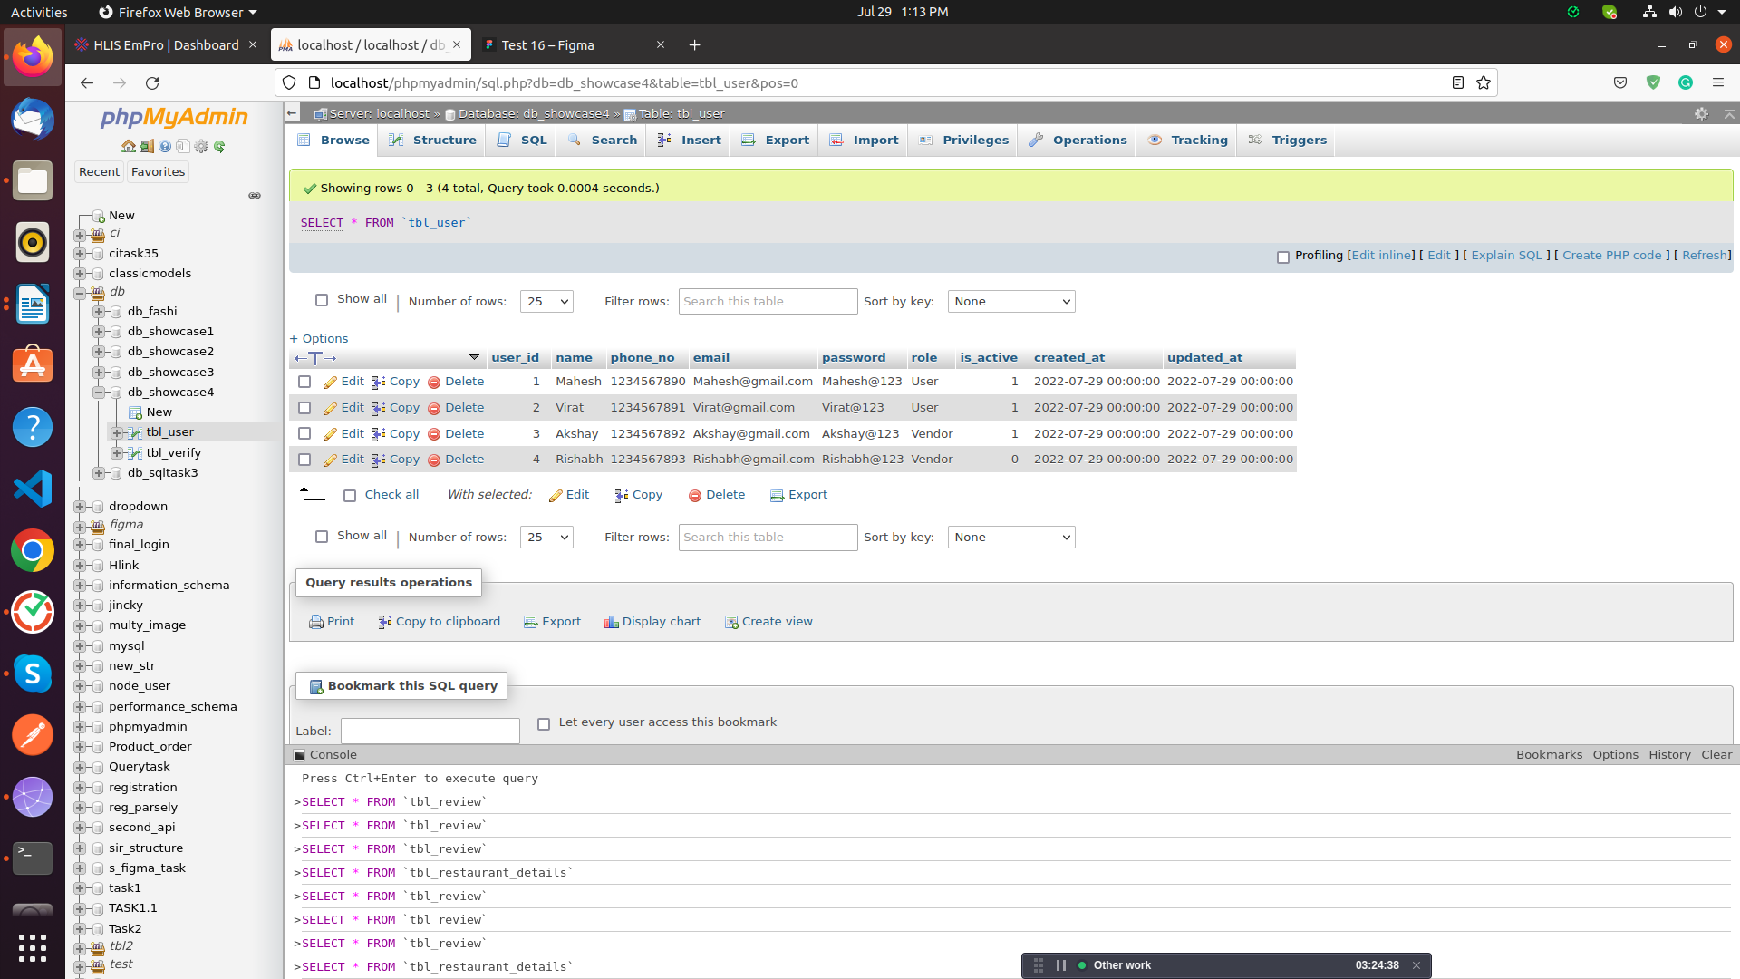

2.Insert Query in table of verify

-->INSERT INTO `tbl_verify`(`verify_id`, `user_id`, `otp`, `is_active`, `created_at`, `updated_at`)
VALUES (1,1,2568,1,'2022-07-29','2022-07-29'),
(2,3,2538,1,'2022-07-29','2022-07-29'),
(3,2,2548,1,'2022-07-29','2022-07-29'),
(4,4,2558,0,'2022-07-29','2022-07-29');

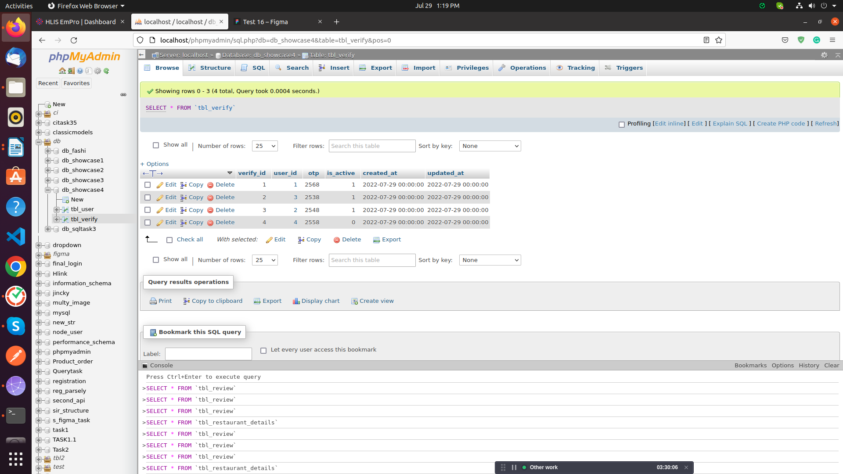

3.Insert Query in table store categories

-->INSERT INTO `tbl_store_categories`(`store_categories_id`, `name`, `is_active`, `created_at`, `updated_at`)
VALUES (1,'HouseHold',1,'2022-07-01','2022-07-01'),
(2,'Grocery',1,'2022-07-01','2022-07-01'),
(3,'Furniture',0,'2022-07-01','2022-07-01'),
(4,'Pharmacy',1,'2022-07-01','2022-07-01');

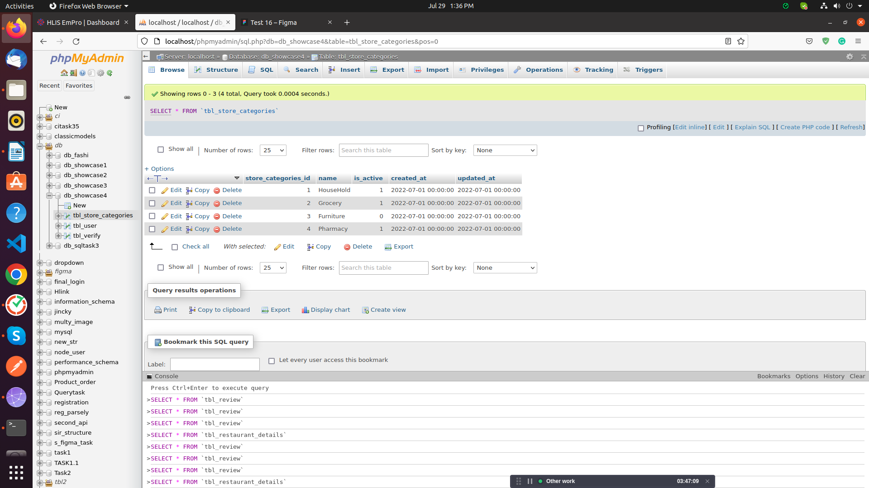

4.Insert Query in table of store

-->INSERT INTO `tbl_store`(`store_id`, `store_categories_id`, `name`, `image`, `location`, `latitude`, `longitude`, `avg_rating`, `email`, `phone_no`, `is_active`, `created_at`, `updated_at`)VALUES
(1,1,'Walmart','walmart.png','Ahmedabad',' 48.1667° N ','100.1667° W','10.1','Walmart@gmail.com','9635214556',1,'2022-07-01','022-07-01');

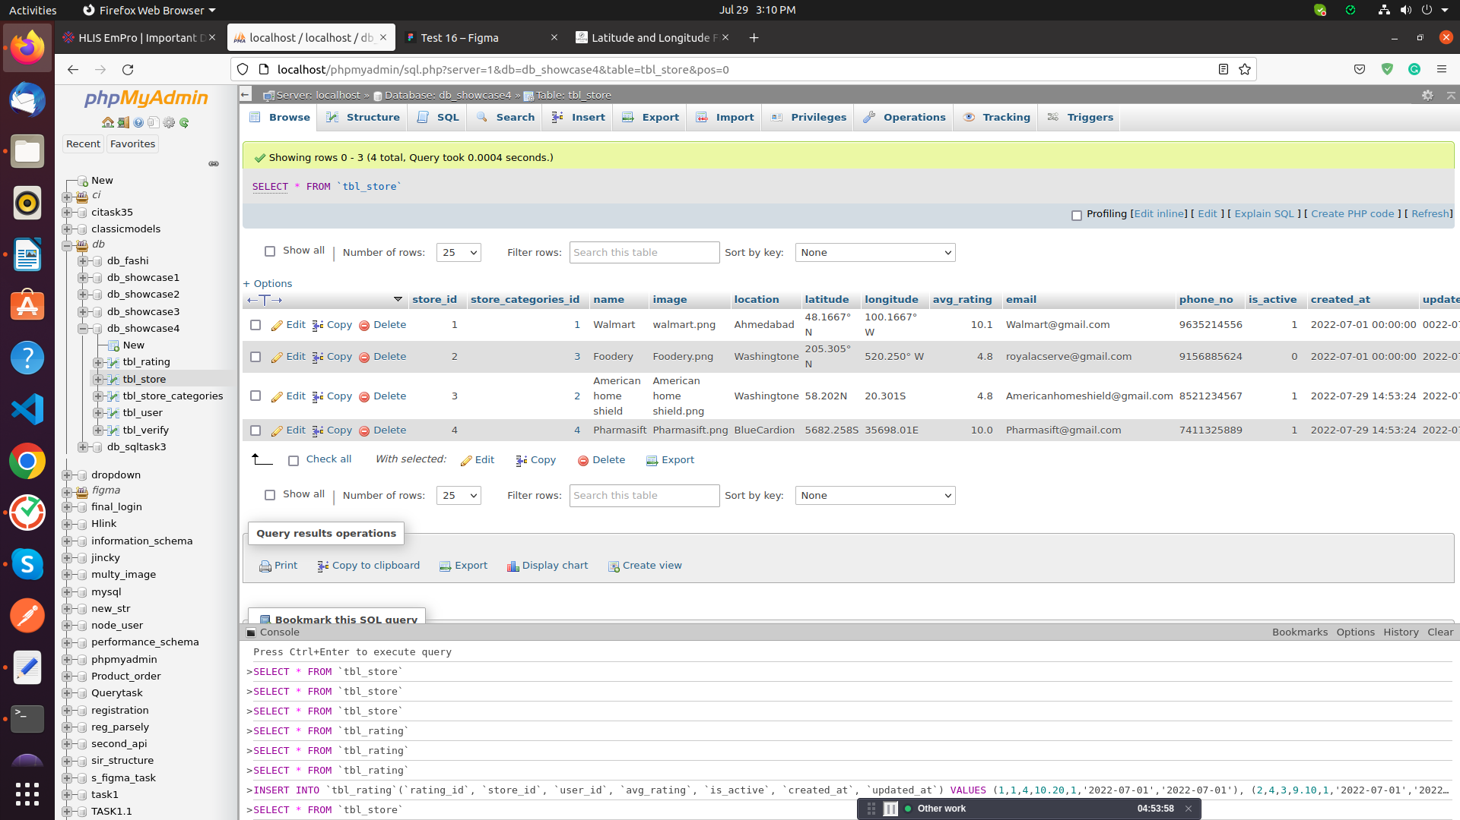

5.Insert Query in table of rating

-->INSERT INTO `tbl_rating`(`rating_id`, `store_id`, `user_id`, `avg_rating`, `is_active`, `created_at`, `updated_at`)
VALUES (1,1,4,10.20,1,'2022-07-01','2022-07-01'),
(2,4,3,9.10,1,'2022-07-01','2022-07-01'),
(3,3,2,10.60,1,'2022-07-01','2022-07-01'),
(4,2,1,8.00,1,'2022-07-01','2022-07-01');

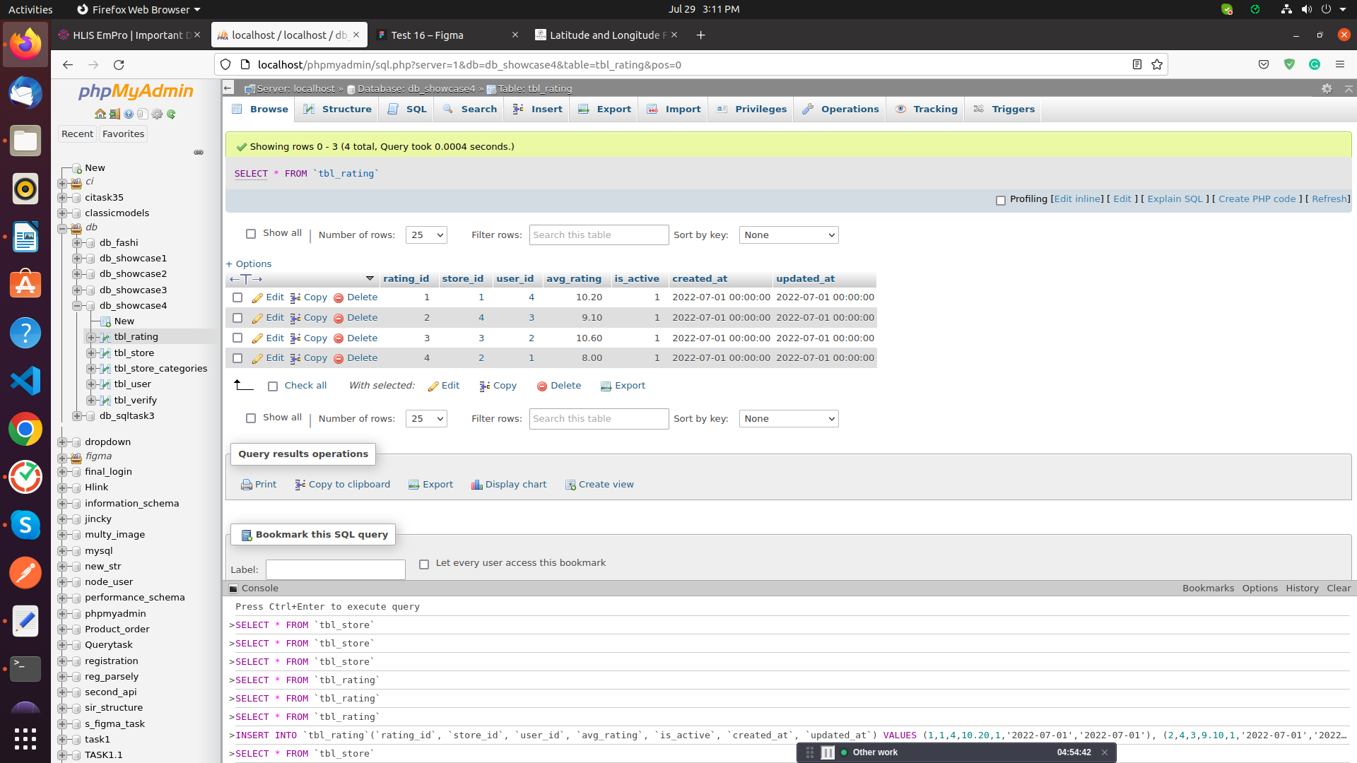

6.Insert Query in table of product categories

-->INSERT INTO `tbl_product_categories`(`product_categories_id`, `store_id`, `product_name`, `is_active`, `created_at`, `updated_at`) VALUES (1,4,'Milk',1,'2022-07-01','2022-07-02'),
(2,3,'Ice-cream',0,'2022-07-01','2022-07-02'),
(3,2,'Bread',1,'2022-07-01','2022-07-02'),
(4,1,'Biscuit',1,'2022-07-01','2022-07-02');

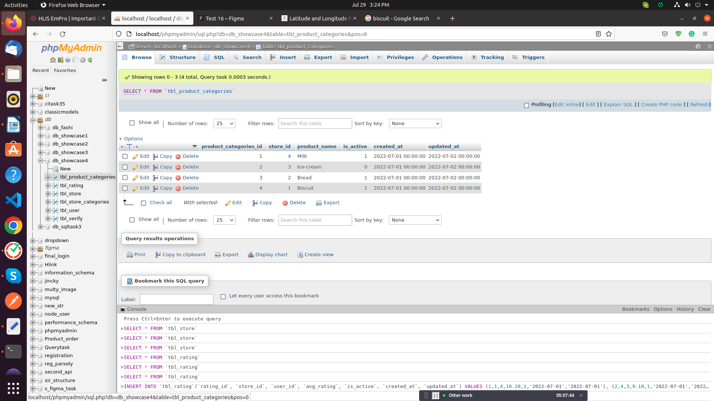

7.Insert Query in table of product item

-->INSERT INTO `tbl_product_item`(`product_item_id`, `product_categories_id`, `name`, `image`, `about`, `price`, `is_active`, `created_at`, `updated_at`)
VALUES (1,4,'paramalat milk','paramalatmilk.png','So nice Milk',100,1,'2022-07-01','2022-07-02'),
(2,1,'Shakti milk','Shakti milk.png','So Amazing Milk',200,1,'2022-07-01','2022-07-02'),
(3,3,'Venila Ice-cream','Venila Ice-cream.png','So nice Ice-crea,',300,0,'2022-07-01','2022-07-02'),
(4,2,'Chocolate Ice-cream','Chocolate Ice-cream.png','So Amazing Ice-cream',400,1,'2022-07-01','2022-07-02');

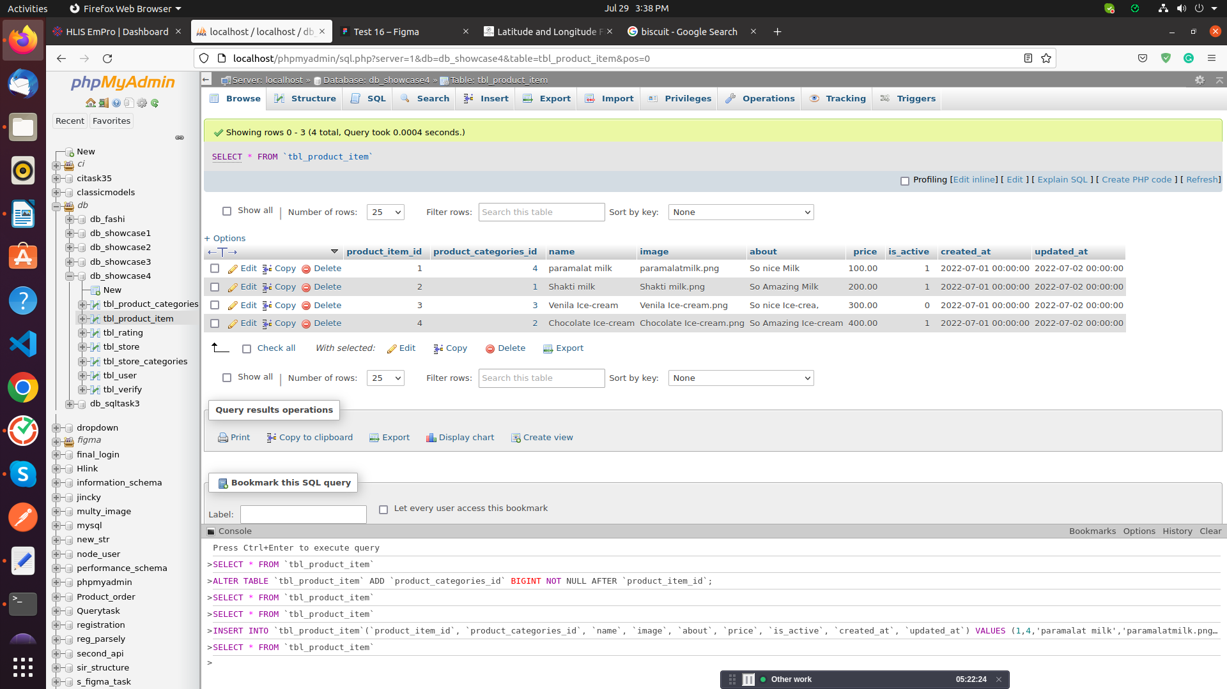

8.Apply trigger on table rating to table store

-->UPDATE tbl_store SET avg_rating=(SELECT AVG(avg_rating) FROM tbl_rating WHERE tbl_rating.store_id=tbl_store.store_id) WHERE store_id=NEW.store_id

9.Select query on where store id = 1

-->SELECT `store_id`, `store_categories_id`, `name`, `image`, `location`, `latitude`, `longitude`, `avg_rating`, `email`, `phone_no`, `is_active`, `created_at`, `updated_at` FROM `tbl_store` WHERE store_id = 1;

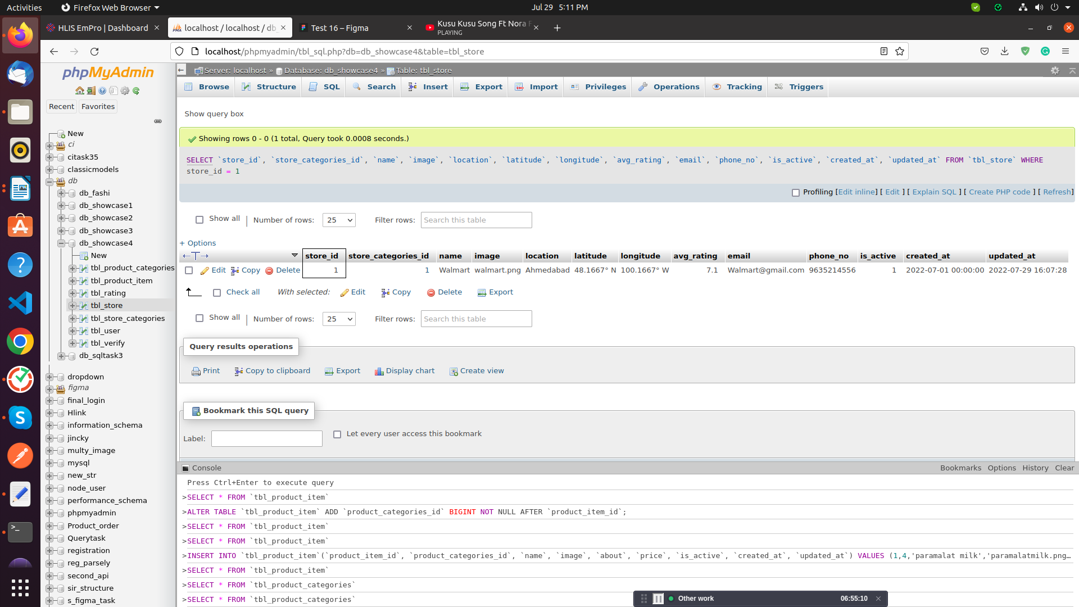

10.Delete query on where store id = 1

-->DELETE FROM `tbl_store` WHERE store_id = 1;

11.Login Screen

SELECT * FROM db_showcase4.tbl_user where phone_no = '1234567890' && password = 'Mahesh@123' && is_active = '1';

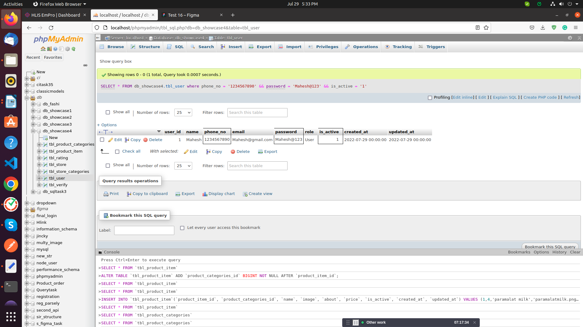

12.Registration Screen

-->INSERT INTO `db_showcase4`.`tbl_user` (`role`,`name`, `phone_no`,`email`, `password`, `is_active`)
VALUES ('user','chirag','9638521471', 'Chirag123@gmail.com', 'Abc2123',1);

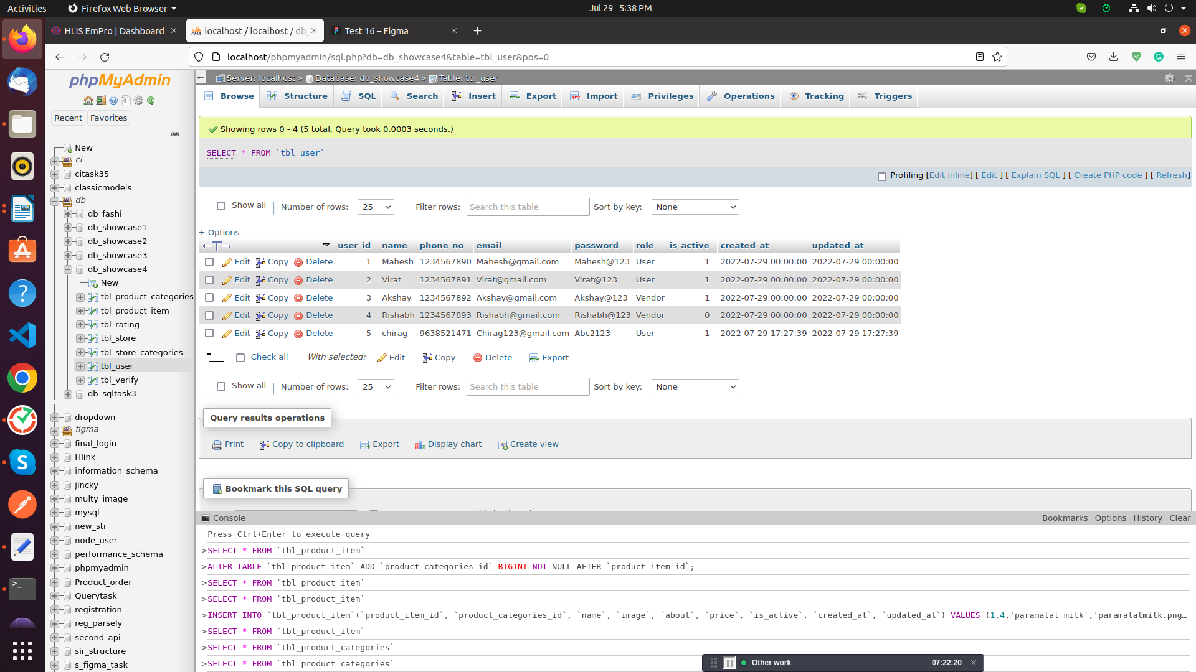

13.otp verify

-->SELECT * FROM db_showcase4.tbl_verify where phone_no = '1234567890' && otp = '2568';

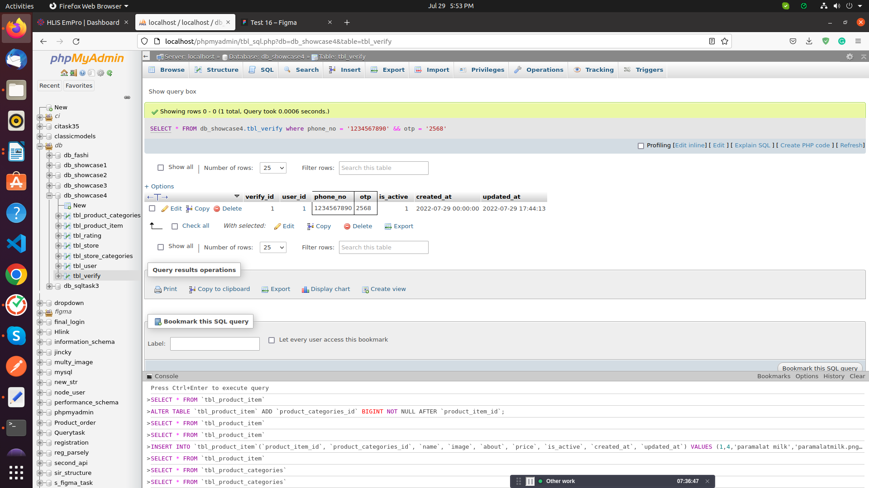
14.Forgot password

-->SELECT user_id FROM db_showcase4.tbl_user where email = 'Virat@gmail.com';

UPDATE db_showcase4.tbl_user SET `password` = 'Xyz@123' WHERE `user_id` = '1';

and then send new password to user in sms then check new password login query when user enter new credentials.

15.Update query on user table

-->UPDATE `tbl_user` SET `name`='Vikash',`phone_no`='9998543416',`email`='Vikash@gmail.com',`password`='Vikash@123' WHERE user_id = 2;

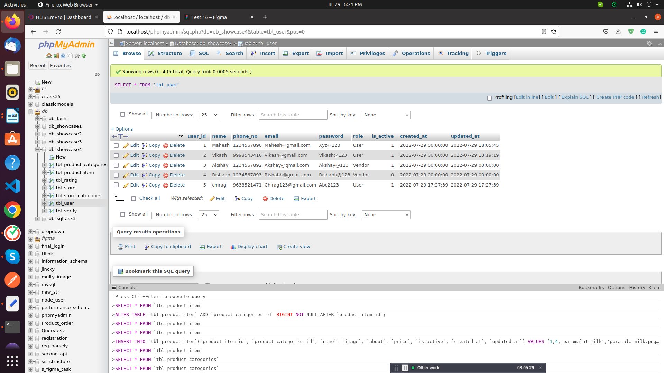

14.Find All product item , product of category is grocery

SELECT c.name as tbl_store_categories ,p.product_name as tbl_product_categories,p1.name as tbl_product_item,p1.image,p1.about,p1.price from tbl_product_item as p1 join tbl_product_categories as p on p1.product_categories_id=p.product_categories_id join tbl_store_categories as c on p.product_categories_id = c.store_categories_id where c.name="Grocery"

#Wrong
SELECT c.name as tbl_store_categories,p.product_name as tbl_product_categories,p1.name as tbl_product_item,p1.image,p1.about,p1.price from tbl_product_item as p1 join tbl_product_categories as p on p1.product_item_id=p.product_categories_id join tbl_store_categories as c on p.product_categories_id = c.store_categories_id where c.name="Furniture"

#Riddhi
8. insert new product item in category is grocery and product is rice

INSERT INTO `tbl_productItem`(`id`, `store_id`, `category_id`, `product_id`, `name`, `image`, `about`, `price`, `is_active`) VALUES
('5','2','2','2','India Gate Basmati Rice','rice.png','The areas of Basmati Rice production in India are in the states of J & K, Himanchal Pradesh, Punjab, Haryana, Delhi, uttarakhand and western Uttar Pradesh. India is the leading exporter of the Basmati Rice to the global market.','2250','1')

14.Find All product item , product of category is grocery

SELECT c.name as category,p.name as product,p1.name as item,p1.image,p1.about,p1.price from tbl_productItem as p1 join tbl_product as p on p1.product_id=p.id join tbl_category as c on p.category_id = c.id where c.name="grocery";

==================================================================

15. Find the details of category is furniture

SELECT c.name as category,p.name as product,p1.name as item,p1.image,p1.about,p1.price from tbl_productItem as p1 join tbl_product as p on p1.product_id=p.id join tbl_category as c on p.category_id = c.id where c.name="furniture";

==================================================================

16. Display All item acoording the product as well as category

SELECT c.name as category,p.name as product,p1.name as item,p1.image,p1.about,p1.price from tbl_productItem as p1 join tbl_product as p on p1.product_id=p.id join tbl_category as c on p.category_id = c.id;

