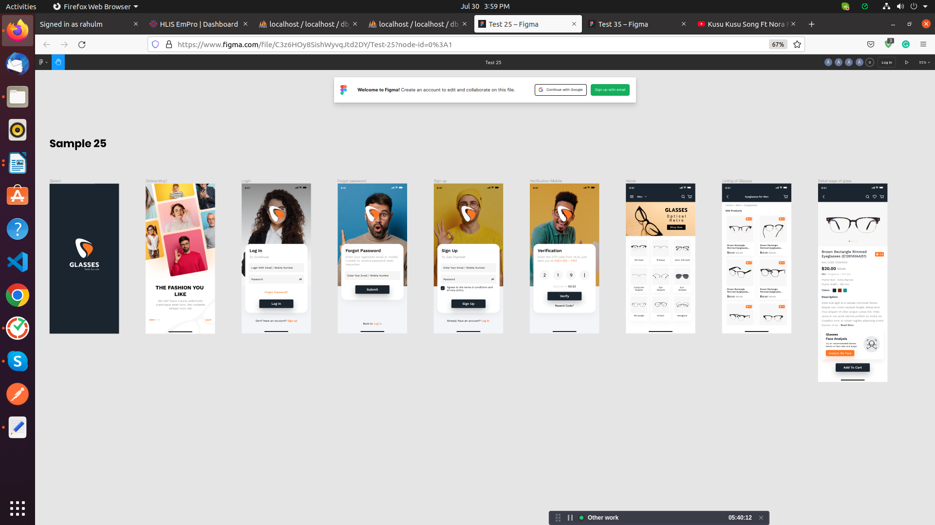

Task – SQL ShowCase-5 in
Databse name: db_showcase5

For the following relation schema:
1- tbl_user(Structure create base of all question)
1- tbl_verify(Structure create base of all question)
3-tbl_glass_categories(Structure create base of all question)
4-tbl_glass_deatials(Structure create base of all question)
5- tbl_image(Structure create base of all question)
6-tbl_rating(Structure create base of all question)
7- tbl_color(Structure create base of all question)
8- tbl_frame_size(Structure create base of all question)
9- tbl_frame_width(Structure create base of all question)
1.Insert Query in table of user

-->INSERT INTO `tbl_user`(`user_id`, `name`, `email`, `mobile`, `password`, `role`, `is_active`, `created_at`, `updated_at`)
VALUES (1,'Vijay','Vijay@gmail.com','9998543416','Vijay@123','User',1,'2022-07-01','2022-07-01');

2.Login Screen

-->SELECT * FROM db_showcase5.tbl_user where mobile = '9998543416' && email='Vijay@gmail.com' && password = 'Vijay@123' && is_active = '1';

3.Forgot password

-->SELECT user_id FROM db_showcase5.tbl_user where email = 'Vijay@gmail.com' && mobile= '9998543416';

UPDATE db_showcase5.tbl_user SET `password` = 'Xyz@123' WHERE `user_id` = '1';

and then send new password to user in sms then check new password login query when user enter new credentials.

2.4 Screen Sign Up

-->SELECT * FROM db_showcase5.tbl_user where mobile = '9998543416' && email='Vijay@gmail.com' && password = 'Vijay@123' && is_active = '1';
5.otp verify

-->SELECT * FROM db_showcase5.tbl_verify where mobile = '9998543416' && otp = 2550;

6.Apply trigger on tbl_rating to tbl_glass_details After insert

-->UPDATE tbl_glass_details SET avg_rating=(SELECT AVG(avg_rating) FROM tbl_rating WHERE tbl_rating.glass_details_id=tbl_glass_details.glass_details_id) WHERE glass_details_id=NEW.glass_details_id

7.Select query on tbl_glass_categories

-->SELECT `name`, `image` FROM `tbl_glass_categories` WHERE glass_categories_id = 1

#Riddhi
6. find the all product and their item in category=”men”

SELECT c.name as categoryname, p.name as productname,p1.name as item,i.image,p1.skucode,p1.description,p1.price,p1.discount,p1.avg_rating,c1.name as color
from tbl_category as c
join tbl_product as p on p.category_id = c.id
join tbl_productItem as p1 on p1.product_id=p.id
join tbl_color as c1 on c1.product_id = p.id
join tbl_image as i on i.color_id = p1.product_id
where c.name="men";

7. find the all product and their item in category men and women

SELECT c.name as categoryname, p.name as productname,p1.name as item,i.image,p1.skucode,p1.description,p1.price,p1.discount,p1.avg_rating,c1.name as color
from tbl_category as c
join tbl_product as p on p.category_id = c.id
join tbl_productItem as p1 on p1.product_id=p.id
join tbl_color as c1 on c1.product_id = p.id
join tbl_image as i on i.color_id = p1.product_id;

9.Display the all product belongs to category=”women”

SELECT c.name as categoryname, i.image,p.name as productname,c1.name as color from tbl_category as c join tbl_product as p on p.category_id = c.id join tbl_color as c1 on c1.product_id = p.id join tbl_image as i on i.color_id = p.id where c.name="women";

10.Display the product=”rimmed” belongs to category=”women”

SELECT c.name as categoryname, i.image,p.name as productname,c1.name as color from tbl_category as c join tbl_product as p on p.category_id = c.id join tbl_color as c1 on c1.product_id = p.id join tbl_image as i on i.color_id = p.id where c.name="women" and p.name="rimmed";

