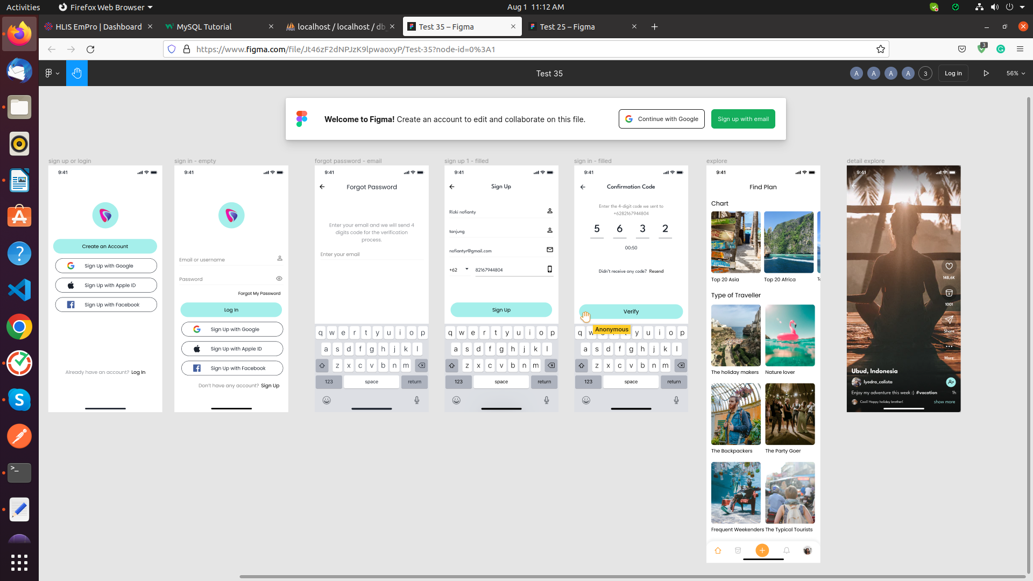

Task – SQL ShowCase-6 in
Databse name: db_showcase6

For the following relation schema:
1- tbl_user(Structure create base of all question)
1- tbl_otp(Structure create base of all question)
3-tbl_post(Structure create base of all question)
4-tbl_likes(Structure create base of all question)
5- tbl_comments(Structure create base of all question)
6-tbl_share(Structure create base of all question)

1.Insert Query in table of user

-->INSERT INTO `tbl_user`(`user_id`, `first_name`, `last_name`, `email`, `password`, `mobile`, `role`, `social_id`, `login_type`, `is_active`, `created_at`, `updated_at`) VALUES
(2,'Vansh','Damor','VanshDamor@gmail.com','Vansh@123','9998543416','User','Vansh_11','A',1,'2022-08-01','2022-08-01');

2.Login Screen

-->SELECT * FROM db_showcase6.tbl_user where mobile = '9998543416' && email='VanshDamor@gmail.com' && password = 'Vansh@123' && is_active = '1';

3.Forgot password

-->SELECT user_id FROM db_showcase6.tbl_user where email = 'VanshDamor@gmail.com' && mobile= '9998543416';

UPDATE db_showcase6.tbl_user SET `password` = 'Xyz@123' WHERE `user_id` = '2';

and then send new password to user in sms then check new password login query when user enter new credentials.

4 Screen Sign Up

-->SELECT * FROM db_showcase6.tbl_user where first_name='Vansh' && last_name='Damor' && email='VanshDamor@gmail.com' && mobile = '9998543416' && is_active = '1';

5.otp verify

-->SELECT * FROM db_showcase6.tbl_otp where email='premal@gmail.com' && mobile = '9638521472' && otp = 1447;

