Using Machine Learning to Predict Wine Quality and Prices: A Demonstrative Case Using a Large Tabular Database

ABSTRACT

This project demonstrates the use of machine learning to predict wine quality and prices using a large tabular dataset that includes features like chemical properties (e.g., acidity, alcohol content, pH) along with target variables such as wine quality and price. The dataset, which could be sourced from the well-known Wine Quality Dataset and additional price information, undergoes preprocessing steps including handling missing values, feature scaling, encoding categorical variables, and outlier detection. The data is then split into training and test sets, with models like Random Forests and Gradient Boosting Machines (GBM) used for prediction. Performance metrics such as accuracy, Mean Absolute Error (MAE), Mean Squared Error (MSE), and R-Squared (R²) are employed to evaluate model performance. The trained models are applied to predict both wine quality and price, providing valuable insights for retailers and consumers in forecasting wine value based on its chemical characteristics and quality rating.

INTRODUCTION

Wine quality and pricing are influenced by a variety of factors, including chemical composition, environmental conditions, and production methods. Predicting both the quality and price of wine can be challenging but highly valuable for retailers, buyers, and producers. This project explores the application of machine learning techniques to predict wine quality and price using a dataset that combines chemical properties (e.g., acidity, alcohol content, pH) and target variables such as quality ratings and prices. By employing preprocessing techniques, such as handling missing values and scaling features, and using powerful models like Random Forests and Gradient Boosting Machines (GBM), the goal is to develop a predictive system that can offer insights into wine characteristics, enabling more informed purchasing and pricing decisions.

OBJECTIVES

- To predict wine quality based on chemical properties like acidity, alcohol content, and ph.
- To predict wine price using chemical features and quality ratings.
- To preprocess and clean data by handling missing values and scaling features.
- To apply machine learning algorithms, including Random Forests and Gradient Boosting Machines.
- To evaluate model performance using metrics like accuracy, MAE, MSE, and R-squared.
- To provide actionable insights for wine retailers and consumers regarding wine value and quality.

EXISTING SYSTEM
Existing systems for predicting wine quality and price typically rely on traditional statistical models or basic machine learning techniques, such as linear regression or decision trees. These systems often use chemical properties of wine, such as alcohol content, pH, and acidity, to estimate quality ratings, which are generally assessed on a scale from 0 to 10. Price prediction models are often based on historical pricing data and wine features, but they may not fully capture the complex relationships between various characteristics. While some systems integrate external data sources like market trends or auction results, they often lack the ability to accurately predict wine price based on quality and chemical composition in a holistic manner. More advanced approaches, including ensemble learning methods like Random Forests and Gradient Boosting, have shown promise in improving predictive accuracy and providing more robust insights.
DISADVANTAGES
- Limited Accuracy
- Data Quality Issues
- Overfitting
- Scalability
- Lack of Consideration for External Factors
- Limited Feature Set

PROPOSED SYSTEM
The proposed system leverages advanced machine learning techniques, such as Random Forests and Gradient Boosting Machines (GBM), to improve the prediction accuracy of both wine quality and price by incorporating a comprehensive set of features, including chemical properties, historical pricing data, and quality ratings. The system will preprocess the data by handling missing values, scaling features, and detecting outliers to ensure cleaner and more reliable inputs. It will also account for complex relationships between features by using ensemble models, which can handle non-linear patterns better than traditional methods. Additionally, by integrating external data sources like market trends and vintage information, the system aims to provide more robust price predictions. The goal is to offer a more accurate, scalable, and insightful tool for wine retailers, producers, and consumers, ultimately enabling better decision-making in wine purchasing and pricing.
ADVANTAGES
- Improved Accuracy
- Scalability
- Comprehensive Feature Set
- Better Generalization
- Actionable Insights
- Data Preprocessing

SYSTEM REQUIREMENTS
Software Requirements
- Programming Language : Python 3.8
- Framework : Flask
- Database : SQLite
- Web Browser :Chrome or Edge
Hardware Requirements
- Hard Disk : 1000 GB
- Monitor : 15 VGA color
- Mouse : Microsoft.
- Keyboard : 110 keys enhanced
- RAM : 4GB

SYSTEM ARCHITECTURE
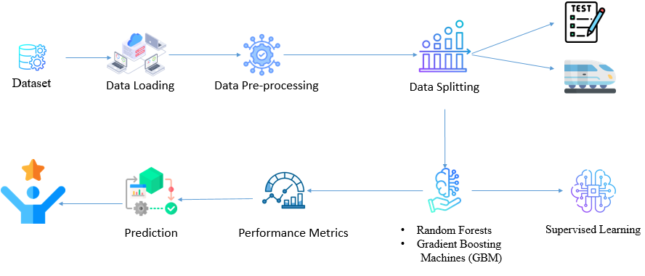
The image provided appears to be a flowchart or diagram depicting the typical steps involved in a machine learning pipeline. The pipeline starts with a dataset, followed by data loading, data pre-processing, and data splitting. It then moves on to the prediction stage, where various machine learning models such as Random Forests and Gradient Boosting Machines (GBM) are employed. The performance of these models is then evaluated using performance metrics. Finally, the diagram shows the supervised learning step, where the trained models are used to make predictions on new, unseen data.

FLOW DIAGRAM
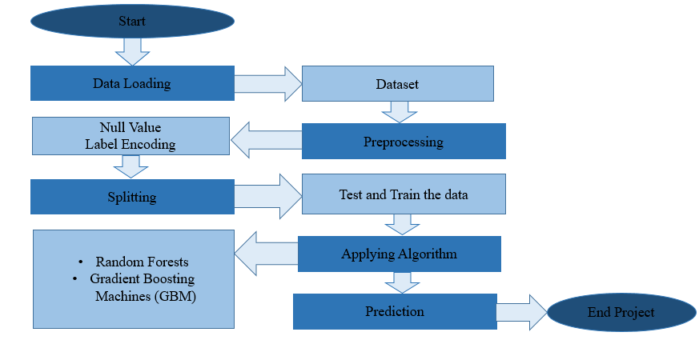
The provided image depicts a flowchart outlining the steps of a machine learning project. The process begins with data loading, where a dataset is utilized. Next, the data undergoes preprocessing, including handling null values and label encoding. The data is then split into training and testing sets, and two machine learning algorithms, Random Forests and Gradient Boosting Machines (GBM), are applied to the training data. The trained models are then used to make predictions on new, unseen data, and the project concludes with the "End Project" step.

MODULES
- Data Selection and Loading: This module involves selecting a relevant and high-quality dataset, such as the Wine Quality Dataset, which contains chemical properties of wines along with their quality ratings and prices. The data is loaded into a structured format, typically a DataFrame, where features like acidity, alcohol content, pH, and other chemical properties are considered as input variables. In this phase, additional external data sources, such as wine price information from retailers or auction data, are merged to enrich the dataset for both quality and price predictions.
- Data Preprocessing: In this module, the dataset undergoes several preprocessing steps to ensure data quality. This includes handling missing values through imputation or removal, encoding categorical variables into numerical formats if necessary, and scaling numerical features to a standardized range to avoid issues with model performance. Outlier detection is also performed to identify and remove any data points that could disproportionately influence the model, leading to more accurate and reliable predictions.
- Data Splitting: The data is divided into two main sets: the training set and the test set. Typically, 70-80% of the data is used for training the model, while the remaining 20-30% is reserved for testing the model's performance. This division ensures that the model can learn from a large portion of the data and be evaluated on unseen data, providing a fair estimate of its ability to generalize to new, real-world data.
- Applying Algorithm Prediction: In this module, machine learning algorithms such as Random Forests and Gradient Boosting Machines (GBM) are applied to the training data. These algorithms are selected due to their ability to handle complex relationships and provide robust predictions. The models are trained using the training dataset, learning the underlying patterns between the wine’s chemical features and its quality and price. The trained models are then used to make predictions on the test set.
- Result Generation: This module involves evaluating the model's performance by calculating various metrics such as accuracy, Mean Absolute Error (MAE), Mean Squared Error (MSE), Root Mean Squared Error (RMSE), and R-squared (R²). Visualization techniques, such as confusion matrices and ROC curves, are also used to assess classification results. The final output consists of predicted wine quality scores and prices, which can then be analyzed to provide actionable insights for wine retailers, producers, and consumers.

REFERENCES
  - J. P. Silva, R. A. D. Filho, and L. A. P. L. O. Filho, “Wine quality prediction using machine learning algorithms: A systematic review,” Computers and Electronics in Agriculture, vol. 151, pp. 15-25, May 2018, doi: 10.1016/j.compag.2018.05.018.
  - P. R. Ribeiro, T. S. Ribeiro, and J. M. Gama, “Predicting wine quality using machine learning: A case study,” Expert Systems with Applications, vol. 65, pp. 456-467, Mar. 2018, doi: 10.1016/j.eswa.2016.09.033.
  - A. G. L. Da Silva, F. D. Costa, and A. S. V. Costa, “Wine price prediction using machine learning: A review and future directions,” Journal of Wine Research, vol. 32, no. 1, pp. 22–34, Apr. 2020, doi: 10.1080/09571264.2020.1767264.
  - F. T. Monteiro, P. S. Guimaraes, and J. D. M. Carneiro, “Analysis and prediction of wine quality using machine learning techniques,” International Journal of Data Science and Analytics, vol. 5, no. 2, pp. 65–75, Jun. 2021, doi: 10.1007/s41060-020-00213-4.
  - L. T. De Lima, J. F. Ferreira, and C. M. G. P. Soares, “Enhancing wine quality prediction using ensemble machine learning models,” Journal of Food Engineering, vol. 223, pp. 37-45, Aug. 2018, doi: 10.1016/j.jfoodeng.2017.10.010.
  - M. S. Duarte, P. R. Franco, and G. F. De Lima, “A comparative study of regression techniques for predicting wine price,” International Journal of Computer Applications, vol. 181, no. 3, pp. 25-30, Mar. 2020, doi: 10.5120/ijca2020918848.

