PROJECT 8 TITLE

SMART WATER FOUNTAIN

PHASE 2: PUT YOUR DESIGN INTO INNOVATION TO SOLVE THE PROBLEM

**AIM AND OBJECTIVES :The aim of this project is to build a water fountain and automatic plant watering system that senses soil moisture using soil moisture sensor and to provide water to the plants or garden automatically with the help of a microcontroller when students are busy with lectures and when schools are going on vacation. The following are objectives of the studies:**

**• To minimize water loss and maximize the efficiency of water used.**

**• To reduce human interference and ensure proper watering**

**• To build a functional water fountain.**

**• To prevent over labor of the pumping machine and prevent it from getting bad**

**DESIGN AND CONSTRUCTION OF SMART WATER FOUNTAIN**

**1)MATERIAL AND METHODOLOGY**

**The block diagram in this system is used to describe the most basic and less detailed description and operation of the automatic sprinkler and auto refill system. It shows the hardware used in the project which includes the Atmega328P microcontroller IC, real-time clock module, soil moisture sensor, float switch, submersible pump, refill pump, sprinkler pump, etc.**

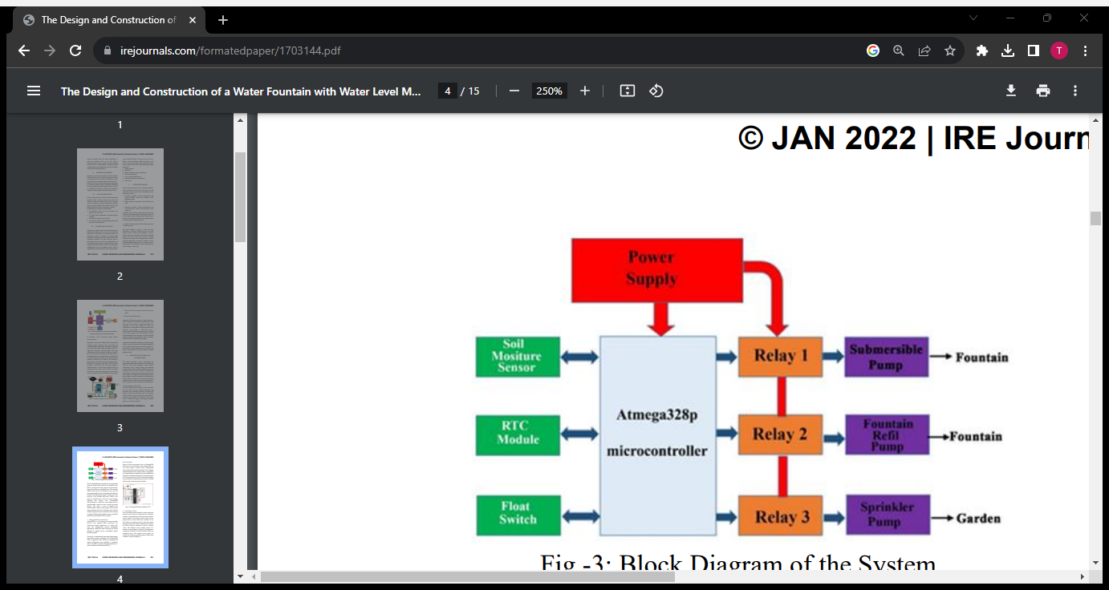

* **The ATmega328P microcontroller IC is programmed using the Arduino IDE software. The function of the RTC is to keep track of the system in real time and to trigger the system at a designated time. The moisture sensor senses the level of moisture in the soil. The water pump supplies water to the plants and refills the fountain.**
* **The submersible pump is submerged in the reservoir of the fountain and moves water to the aerator or fountain piece where the water emerges. Although this project uses ATmega328P microcontroller to control the water pumps, but the microcontroller cannot be used to trigger the pump directly. The relay is used to interface the microcontroller with the water pumps.**
* **The moisture sensor measures the level of moisture in the soil and sends the signal to the microcontroller when watering is required. Water pump supplies water to the plants until the desired moisture level is reached.**
* **Soil Moisture Sensor :**

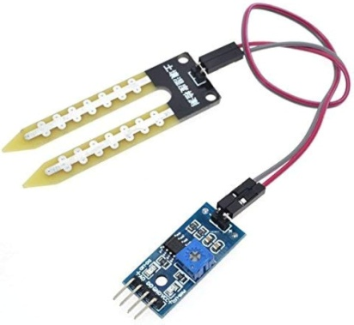

**In this Plant Irrigation System, we have used a Homemade Soil Moisture Sensor Probe to sense the soil moisture level. To make probe, we have cut and etched a Copper clad Board according to the Picture shown above. One side of the probe is directly connected to Vcc and other probe terminal goes to the vero board which is connected with aurduino. It works like not gate. A potentiometer is connected to the base of the transistor to adjust the sensitivity of the sensor.The soil moisture sensor module is used to detect the moisture level of the soil. It measures the volumetric content of water inside the soil and gives the moisture level as output. The moisture sensor consists of two probes that are used to detect the moisture of the soil. These two probes are used to pass the current through the soil to the LM393 comparator IC, and then the sensor reads the resistance to get the moisture values. This Moisture sensor module consists of a moisture sensor, Resistors, Capacitor, Potentiometer, Comparator (LM393 IC), Power and Status LED in an integrated circuit. The moisture sensor probes are coated with immersion gold that protects Nickel from oxidation.**

**b) Realtime Clock (DS3231)**:

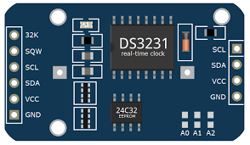

* **DS3231 - AT24C32 -  I2C Real Time Clock Module  
  DS3231 is a extremely accurate I2C real-time clock (RTC), with an integrated temperature-compensated crystal oscillator (TCXO) and crystal. The device incorporates a battery input, disconnect the main power supply and maintains accurate timekeeping. Integrated oscillator improve long-term accuracy of the device and reduces the number of components of the production line.**
* **The DS3231 is available in commercial and industrial temperature ranges, using a 16-pin 300mil SO package.  
  RTC maintains seconds, minutes, hours, day, date, month, and year information. Less than 31 days of the month, the end date will be automatically adjusted, including corrections for leap year.**
* **The clock operates in either the 24 hours or band / AM / PM indication of the 12-hour format. Provides two configurable alarm clock and a calendar can be set to a square wave output. Address and data are transferred serially through an I2C bidirectional bus. This temperature sensor accuracy is ± 3 ° C. On-chip power supply control circuit can automatically detect and manage the main and standby power (i.e., low-voltage battery) to switch between the power supply. If the main power failure, the device can continue to provide accurate time in**

**c)Float Switch:**

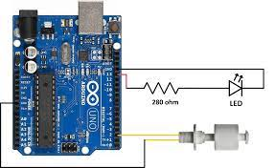

**Float sensor is used in projects where you need to detect the level of water in a tank or any reservoir. In this tutorial we will see what is a Float sensor, How it works and how to interface this sensor with Arduino with wiring connections and the code. The float sensor consists of an electromagnetic switch. It operates just like any other switch. Here a Magnetic reed switch is placed in the stem of the sensor. A magnet will be in the bulb structure of float sensor. When water fills up in a reservoir the bulb structure which has the magnet starts moving up once water reaches a certain level. It moves up close to stem near the reed switch. Due to the force of attraction from this magnet reed switch closes indicating water level is high.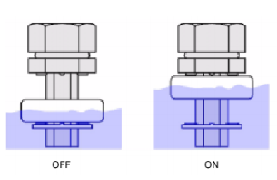When the water level goes down the bulb moves down and reed switch contact breaks and by this way the system detects that water level has gone down and acts accordingly.**

* **The maximum switch current of the float is 0.5A and the switch voltage of 100V DC.**
* **The temperature rating is about 10-85 degrees centigrade.**
* **The power rating of this sensor is about 10W.**
* **The entire body of this sensor is made up of plastic.**

**d) power supply**

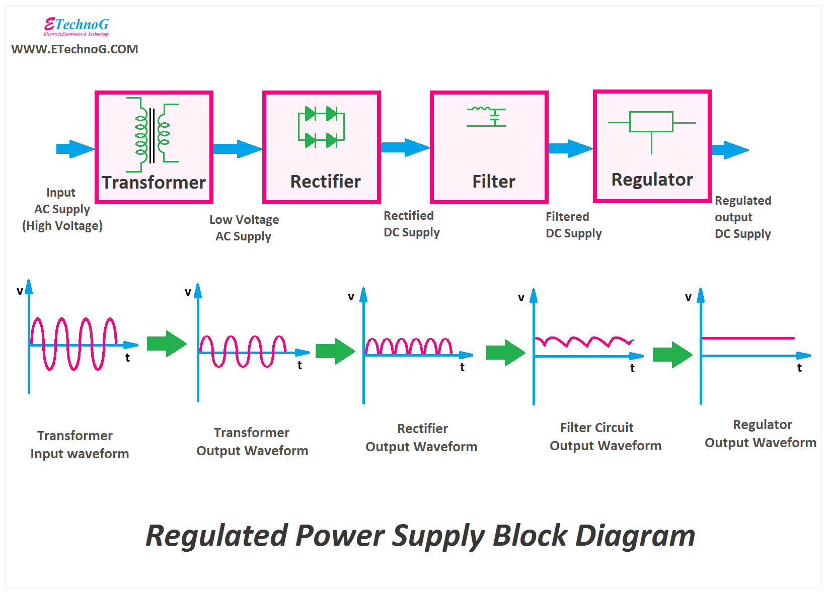

**REGULATOR POWER SUPPLY BLOCK DIAGRAM**

**A power supply is an electrical device that supplies electric power to an electrical load. The primary function of a power supply is to convert electric current from a source to the correct voltage, current, and frequency to power the load. As a result, power supplies are sometimes referred to as electric power converters. Some power supplies are separate standalone pieces of equipment, while others are built into the load appliances that they power.WE also connected a USB data cable. Examples of the latter include power supplies found in desktop computers and consumer electronicsdevices. Other functions that power supplies may perform include limiting the current drawn by the load to safe levels, shutting off the current in the event of an electrical fault, power conditioning to prevent electronic noise or voltage surges on the input from reaching the load, power-factor correction, and storing energy so it can continue to power the load in the event of a temporary interruption in the source power (uninterruptible power supply).**

**E) ATmega328P Microcontroller IC:**

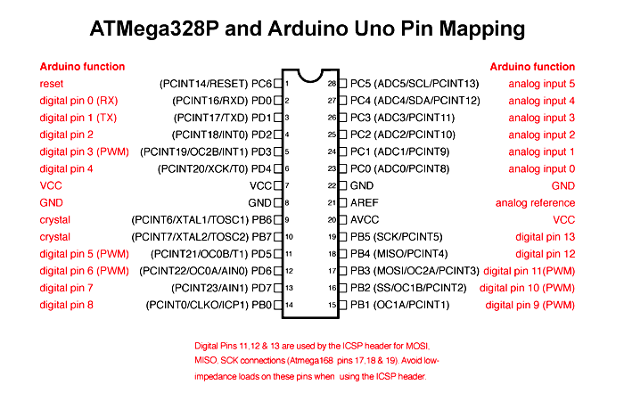

**The ATMEGA328P-PN is a popular microcontroller due to it being a major component in the Arduino board products. The ATMEGA328P-PN is the 8-bit RISC heart of the Arduino Uno and Nano, with a maximum clock frequency of 20MHz, 32KB program FLASH, and 2KB of RAM. The ATMEGA328P-PN contains many on-board peripherals, including UART, SPI, timers, ADC, comparators, and a watchdog, and is housed in a 28-DIP package which enables designers to easily prototype their designs before committing to surface mount technology. With a temperature range of -40°C to 105°C and voltage range of 1.8V to 5.5V, the ATMEGA328 truly is a versatile, cost-effective microcontroller.The pictorial view of ATmega328P chip when it is used in place of the Arduino UNO or vice versa. Figure 5 below shows ATmega328P microcontroller pins and its description. The 14 digital input/output pins can be used as input or output pins by using pin Mode (), digital Write () and digital Read () functions in Arduino programming. Each pin operates at 5V and can provide or receive a maximum of 40mA current and has an internal pull-up resistor of 20-50K Ohms which are disconnected by default.**

**f) RELAY:**

**This device includes a transistor (BC109) that acts as a switch, DC generator, and relay. For switching applications the common NPN transistor emitter configuration is typically used, thus this project uses NPN transistor. Many relays use the electromagnetism concept to operate but even others such as a solid-state are employed. A contactor is a relay type that can handle a high power required directly to control an electric motor or other loads. Whenever a relay is powered out of a network that has sensitive components such as integrated circuits or transistors, a diode is often inserted across the relay coil to avoid the relay from damaging the circuit. The relay circuit/connection is shown in the diagram.**

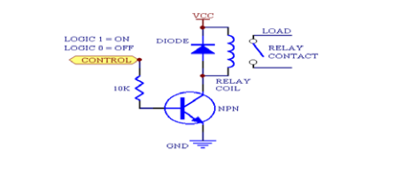

**When the relay is connected in a circuit a diode is connected in parallel with the relay coil, this diode is called the freewheeling diode, its purpose is to protect the transistor from the stored charges in the relay coil. The transistor is used to drive the relay coil because the current that the coil draws is higher than the microprocessor current, the circuit of a relay.**

### Flow Chart of the system:

**Flowchart is a pictorial representation of the logic flow of the program, it helps to visualize more easily how the program statement will connect. The chart will be divided into two sections, one section is for the automatic sprinkler system and the other is for the automatic refill system. Figure 1 below is a pictorial representation of how the automatic refill system will operate, Figure 2 is a pictorial representation of the sprinkler system**

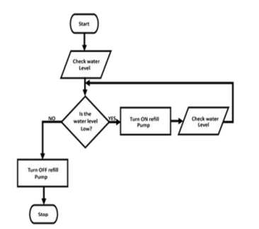

**Figure 1 : Automatic Refill System flow chart**

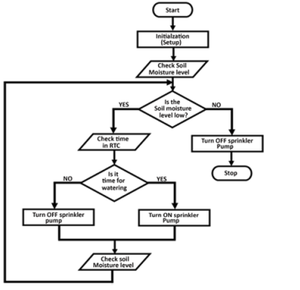

### figure 2 : Automatic Sprinkler System flow chart

### DESIGN FEATURES:

* Fountains wirelessly communicate with base stations
* Base stations collect and transmit usage, filter, and system health information to the cloud via Ethernet
* Wireless communications use a low-power unlicensed band for improved security and power savings

THANK YOU