Product Design
Team | <Team No: 24, Ayush Agrawal, Janapati Sai Akash, Polavarpu Neeraj, Rahul Mallavarpu >

Design Overview

Architectural design
- Student’s Reports Module: To show grade sheet of students and detailed report and analysis of each student which includes all the sentences spoken by him, his average performance chapter wise etc.
- Teaching Module: To teach using selected sentences by recording students’ speech, evaluating with the help of voisTutor API and monitoring class performance
- Assessment Module: To assess the students individually and maintain their grade sheets through in class speech and evaluations
- Practice Speaking Module: To practice speaking sentences by getting feedback from the app along with the option to listen to expert audio
- Self – Tests Module: To evaluate self by taking tests (for students)
- Account Maintenance Module: To add new users, view existing users and remove existing users
- Backend Module: To store all the information in database and provide API endpoints for frontend to fetch data
- voisTutor API : To evaluate speech and provide feedback on various metrics like pronunciation, intonation etc.
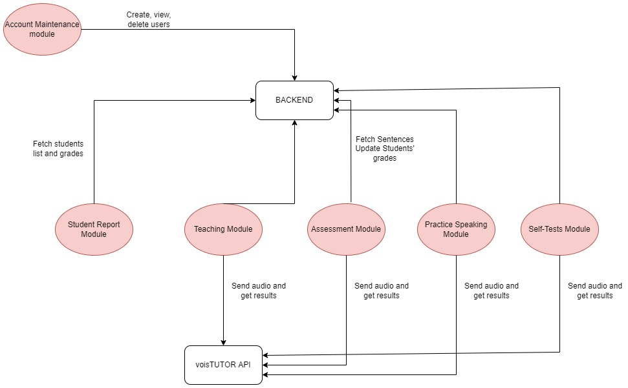

System interfaces
User Interface:
- First, all users login to the application using a Common login page for all.
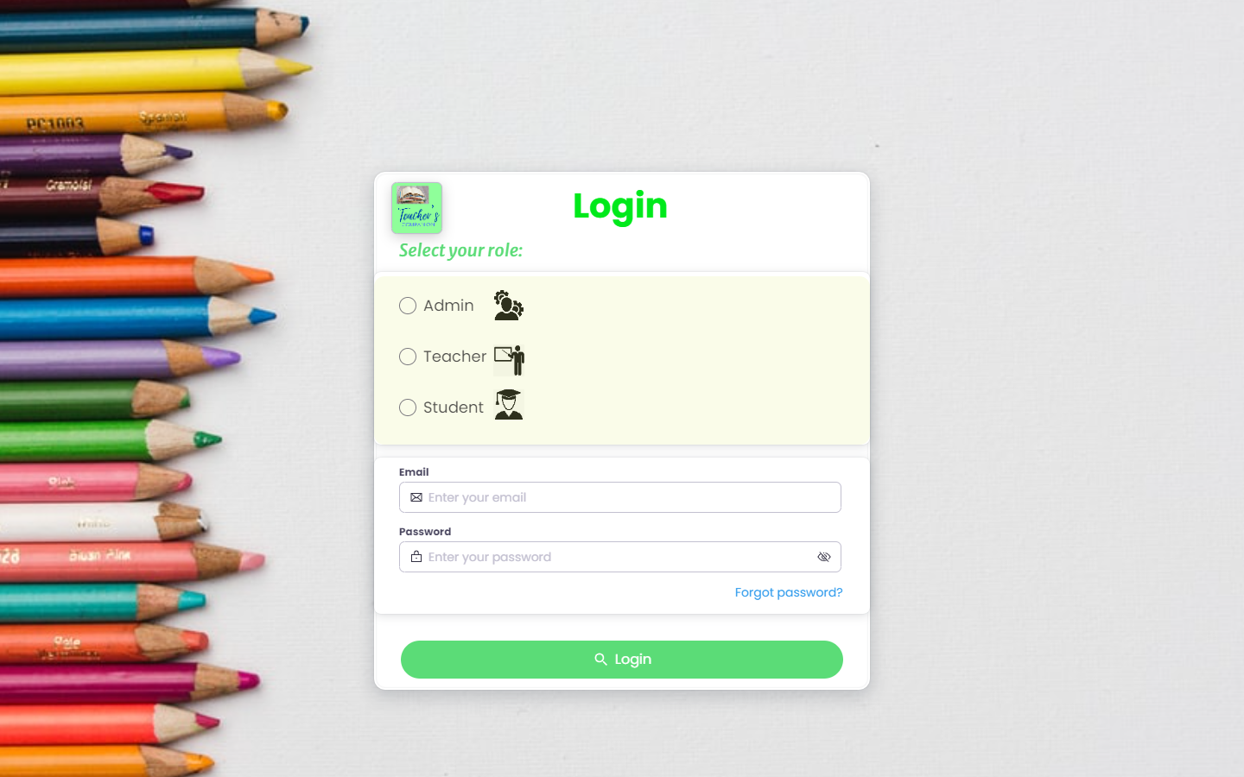

2. Based on his role, he/she will be directed to their respected dashboards.
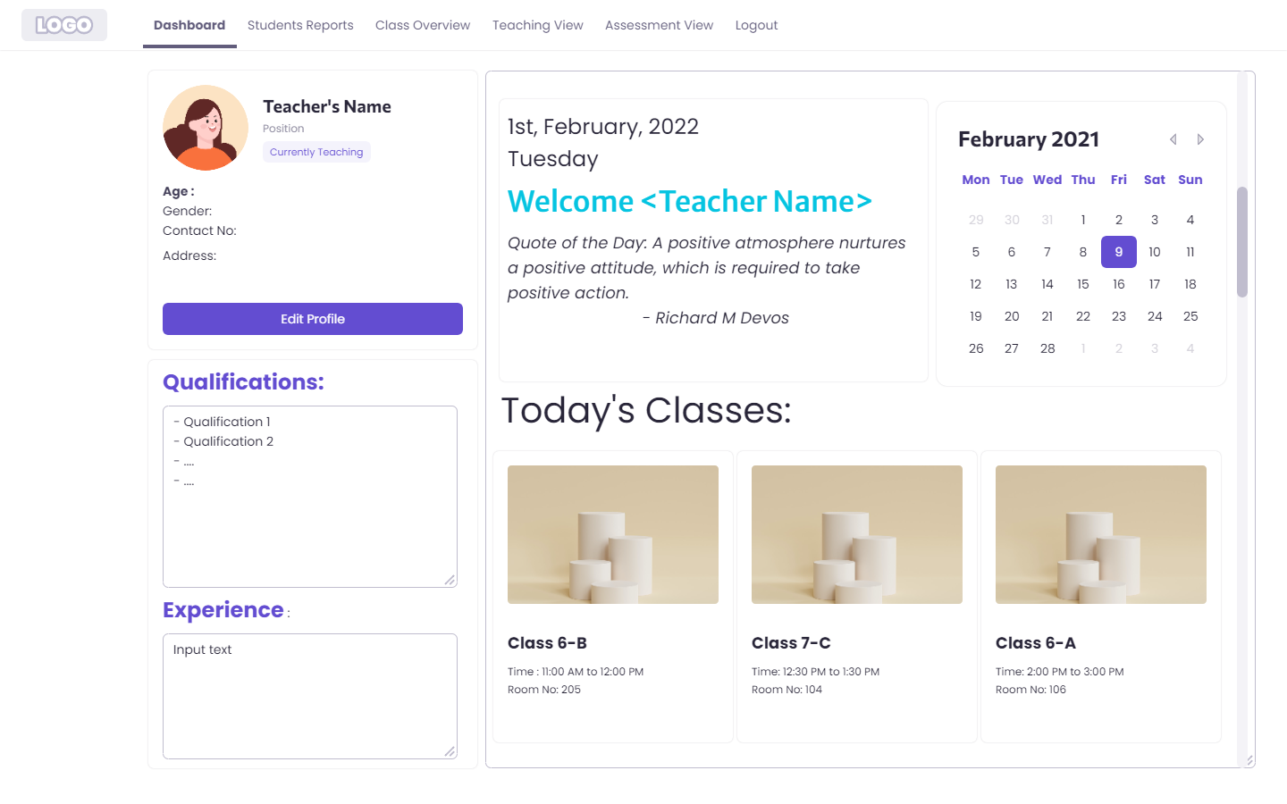

Dashboard for Desktop screen

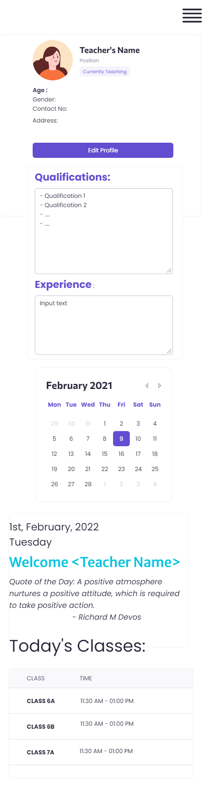

- For Admin:
- He will have options to Add new users
- Similarly, to remove if needed
- For Teacher:
- She can view Class performance
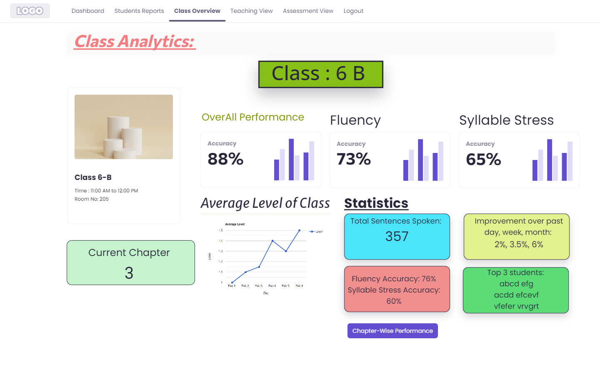
- She can view Student reports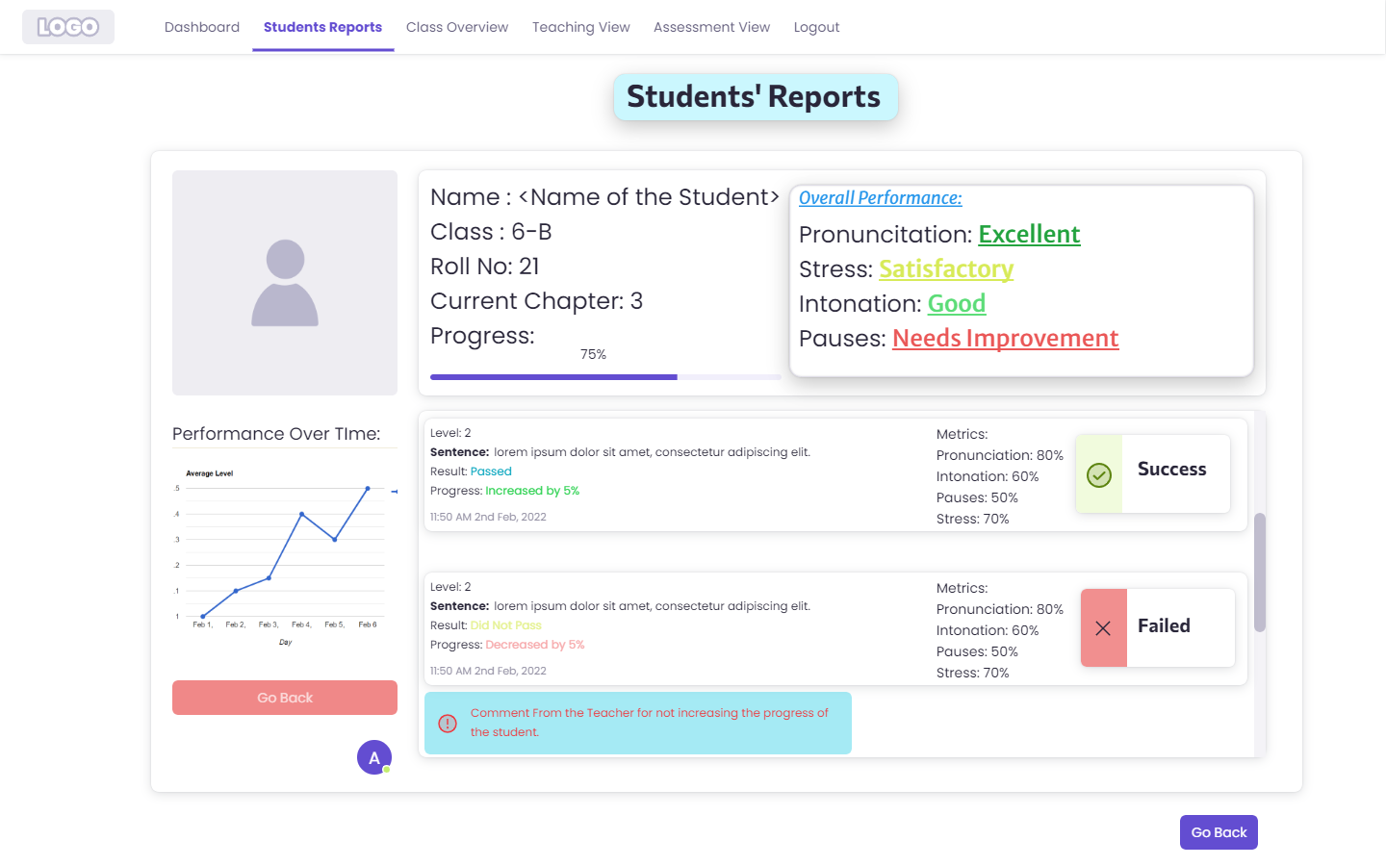
- She can Plan lesson to teach
- She can edit details
- She will have a teaching view, where she have options to evaluate students, modify sentences, and plan the lesson
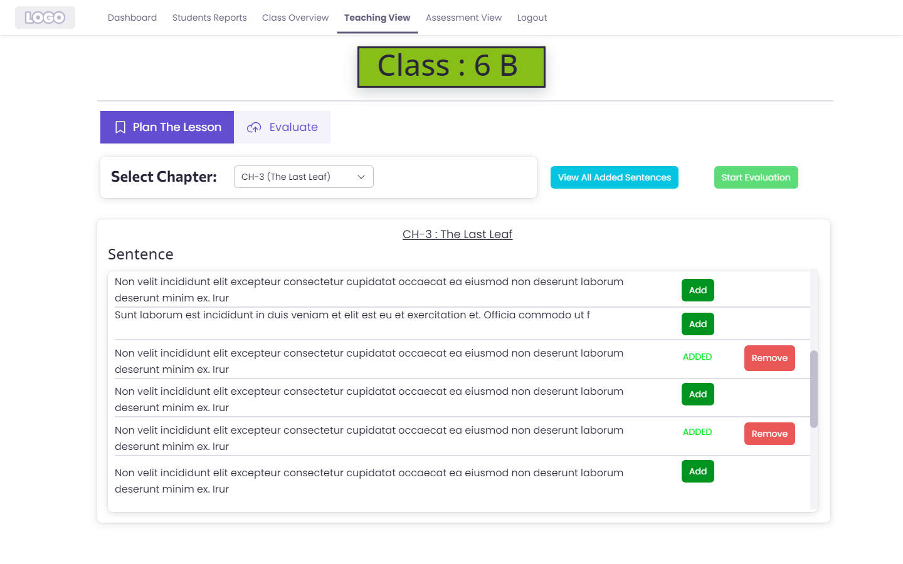
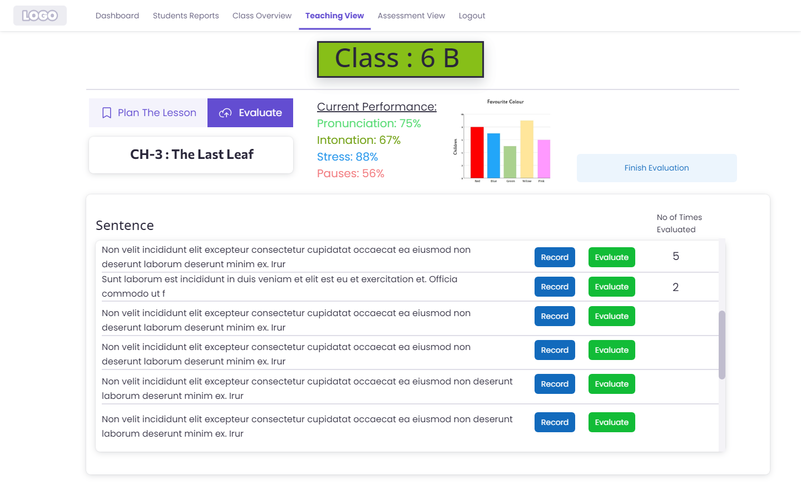
- In case of evaluation, student will be prompted a sentence on screen to read.
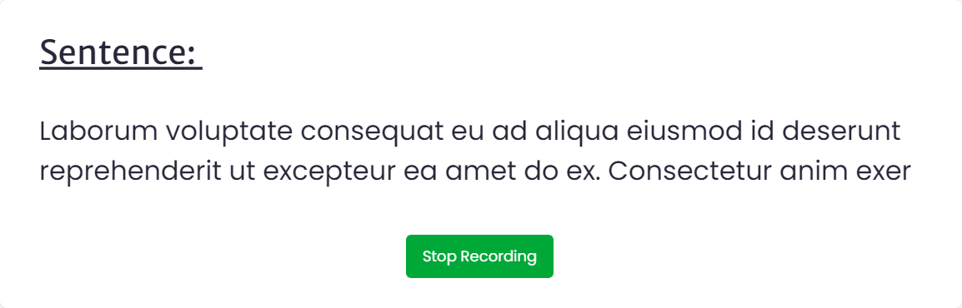
- On evaluating the recorded audio, results will pop up
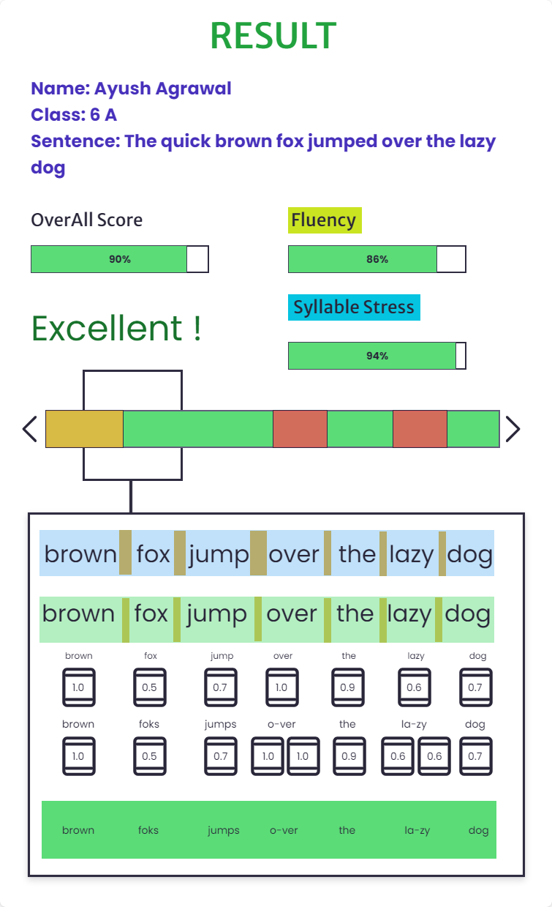
- Assignment view is similar to teaching view with additional features of evaluating specific students.
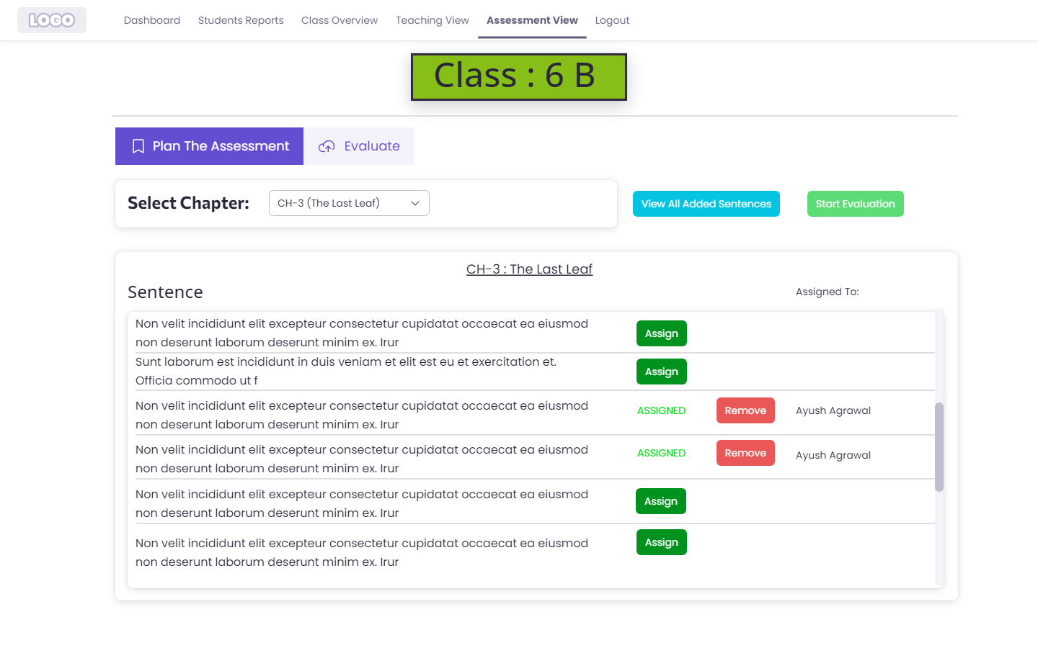
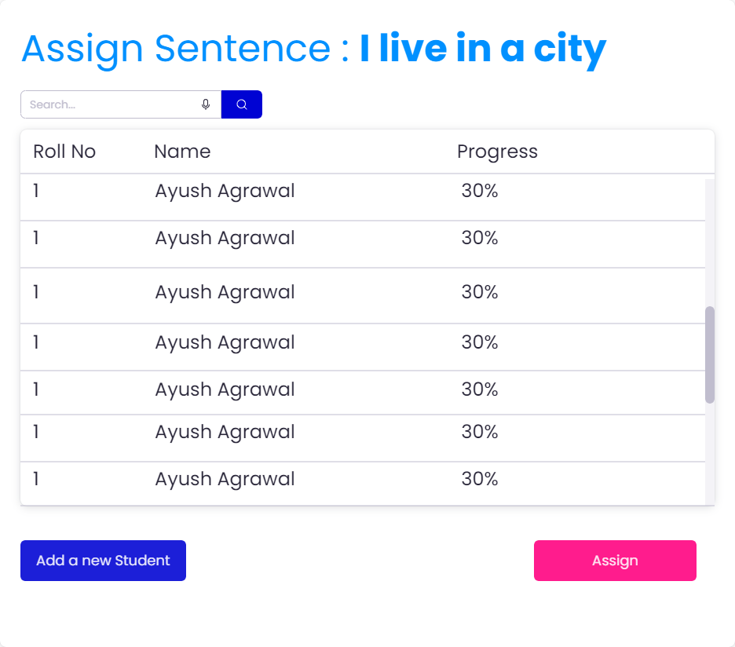
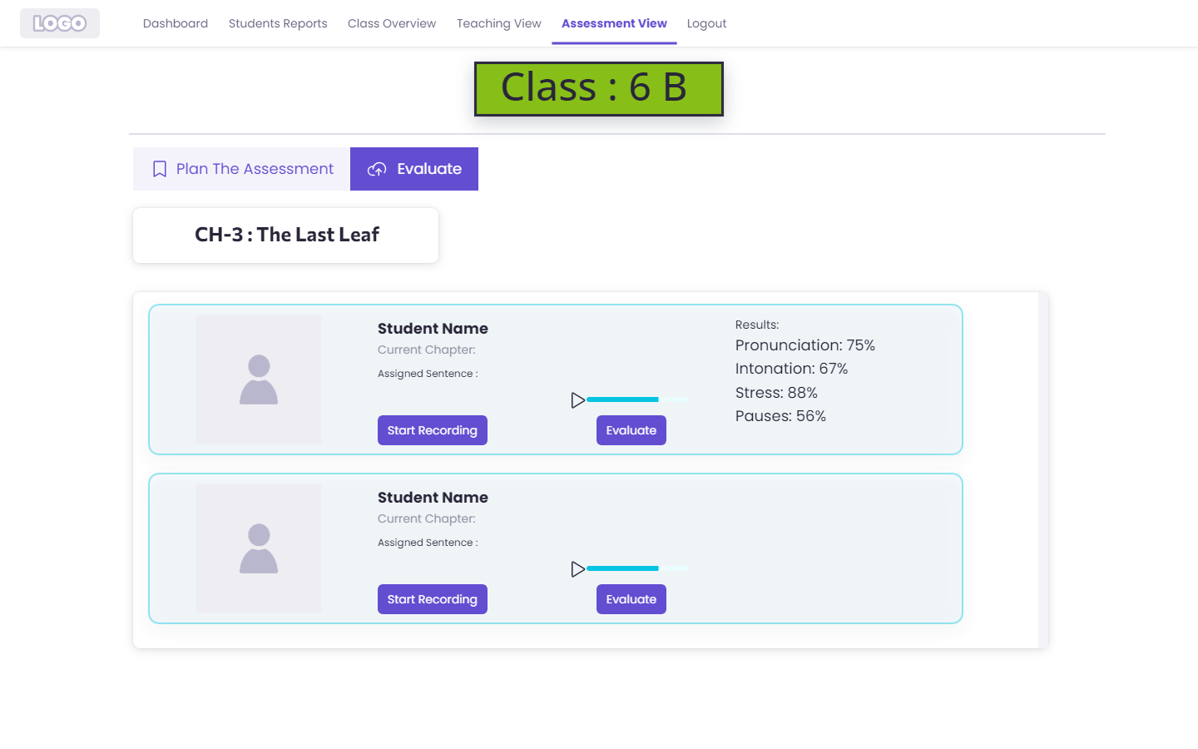
- Upon completion of the test, teacher will be displayed the results and prompted with a suggestion to change the level of student
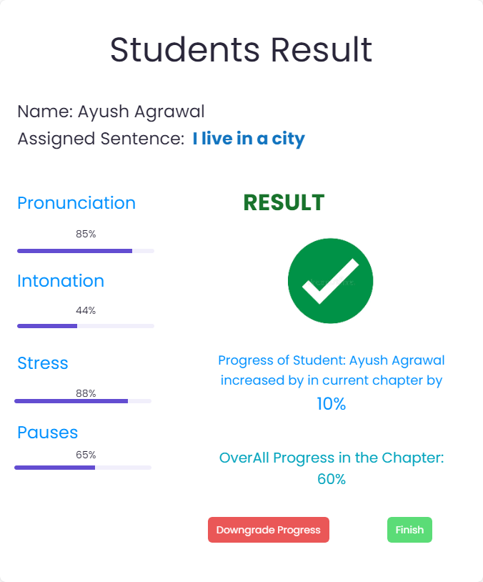
- For Student:
- He can train based on his current level of proficiency
- He can test himself

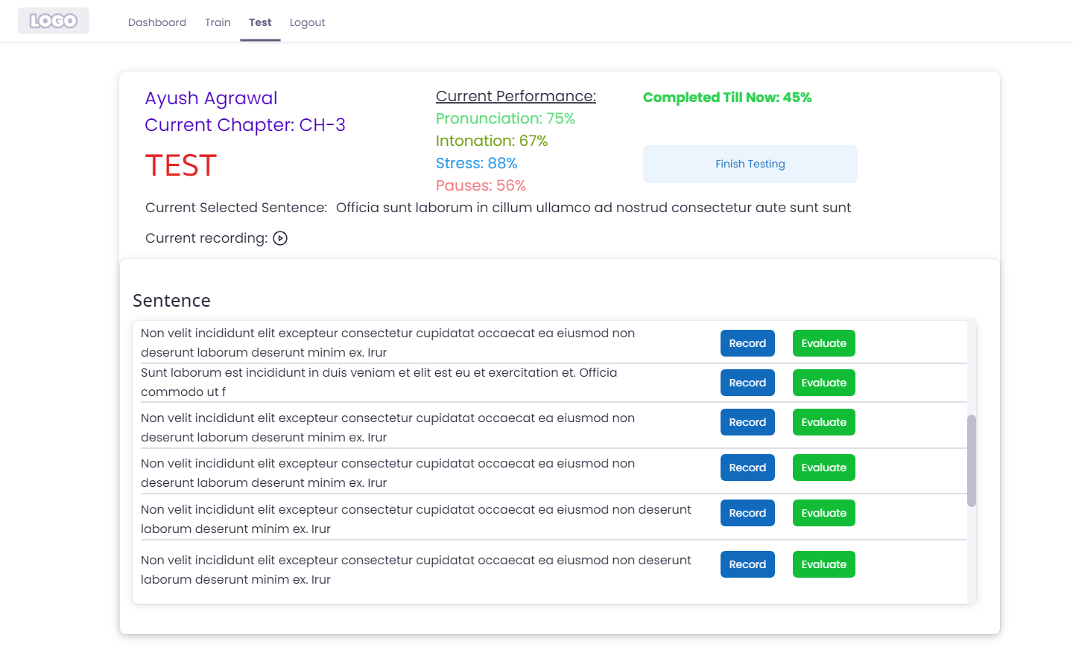
APIs
Note: app.com is just used to depict the usage of api’s and it is not the final.
- To login: app.com/login.
Description: Allows to login for registered users
HTTP Method: POST
Possible errors:
- ERROR 400, If all fields are not present
- ERROR 401 Unauthorized - Access token is invalid or has been revoked.

- To Register: app.com/register
Description: Allows to register new users by Admin
HTTP Method: POST
Possible errors:
- Teacher:
- View Class: app.com/teacher/:id
- Description: view class report of a particular class
- HTTP Request: GET
- Possible errors
- ERROR 400, If all fields are not present
- ERROR 401 Unauthorized - Access token is invalid or has been revoked.

- Class roster : app.com/teacher/roster/:id
- Description: View Class roster of a class
- HTTP Request: GET
- Possible errors
- ERROR 400, If all fields are not present
- ERROR 401 Unauthorized - Access token is invalid or has been revoked.
- Edit her details : app.com/teacher/edit/:id
- Description: Edit details of Teacher
- HTTP Request : POST
- Possible errors:
- ERROR 400, If all fields are not present
- ERROR 401 Unauthorized - Access token is invalid or has been revoked.
- Teaching view - Evaluate: app.com/teacher/evaluate/:id
- Description: Evaluates recorded audio and displays result
- HTTP Request: POST
- Possible errors:
- ERROR 400, If all fields are not present
- ERROR 401 Unauthorized - Access token is invalid or has been revoked.
- Assignment view – Evaluate: app.com/evaluate/:id
- Description: Evaluate the recorded audio of student
- HTTP Request : POST
- Possible errors:
- ERROR 400, If all fields are not present
- ERROR 401 Unauthorized - Access token is invalid or has been revoked.
- Assignment view – Update
- Description: Update results based on teacher’s suggestions
- HTTP Request: POST
- Possible errors:
- ERROR 400, If all fields are not present
- ERROR 401 Unauthorized - Access token is invalid or has been revoked.

- Student:
- Test: app.com/student/test/evaluate/:id
- Description: Evaluate the recorded audio of student
- HTTP Request: POST
- Possible errors
- ERROR 400, If all fields are not present
- ERROR 401 Unauthorized - Access token is invalid or has been revoked.
- Train app.com/student/train/:id
- Description: Evaluate the recorded audio of student
- HTTP Request : POST
- Possible errors
- ERROR 400, If all fields are not present
- ERROR 401 Unauthorized - Access token is invalid or has been revoked.
- Results : app.com/student/results/
- Description: Show results of Student
- HTTP Request: GET
- Possible errors
- ERROR 400, If all fields are not present
- ERROR 401 Unauthorized - Access token is invalid or has been revoked.
5.
- Logout: app.com/logout
- Description: Logout from application
- HTTP Request: POST

Model
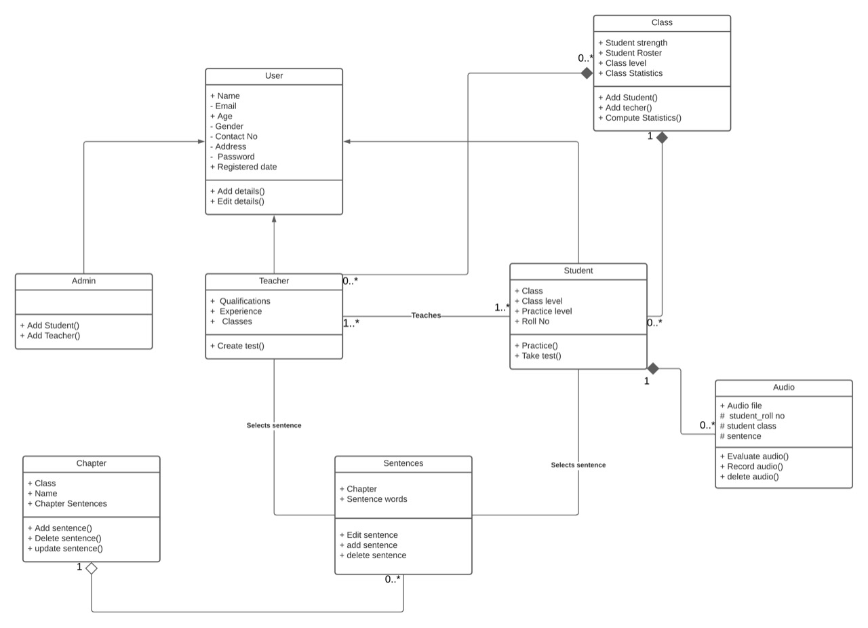.
User | Class state  - Name of the user(admin/teacher/student)  - Email of the user(admin/teacher/student)  - Age of the user(admin/teacher/student)  - Gender of the user(admin/teacher/student)  - Contact No. of the user(admin/teacher/student)  - Address of the user(admin/teacher/student)  - Password of the user(admin/teacher/student)  - Reg date. of the user(admin/teacher/student)  Class behavior  - We can add the above details  - We can edit the above details
Teacher | Class state  - We will have the same information as the user  - Also, we will have qualification, experience, class of teacher  Class behavior  - Teacher can create test for evaluating students
Student | Class state  - We will have the same information as the user  - Also, Class level of the student in that class  - Class-section of the student  - Practice level of the student which is used for practicing test  - Roll_number of the student  Class behavior  - Can practice from all the chapters  - Can take test from the current chapter or specified by teacher
Admin | Class state  - We will have the same information as the user  Class behavior  - Admin can add students, teachers new to the school  - Admin can edit and delete students, teachers
Class | Class state  - We store students strength, student roaster  - Class level, which is the level all the students are in.  - Statistics of the entire class. (Like: pronounciation, phoneme, intonation)  Class behavior  - Can add student, teacher to the specified class  - Compute statistics of the entire class based on pronounciation, phoneme, intonation.
Chapter | Class state  - Has class name, chapter name  - Stores all the sentences in a chapter  Class behavior  - Can add all the sentences.  - Delete sentences  - Can edit sentences.
Sentences | Class state  - Name of the chapter  - All the words of a sentence from a chapter  Class behavior  - Can edit a sentence  - Can delete a sentence  - Add a sentence
Audio | Class state  - Audio file which contains the audio of student recorded  - Student details like roll number, class, sentence  Class behavior  - Recording audio()  - Deleting audio()  - Evaluation audio()

Sequence Diagram(s)
