MINOR PROJECT REPORT

ON

“Text Summarization of Software License Agreement”

Submitted in Partial Fulfillment of Requirements for the Award of Degree of Bachelor of Technology in Computer Science and Engineering

**Submitted to:**



**GURU GOBIND SINGH INDRAPRASTHA UNIVERSITY, DELHI**

**Submitted by**

Rahul Chaudhry

70716403216

**Under the Guidance of**

**Dr. Anurag Jain**

**UNIVERSITY SCHOOL OF INFORMATION, COMMUNICATION & TECHNOLOGY**

**Certificate of Originality**

I hear by declare that the project work entitled **“Text summarization of Software License Agreement”** submitted to the **GGSIPU, Delhi** is a record of an original work done by me under the guidance of **Mr Anurag Jain ( Associate Professor) of USICT ,GGSIPU, Delhi** and this project work is submitted in the partial fulfillment of the requirements for the degree of bachelors of technology in computer science engineering. The results embodied in this project have not been submitted to any other university or institute for the award of any degree or diploma.

Date:

----------------------------------- Rahul Chaudhry

70716403216

I certify that the above statements made by the student are correct to the best of my knowledge and beliefs.

Date:

--------------------------------------

**Anurag Jain**

**Assistant Professor**

University School of

Information and

Communication Technology

**ACKNOWLEDGEMENT**

The extensive endeavor and euphoria that accompany the successful completion of any project would be incomplete without the mention of of the people who made it a success and whose constant guidance and encouragement crown all the effort. It was not only a technical endeavor but also the initialization of us into the world of industrial engineering field.

I express my heartfelt gratitude to **Mr Anurag Jain** for his valuable guidance and cooperation throughout the whole project and I finally extent my gratitude to my friends and family whose constant support made me enthusiastic enough to accomplish the task and finally emerge with a successful project.

---------------------------------

Rahul Chaudhry

70716403216

**Table of Content**

1. Abstract
2. Introduction
3. Background
   1. Text Summarization
   2. Text Rank Algorithm
   3. Cosine Similarity Function
   4. Benefits of text summarization
4. Methodology/Report
   1. Problem Statement
   2. Flow of work
   3. Examples and Results
5. Design issues in text summarization based on existing work
6. Conclusion and Future Scope
7. References

**Abstract**

In everyday work to work we download many software’s and due to our laziness we skip the fine details present in the license agreement of the software while installing it.

This project is about summarizing the whole end user license agreement so that we never miss any minor detail due to which we can later get into legal trouble or we may get compromised on our privacy or maybe our personal data be used somewhere else.

EULASummarizer is built in Python and uses the feature-rich Natural Language ToolKit (NLTK) module for preprocessing by splitting documents into sentences which are stemmed, lemmatized, case-normalized, and cleared of stop words.

Sentences are scored using a similarity matrix, which counts term frequency using cosine similarity. These scores are summed over each sentence and normalized by the sentence length. This normalization step ensures the system does not bias long sentences. In order to include additional domain information, EULASummarizer first extracts a list of all entities from the text. Similarly, abbreviations of text are identified by EULASummarizer to aid the reader’s understanding of summaries.

EULASummarizer is basically an example of a single-domain-multiple-documents summarization task, i.e., we will take multiple articles as input and generate a single bullet-point summary.

**INTRODUCTION**

When we install software or download software, there will show up so big mass document to state the rights and obligations, for which lots of person are not patient to read it or understand it. That would may make users feel distrust for the software. In this Project, we propose a solution to summarize the Software License Agreement.

Software license agreement normally designed according to Copy-right Law. The construction of software license agreement domain ontology is based on a large number of law articles and different software license agreements collected from internet.

The modeling of software license agreements is not a trivial issue and hardly to solve, especially concerning the diverse software and terminologies. This project’s objective is to propose an appropriate methodology and a uniform conceptual model to provide a descriptive and strong expansibility semantic knowledge representation for the domain of software license agreement.

The goal of our work is to take an information source, extract content from it and present the most important content to the user in a condensed form that is manner sensitive to the user's or applications' needs. Though this project doesn’t assure the exact legality of but our intention is that with the help of this project, we provide every software end users a utility recommendation system / a summarizer, to acquire the most important part of software license agreement as possible so that the people in haste can’t get trapped into some legal problems.

the omnipresent availability and use of cloud services, soft-

ware tools, Web portals or services, legal contracts in the form of

license agreements or terms and conditions regulating their use are

of paramount importance. Often the textual documents describing

these regulations comprise many pages and can not be reasonably

assumed to be read and understood by humans. In this work, we

describe a method for extracting and clustering relevant parts of

such documents, including permissions, obligations, and prohibi-

tions. The clustering is based on semantic similarity employing a

distributional semantics approach on large word embeddings data-

base. An evaluation shows that it can signicantly improve human

comprehension and that improved feature-based clustering has a

potential to further reduce the time required for EULA digestion.

Our implementation is available as a web service, which can directly

be used to process and prepare legal usage contracts

**BACKGROUND**

Text summarization is the process of distilling the most important information from a source (or sources) to produce an abridged version for a particular user (or users) and task (or tasks).

Humans are generally quite good at this task as we have the capacity to understand the meaning of a text document and extract salient features to summarize the documents using our own words. However, automatic methods for text summarization are crucial in today’s world where there is an over-abundance of data and lack of manpower as well as time to interpret the data. There are many reasons why Automatic Text Summarization is useful:

1. Summaries reduce reading time.
2. When researching documents, summaries make the selection process easier.
3. Automatic summarization improves the effectiveness of indexing.
4. Automatic summarization algorithms are less biased than human summarizers.
5. Personalized summaries are useful in question-answering systems as they provide personalized information.
6. Using automatic or semi-automatic summarization systems enables commercial abstract services to increase the number of text documents they are able to process.

Text summarization methods can be classified into different types.

**Based on input type:**

1. Single Document, where the input length is short. Many of the early summarization systems dealt with single document summarization.
2. Multi Document, where the input can be arbitrarily long.

**Based on the purpose:**

1. Generic, where the model makes no assumptions about the domain or content of the text to be summarized and treats all inputs as homogeneous. The majority of the work that has been done revolves around generic summarization.
2. Domain-specific, where the model uses domain-specific knowledge to form a more accurate summary. For example, summarizing research papers of a specific domain, biomedical documents, etc.
3. Query-based, where the summary only contains information which answers natural language questions about the input text.

**Based on output type:**

1. **Extractive**, where important sentences are selected from the input text to form a summary. Most summarization approaches today are extractive in nature.
2. **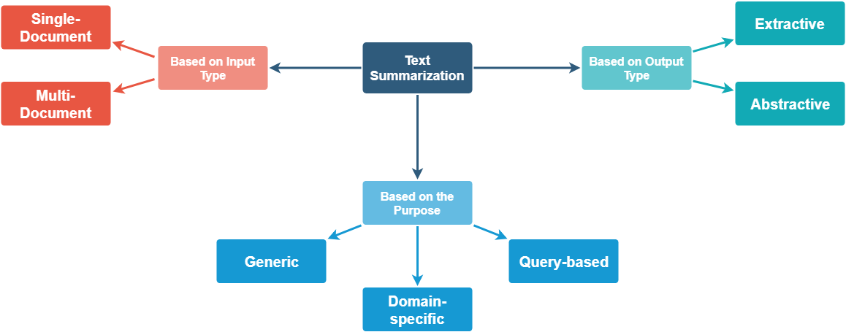Abstractive**, where the model forms its own phrases and sentences to offer a more coherent summary, like what a human would generate. This approach is definitely a more appealing, but much more difficult than extractive summarization.

Figure – Types of Text Summarization

## Understanding the TextRank Algorithm

Before getting started with the TextRank algorithm, there’s another algorithm which we should become familiar with – the PageRank algorithm. In fact, this actually inspired TextRank.

**PageRank is used primarily for ranking web pages in online search results.** 

**PageRank Algorithm**

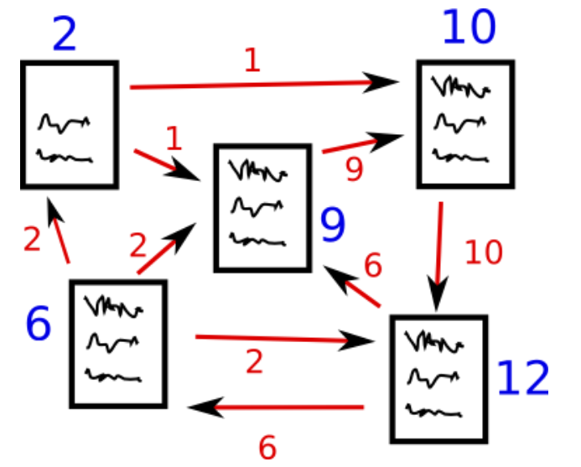

http://www.scottbot.net/H Figure – Example of page ranking/

**PageRank** (**PR**) is an [algorithm](https://en.wikipedia.org/wiki/Algorithm) used by [Google Search](https://en.wikipedia.org/wiki/Google_Search) to rank [web pages](https://en.wikipedia.org/wiki/Webpages) in their [search engine](https://en.wikipedia.org/wiki/Search_engine) results. PageRank was named after [Larry Page](https://en.wikipedia.org/wiki/Larry_Page),[[1]](https://en.wikipedia.org/wiki/PageRank" \l "cite_note-1) one of the founders of Google. PageRank is a way of measuring the importance of website pages. PageRank works by counting the number and quality of links to a page to determine a rough estimate of how important the website is. The underlying assumption is that more important websites are likely to receive more links from other websites.

Currently, PageRank is not the only algorithm used by Google to order search results, but it is the first algorithm that was used by the company, and it is the best known

Suppose we have 4 web pages — w1, w2, w3, and w4. These pages contain links pointing to one another. Some pages might have no link – these are called dangling pages.

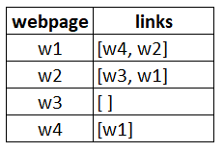

* Web page w1 has links directing to w2 and w4
* w2 has links for w3 and w1
* w4 has links only for the web page w1
* w3 has no links and hence it will be called a dangling page

In order to rank these pages, we would have to compute a score called the **PageRank score**. This score is the probability of a user visiting that page.

To capture the probabilities of users navigating from one page to another, we will create a square **matrix M**, having n rows and n columns, where **n** is the number of web pages.

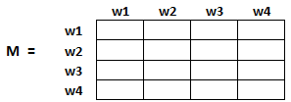

  Each element of this matrix denotes the probability of a user transitioning from one web page to another.

The highlighted cell below contains the probability of transition from w1 to w2.

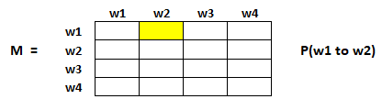

The initialization of the probabilities is explained in the steps below:

1. Probability of going from page i to j, i.e., M[ i ][ j ], is initialized with **1/(number of unique links in web page wi)**
2. If there is no link between the page i and j, then the probability will be initialized with **0**
3. If a user has landed on a dangling page, then it is assumed that he is equally likely to transition to any page. Hence, M[ i ][ j ] will be initialized with **1/(number of web pages)**

Hence, in our case, the matrix M will be initialized as follows:

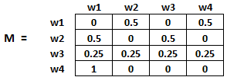

Finally, the values in this matrix will be updated in an iterative fashion to arrive at the web page rankings.

### TextRank Algorithm

Let’s understand the TextRank algorithm, now that we have a grasp on PageRank. I have listed the similarities between these two algorithms below:

* In place of web pages, we use sentences
* Similarity between any two sentences is used as an equivalent to the web page transition probability
* The similarity scores are stored in a square matrix, similar to the matrix M used for PageRank

**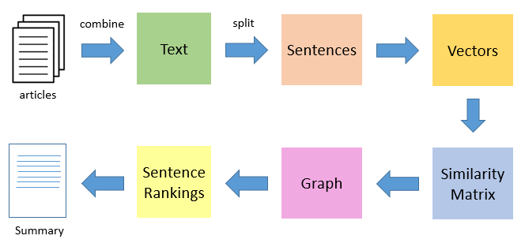TextRank is an extractive and unsupervised text summarization technique.** Let’s take a look at the flow of the TextRank algorithm that we will be following:

Figure – Process of Text Summarization

* The first step would be to concatenate all the text contained in the articles
* Then split the text into individual sentences
* In the next step, we will find vector representation (word embeddings) for each and every sentence
* Similarities between sentence vectors are then calculated and stored in a matrix
* The similarity matrix is then converted into a graph, with sentences as vertices and similarity scores as edges, for sentence rank calculation
* Finally, a certain number of top-ranked sentences form the final summary

**Cosine Similarity**

Cosine similarity is a metric used to determine how similar the documents are irrespective of their size.

Mathematically, it measures the cosine of the angle between two vectors projected in a multi-dimensional space. In this context, the two vectors I am talking about are arrays containing the word counts of two documents.

As a similarity metric, how does cosine similarity differ from the number of common words?

When plotted on a multi-dimensional space, where each dimension corresponds to a word in the document, the cosine similarity captures the orientation (the angle) of the documents and not the magnitude. If you want the magnitude, compute the Euclidean distance instead.

The cosine similarity is advantageous because even if the two similar documents are far apart by the Euclidean distance because of the size (like, the word ‘cricket’ appeared 50 times in one document and 10 times in another) they could still have a smaller angle between them. Smaller the angle, higher the similarity.

**COSINE SIMILARITY FORMULA**

As you include more words from the document, it’s harder to visualize a higher dimensional space. But you can directly compute the cosine similarity using this math formula.

[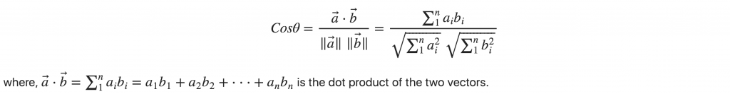](https://www.machinelearningplus.com/wp-content/uploads/2018/10/Cosine-Similarity-Formula-1.png)

**Benefits of text summarization**

There are many reasons why Automatic Text Summarization is useful:

1. Summaries reduce reading time.
2. When researching documents, summaries make the selection process easier.
3. Automatic summarization improves the effectiveness of indexing.
4. Automatic summarization algorithms are less biased than human summarizers.
5. Personalized summaries are useful in question-answering systems as they provide personalized information.
6. Using automatic or semi-automatic summarization systems enables commercial abstract services to increase the number of text documents they are able to process.

**Methodology**

**PROBLEM STATEMENT**

The goal of this project is to build a model that can summarize the whole license agreement, based on a combination of features that describes the legal terms so that the user saves the time in reading the bylaws which can later land them in some legal problems or infiltration of their privacy.

**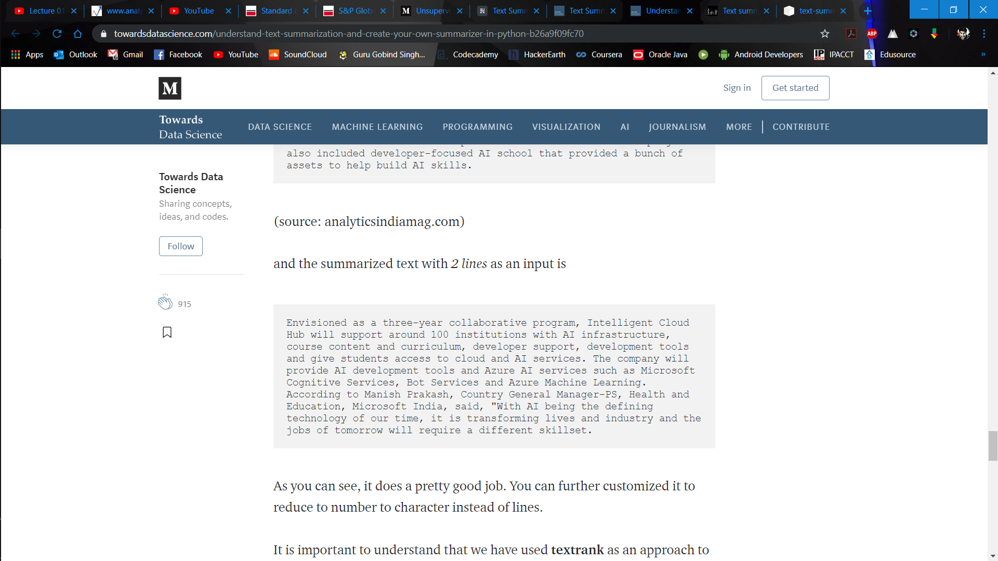EXAMPLE SUMMARIZED TEXT**

**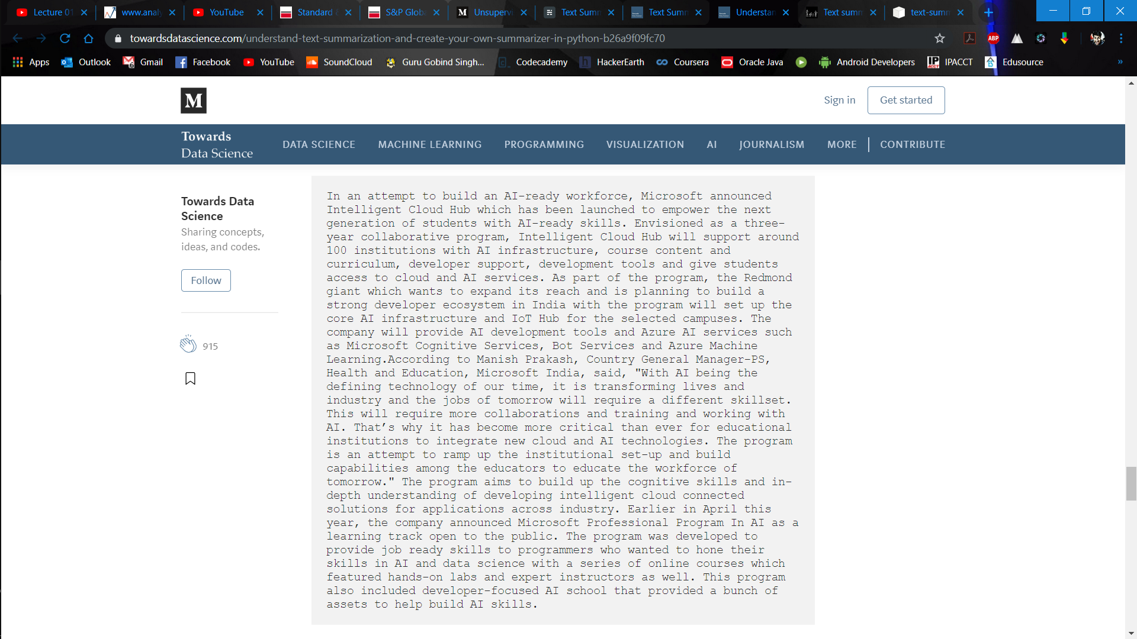**

Figure – Example of Text Summarization

**Flow of work**

**Flow of work**

1. Import the Libraries
2. Read the dataset
3. Drop Duplicates and NA values
4. Preprocessing

* Text Cleaning
* Convert everything to lowercase
* Contraction mapping
* Remove (‘s)
* Remove any text inside the parenthesis ( )
* Eliminate punctuations and special characters
* Remove stopwords
* Remove short words
* Summary Cleaning
* Understanding the distribution of the sequences

1. Preparing the Tokenizer

A tokenizer builds the vocabulary and converts a word sequence to an integer sequence

## Generate the summary

* Import tokens
* Create a similarity matrix
* Apply test rank algorithm
* Extract the summary

**Youtube EULA**

1. Your Acceptance

By using or visiting the YouTube website or any YouTube products, software, data feeds, and services provided to you on, from, or through the YouTube website (collectively the "Service") you signify your agreement to (1) these terms and conditions (the "Terms of Service"), (2) Google's Privacy Policy, found at <https://www.youtube.in/t/privacy> and incorporated herein by reference, and (3) YouTube's Community Guidelines, found at <https://www.youtube.in/t/community_guidelines> and also incorporated herein by reference. If you do not agree to any of these terms, the Google Privacy Policy, or the Community Guidelines, please do not use the Service. The Service is provided by YouTube, LLC, which, along with its products and services, is referred to as “YouTube” in these Terms of Service.

Although we may attempt to notify you when major changes are made to these Terms of Service, you should periodically review the most up-to-date version <https://www.youtube.in/t/terms>). YouTube may, in its sole discretion, modify or revise these Terms of Service and policies at any time, and you agree to be bound by such modifications or revisions. Nothing in these Terms of Service shall be deemed to confer any third-party rights or benefits.

2. Service

These Terms of Service apply to all users of the Service, including users who are also contributors of Content on the Service. “Content” includes the text, software, scripts, graphics, photos, sounds, music, videos, audiovisual combinations, interactive features and other materials you may view on, access through, or contribute to the Service. The Service includes all aspects of YouTube, including but not limited to all products, software and services offered via the YouTube website, such as the YouTube channels, the YouTube "Embeddable Player," the YouTube "Uploader" and other applications.

The Service may contain links to third party websites that are not owned or controlled by YouTube. YouTube has no control over, and assumes no responsibility for, the content, privacy policies, or practices of any third party websites. In addition, YouTube will not and cannot censor or edit the content of any third-party site. By using the Service, you expressly relieve YouTube from any and all liability arising from your use of any third-party website.

Accordingly, we encourage you to be aware when you leave the Service and to read the terms and conditions and privacy policy of each other website that you visit.

3. YouTube Accounts

In order to access some features of the Service, you will have to create a YouTube or Google Account. You may never use another's account without permission. When creating your account, you must provide accurate and complete information. You are solely responsible for the activity that occurs on your account, and you must keep your account password secure. You must notify YouTube immediately of any breach of security or unauthorized use of your account.

Although YouTube will not be liable for your losses caused by any unauthorized use of your account, you may be liable for the losses of YouTube or others due to such unauthorized use.

4. General Use of the Service—Permissions and Restrictions

YouTube hereby grants you permission to access and use the Service as set forth in these Terms of Service, provided that:

You agree not to distribute in any medium any part of the Service or the Content without YouTube's prior written authorization, unless YouTube makes available the means for such distribution through functionality offered by the Service (such as the Embeddable Player).

You agree not to alter or modify any part of the Service.

You agree not to access Content through any technology or means other than the video playback pages of the Service itself, the Embeddable Player, or other explicitly authorized means YouTube may designate.

You agree not to use the Service for any of the following commercial uses unless you obtain YouTube's prior written approval:

the sale of access to the Service;

the sale of advertising, sponsorships, or promotions placed on or within the Service or Content; or

the sale of advertising, sponsorships, or promotions on any page of an ad-enabled blog or website containing Content delivered via the Service, unless other material not obtained from YouTube appears on the same page and is of sufficient value to be the basis for such sales.

Prohibited commercial uses do not include:

uploading an original video to YouTube, or maintaining an original channel on YouTube, to promote your business or artistic enterprise;

showing YouTube videos through the Embeddable Player on an ad-enabled blog or website, subject to the advertising restrictions set forth above in Section 4.D; or

any use that YouTube expressly authorizes in writing.

(For more information about what constitutes a prohibited commercial use, [see our FAQ](https://support.google.com/youtube/answer/71011).)

If you use the Embeddable Player on your website, you may not modify, build upon, or block any portion or functionality of the Embeddable Player, including but not limited to links back to the YouTube website.

If you use the YouTube Uploader, you agree that it may automatically download and install updates from time to time from YouTube. These updates are designed to improve, enhance and further develop the Uploader and may take the form of bug fixes, enhanced functions, new software modules and completely new versions. You agree to receive such updates (and permit YouTube to deliver these to you) as part of your use of the Uploader.

You agree not to use or launch any automated system, including without limitation, "robots," "spiders," or "offline readers," that accesses the Service in a manner that sends more request messages to the YouTube servers in a given period of time than a human can reasonably produce in the same period by using a conventional on-line web browser. Notwithstanding the foregoing, YouTube grants the operators of public search engines permission to use spiders to copy materials from the site for the sole purpose of and solely to the extent necessary for creating publicly available searchable indices of the materials, but not caches or archives of such materials. YouTube reserves the right to revoke these exceptions either generally or in specific cases. You agree not to collect or harvest any personally identifiable information, including account names, from the Service, nor to use the communication systems provided by the Service (e.g., comments, email) for any commercial solicitation purposes. You agree not to solicit, for commercial purposes, any users of the Service with respect to their Content.

In your use of the Service, you will comply with all applicable laws.

YouTube reserves the right to discontinue any aspect of the Service at any time.

5. Your Use of Content

In addition to the general restrictions above, the following restrictions and conditions apply specifically to your use of Content.

The Content on the Service, and the trademarks, service marks and logos ("Marks") on the Service, are owned by or licensed to YouTube, subject to copyright and other intellectual property rights under the law.

Content is provided to you AS IS. You may access Content for your information and personal use solely as intended through the provided functionality of the Service and as permitted under these Terms of Service. You shall not download any Content unless you see a “download” or similar link displayed by YouTube on the Service for that Content. You shall not copy, reproduce, make available online or electronically transmit, publish, adapt, distribute, transmit, broadcast, display, sell, license, or otherwise exploit any Content for any other purposes without the prior written consent of YouTube or the respective licensors of the Content. YouTube and its licensors reserve all rights not expressly granted in and to the Service and the Content.

You agree not to circumvent, disable or otherwise interfere with security-related features of the Service or features that prevent or restrict use or copying of any Content or enforce limitations on use of the Service or the Content therein.

You understand that when using the Service, you will be exposed to Content from a variety of sources, and that YouTube is not responsible for the accuracy, usefulness, safety, or intellectual property rights of or relating to such Content. You further understand and acknowledge that you may be exposed to Content that is inaccurate, offensive, indecent, or objectionable, and you agree to waive, and hereby do waive, any legal or equitable rights or remedies you have or may have against YouTube with respect thereto, and, to the extent permitted by applicable law, agree to indemnify and hold harmless YouTube, its owners, operators, affiliates, licensors, and licensees to the fullest extent allowed by law regarding all matters related to your use of the Service.

6. Your Content and Conduct

As a YouTube account holder you may submit Content to the Service, including videos and user comments. You understand that YouTube does not guarantee any confidentiality with respect to any Content you submit.

You shall be solely responsible for your own Content and the consequences of submitting and publishing your Content on the Service. You affirm, represent, and warrant that you own or have the necessary licenses, rights, consents, and permissions to publish Content you submit; and you license to YouTube all patent, trademark, trade secret, copyright or other proprietary rights in and to such Content for publication on the Service pursuant to these Terms of Service.

For clarity, you retain all of your ownership rights in your Content. However, by submitting Content to YouTube, you hereby grant YouTube a worldwide, non-exclusive, royalty-free, sublicenseable and transferable license to use, reproduce, distribute, prepare derivative works of, display, publish, adapt, make available online or electronically transmit, and perform the Content in connection with the Service and YouTube's (and its successors' and affiliates') business, including without limitation for promoting and redistributing part or all of the Service (and derivative works thereof) in any media formats and through any media channels. You also hereby grant each user of the Service a non-exclusive license to access your Content through the Service, and to use, reproduce, distribute, display, publish, make available online or electronically transmit, and perform such Content as permitted through the functionality of the Service and under these Terms of Service. The above licenses granted by you in video Content you submit to the Service terminate within a commercially reasonable time after you remove or delete your videos from the Service. You understand and agree, however, that YouTube may retain, but not display, distribute, or perform, server copies of your videos that have been removed or deleted. The above licenses granted by you in user comments you submit are perpetual and irrevocable.

You further agree that Content you submit to the Service will not contain third party copyrighted material, or material that is subject to other third party proprietary rights, unless you have permission from the rightful owner of the material or you are otherwise legally entitled to post the material and to grant YouTube all of the license rights granted herein.

You further agree that you will not submit to the Service any Content or other material that is contrary to the YouTube Community Guidelines, currently found at <https://www.youtube.in/t/community_guidelines>, which may be updated from time to time, or contrary to applicable local, national, and international laws and regulations.

YouTube will process any audio or audiovisual content uploaded by you to the Service in accordance with the YouTube Data Processing Terms ([www.youtube.com/t/terms\_dataprocessing](https://www.youtube.in/t/terms_dataprocessing)), except in cases where you uploaded such content for personal purposes or household activities. Learn more here: [support.google.com/youtube/?p=data\_applicability](https://support.google.com/youtube/?p=data_applicability).

YouTube does not endorse any Content submitted to the Service by any user or other licensor, or any opinion, recommendation, or advice expressed therein, and YouTube expressly disclaims any and all liability in connection with Content. YouTube does not permit copyright infringing activities and infringement of intellectual property rights on the Service, and YouTube will remove all Content if properly notified that such Content infringes on another's intellectual property rights. YouTube reserves the right to remove Content without prior notice.

7. Account Termination Policy

YouTube will terminate a user's access to the Service if, under appropriate circumstances, the user is determined to be a repeat infringer.

YouTube reserves the right to decide whether Content violates these Terms of Service for reasons other than copyright infringement, such as, but not limited to, pornography, obscenity, or excessive length. YouTube may at any time, without prior notice and in its sole discretion, remove such Content and/or terminate a user's account for submitting such material in violation of these Terms of Service.

8. Copyright Policy

YouTube operates a clear copyright policy in relation to any Content alleged to infringe the copyright of a third party. Details of that policy can be found here <https://www.youtube.in/t/copyright_notice>.

As part of YouTube's copyright policy, YouTube will terminate user access to the Website if a user has been determined to be a repeat infringer. A repeat infringer is a user who has been notified of infringing activity more than twice.

9. Warranty Disclaimer

YOU AGREE THAT YOUR USE OF THE SERVICES SHALL BE AT YOUR SOLE RISK. TO THE FULLEST EXTENT PERMITTED BY LAW, YOUTUBE, ITS OFFICERS, DIRECTORS, EMPLOYEES, AND AGENTS EXCLUDE ALL WARRANTIES, EXPRESS OR IMPLIED, IN CONNECTION WITH THE SERVICES AND YOUR USE THEREOF. TO THE FULLEST EXTENT PERMITTED BY LAW, YOUTUBE EXCLUDES ALL WARRANTIES, CONDITIONS, TERMS OR REPRESENTATIONS ABOUT THE ACCURACY OR COMPLETENESS OF THIS SITE'S CONTENT OR THE CONTENT OF ANY SITES LINKED TO THIS SITE AND ASSUMES NO LIABILITY OR RESPONSIBILITY FOR ANY (I) ERRORS, MISTAKES, OR INACCURACIES OF CONTENT, (II) PERSONAL INJURY OR PROPERTY DAMAGE, OF ANY NATURE WHATSOEVER, RESULTING FROM YOUR ACCESS TO AND USE OF OUR SERVICES, (III) ANY UNAUTHORIZED ACCESS TO OR USE OF OUR SECURE SERVERS AND/OR ANY AND ALL PERSONAL INFORMATION AND/OR FINANCIAL INFORMATION STORED THEREIN, (IV) ANY INTERRUPTION OR CESSATION OF TRANSMISSION TO OR FROM OUR SERVICES, (IV) ANY BUGS, VIRUSES, TROJAN HORSES, OR THE LIKE WHICH MAY BE TRANSMITTED TO OR THROUGH OUR SERVICES BY ANY THIRD PARTY, AND/OR (V) ANY ERRORS OR OMISSIONS IN ANY CONTENT OR FOR ANY LOSS OR DAMAGE OF ANY KIND INCURRED AS A RESULT OF THE USE OF ANY CONTENT POSTED, EMAILED, TRANSMITTED, OR OTHERWISE MADE AVAILABLE VIA THE SERVICES. YOUTUBE DOES NOT WARRANT, ENDORSE, GUARANTEE, OR ASSUME RESPONSIBILITY FOR ANY PRODUCT OR SERVICE ADVERTISED OR OFFERED BY A THIRD PARTY THROUGH THE SERVICES OR ANY HYPERLINKED SERVICES OR FEATURED IN ANY BANNER OR OTHER ADVERTISING, AND YOUTUBE WILL NOT BE A PARTY TO OR IN ANY WAY BE RESPONSIBLE FOR MONITORING ANY TRANSACTION BETWEEN YOU AND THIRD-PARTY PROVIDERS OF PRODUCTS OR SERVICES. AS WITH THE PURCHASE OF A PRODUCT OR SERVICE THROUGH ANY MEDIUM OR IN ANY ENVIRONMENT, YOU SHOULD USE YOUR BEST JUDGMENT AND EXERCISE CAUTION WHERE APPROPRIATE.

10. Limitation of Liability

TO THE FULLEST EXTENT PERMITTED BY LAW, IN NO EVENT SHALL YOUTUBE, ITS OFFICERS, DIRECTORS, EMPLOYEES, OR AGENTS, BE LIABLE TO YOU FOR ANY DIRECT, INDIRECT, INCIDENTAL, SPECIAL, PUNITIVE, LOSSES OR EXPENSES OR CONSEQUENTIAL DAMAGES WHATSOEVER RESULTING FROM ANY (I) ERRORS, MISTAKES, OR INACCURACIES OF CONTENT, (II) PERSONAL INJURY OR PROPERTY DAMAGE, OF ANY NATURE WHATSOEVER, RESULTING FROM YOUR ACCESS TO AND USE OF OUR SERVICES, (III) ANY UNAUTHORIZED ACCESS TO OR USE OF OUR SECURE SERVERS AND/OR ANY AND ALL PERSONAL INFORMATION AND/OR FINANCIAL INFORMATION STORED THEREIN, (IV) ANY INTERRUPTION OR CESSATION OF TRANSMISSION TO OR FROM OUR SERVICES, (IV) ANY BUGS, VIRUSES, TROJAN HORSES, OR THE LIKE, WHICH MAY BE TRANSMITTED TO OR THROUGH OUR SERVICES BY ANY THIRD PARTY, AND/OR (V) ANY ERRORS OR OMISSIONS IN ANY CONTENT OR FOR ANY LOSS OR DAMAGE OF ANY KIND INCURRED AS A RESULT OF YOUR USE OF ANY CONTENT POSTED, EMAILED, TRANSMITTED, OR OTHERWISE MADE AVAILABLE VIA THE SERVICES, WHETHER BASED ON WARRANTY, CONTRACT, TORT, OR ANY OTHER LEGAL THEORY, AND WHETHER OR NOT THE COMPANY IS ADVISED OF THE POSSIBILITY OF SUCH DAMAGES.

WE UNDERSTAND THAT, IN SOME JURISDICTIONS, WARRANTIES, DISCLAIMERS AND CONDITIONS MAY APPLY THAT CANNOT BE LEGALLY EXCLUDED, IF THAT IS TRUE IN YOUR JURISDICTION, THEN TO THE EXTENT PERMITTED BY LAW, YOUTUBE LIMITS ITS LIABILITY FOR ANY CLAIMS UNDER THOSE WARRANTIES OR CONDITIONS TO EITHER SUPPLYING YOU THE SERVICES AGAIN (OR THE COST OF SUPPLYING YOU THE SERVICES AGAIN).

YOU SPECIFICALLY ACKNOWLEDGE THAT YOUTUBE SHALL NOT BE LIABLE FOR CONTENT OR THE DEFAMATORY, OFFENSIVE, OR ILLEGAL CONDUCT OF ANY THIRD PARTY AND THAT THE RISK OF HARM OR DAMAGE FROM THE FOREGOING RESTS ENTIRELY WITH YOU.

The Service is controlled and offered by YouTube from its facilities in the United States of America. YouTube makes no representations that the Service is appropriate or available for use in other locations. Those who access or use the Service from other jurisdictions do so at their own volition and are responsible for compliance with local law.

11. Indemnity

To the extent permitted by applicable law, you agree to defend, indemnify and hold harmless YouTube, its parent corporation, officers, directors, employees and agents, from and against any and all claims, damages, obligations, losses, liabilities, costs or debt, and expenses (including but not limited to attorney's fees) arising from: (i) your use of and access to the Service; (ii) your violation of any term of these Terms of Service; (iii) your violation of any third party right, including without limitation any copyright, property, or privacy right; or (iv) any claim that your Content caused damage to a third party. This defense and indemnification obligation will survive these Terms of Service and your use of the Service.

12. Ability to Accept Terms of Service

You affirm that you are either more than 18 years of age, or an emancipated minor, or possess legal parental or guardian consent, and are fully able and competent to enter into the terms, conditions, obligations, affirmations, representations, and warranties set forth in these Terms of Service, and to abide by and comply with these Terms of Service. In any case, you affirm that you are over the age of 13, as the Service is not intended for children under 13. If you are under 13 years of age, then please do not use the Service. There are lots of other great web sites for you. Talk to your parents about what sites are appropriate for you.

We provide these Terms of Service with our Service so that you know what terms apply to your use. You acknowledge that we have given you a reasonable opportunity to review these Terms of Service and that you have agreed to them.

13. Assignment

These Terms of Service, and any rights and licenses granted hereunder, may not be transferred or assigned by you, but may be assigned by YouTube without restriction.

14. General

You agree that: (i) the Service shall be deemed solely based in California; and (ii) the Service shall be deemed a passive website that does not give rise to personal jurisdiction over YouTube, either specific or general, in jurisdictions other than California. You agree that the laws of California, excluding California’s choice of law rules, will apply to these Terms of Service. In addition, for any dispute arising out of or related to the Service, the parties consent to personal jurisdiction in, and exclusive venue of, the courts in Santa Clara County, California. These Terms of Service, together with the Privacy Notice at <https://www.youtube.in/t/privacy> and any other legal notices published by YouTube on the Service, shall constitute the entire agreement between you and YouTube concerning the Service. If it turns out that a particular term is not enforceable, this will not affect any other terms. No waiver of any term of this Terms of Service shall be deemed a further or continuing waiver of such term or any other term, and YouTube's failure to assert any right or provision under these Terms of Service shall not constitute a waiver of such right or provision. YOU AND YOUTUBE AGREE THAT ANY CAUSE OF ACTION ARISING OUT OF OR RELATED TO THE SERVICES MUST COMMENCE WITHIN ONE (1) YEAR AFTER THE CAUSE OF ACTION ACCRUES. OTHERWISE, SUCH CAUSE OF ACTION IS PERMANENTLY BARRED.

**Summarized Youtube EULA**

1. You agree not to distribute in any medium any part of the Service or the Content without YouTube's prior written authorization, unless YouTube makes available the means for such distribution through functionality offered by the Service (such as the Embeddable Player).
2. YouTube may at any time, without prior notice and in its sole discretion, remove such Content and/or terminate a user's account for submitting such material in violation of these Terms of Service.
3. You may access Content for your information and personal use solely as intended through the provided functionality of the Service and as permitted under these Terms of Service.
4. However, by submitting Content to YouTube, you hereby grant YouTube a worldwide, non-exclusive, royalty-free, sublicenseable and transferable license to use, reproduce, distribute, prepare derivative works of, display, publish, adapt, make available online or electronically transmit, and perform the Content in connection with the Service and YouTube's (and its successors' and affiliates') business, including without limitation for promoting and redistributing part or all of the Service (and derivative works thereof) in any media formats and through any media channels.
5. You further agree that you will not submit to the Service any Content or other material that is contrary to the YouTube Community Guidelines, currently found at <https://www.youtube.in/t/community_guidelines,> which may be updated from time to time, or contrary to applicable local, national, and international laws and regulations.
6. To the fullest extent permitted by law, in no event shall youtube, its officers, directors, employees, or agents, be liable to you for any direct, indirect, incidental, special, punitive, losses or expenses or consequential damages whatsoever resulting from any errors, mistakes, or inaccuracies of content, personal injury or property damage, of any nature whatsoever, resulting from your access to and use of our services, any unauthorized access to or use of our secure servers and/or any and all personal information and/or financial information stored therein, any interruption or cessation of transmission to or from our services, any bugs, viruses, trojan horses, or the like, which may be transmitted to or through our services by any third party, and/or any errors or omissions in any content or for any loss or damage of any kind incurred as a result of your use of any content posted, emailed, transmitted, or otherwise made available via the services, whether based on warranty, contract, tort, or any other legal theory, and whether or not the company is advised of the possibility of such damages.we understand that, in some jurisdictions, warranties, disclaimers and conditions may apply that cannot be legally excluded, if that is true in your jurisdiction, then to the extent permitted by law, youtube limits its liability for any claims under those warranties or conditions to either supplying you the services again (or the cost of supplying you the services again).
7. The service shall be deemed solely based in california and the service shall be deemed a passive website that does not give rise to personal jurisdiction over youtube, either specific or general, in jurisdictions other than california.
8. You agree not to use the Service for any of the following commercial uses unless you obtain YouTube's prior written approval: the sale of access to the Service; the sale of advertising, sponsorships, or promotions placed on or within the Service or Content; or the sale of advertising, sponsorships, or promotions on any page of an ad-enabled blog or website containing Content delivered via the Service, unless other material not obtained from YouTube appears on the same page and is of sufficient value to be the basis for such sales.
9. To the fullest extent permitted by law, youtube excludes all warranties, conditions, terms or representations about the accuracy or completeness of this site's content or the content of any sites linked to this site and assumes no liability or responsibility for any errors, mistakes, or inaccuracies of content, personal injury or property damage, of any nature whatsoever, resulting from your access to and use of our services, any unauthorized access to or use of our secure servers and/or any and all personal information and/or financial information stored therein, any interruption or cessation of transmission to or from our services, any bugs, viruses, trojan horses, or the like which may be transmitted to or through our services by any third party, and/or any errors or omissions in any content or for any loss or damage of any kind incurred as a result of the use of any content posted, emailed, transmitted, or otherwise made available via the services.
10. The above licenses granted by you in video Content you submit to the Service terminate within a commercially reasonable time after you remove or delete your videos from the Service.
11. You also hereby grant each user of the Service a non-exclusive license to access your Content through the Service, and to use, reproduce, distribute, display, publish, make available online or electronically transmit, and perform such Content as permitted through the functionality of the Service and under these Terms of Service.
12. You agree not to access Content through any technology or means other than the video playback pages of the Service itself, the Embeddable Player, or other explicitly authorized means YouTube may designate.

**Eclipse EULA**

1. DEFINITIONS

"Contribution" means:

a) in the case of the initial Contributor, the initial code and documentation distributed under this Agreement, and b) in the case of each subsequent Contributor: i) changes to the Program, and ii) additions to the Program; where such changes and/or additions to the Program originate from and are distributed by that particular Contributor. A Contribution 'originates' from a Contributor if it was added to the Program by such Contributor itself or anyone acting on such Contributor's behalf. Contributions do not include additions to the Program which: (i) are separate modules of software distributed in conjunction with the Program under their own license agreement, and (ii) are not derivative works of the Program. "Contributor" means any person or entity that distributes the Program.

"Licensed Patents " mean patent claims licensable by a Contributor which are necessarily infringed by the use or sale of its Contribution alone or when combined with the Program.

"Program" means the Contributions distributed in accordance with this Agreement.

"Recipient" means anyone who receives the Program under this Agreement, including all Contributors.

2. GRANT OF RIGHTS

a) Subject to the terms of this Agreement, each Contributor hereby grants Recipient a non-exclusive, worldwide, royalty-free copyright license to reproduce, prepare derivative works of, publicly display, publicly perform, distribute and sublicense the Contribution of such Contributor, if any, and such derivative works, in source code and object code form. b) Subject to the terms of this Agreement, each Contributor hereby grants Recipient a non-exclusive, worldwide, royalty-free patent license under Licensed Patents to make, use, sell, offer to sell, import and otherwise transfer the Contribution of such Contributor, if any, in source code and object code form. This patent license shall apply to the combination of the Contribution and the Program if, at the time the Contribution is added by the Contributor, such addition of the Contribution causes such combination to be covered by the Licensed Patents. The patent license shall not apply to any other combinations which include the Contribution. No hardware per se is licensed hereunder. c) Recipient understands that although each Contributor grants the licenses to its Contributions set forth herein, no assurances are provided by any Contributor that the Program does not infringe the patent or other intellectual property rights of any other entity. Each Contributor disclaims any liability to Recipient for claims brought by any other entity based on infringement of intellectual property rights or otherwise. As a condition to exercising the rights and licenses granted hereunder, each Recipient hereby assumes sole responsibility to secure any other intellectual property rights needed, if any. For example, if a third party patent license is required to allow Recipient to distribute the Program, it is Recipient's responsibility to acquire that license before distributing the Program. d) Each Contributor represents that to its knowledge it has sufficient copyright rights in its Contribution, if any, to grant the copyright license set forth in this Agreement.

3. REQUIREMENTS

A Contributor may choose to distribute the Program in object code form under its own license agreement, provided that:

a) it complies with the terms and conditions of this Agreement; and b) its license agreement: i) effectively disclaims on behalf of all Contributors all warranties and conditions, express and implied, including warranties or conditions of title and non-infringement, and implied warranties or conditions of merchantability and fitness for a particular purpose; ii) effectively excludes on behalf of all Contributors all liability for damages, including direct, indirect, special, incidental and consequential damages, such as lost profits; iii) states that any provisions which differ from this Agreement are offered by that Contributor alone and not by any other party; and iv) states that source code for the Program is available from such Contributor, and informs licensees how to obtain it in a reasonable manner on or through a medium customarily used for software exchange. When the Program is made available in source code form:

a) it must be made available under this Agreement; and b) a copy of this Agreement must be included with each copy of the Program. Contributors may not remove or alter any copyright notices contained within the Program. Each Contributor must identify itself as the originator of its Contribution, if any, in a manner that reasonably allows subsequent Recipients to identify the originator of the Contribution.

4. COMMERCIAL DISTRIBUTION

Commercial distributors of software may accept certain responsibilities with respect to end users, business partners and the like. While this license is intended to facilitate the commercial use of the Program, the Contributor who includes the Program in a commercial product offering should do so in a manner which does not create potential liability for other Contributors. Therefore, if a Contributor includes the Program in a commercial product offering, such Contributor ("Commercial Contributor") hereby agrees to defend and indemnify every other Contributor ("Indemnified Contributor") against any losses, damages and costs (collectively "Losses") arising from claims, lawsuits and other legal actions brought by a third party against the Indemnified Contributor to the extent caused by the acts or omissions of such Commercial Contributor in connection with its distribution of the Program in a commercial product offering. The obligations in this section do not apply to any claims or Losses relating to any actual or alleged intellectual property infringement. In order to qualify, an Indemnified Contributor must: a) promptly notify the Commercial Contributor in writing of such claim, and b) allow the Commercial Contributor to control, and cooperate with the Commercial Contributor in, the defense and any related settlement negotiations. The Indemnified Contributor may participate in any such claim at its own expense.

For example, a Contributor might include the Program in a commercial product offering, Product X. That Contributor is then a Commercial Contributor. If that Commercial Contributor then makes performance claims, or offers warranties related to Product X, those performance claims and warranties are such Commercial Contributor's responsibility alone. Under this section, the Commercial Contributor would have to defend claims against the other Contributors related to those performance claims and warranties, and if a court requires any other Contributor to pay any damages as a result, the Commercial Contributor must pay those damages.

5. NO WARRANTY

EXCEPT AS EXPRESSLY SET FORTH IN THIS AGREEMENT, THE PROGRAM IS PROVIDED ON AN "AS IS" BASIS, WITHOUT WARRANTIES OR CONDITIONS OF ANY KIND, EITHER EXPRESS OR IMPLIED INCLUDING, WITHOUT LIMITATION, ANY WARRANTIES OR CONDITIONS OF TITLE, NON-INFRINGEMENT, MERCHANTABILITY OR FITNESS FOR A PARTICULAR PURPOSE. Each Recipient is solely responsible for determining the appropriateness of using and distributing the Program and assumes all risks associated with its exercise of rights under this Agreement , including but not limited to the risks and costs of program errors, compliance with applicable laws, damage to or loss of data, programs or equipment, and unavailability or interruption of operations.

6. DISCLAIMER OF LIABILITY

EXCEPT AS EXPRESSLY SET FORTH IN THIS AGREEMENT, NEITHER RECIPIENT NOR ANY CONTRIBUTORS SHALL HAVE ANY LIABILITY FOR ANY DIRECT, INDIRECT, INCIDENTAL, SPECIAL, EXEMPLARY, OR CONSEQUENTIAL DAMAGES (INCLUDING WITHOUT LIMITATION LOST PROFITS), HOWEVER CAUSED AND ON ANY THEORY OF LIABILITY, WHETHER IN CONTRACT, STRICT LIABILITY, OR TORT (INCLUDING NEGLIGENCE OR OTHERWISE) ARISING IN ANY WAY OUT OF THE USE OR DISTRIBUTION OF THE PROGRAM OR THE EXERCISE OF ANY RIGHTS GRANTED HEREUNDER, EVEN IF ADVISED OF THE POSSIBILITY OF SUCH DAMAGES.

7. GENERAL

If any provision of this Agreement is invalid or unenforceable under applicable law, it shall not affect the validity or enforceability of the remainder of the terms of this Agreement, and without further action by the parties hereto, such provision shall be reformed to the minimum extent necessary to make such provision valid and enforceable.

If Recipient institutes patent litigation against any entity (including a cross-claim or counterclaim in a lawsuit) alleging that the Program itself (excluding combinations of the Program with other software or hardware) infringes such Recipient's patent(s), then such Recipient's rights granted under Section 2(b) shall terminate as of the date such litigation is filed.

All Recipient's rights under this Agreement shall terminate if it fails to comply with any of the material terms or conditions of this Agreement and does not cure such failure in a reasonable period of time after becoming aware of such noncompliance. If all Recipient's rights under this Agreement terminate, Recipient agrees to cease use and distribution of the Program as soon as reasonably practicable. However, Recipient's obligations under this Agreement and any licenses granted by Recipient relating to the Program shall continue and survive.

Everyone is permitted to copy and distribute copies of this Agreement, but in order to avoid inconsistency the Agreement is copyrighted and may only be modified in the following manner. The Agreement Steward reserves the right to publish new versions (including revisions) of this Agreement from time to time. No one other than the Agreement Steward has the right to modify this Agreement. The Eclipse Foundation is the initial Agreement Steward. The Eclipse Foundation may assign the responsibility to serve as the Agreement Steward to a suitable separate entity. Each new version of the Agreement will be given a distinguishing version number. The Program (including Contributions) may always be distributed subject to the version of the Agreement under which it was received. In addition, after a new version of the Agreement is published, Contributor may elect to distribute the Program (including its Contributions) under the new version. Except as expressly stated in Sections 2(a) and 2(b) above, Recipient receives no rights or licenses to the intellectual property of any Contributor under this Agreement, whether expressly, by implication, estoppel or otherwise. All rights in the Program not expressly granted under this Agreement are reserved.

This Agreement is governed by the laws of the State of New York and the intellectual property laws of the United States of America. No party to this Agreement will bring a legal action under this Agreement more than one year after the cause of action arose. Each party waives its rights to a jury trial in any resulting litigation.

**Apache EULA**

1. Definitions.

"License" shall mean the terms and conditions for use, reproduction, and distribution as defined by Sections 1 through 9 of this document.

"Licensor" shall mean the copyright owner or entity authorized by the copyright owner that is granting the License.

"Legal Entity" shall mean the union of the acting entity and all other entities that control, are controlled by, or are under common control with that entity. For the purposes of this definition, "control" means (i) the power, direct or indirect, to cause the direction or management of such entity, whether by contract or otherwise, or (ii) ownership of fifty percent (50%) or more of the outstanding shares, or (iii) beneficial ownership of such entity.

"You" (or "Your") shall mean an individual or Legal Entity exercising permissions granted by this License.

"Source" form shall mean the preferred form for making modifications, including but not limited to software source code, documentation source, and configuration files.

"Object" form shall mean any form resulting from mechanical transformation or translation of a Source form, including but not limited to compiled object code, generated documentation, and conversions to other media types.

"Work" shall mean the work of authorship, whether in Source or Object form, made available under the License, as indicated by a copyright notice that is included in or attached to the work (an example is provided in the Appendix below).

"Derivative Works" shall mean any work, whether in Source or Object form, that is based on (or derived from) the Work and for which the editorial revisions, annotations, elaborations, or other modifications represent, as a whole, an original work of authorship. For the purposes of this License, Derivative Works shall not include works that remain separable from, or merely link (or bind by name) to the interfaces of, the Work and Derivative Works thereof.

"Contribution" shall mean any work of authorship, including the original version of the Work and any modifications or additions to that Work or Derivative Works thereof, that is intentionally submitted to Licensor for inclusion in the Work by the copyright owner or by an individual or Legal Entity authorized to submit on behalf of the copyright owner. For the purposes of this definition, "submitted" means any form of electronic, verbal, or written communication sent to the Licensor or its representatives, including but not limited to communication on electronic mailing lists, source code control systems, and issue tracking systems that are managed by, or on behalf of, the Licensor for the purpose of discussing and improving the Work, but excluding communication that is conspicuously marked or otherwise designated in writing by the copyright owner as "Not a Contribution."

"Contributor" shall mean Licensor and any individual or Legal Entity on behalf of whom a Contribution has been received by Licensor and subsequently incorporated within the Work.

2. Grant of Copyright License.

Subject to the terms and conditions of this License, each Contributor hereby grants to You a perpetual, worldwide, non-exclusive, no-charge, royalty-free, irrevocable copyright license to reproduce, prepare Derivative Works of, publicly display, publicly perform, sublicense, and distribute the Work and such Derivative Works in Source or Object form.

3. Grant of Patent License.

Subject to the terms and conditions of this License, each Contributor hereby grants to You a perpetual, worldwide, non-exclusive, no-charge, royalty-free, irrevocable (except as stated in this section) patent license to make, have made, use, offer to sell, sell, import, and otherwise transfer the Work, where such license applies only to those patent claims licensable by such Contributor that are necessarily infringed by their Contribution(s) alone or by combination of their Contribution(s) with the Work to which such Contribution(s) was submitted. If You institute patent litigation against any entity (including a cross-claim or counterclaim in a lawsuit) alleging that the Work or a Contribution incorporated within the Work constitutes direct or contributory patent infringement, then any patent licenses granted to You under this License for that Work shall terminate as of the date such litigation is filed.

4. Redistribution.

You may reproduce and distribute copies of the Work or Derivative Works thereof in any medium, with or without modifications, and in Source or Object form, provided that You meet the following conditions:

You must give any other recipients of the Work or Derivative Works a copy of this License; and You must cause any modified files to carry prominent notices stating that You changed the files; and You must retain, in the Source form of any Derivative Works that You distribute, all copyright, patent, trademark, and attribution notices from the Source form of the Work, excluding those notices that do not pertain to any part of the Derivative Works; and If the Work includes a "NOTICE" text file as part of its distribution, then any Derivative Works that You distribute must include a readable copy of the attribution notices contained within such NOTICE file, excluding those notices that do not pertain to any part of the Derivative Works, in at least one of the following places: within a NOTICE text file distributed as part of the Derivative Works; within the Source form or documentation, if provided along with the Derivative Works; or, within a display generated by the Derivative Works, if and wherever such third-party notices normally appear. The contents of the NOTICE file are for informational purposes only and do not modify the License. You may add Your own attribution notices within Derivative Works that You distribute, alongside or as an addendum to the NOTICE text from the Work, provided that such additional attribution notices cannot be construed as modifying the License. You may add Your own copyright statement to Your modifications and may provide additional or different license terms and conditions for use, reproduction, or distribution of Your modifications, or for any such Derivative Works as a whole, provided Your use, reproduction, and distribution of the Work otherwise complies with the conditions stated in this License.

5. Submission of Contributions.

Unless You explicitly state otherwise, any Contribution intentionally submitted for inclusion in the Work by You to the Licensor shall be under the terms and conditions of this License, without any additional terms or conditions. Notwithstanding the above, nothing herein shall supersede or modify the terms of any separate license agreement you may have executed with Licensor regarding such Contributions.

6. Trademarks.

This License does not grant permission to use the trade names, trademarks, service marks, or product names of the Licensor, except as required for reasonable and customary use in describing the origin of the Work and reproducing the content of the NOTICE file.

7. Disclaimer of Warranty.

Unless required by applicable law or agreed to in writing, Licensor provides the Work (and each Contributor provides its Contributions) on an "AS IS" BASIS, WITHOUT WARRANTIES OR CONDITIONS OF ANY KIND, either express or implied, including, without limitation, any warranties or conditions of TITLE, NON-INFRINGEMENT, MERCHANTABILITY, or FITNESS FOR A PARTICULAR PURPOSE. You are solely responsible for determining the appropriateness of using or redistributing the Work and assume any risks associated with Your exercise of permissions under this License.

8. Limitation of Liability.

In no event and under no legal theory, whether in tort (including negligence), contract, or otherwise, unless required by applicable law (such as deliberate and grossly negligent acts) or agreed to in writing, shall any Contributor be liable to You for damages, including any direct, indirect, special, incidental, or consequential damages of any character arising as a result of this License or out of the use or inability to use the Work (including but not limited to damages for loss of goodwill, work stoppage, computer failure or malfunction, or any and all other commercial damages or losses), even if such Contributor has been advised of the possibility of such damages.

9. Accepting Warranty or Additional Liability.

While redistributing the Work or Derivative Works thereof, You may choose to offer, and charge a fee for, acceptance of support, warranty, indemnity, or other liability obligations and/or rights consistent with this License. However, in accepting such obligations, You may act only on Your own behalf and on Your sole responsibility, not on behalf of any other Contributor, and only if You agree to indemnify, defend, and hold each Contributor harmless for any liability incurred by, or claims asserted against, such Contributor by reason of your accepting any such warranty or additional liability.

**Summarized Apache EULA**

1. Subject to the terms and conditions of this License, each Contributor hereby grants to You a perpetual, worldwide, non-exclusive, no-charge, royalty-free, irrevocable copyright license to reproduce, prepare Derivative Works of, publicly display, publicly perform, sublicense, and distribute the Work and such Derivative Works in Source or Object form.
2. Subject to the terms and conditions of this License, each Contributor hereby grants to You a perpetual, worldwide, non-exclusive, no-charge, royalty-free, irrevocable (except as stated in this section) patent license to make, have made, use, offer to sell, sell, import, and otherwise transfer the Work, where such license applies only to those patent claims licensable by such Contributor that are necessarily infringed by their Contribution(s) alone or by combination of their Contribution(s) with the Work to which such Contribution(s) was submitted.
3. Unless required by applicable law or agreed to in writing, Licensor provides the Work (and each Contributor provides its Contributions) on an "AS IS" BASIS, WITHOUT WARRANTIES OR CONDITIONS OF ANY KIND, either express or implied, including, without limitation, any warranties or conditions of TITLE, NON-INFRINGEMENT, MERCHANTABILITY, or FITNESS FOR A PARTICULAR PURPOSE.
4. You may reproduce and distribute copies of the Work or Derivative Works thereof in any medium, with or without modifications, and in Source or Object form, provided that You meet the following conditions: You must give any other recipients of the Work or Derivative Works a copy of this License; and You must cause any modified files to carry prominent notices stating that You changed the files; and You must retain, in the Source form of any Derivative Works that You distribute, all copyright, patent, trademark, and attribution notices from the Source form of the Work, excluding those notices that do not pertain to any part of the Derivative Works; and If the Work includes a "NOTICE" text file as part of its distribution, then any Derivative Works that You distribute must include a readable copy of the attribution notices contained within such NOTICE file, excluding those notices that do not pertain to any part of the Derivative Works, in at least one of the following places: within a NOTICE text file distributed as part of the Derivative Works; within the Source form or documentation, if provided along with the Derivative Works; or, within a display generated by the Derivative Works, if and wherever such third-party notices normally appear.
5. "Work" shall mean the work of authorship, whether in Source or Object form, made available under the License, as indicated by a copyright notice that is included in or attached to the work (an example is provided in the Appendix below).
6. You may add Your own copyright statement to Your modifications and may provide additional or different license terms and conditions for use, reproduction, or distribution of Your modifications, or for any such Derivative Works as a whole, provided Your use, reproduction, and distribution of the Work otherwise complies with the conditions stated in this License.
7. "Contribution" shall mean any work of authorship, including the original version of the Work and any modifications or additions to that Work or Derivative Works thereof, that is intentionally submitted to Licensor for inclusion in the Work by the copyright owner or by an individual or Legal Entity authorized to submit on behalf of the copyright owner.
8. Unless You explicitly state otherwise, any Contribution intentionally submitted for inclusion in the Work by You to the Licensor shall be under the terms and conditions of this License, without any additional terms or conditions.
9. This License does not grant permission to use the trade names, trademarks, service marks, or product names of the Licensor, except as required for reasonable and customary use in describing the origin of the Work and reproducing the content of the NOTICE file.
10. "License" shall mean the terms and conditions for use, reproduction, and distribution as defined by Sections 1 through 9 of this document.
11. For the purposes of this definition, "submitted" means any form of electronic, verbal, or written communication sent to the Licensor or its representatives, including but not limited to communication on electronic mailing lists, source code control systems, and issue tracking systems that are managed by, or on behalf of, the Licensor for the purpose of discussing and improving the Work, but excluding communication that is conspicuously marked or otherwise designated in writing by the copyright owner as "Not a Contribution."
12. While redistributing the Work or Derivative Works thereof, You may choose to offer, and charge a fee for, acceptance of support, warranty, indemnity, or other liability obligations and/or rights consistent with this License.

**Design issues in text summarization based on existing work**

* The biggest challenge we have to face is the accuracy of the summary of the text i.e. - the meaning and the interpretation of the whole text.
* The next challenge that occurs is to convert the whole data to one language if it contains multiple languages
* The most major task of this whole project was to extract the major points out of the whole data.

**Conclusion and** **Future Scope**

As you can see that EULASummarizer has summarized 3 of the major EULAs but we have faced a lot of design issues and most importantly the verification.

But via this we have atleast got a basic summary of the EULA so that we don’t miss the minor/ fine details of the agreement.

Automatic Text Summarization is a hot topic of research, and we have covered just the tip of the iceberg. Going forward, we can explore the abstractive text summarization techniques where deep learning plays a big role. In addition, we can also look into the following summarization tasks:

Problem-specific

* Multiple domain text summarization
* Single document summarization
* Cross-language text summarization (source in some language and summary in another language)

Algorithm-specific

* Text summarization using RNNs and LSTM
* Text summarization using Reinforcement Learning
* Text summarization using Generative Adversarial Networks (GANs)

**REFERENCES**

1. Arvind Pai – Comprehensive guide to text summarization using deep learning in python

<https://www.analyticsvidhya.com/blog/2019/06/comprehensive-guide-text-summarization-using-deep-learning-python/>

1. Najmeh Mousavi Nejad, Sören Auer, Simon Scerri - Semantic similarity based clustering of license excerpts for improved end user interpretation

<https://www.researchgate.net/publication/318361089_Semantic_Similarity_based_Clustering_of_License_Excerpts_for_Improved_End-User_Interpretation>

1. Seth Polsley, Pooja Jhunjhunwala, Ruihong Huang - CaseSummarizer: A System for Automated Summarization of Legal Texts

<http://faculty.cse.tamu.edu/huangrh/papers/coling16_caseSummarizer.pdf>

1. Dipanjan Das, Andr´e F.T. Martins - A Survey on Automatic Text Summarization

<https://www.cs.cmu.edu/~nasmith/LS2/das-martins.07.pdf>

1. Prateek Joshi – An introduction to text summarization using textrank algorithm

<https://www.analyticsvidhya.com/blog/2018/11/introduction-text-summarization-textrank-python/>

1. Tavish Shrivastava – A step by step guide to extract insights from free text

<https://www.analyticsvidhya.com/blog/2014/08/step-step-guide-extract-inforation-free-text-unstructured-data/>

1. Seth Polsley, Pooja Jhunjhunwala, Ruihong Huang - CaseSummarizer: A System for Automated Summarization of Legal Texts

<https://www.aclweb.org/anthology/C16-2054>

1. Amir Zaki – Beam search and attention for text summarization

<https://hackernoon.com/beam-search-attention-for-text-summarization-made-easy-tutorial-5-3b7186df7086>

1. Wenhuan Lu, Xiaoqing Li, Zengqin Gan, Jianguo Wei- An ontology based trust verification of software license agreement

<https://iopscience.iop.org/article/10.1088/1742-6596/887/1/012057/pdf>

1. Naresh Kumar & Dr. Rajender Nath - Automatic Multiple Document Text Summarization Using Wordnet and Agility Tool

<https://globaljournals.org/GJCST_Volume14/6-Automatic-Multiple-Document.pdf>

1. Praveen Dubey – understand text summarization and create your own summarizer in python

<https://towardsdatascience.com/understand-text-summarization-and-create-your-own-summarizer-in-python-b26a9f09fc70>