Proposal for Master’s thesis
Trustworthy Evaluation Frameworks for AI-Assisted Painting Restoration

Author: Rahul Maddineni
Student ID : 2510854008
Study program: Master Data Science
Advisor: Dr. Rosana De Oliveira Gomes
Version: 1.1
Date: June 14, 2026

Problem area

Cultural institutions like museums, art galleries and exhibitions are increasingly digitizing artworks at high resolution. High-resolution digital images of paintings are now available through museum collections and open cultural heritage initiatives, creating a basis for computational analysis like damage detection, virtual restoration and even comparison across artists, styles and ages. In this context, AI-assisted painting restoration can be used to generate virtual restoration candidates before any physical conservation work is considered.

Existing research has shown that machine learning and deep learning methods can support cultural heritage preservation, including digitization, damage analysis, and virtual restoration. Inpainting-based methods have also shown that damaged or missing image regions can be reconstructed using surrounding visual context. Recent generative models can produce visually convincing results even for complex or irregular missing areas (Gaber, 2023; Lee, 2025). Large-mask inpainting and diffusion-based models further show that pretrained architectures can be used to generate plausible completions without training a restoration model from scratch (Suvorov et al., 2022; Rombach et al., 2022).

However, painting restoration is not a traditional image-editing task. A restoration output must not only look plausible, but also remain consistent with the artwork’s style, texture, content, and historical context. This is where the existing methods fall short, as current generative restoration systems often hallucinate details that were not present in the original artwork. This is problematic in cultural heritage. A generated area may appear realistic while adding inconsistent brushwork, incoherent objects, altered iconography, or misleading visual evidence. For museums and conservators, this means that the restoration output itself is not enough. The output also needs to be evaluated and interpreted.

Traditional image similarity metrics such as PSNR and SSIM are useful when a clean reference image is available, but they only describe a part of the restoration quality. They do not sufficiently capture style consistency, brushstroke-like texture, semantic content, or historical plausibility. Perceptual metrics such as LPIPS use deep neural network features rather than only pixel-wise distances (Zhang et al., 2018) to compare images while representation-based methods such as CLIP and DINOv2 can also be used to compare semantic and visual features of original and restored images (Radford et al., 2021; Oquab et al., 2023). These methods cannot prove historical authenticity, but they can provide measurable indicators for plausibility and consistency.

Another limitation is uncertainty estimation. A single restored image can hide the fact that several different completions may be possible for the same damaged region. This is especially applicable for generative inpainting, where multiple outputs, while looking similar, may differ in detail, texture, or semantic content. Comparing many restoration candidates can help identify stable regions and speculative regions. In a research workflow like this, such uncertainty information is important because visually convincing but uncertain restorations should not be interpreted as definitive reconstructions.

This thesis addresses the lack of a structured, museum-oriented evaluation framework for AI-assisted painting restoration. Existing restoration and inpainting models can generate candidate reconstructions, but their outputs need to be evaluated with criteria that are meaningful for museums. The proposed framework will combine visual fidelity, perceptual similarity, style and texture consistency, semantic plausibility, and uncertainty estimation.

The thesis will not train a new restoration model from scratch. Instead, clean digital paintings will be artificially damaged using diverse masks that simulate missing paint, cracks, scratches, and irregular surface damage. Selected pretrained inpainting models will generate restoration candidates. These outputs will then be evaluated using a multi-metric framework combining traditional similarity metrics, perceptual metrics, embedding-based style and semantic comparison, texture analysis, and uncertainty estimation from multiple generated restorations.

The expected result is an evaluation framework that produces interpretable restoration reports, identifiable zones of uncertainty, and comparative insights across restoration models, artistic styles, and damage types. The framework is intended to support human decision-making in conservation-oriented workflows rather than replace expert judgment.

Data description

A curated dataset of clean digital painting images along with their artwork metadata forms the base of the data. Clean images are necessary since artificial damage will be simulated on them, allowing the original image to be used as a reference for evaluation. The metadata should include artist, title, historical period, artistic style or movement, medium, image URL and license information.

Potential data sources included but are not limited to art-image datasets such as The Metropolitan Museum of Art Open Access Collection, the Rijksmuseum dataset, WikiArt, and ArtBench-10. ArtBench-10 is especially relevant because it provides a benchmark-style artwork dataset organised across artistic styles, making it suitable for style-based analysis in this thesis (Liao et al., 2022). The final dataset will be picked based on image quality, licensing, metadata completeness, and enough coverage across three to five artistic styles. A smaller pilot subset will first be used to validate the full pipeline. After that, a larger benchmark of approximately 300 to 1000 paintings will be created, depending on computational feasibility and metadata quality.

Data Component | Purpose
Clean painting images | Ground truth for masking, restoration and evaluation.
Artwork metadata | Grouping and analysis across styles and periods.
Artificial damage masks | Simulation of missing paint, cracks, holes, edge damages.
Masked painting images | Input images for selected inpainting models.
Restoration outputs | Generated candidates to be evaluated
Metric outputs | Quantitative comparison of restoration quality, plausibility and uncertainty

The data will require cleaning and reduction. This includes filtering for paintings only, removing low-resolution or restricted images, handling missing or inconsistent metadata, standardizing image size and format, removing duplicates, and balancing the selected subset across artistic styles where possible. Since the project uses open artwork datasets and does not involve personal data, no individual consent is expected to be required. Licensing and usage restrictions will still be checked before the final dataset is selected.

Some metadata fields, especially style or period labels, may be incomplete or inconsistent across sources. Real paired datasets of damaged and undamaged paintings are rare, so artificial damage masks will be used. These masks cannot fully represent all forms of real deterioration, but they provide controlled ground truth for systematic quantitative evaluation.

Research questions / hypotheses
How can AI-assisted painting restoration outputs be evaluated in a trustworthy and museum-oriented way using visual, perceptual, style-aware, semantic, and uncertainty-based indicators?

- How can a multi-metric evaluation framework be designed to assess AI-generated painting restorations beyond traditional image similarity metrics?
- How do selected pretrained inpainting models differ in restoration quality across artistic styles and artificial damage types?
- To what extent can uncertainty estimation from multiple restoration candidates identify speculative or unreliable restored regions?
Hypotheses

- A multi-metric evaluation framework will provide a more informative assessment of restoration outputs than traditional image similarity metrics such as PSNR and SSIM alone.
- Restoration quality will differ across artistic styles and artificial damage types, since texture, brushstroke structure, composition, and missing-region size influence the difficulty of the inpainting task.
- Regions with higher variation across multiple generated restoration candidates will correspond to less reliable or more speculative restored areas.

Methods
The thesis follows a typical applied data science workflow consisting of data collection, preprocessing, artificial damage generation, restoration candidate generation, quantitative evaluation, uncertainty analysis, and result reporting. The methods are structured according to the research questions.

For the first research question, a multi-metric evaluation framework will be developed. Traditional similarity metrics such as PSNR and SSIM will be used as baseline methods for measuring pixel-level and structural similarity. Perceptual similarity will be measured using LPIPS (Zhang et al., 2018). Style-aware and semantic similarity will be evaluated using representation-based methods such as CLIP and DINOv2 embeddings (Radford et al., 2021; Oquab et al., 2023). Texture analysis will also be included to compare local visual patterns and brushstroke structures in original and restored regions. These methods are selected because painting restoration quality cannot be evaluated only by pixel similarity.

For the second research question, selected pretrained inpainting models will be compared on the same artificially damaged painting inputs. The thesis will not train a new restoration model from scratch. Instead, existing pretrained models will be selected based on available research, code availability, suitability for image inpainting, and feasibility within the project scope. Possible restoration candidates include LaMa as a large-mask inpainting baseline, Stable Diffusion Inpainting as a diffusion-based generative approach, and other GAN or diffusion-based restoration methods where usable implementations are available (Suvorov et al., 2022; Rombach et al., 2022). Art or cultural heritage-specific restoration models may also be included if existing code and pretrained weights are suitable for the experiment. Each model will be applied to the same masked images so that their outputs can be compared under consistent conditions. The comparison will be analysed across artistic styles and artificial damage types.

For the third research question, uncertainty estimation will be based on multiple restoration candidates generated for the same damaged input. Differences between these outputs will be used to identify stable and speculative regions. This may include pixel-level variation inside the masked area, feature-level variation using embeddings, and visual uncertainty plots and heatmaps. Regions with higher variation across restoration candidates will be interpreted as less stable and potentially more speculative. This approach is suitable for generative inpainting because a single restored image can hide the fact that several plausible completions may exist.

The experimental pipeline will begin with a selected subset of clean digital paintings. Images will be filtered, standardized, and grouped by style or period where the metadata allows it. Artificial masks will then be generated to simulate different forms of damage, including missing paint, cracks, scratches, irregular holes, and edge damage. The masked images will be passed through the selected pretrained inpainting models. For each experiment, the original image, mask, masked image, restoration output, and metric results will be stored together.

Expected results

Research Question 1:
A structured evaluation framework for AI-assisted painting restoration, including a defined set of visual, perceptual, style-aware, semantic, texture-based, and uncertainty-related indicators.

Research Question 2:
A benchmark comparison of selected pretrained inpainting models across artistic styles and artificial damage types, including metric tables and analysis of performance differences.

Research Question 3:
An uncertainty analysis showing which restored regions are stable and which are more speculative, supported by uncertainty heatmaps or similar visualizations.

Practical output:
An interpretable restoration report format combining image comparisons, metric summaries, uncertainty visualizations, and optional expert-oriented feedback if feasible.

Overview Research questions – methods – expected results

Research questions/ hypotheses | Method(s) per research question | Expected kind of result per method
How can a multi-metric evaluation framework be designed to assess AI-generated painting restorations beyond traditional image similarity metrics? | PSNR, SSIM, LPIPS, CLIP/DINOv2 embeddings, texture analysis | Structured evaluation framework with defined indicators
How do selected pretrained inpainting models differ in restoration quality across artistic styles and artificial damage types? | Benchmarking selected pretrained inpainting models such as LaMa, Stable Diffusion Inpainting / SDXL Inpainting | Comparative benchmark results, metric tables, and model performance analysis
To what extent can uncertainty estimation from multiple restoration candidates identify speculative or unreliable restored regions? | Multiple restoration candidates, variation analysis, uncertainty heatmaps | Uncertainty analysis showing stable and speculative restored regions
Practical output: How can the evaluation results be communicated in a conservation-oriented workflow? | Visual report format, metric summaries, optional expert feedback | Interpretable restoration report that supports comparison and facilitates interpretation.

Timetable

Milestone plan

Nr | Name | Plan | Adapted by | Actual date
M1 | Master’s thesis started | 10.06.2026
M2 | Proposal approved | 10.09.2026
M3 | Literature review and final dataset selection | 30.09.2026
M4 | Data collection, cleaning, and preprocessing completed | 31.10.2026
M5 | Artificial mask generation pipeline completed | 15.11.2026
M6 | Pretrained restoration models selected and tested | 30.11.2026
M7 | Multi-metric evaluation framework implemented | 31.12.2026
M8 | Intermediate appointment held with supervisor | 15.01.2027
M9 | Main restoration experiments completed | 31.01.2027
M10 | Uncertainty analysis and result reporting completed | 28.02.2027
M11 | Complete first version handed in | 31.03.2027
M12 | Final appointment with supervisor held | 15.04.2027
M13 | Final version handed in | 31.05.2027
M14 | Paper / Extended Abstract handed in | 15.06.2027

Project bar chart

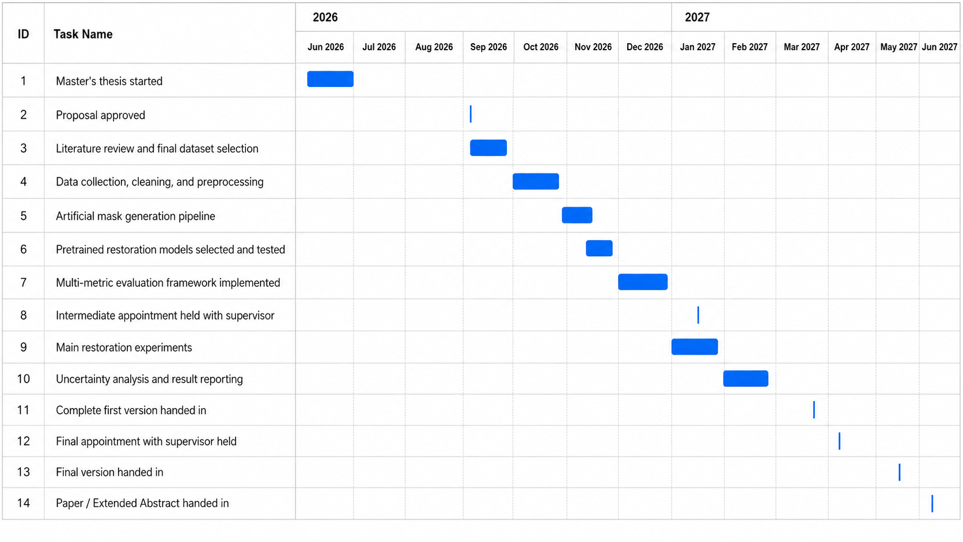

Table of contents of the planned work

- First page: Title, author, study programme, advisor, date
- Declaration of authenticity
- Abstract
  - Motivation
  - Problem description
  - Solution / Approach
  - Results
  - Consequences
- Acknowledgements (optional)
- Table of contents
- Introduction (10%)
  - Topic and object of research
  - Problem area and motivation
  - Research gap
  - Research questions and hypotheses
  - Structure of the thesis
- Chapter 1: Literature Review (15%)
  - AI-assisted painting restoration and cultural heritage preservation
  - Image inpainting and pretrained restoration models
  - Evaluation metrics for image restoration
  - Style-aware, semantic, texture-based, and uncertainty-based evaluation
- Chapter 2: Methods (20%)
  - Dataset selection and preprocessing
  - Artificial damage mask generation
  - Selection of pretrained inpainting models
  - Multi-metric evaluation framework
  - Uncertainty estimation method
  - Restoration report concept
- Chapter 3: Results and Analysis (35%)
  - Dataset and mask generation results
  - Benchmark comparison of selected inpainting models
  - Metric-based evaluation results
  - Cross-style and cross-damage-type analysis
  - Uncertainty heatmaps and speculative region analysis
  - Example restoration reports
- Chapter 4: Discussion (15%)
  - Relationship of results to the research questions
  - Relationship between metric-based results and uncertainty results
  - Generalization across painting styles and damage types
  - Limitations of data, models, metrics, and artificial masks
  - Significance of results
  - Ethical considerations and possible risks
- Conclusion – Summary – Outlook (5%)
  - Summary of research question, approach, methods, and results
  - Main contribution of the thesis
  - Outlook and further research
- Bibliography
- Appendix and indexes
  - Code notebooks and implementation details
  - Additional restoration examples
  - Additional metric tables
  - Optional expert review material

Literature
Gaber, J.A., Youssef, S.M. and Fathalla, K.M. (2023) ‘The role of artificial intelligence and machine learning in preserving cultural heritage and art works via virtual restoration’, ISPRS Annals of the Photogrammetry, Remote Sensing and Spatial Information Sciences, X-1/W1-2023, pp. 185–190. doi:10.5194/isprs-annals-X-1-W1-2023-185-2023.

Lee, J. and Choi, J. (2025) ‘Visual design from cultural heritage through inpainting-based restoration’, Proceedings of the IEEE/CVF International Conference on Computer Vision Workshops, pp. 4491–4496.

Liao, P., Li, X., Liu, X. and Keutzer, K. (2022) ‘The ArtBench dataset: Benchmarking generative models with artworks’, arXiv preprint, arXiv:2206.11404.

Oquab, M. et al. (2023) ‘DINOv2: Learning robust visual features without supervision’, arXiv preprint, arXiv:2304.07193.

Radford, A. et al. (2021) ‘Learning transferable visual models from natural language supervision’, Proceedings of the 38th International Conference on Machine Learning, PMLR 139, pp. 8748–8763.

Rombach, R., Blattmann, A., Lorenz, D., Esser, P. and Ommer, B. (2022) ‘High-resolution image synthesis with latent diffusion models’, Proceedings of the IEEE/CVF Conference on Computer Vision and Pattern Recognition, pp. 10684–10695.

Suvorov, R. et al. (2022) ‘Resolution-robust large mask inpainting with Fourier convolutions’, Proceedings of the IEEE/CVF Winter Conference on Applications of Computer Vision, pp. 2149–2159.

Zhang, R., Isola, P., Efros, A.A., Shechtman, E. and Wang, O. (2018) ‘The unreasonable effectiveness of deep features as a perceptual metric’, Proceedings of the IEEE Conference on Computer Vision and Pattern Recognition, pp. 586–595.

