AWS Cloud Project Report

Project: AWS S3 and Lambda Integration

# Introduction

This project demonstrates the integration of Amazon S3 with AWS Lambda to automate the response to file uploads. When a file is uploaded to a designated S3 bucket, a Lambda function is triggered, logging an event and confirming successful execution.

# Service Descriptions

## Amazon S3

Amazon Simple Storage Service (S3) is an object storage service that offers scalability, data availability, and security. In this project, it is used to store and trigger events based on file uploads.

## AWS Lambda

AWS Lambda is a serverless compute service that lets you run code without provisioning servers. In this project, Lambda responds to events in S3 by executing Python code whenever a file is uploaded.

# Implementation Steps

## Created an S3 bucket named 'rahulcloud-mys3'.

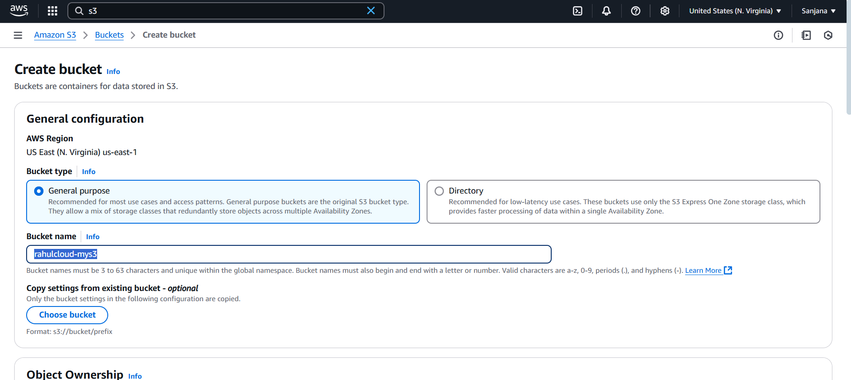

## Created a Lambda function 'rahulcloud-mylamb' using Python 3.13.

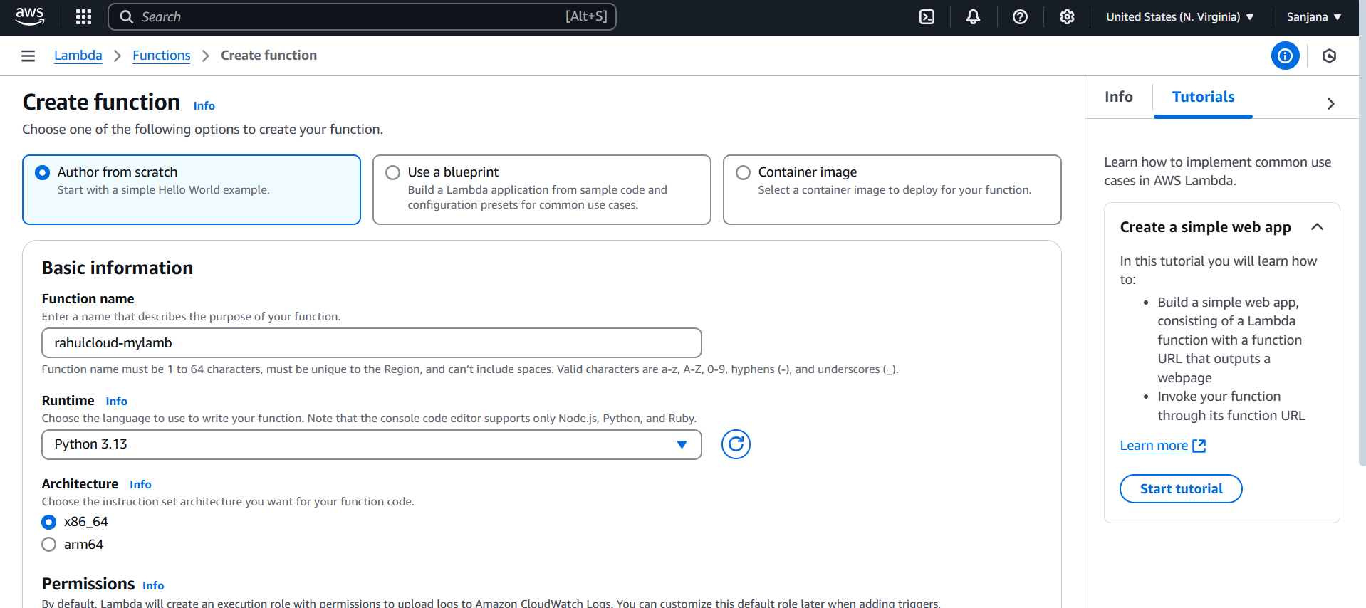

## Added code to the Lambda function to print a message when a file is uploaded.

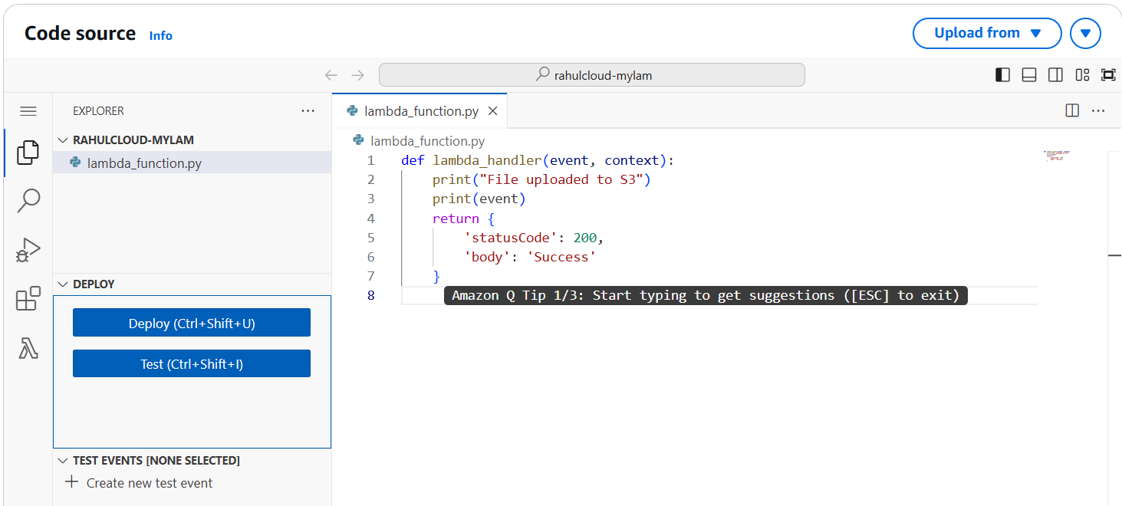

## Configured S3 as a trigger for the Lambda function using the PUT event.

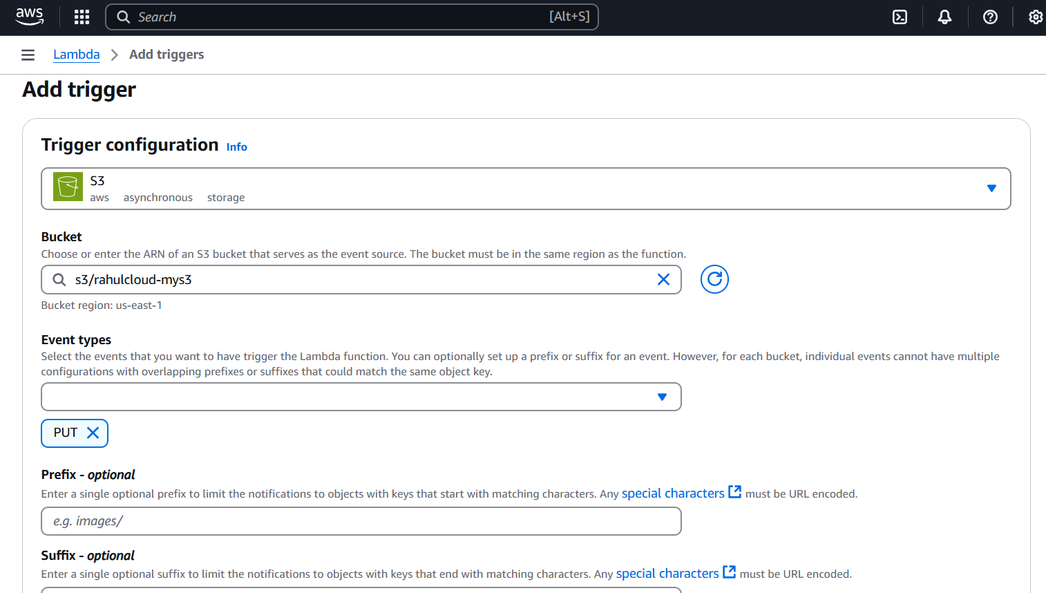

## Uploaded an image file to the S3 bucket to trigger the Lambda function.

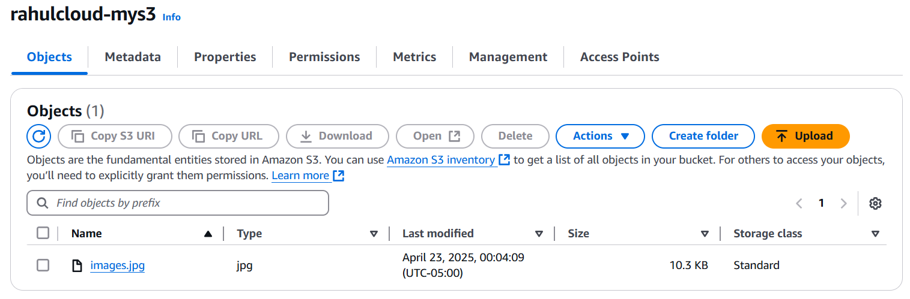

## Verified in CloudWatch Logs that the Lambda function executed upon file upload.

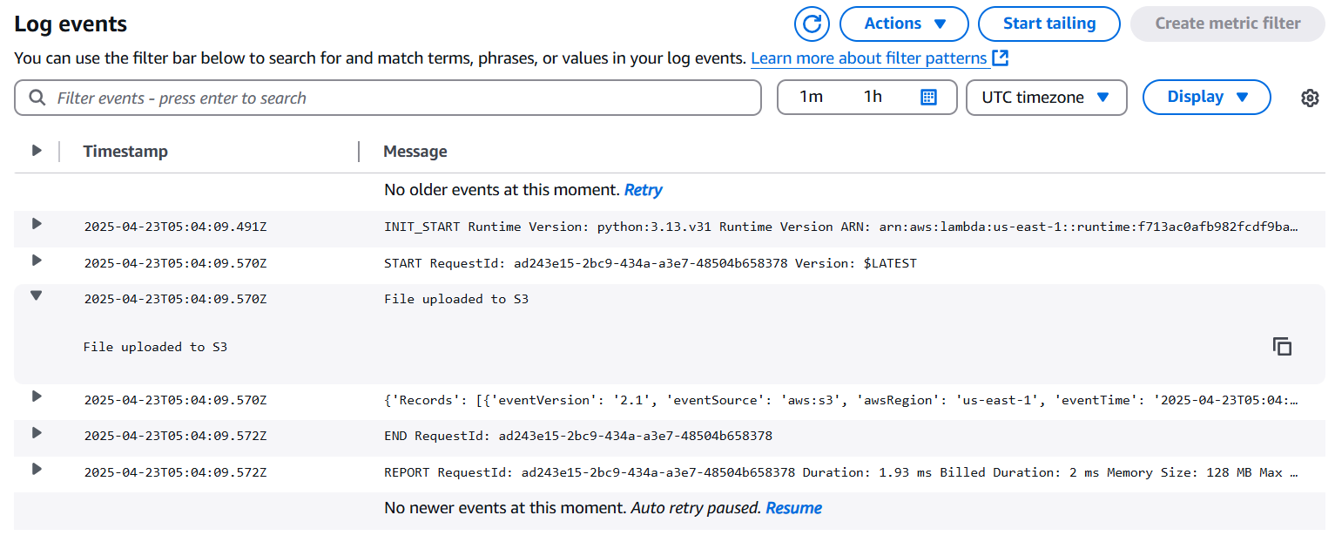

# Execution Summary

The system worked as expected. Uploading a file to the S3 bucket successfully triggered the Lambda function. The logs confirmed the event, displaying the expected output from the Lambda code.

# Conclusion

This project successfully demonstrated the use of AWS S3 and Lambda to build a simple, automated cloud-based file monitoring system. It also provided hands-on experience with AWS services and event-driven serverless computing.