Data Cleaning and Preliminary Analysis with R
Week 1 Task Report
Dataset: Titanic Passenger Data (Kaggle Titanic - Machine Learning from Disaster)
Prepared with R 4.3
August 2026

1. Dataset Overview
This report documents the data cleaning, preprocessing, and exploratory analysis workflow performed in R on a publicly available dataset: the Titanic passenger manifest from Kaggle's “Titanic - Machine Learning from Disaster” competition (the standard 891-row training set). The dataset was selected because it satisfies the core requirements for this exercise: it mixes numerical variables (Age, Fare, SibSp, Parch), categorical variables (Sex, Embarked, Pclass), free-text fields (Name, Ticket, Cabin), and it contains real missing data across three columns of varying severity (Age, Cabin, Embarked).

1.1 Source and Access
- Source: Kaggle “Titanic - Machine Learning from Disaster” competition training set (train.csv), mirrored publicly on GitHub for reproducible download.
- Rows: 891 passengers. Columns: 12 (raw).
- Download method: read directly into R via a public raw file URL (no authentication required), ensuring the analysis is fully reproducible from the code alone.

1.2 Raw Variable Dictionary
Variable | Type | Description
PassengerId | Integer | Unique row identifier
Survived | Integer (0/1) | Target/outcome: 0 = did not survive, 1 = survived
Pclass | Integer (1/2/3) | Ticket / passenger class, proxy for socio-economic status
Name | Text | Full name (title embedded, e.g. Mr., Mrs., Miss.)
Sex | Categorical | male / female
Age | Numeric | Age in years (177 missing)
SibSp | Integer | # of siblings / spouses aboard
Parch | Integer | # of parents / children aboard
Ticket | Text | Ticket number
Fare | Numeric | Passenger fare (British pounds)
Cabin | Text | Cabin number (687 of 891 missing, ~77%)
Embarked | Categorical | Port of embarkation: C, Q, S (2 missing)

1.3 Initial Inspection in R
The dataset was loaded and inspected using base R functions to confirm dimensions, structure, and the presence of missing data before any cleaning was performed.
R code — load and inspect
df <- read.csv("titanic.csv", stringsAsFactors = FALSE)
dim(df)
str(df)
head(df)
summary(df)
colSums(is.na(df))
Console output — dim() and str()
[1] 891 12
'data.frame': 891 obs. of 12 variables:
$ PassengerId: int 1 2 3 4 5 6 7 8 9 10 ...
$ Survived : int 0 1 1 1 0 0 0 0 1 1 ...
$ Pclass : int 3 1 3 1 3 3 1 3 3 2 ...
$ Name : chr "Braund, Mr. Owen Harris" ...
$ Sex : chr "male" "female" "female" "female" ...
$ Age : num 22 38 26 35 35 NA 54 2 27 14 ...
$ SibSp : int 1 1 0 1 0 0 0 3 0 1 ...
$ Parch : int 0 0 0 0 0 0 0 1 2 0 ...
$ Ticket : chr "A/5 21171" "PC 17599" "STON/O2. 3101282" "113803" ...
$ Fare : num 7.25 71.28 7.92 53.1 8.05 ...
$ Cabin : chr "" "C85" "" "C123" ...
$ Embarked : chr "S" "C" "S" "S" ...
Console output — missing values per column
PassengerId Survived Pclass Name Sex Age
0 0 0 0 0 177
SibSp Parch Ticket Fare Cabin Embarked
0 0 0 0 0 0
Note: colSums(is.na(df)) initially reports 0 missing values for Cabin and Embarked because those columns use empty strings ("") rather than R's NA to represent missing data. A dedicated check for empty strings revealed 687 missing Cabin values (77.1% of rows) and 2 missing Embarked values — this discrepancy itself was an important early finding and is addressed explicitly in the cleaning process below.
Console output — empty-string check on character columns
Name Ticket Cabin Embarked
0 0 687 2

2. Data Cleaning Process
Cleaning proceeded in six explicit stages: (A) standardizing missing-value representation, (B) handling missing values, (C) outlier detection, (D) normalization, (E) encoding categorical variables, and (F) exporting the final cleaned dataset.

2.A Standardizing Missing-Value Representation
Empty strings in Cabin and Embarked were first converted to proper NA values so that all subsequent missing-data functions in R treat them consistently.
R code
df$Cabin[df$Cabin == ""] <- NA
df$Embarked[df$Embarked == ""] <- NA
colSums(is.na(df))
PassengerId Survived Pclass Name Sex Age
0 0 0 0 0 177
SibSp Parch Ticket Fare Cabin Embarked
0 0 0 0 687 2

2.B Handling Missing Values
Each of the three variables with missing data was handled with a method appropriate to its missingness rate and role in the analysis, rather than a single blanket approach:
- Age (19.9% missing): imputed using the median age within each Pclass × Sex subgroup. This is more accurate than a single global median because age clearly varies with class and sex in this population (e.g. 1st-class passengers skew older).
- Embarked (0.2% missing, 2 rows): imputed with the mode (most frequent port), an acceptable approach given the negligible number of affected rows.
- Cabin (77.1% missing): too sparse to impute credibly. Instead of dropping the signal entirely, it was converted into a binary indicator HasCabinRecord (1 = a cabin was recorded, 0 = not recorded), and the original free-text column was dropped. Whether a cabin was recorded turns out to correlate with survival (see correlation analysis, Section 3.2), likely because it proxies for cabin location / class.
R code — median-by-group imputation for Age
age_lookup <- df %>%
group_by(Pclass, Sex) %>%
summarise(median_age = median(Age, na.rm = TRUE), .groups = "drop")

df <- df %>%
left_join(age_lookup, by = c("Pclass", "Sex")) %>%
mutate(Age = ifelse(is.na(Age), median_age, Age)) %>%
select(-median_age)
Console output — imputation lookup table
Pclass Sex median_age
1 1 female 35
2 1 male 40
3 2 female 28
4 2 male 30
5 3 female 21.5
6 3 male 25
R code — Embarked mode imputation and Cabin flag
embarked_mode <- names(sort(table(df$Embarked), decreasing = TRUE))[1] # "S"
df$Embarked[is.na(df$Embarked)] <- embarked_mode

df$HasCabinRecord <- ifelse(is.na(df$Cabin), 0, 1)
df$Cabin <- NULL
Console output — missing values after cleaning
PassengerId Survived Pclass Name Sex
0 0 0 0 0
Age SibSp Parch Ticket Fare
0 0 0 0 0
Embarked HasCabinRecord
0 0

2.C Outlier Detection
Outliers were detected using the 1.5× IQR rule on all numeric variables:
R code
detect_outliers <- function(x) {
q1 <- quantile(x, 0.25, na.rm = TRUE); q3 <- quantile(x, 0.75, na.rm = TRUE)
iqr <- q3 - q1
sum(x < q1 - 1.5*iqr | x > q3 + 1.5*iqr, na.rm = TRUE)
}
sapply(df[c("Fare","Age","SibSp","Parch")], detect_outliers)
Console output
Fare outliers : 116 out of 891 rows
Age outliers : 33 out of 891 rows
SibSp outliers: 46 out of 891 rows
Parch outliers: 213 out of 891 rows
Fare shows the most extreme outliers (max £512.33 vs. a median of £14.45) and is heavily right-skewed. Because these high fares correspond to legitimate first-class bookings rather than data-entry errors, rows were not deleted. Instead, Fare was winsorized (capped) at its 99th percentile (£249.01) to reduce the influence of extreme values on later scaling and correlation while preserving every record. SibSp and Parch show many “outliers” only because they are highly right-skewed count variables (most passengers travelled with 0 family members) — these are legitimate values, not errors, and were left unmodified.
R code — winsorizing Fare
fare_cap <- quantile(df$Fare, 0.99, na.rm = TRUE) # 249.01
df$Fare_Capped <- ifelse(df$Fare > fare_cap, fare_cap, df$Fare)
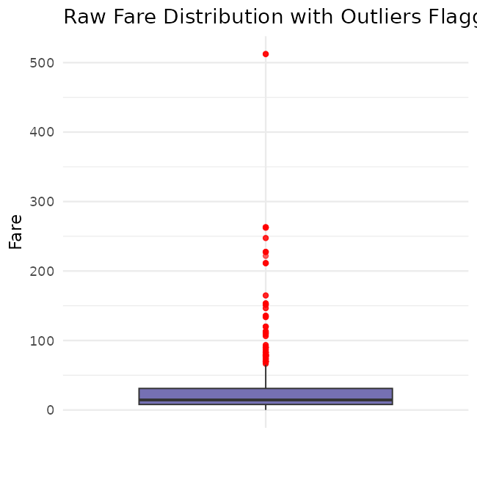
Figure 1. Boxplot of raw Fare showing right-skew and high-value outliers (in red) before capping.

2.D Normalization
Age and the outlier-capped Fare were each scaled two ways so that either can be used depending on the downstream modeling need: z-score standardization (mean 0, SD 1) for distance-based / regression methods, and min-max scaling (0–1) as an alternative bounded representation. Both were added as new columns, keeping the original interpretable values intact.
R code
df$Age_z <- as.numeric(scale(df$Age))
df$Fare_z <- as.numeric(scale(df$Fare_Capped))

minmax <- function(x) (x - min(x)) / (max(x) - min(x))
df$Age_minmax <- minmax(df$Age)
df$Fare_minmax <- minmax(df$Fare_Capped)
Console output — normalized columns (first rows)
Age Age_z Age_minmax Fare Fare_Capped Fare_z Fare_minmax
1 22 -0.5345909 0.2711737 7.2500 7.2500 -0.5637921 0.02911574
2 38 0.6680166 0.4722292 71.2833 71.2833 0.9420190 0.28627116
3 26 -0.2339390 0.3214375 7.9250 7.9250 -0.5479188 0.03182651
4 35 0.4425277 0.4345313 53.1000 53.1000 0.5144194 0.21324769

2.E Encoding Categorical Variables
Four complementary encoding strategies were applied, since different downstream techniques require different representations:
- Factor encoding: Sex, Embarked converted to unordered factors; Pclass converted to an ordered factor (3 < 2 < 1) since passenger class carries a natural socio-economic ranking.
- Label (integer) encoding: Sex_label, Embarked_label — compact numeric codes for algorithms that accept integer categorical codes.
- One-hot encoding: Sex and Embarked expanded into binary indicator columns (Sex_female/Sex_male, Embarked_C/Embarked_Q/Embarked_S) via model.matrix(), appropriate for models that assume no ordinal relationship between categories.
- Feature engineering — Title extraction: a Title field (Mr, Mrs, Miss, Master, Other) was parsed out of the free-text Name column using a regular expression, rare titles collapsed into “Other”, and the result stored as a factor. This converts an unusable free-text field into a meaningful categorical predictor.
R code
df$Pclass_f <- factor(df$Pclass, levels = c(3,2,1), ordered = TRUE)
df$Sex_f <- factor(df$Sex)
df$Embarked_f <- factor(df$Embarked)

df$Sex_label <- as.integer(df$Sex_f)
df$Embarked_label <- as.integer(df$Embarked_f)

onehot_sex <- model.matrix(~ Sex_f - 1, data = df)
onehot_embarked <- model.matrix(~ Embarked_f - 1, data = df)
df <- cbind(df, onehot_sex, onehot_embarked)

df$Title <- sub(".*, (.*?)\\..*", "\\1", df$Name)
rare <- names(table(df$Title))[table(df$Title) < 10]
df$Title[df$Title %in% rare] <- "Other"
df$Title <- factor(df$Title)
table(df$Title)
Console output — engineered Title feature
Master Miss Mr Mrs Other
40 182 517 125 27

2.F Final Cleaned Dataset
After cleaning, transformation, and encoding, the dataset grew from 12 to 28 columns (0 remaining missing values) and was exported for downstream analysis and modeling.
R code
write.csv(df, "titanic_cleaned.csv", row.names = FALSE)
saveRDS(df, "titanic_cleaned.rds")
dim(df)
[1] 891 28

3. Exploratory Analysis

3.1 Descriptive Statistics
R code
summary(df[, c("Age","Fare_Capped","SibSp","Parch")])
Console output
Age Fare_Capped SibSp Parch
Min. : 0.42 Min. : 0.00 Min. :0.000 Min. :0.0000
1st Qu.:21.50 1st Qu.: 7.91 1st Qu.:0.000 1st Qu.:0.0000
Median :26.00 Median : 14.45 Median :0.000 Median :0.0000
Mean :29.11 Mean : 31.22 Mean :0.523 Mean :0.3816
3rd Qu.:36.00 3rd Qu.: 31.00 3rd Qu.:1.000 3rd Qu.:0.0000
Max. :80.00 Max. :249.01 Max. :8.000 Max. :6.0000
Key survival breakdowns (proportions computed with table() / prop.table()):
Breakdown | Group | Survival Rate
Overall | All passengers | 38.4%
By Sex | Female | 74.2%
By Sex | Male | 18.9%
By Class | 1st class | 63.0%
By Class | 2nd class | 47.3%
By Class | 3rd class | 24.2%
By Title | Mrs | 79.2%
By Title | Miss | 69.8%
By Title | Master | 57.5%
By Title | Mr | 15.7%

3.2 Correlation Analysis
Pairwise Pearson correlations were computed for the key numeric / binary variables:
R code
num_vars <- df %>% select(Survived, Pclass, Age, SibSp, Parch, Fare_Capped, HasCabinRecord)
corr_mat <- cor(num_vars, use = "complete.obs")
round(corr_mat, 2)
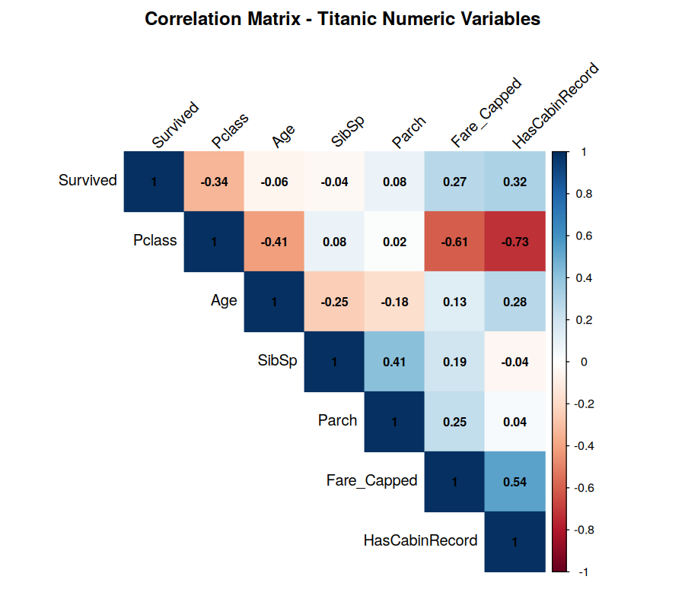
Figure 2. Correlation heatmap of key numeric variables.
The strongest relationships with survival are Pclass (−0.34), HasCabinRecord (+0.32) and Fare_Capped (+0.27). Pclass is also strongly correlated with Fare (−0.61) and HasCabinRecord (−0.73), confirming that class, fare, and cabin-recording are largely capturing the same underlying socio-economic dimension rather than independent effects.

3.3 Visualizations and Insights

Age Distribution
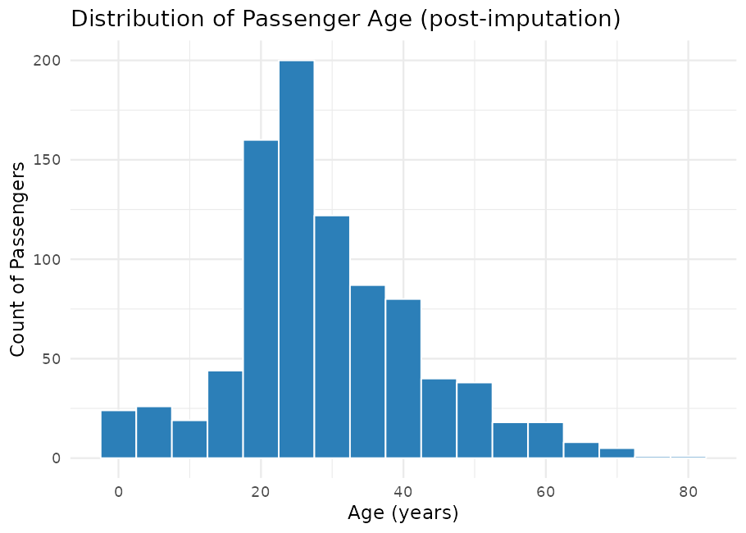
Figure 3. Distribution of passenger age after median-based imputation.
The age distribution is concentrated between 20 and 40 years, with a visible peak in the 20–30 bucket partly reinforced by the group-median imputation used for the 177 missing values.

Survival by Sex
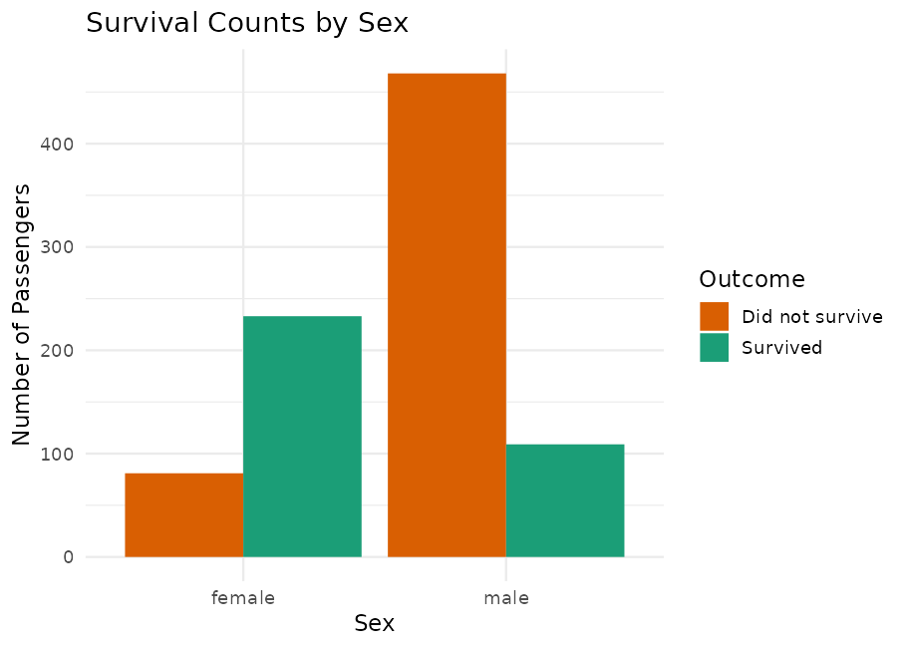
Figure 4. Survival counts split by sex.
Women survived at roughly four times the rate of men (74.2% vs. 18.9%), the single strongest categorical predictor of survival in this dataset — consistent with the historical “women and children first” evacuation protocol.

Fare by Passenger Class
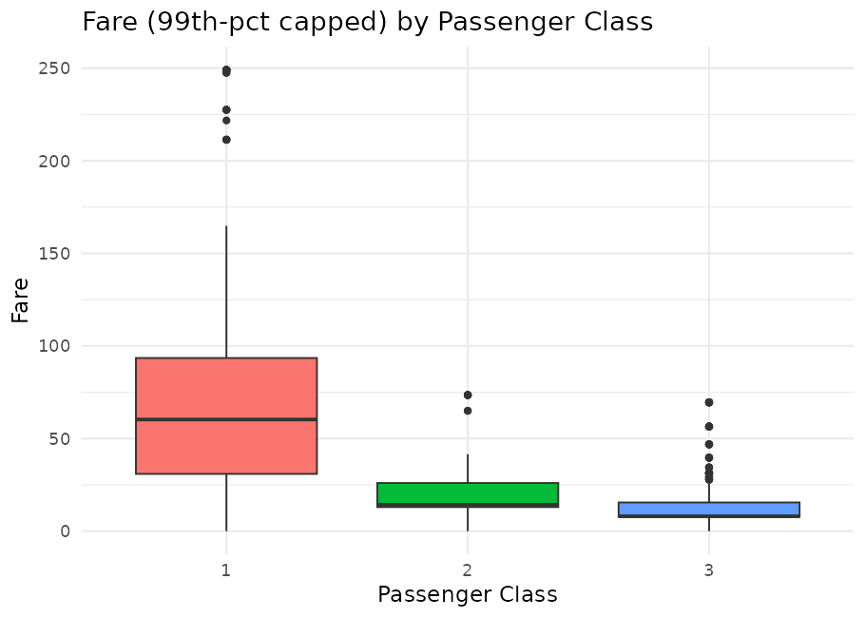
Figure 5. Fare (99th-percentile capped) distribution by passenger class.
First-class fares are markedly higher and more variable than second- and third-class fares, confirming Fare as a reasonable proxy for socio-economic status even after capping extreme outliers.

Survival Rate by Class and Sex
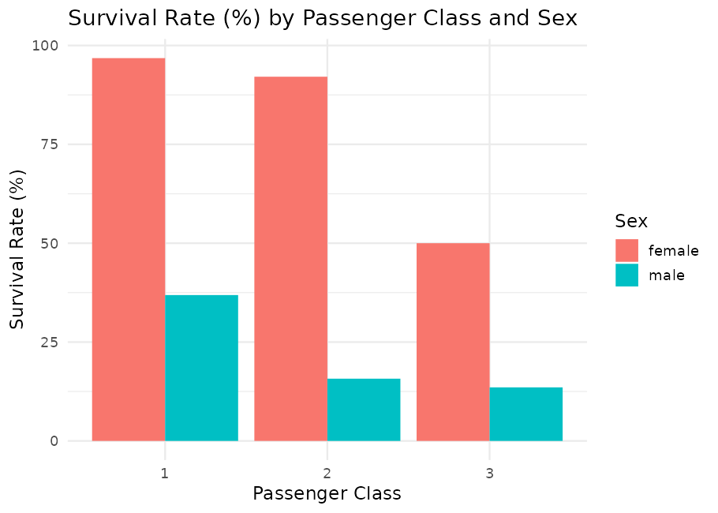
Figure 6. Survival rate (%) split jointly by passenger class and sex.
The class effect and the sex effect compound: first-class women survived at ~97%, while third-class men survived at only ~14%, showing that class and sex interact rather than acting independently.

4. Summary of Key Insights
- Missingness was concentrated in three columns (Age 19.9%, Cabin 77.1%, Embarked 0.2%), each requiring a different treatment; a naive listwise deletion would have discarded the vast majority of rows.
- Sex was the single strongest predictor of survival (74.2% for women vs. 18.9% for men).
- Passenger class showed a clear monotonic relationship with survival (63.0% → 47.3% → 24.2% from 1st to 3rd class) and was strongly correlated with Fare and cabin-recording, indicating these variables jointly capture socio-economic status.
- Sex and class interact: survival ranged from ~97% (1st-class women) down to ~14% (3rd-class men), a nearly seven-fold spread.
- Fare was heavily right-skewed with legitimate high-value outliers; capping at the 99th percentile rather than deleting rows preserved sample size while limiting the influence of extreme values on scaling and correlation.
- Whether a passenger had a recorded Cabin number was itself informative (correlation of +0.32 with survival), most likely because it is a byproduct of ticket class and cabin location rather than a causal factor.

5. Files Produced
- titanic_cleaned.csv / titanic_cleaned.rds — final cleaned, transformed, and encoded dataset (891 rows × 28 columns).
- 01_load_inspect.R, 02_clean_transform.R, 03_eda_analysis.R — the three R scripts documented in this report.
- plots/ — all six figures embedded in this document, saved as standalone PNG files.

