<https://oauth.canarabank.in/v1/oauth2/authorize?client_id=NADcfT80Mw2fDBtor0869Jo0dtDLixPi&redirect_uri=https://can-webhook.web1.one/payin/pay83/webhookhandler_83&response_type=code&state=acdfgb&scope=upi>

This is the Code Url

When you will hit the url in browser,you will redirect the login page when you will login after fill captcha

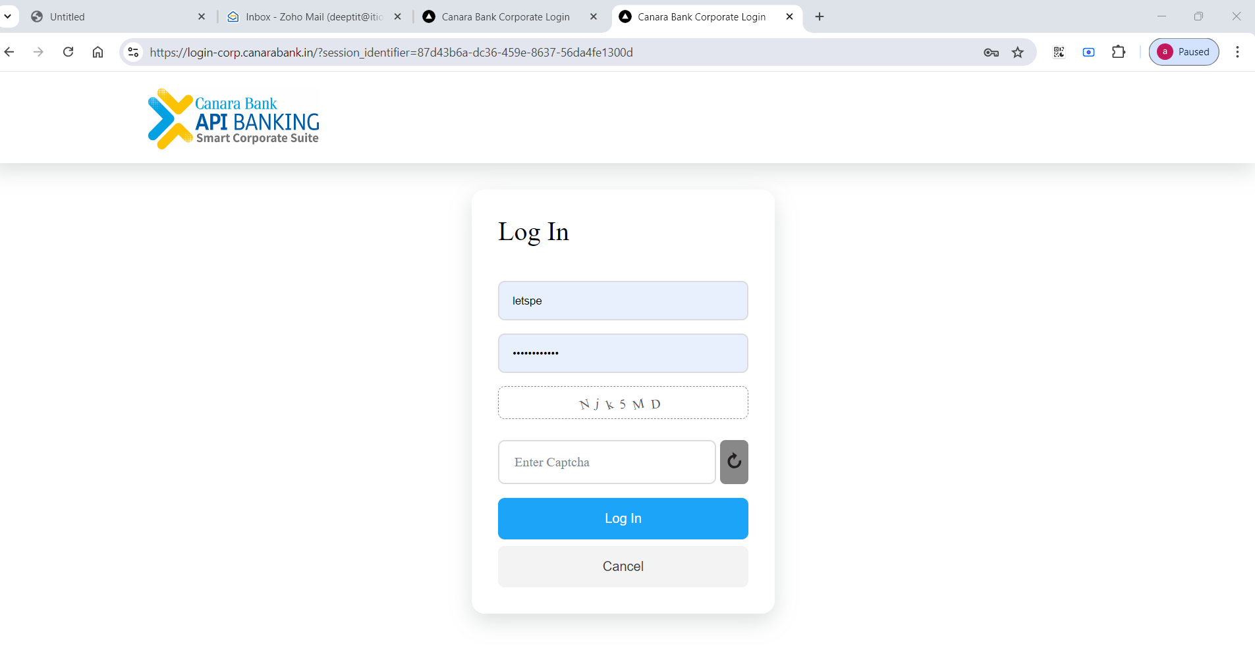

After login you will redirect on otp page then you need to call ankitesh

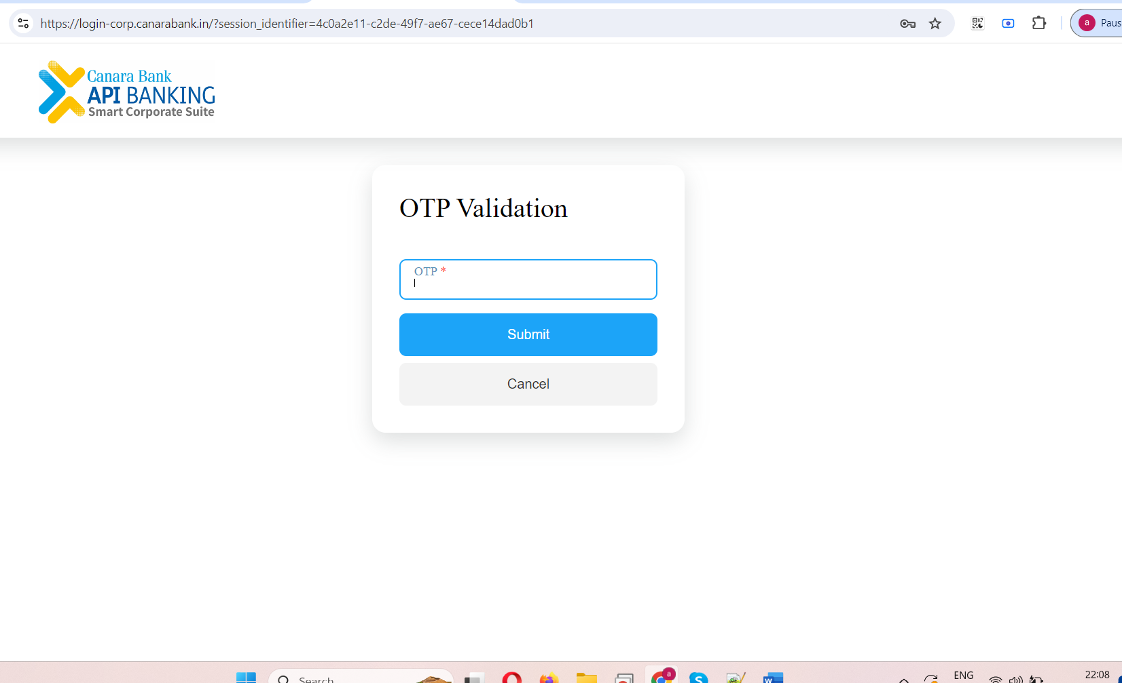

After fill the Otp you will get code

Code will get in browser