Import java.io.\* so that all IO packages are imported in the program.

We will use append method to append something(let’s say string) in a file.

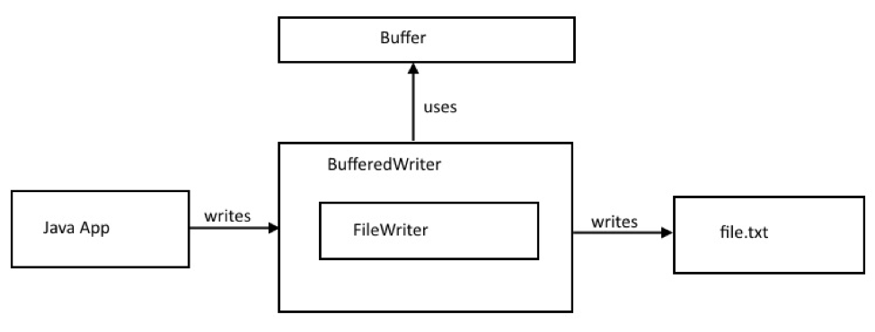

We can use Bufferedwriter class.

So we will open the file in an append mode using Bufferedwriter object.

We will create a string object to write something into the file.

We can do this in the Try catch method so that any exception encountered can be handled.

We will now move to the main method to create any sample file with a given set of details(in this case any string values to be written in that file).

Now we will enter any texts or words into that string object.

We will call the append method----> append given string to the file.

Now use the try catch block so that we can handle the exceptions.

In the block----->

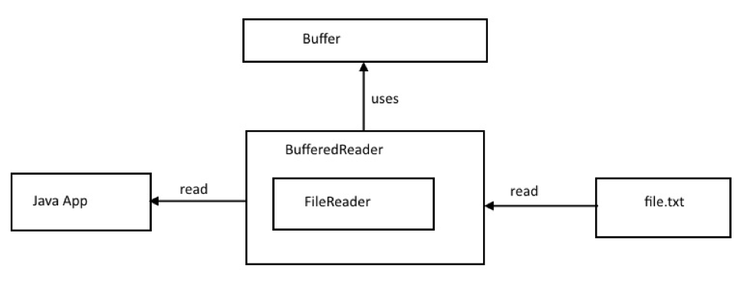

We will use the bufferedreader to read the context in the file.

We will create a string object and now using the while loop we will make a condition

That--> Till there is content in string, the condition will hold true, and it will print the content.

Catch block to handle the exception and to end the program.