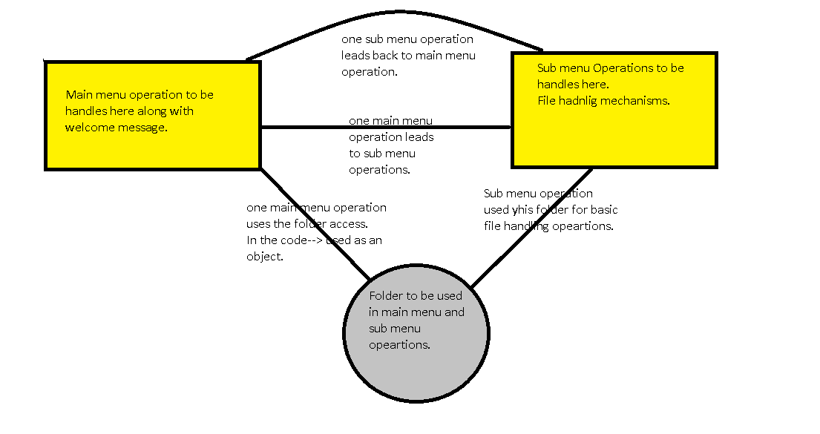

Welcome Screen of the LockedMe application is as shown below:

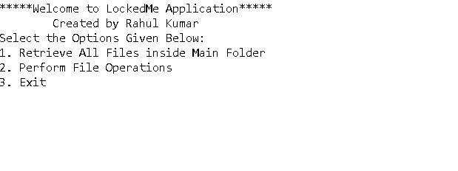

A main menu operation has been performed to clarify.

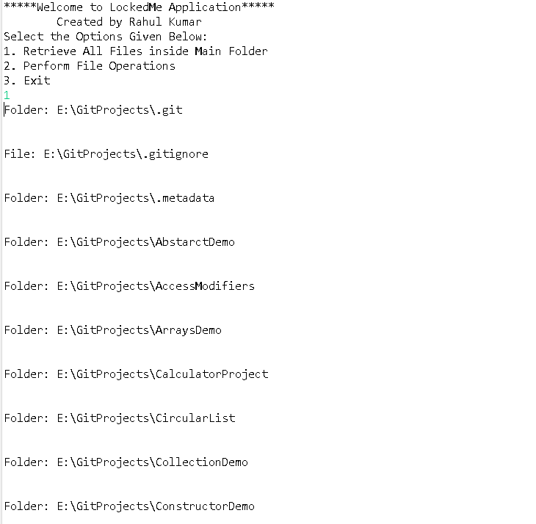

Sub-operations menu and to clarify one operation have been performed.

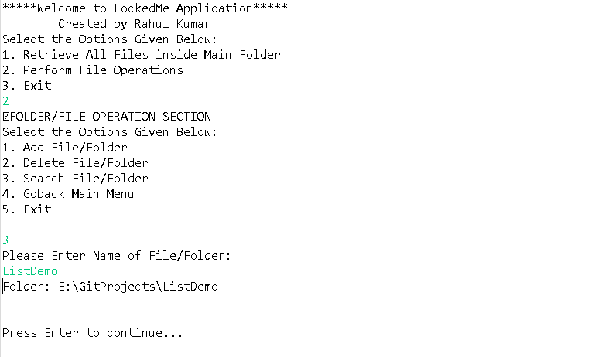

Technologies used are:-

1. Java 14
2. Eclipse IDE

Some important Methods used :-

1. Sorting for listing files in ascending order
2. Search for searching files in that directory
3. Add a file/Read/Delete(file handling) method to perform respective operations