A Project Report on
AI Powered Farmer-to-Market
Advisory System

Submitted in partial fulfilment for award of
Bachelor of Technology
Degree
in
CSE (Artificial Intelligence and Machine Learning)
By
Marella Suchithra (Y22ACM448) Matte Rahul (Y22ACM451)
Sriram Balaji (Y22ACM476)

Under the guidance of
G.V. Leela Kumari, _{M.Tech}
Assistant Professor

Department of CSE (Artificial Intelligence and Machine Learning)
Bapatla Engineering College
(Autonomous)
(Affiliated to Acharya Nagarjuna University)
BAPATLA – 522 102, Andhra Pradesh, INDIA
2025-2026

Department of
CSE (Artificial Intelligence and Machine Learning)

CERTIFICATE

This is to certify that the project report AI Powered Farmer-to-Market Advisory System being submitted by Marella. Suchithra (Y22ACM448), Matte.Rahul(Y22ACM451), Sriram.Balaji(Y22ACM476), in partial fulfillment for the award of the Degree of Bachelor of Technology in CSE (Artificial Intelligence and Machine Learning) to Acharya Nagarjuna University is a record of bonafide work carried out by them under our guidance and supervision.
Date:

Signature of the Guide Signature of the HOD
G.V. Leela Kumari Dr K. Manideep
Assistant Professor Assoc. Prof. &HOD

DECLARATION
We declare that this project work is composed by ourselves, that the work contained herein is our own except where explicitly stated otherwise in the text, and that this work has not been submitted for any other degree or professional qualification except as specified.

Acknowledgement

We sincerely thank the following distinguished personalities who have given their advice and support for the successful completion of the work.
We are deeply indebted to our most respected guide, Mrs G.V. Leela Kumari, Department of CSE (AIML), for his/her valuable and inspiring guidance, comments, suggestions and encouragement.
We extend our sincere thanks to Dr K. Mani Deep, Assoc. Prof. & Head, Department of CSE(AIML) for extending his cooperation and providing the required resources.
We would like to thank our beloved Principal, Dr B. Srinivasa Rao, for providing the online resources and other facilities to carry out this work.
We would like to thank our project coordinator, Mrs G. V. Leela Kumari, Assistant Prof., Dept. of CSE(AIML), for her helpful suggestions in presenting this document.
We extend our sincere thanks to all other teaching faculty and non-teaching staff of the department, who helped directly or indirectly, for their cooperation and encouragement.

ABSTRACT
Farmers often lack access to integrated market intelligence that combines price trends, weather variability, and transportation costs, which leads to poor selling decisions and significant post-harvest losses. To address this issue, this study proposes an AI-driven Farmer-to-Market Advisory System that brings together multiple advanced technologies into a single platform. The system uses computer vision to identify crops, retrieves real-time mandi prices, estimates transportation costs based on geolocation, and performs storage profitability analysis to determine whether farmers should sell immediately or wait for better prices. By analyzing this multimodal data, the system provides recommendations on the most profitable markets and optimal selling time, helping farmers maximize their net income. Experimental results using real-time agricultural datasets show that the system improves decision-making accuracy and reduces the risk of crop spoilage. Overall, the proposed solution demonstrates how AI-enabled platforms can enhance agricultural marketing efficiency and support farmers in making informed, data-driven economic decisions.

TABLE OF CONTENTS
ABSTRACT iv
TABLE OF CONTENTS v
LIST OF TABLES vii
LIST OF FIGURES viii
1. INTRODUCTION 1
1.1 Background of the Study 1
1.2 Problem Statement 2
1.3 Objectives 3
1.4 Scope 4
1.5 Organisation of the Report 5
2. LITERATURE REVIEW 6
2.1 Overview of Existing Work 6
2.2 Comparison of Previous Approaches 7
3. SYSTEM ANALYSIS 8
3.1 Existing System 8
3.2 Proposed System 8
3.3 Feasibility Study 10
3.4 Requirements 11
3.4.1 Hardware Requirement 11
3.4.2 Software Requirements 12
3.4.3 Functional Requirements 13
3.4.4 Non-Functional Requirements 14
4. SOFTWARE DESIGN 15
4.1 Architecture Design 15
4.2 UML Diagrams 16
4.2.1 Class Diagram 16
4.2.2 Interaction Diagrams 18
4.2.2.1 Sequence Diagram 18
4.2.2.2 Collaboration Diagram 19
4.2.3 Object Diagram 21
4.2.4 Use Case Diagram 22
4.2.5 Activity Diagram 23
4.2.6 Control Flow Diagram 25
4.3 Database Design 27
4.4 Algorithm / Design Methodology 27
5. IMPLEMENTATION 28
5.1 Technologies Used 28
5.2 Modules Description 29
5.2.1 User Input Module 29
5.2.2 Crop Identification Module 29
5.2.3 Data Collection Module 29
5.2.4 Transportation Analysis Module 30
5.2.5 Market Analysis Module 30
5.2.6 Storage Decision Module 30
5.2.7 Recommendation Engine 30
5.2.8 Output Module 30
5.3 Coding 31
5.3.1 Project Folder Structure 31
5.3.2 Backend Implementation 31
5.3.3 Frontend Implementation 32
6. TESTING 60
6.1 Test Cases 60
6.2 Testing Methods 62
6.2.1 Unit Testing 62
6.2.2 Integration Testing 62
6.2.3 System Testing 62
6.3 Results and Analysis 63
7. RESULTS AND DISCUSSION 64
7.1 Output Screenshots 64
7.2 Performance Analysis 66
7.3 Comparison with Existing System 67
8. CONCLUSION AND FUTURE WORK 68
8.1 Summary of the Project 68
8.2 Achievements 68
8.3 Limitations 69
8.4 Future Enhancements 69
9. REFERENCES 70

LIST OF TABLES
Table No. | Table Name | Page No.
Table 2.1 | Comparison of Existing Farmer-to-Market Advisory system | 7
Table 6.1 | Test Cases of AI Powered Farmer-to-Market Advisory system | 61
Table 7.1 | Comparison of Existing and Proposed Systems | 67

LIST OF FIGURES
Figure No. | Figure Name | Page No.
Fig 4.1 | Architecture of the Explainable AI-Based Adaptive Study Planner | 16
Fig 4.2.1 | Class Diagram | 18
Fig 4.2.2.1 | Sequence Diagram | 19
Fig 4.2.2.2 | Collaboration Diagram | 20
Fig 4.2.3 | Object Diagram | 22
Fig 4.2.4 | Use Case Diagram | 23
Fig 4.2.5 | Activity Diagram | 25
Fig 4.2.6 | Control Flow Diagram | 26
Fig 7.1.1 | User Interface of AI Farmer Advisory System | 64
Fig 7.1.2 | Cold Storage Profit Analysis Module | 65
Fig 7.1.3 | Profit Roadmap & Forecast | 65
Fig 7.1.4 | Market Transportation Cost and Route Visualization | 66

CHAPTER 1
INTRODUCTION
Farming these days has become quite essential in India. So many people depend on agriculture for their day-to-day income and livelihood. During the whole year, Farmers grow their various crops like vegetables, fruits, and grains. At Present, farmers way of living completely depends on their ability to sell their crops in the market.
Although many farmers are not aware of how to sell, when to sell and where to sell their crops in the market. Farmers do not receive proper guidance and up-to-date information about current market prices, weather conditions, and demands for their crops. Because of this problem, farmers sell their crop through middlemen or local buyers in the market. Middlemen sometimes give lower prices, and farmers lack knowledge about the current market price of their crops. For this reason, they do not get their full income.
Based on these issues related to crop prices and the major impact of weather changes on agriculture, farmers are essential for improved guidance. Sudden changes in weather such as rain, extreme heat, or storms can damage crops and reduce the quality. Farmers do not know about the how to predict weather conditions, farmers cannot choose the right time to harvest, store, or sell their crops.
The aim of this project is used to solve the above problems by designing a smart farmers guidance system that is available for real time data and current information to farmers. The system combined knowing the crops, real time market price and weather updates on a single platform. Farmers can use the system to take their own decisions about where and when to sell their crops, which can help improve their profits and reduce losses.
1.1 BACKGROUND OF THE STUDY
The agricultural sector plays a vital role in the economy, yet farmers often face significant challenges due to the lack of access to integrated and reliable market information. In many cases, they depend on limited or outdated data related to market prices, weather conditions, and transportation costs. This lack of proper information leads to inefficient decision-making, where farmers may choose unsuitable markets or sell their produce at lower prices, ultimately reducing their profits and causing post-harvest losses.

The absence of a unified system that combines these critical factors further worsens the situation. Without proper guidance, farmers are unable to analyze market trends, estimate transportation expenses, or decide the right time to sell their produce. As a result, they often experience financial losses and crop spoilage. With the rapid advancement of artificial intelligence, there is a growing opportunity to overcome these challenges by developing intelligent systems that can provide accurate and timely insights.

This project focuses on developing an AI-powered Farmer-to-Market Advisory System that integrates crop identification, real-time market price analysis, geolocation-based transport cost estimation, and storage decision support. By combining these technologies, the system provides farmers with recommendations on the most profitable markets and the best time to sell their produce. This approach not only improves market efficiency but also empowers farmers to make data-driven decisions, thereby increasing profitability and reducing losses in the agricultural supply chain.
1.2 PROBLEM STATEMENT
Farmers often face significant difficulties in making proper decisions about selling their crops due to the lack of accurate and real-time information. They are usually unaware of current market prices, which leads them to depend on middlemen or local sources that may not provide reliable data. In addition, unpredictable weather conditions such as sudden rainfall, temperature changes, or drought can negatively impact crop quality and storage, resulting in spoilage. Transportation and logistics costs further add to the problem, as farmers are unable to estimate expenses and choose the most profitable market. Moreover, traditional farming practices rely heavily on experience and limited knowledge rather than data-driven insights. Due to these challenges, farmers often sell their produce at lower prices, face financial losses, and experience inefficiencies in decision-making.
To overcome these challenges, there is a need for an intelligent and integrated solution that can assist farmers in making better decisions. An AI-Powered Farmer-to-Market Advisory System can provide such support by combining advanced technologies like computer vision, machine learning, and real-time data integration. The system enables farmers to upload or capture images of their crops, which are then analyzed to identify the crop type. It also gathers real-time information such as market prices, weather conditions, and transportation costs from online sources. By analyzing all these factors, the system generates intelligent recommendations, including the best market to sell the product, expected profit, and whether the farmer should sell immediately or store the produce. This approach helps farmers improve profitability, reduce crop spoilage, and make informed, data-driven decisions, ultimately enhancing the efficiency of agricultural practices.
1.3 OBJECTIVES
The primary objective of this project is to develop an intelligent advisory system that assists farmers in making better decisions using advanced technologies like Computer Vision, Large Language Models, and real-time data integration.
1.3.1 Crop Identification using Computer Vision
The system aims to accurately identify the type of crop by analyzing images uploaded by farmers. Using Computer Vision techniques, the model processes visual features such as color, shape, and texture to detect crops (e.g., tomato, potato). This helps in automating the identification process and reduces dependency on manual input.
    - Market Recommendation Based on Real-Time Prices
Another key objective is to provide farmers with the best market (mandi) recommendations by analyzing real-time price data. The system compares prices across multiple markets and suggests the most profitable location for selling the produce, ensuring better returns.
1.3.3 Weather-Based Storage Decision Support
The system analyzes weather conditions such as temperature, humidity, and rainfall forecasts to help farmers decide whether to store or sell their crops immediately. This reduces the risk of spoilage and supports better post-harvest management.
1.3.4Reduction of Crop Wastage and Improvement of Profitability
The ultimate goal of the system is to minimize post-harvest losses and maximize farmer profits. By providing timely, accurate, and data-driven recommendations, the system helps farmers make informed decisions that improve efficiency and reduce waste.
1.4 SCOPE OF THE PROJECT
The scope of the AI-Powered Farmer-to-Market Advisory System defines the boundaries, functionalities, and potential applications of the system. It focuses on improving agricultural decision-making by integrating advanced technologies and real- time data sources.
1.4.1 Crop Identification and Analysis
The system is designed to identify crop types using Computer Vision techniques. Farmers can upload images of their produce, and the system analyzes visual features to detect the crop accurately. This feature reduces manual effort and ensures correct identification, which is essential for further analysis and recommendations.
1.4.2 Real-Time Market Data Integration
The project includes integration with real-time market data sources such as agricultural APIs. It collects and analyzes current market prices from multiple mandis, allowing farmers to compare prices and choose the most profitable market for selling their produce.
1.4.3 Weather Forecast Integration
The system incorporates weather data to assist farmers in making decisions related to harvesting, storage, and transportation. By analyzing parameters such as rainfall, temperature, and humidity, it helps reduce risks associated with unfavourable weather conditions.
1.4.4 Intelligent Advisory Generation
A major scope of the project is the use of a Large Language Model (LLM) to generate personalized recommendations.
Based on all inputs, the system provides guidance on:
- Best market to sell
- Whether to store or sell immediately
- Expected profit outcomes

1.4.5 Decision Support for Storage and Selling
The system evaluates whether storing crops will yield more profit compared to immediate selling. This helps farmers make economically beneficial decisions and avoid unnecessary losses due to price drops or spoilage.
1.4.6 Reduction of Post-Harvest Losses
By providing timely recommendations and considering storage conditions, the system helps in reducing crop wastage. This improves resource utilization and increases overall efficiency in the agricultural supply chain.
1.4.7 User-Friendly Interface for Farmers
The project includes a simple and accessible interface (web/mobile-based) that allows farmers to:
- Upload crop images
- Enter basic details (location, quantity)
- Receive easy-to-understand recommendations

1.4.8 Scalability and Future Expansion
The system is designed to be scalable and can be expanded in the future to include:
- More crop varieties
- Additional markets and regions
- Multi-language support
- Integration with government agricultural schemes
1.4.9 Limitations of the Scope
- Depends on availability of accurate real-time data
- Requires internet connectivity
- Accuracy depends on quality of input images and models

1.5 ORGANISATION OF THE REPORT
This report is organized into multiple chapters for systematic presentation of the proposed AI Powered Farmer-to-Market Advisory System. Chapter 1 introduces the project including background, problem statement, objectives, and scope. Chapter 2 presents the literature review and comparison of existing approaches. Chapter 3 discusses system analysis including existing system, proposed system, feasibility study, and requirements. Chapter 4 explains software design including architecture, UML diagrams and methodology. Chapter 5 describes implementation details and technologies used. Chapter 6 presents testing methodologies and results. Chapter 7 illustrates output screens and performance results. Finally, Chapters 8 and 9 provide conclusion and future scope respectively.

CHAPTER 2
LITERATURE REVIEW
2.1 OVERVIEW OF EXISTING WORK
This study explains a digital price information system for farmers. It collects daily mandi prices and shows them to farmers. But it gives only price data and does not indicate the best market or selling time [1]. This study related on weather prediction or report systems for farming purposes. Farmers get day-to-day and weekly weather report to choose the best time for irrigation and harvesting activities. But it does not connect weather data with selling decisions or profit estimation [2]. This study presents an image-based crop recognition system. Farmers upload images for their crop, and the system determines the crop variety. It helps in managing crop effectively, but it does not give the market-related guidance or time to sell [3]. This research work describes an image analysis technique to detect plant diseases. The system can detect diseases at an early stage and helps farmers in taking preventive actions. But , it does not involve price comparison or market suggestions [4]. This study mainly concentrates on predicting the crop price using past market data. It studies the past records of the prices to predict the future prices. But, it doesn't take into consideration the current weather and transport costs [5]. This proposed research work deals with a location-based market comparison system. It compares prices from different mandis and assists farmers in choosing better markets. But, it does not involve identification of the crop and weather information [6]. This study describes about the use of transport cost analysis in agriculture. This system estimates the travel distance and transportation costs between farms and markets. But, it does not integrate price, weather, and crop data [7]. This study discusses about the integrated smart farming systems. The different digital tools are combined in this paper to assist farmers. Nevertheless, most of these systems still do not have the complete integration of crop identification, real-time prices, weather updates, and final suggestions [8].

2.2 COMPARISON OF PREVIOUS APPROACHES

Table 2.1: Comparison of Existing AI Powered Farmer-to-Market Advisory system

Study / Tool | Methodology | Limitation
Traditional Market System | Farmers rely on local agents and manual price collection | Lack of real-time data and high dependency on middlemen
eNAM Platform | Online portal providing mandi price information | Does not provide predictive insights or personalized recommendations
Agmarknet | Government database for agricultural market prices | Data may not always be real-time or user-friendly
Weather Apps | Provides weather forecasts using meteorological data | Not integrated with market price or selling decisions
Basic Farming Apps | Mobile apps offering price updates and farming tips | Limited features, no AI-based decision support
Logistics Estimation Tools | Manual or basic tools for calculating transportation costs | No optimization or integration with market selection
Storage Advisory Methods | Traditional knowledge or experience-based storage decisions | No data-driven profitability analysis
Proposed AI-Based System | Integrates AI, computer vision, real-time data, and predictive analytics | Requires internet access and initial user adaptation

CHAPTER 3
SYSTEM ANALYSIS
3.1 EXISTING SYSTEM
The existing agricultural marketing system is largely traditional and lacks the use of advanced technologies, resulting in inefficiencies and reduced profits for farmers. They typically sell their produce in nearby mandis without access to complete market information, relying on guesswork or past experience to decide when and where to sell. Farmers also depend heavily on middlemen, who often exploit them by offering lower prices and taking a significant share of the profit. Additionally, the system does not provide real-time data on market prices, demand and supply conditions, or weather forecasts, which limits informed decision-making. Most decisions related to selling, storage, and transportation are made manually without analytical support, leading to poor planning. As a result, inadequate storage guidance and delayed selling often cause crop spoilage, contributing to high post-harvest losses and reduced income for farmers.
Limitations of Existing System
The major limitations of current Advisory systems are:
- No use of advanced technologies like AI or data analytics
- Limited access to market information
- High dependency on intermediaries
- Lack of weather-based decision support
- Increased wastage and reduced profitability
3.2 PROPOSED SYSTEM
The proposed AI-Powered Farmer-to-Market Advisory System is designed to provide step-by-step guidance to farmers for making informed decisions. The system integrates Computer Vision, real-time data, and AI-based analysis to deliver accurate and practical recommendations. The working of the system is divided into the following modules:

3.2.1 Crop Image Upload and Identification Module
In this module, farmers upload images of their crops through a user-friendly application interface. The system uses Computer Vision techniques to analyze the uploaded image and identify the crop type.
The model examines visual features such as:
- Colour
- Shape
- Texture
Based on these features, the system accurately classifies the crop (e.g., tomato, rice, potato). This automated identification reduces manual effort and ensures correct input for further processing.
3.2.2 Farmer Input Details Module
After identifying the crop, the system collects additional information from the farmer, including:
- Location (village/city)
- Quantity of crop
The location data is used to identify nearby markets (mandis) and calculate transportation distance and cost. The quantity of crop helps in estimating demand, total profit, and market suitability. This module ensures that recommendations are personalized and accurate.
3.2.3 Real-Time Data Collection Module
This module collects real-time data from external sources using APIs. The system gathers:
- Market Price Data: Current prices of crops in different mandis
- Weather Data: Temperature, rainfall, humidity, and forecasts
- Transportation Cost: Distance, travel time, and cost estimation
This real-time information is essential for making up-to-date and reliable decisions. It ensures that farmers receive recommendations based on current market and environmental conditions.
3.2.4 AI Analysis and Recommendation Module
This is the core module of the system where all collected data is processed using AI techniques. The system analyzes:
- Market price comparisons
- Weather conditions
- Transportation costs
- Crop type and quantity
Based on this analysis, the system generates intelligent recommendations such as:
- Best market to sell the crop
- Expected profit estimation
- Whether to store or sell immediately
The decision logic ensures that farmers can maximize profit while minimizing losses due to spoilage or poor market selection.
3.2.5 User-Friendly Output Module
The final recommendations are presented to farmers in a simple and easy-to-understand format. The system displays:
- Recommended market
- Profit estimation
- Storage or selling advice
The interface is designed to be user-friendly so that even farmers with minimal technical knowledge can easily use the system. The goal is to make complex data understandable and actionable for everyday use.
Advantages of Proposed System
- Provides real-time mandi price updates for better selling decisions.
- Uses AI to give accurate and data-driven recommendations.
- Helps farmers choose the most profitable market.
- Estimates transportation costs to reduce expenses.
- Suggests whether to store or sell crops at the right time.
- Reduces dependency on middlemen and increases farmer profit.
- Minimizes crop spoilage and post-harvest losses.
- Integrates weather, price, and cost data in one platform.
3.3 FEASIBILITY STUDY
The feasibility study evaluates the practicality and effectiveness of the proposed AI-Powered Farmer-to-Market Advisory System in terms of technical, economic, operational, and social aspects. This analysis ensures that the system can be successfully developed and implemented to meet the needs of farmers.
Technical Feasibility
The proposed system is technically feasible as it utilizes widely available technologies such as Python, machine learning libraries, computer vision tools, and APIs for real-time data (market prices, weather, and maps). These technologies are well-supported and can be implemented using standard computing resources. The integration of AI models and APIs is achievable with existing frameworks, making the system reliable and scalable.
Economic Feasibility
The system is cost-effective as it primarily relies on open-source tools and publicly available APIs. Development and deployment costs are relatively low compared to the benefits provided. By helping farmers choose better markets and reduce losses, the system contributes to increased income, making it economically beneficial in the long run.
Operational Feasibility
The proposed AI-Powered Farmer-to-Market Advisory System is operationally feasible as it provides a simple and user-friendly interface that can be easily used by farmers with minimal technical knowledge. It allows users to upload crop images, enter basic details, and receive clear recommendations through web or mobile platforms. The system integrates smoothly with existing farming practices and presents outputs in an easy-to-understand format, enabling quick decision-making with minimal training and effort.
3.4 REQUIREMENTS
3.4.1 Hardware Requirements
The hardware requirements for implementing the AI-Powered Farmer-to-Market Advisory System depend on the level of performance and efficiency expected from the system. Since the project involves image processing, and real-time data handling, a system with moderate to high computational capability is required.
1.Processor
Minimum: Intel i5 or equivalent
Recommended: Intel i7 or higher
Explanation: Handles system operations and model execution; higher processors give faster performance.
2. RAM (Memory)
Minimum: 8 GB
Recommended: 16 GB
Explanation: Supports multitasking; higher RAM improves speed and smooth execution.

3. Storage
Minimum: 256 GB
Recommended: 512 GB or more
Explanation: Used to store datasets and application files; more storage supports scalability.
4. Internet Connection
Requirement: Stable and continuous internet
Explanation: Required for accessing real-time data like market prices and weather updates.
3.4.2 Software Requirements
The software requirements define the tools, platforms, and technologies needed to develop and run the AI-Powered Farmer-to-Market Advisory System. These components help in data processing, model building, user interaction, and real-time information retrieval.
1.Operating System Windows / Linux / macOS
Explanation:
The system can be developed and executed on any modern operating system. These platforms provide the necessary environment and compatibility for running Python, libraries, and frameworks required for the project.
2.Programming Language
Python 3.x
Explanation:
Python is used as the primary programming language due to its simplicity and strong support for machine learning, data analysis, and image processing. It provides a wide range of libraries that make development faster and more efficient.
3.Frameworks
Streamlit – for building user interface
Explanation:
Streamlit is used to create an interactive and user-friendly interface for farmers to upload images and view results easily.
4.Libraries
NumPy – Numerical Computations
Used for performing mathematical operations and handling arrays efficiently.
Pandas – Data Processing and Analysis
Used to organize, clean, and analyse data in structured formats like tables.

OpenCV – Image Processing
Used to process and analyse images, such as identifying crops from uploaded images.
Matplotlib – Data Visualization
Used to create graphs and charts for better understanding of data.
5. APIs Used
Weather API – for weather forecasts
Market Price API (Agmarknet or similar) – for price data
Google Maps API – for location and distance calculation
Explanation:
APIs are used to fetch real-time data required for decision-making. Weather APIs provide climate information, market APIs give current crop prices, and Google Maps API helps in identifying nearby markets and calculating transportation distance and cost.
3.4.3 Functional Requirements
Functional requirements define the core features and operations that the system must perform to achieve its objectives.
The proposed AI-Powered Farmer-to-Market Advisory System must provide an interface that allows farmers to upload or capture images of their crops. These images are processed using computer vision techniques to accurately identify the type of crop. This feature reduces manual effort and ensures correct identification.
The system should also collect essential user inputs, such as the farmer’s current location and the quantity of the crop. This information is necessary to provide personalized and location-specific recommendations.
Another important function of the system is to fetch real-time data from external sources using APIs. This includes:
- Current market prices of crops
- Weather conditions and forecasts
- Transportation costs and distance to nearby markets
After gathering all the required data, the system must analyse the information using AI and machine learning algorithms. Based on this analysis, the system generates useful recommendations for the farmer
The system should provide the following outputs:
- Suggest the best nearby market (mandi) for selling the crop
- Recommend the optimal time to sell the product
- Advise whether to sell immediately or store the crop for future profit
- Provide an estimated profit analysis
Overall, the system must ensure that all functionalities work together to support farmers in making accurate and data-driven decisions.
3.4.4 Non-Functional Requirements
Non-functional requirements describe the quality attributes and performance standards of the system.
The system must be user-friendly and easy to operate, especially for farmers who may have limited technical knowledge. The interface should be simple, clear, and intuitive.
Performance is a critical factor. The system should provide fast responses when processing data and generating recommendations, ensuring real-time decision-making without delays.
Reliability is essential to maintain trust among users. The system must consistently provide accurate and dependable recommendations based on real-time data.
The system should also be scalable, meaning it must handle a growing number of users and increasing data without affecting performance. This ensures long-term usability and expansion.
Security is another important requirement. The system must protect user data, such as location and crop information, from unauthorized access. Proper data handling and secure communication should be ensured.
Additionally, the system should be maintainable and flexible, allowing future updates, improvements, and integration of new features without major changes to the existing structure.

CHAPTER 4
SOFTWARE DESIGN
4.1 ARCHITECTURE DESIGN
The AI-Powered Farmer-to-Market Advisory System is designed using a modular architecture that integrates multiple components to provide intelligent recommendations to farmers. The process begins with the User Interface, where the farmer uploads crop images, enters crop details, and provides location inputs. This information is then passed to the Input Processing Module, which validates the inputs and processes geolocation data using GPS.
The uploaded crop image is analysed in the Computer Vision Module, where crop identification, quality analysis, and freshness estimation are performed. This ensures accurate detection of the crop type and its condition. Simultaneously, the Data Collection Layer gathers real-time information such as transportation costs, weather data, and market prices through APIs like Weather API, Market API (Agmarknet), and Google Maps API.
The collected data is processed in the Processing and Analysis Module, which performs transportation cost estimation, distance calculation, and market price analysis. Based on this, the system calculates the expected profit for different market options. The Storage Decision Module further analyzes future price predictions and storage costs to decide whether the farmer should sell immediately or store the crop for better returns.
The Recommendation Engine acts as the core component, optimizing profit and selecting the best market by ranking multiple mandis. Finally, the Output Module presents the results to the farmer in an easy-to-understand format, including voice summaries, visual recommendations, profit forecasts, and navigation assistance to the selected market.
Overall, the system integrates computer vision, real-time data, and AI-based analysis to provide accurate, data-driven, and user-friendly advisory support to farmers.

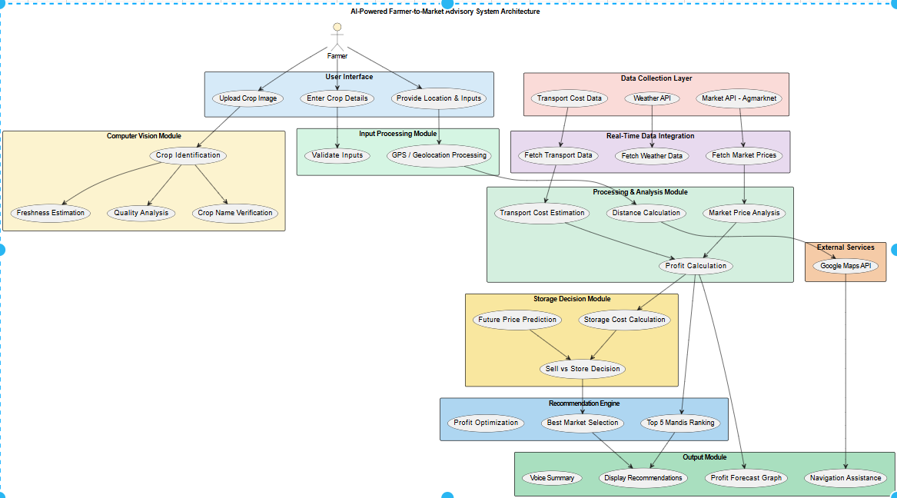
Fig 4.1: Architecture of AI Powered Farmer-to-Market Advisory System
4.2 UML DIAGRAMS
Unified Modeling Language (UML) is a general-purpose modeling language. The main aim of UML is to define a standard way to visualize the way a system has been designed. It is quite similar to blueprints used in other fields of engineering. We use UML diagrams to show the behavior and structure of a system.UML helps software engineers, businessmen, and system architects with modeling, design, and analysis.
4.2.1 Class Diagram
Objective:
Define the static structure of the AI-Based Farmer-to-Market Advisory System, including classes, their attributes, methods, and the relationships between system components.
Description:
- Classes: Farmer,Crop,AdvisoryEngine, AIRecommendation, AnalysisModule, StorageModule, MarketService, WeatherService, TransportService, APIService
- Farmer – Represents the user (farmer) who interacts with the system.
- Attributes: farmerId, name, location
- Methods: enter Details (), upload Image ()
- Crop –Represents the crop details provided by the farmer.
- Attributes: crop Id, name, quantity, quality, image
- Methods: upload Crop (), update Crop ()
- Advisory Engine – Core module responsible for processing data and generating recommendations.
- Attributes: market Data, weather Data, transport Cost
- Methods: analyze Data (), generate Recommendation (), compare Profit ()
- AIRecommendation – Represents the intelligent output generated by the system.
- Attributes: best Market, suggested Time, storage Decision, profit Estimation
- Methods: predictBestMarket(), decideSellOrStore()
- AnalysisModule – Performs data analysis such as price comparison and profit calculation.
- Attributes: price Comparison, profit Rate
- Methods: calculate Profit (), compare Markets ()
- StorageModule – Handles storage-related decision-making.
- Attributes: storage Cost, storage Time
- Methods: estimate Storage Profit (), recommend Storage ()
- MarketService – Provides real-time market price data.
- Attributes: prices
- Methods: get Market Prices ()
- WeatherService – Provides weather forecast data.
- Attributes: forecast
- Methods: get Weather Data ()
- TransportService – Calculates transportation cost and distance.
- Attributes: distance, cost
- Methods: calculate Transport ()
- APIService – Connects the system with external APIs.
- Attributes: apiKey
- Methods: fetch Market API (), fetch Weather API (), fetch Transport API ()
Relationships:
- Farmer provides Crop details and uploads images to the system.
- Crop acts as input to the Advisory Engine.
- Advisory Engine uses AnalysisModule, StorageModule, WeatherService, MarketService, and TransportService for processing data.
- AIRecommendation is generated by Advisory Engine based on analysis.
- AnalysisModule uses MarketService and TransportService for profit calculation.
- MarketService, WeatherService, and TransportService use APIService to fetch real-time data.
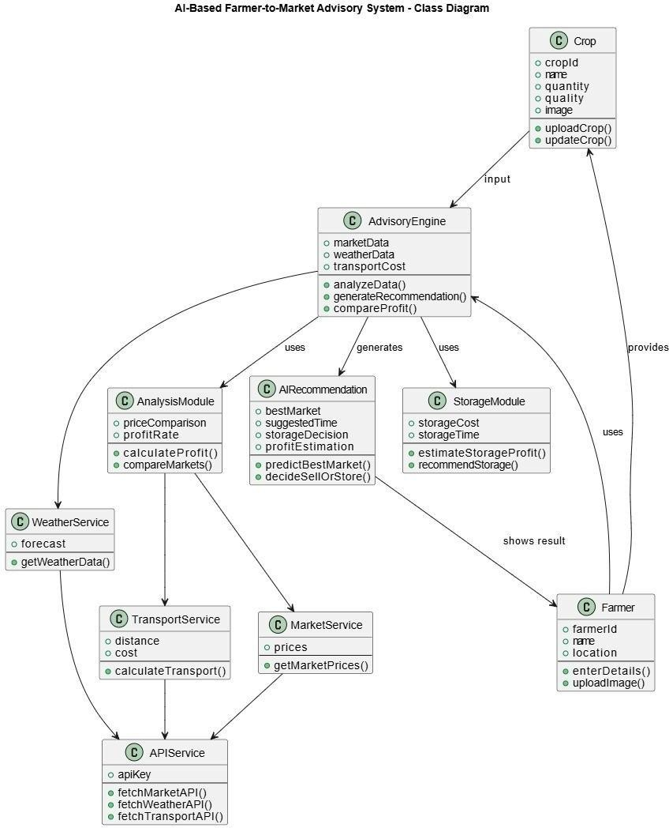
- AIRecommendation is displayed to the Farmer as the final output.

Fig 4.2.1. Class Diagram

4.2.2 Interaction Diagrams
4.2.2.1 Sequence Diagram
Objective:
Show how different system components interact in a sequence to generate intelligent farmer-to-market recommendations.
Actors: Farmer, Streamlit UI, Price API, Maps API, AI Models, Decision Engine
Sequence:
- Farmer enters crop details such as crop name, quantity, and location into the system through the user interface.
- Farmer uploads the crop image, which is sent to the Streamlit UI for processing.
- The Streamlit UI forwards the image to AI Models to analyze and identify the crop type and quality.
- The AI Models process the image and return the crop identification and quality details to the system.
- The Streamlit UI sends a request to the Price API to fetch real-time market prices for the identified crop.
- The Price API returns price data from different markets (mandis).
- The Streamlit UI sends a request to the Maps API to find nearby markets and calculate distance and routes.
- The Maps API returns distance and transportation details required for cost estimation.
- The Decision Engine collects all data (crop details, price data, weather, and transport cost) and performs profit analysis.
- The Decision Engine uses AI Models to determine the best strategy, including the best market and whether to sell or store the crop.
- The final recommendation is generated, including profit estimation and selling strategy.
- The Streamlit UI displays the result to the farmer in a simple and understandable format.
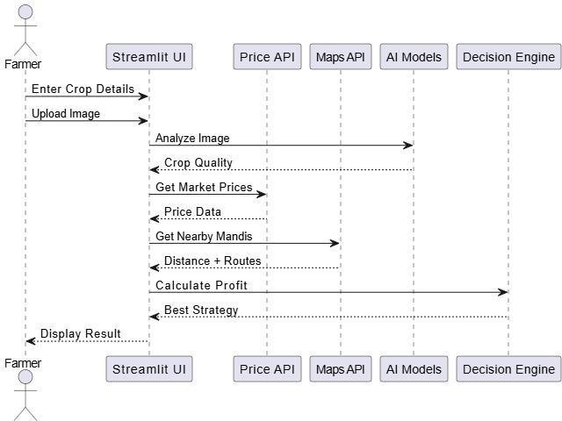
Fig.4.2.2.1 Sequence Diagram
4.2.2.2 Collaboration Diagram
Objective:
To illustrate how different system components collaborate to provide intelligent farmer- to-market advisory recommendations, including pricing, transportation, storage, and profit analysis.
Description:
- Actors: Farmer , Farmer Interface (Dashboard/UI), Crop Module, Advisory Engine, Market Service, Transport Service, Storage Module, Analytics Module, AI Model (Crop Analysis)
- Interactions:
- The Farmer enters crop details such as location, quantity, and uploads crop images through the Farmer Interface.
- Farmer Interface forwards the entered data to the Crop Module for processing.
- The Crop Module validates, organizes, and stores the crop information.
- The AI Model analyzes the uploaded crop image and provides details such as crop type and quality.
- The Advisory Engine retrieves processed crop data and integrates information from multiple services.
- The Market Service provides real-time market prices for the given crop.
- The Transport Service calculates distance, routes, and transportation costs.
- The Storage Module estimates potential profit from storing the crop instead of immediate selling.
- The Analytics Module compares all factors (market price, transport cost, storage profit) and generates insights.
- The Advisory Engine generates the final recommendation, suggesting whether to sell or store, along with the best market and route.
- The Farmer Interface displays the final advisory results, including profit analysis and recommendations, to the Farmer.
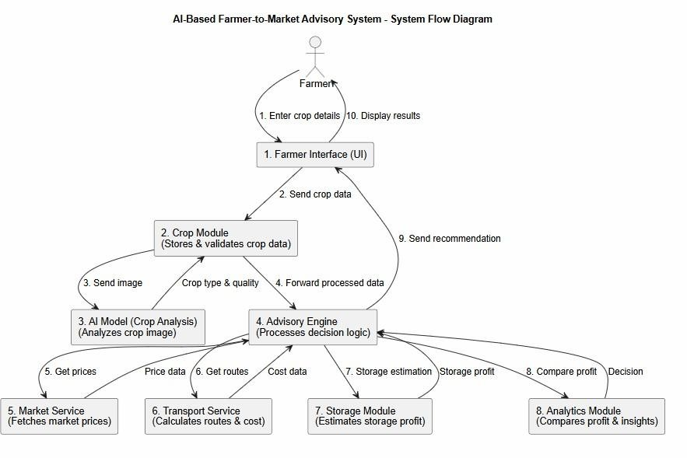
Fig. 4.2.2.2 Collaboration Diagram
4.2.3 Object Diagram
Objective:
Represent an object in the AI-Based Farmer-to-Market Advisory System at a particular moment and illustrate how instances of system components interact to generate market recommendations and profit analysis.
Objects: Farmer, Crop, AdvisoryEngine, AIModel, MarketService, TransportService, StorageModule, AnalyticsModule, FarmerInterface
Interactions:
- The Farmer object creates a Crop instance by entering details such as crop type, quantity, location, and uploading an image through the Farmer Interface.
- The Crop object stores crop-related information including type, quantity, and quality after validation.
- The AIModel object analyzes the crop image and updates the Crop object with
quality and classification details.
- The AdvisoryEngine object retrieves Crop instance data and evaluates parameters such as market price, transport cost, and storage profit.
- The MarketService object provides real-time pricing information for the crop.
- The TransportService object calculates distance, routes, and transportation cost for delivering the crop to markets.
- The StorageModule object estimates the profit that can be gained by storing the crop instead of immediate selling.
- The AnalyticsModule object analyzes all collected data and generates insights to support decision-making.
- The AdvisoryEngine object combines all inputs and produces a final recommendation (sell or store, best market, expected profit).
- The FarmerInterface object displays the generated recommendation, including price details, transport cost, and profit analysis, to the Farmer.
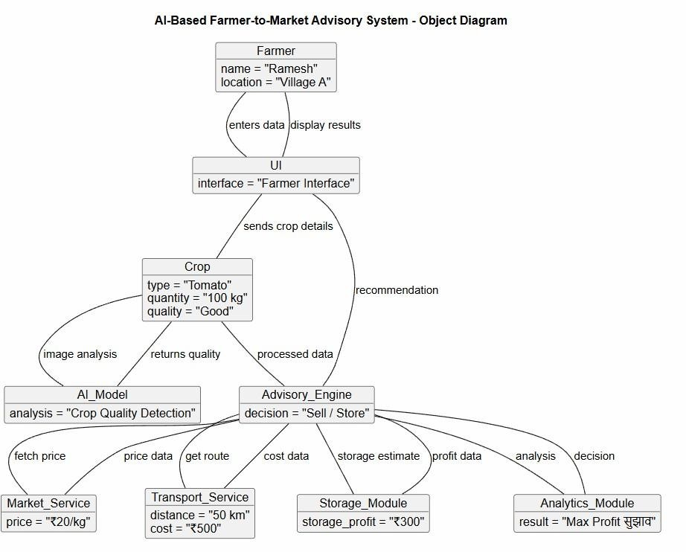
Fig. 4.2.3 Object Diagram
4.2.4 Use Case Diagram
This use case diagram illustrates the functional interactions between the user (Farmer) and the AI-Based Farmer to Market Advisory System, highlighting the key system functionalities.
- Actor: Farmer
- Use Cases:
- Enter Crop Details
The farmer provides essential crop information such as crop type, quantity, quality, and expected harvest time.
- Upload Crop Image
The farmer uploads an image of the crop to enable AI-based analysis for quality assessment and disease detection.
- Capture Camera Image
The farmer can directly capture a real-time image of the crop using the device camera for instant analysis.
- Get Live Location
The system fetches the farmer’s current location to provide nearby market (mandi) suggestions and services.
- Analyze Crop Data
The system processes crop details and images using AI to evaluate crop quality, detect issues, and suggest improvements.
- View Best Mandi
The system recommends the most suitable mandi based on price trends, demand, and proximity.
- Check Transport Cost
The farmer can view estimated transportation costs to different mandis for better decision-making.
- View Cold Storage
The system suggests nearby cold storage facilities to help prevent spoilage and extend crop shelf life.
- View Profit Forecast
The system predicts potential profit by considering market prices, transport costs, and storage options.
- Navigate to Mandi
The farmer receives navigation support to reach the selected mandi using optimal routes.
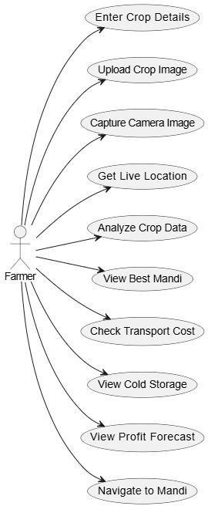
Fig. 4.2.4 Use Case Diagram
4.2.5 Activity Diagram
Represent the workflow of the AI-Based Farmer-to-Market Advisory System by illustrating the sequence of activities involved in generating optimized market recommendations from farmer input to final decision output.
Activities: Farmer Input, Crop Data Processing, Image Analysis, Market Data Fetching Transport Cost Calculation, Profit Analysis, AI Recommendation, Result Display
Flow:
- The farmer starts the application and enters crop details such as crop name, quantity, and uploads the crop image along with location information.
- The system (Farmer Interface) collects and forwards the input data to the Crop Module for validation and preprocessing.
- The Crop Module processes the data and sends the crop image to the AI Model for analysis to identify crop type and quality.
- The system checks for location availability:
- If GPS is available, it retrieves real-time coordinates.
- Otherwise, it uses manually entered location details.
- The Advisory Engine fetches real-time market prices from external APIs based on the farmer’s location.
- The system calculates transportation cost using distance and route information obtained from Maps API services.
- The AI Model evaluates crop freshness and quality to estimate market value and selling potential.
- The Analytics Module compares mandi prices, transport cost, and storage cost to calculate profit scenarios.
- The system performs decision analysis:
- If storing yields higher profit → Recommend Cold Storage
- Otherwise → Recommend Best Market (Mandi)
- The system generates a profit forecast including expected earnings and cost breakdown.
- The system provides navigation routes to the selected market for efficient transportation.
- Finally, the Farmer Interface displays the complete recommendation including best market, storage decision, profit estimation, and route details.
- The farmer can act on the recommendation, and future inputs can improve system accuracy through continuous learning.
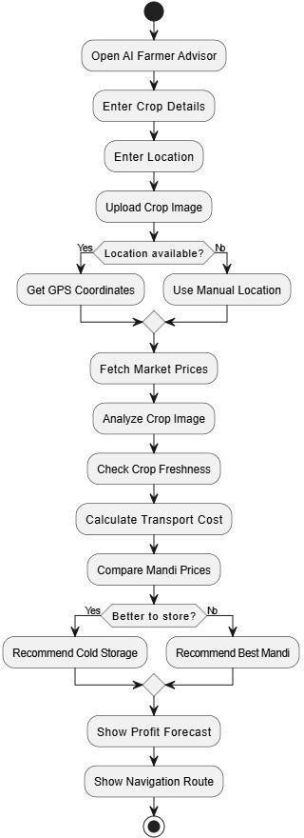
Fig. 4.2.5 Activity Diagram
4.2.6 Control Flow Diagram
Represent the flow of control within the AI-Based Farmer-to-Market Advisory System from farmer input to recommendation generation and result visualization.
Description:
- Components: Farmer, Farmer Interface (Dashboard UI), Crop Module, Advisory Engine, AI Model, Market Service, Transport Service, Storage Module, Analytics Module, Dashboard Interface
- Flow:
- The farmer enters crop details such as crop name, quantity, and uploads the crop image along with location information through the Farmer Interface.
- The Crop Module receives and stores the entered crop data, validating and preparing it for further processing.
- The system sends the uploaded crop image to the AI Model , which analyzes the image to identify crop type and quality.
- The Advisory Engine retrieves the processed crop data and evaluates parameters such as crop quality, location, and quantity.
- The Advisory Engine fetches real-time market prices using the Market Service (Price API) based on the farmer’s location.
- The Transport Service (Maps API) calculates distance, route, and transportation cost for delivering the crop to different markets.
- The Storage Module estimates potential profit if the crop is stored for a certain duration instead of immediate selling.
- The Analytics Module compares different profit scenarios, including selling in various markets and storing the crop, to determine the optimal decision.
- The Advisory Engine generates the final recommendation, which includes:
- Best market (mandi) to sell
- Whether to sell immediately or store
- Expected profit estimation
- The Dashboard Interface displays the generated recommendation, profit forecast, and navigation route details to the farmer.
- The farmer follows the recommendation, and future inputs and outcomes can be used to improve system accuracy and decision-making.
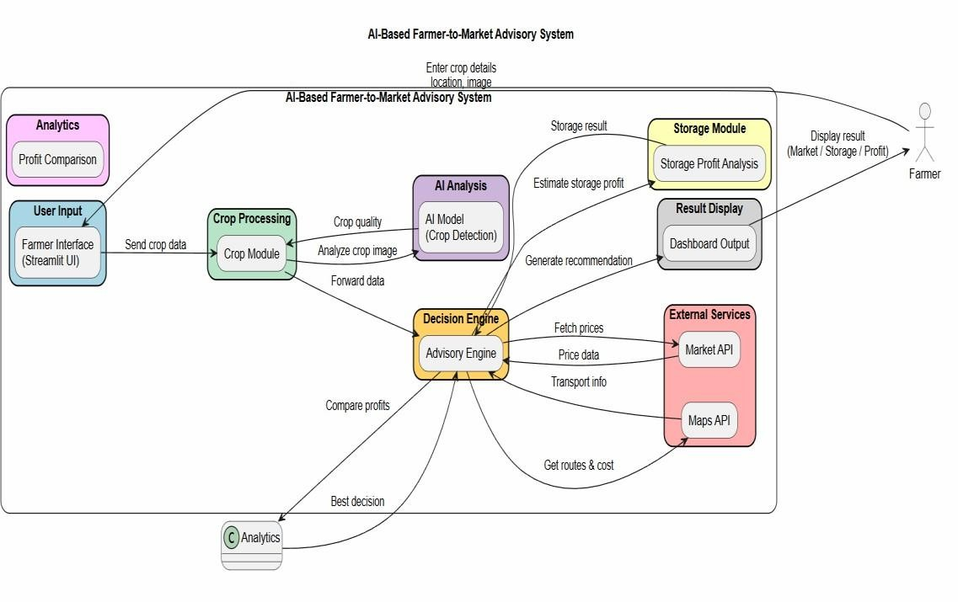
Fig. 4.2.6 Control Flow Diagram

4.3 DATABASE DESIGN
The database design of the AI-Powered Farmer-to-Market Advisory System uses a relational approach to efficiently store and manage data related to farmers, crops, market information, and recommendations. The Farmer table stores basic details, while the Crop table maintains crop information with a one-to-many relationship. The Market Data and Weather Data tables store real-time price and weather information, and the Transport Data table manages distance and cost details. The Storage Module Table records storage-related data for profit analysis, and the Recommendation Table stores final outputs such as best market, selling decision, and profit estimation. Overall, the database ensures efficient data handling and supports accurate decision-making.
4.4 ALGORITHM / DESIGN METHODOLOGY
The proposed system follows an intelligent decision-making algorithm that dynamically generates market and selling recommendations based on real-time prices, transportation cost, weather conditions, and crop quality.
Scheduling Methodology
- The farmer uploads crop image, enters crop details, and provides location.
- The Input Processing Module validates and stores the input data.
- The Computer Vision Module identifies the crop type and analyzes quality.
- Real-time data such as market prices, weather conditions, and transport cost is collected using APIs.
- The system calculates transportation cost and distance to different mandis.
- Market prices are compared across multiple markets to identify profitable options.
- Profit estimation is performed for each market based on price and cost factors.
- The Storage Decision Module evaluates whether to sell immediately or store the crop.
- The Recommendation Engine selects the best market and optimal selling strategy.
- The final recommendation, including profit estimation and navigation details, is displayed to the farmer.

CHAPTER 5
IMPLEMENTATION

5.1 TECHNOLOGIES USED
The proposed AI-Powered Farmer-to-Market Advisory System is developed using modern technologies and AI-based tools to ensure scalability, accuracy, and efficient decision-making. The technologies used in the implementation of the system are described below:
Python
Python is used as the primary programming language for developing the system. It provides strong support for data analysis, machine learning, and image processing, making it suitable for building intelligent applications.
Streamlit
Streamlit is used to develop the frontend interface of the application. It enables quick creation of interactive and user-friendly web applications for farmers to upload inputs and view results.
OpenCV (Computer Vision Library)
OpenCV is used for image processing and crop identification. It analyzes crop images based on features like color, shape, and texture to detect crop type and quality.
NumPy
NumPy is used for numerical computations and handling large datasets efficiently. It supports mathematical operations required for analysis.
Pandas
Pandas is used for data processing and analysis. It helps in organizing, cleaning, and managing structured data such as market prices and weather data.
Matplotlib
Matplotlib is used for data visualization. It helps in presenting profit analysis and comparisons through graphs and charts.
Weather API
Weather API is used to fetch real-time weather data such as temperature, humidity, and rainfall, which helps in decision-making.

Market Price API (Agmarknet or similar)
This API provides real-time mandi price data, allowing the system to compare prices across multiple markets.
Google Maps API
Google Maps API is used for location-based services such as distance calculation, route optimization, and transportation cost estimation.
Local Storage / Database
Used to store farmer inputs, crop details, and recommendation history for future reference and analysis.
Visual Studio Code
Visual Studio Code is used as the development environment for writing, testing, and debugging the project code.
5.2 MODULES DESCRIPTION
The AI-Powered Farmer-to-Market Advisory System is designed using a modular architecture, where each module performs a specific task and collectively contributes to intelligent decision-making. The detailed description of each module is as follows:
5.2.1 User Input Module
This module acts as the entry point of the system where farmers provide essential inputs required for analysis. It allows users to enter details such as crop name, quantity, and location, and also upload crop images through a simple interface. The module ensures that all inputs are collected in a structured format and performs basic validation to avoid errors. It is designed to be user-friendly so that even farmers with limited technical knowledge can easily interact with the system.
5.2.2 Crop Identification Module
This module uses computer vision techniques to analyze the uploaded crop images. It extracts visual features such as color, shape, and texture to accurately identify the crop type. In addition to identification, the module can also assess the quality and freshness of the crop. This automated process reduces human effort and ensures reliable input for further analysis.
5.2.3 Data Collection Module
The data collection module is responsible for gathering real-time information from external sources using APIs. It collects market price data from multiple mandis, weather information such as temperature and rainfall, and transportation-related data like distance and travel time. This module ensures that all required data is up-to-date, accurate, and relevant for decision-making.
5.2.4 Transportation Analysis Module
This module calculates the distance and route between the farmer’s location and various markets using geolocation services such as Google Maps API. It estimates transportation costs based on distance, fuel charges, and travel time. The module helps farmers understand logistics expenses and choose cost-effective routes, which directly impacts profit calculation.
5.2.5 Market Analysis Module
The market analysis module evaluates and compares crop prices across different mandis. It considers factors such as demand, price trends, and location advantages to identify the most profitable market. By analyzing multiple markets simultaneously, the module ensures that farmers are guided towards the best selling option.
5.2.6 Storage Decision Module
This module focuses on determining whether it is beneficial to store the crop or sell it immediately. It analyzes factors such as current price, predicted future price trends, storage costs, and crop perishability. If storing the crop is likely to yield higher profit, the system recommends storage; otherwise, it suggests immediate selling.
5.2.7 Recommendation Engine
The recommendation engine is the core component of the system. It integrates outputs from all other modules and performs intelligent analysis using AI techniques. It calculates expected profit, ranks available markets, and determines the optimal selling strategy. This module ensures that all decisions are data-driven and optimized for maximum benefit.
5.2.8 Output Module
The output module presents the final recommendations to the farmer in a clear and understandable format. It displays information such as the best market, expected profit, storage advice, and transportation details. The module may also include visual representations like charts or graphs and provide navigation support. The goal is to make complex analysis easy to understand and actionable for farmers.

5.3 CODING
5.3.1 Project Folder Structure
The project follows a modular and organized folder structure to separate different functionalities such as UI, APIs, AI models, and utility functions. This improves maintainability and ease of development.
Main Directory Structure:

AI_Farmer_Advisor/

├── app.py

├── utils/

├── models/
├── data/
├── assets/
└── requirements.txt
Explanation:
app.py → Main application file (frontend + control flow)
utils/ → Contains API integrations and helper functions
models/ → AI and ML models
data/ → Dataset storage
assets/ → Images and static resources
requirements.txt → Dependencies
5.3.2 Backend
The backend consists of multiple modules responsible for data processing, API communication, AI analysis, and decision-making.
Key Backend Components:
price_api.py
Fetches real-time crop prices from external sources such as Agmarknet. It helps in comparing prices across different mandis to identify the bestselling option.
weather_api.py
Provides current weather conditions based on the selected location. This information supports decision-making, especially for storage and transportation planning.
maps_api.py
Manages location-based services such as route generation and distance calculation. It also identifies nearby mandis and cold storage facilities for better planning.
decision.py
Acts as the core decision-making module of the system. It calculates profit, analyzes storage benefits, and suggests whether to sell or store crops.
transport_ai.py
Estimates transportation cost based on distance, crop type, and quantity. It uses AI- based logic to improve cost prediction accuracy.
db.py
Stores farmer input data such as crop details and location information. This data can be used for future analysis and system improvements.
translator.py & localization.py
Provide multilingual support for the application interface. They help translate content into different languages for better accessibility.
voice_out.py
Converts text-based output into speech for farmers. This improves usability, especially for users with limited reading ability.
location.py
Fetches the user’s live location using GPS or IP-based tracking. It enables accurate and personalized recommendations based on location.
5.3.3 Frontend
The frontend is implemented using Streamlit, providing an interactive and user-friendly interface.
Main File: app.py
The app.py file is the central component of the frontend, responsible for designing the user interface and controlling application flow. It connects user inputs with backend modules and dynamically displays results.
Frontend Responsibilities
1. Accepting Farmer Inputs
The system collects essential details such as crop name, quantity, cost, and location through input fields. This data is used for analysis and generating personalized recommendations.
2. Image Upload or Camera Capture

Users can upload crop images or capture them using a camera. These images are processed by AI models for crop verification and quality assessment.
3. Language Selection
The interface allows users to select their preferred language. This ensures better accessibility and understanding for farmers from different regions.
4. Navigation Between Pages
The frontend provides smooth navigation between different sections like input forms, analysis, and results. This improves user experience and makes the application easy to use.
5. Displaying Results and Analytics
The system presents outputs such as profit comparison, best market selection, and storage suggestions. Results are displayed in a clear and understandable format.
UI Features
1. Simple Form-Based Input System
The interface uses structured forms for entering data, making it easy for users with minimal technical knowledge to interact with the system.
2. Live GPS Location Detection
The system automatically detects the user’s location using GPS or browser-based tracking. This helps in providing accurate and location-specific recommendations.
3. Multi-Language Interface
The application supports multiple languages through translation features. This enhances usability for farmers who prefer regional languages.
4. Interactive Dashboards and Visualization
Results are shown using graphs and dashboard elements for better visualization. This helps users quickly understand insights like price comparison and profit analysis.
Main files: app.py
Code:
import streamlit as st
from utils import *
from models import *

st.set_page_config(page_title="AI Farmer Advisor", layout="wide")

# ===== SESSION =====
ss = st.session_state
ss.setdefault("page", "home")
ss.setdefault("lang", "en")

# ===== SIDEBAR =====
ss.lang = st.sidebar.selectbox("Language", ["en","hi","te","ta","kn","mr"])

# ===== HOME =====
if ss.page == "home":
st.title("🌾 AI Farmer Advisor")

crop = st.text_input("Crop Name")
location = st.text_input("Location")
qty = st.number_input("Quantity", min_value=1)
cost = st.number_input("Cost", min_value=0)
days = st.number_input("Storage Days", min_value=0)
img = st.file_uploader("Upload Image")

if st.button("Analyze"):
ss.update({"crop": crop, "location": location, "qty": qty,
"cost": cost, "days": days, "img": img})
ss.page = "analysis"

# ===== ANALYSIS =====
elif ss.page == "analysis":
st.button("⬅ Back", on_click=lambda: ss.update(page="home"))

crop, loc = ss.crop, ss.location
qty, cost, days = ss.qty, ss.cost, ss.days

# Image Analysis
if ss.img:
freshness = check_freshness(ss.img, days)
quality = analyze_image(ss.img)

# Data Fetch
price_data = get_market_prices(crop)
weather = get_weather_condition(loc)

# Transport + Profit
rate = estimate_transport_rate(crop, qty)["rate_per_km"]
mandis = get_mandi_routes(loc)
best = best_mandi_profit(mandis, price_data, qty, cost, rate)

# Storage Decision
rec = store_analysis(price_data, qty, cost, mandis, crop, days)
decision = "STORE" if rec[3] > best["profit"] else "SELL"

# Output
st.success(f"Best Strategy: {decision}")
st.write(f"Profit: ₹{int(rec[3] if decision=='STORE' else best['profit'])}")

# AI Farmer Advisor - Navigation & Cold Storage Analysis
# Version: 1.1.0 - Improved Precise GPS Navigation
import streamlit as st
import os
import pandas as pd
from datetime import datetime

# ================== IMPORTS ==================
from utils.price_api import get_price
from utils.weather_api import get_weather_condition
from utils.maps_api import get_all_mandi_routes, get_nearby_cold_storage, get_mandi_routes_by_coords, get_nearby_cold_storage_by_coords, reverse_geocode
from utils.decision import best_mandi_profit, store_analysis, compare_profits
from utils.db import save_farmer

from utils.voice_out import speak_full, detect_lang
from utils.translator import translate
from models.freshness_model import check_freshness
from models.cv_model import analyze_image, verify_crop_image
from utils.transport_ai import estimate_transport_rate
from utils.localization import get_text
from utils.location import get_live_location
from streamlit_js_eval import get_geolocation

# ================== CONFIG ==================
st.set_page_config(
page_title="AI Farmer Advisor",
layout="wide",
page_icon="🌾"
)

# ================== SESSION STATE INIT ==================
if "lang" not in st.session_state:
st.session_state.lang = "en"

# Navigation State
if "page" not in st.session_state:
st.session_state.page = "home"

# Analysis Data Persistence
if "final_crop" not in st.session_state: st.session_state.final_crop = ""
if "final_location" not in st.session_state: st.session_state.final_location = ""
if "final_quantity" not in st.session_state: st.session_state.final_quantity = 1
if "final_cost" not in st.session_state: st.session_state.final_cost = 0
if "final_days" not in st.session_state: st.session_state.final_days = 0
if "analyzed_image" not in st.session_state: st.session_state.analyzed_image = None
# Auto-detect location tracking
if "auto_city" not in st.session_state: st.session_state.auto_city = None
if "coords" not in st.session_state: st.session_state.coords = None
if "geo_ts" not in st.session_state: st.session_state.geo_ts = 0

# Initial Location Check
if "location_init_done" not in st.session_state:
# Try to fetch live location once on startup
live_loc = get_live_location()
if live_loc:
st.session_state.final_location = live_loc["city"]
st.session_state.auto_city = live_loc["city"] # Track auto-detected name
st.session_state.coords = {"lat": live_loc["lat"], "lon": live_loc["lon"]}

# State matching logic
detected_region = live_loc["region"]
supported_states = ["Andhra Pradesh", "Telangana", "Maharashtra", "Karnataka", "Tamil Nadu"]
found_state = None

for s in supported_states:
if s.lower() in detected_region.lower() or detected_region.lower() in s.lower():
found_state = s
break

if not found_state:
if "Andhra" in detected_region: found_state = "Andhra Pradesh"
elif "Telangana" in detected_region: found_state = "Telangana"

if found_state:
st.session_state.state_idx = supported_states.index(found_state)
# Update Widget State Directly
st.session_state.w_state = found_state
st.session_state.w_location = live_loc["city"]
else:
st.session_state.auto_city = None

st.session_state.location_init_done = True

# ================== SIDEBAR ==================
with st.sidebar:
st.header(get_text("settings", st.session_state.lang))

def change_lang():
st.session_state.lang = st.session_state.lang_select

st.selectbox(
get_text("lang_select", st.session_state.lang),
["en", "hi", "te", "ta", "kn", "mr"],
key="lang_select",
on_change=change_lang
)

# ================== TITLE ==================
st.markdown(
f"<h1 style='text-align:center;'>{get_text('title', st.session_state.lang)}</h1>",
unsafe_allow_html=True
)

# ================== HOME PAGE (INPUT) ==================
if st.session_state.page == "home":
col1, col2 = st.columns(2)

with col1:
st.subheader(get_text("farmer_details", st.session_state.lang))

supported_states = ["Andhra Pradesh", "Telangana", "Maharashtra", "Karnataka", "Tamil Nadu"]
s_idx = st.session_state.get("state_idx", 0)

# Text Input for Crop (Use w_ prefix for widgets to distinguish from persistent Final vars)
st.text_input(get_text("crop_name", st.session_state.lang), key="w_crop", value=st.session_state.final_crop)

# Location Row with Live Button
loc_c1, loc_c2 = st.columns([0.7, 0.3])

# Execute Button Logic FIRST (Right Column)
with loc_c2:
st.write("") # Spacer
st.write("")

# Browser-based Geolocation Button
loc_data = get_geolocation(component_key="get_loc")

if loc_data and "coords" in loc_data:
lat = loc_data["coords"]["latitude"]
lon = loc_data["coords"]["longitude"]
timestamp = loc_data.get("timestamp", 0)

# Check if this is a new update to avoid loop
if timestamp > st.session_state.get("geo_ts", 0):
st.session_state.geo_ts = timestamp
st.session_state.coords = {"lat": lat, "lon": lon}

# Reverse Geocode to get City/State
with st.spinner("📍 Found coordinates! Getting address..."):
rev = reverse_geocode(lat, lon)

if rev:
# Update Widget State Indirectly?
# Streamlit widgets obey 'value' only on init. To update programmatically, we set session_state['w_location']
st.session_state.w_location = rev["city"]
st.session_state.auto_city = rev["city"]

# Map State
detected_state = rev["state"]
found_state = None
for s in supported_states:
if s.lower() in detected_state.lower() or detected_state.lower() in s.lower():
found_state = s
break

if not found_state:
if "Andhra" in detected_state: found_state = "Andhra Pradesh"
elif "Telangana" in detected_state: found_state = "Telangana"

if found_state:
st.session_state.state_idx = supported_states.index(found_state)
st.session_state.w_state = found_state

st.success(f"📍 {rev['city']}, {rev['state']}")
st.rerun()
else:
st.warning("📍 Coords found, but address lookup failed.")

# Render Input Field SECOND (Left Column)
with loc_c1:
# Default value comes from persistent state if available
st.text_input(get_text("location", st.session_state.lang) + " *", key="w_location", value=st.session_state.final_location)

state = st.selectbox(
get_text("state", st.session_state.lang) + " *",
supported_states,
index=s_idx,
key="w_state"
)

st.number_input(get_text("quantity", st.session_state.lang), min_value=1, key="w_quantity", step=1, value=st.session_state.final_quantity)
st.number_input(get_text("cost", st.session_state.lang), min_value=0, key="w_cost", step=1, value=st.session_state.final_cost)
st.number_input(get_text("days", st.session_state.lang), min_value=0, key="w_days", step=1, value=st.session_state.final_days)

with col2:
st.subheader(get_text("crop_image", st.session_state.lang))

img_option = st.radio("Input Method", ["Camera", "Upload"], horizontal=True, label_visibility="collapsed")

if img_option == "Camera":
st.camera_input(get_text("take_photo", st.session_state.lang), key="w_cam_input")
else:
st.file_uploader("Upload Image", type=["jpg", "png", "jpeg"], key="w_file_input")

# ================== ANALYZE BUTTON ==================
def on_analyze_click():
# Validation
if not st.session_state.w_location or not st.session_state.w_state:
st.session_state.input_error = "📍 Village/City and State are required fields!"
return

# Persist inputs
st.session_state.input_error = None
st.session_state.final_crop = st.session_state.w_crop
st.session_state.final_location = st.session_state.w_location
st.session_state.final_quantity = st.session_state.w_quantity
st.session_state.final_cost = st.session_state.w_cost
st.session_state.final_days = st.session_state.w_days
st.session_state.final_state = st.session_state.w_state

# Persist Image
img = None
if st.session_state.get("w_cam_input"):
img = st.session_state.w_cam_input
elif st.session_state.get("w_file_input"):
img = st.session_state.w_file_input

if img:
st.session_state.analyzed_image = img

# Navigate
st.session_state.page = "analysis"

if st.session_state.get("input_error"):
st.error(st.session_state.input_error)

st.button(get_text("analyze", st.session_state.lang), use_container_width=True, on_click=on_analyze_click)

# ================== ANALYSIS PAGE (RESULTS) ==================
elif st.session_state.page == "analysis":

# Back Button
col_back, col_title = st.columns([0.2, 0.8])
with col_back:
def go_home():
st.session_state.page = "home"
# Optional: Clear image?
# st.session_state.analyzed_image = None
st.button("⬅️ Back to Search", on_click=go_home)

# Fetch Persistent Data
crop = st.session_state.final_crop
location = st.session_state.final_location
qty = st.session_state.final_quantity
cost = st.session_state.final_cost
days = st.session_state.final_days
state = st.session_state.get("final_state", "Andhra Pradesh") # Default fallback
image = st.session_state.analyzed_image
lang = st.session_state.lang

# ===== EXACT GPS CAPTURE (Browser-based, takes priority over IP) =====
# Request browser GPS on the analysis page too
analysis_loc = get_geolocation(component_key="analysis_gps")
if analysis_loc and "coords" in analysis_loc:
gps_lat = analysis_loc["coords"]["latitude"]
gps_lon = analysis_loc["coords"]["longitude"]
gps_ts = analysis_loc.get("timestamp", 0)

# Only update if newer than what we have
if gps_ts > st.session_state.get("geo_ts", 0):
st.session_state.geo_ts = gps_ts
st.session_state.coords = {"lat": gps_lat, "lon": gps_lon}

# Also reverse-geocode to update city/state if not manually entered
if location == st.session_state.get("auto_city"):
rev = reverse_geocode(gps_lat, gps_lon)
if rev:
location = rev["city"]
st.session_state.final_location = location
st.session_state.auto_city = location

# Show user which coordinates are being used
if st.session_state.get("coords"):
user_lat = st.session_state.coords["lat"]
user_lon = st.session_state.coords["lon"]
st.caption(f"📍 **Your coordinates:** {user_lat:.6f}, {user_lon:.6f} — [Verify on Map](https://www.google.com/maps?q={user_lat},{user_lon})")

if not crop:
st.error(get_text("error_req", lang))
# Button to go back
else:

# Auto-detect location if not provided
if not location:
with st.spinner(get_text("analyzing", lang) + " (Detecting Location...)"):
loc_data = get_live_location()
if loc_data:
location = loc_data["city"]
st.session_state.final_location = location
st.session_state.auto_city = location
# Only set IP coords if no GPS coords already captured
if not st.session_state.get("coords"):
st.session_state.coords = {"lat": loc_data["lat"], "lon": loc_data["lon"]}

# Update State automatically
detected_region = loc_data["region"]
supported_states = ["Andhra Pradesh", "Telangana", "Maharashtra", "Karnataka", "Tamil Nadu"]
for s in supported_states:
if s.lower() in detected_region.lower() or detected_region.lower() in s.lower():
state = s
st.session_state.state_idx = supported_states.index(s)
break

st.success(f"📍 Auto-detected: {location}, {state}")
else:
st.error("Could not detect location. Please enter manually.")
st.stop()

with st.spinner(get_text("analyzing", lang)):

freshness, quality = "N/A", "N/A"
crop_image_match = None
if image:
freshness = check_freshness(image, days)
quality = analyze_image(image)

# Feature 4: Crop image vs name mismatch detection
# Check seekable
try:
image.seek(0) # Reset stream before verification
crop_image_match = verify_crop_image(image, crop)
image.seek(0) # Reset again for any downstream use
except:
pass # Image might not be seekable depending on type

# Get full price data (Average + Per Market)
from utils.price_api import get_market_prices
price_data = get_market_prices(crop, state)

# Invalid Crop Handling
if isinstance(price_data, dict) and "error" in price_data:
st.error(price_data["error"])
st.stop()

if price_data is None:
st.error(f"⚠️ Could not fetch market price for '{crop}' in '{state}'. Please check the crop name or try a generic name (e.g., 'Tomato' instead of 'Tomato Hybrid').")
st.stop()

# Extract average for display default
avg_price = price_data.get("average", 0)
resolved_crop = price_data.get("crop_name", crop)

# Display resolved crop name if fuzzy matched
if resolved_crop.lower() != crop.lower():
st.info(f"ℹ️ **Note:** Searched for '**{resolved_crop}**' instead of '{crop}'.")
crop = resolved_crop # Update crop name for downstream logic

# Location Logic: STRICT MANUAL PRIORITY
target_lat, target_lon = None, None
route_origin_lat, route_origin_lon = None, None # For Google Maps origin

# Check if manual input differs from auto-detected city
is_manual = location != st.session_state.get("auto_city")

from utils.maps_api import get_lat_lon, get_mandi_routes_by_coords, get_all_mandi_routes, get_nearby_cold_storage_by_coords

# ALWAYS use session coords (GPS/IP) as the true route origin for navigation
if st.session_state.get("coords"):
route_origin_lat = st.session_state.coords["lat"]
route_origin_lon = st.session_state.coords["lon"]

if is_manual:
# Force geocode new location — get coords for the entered city
geo_lat, geo_lon = get_lat_lon(f"{location}, {state}, India")
if geo_lat:
target_lat, target_lon = geo_lat, geo_lon
# If no GPS/IP coords, use geocoded coords as route origin too
if not route_origin_lat:
route_origin_lat, route_origin_lon = geo_lat, geo_lon
else:
target_lat = None # Geocoding failed
else:
# Use stored coords if available (GPS/IP based)
if st.session_state.get("coords"):
target_lat = st.session_state.coords["lat"]
target_lon = st.session_state.coords["lon"]

# Mandi/Coord Logic
mandis = []
best = None
has_location_coords = False

if target_lat:
has_location_coords = True
mandis = get_mandi_routes_by_coords(target_lat, target_lon, state)
else:
# Geocoding failed or no coords.
if is_manual:
st.warning(f"⚠️ Could not pinpoint exact location for '**{location}**'. Distance calculations and Map links will be disabled.")

# Fallback: Just proceed with NO mandis found for distance logic, but we still have Prices.

if has_location_coords and not mandis:
st.warning(f"No mandis found within {state} for the given location.")

# Feature 3: AI-based Transport Cost Estimation (Run early for profit calc)
# Default rate if AI fails or not run
ai_rate_val = 3.0
ai_transport = {"rate_per_km": 3.0, "reasoning": "Default rate (AI pending)"}

if crop and qty > 0:
ai_transport = estimate_transport_rate(crop, qty)
ai_rate_val = float(ai_transport["rate_per_km"])

if mandis:
# Pass AI-estimated rate to profit calculation
best = best_mandi_profit(mandis, price_data, qty, cost, transport_rate=ai_rate_val)
weather = get_weather_condition(best["mandi"]) if best else "Unknown"
else:
best = None
weather = "Unknown"

# Get storage rate from session state or default
storage_rate_pct = st.session_state.get("w_storage_rate", 1.0)
storage_rate_val = storage_rate_pct / 100.0

# Check Cold Storage option
# Pass AI-estimated rate and user storage rate to storage analysis
rec_days, rec_date, future_price, stored_profit, best_stored, profit_roadmap = store_analysis(
price_data, qty, cost, mandis, crop, days, transport_rate=ai_rate_val, storage_rate=storage_rate_val
)

should_store, profit_inc = compare_profits(best["profit"] if best else 0, stored_profit)

decision = "STORE" if should_store else "SELL"

save_farmer(crop, location, qty, cost)

decision_text = f"✅ **Best Strategy:** {'Sell Now' if not should_store else f'Store for {rec_days} days'}"
st.success(decision_text)

# Display explicit comparison
sell_profit = int(best['profit']) if best else 0
if should_store:
st.info(f"💡 **Why?** Storing until **{rec_date}** increases profit from **₹{sell_profit}** to **₹{int(stored_profit)}** (+{profit_inc}%).")
else:
st.info(f"💡 **Why?** Selling now is the best option with a profit of **₹{sell_profit}**.")

# No longer showing image quality or mismatch warnings as requested
pass

# ================== NEW STRATEGY SECTION ==================
# Only show if valid location coords were found
if has_location_coords:
st.divider()
st.header(f"🚀 Market Strategy (1000km Radius)")

# Feature 3: AI-based Transport Cost Estimation (Already calculated above)
# ai_transport = estimate_transport_rate(crop, qty) -> Moved up
ai_rate = ai_transport["rate_per_km"]

strat_col1, strat_col2 = st.columns(2)
with strat_col1:
# AI-estimated transport cost with manual override option
trans_cost_per_km = st.number_input(
f"🚚 Transport Cost (₹/km for {qty}kg)",
min_value=0.0, value=float(ai_rate), step=0.5, format="%.2f",
help="AI-estimated rate. You can adjust manually."
)

with strat_col2:
# Storage Cost Rate
st.number_input(
"❄️ Storage Rate (% per day)",
min_value=0.0, max_value=10.0, value=1.0, step=0.1, key="w_storage_rate",
help="Daily cost to store crop in cold storage (as % of current value)."
)
st.caption(f"🤖 **Transport AI Estimate:** ₹{ai_rate}/km")
st.caption(f"{ai_transport['reasoning']}")

# 1. Use the coordinates we resolved earlier (target_lat/lon)
strat_lat, strat_lon = target_lat, target_lon

# 2. Filter Mandis within 100km
nearby_mandis = []
if strat_lat:
nearby_mandis = get_mandi_routes_by_coords(strat_lat, strat_lon, state, radius_km=1000)

# ALWAYS rebuild map links with user's real coords (GPS/IP) as origin
if route_origin_lat:
for m in nearby_mandis:
m["map"] = f"https://www.google.com/maps/dir/?api=1&origin={route_origin_lat},{route_origin_lon}&destination={m['lat']},{m['lon']}&travelmode=driving"

# 3. Calculate Profit for filtered mandis using Custom Transport Cost
strategy_results = []

market_prices = price_data.get("markets", {}) if isinstance(price_data, dict) else {}

# Fallback price
base_price = price_data if isinstance(price_data, (int, float)) else price_data.get("average", 0)

if nearby_mandis:
# Calculate for each nearby mandi
for m in nearby_mandis:
# Determine price (Exact or Average)
m_price = base_price
m_name = m["name"].title()

# Key matching logic
if m_name in market_prices:
m_price = market_prices[m_name]
else:
for k, v in market_prices.items():
if m_name in k or k in m_name:
m_price = v
break

t_cost = m["distance"] * trans_cost_per_km
revenue = m_price * qty
net_profit = revenue - cost - t_cost

strategy_results.append({
"Mandi": m["name"],
"Distance (km)": m["distance"],
"Price (₹/kg)": m_price,
"Transport Cost (₹)": round(t_cost, 1),
"Net Profit (₹)": int(net_profit),
"Map": m["map"]
})

# Sort by Net Profit
strategy_results.sort(key=lambda x: x["Net Profit (₹)"], reverse=True)

# Display Top 5
top_5 = strategy_results[:5]

if top_5:
# 1. Recommend Best
best_strat = top_5[0]
st.success(f"🏆 **Best Option:** **{best_strat['Mandi']}** (Profit: ₹{best_strat['Net Profit (₹)']})")

# Show calculation breakdown for best option
calc_dist = best_strat['Distance (km)']
calc_rate = trans_cost_per_km
calc_t_cost = best_strat['Transport Cost (₹)']
st.caption(f"ℹ️ **Transport Calculation:** {calc_dist} km × ₹{calc_rate}/km = ₹{calc_t_cost}")
st.markdown(f"📍 **[Navigate to {best_strat['Mandi']}]({best_strat['Map']})**")

# 2. Results shown in expander for cleaner UI
with st.expander("📋 View Top 5 Profitable Mandis"):
import pandas as pd
df_display = pd.DataFrame(top_5).drop(columns=["Map"])
st.table(df_display)

else:
st.warning("No profitable mandis found within 1000km.")

else:
st.warning("No mandis found within 1000km radius of your location.")

# Fallback View: show Market Prices if NO location found or just as comprehensive info
if price_data and isinstance(price_data, dict) and "markets" in price_data:
with st.expander("📊 View All Market Prices (Statewide)"):
st.json(price_data["markets"])

# Cold Storage Recommendation - Show Analysis Always if valid days
if rec_days > 0:
st.divider()
st.subheader(f"❄️❄️ {get_text('cold_storage', lang)}")

# Strategy Display
display_future_price = 0
try:
if isinstance(future_price, (int, float)):
display_future_price = future_price
elif isinstance(future_price, dict) or hasattr(future_price, "get"):
display_future_price = future_price.get("average", 0)
else:
display_future_price = float(future_price)
except:
display_future_price = 0

if display_future_price and display_future_price != 0 and should_store:
# Calculate breakdown
if best_stored:
storage_cost_total = int(best_stored['profit'] - stored_profit)
revenue_future = int(best_stored['price'] * qty)
trans_cost_future = int(best_stored['transport'])

st.write(f"### ❄️ Storing Breakdown ({rec_days} Days)")
st.success(f"""
💰 **Net Profit after Storage: ₹{int(stored_profit)}**
- Expected Revenue: ₹{revenue_future}
- Cultivation Cost: -₹{cost}
- Transport Cost: -₹{trans_cost_future}
- **Storage Cost: -₹{storage_cost_total}**
""")
else:
st.success(f"📌 **Strategy:** Store until **{rec_date}** ({rec_days} days) -> to get approx **₹{display_future_price}/kg**. Est Net Profit: **₹{int(stored_profit)}**")
elif not should_store:
st.info("❄️ Cold storage is available, but selling now is more profitable.")
else:
st.warning(f"⚠️ Strategy data incomplete.")

msg = get_text("cs_msg", lang).format(profit_diff=profit_inc)
st.write(msg)

# Cold Storage Search (Coords vs Text) - Fetch Top 5
all_cs = []
if has_location_coords:
# Use the new Viewbox search logic
from utils.maps_api import get_cold_storage_routes_by_coords
all_cs = get_cold_storage_routes_by_coords(target_lat, target_lon, location, state, radius_km=1000)

# ALWAYS rebuild cold storage map links with user's real coords as origin
if route_origin_lat:
for cs_loc in all_cs:
cs_map_parts = cs_loc["map"].split("destination=")
if len(cs_map_parts) > 1:
cs_dest = cs_map_parts[1].split("&")[0]
cs_loc["map"] = f"https://www.google.com/maps/dir/?api=1&origin={route_origin_lat},{route_origin_lon}&destination={cs_dest}&travelmode=driving"
else:
# Fallback to nearest via text search
try:
from utils.maps_api import get_nearby_cold_storage
nearest = get_nearby_cold_storage(location, state)
if nearest: all_cs = [nearest]
except: all_cs = []

if all_cs:
st.write(f"🏭 **{get_text('nearest_cs', lang)}**")

# Prepare display data
cs_display_list = []
for cs in all_cs[:5]:
# Special Case: KSR Cold Storage (Hardcoded for accuracy as requested)
contact = "N/A"
if "KSR" in cs['name'] or "K S R" in cs['name']:
contact = "Kari Srinivasa Rao: +91 8008001199"
elif cs.get('phone'):
contact = cs['phone']
else:
contact = cs.get('full_address', 'N/A')

cs_display_list.append({
"Facility Name": cs['name'],
"Distance (km)": cs['distance'],
"Contact": contact,
"Action": f"[📍 Navigate]({cs['map']})"
})

# Render custom markdown table for clickable links
table_header = "| Facility Name | Distance (km) | Contact | Action |\n| :--- | :--- | :--- | :--- |\n"
table_rows = ""
for cs in cs_display_list:
table_rows += f"| {cs['Facility Name']} | {cs['Distance (km)']} | {cs['Contact']} | {cs['Action']} |\n"

st.markdown(table_header + table_rows)
st.caption("ℹ️ Click '📍 Navigate' to open directions in Google Maps.")
else:
st.warning("No cold storage facilities found within 1000km.")

# Profit Roadmap Visualization
if profit_roadmap:
st.divider()
st.header("📈 Profit Roadmap & Forecast")

df_plot = pd.DataFrame(profit_roadmap)

# 2. Forecast Slider
max_days = int(df_plot['Day'].max())
selected_days = st.slider(
"📅 Forecast Lookahead (Days)",
min_value=0, max_value=max_days, value=rec_days,
help="Slide to see how profit changes over time."
)

# Filter based on slider
df_filtered = df_plot[df_plot['Day'] <= selected_days].copy()

# 3. Visual Chart (Altair for better control)
import altair as alt

# Add current profit as a benchmark baseline
current_profit_val = sell_profit

# Create a baseline dataframe
df_baseline = pd.DataFrame({'Profit': [current_profit_val], 'Label': ['Sell Now']})

# Baseline rule
baseline = alt.Chart(df_baseline).mark_rule(
color='#e74c3c',
strokeDash=[5, 5],
size=2
).encode(
y='Profit:Q'
)

# Baseline text
baseline_text = alt.Chart(df_baseline).mark_text(
align='left',
dx=5,
dy=-10,
color='#e74c3c',
fontWeight='bold'
).encode(
y='Profit:Q',
text=alt.value('Current Profit')
)

# Main chart
# Calculate profit increase % for tooltips
df_filtered['Increase %'] = ((df_filtered['Profit'] - current_profit_val) / abs(current_profit_val) * 100).round(1) if current_profit_val != 0 else 0

line = alt.Chart(df_filtered).mark_line(
point=alt.OverlayMarkDef(color='#2ecc71', size=60),
color='#2ecc71',
size=3
).encode(
x=alt.X('Date:N', sort=None, title='Date'),
y=alt.Y('Profit:Q', title='Net Profit (₹)', scale=alt.Scale(zero=False)),
tooltip=[
alt.Tooltip('Date:N', title='Prediction Date'),
alt.Tooltip('Profit:Q', title='Net Profit (₹)', format=','),
alt.Tooltip('Increase %:Q', title='Gain vs Now (%)'),
alt.Tooltip('StorageCost:Q', title='Total Storage Cost (₹)')
]
).properties(
title='📈 Profit Potential Over Time',
height=350
)

# Combine
final_chart = (baseline + baseline_text + line).configure_axis(
labelFontSize=12,
titleFontSize=14
).configure_title(
fontSize=18,
anchor='middle',
color='#2ecc71'
)

st.altair_chart(final_chart, use_container_width=True)

# 4. Interactive Recommendation Text
if selected_days == rec_days:
st.success(f"🌟 **Recommended Strategy:** Store for **{rec_days} days** until **{rec_date}** for maximum profit of **₹{int(stored_profit)}**.")
else:
target_row = df_filtered[df_filtered['Day'] == selected_days].iloc[0]
st.info(f"💡 Selling on **{target_row['Date']}** yields a net profit of **₹{int(target_row['Profit'])}** (including ₹{int(target_row['StorageCost'])} storage cost).")

# Detailed data remains in expander
with st.expander("📊 View Detailed Analysis Table"):
df_display = df_plot[["Date", "Profit", "StorageCost"]].copy()
df_display.columns = ["Date", "Net Profit (₹)", "Storage Cost (₹)"]
st.dataframe(df_display, use_container_width=True)

# Final Summary for Text-to-Speech
speech_summary = f"Best Strategy: {'Sell Now' if not should_store else f'Store for {rec_days} days'}. " \
f"Estimated profit: ₹{int(stored_profit if should_store else sell_profit)}."

speak_full(speech_summary, st.session_state.lang)

CHAPTER 6
TESTING

6.1 TEST CASES
Test cases were designed and executed to validate the major functionalities of the AI-Powered Farmer-to-Market Advisory System. The purpose of these test cases was to ensure that the system performs accurately for various inputs such as crop details, location, market data, and operational scenarios like price comparison, transportation cost estimation, and storage decision-making.
Table 6.1: Test Cases of AI Powered Farmer-to-Market Advisory system
Test Case ID | Test Scenario | Input | Expected Output | Result
TC01 | Enter Farmer Details | Valid crop, location, quantity | Details should be accepted successfully | Passed
TC02 | Upload Crop Image | Valid crop image | Image should be uploaded and processed | Passed
TC03 | Crop Identification | Crop image | System should identify crop type correctly | Passed
TC04 | Fetch Market Prices | Crop name and location | Real-time mandi prices should be displayed | Passed
TC05 | Transport Cost Calculation | Location and market distance | Transportation cost should be calculated accurately | Passed
TC06 | Market Comparison | Multiple mandi data | Best market with highest profit should be suggested | Passed
TC07 | Storage Decision | Price trends and storage days | System should suggest sell or store | Passed
TC08 | Recommendation Generation | All input data | Final recommendation should be displayed | Passed
TC09 | Location Detection | GPS/location input | System should detect and use user location | Passed
TC10 | Display Results | Completed analysis | Profit, market, and navigation details shown clearly | Passed

6.2 TESTING METHODS

6.2.1 Unit Testing

Unit testing is performed to test individual modules or components of the system independently. Each backend module such as price_api.py, weather_api.py, maps_api.py, decision.py, and AI models is tested separately to ensure correct functionality.

For example:

The price API module is tested to verify accurate retrieval of market prices. The decision module is tested to ensure correct profit calculation.

The image analysis module is tested for proper crop detection.

Unit testing ensures that each component works correctly before integrating with other modules.

6.2.2 Integration Testing

Integration testing is carried out to ensure that different modules of the system work together seamlessly. Since the project integrates APIs, AI models, and decision logic, it is important to test their interaction.

Key integrations tested:
- Frontend (Streamlit) with backend modules AI models with input data
- APIs with decision engine
- Location services with route calculation

This testing ensures smooth data flow and proper coordination between all system components.

6.2.3 System Testing

System testing was conducted to evaluate the overall performance of the AI-Powered Farmer-to-Market Advisory System as an integrated application, ensuring that all modules work seamlessly together. Various test scenarios with different inputs such as crop type, location, quantity, and storage duration were used to verify accuracy, real-time data retrieval, profit calculations, and recommendation generation. Edge cases like invalid inputs and missing data were also tested to ensure robustness, while usability and performance testing confirmed that the system is user-friendly, responsive, and reliable in providing accurate recommendations.

6.3 RESULTS AND ANALYSIS
The testing results indicate that the system performs efficiently and produces accurate recommendations under various conditions. All modules function correctly, and the integration between components is successful.
Key observations:
Accurate market price retrieval and comparison Correct profit calculation and decision-making Proper image analysis and crop verification Smooth user interface interaction
The system successfully meets the project objectives by providing reliable, real-time advisory services to farmers.

CHAPTER 7
RESULTS&DISSCUSSIONS
The AI Farmer Advisory System was tested with real-time inputs and government market data to provide recommendations based on accurate profits. The solution computed crop information, location, financial cost and shelf life to give a comprehensive advisory output.
7.1 OUTPUT SCREENSHOTS
7.1.1 Market Price Retrieval
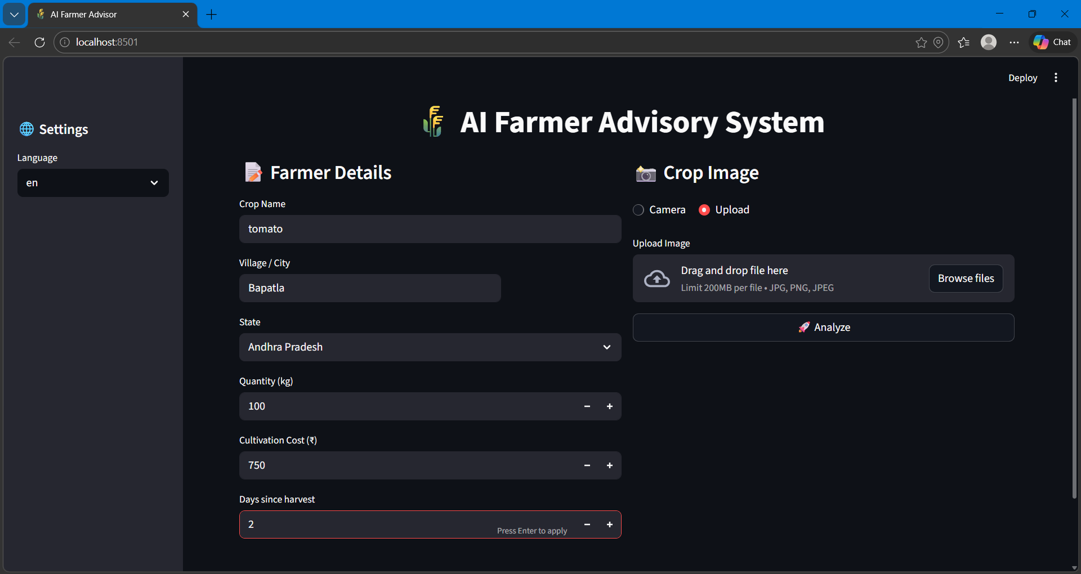
It fetched the real-time commodity prices from the agmarknet database and extracted market-wise modal prices. Hence, by filtering and validating the data temporally filtered based on states we could maintain accurate data for computing profit.
Figure 7.1.1: User Interface of AI Farmer Advisory System
7.1.2 Computation of Profits and Position in the Market
Revenue and net profit for each mandi was computed after adding transport costs. The markets were ranked based on net profit to select bestselling locations.
7.1.3 Cold Storage Analysis
The storage module evaluated the predicted profit from storing the product against with expected profits from immediate sale. The system generated recommendations based on profitability comparison.
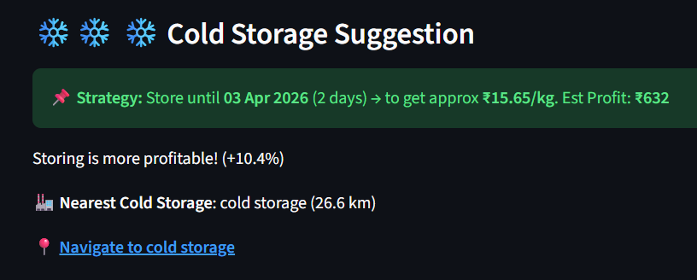

Figure 7.1.2: Cold Storage Profit Analysis Module
7.1.4 Profit Forecast Visualization
A roadmap shows the outlines of the profit growth trends over time, contrasting to selling the product right away. The responsiveness slider allowed the system to simulation of future selling dates.
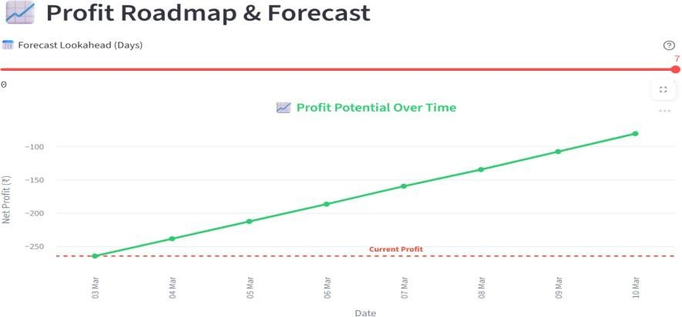
Figure 7.1.3: Profit Roadmap & Forecast

7.1.5 Route and Navigation Integration
The distance from the mandi was computed (geographically) and navigation links were created for every recommendation to make sure that the recommendations provided meet the user location criteria.
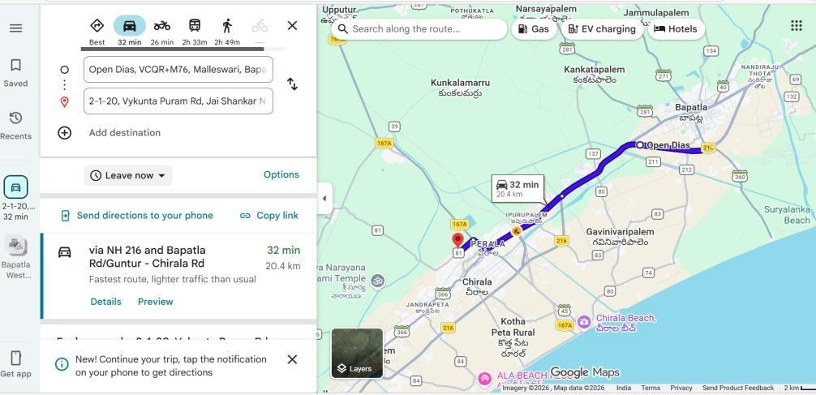
Figure 7.1.4: Market Transportation Cost and Route Visualization
7.1.6 Overall Performance
The findings indicate that the system successfully integrates day-to-day update price data, transport charges, storage planning, profit estimation and navigation tools to deliver provide data-based agricultural advisory advice.
7.2 PERFORMANCE ANALYSIS
The performance analysis of the AI-Powered Farmer-to-Market Advisory System was carried out to evaluate its efficiency, accuracy, and responsiveness under different operating conditions. The system was tested with various inputs such as different crop types, locations, and quantities to measure how quickly and accurately it generates recommendations. The results showed that the system efficiently processes real-time data from APIs, including market prices, weather information, and transportation details, with minimal delay.
The accuracy of the system was validated by comparing predicted profits and recommendations with actual market trends, demonstrating reliable decision-making. The response time of the system was observed to be fast, ensuring that users receive outputs without significant waiting time. Additionally, the system maintained stable performance even when handling multiple data inputs simultaneously.
Performance observations include:
- The system provides fast response time, generating recommendations within a few seconds.
- Real-time APIs (market price, weather, maps) are fetched efficiently with minimal delay.
- The system shows high accuracy in profit estimation based on input data.
- Stable performance is maintained even with multiple inputs and repeated usage.
- The recommendation engine produces consistent and reliable outputs.
- Transportation cost calculation is accurate and dynamically adjusted based on distance.
- The system handles invalid or missing inputs effectively without crashing.
- Image processing (crop identification) works efficiently with acceptable processing time.
- The interface remains smooth and responsive across different devices.
7.3 COMPARISON WITH EXISTING SYSTEM
A comparison was made between traditional agricultural practices and the proposed AI-Powered Farmer-to-Market Advisory System to evaluate its effectiveness. The analysis shows that traditional methods rely on limited data and manual decisions, while the proposed system uses real-time data and AI to provide accurate recommendations, improving decision-making and profitability.
Table 7.1: Comparison of Existing and Proposed Systems
Feature | Existing System | Proposed System
Market Information | Limited and manual | Real-time data using APIs
Decision Making | Based on experience and guesswork | AI-based intelligent decision making
Market Selection | Nearby mandis only | Multiple mandis comparison
Price Accuracy | Often outdated | Up-to-date and accurate prices
Transportation Planning | Not considered properly | Distance and cost optimization using maps
Weather Consideration | Not included | Integrated weather analysis
Storage Decision | Manual and uncertain | Data-driven storage profitability analysis
Dependency on Middlemen | High | Reduced dependency
Crop Quality Analysis | Manual inspection | Automated using computer vision
Accessibility | Low (traditional methods) | High (web/mobile-based system)

CHAPTER 8
CONCLUSION AND FUTURE WORK
8.1 SUMMARY OF THE PROJECT
The AI-Powered Farmer-to-Market Advisory System is developed to help farmers make better decisions regarding where and when to sell their crops. The system integrates technologies such as computer vision, real-time APIs, and data analysis to provide accurate and useful recommendations. Farmers can input crop details, upload images, and provide location information, after which the system analyzes market prices, weather conditions, and transportation costs.
Based on this analysis, the system suggests the most profitable market and the best time to sell or store the crops. It also helps reduce dependency on middlemen and minimizes post-harvest losses by guiding farmers with data-driven insights.
Overall, the project demonstrates how AI can improve agricultural marketing efficiency, increase farmer profits, and support better decision-making in real-world scenarios.
8.2 ACHIEVEMENTS
The major achievements of the proposed AI Powered Farmer-to-Market Advisory system include:
- Successfully developed an AI-based Farmer-to-Market Advisory System.
- Integrated computer vision for crop identification and quality analysis.
- Implemented real-time market price, weather, and transport data integration.
- Achieved accurate profit estimation and market recommendation.
- Developed a storage decision model to suggest sell or store strategies.
- Reduced dependency on middlemen through direct market insights.
- Improved decision-making accuracy for farmers.
- Minimized post-harvest losses and crop spoilage risks.
- Designed a user-friendly interface suitable for farmers.
8.3 LIMITATIONS
Despite the effectiveness of the developed system, certain limitations exist in the current implementation:
- Depends heavily on internet connectivity for real-time data retrieval.
- Accuracy of results relies on API data quality and availability.
- Computer vision model may give incorrect results for unclear or low-quality images.
- Limited to supported crops and regions (not fully generalized).
- Weather and price predictions may have uncertainties.
- Transportation cost estimation may not include all real-world factors (fuel changes, traffic, etc.).
- Requires basic digital literacy for effective usage by farmers.
- System performance may reduce with large-scale data or high user load.
- Does not fully consider market demand fluctuations in real-time auctions.
- Cold storage recommendations may vary due to unpredictable storage conditions.
8.4 FUTURE ENHANCEMENTS
Several enhancements can be incorporated in future versions of the proposed system to improve functionality and scalability:
- Integration of more crops and wider geographic regions for better coverage.
- Use of advanced machine learning models for more accurate price prediction.
- Addition of real-time demand and supply analysis from markets.
- Development of a mobile application for easier access by farmers.
- Support for more regional languages to improve usability.
- Integration with government schemes and subsidies information.
- Implementation of offline mode for areas with low internet connectivity.
- Enhancement of computer vision model for better crop and quality detection.
- Inclusion of live market bidding/auction data for accurate pricing.
- Integration with logistics services for direct transportation booking.

REFERENCES
[1] Government of India, “Agmarknet: Agricultural Marketing Information System,”
Directorate of Marketing and Inspection, Ministry of Agriculture, 2023.
[2] India Meteorological Department, “Weather Forecasting Services for Agriculture,”
Ministry of Earth Sciences, Government of India, 2022.
[3] Alex Krizhevsky, Ilya Sutskever, and Geoffrey Hinton, “ImageNet Classification with Deep Convolutional Neural Networks,” Communications of the ACM, vol. 60, no. 6, pp. 84–90, 2017.
[4] Sharada P. Mohanty, David P. Hughes, and Marcel Salathé, “Using Deep Learning for Image-Based Plant Disease Detection,” Frontiers in Plant Science, vol. 7, pp. 1–10, 2016.
[5] Food and Agriculture Organization, “Crop Price Forecasting Using Historical Market Data,” FAO Agricultural Market Analysis Report, 2021.
[6] Indian Council of Agricultural Research, “Location-Based Agricultural Market Information Systems,” ICAR Research Bulletin, 2020.
[7] World Bank, “Agricultural Transportation and Market Access Analysis,” World Bank Agriculture Report, 2021.
[8] International Journal of Agricultural Informatics, “Smart Farming Systems Using IoT and Data Analytics,” vol. 11, no. 2, pp. 45–53, 2022.

