Instructions

- If the user accepts to share data, the following steps will take place:
- A bank will check the blockchain to fetch the hash of the customer data and use the hash to fetch the actual customer data from a secure storage
- Any bank can raise the KYC request of the customer given that the customer has provided additional information for the same to the bank.
- A bank will update the KYC data if required.
- If the data is not already present with the Smart Contract, then the bank will create a new request to add the KYC of the customer.
- Banks will additionally provide upvotes/downvotes over the user data for KYC.
Banks can also report the other banks for security and authenticity of the banks in the network.

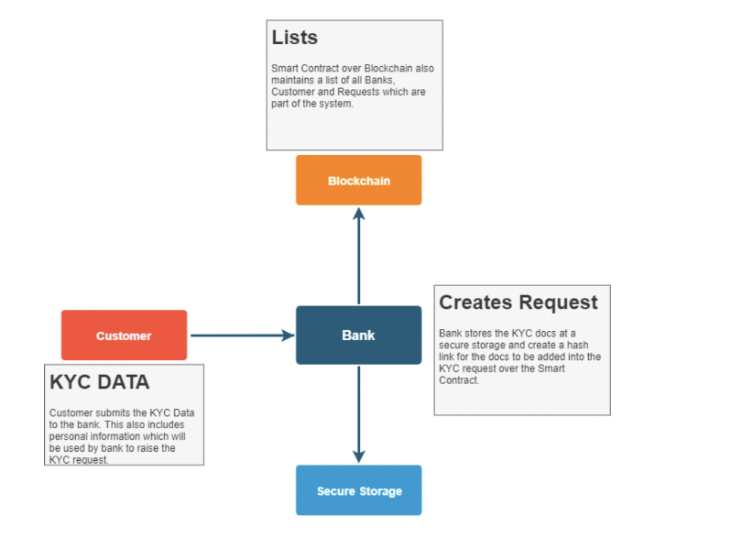
- Open remix.ethereum.org

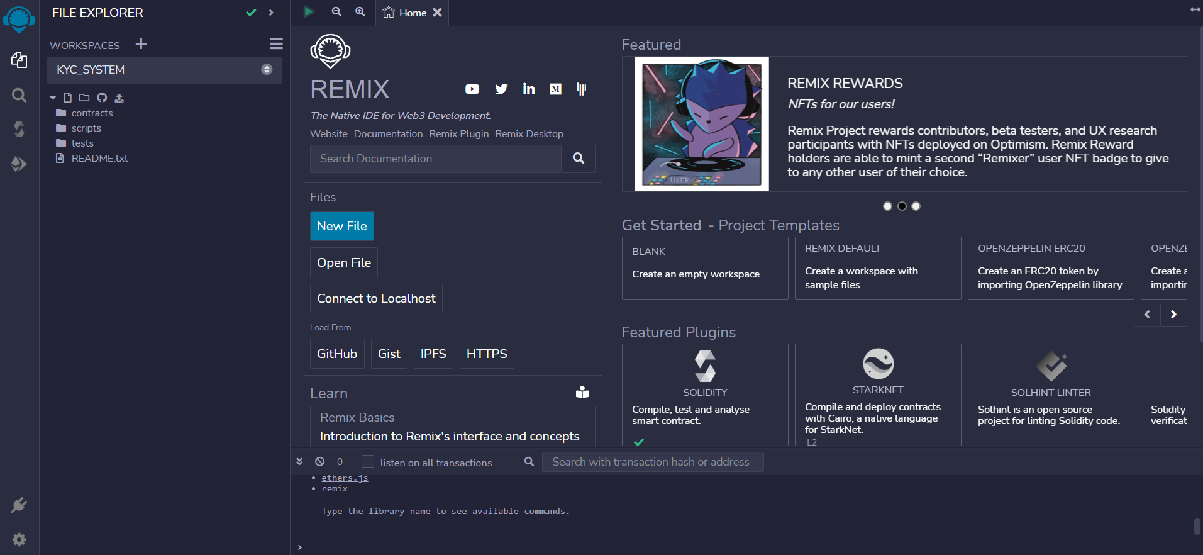

- Write your Kyc Smart Contract

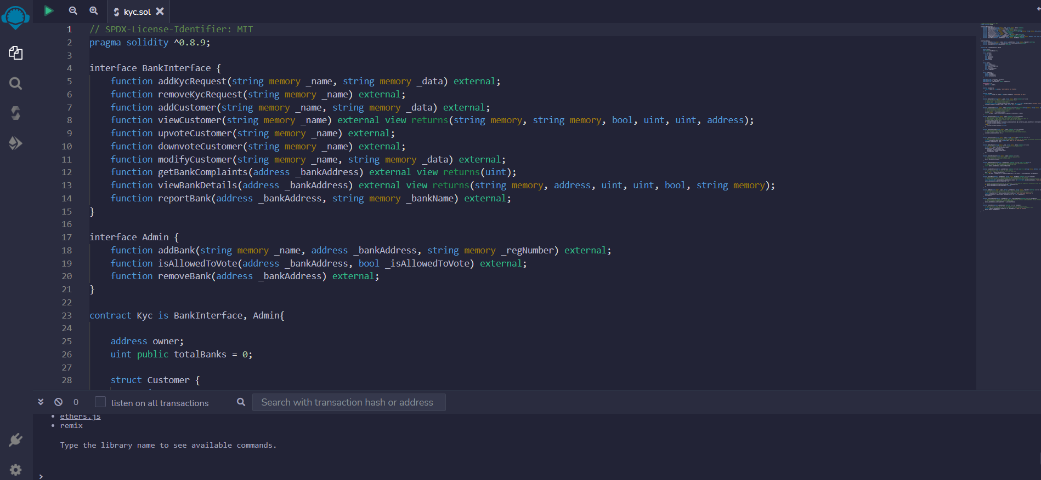

- Compile Kyc.sol
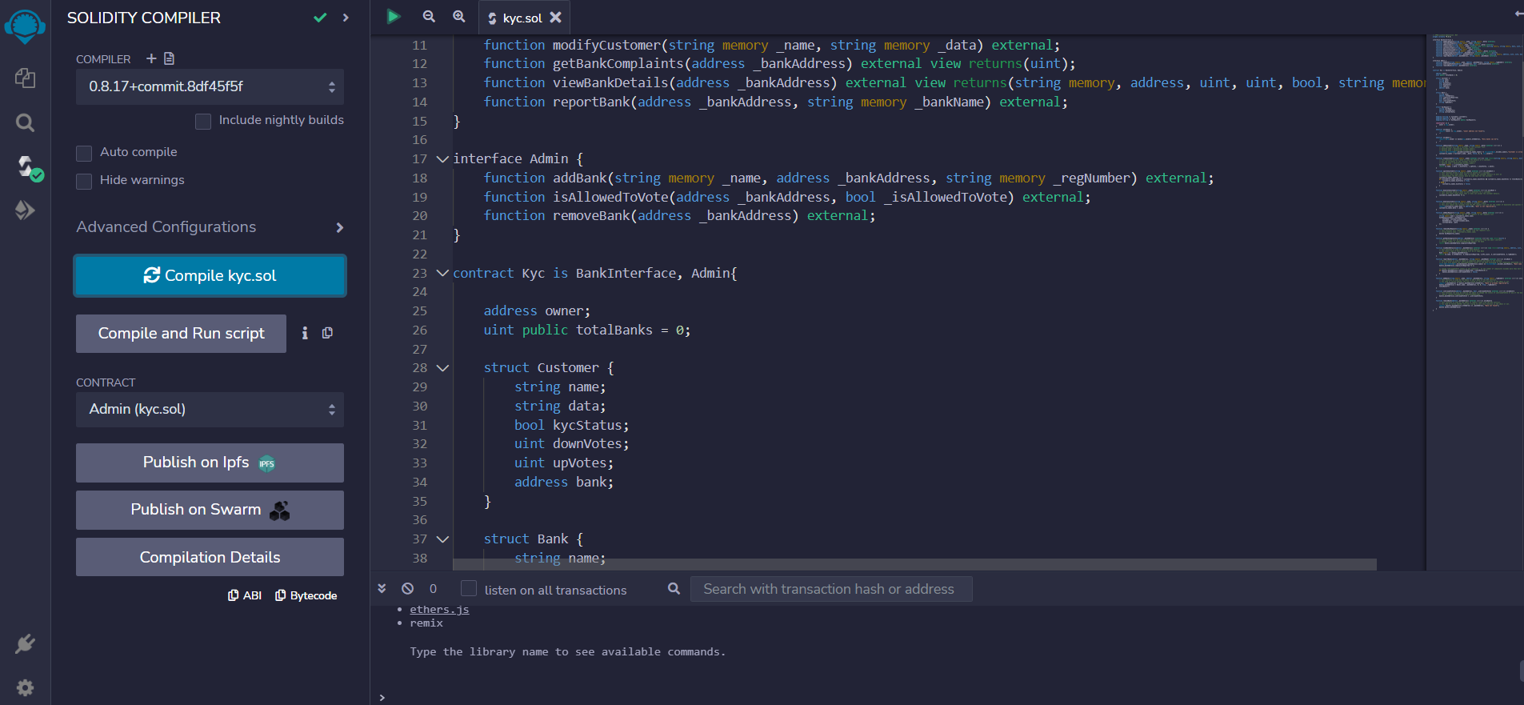

- Deploy Kyc.sol

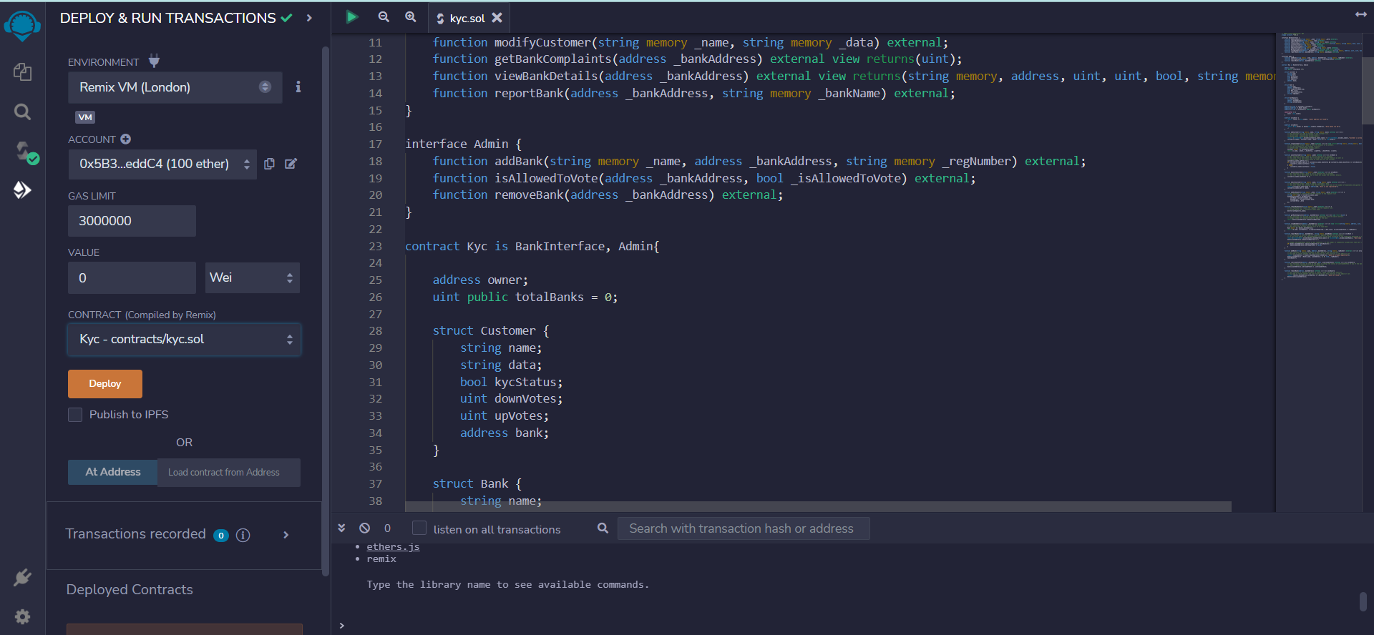

- Now you can use your smart contract
