**SQL Bolt – Task:**

**SQL Lesson 1: SELECT queries 101.**

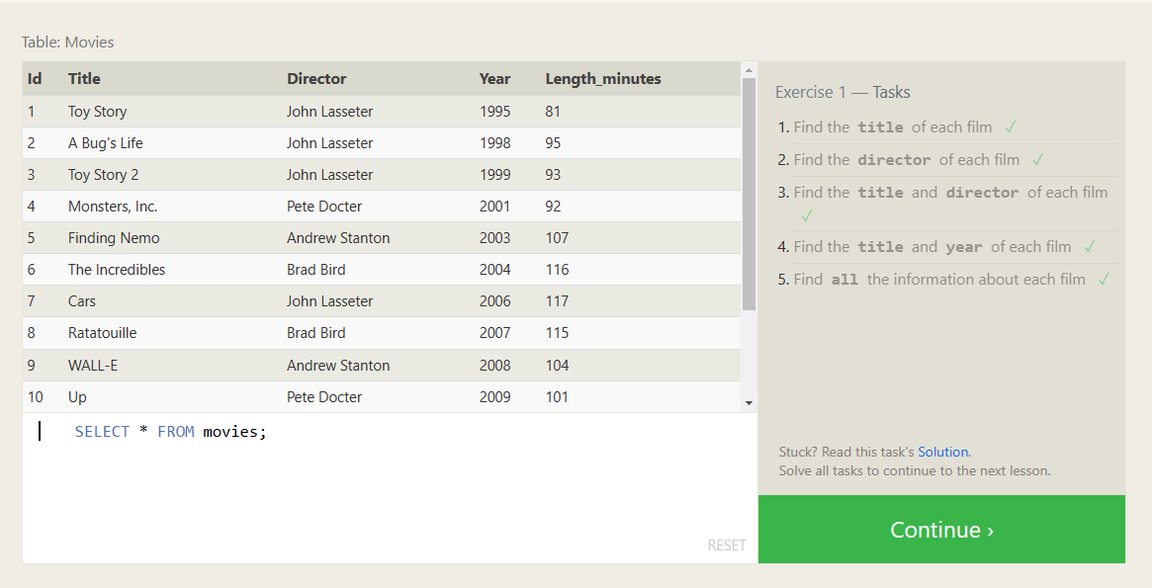

* SELECT title FROM movies;
* SELECT director FROM movies;
* SELECT title, director FROM movies;
* SELECT title, year FROM movies;
* SELECT * FROM movies;

**SQL Lesson 2: Queries with constraints (Pt. 1).**

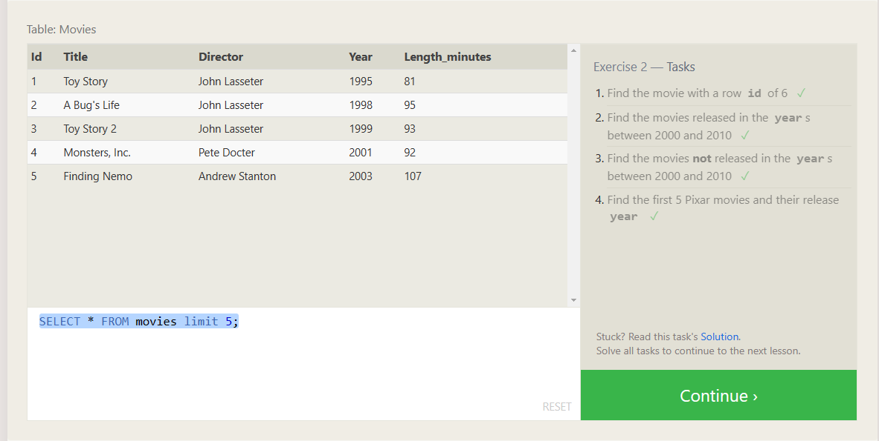

* SELECT * FROM movies where id = 6;
* SELECT * FROM movies where year between 2000 and 2010;
* SELECT * FROM movies where not year between 2000 and 2010;
* SELECT * FROM movies limit

**SQL Lesson 3: Queries with constraints (Pt. 2).**

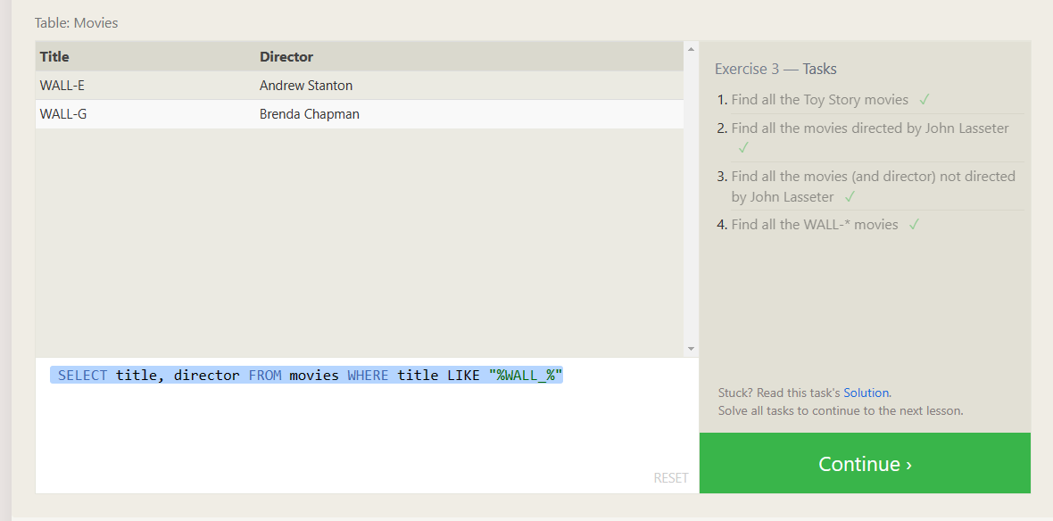

* SELECT * FROM movies WHERE title LIKE "%toy story%";
* SELECT title FROM movies WHERE director = "John Lasseter";
* SELECT title FROM movies WHERE director != "John Lasseter";
* SELECT title, director FROM movies WHERE title LIKE "%WALL_%"

**SQL Lesson 4: Filtering and sorting Query results.**

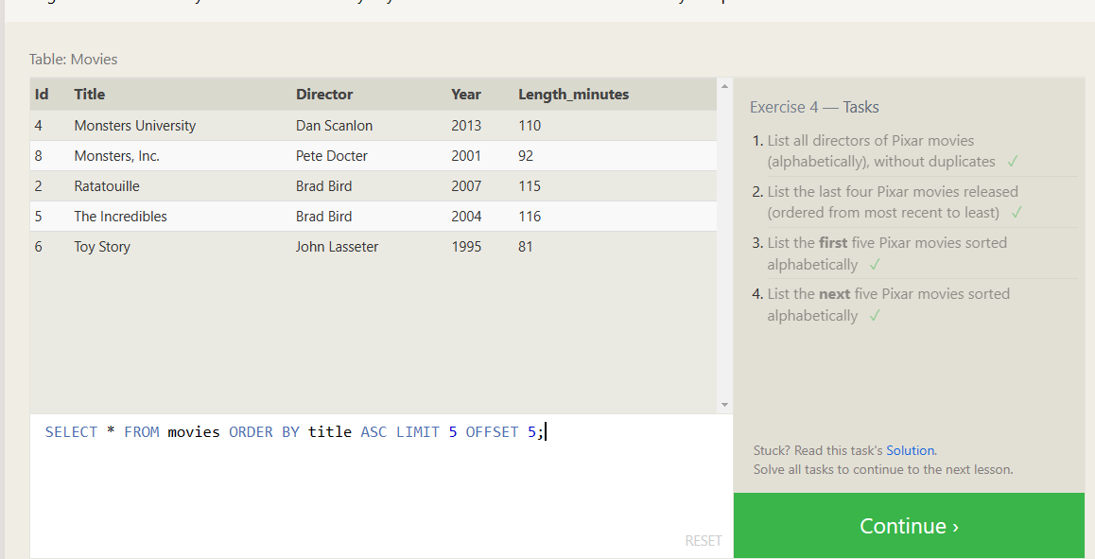

* SELECT DISTINCT director FROM movies ORDER BY director;
* SELECT * FROM movies ORDER BY year DESC LIMIT 4;
* SELECT * FROM movies ORDER BY title ASC LIMIT 5;
* SELECT * FROM movies ORDER BY title ASC LIMIT 5 OFFSET 5;

**SQL Review Lesson 5: Simple SELECT Queries.**

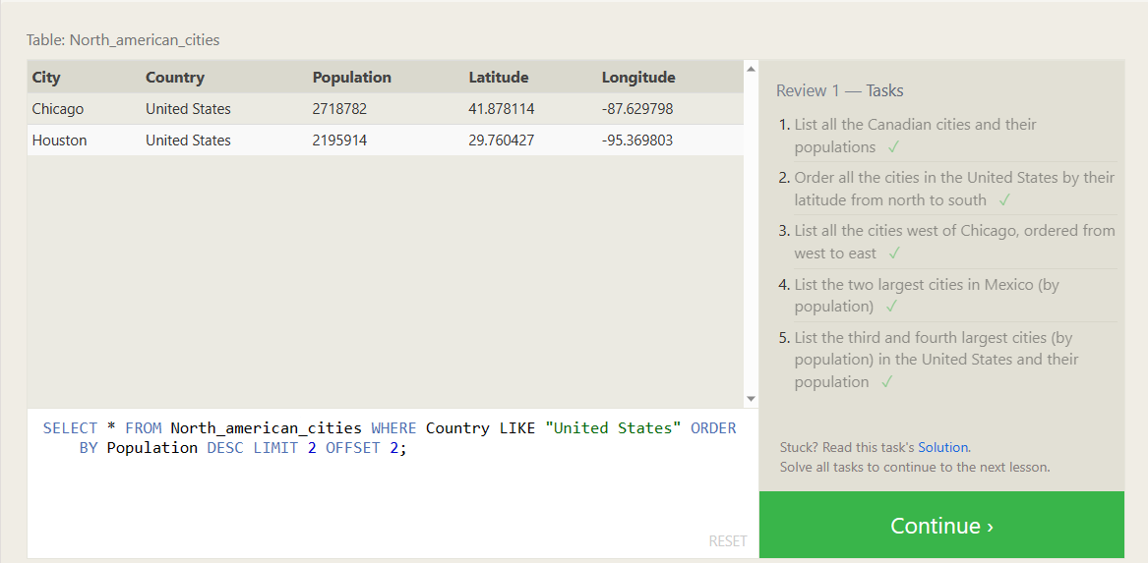

* SELECT * FROM North_american_cities WHERE Country LIKE "Canada";
* SELECT * FROM North_american_cities WHERE Country = "United States" ORDER BY Latitude DESC;
* SELECT * FROM North_american_cities WHERE Longitude < -87.69 ORDER BY Longitude ASC;
* SELECT * FROM North_american_cities WHERE Country LIKE "Mexico" ORDER BY Population DESC LIMIT 2;
* SELECT * FROM North_american_cities WHERE Country LIKE "United States" ORDER BY Population DESC LIMIT 2 OFFSET 2;

**SQL Lesson 6: Multi-table queries with JOINs**

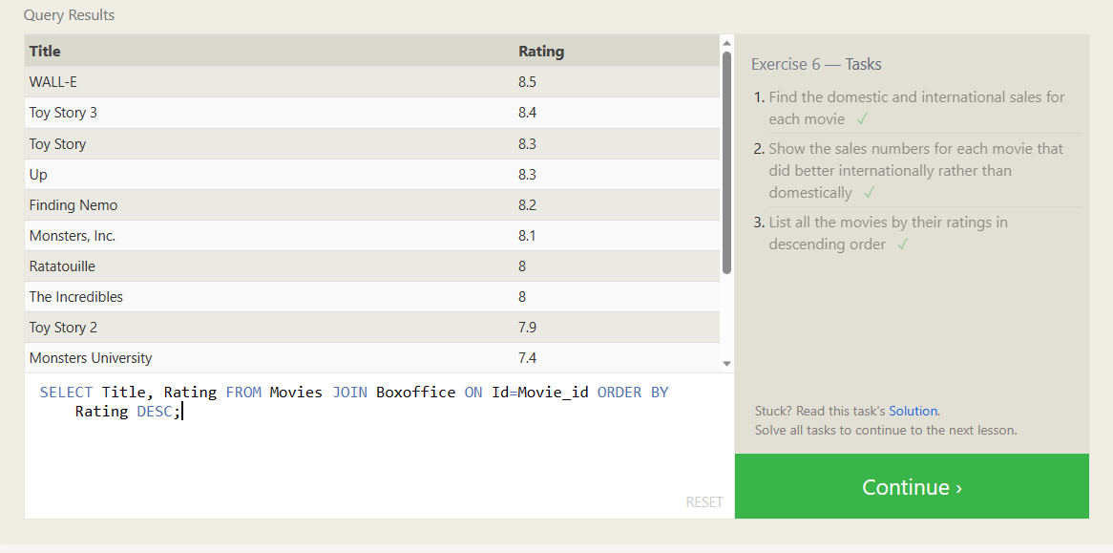

* SELECT Title, International_sales, Domestic_sales FROM Movies JOIN Boxoffice ON Id=Movie_id;
* SELECT Title, International_sales, Domestic_sales FROM Movies JOIN Boxoffice ON Id=Movie_id WHERE International_sales > Domestic_sales;
* SELECT Title, Rating FROM Movies JOIN Boxoffice ON Id=Movie_id ORDER BY Rating DESC;

**SQL Lesson 7: OUTER JOINs**

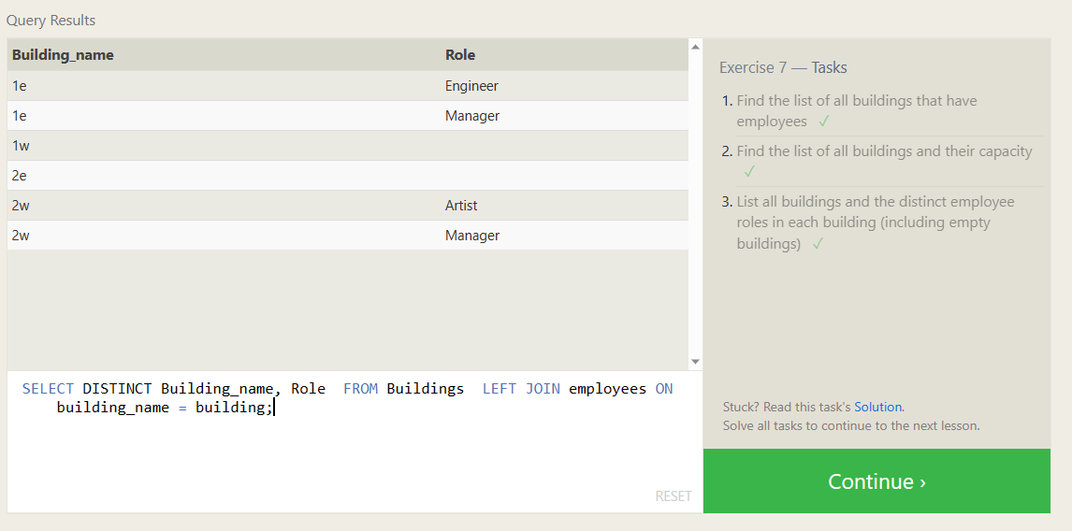

* SELECT DISTINCT Building FROM Employees LEFT JOIN Buildings ON Building=Building_name WHERE Years_employed NOT NULL;
* SELECT * FROM Buildings;
* SELECT DISTINCT Building_name, Role FROM Buildings LEFT JOIN employees ON building_name = building;

**SQL Lesson 8: A short note on NULLs**

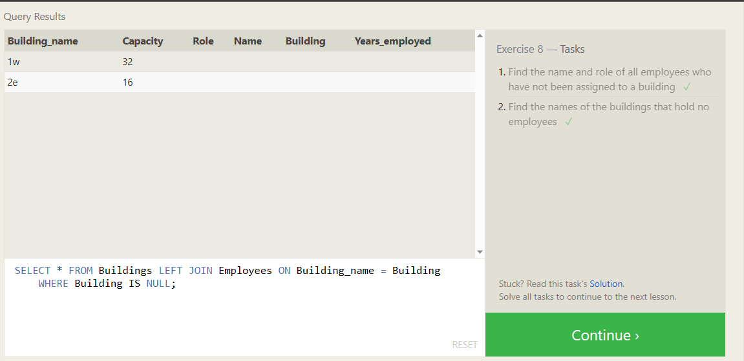

* SELECT * FROM Employees LEFT JOIN Buildings ON Building_name = Building WHERE Building IS NULL;
* SELECT * FROM Buildings LEFT JOIN Employees ON Building_name = Building WHERE Building IS NULL;

**SQL Lesson 9: Queries with expressions**

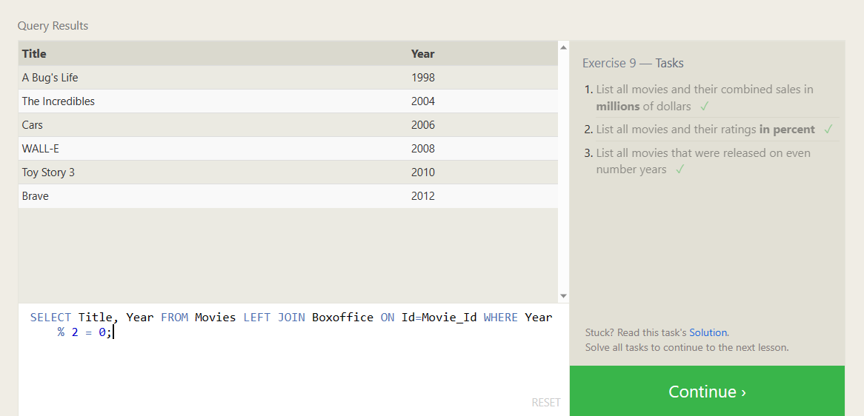

* SELECT Title, (Domestic_sales + International_sales)/1000000 AS Total_Sales_Millions FROM Movies LEFT JOIN Boxoffice ON Id=Movie_Id;
* SELECT Title, Rating*10 as Percent FROM Movies LEFT JOIN Boxoffice ON Id=Movie_Id;
* SELECT Title, Year FROM Movies LEFT JOIN Boxoffice ON Id=Movie_Id WHERE Year % 2 = 0;

**SQL Lesson 10: Queries with aggregates (Pt. 1)**

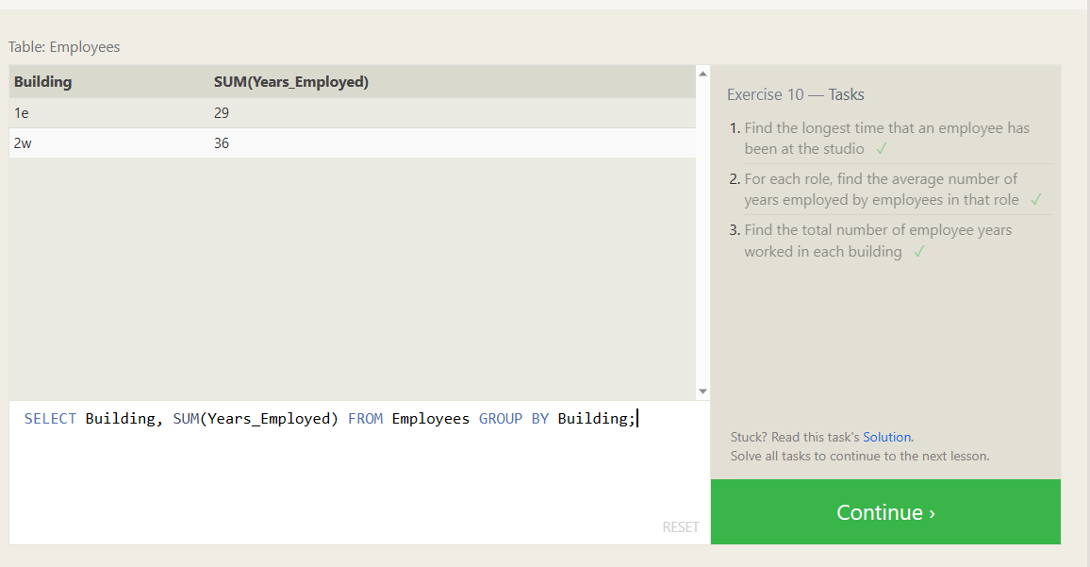

* SELECT MAX(Years_employed) FROM Employees;
* SELECT Role, AVG(Years_Employed) FROM Employees GROUP BY Role;
* SELECT Building, SUM(Years_Employed) FROM Employees GROUP BY Building;

**SQL Lesson 11: Queries with aggregates (Pt. 2)**

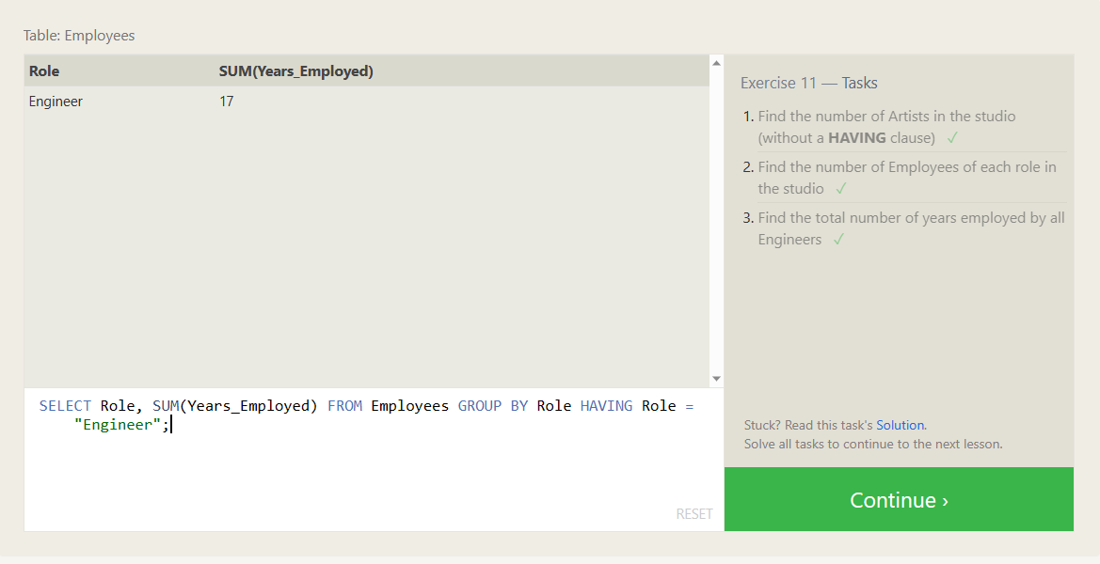

* SELECT Role, COUNT(*) AS Number_of_Artists FROM Employees WHERE Role = "Artist";
* SELECT Role, COUNT(*) FROM Employees GROUP BY Role;
* SELECT Role, SUM(Years_Employed) FROM Employees GROUP BY Role HAVING Role = "Engineer";

**SQL Lesson 12: Order of execution of a Query**

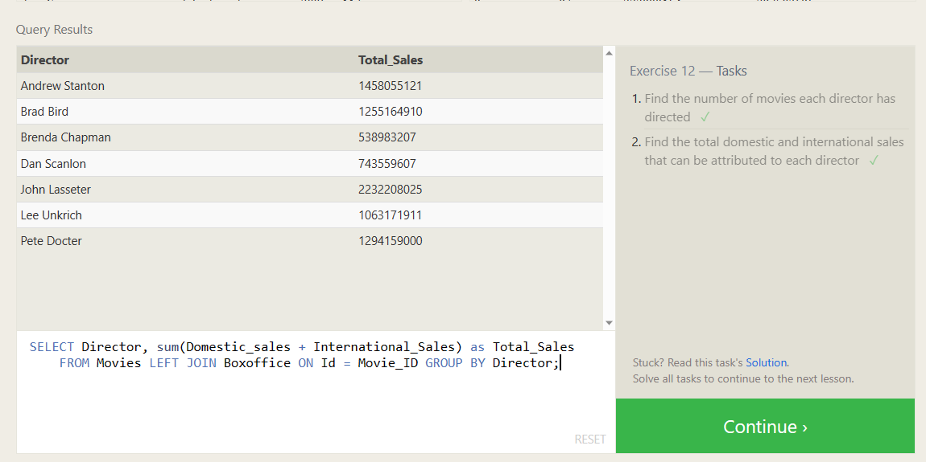

* SELECT *, COUNT(Title) FROM Movies GROUP BY Director;
* SELECT Director, sum(Domestic_sales + International_Sales) as Total_Sales FROM Movies LEFT JOIN Boxoffice ON Id = Movie_ID GROUP BY Director;

**SQL Lesson 13: Inserting rows**

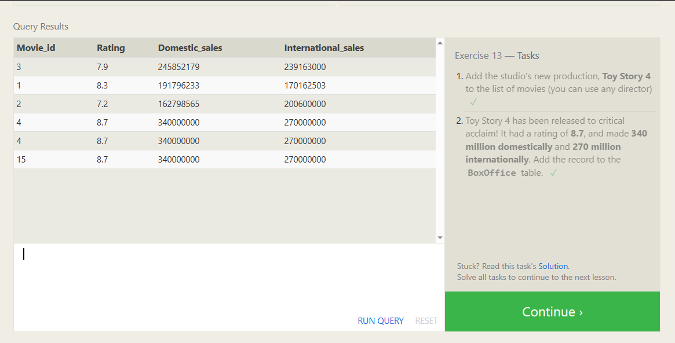

* INSERT INTO Movies(Title,Director) VALUES ('Toy Story 4','John Lasseter')
* INSERT INTO Boxoffice VALUES (15,8.7,340000000, 270000000)

**SQL Lesson 14: Updating rows**

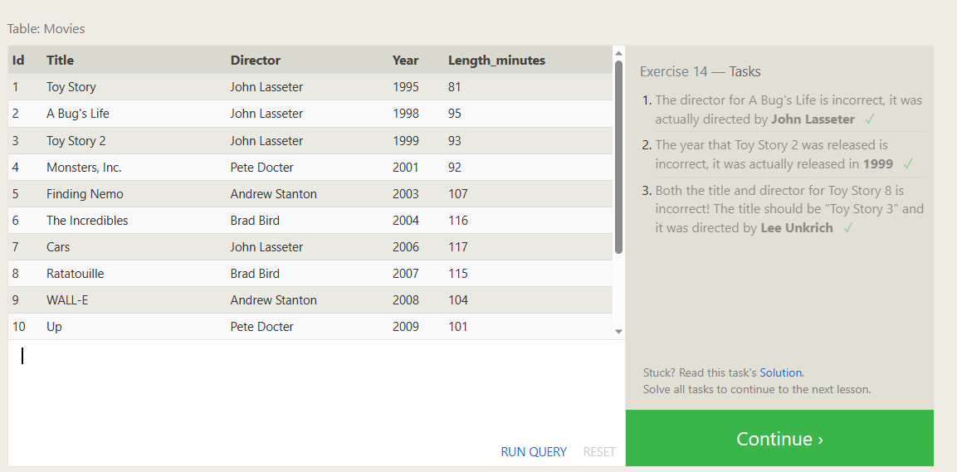

* UPDATE Movies SET Director = "John Lasseter" WHERE Id = 2;
* UPDATE Movies SET Year = "1999" WHERE Id = 3;
* UPDATE Movies SET Title = "Toy Story 3", Director = "Lee Unkrich" WHERE Id = 11;

**SQL Lesson 15: Deleting rows**

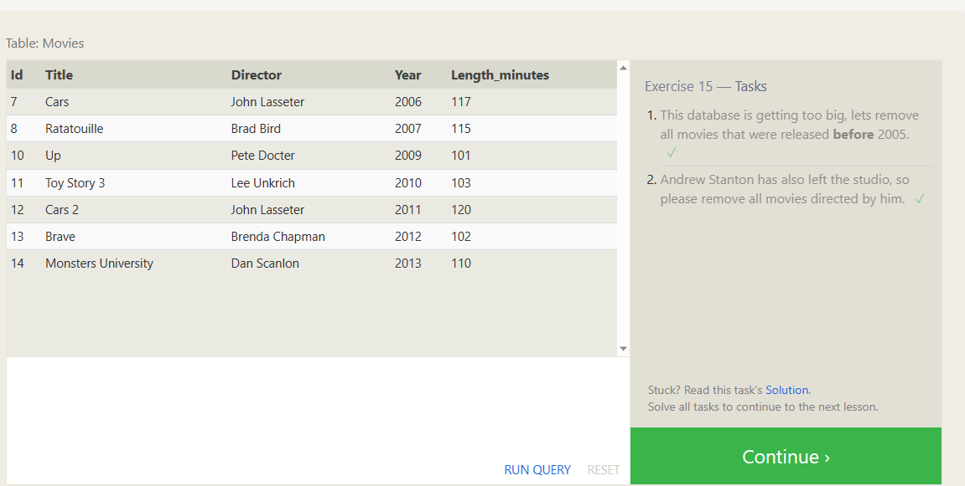

* DELETE FROM Movies WHERE Year < 2005;
* DELETE FROM Movies WHERE Director = "Andrew Stanton";

**SQL Lesson 16: Creating tables**

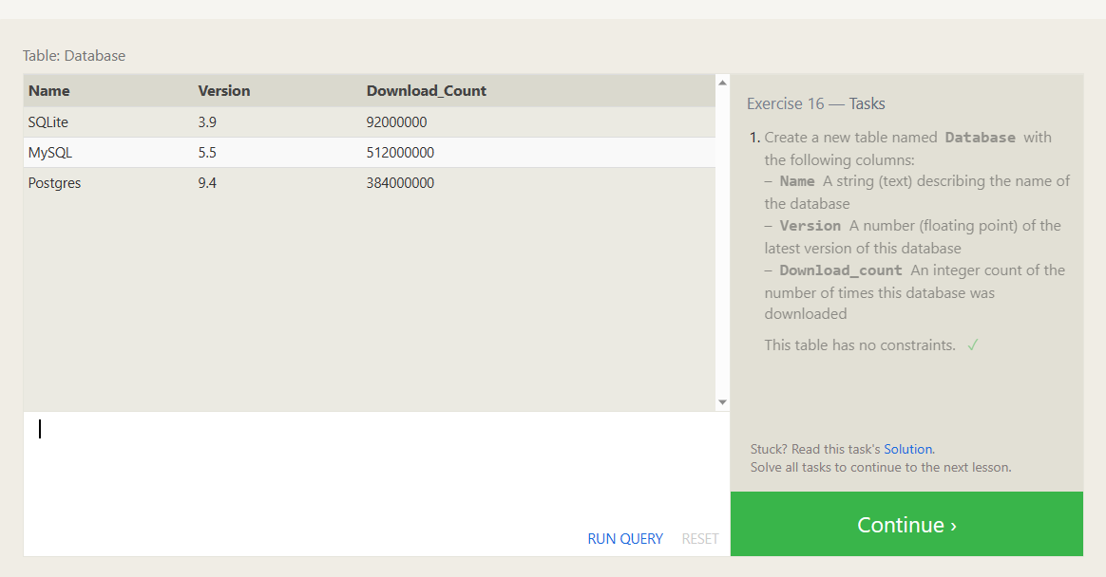

* CREATE TABLE Database (Name TEXT, Version FLOAT, Download_Count INTEGER);

**SQL Lesson 17: Altering tables**

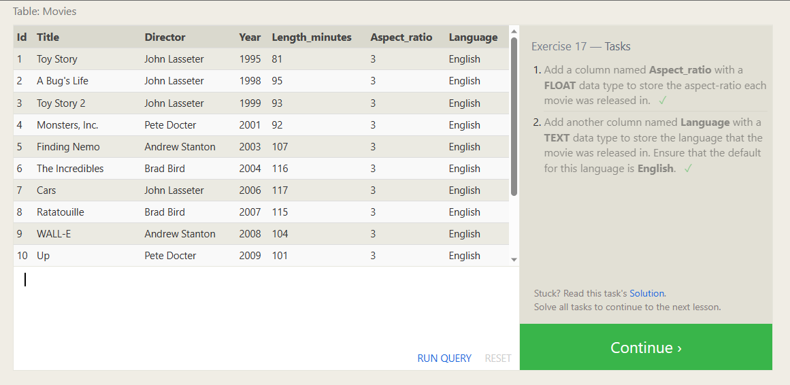

* ALTER TABLE Movies ADD COLUMN Aspect_ratio FLOAT DEFAULT 3;
* ALTER TABLE Movies ADD COLUMN Language TEXT DEFAULT "English";
* **SQL Lesson 18: Dropping tables**

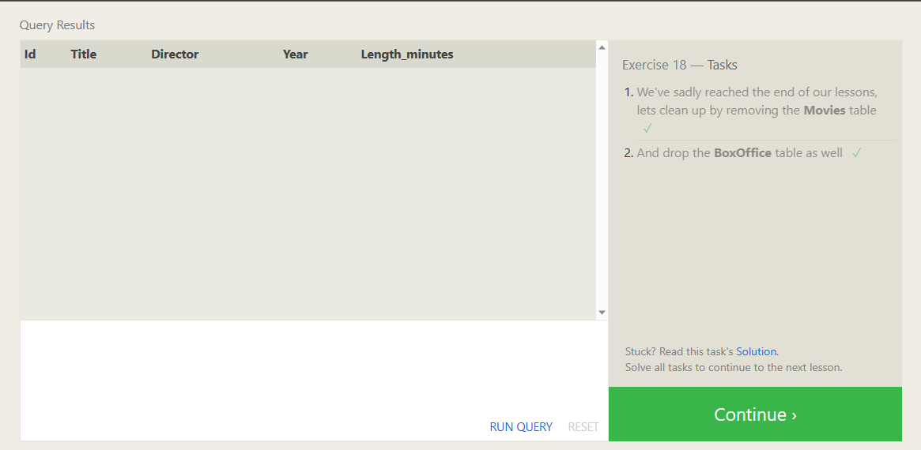

* DROP TABLE Movies;
* DROP TABLE BoxOffice