Computer Networks Lab Report
Submitted By
RAHUL R
RA2411030050044

Under the guidance of
Dr. Mallika
(Assistant Professor, School of Computing)

in partial fulfilment for the award of the degree
of
BACHELOR OF TECHNOLOGY
in
DEPARTMENT OF COMPUTER SCIENCE AND ENGINEERING WITH CYBER SECURITY
Of
FACULTY OF ENGINEERING AND TECHNOLOGY

SRM INSTITUTE OF SCIENCE AND TECHNOLOGY, TIRUCHIRAPPALLI
Academic Year: 2026–2027
Date: 23 October 2026
EXPERIMENT 1: IMPLEMENTATION OF BASIC NETWORK TOPOLOGY USING CISCO PACKET TRACER

1. AIM
To implement a basic network by connecting two PCs through a switch in Cisco Packet Tracer and to verify connectivity using the ping command.

2. SOFTWARE AND DEVICES REQUIRED
Category | Item | Quantity
Software | Cisco Packet Tracer | 1
End device | PC-PT (generic PC) | 2
Network device | Cisco 2950-24 switch | 1
Cable | Copper straight-through | 2

3. THEORY
A basic network connects end devices through a switch so that they can share data. The switch learns the MAC address of each connected device and forwards each frame only to the port of the destination device. Devices in the same network need IP addresses with the same network portion, and connectivity is tested with the ping command, which sends ICMP echo requests and waits for echo replies. Simulation mode in Packet Tracer shows the path of each packet step by step.

4. PROCEDURE
- Open Cisco Packet Tracer and place two PCs (PC0 and PC1) and one 2950-24 switch (Switch0) in the logical workspace.
- Connect PC0 and PC1 to Switch0 using copper straight-through cables.
- Open Desktop, then IP Configuration on each PC, select Static and enter the IPv4 address and subnet mask.
- Wait until the link indicators turn green.
- Switch to simulation mode, send a simple PDU from PC0 to PC1 and observe the path.
- Open the Command Prompt of PC0 and run ping 192.168.10.2.

5. IP ADDRESS CONFIGURATION
Device | Interface | IP Address | Subnet Mask
PC0 | FastEthernet0 | 192.168.10.1 | 255.255.255.0
PC1 | FastEthernet0 | 192.168.10.2 | 255.255.255.0
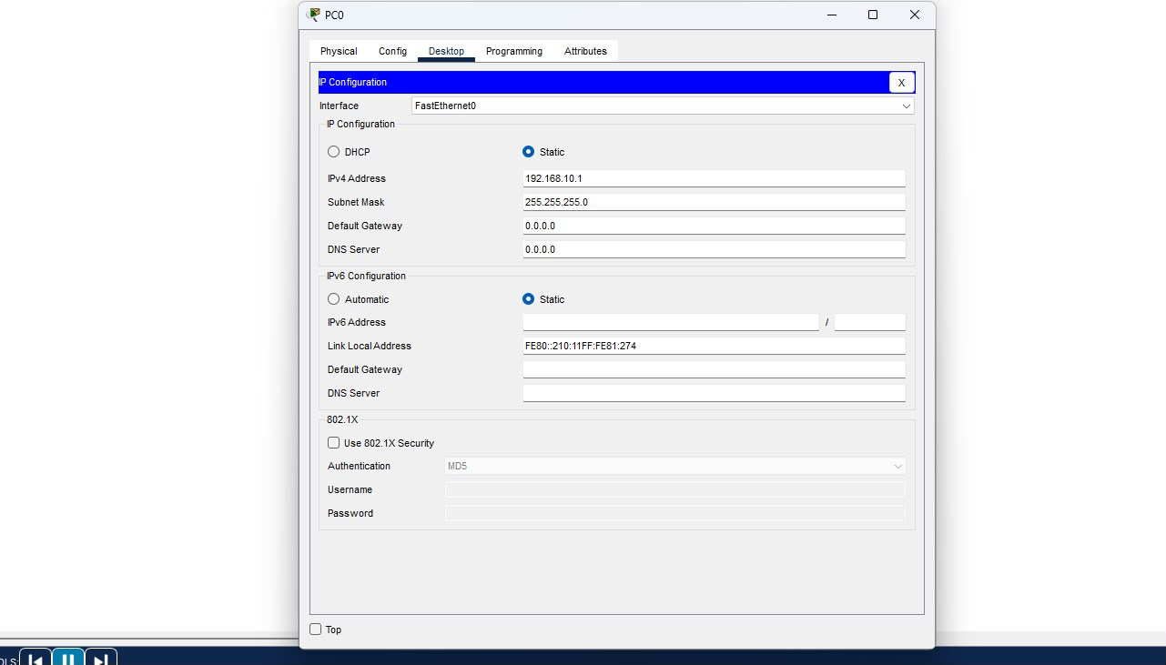
Figure 1. IP configuration of PC0

6. OBSERVATION
The PDU sent from PC0 reached Switch0 and was forwarded to PC1. The ping from PC0 to 192.168.10.2 sent 4 packets and received 4 with 0% loss; every reply took less than 1 ms and TTL=128.

7. OUTPUT
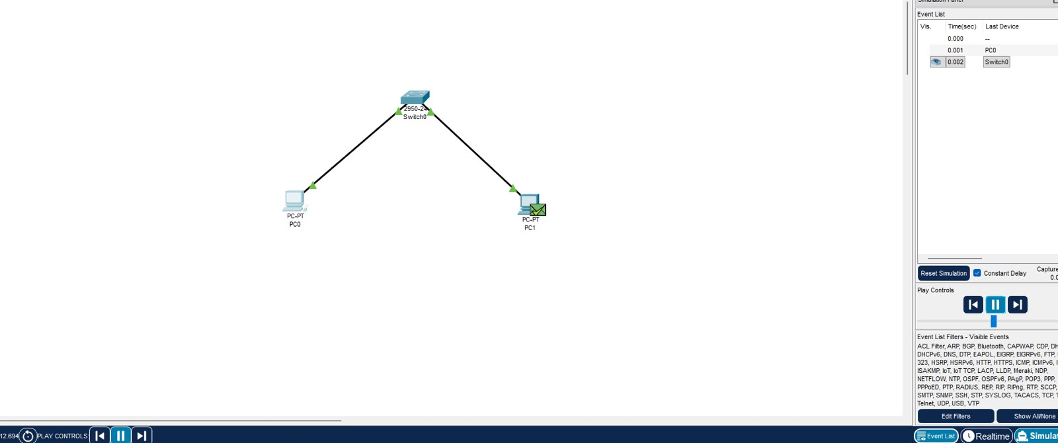
Figure 2. Basic network in simulation mode with a PDU from PC0 to PC1 through Switch0
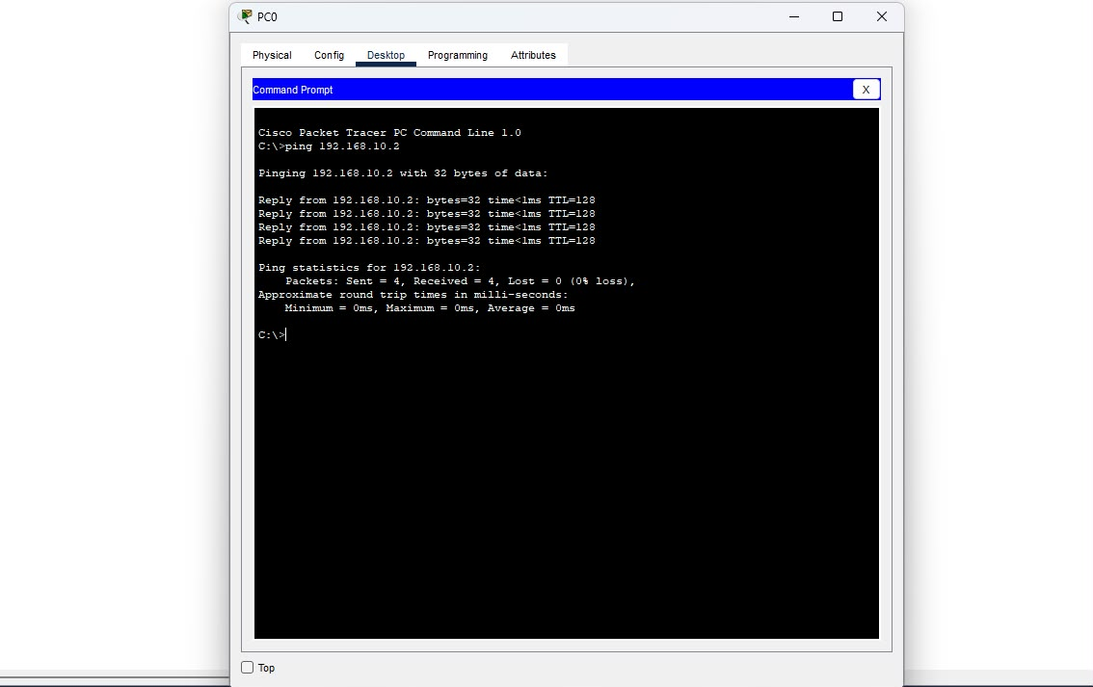
Figure 3. Command prompt of PC0 showing ping replies from 192.168.10.2

8. RESULT
The basic network of two PCs connected through a switch was implemented and connectivity between PC0 and PC1 was verified using ping.
EXPERIMENT 2: IMPLEMENTATION AND STUDY OF DIFFERENT NETWORK TOPOLOGIES USING CISCO PACKET TRACER

1. AIM
To design, implement and study the point-to-point, bus, star, ring, mesh, tree and hybrid network topologies using Cisco Packet Tracer, and to verify connectivity in each topology using the ping command and simulation mode.

2. SOFTWARE AND DEVICES REQUIRED
Category | Item | Quantity
Software | Cisco Packet Tracer | 1
End device | PC-PT (generic PC) | As per topology
Network device | Cisco 2950-24 switch | As per topology
Network device | Hub-PT (hub) | 1 (hybrid only)
Cable | Copper straight-through | As per topology
Cable | Copper cross-over | As per topology

3. THEORY
A network topology is the arrangement of the nodes and links of a network. The physical topology describes how devices are cabled, and the logical topology describes how data moves between them. The choice of topology decides the cost, performance, fault tolerance and scalability of a network.
Point-to-point, bus, star, ring, mesh, tree and hybrid are the seven topologies studied here. In Cisco Packet Tracer, straight-through cables join unlike devices (PC to switch) and cross-over cables join like devices (switch to switch, PC to PC). Connectivity is verified with ICMP echo requests using the ping command, and the path of a packet is traced using simulation mode.

4. IMPLEMENTATION OF NETWORK TOPOLOGIES

4.1 Point-to-Point Topology
Aim: To implement a point-to-point topology between two PCs and verify connectivity using ping.
Theory: A point-to-point topology joins exactly two devices with a dedicated link, so the full bandwidth of the link is available to those two devices. It is the simplest topology to build and secure, but it cannot be extended to more than two nodes without adding other devices.
Devices Required
Device / Item | Type / Model | Quantity
PC-PT | End device | 2
Copper cross-over cable | Cable | 1

Procedure
- Open Cisco Packet Tracer and place two PCs (PC0 and PC1) in the logical workspace.
- Select the copper cross-over cable and connect FastEthernet0 of PC0 to FastEthernet0 of PC1.
- Open Desktop, then IP Configuration on each PC, and assign the IP address and subnet mask.
- Wait until both link indicators turn green.
- Open the Command Prompt of PC0 and ping the IP address of PC1.
IP Address Configuration
Device | Interface | IP Address | Subnet Mask
PC0 | FastEthernet0 | 192.168.10.1 | 255.255.255.0
PC1 | FastEthernet0 | 192.168.10.2 | 255.255.255.0

Screenshot
[Insert point-to-point topology and command prompt screenshot here]
Observation: The two PCs are joined directly with no intermediate device. Both lie in the 192.168.10.0/24 network, so they can exchange packets over the dedicated link.
Result: The point-to-point topology was implemented and connectivity between PC0 and PC1 was verified.

4.2 Bus Topology
Aim: To implement a bus topology using a linear backbone of switches and verify connectivity between end devices.
Theory: In a bus topology all nodes share a single backbone. Data sent by one node travels along the backbone and every node can see it, but only the addressed node accepts it. It needs little cabling and is cheap, but a break in the backbone splits the network and performance falls as more nodes are added. In Packet Tracer the backbone is built as a linear chain of switches.
Devices Required
Device / Item | Type / Model | Quantity
PC-PT | End device | 4
Cisco 2950-24 switch | Network device | 4
Copper straight-through cable | Cable (PC to switch) | 4
Copper cross-over cable | Cable (switch to switch) | 3

Procedure
- Place four PCs (PC0 to PC3) and four 2950-24 switches (Switch0 to Switch3) in the workspace.
- Connect Switch0, Switch1, Switch2 and Switch3 in a straight line using copper cross-over cables to form the backbone.
- Connect PC0, PC1, PC2 and PC3 to Switch0, Switch1, Switch2 and Switch3 respectively using copper straight-through cables.
- Assign an IP address from the 192.168.10.0/24 network to each PC.
- Switch to simulation mode, send a simple PDU from PC0 to PC3 and observe the path.
- Open the Command Prompt of PC3 and run the ping command.
Screenshot
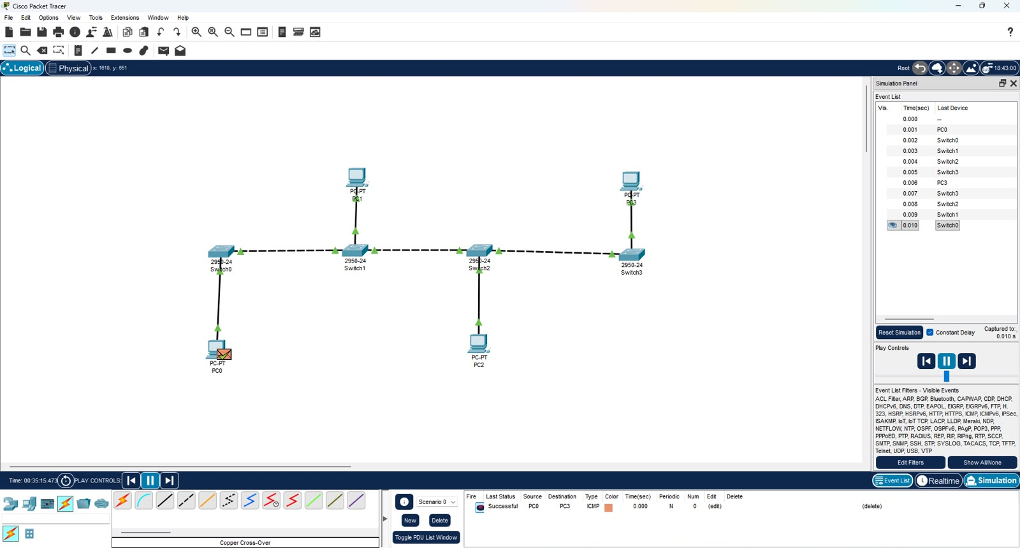
Figure 4. Bus topology in simulation mode with a successful ICMP PDU from PC0 to PC3
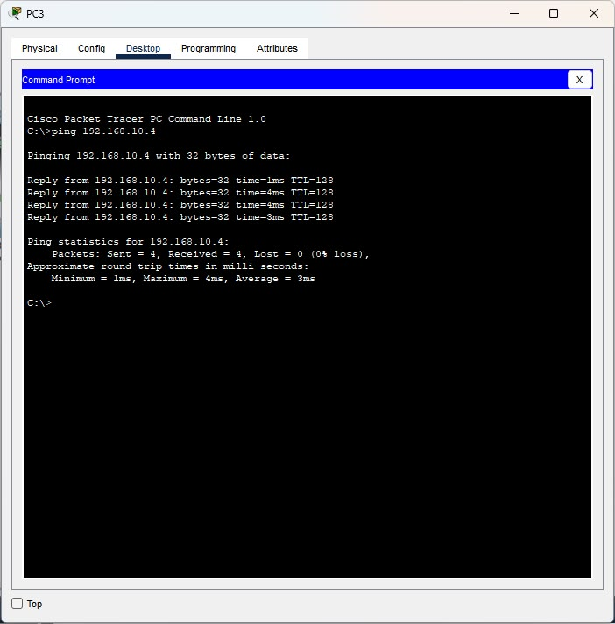
Figure 5. Command prompt of PC3 showing ping replies from 192.168.10.4
Observation: The simple PDU from PC0 to PC3 passed through Switch0, Switch1, Switch2 and Switch3 in turn along the backbone and returned along the same path. The ping test sent 4 packets and received 4 with 0% loss; round-trip time ranged from 1 ms to 4 ms with an average of 3 ms and TTL=128.
Result: The bus topology was implemented and end-to-end connectivity across the backbone was verified.

4.3 Star Topology
Aim: To implement a star topology with a central switch and verify connectivity between the PCs.
Theory: In a star topology every node connects to a central device, here a switch. All traffic passes through the switch, which forwards frames only to the destination port. A faulty cable affects only one node and new nodes are easy to add, but the central switch is a single point of failure.
Devices Required
Device / Item | Type / Model | Quantity
PC-PT | End device | 4
Cisco 2950-24 switch | Network device | 1
Copper straight-through cable | Cable | 4

Procedure
- Place one 2950-24 switch (Switch1) in the centre of the workspace and four PCs (PC4 to PC7) around it.
- Connect each PC to the switch using a copper straight-through cable.
- Assign the IP address and subnet mask to each PC.
- Switch to simulation mode, send a simple PDU from PC4 to PC7 and observe the path.
- Open the Command Prompt of PC4 and ping 192.168.10.4.
IP Address Configuration
Device | Interface | IP Address | Subnet Mask
PC4 | FastEthernet0 | 192.168.10.1 | 255.255.255.0
PC5 | FastEthernet0 | 192.168.10.2 | 255.255.255.0
PC6 | FastEthernet0 | 192.168.10.3 | 255.255.255.0
PC7 | FastEthernet0 | 192.168.10.4 | 255.255.255.0

Screenshot
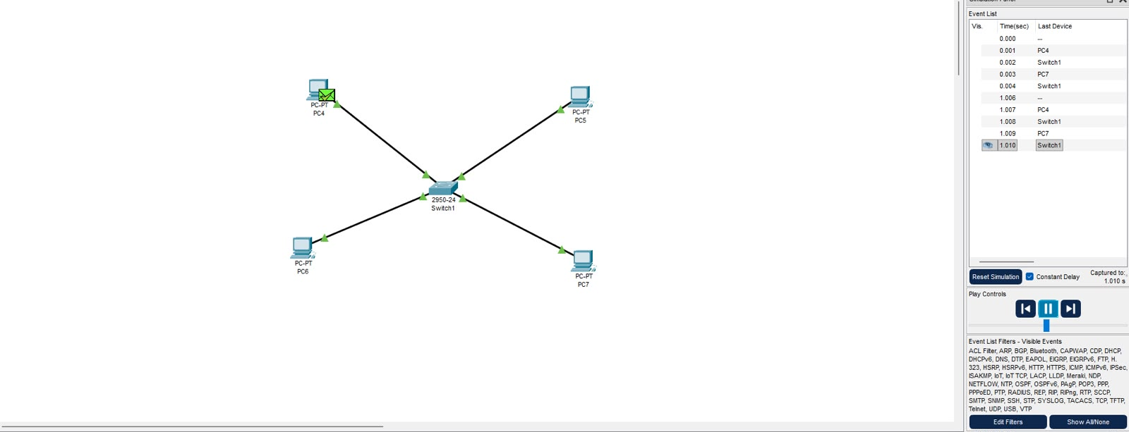
Figure 6. Star topology in simulation mode with a PDU from PC4 to PC7 through Switch1
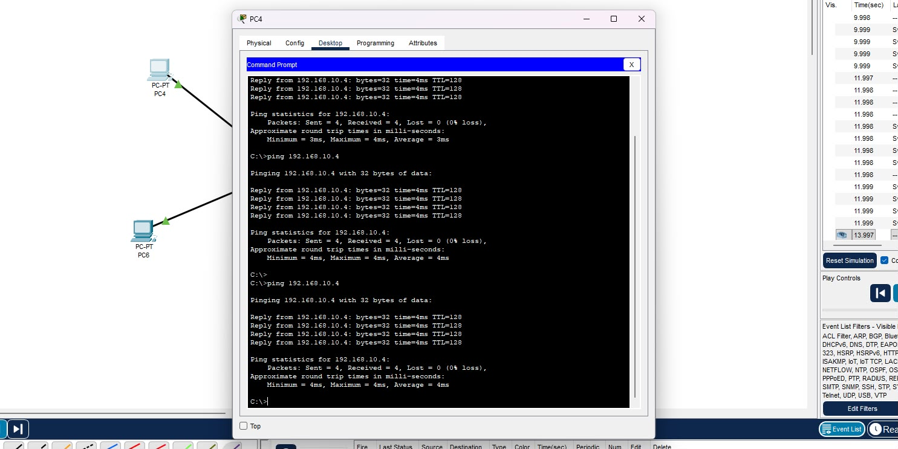
Figure 7. Command prompt of PC4 showing ping replies from 192.168.10.4
Observation: The PDU from PC4 reached PC7 through the central switch only, and the reply returned by the same route. Every ping test sent 4 packets and received 4 with 0% loss; round-trip time was 3 ms to 4 ms and TTL=128.
Result: The star topology was implemented and connectivity between all PCs through the central switch was verified.

4.4 Ring Topology
Aim: To implement a ring topology using four switches and verify connectivity between the PCs.
Theory: In a ring topology each node connects to exactly two neighbours so that the nodes form a closed loop. Data can travel in either direction and a second path exists if one link fails. A switched ring creates a Layer 2 loop, so the Spanning Tree Protocol (STP) blocks one link (shown by an orange marker in Packet Tracer) and brings it back into use if another link fails.
Devices Required
Device / Item | Type / Model | Quantity
PC-PT | End device | 4
Cisco 2950-24 switch | Network device | 4
Copper straight-through cable | Cable (PC to switch) | 4
Copper cross-over cable | Cable (switch to switch) | 4

Procedure
- Place four 2950-24 switches (Switch0 to Switch3) and four PCs (PC0 to PC3) in the workspace.
- Connect the switches in a closed loop using copper cross-over cables: Switch0 to Switch1, Switch1 to Switch3, Switch3 to Switch2 and Switch2 to Switch0.
- Connect one PC to each switch using a copper straight-through cable.
- Assign the IP address and subnet mask to each PC.
- Switch to simulation mode, send a simple PDU from PC0 to PC1 and observe the path.
- Open the Command Prompt of PC3 and ping 192.168.10.4.
IP Address Configuration
Device | Interface | IP Address | Subnet Mask
PC0 | FastEthernet0 | 192.168.10.1 | 255.255.255.0
PC1 | FastEthernet0 | 192.168.10.2 | 255.255.255.0
PC2 | FastEthernet0 | 192.168.10.3 | 255.255.255.0
PC3 | FastEthernet0 | 192.168.10.4 | 255.255.255.0

Screenshot
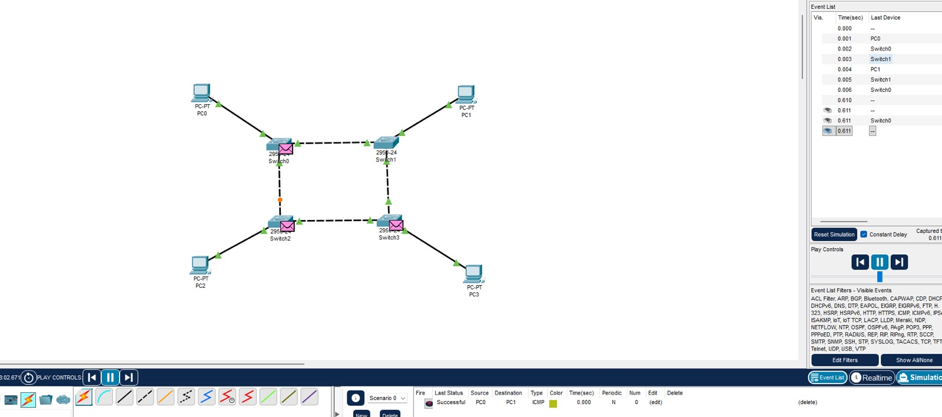
Figure 8. Ring topology in simulation mode with a PDU from PC0 to PC1
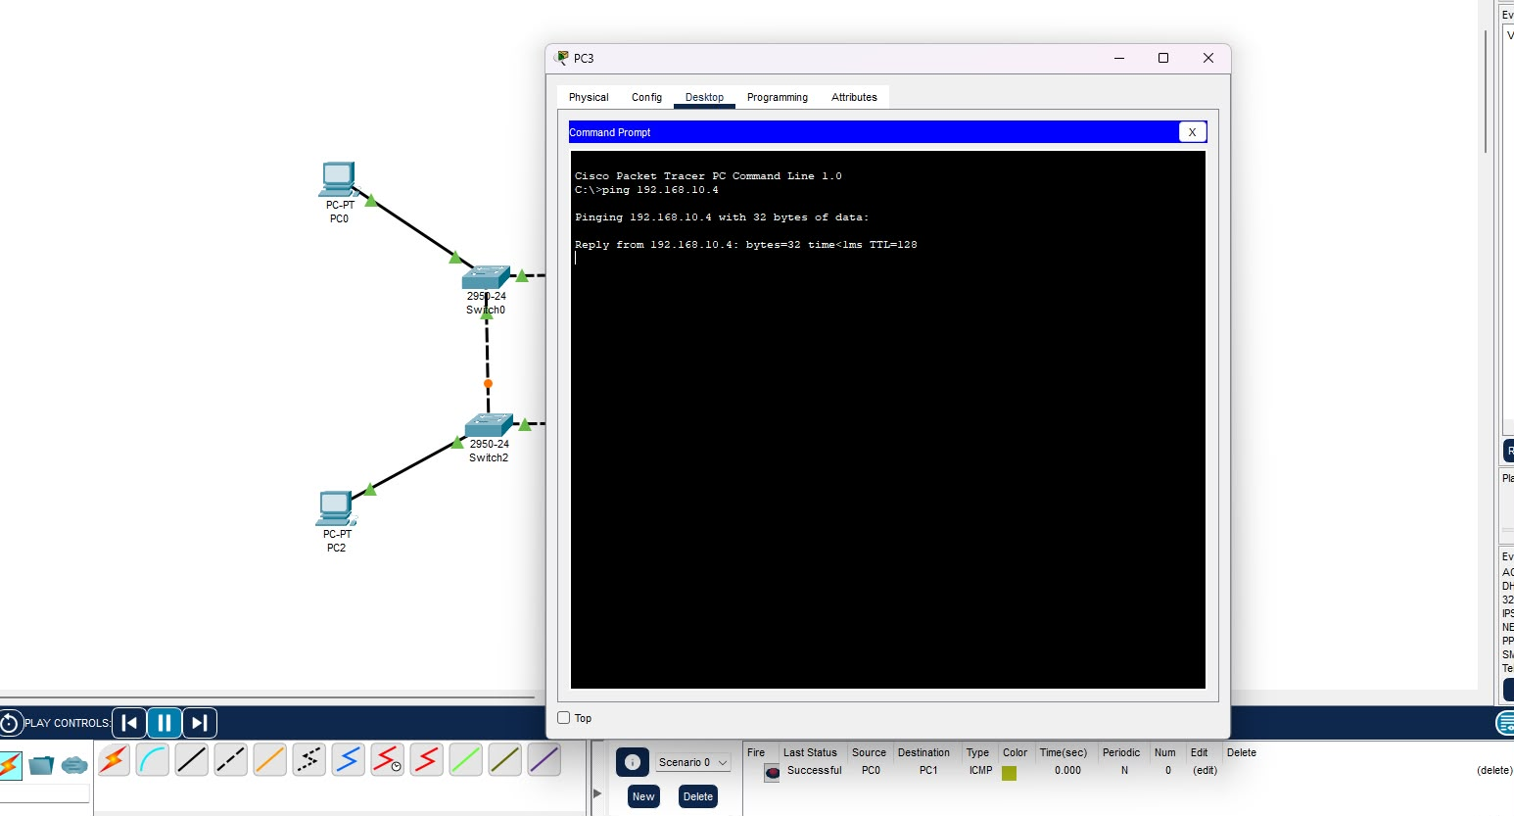
Figure 9. Command prompt of PC3 showing a ping reply from 192.168.10.4
Observation: The PDU from PC0 reached PC1 through Switch0 and Switch1. The link between Switch0 and Switch2 is marked by an orange dot, which shows that STP blocked that link to prevent a loop while the other three links carry traffic. The ping reply from 192.168.10.4 was received with time below 1 ms and TTL=128.
Result: The ring topology was implemented and connectivity between the PCs was verified, with STP preventing a switching loop.

4.5 Mesh Topology
Aim: To implement a full mesh topology using four switches and verify connectivity between the PCs.
Theory: In a full mesh topology every node has a direct link to every other node. A network of n nodes needs n(n-1)/2 links, so four switches need six links. It gives the highest fault tolerance because many alternative paths exist, but it is the most expensive and complex topology to cable and manage.
Devices Required
Device / Item | Type / Model | Quantity
PC-PT | End device | 4
Cisco 2950-24 switch | Network device | 4
Copper straight-through cable | Cable (PC to switch) | 4
Copper cross-over cable | Cable (switch to switch) | 6

Procedure
- Place four 2950-24 switches (Switch0 to Switch3) and four PCs (PC0 to PC3) in the workspace.
- Connect every switch to each of the other three switches using six copper cross-over cables.
- Connect one PC to each switch using a copper straight-through cable.
- Assign the IP address and subnet mask to each PC.
- Switch to simulation mode, send a simple PDU from PC0 to PC3 and observe the path.
- Open the Command Prompt of PC0 and ping 192.168.10.4.
IP Address Configuration
Device | Interface | IP Address | Subnet Mask
PC0 | FastEthernet0 | 192.168.10.1 | 255.255.255.0
PC1 | FastEthernet0 | 192.168.10.2 | 255.255.255.0
PC2 | FastEthernet0 | 192.168.10.3 | 255.255.255.0
PC3 | FastEthernet0 | 192.168.10.4 | 255.255.255.0

Screenshot
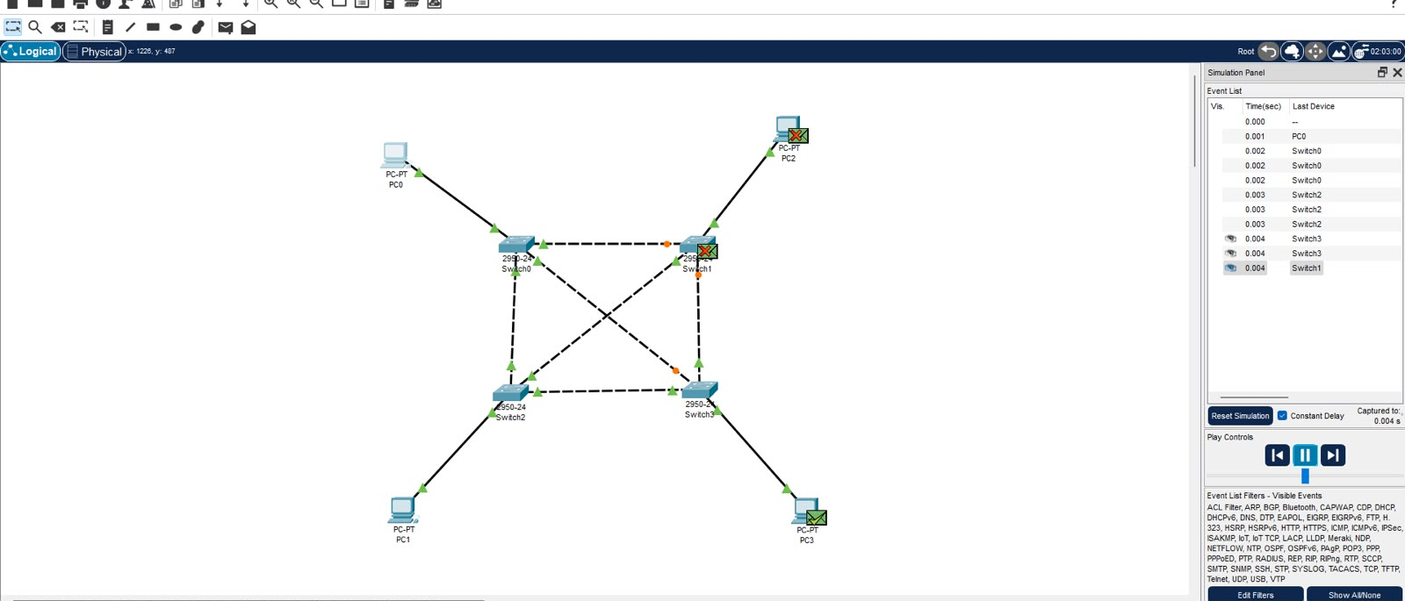
Figure 10. Mesh topology in simulation mode with a PDU from PC0 to PC3
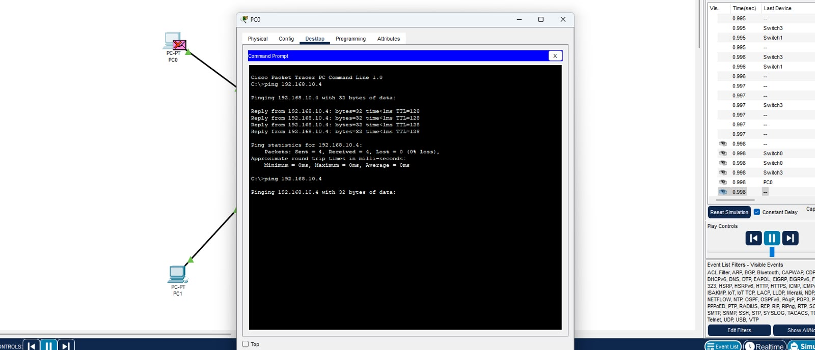
Figure 11. Command prompt of PC0 showing ping replies from 192.168.10.4
Observation: Each switch has a direct link to every other switch. STP blocked some of the redundant links (orange dots) to avoid loops, and copies of the broadcast frame that reached other devices were dropped (red cross). The ping test sent 4 packets and received 4 with 0% loss; the round-trip time was below 1 ms and TTL=128.
Result: The mesh topology was implemented and connectivity was verified, with redundant links available between the switches.

4.6 Tree Topology
Aim: To implement a tree topology using a root switch and two branch switches and verify connectivity between the PCs.
Theory: A tree topology arranges devices in a hierarchy: a root node connects to branch nodes, which in turn connect to end devices. It combines the bus and star topologies, supports easy expansion by adding branches, and allows a failure to be isolated to one branch. If the root device fails, the branches are cut off from each other.
Devices Required
Device / Item | Type / Model | Quantity
PC-PT | End device | 4
Cisco 2950-24 switch | Network device | 3
Copper straight-through cable | Cable (PC to switch) | 4
Copper cross-over cable | Cable (switch to switch) | 2

Procedure
- Place one root switch, two branch switches and four PCs in the workspace.
- Connect each branch switch to the root switch using copper cross-over cables.
- Connect two PCs to each branch switch using copper straight-through cables.
- Assign the IP address and subnet mask to each PC.
- Open the Command Prompt of a PC on one branch and ping a PC on the other branch.
IP Address Configuration
Device | Interface | IP Address | Subnet Mask
PC0 | FastEthernet0 | 192.168.10.1 | 255.255.255.0
PC1 | FastEthernet0 | 192.168.10.2 | 255.255.255.0
PC2 | FastEthernet0 | 192.168.10.3 | 255.255.255.0
PC3 | FastEthernet0 | 192.168.10.4 | 255.255.255.0

Screenshot
[Insert tree topology and command prompt screenshot here]
Observation: Traffic between PCs on the same branch is switched by the branch switch alone, while traffic between PCs on different branches passes through the root switch.
Result: The tree topology was implemented and connectivity between the PCs on different branches was verified.

4.7 Hybrid Topology
Aim: To implement a hybrid topology that combines ring, mesh, bus, star and hub-based segments and verify connectivity between PCs in different segments.
Theory: A hybrid topology combines two or more basic topologies in one network. It is flexible and scalable and lets each segment use the topology that suits it, but it is more complex to design, cable and manage. Here a ring, a mesh, a bus, a star and a hub segment are joined together.
Devices Required
Device / Item | Type / Model | Quantity
PC-PT | End device | 19
Cisco 2950-24 switch | Network device | 13
Hub-PT | Network device | 1
Copper straight-through cable | Cable (PC to switch or hub) | As required
Copper cross-over cable | Cable (switch to switch or hub) | As required

Procedure
- Build the ring segment with Switch0 to Switch3 and PC0 to PC3.
- Build the mesh segment with Switch4 to Switch7 and PC4 to PC7.
- Build the bus segment as a chain of Switch8 to Switch11 with PC15 to PC18.
- Build the star segment with Switch12 and PC11 to PC14, and the hub segment with Hub0 and PC8 to PC10.
- Join the segments through the switch-to-switch and switch-to-hub cross-over links and assign the IP address and subnet mask to every PC.
- Switch to simulation mode, send a simple PDU from PC4 to PC15 and observe the path.
- Open the Command Prompt of PC4 and ping 192.168.10.9.
IP Address Configuration
Device | Interface | IP Address | Subnet Mask
PC0 | FastEthernet0 | 192.168.10.1 | 255.255.255.0
PC1 | FastEthernet0 | 192.168.10.2 | 255.255.255.0
PC2 | FastEthernet0 | 192.168.10.3 | 255.255.255.0
PC3 | FastEthernet0 | 192.168.10.4 | 255.255.255.0
PC4 | FastEthernet0 | 192.168.10.5 | 255.255.255.0
PC5 | FastEthernet0 | 192.168.10.6 | 255.255.255.0
PC6 | FastEthernet0 | 192.168.10.7 | 255.255.255.0
PC7 | FastEthernet0 | 192.168.10.8 | 255.255.255.0
PC8 | FastEthernet0 | 192.168.10.10 | 255.255.255.0
PC9 | FastEthernet0 | 192.168.10.11 | 255.255.255.0
PC10 | FastEthernet0 | 192.168.10.12 | 255.255.255.0
PC11 | FastEthernet0 | 192.168.10.13 | 255.255.255.0
PC12 | FastEthernet0 | 192.168.10.14 | 255.255.255.0
PC13 | FastEthernet0 | 192.168.10.15 | 255.255.255.0
PC14 | FastEthernet0 | 192.168.10.16 | 255.255.255.0
PC15 | FastEthernet0 | 192.168.10.9 | 255.255.255.0
PC16 | FastEthernet0 | 192.168.10.17 | 255.255.255.0
PC17 | FastEthernet0 | 192.168.10.18 | 255.255.255.0
PC18 | FastEthernet0 | 192.168.10.19 | 255.255.255.0

Screenshot
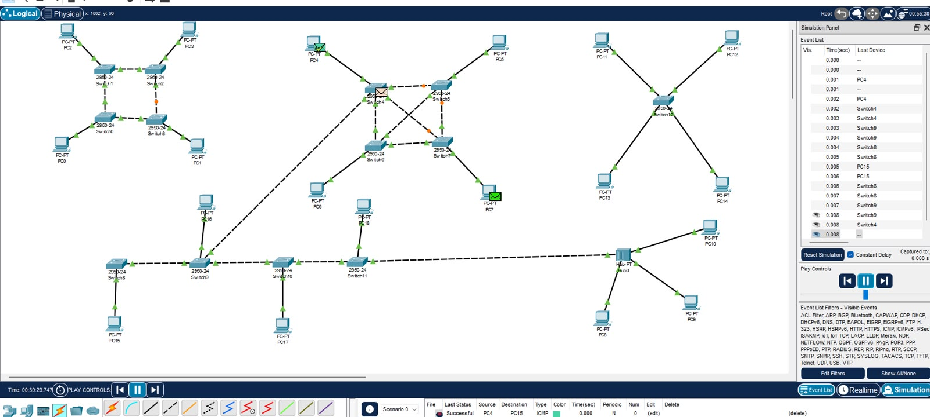
Figure 12. Hybrid topology in simulation mode with a PDU from PC4 to PC15
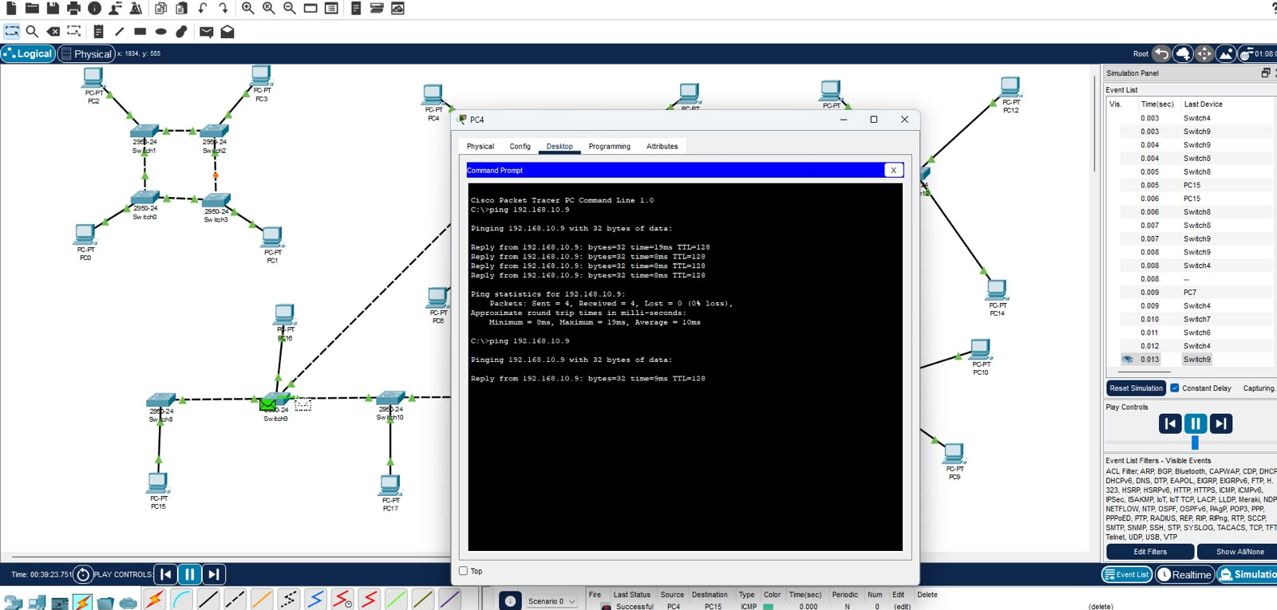
Figure 13. Command prompt of PC4 showing ping replies from 192.168.10.9
Observation: The PDU from PC4 in the mesh segment travelled through Switch4, Switch9 and Switch8 to PC15 in the bus segment and returned along the same path. The ping test sent 4 packets and received 4 with 0% loss; round-trip time ranged from 8 ms to 19 ms with an average of 10 ms and TTL=128. The delay is higher than in the single-topology networks because the packets cross several switches and segments.
Result: The hybrid topology was implemented and connectivity between PCs in different segments was verified.

5. COMPARISON OF NETWORK TOPOLOGIES
Topology | Connection Method | Cost | Fault Tolerance | Scalability | Main Limitation
Point-to-Point | Dedicated link between two devices | Very low | None; link failure ends communication | Not scalable | Only two devices
Bus | Single shared backbone | Low | Low; backbone break splits the network | Limited | Backbone failure and shared bandwidth
Star | Every node to a central switch | Medium | Node fault is isolated; switch fault stops the network | High | Central switch is a single point of failure
Ring | Each node to two neighbours in a closed loop | Medium | Medium; alternate path through the ring | Moderate | Needs STP to avoid loops
Mesh | Every node to every other node | Very high | Very high; many alternate paths | Difficult; n(n-1)/2 links | High cost and cabling complexity
Tree | Hierarchy of star networks under a root | Medium to high | Moderate; branch faults are isolated | High | Root failure cuts off the branches
Hybrid | Combination of two or more topologies | High | High | Very high | Complex design and management

6. OBSERVATION
- Point-to-point uses a single dedicated link and needs no switch, but supports only two devices.
- In the bus topology the PDU from PC0 to PC3 travelled along the whole backbone, and the ping average was 3 ms with 0% loss.
- In the star topology all traffic passed through the central switch, and the ping average was 3 ms to 4 ms with 0% loss.
- In the ring and mesh topologies STP blocked redundant links (orange dots) to prevent loops; the ping replies arrived in under 1 ms.
- The tree topology routes traffic between branches through the root switch.
- In the hybrid topology the ping from PC4 to PC15 crossed several segments, giving an average of 10 ms with 0% loss.
- Fault tolerance and cost rise together: the mesh is the most reliable and the most expensive, while the point-to-point and bus topologies are the cheapest and the least reliable.

7. RESULT
The point-to-point, bus, star, ring, mesh, tree and hybrid topologies were implemented using Cisco Packet Tracer, connectivity in each was verified using ping and simulation mode, and the topologies were compared on cost, fault tolerance and scalability.

