DATA SCRAPING TO COMPARE JOB POSTINGS, SALARIES, AND COST OF LIVING

INTRODUCTION

This project involves a comprehensive analysis of the relationship between job postings, salaries, and salary rates across various locations in the United States. It encompasses three distinct phases to gather insights and provide valuable information to job seekers:

Webscraping: The project utilizes BeautifulSoup and Selenium libraries for web scraping. With BeautifulSoup, HTML scraping is performed to extract job statistics and links to access the full job descriptions. Selenium is used for dynamic page loading, allowing the collection of comprehensive data from online job portals.

Job description preprocessing: The extracted job descriptions undergo preprocessing, including tokenization and smoothing techniques. This process enables the creation of smoothed TF-IDF (Term Frequency-Inverse Document Frequency) models. These models facilitate the analysis of job requirements and identify significant keywords and phrases that have a higher impact on job applications.

Popular skills extraction: The project focuses on extracting popular soft skills and technical skills through the application of techniques such as n-grams, semantic network analysis, word embedding, and K-means clustering. By utilizing trending technical and soft skills data from authoritative sources like the Bureau of Labor Statistics, specifically the Occupational Information Network (O*NET), the project aims to identify the key skills that applicants should prioritize to remain competitive in the job market.

By combining the extracted statistics on job postings, average salaries per state, and trending skills data, the project aims to distill crucial insights for job seekers. It seeks to provide guidance on the skills that applicants should focus on to enhance their competitiveness and maximize exposure in an increasingly competitive job market. Additionally, by considering the average location salary delta, the project aims to offer insights into the purchasing power and cost of living disparities across different locations. For example, understanding that $50,000 in Montana and in New York does not have the same buying power can help job seekers balance job attributes with the quality of life they desire.

Overall, this project aims to empower job seekers with valuable information, including the skills in demand, key phrases for resumes and cover letters, and considerations regarding salary and cost of living, ultimately assisting them in making informed decisions about their careers and maximizing their chances of success in the job market.
LITERATURE REVIEW

This paper discusses the need for a systematic classification system for research papers to make it easier for users to find relevant papers. The authors propose a system based on term frequency-inverse document frequency (TF-IDF) and Latent Dirichlet allocation (LDA) schemes, which involves constructing a representative keyword dictionary, using TF-IDF to extract subject words from the abstracts of papers, and applying the K-means clustering algorithm to classify papers with similar subjects. To extract subject words efficiently, the authors use Hadoop Distributed File Systems and the map-reduce programming model. The proposed system is evaluated based on actual paper data from the Future Generation Compute Systems journal, and the experimental results show that it can classify papers with similar subjects accurately. The paper is organized as follows: it provides related work on research paper classification, presents a system flow diagram for the proposed system, explains the paper classification system in detail, carries out experiments to evaluate its performance using the Elbow and Silhouette schemes, and concludes the paper. Overall, the proposed system offers a promising solution to the problem of classifying a huge number of research papers with similar subjects efficiently and accurately.

RESEARCH QUESTION

How does the salary-to-cost-of-living ratio vary across different locations for specific job positions?

By combining the extracted statistics on job postings, average salaries per state, and trending skills data, the project aims to provide invaluable insights for job seekers. It seeks to guide applicants on the skills they should prioritize to enhance their competitiveness and maximize their exposure in an increasingly competitive job market. Additionally, the project takes into account the salary delta, which refers to the difference between the salaries posted in job advertisements and the average salaries derived from the ONET (Occupational Information Network) data.

Analyzing the salary delta offers crucial information for job seekers in understanding the compensation landscape. By comparing the salary ranges mentioned in job postings with the average salaries provided by the ONET data, applicants can gain a deeper understanding of the potential salary disparities. This knowledge empowers them to make informed decisions and negotiate job offers effectively. For instance, if the salary posted in a job advertisement is significantly higher or lower than the average salary in a particular location, job seekers can factor in this information to evaluate the overall compensation package and determine whether it aligns with their expectations and the cost of living in that area.

Moreover, considering the salary delta allows job seekers to make informed choices regarding their career paths and geographic preferences. They can evaluate the balance between job attributes and the quality of life they desire, taking into account the purchasing power associated with different salary levels in various locations. Understanding that $50,000 in one location may have a higher or lower value compared to another location enables job seekers to weigh their options effectively and make decisions that align with their financial goals and lifestyle aspirations.

In summary, by analyzing the salary delta and combining it with other data sources on in-demand technical skills and soft skills, this project provides job seekers with valuable insights into the compensation landscape. It equips them with the necessary knowledge to focus on relevant skills, negotiate job offers, and make informed decisions that optimize their competitiveness and align with their desired quality of life.

METHODOLOGY

a. DATA CRAWLING

We leveraged Selenium webdriver, an automation tool, to conduct web scraping on Indeed, a well-known job search engine. Our aim was to collect extensive job posting data by extracting crucial information such as job title, company name, location, salary, employment type, and description. Using Selenium's capabilities, we navigated to the Indeed jobs page and employed CSS selectors and class names to identify the specific HTML elements containing the desired data. With Selenium's element location methods, we extracted the text content of these elements, effectively gathering essential details from each job posting.

The extracted information was then organized and stored in a well-structured dataset, laying the foundation for further analysis. To enhance our data collection efforts, we utilized Selenium webdriver to follow reference links and scrape the complete job descriptions. By strategically managing webpage links and minimizing clicks, we successfully bypassed anti-bot measures, expanding the scope of our data collection and enriching our dataset. To enhance our data collection efforts, we utilized Selenium webdriver to follow reference links and scrape the complete job descriptions. By strategically managing webpage links and minimizing clicks, we successfully bypassed anti-bot measures, expanding the scope of our data collection and enriching our dataset.

b. DESCRIPTION OF DATASET

In the data preprocessing phase of our project, we extracted job location and job type information, standardized the salary column, and eliminated duplicate job postings. We parsed the location string to identify city, state, and job type, storing them in separate columns from two different dates, resulting in a maximum amount of 210 job postings. After removing duplicates, the dataset contained 191 postings with 6,592 total sentences comprising the entire corpus.

By using regular expressions, we consistently extracted the state abbreviation from the location string. The salary column was standardized by removing non-numeric characters, averaging salary ranges if applicable, and converting salaries to an annual rate. Duplicate job postings were removed, ensuring each unique posting appeared only once in the dataset. These preprocessing steps improved data quality and prepared it for further analysis.

In the subsequent exploratory data analysis (EDA) process, we calculated the salary difference relative to the average salary for each location. The process involved reading a CSV file with mean annual salary data for all US states and territories and creating a dictionary of state names and their respective mean salaries. We then iterated through the dataset and calculated the salary delta for each data point. If the job was listed as remote, the salary delta was calculated using the US average salary and stored in the 'salary_delta' column. This analysis provided insights into the competitiveness of salaries across different locations, aiding job seekers in evaluating compensation offers.

Lists of in-demand technical skills as well as common soft skills and their clusters from ONET were read in from .csv files to compare to the language processing model outputs. By aligning these skills with the information contained in the job postings, differences in pay between skills can be understood as well as the most desirable soft skills to target. Together, these preprocessing and EDA steps refined and structured the data, enabling us to derive valuable insights and make informed decisions in our project.

c. ANALYTICAL STRATEGY

TOKENIZATION

Tokenization is a text preprocessing pipeline that breaks down a corpus of documents into individual tokens, removes stopwords, punctuation, and whitespace, and applies lemmatization to reduce variance and noise while reducing dimensionality.

The function drop_top_and_bottom is used to eliminate terms that appear in at least 80 documents or 5 documents or less, along with additional stop words. This step aims to remove irrelevant terms that are either too common or too rare in the corpus, as they do not provide meaningful information for analysis.

In addition, the function helps identify high similarity between documents. By removing these unnecessary terms, the focus is shifted towards the more distinctive and informative content.

The cleaned tokens are then concatenated into a single string for each document using the apply and join functions. This consolidated string is stored in a new column called 'cleaned_desc' in the dataframe,

facilitating further analysis and exploration of the text data.

TOP PHRASES

The function "most_popular_ngrams" is designed to process a corpus of documents and identify the most significant n-grams based on their average TF-IDF (Term Frequency-Inverse Document Frequency) scores across the entire corpus.

To achieve this, the function utilizes the TfidfVectorizer object from the scikit-learn library. This vectorizer is initialized with a specified n-gram range, allowing the extraction of n-grams of different lengths (e.g., unigrams, bigrams, trigrams). The smooth_idf=True parameter is set, enabling IDF (Inverse Document Frequency) smoothing to account for potential zero divisions.

After initializing the vectorizer, it is fitted to the corpus, which converts the text data into a term-document matrix of TF-IDF scores. Each entry in this matrix represents the TF-IDF score of a specific term (unigram, bigram, etc.) in a particular document.

Once the matrix is obtained, the function calculates the average TF-IDF score for each n-gram across all documents. This is done by computing the mean of the TF-IDF scores along the columns of the matrix. The n-grams are then sorted in descending order based on their average TF-IDF scores.

Finally, the function returns the top k n-grams, allowing users to identify the most significant n-gram features present in the corpus. It is worth noting that during the analysis, the function found that tri-grams captured more detailed information compared to uni-grams, providing a richer representation of the text data.

Overall, this function provides a valuable tool for extracting and ranking important n-grams based on their TF-IDF scores, enabling users to gain insights into the significant features within a corpus of documents.

N-GRAMS AND SKILL SIMILARITY

The "most_popular_skills" function is designed to identify the top n popular skills based on the similarity between a list of phrases and a list of skills. This function employs various techniques to accomplish the task. To begin, the function utilizes a count vectorizer, which converts the text data from the phrases and skills into numerical representations. By fitting the count vectorizer to the concatenated list of phrases and skills, it prepares the data for further analysis. Next, the function employs cosine similarity, a measure of similarity between vectors, to calculate the similarity matrix between the phrases and skills. This matrix quantifies the similarity between each phrase and each skill based on the occurrence of terms.

Following that, the function computes the average similarity between each phrase and all the skills by taking the mean of the similarity scores for each phrase. This average score represents the overall
similarity between the phrase and the skills. Subsequently, the phrases are sorted in descending order based on their average similarity scores. This sorting process allows for the identification of the most similar skills to the given phrases.

In the final steps, the function is called twice: once to find the top n popular technical skills based on the top n-grams in the list of phrases, and again to find the top n popular soft skills. The results, which represent the skills that are most similar to the phrases, can be printed or returned for further analysis.

Overall, the "most_popular_skills" function employs count vectorization and cosine similarity to determine the top n popular skills based on their similarity to the provided phrases. By leveraging these techniques, it assists in identifying the skills that align closely with the given phrases, providing valuable insights into the most relevant and popular skills in a given context.

SEMANTIC NETWORK

After defining the n-grams function, semantic networks are constructed for the top 20 unigrams and tri-grams. A similarity matrix is constructed by calculating cosine similarity of the smoothed TFIDF matrix for the n-grams. Each n-gram is used as a node for building the graph network. Eigenvector centrality values x1000 are used to scale the size of the nodes for each term, representing the scale of term frequency in comparison to the rest of the nodes in the network. In the semantic network, the node size shows how much influence each term has on the variance of the entire dataset.

WORD EMBEDDING

A Word2Vec() word embedding model was also used to try and classify the technical skills specified in each job post. For this model, due to the high similarity of the documents in the corpus, the dataset had to be re-cleaned with less strict parameters to preserve as much context as possible.

First, all the job descriptions were joined into one large corpus and split at ‘\n’ to get a list of sentences. Then, each sentence was tokenized using nltk.word_tokenize() by converting to lowercase, replacing common internal separators (‘-‘, ‘/’, ‘.’) with blank spaces, and dropping tokens that are punctuation or not at least 2 characters. The tokens are then recombined back into sentences to form the training list of sentences. A Word2Vec() model is then trained using the rejoined sentences with the following parameters:
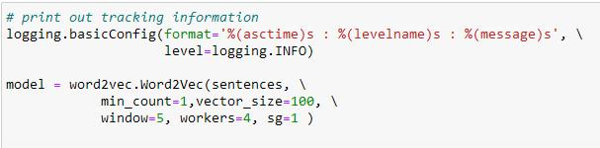

Fig. 1: Word embedding model and parameters.

The trained model is then used to determine which technical skills are present in the model vocabulary by comparing the ONET list of technical skills to the terms present in the vocabulary index using model.wv.most_similar().
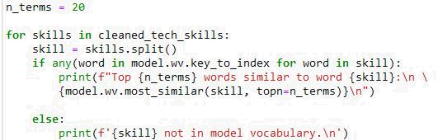

Fig. 2: Determining similarity between word embedding model vocabulary and technical skills.

After the model is trained, the sentences are vectorized by averaging the model word vectors for the sentence tokens present in the model vocabulary for further analysis.
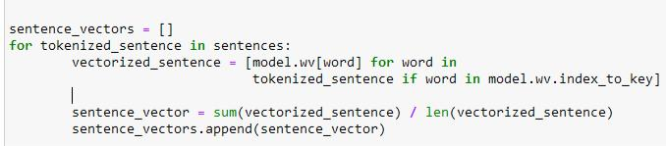

Fig. 3: Converting tokenized sentences into average word vectors.

K-MEANS CLUSTERING

After the word embedding model is trained and the average sentence vectors are created, K-Means clustering is used to try and separate information about soft skills, technical skills, and professional/occupational data such as benefits and government mandated disclaimers. For these reasons as well as experimental outcomes that are discussed in the next section, three clusters are used with n_init=20 different initial centroids.

The K-Means model is then fitted using the vectorized sentences. For each cluster, the centroids are extracted, and cosine similarity is used to calculate the angle between the centroids and embedded word vectors. The similarity scores are then sorted in descending order to find the index of the most similar words from the Word2Vec model in each cluster.
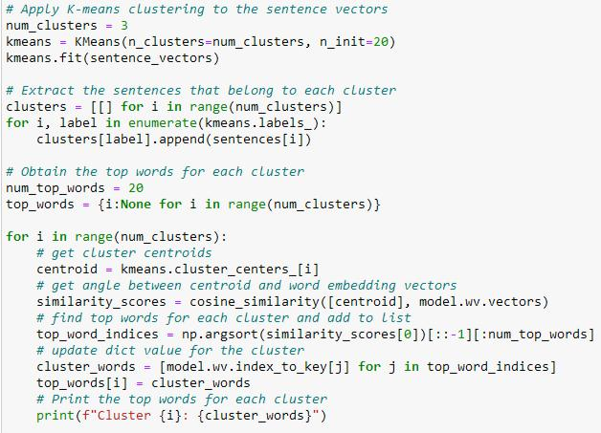

Fig. 4: K-Means clustering process and top cluster words extraction.
The cluster top words and respective sentences are examined to choose a technical skills cluster, soft skills cluster, and benefits/disclaimers cluster. The technical cluster sentences are then compared to the ONET skills lists to extract any technical skills mentioned and map back to their original document. The list of technical skills was also cleaned by dropping company-specific terms such as ‘Microsoft’, and non-unique identifiers like ‘framework’ to improve match accuracy.

To map the skills to their original documents, the number of sentences in each document’s job description are counted to determine which sentence indices belong to each document. A dictionary is then created of the sentence indices and technical skills that match values from the ONET list. A nested loop is used to compare each technical cluster sentence to and all corpus sentences. If a match is found, the cluster sentence’s corresponding skills list is attributed to its matching document by mapping the sentence index back to its document location to create a nested list of skills. The resulting nested lists are then flattened, or empty lists if no matches are found, and used to populate the df[‘tech_skills’] column.

d. RESULTS

N-GRAMS SEMANTIC ANALYSIS

Semantic analysis was conducted to better understand the variance of the data by visualizing the most common unigrams and tri-grams after removing most and least frequent terms and tokenizing the data. Even after this basic reduction, n-grams were not able to provide any useful insight into the most desirable skills. As shown in the graphic below, the unigrams semantic network graph was very dense, indicating high similarity between all documents. Most of the tokens are also very generic, such as ‘job’, and were uniform in size, indicating no tokens were more significant in describing the data than others.
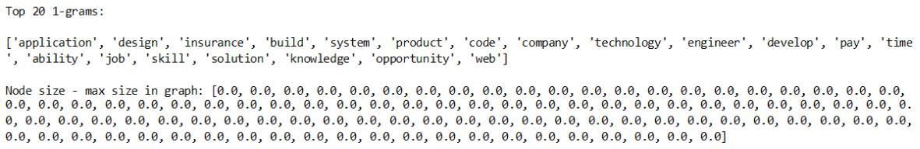
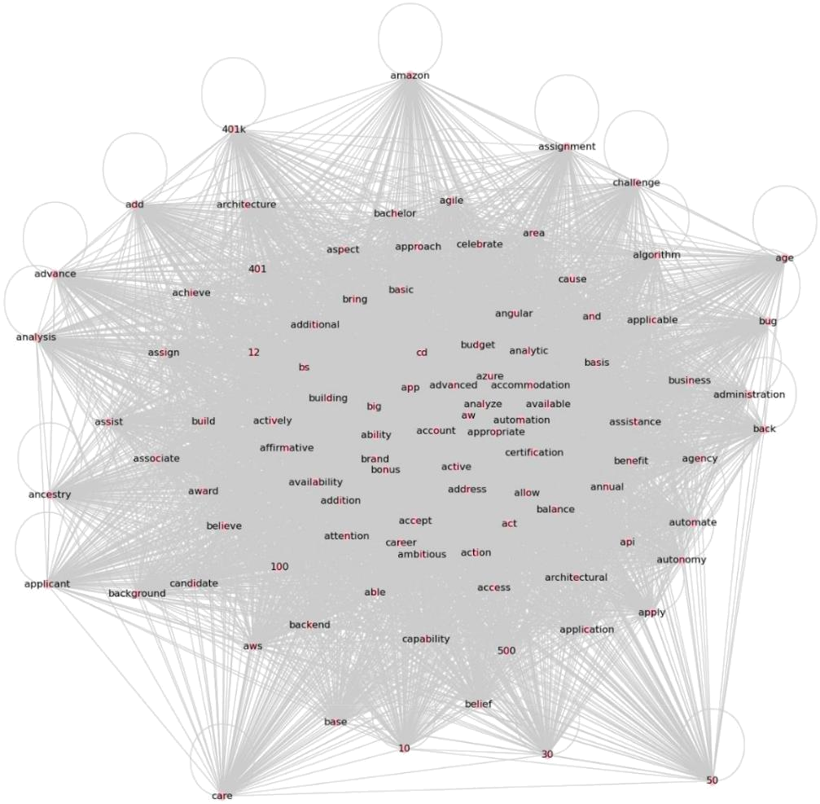

Fig. 5: Top unigrams, node sizes adjusted by average size, and resulting semantic network graph.

Trigrams were also examined, and while they did show more variety in contributions to the semantics of the data, including some technical skills like “2 python minimum’, most of the terms are related to 40lks or insurance benefits. This shows that a simple analysis model like TFIDF and n-grams is enough for extracting data about benefits and other occupational data. While this does not help in answering the research question, it indicates that clustering may be effective by helping separate the benefits-like data from skills related data.
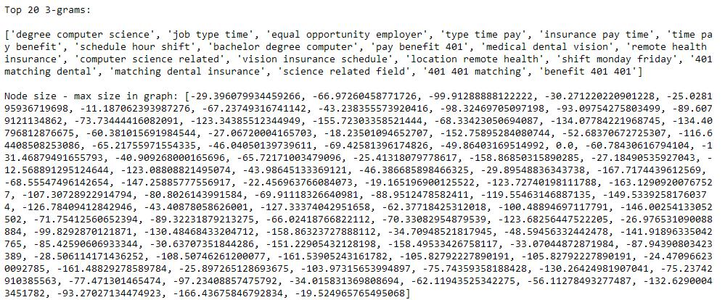
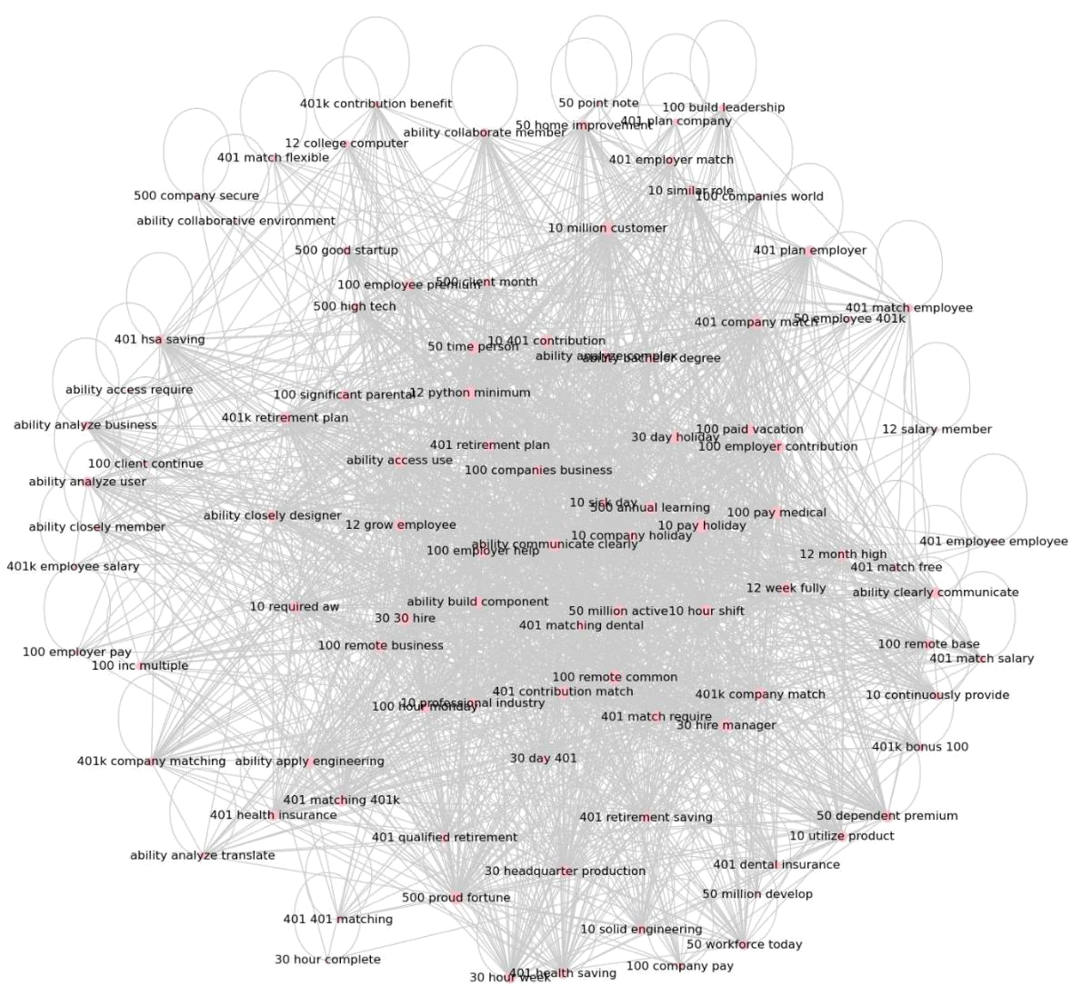

Fig. 6: Top unigrams, node sizes adjusted by average size, and resulting semantic network graph.

WORD EMBEDDING

Since the semantic network was not able to capture much useful information about the most popular soft skills and technical skills, word embedding was used to take advantage of the high similarity between documents to extract key vocabulary. The best performance was found by training the model with full sentences instead of n-grams with min_count=1, vector_size=100, window=5, and sg=1 to use a Skip-Gram (SG) model instead of Continuous Bag of Words (CBOW).

Initially, min_count=5 was used, but this caused issues in matching terms with both common and uncommon tokens, such as [‘oracle’, ‘java’], or [‘cascading’, ‘style’, ‘sheets’, ‘css’]. This was fixed by only keeping the name of tools like ‘css’ and ‘sql’ and dropping their full name, since it is very uncommon name for the tool, and considering matches to any words in the given skill’s token list. Reducing the minimum count also allowed the model to capture more matches and improved the results of finding the most similar words to each technical skill, where the best matches are mostly technical skills and related tools.
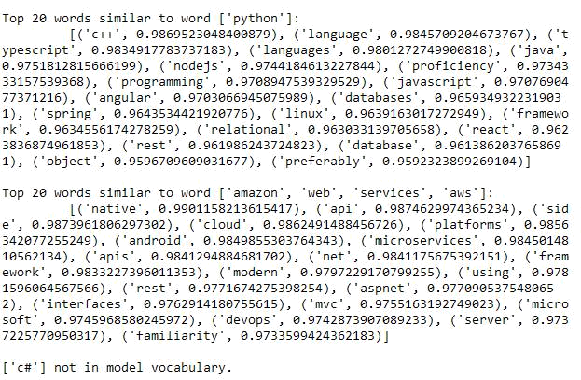

Fig. 7: Sample of top 20 similar word vectors to a given skill term.

Using these methods, the only terms that were usually not found in the model vocabulary were ‘c’ and ‘c#’, which is expected since ‘c’ is a single letter token, and only tokens at least 2 letters were kept to reduce variance and improve overall model performance. ‘c#’ was also difficult to capture, as the two characters were often separate within sentences and not recognized as a joined term.

Using a SG model instead of CBOW also greatly improved performance, specifically for K-Means clustering, due to the huge range of term frequencies. Without specifying SG, infrequent skills like ‘unix’ were not always found in the model vocabulary and led to a lack of separation of skills from high frequency terms like ‘javascript’ that caused overgeneralization of the specifications of each posting. This was concluded from mean of the average length of skill lists over 10 iterations. For CBOW the average was 1.87, while SG had an average of 3.69, which is almost double the amount of identifications.

K-MEANS CLUSTERING

K-Means clustering proved to be a relatively affective method for separating technical skills, soft skills, and professional/occupational data. The model was initially tested using 3,4, and 5 clusters. 3 clusters showed the best performance and was the only configuration that captured technical skills in the top cluster words. The most accurate cluster based on the top 50 words, shown below as ‘Cluster 1’, was the professional/occupational data. This is due to the high level of similarity from the government mandated disclaimers like ‘Equal Opportunity Employer’ and common benefits like ‘401k’ and ‘health insurance’.
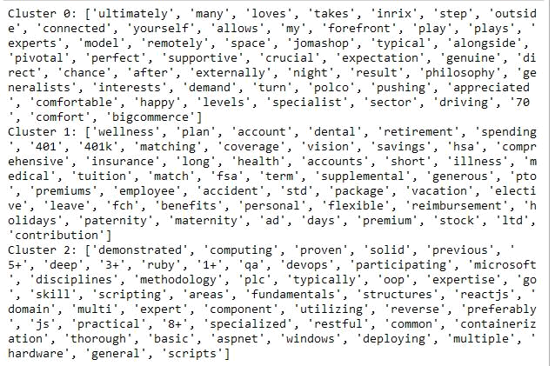

Fig. 8: Sample cluster top terms using word embedding and k-means.

Through K-Means clustering, it was also determined that it was best to keep stop words and numeric characters. The additional variance helped to clarify the separation between sentence sentiment and differentiate between soft skills and technical skills with specifications on years of experience like ‘2+’. As shown above, the technical skills cluster ('Cluster 2') and soft skills cluster ('Cluster 0’) both contained non-technical terms, so keeping stopwords and choosing to use min_count=1 for the sentence vector model also improved cluster separation. As seen below, the soft skills cluster contained the greatest range of sentence length and captured much of the company-specific data that had very low term-document frequency. The non-skilled data cluster had the highest accuracy, and very high similarity between sentence token lists.
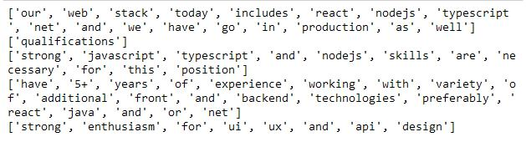

Fig. 9: Sample of 5 sentence vectors from the technical skills cluster.
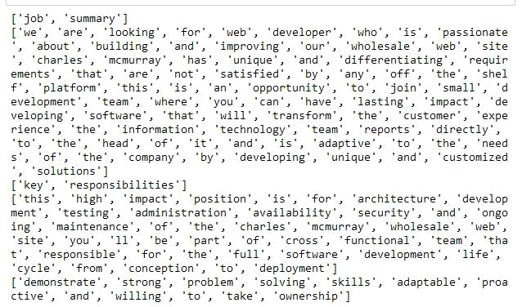

Fig. 10: Sample of 5 sentence vectors from the soft skills cluster.
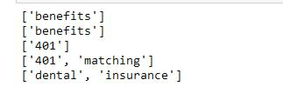

Fig. 11: Sample of 5 sentence vectors from the benefits/occupational cluster.

TECHNICAL SKILLS CORRELATION AND FREQUENCY

To examine the correlation between technical skills, location, and salary delta, a heatmap was created based on each technical skill. A bar chart was also created to show the frequency of skills identified across the entire dataset.
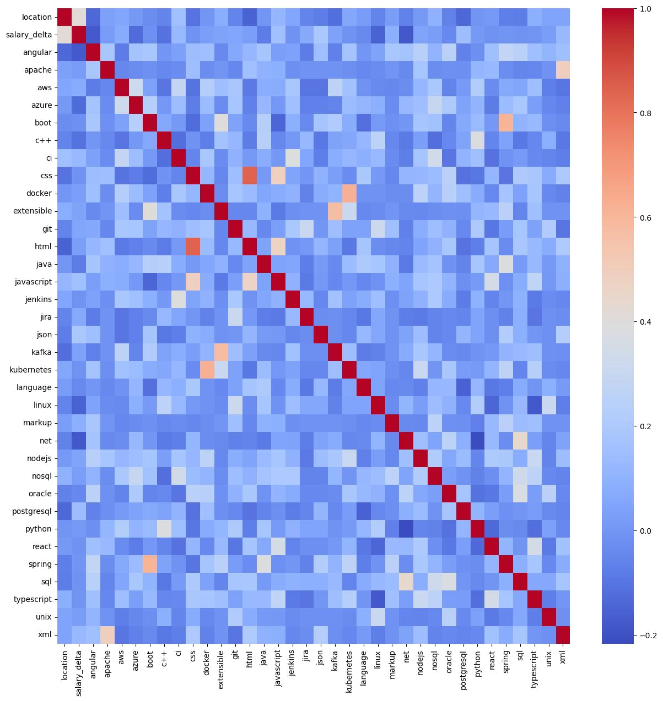

Fig. 12: Correlation between the ONET in-demand technical skills, salary delta, and location.
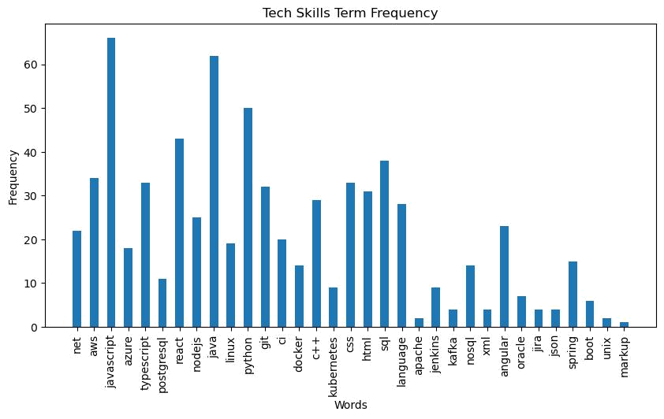

Fig. 13: Frequency of skills across 190 job postings.

The correlation matrix was able to capture some positive correlation between technical skills, such as ‘html’ and ‘css’, but overall showed little correlation between skills, location, and salary deltas. Based on the range of the frequency axis in the bar chart, the model needs more information and additional tuning to improve extraction rates of skills.

Based on the frequency chart, JavaScript, Java, Python, and SQL are the most popular technical skills across all postings. This aligns with the top technical skills given in the reference document, shown in the dataframe below.
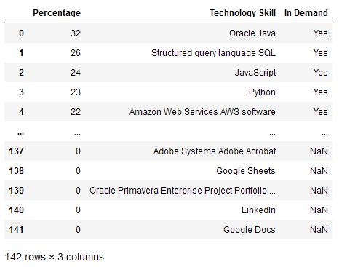

Fig. 14: ONET data of in-demand technical skills.
SOFT SKILLS MOST POPULAR CLUSTERS

Using the original n-grams similarity method, the list of soft skills and their cluster names pre-assigned from ONET were compared to the soft skills cluster sentences to get the top 20 popular soft skills. Their cluster assignments were then counted to find the top 3 clusters to determine the most “hirable” traits. The results are shown below.
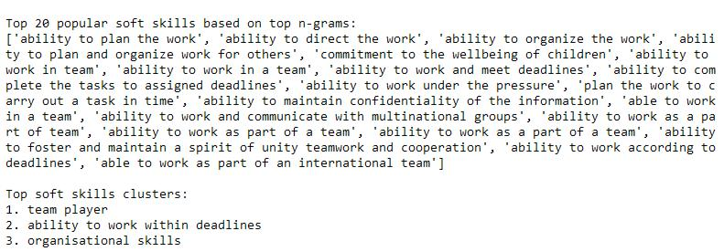

Fig. 15: Top soft skills and soft skill clusters based on n-gram cosine similarity.

DISCUSSION

After shifting from semantic analysis based on n-grams to word embedding and clustering using full sentences, the model performance greatly improved in capturing meaningful data and determining the most popular technical skills and soft skills. The greatest challenge came from the high level of similarity between job postings making it difficult to extract skills due to the high level of extraneous information. It was also difficult to decide on the level of “cleaning” to perform on the data, since there was so little variance present to guide cluster assignments. Increasing the n_init value for K-Means clustering made significant improvements to these issues and the confidence of assignments, as well as the number of posts with assigned skills.

Since there was no ground truth information on the hard and soft skills found in each job posting, it is difficult to determine the accuracy of these assignments. Based on the results of technical skills assignments, and some of the top skills like ‘commitment to the wellbeing of children’ not aligning with software engineering, the soft skills results suggest that further improvements to the models are needed.

As discussed in the K-Means results, the soft skills clusters captured a lot of information such as headers or company-specific words with low term-document frequency. This can lead to poor matching or over-assigning to skills that have more words like ‘commitment to the wellbeing of children’ while using cosine similarity as a metric. Changing the assignment methods or tuning of the Word2Vec() and clustering model can improve performance. Retraining the word embedding and K-Means models using only the soft skills and technical skills clusters could also improve clustering performance to separate outliers.

Looking at the actual rate of technical skills mapping, an average of 50 posts, or about 25% of the dataset did not have any assigned technical skills. After reading the missed posts, it was found that most of them were “misclassified”, meaning they had skills listed that were missed. No immediate pattern was found between these misclassifications, and further analysis of their similarities is necessary to understand how the skill assignments and cluster classifications can be improved.
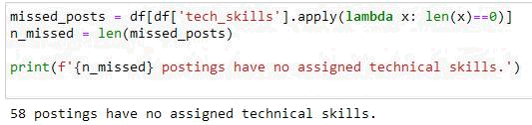

Fig. 16: Analysis of posts with no assigned technical skills.
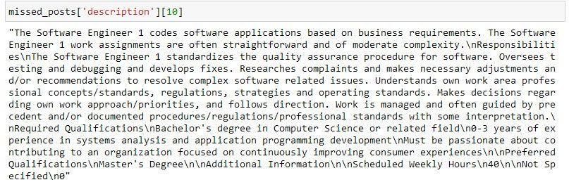

Fig. 17: Example of correctly classified posting with no assigned technical skills.
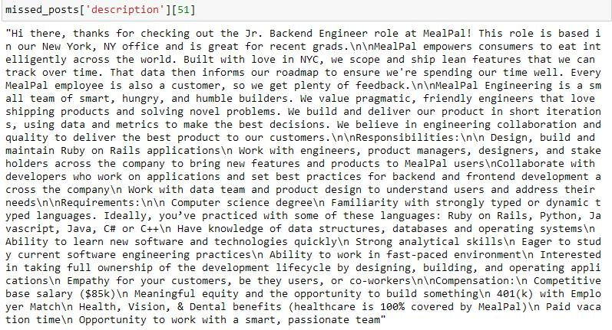

Fig. 18: Example of misclassified posting with no assigned technical skills.

Technical skill assignment issues can also be caused by the mapping of the skills to the documents, as well as the method of matching skills to sentences. Variation in how skills are listed and phrasing within postings, as well as skills being all listed in one sentence, caused issues with finding sentiment significance. Issues were also encountered with the names of tools having multiple meanings, such as ‘React’. Improved performance from changes to the model to deal with errors caused by term frequency or multiple meanings, such as switching to the SG model for word embedding, further point to the model not being able to fully separate the desired information.
Increasing the size of the corpus by adding another 105 posts also greatly improved results. The low variance in the data means that adding more information can be very effective in improving performance, but this also means that choosing the right parameters for data cleaning and modeling are even more essential. Using tools like GridSearchCV() would be helpful for comparing the effect of different parameters and determining where the largest source of error is in the data processing pipeline.
REFERENCES

Kim, SW., Gil, JM. Research paper classification systems based on TF-IDF and LDA schemes. Hum. Cent. Comput. Inf. Sci. 9, 30 (2019). https://doi.org/10.1186/s13673-019-0192-7

