**CHAPTER-1**

**COMPANY PROFILE**

**INFOWIZ** is a nationally recognized IT company which is committed to provide highly customized integrated IT solution to clients and also renowned for superior training programs delivered by an enviable team of qualified experts and highly experienced trainers.

INFOWIZ is an 8 years young organization which has won the NATIONAL AWARD for 2 consecutive years 2014-15 and 2015-16 for BEST Industrial Training from Hon’ble GOVERNOR of Punjab and Haryana Sh. Kaptan Singh Solanki. INFOWIZ is a member of Confederation of Indian Industry (CII membership number- N4654P) and also with an ISO Certification which has been working in the field of CSE, IT, ECE, MECHANICAL, CIVIL and EE, BBA & MBA.

Our skilled team of professionals make sure that the product is developed as per the customer’s needs and keeping the customer informed about the development of their project from time to time. In INFOWIZ our Research & Development arm offers SEO tools for SEM professionals.

INFOWIZ also provides Technical Support & Consultancy to Software Companies like JIA Group, New Zealand, Sagitech solutions Panchkula, Jarc infotech Mohali, Infonet Solution, Delhi etc.

**Company Strategy**

Purpose: - To be a leader in IT industry by providing enhanced services relationships and profitability. We continuously strive to deliver exceptional services and achieve excellent results throughout different sectors.

**Our Mission**

To grow through creativity invention and innovation and to build long term relationships with our clients and provide exceptional customer services by pursuing business through innovation and advances technology.

**OUR VISION**

Our vision is to be recognized as a leading provider of quality services that exceed the expectations of our esteemed clients.

**OUR VALUES**

* Putting Customers First.
* Taking pride in what we do.
* Respecting Others.
* Striving to be the Best.
* Acting with Integrity.

**Our Hottest Clients & Projects: -**

|  |  |  |
| --- | --- | --- |
| **PROJECTS** | **URL's** | **COUNTRY** |
| Viva Sales | www.[infowiz.in/vivasales](http://infowiz.in/vivasales) | UK |
| Mds Creative | www.mdscreative.com | Germany |
| Liddle TV | www.filmon.com | UK |
| Paradigms (Android) | Running | Australia |
| Printcost | www.popgraphics.net | UK |
| PSTDO Bootstrap | www.bootstrap.achieversperfect.com | USA |
| Essencesoftwares | www.essencesoftwares.com | Australia |
| Dashboard (WordPress) | Running | USA |
| Realstate | www.realestate.infowiz.in | Russia |
| Dealpartner (WordPress) | www.dealpartners.co.uk.gridhosted.co.uk | UK |
| Littleton vineyard | www.littletonvineyard.net | USA |
| Gpakoffshore | www.gpakoffshore.com | UK |

**OUR TEAM: -**

Real Generosity toward the future consists in giving all to what is present.

INFOWIZ’s consultative approach can transform your challenge into dynamic business positives.

1) Mr. Kamaljot Kansal (**C.E.O**)

He is the backbone of INFOWIZ and a man with more than 11-year rich practical experience; who believes the Idea that “if you don’t design your own life plan chances are you will fall into someone else plan”.

2) Dr. Seema Kansal **(Managing Director)**

A woman believes that "the harder you work the luckiest you become." She has more than 8 years’ experience in Business Field.

3) Mr. Rajeev Nayyar (**General Manager**)

A man who strongly feel that “opportunities don’t happen, you create them ". A very committed team leader who has been professionally attached with Multinational companies for more than 18 years and has lead the marketing teams in all states of North India.

4) Mr. Surneel Goyal **(Branch Manager)**

A man who believes that "Things work out best for those who make the best of how things work out". He has more than 4 years solid industrial experience in software companies & is very dashing and innovative in His technical approach.

5) Ms. Urvashi (**Dean Academics)**

A woman who possess element of talent which is the most crucial ingredient of recipe of success. She has more than 3 years’ experience in business development.

6) Er. Vishal Goyal (**Head & Technical Advisor at US Branch**)

He has more than 10 years industrial experience in US and smooth handling of the entire US business.

7) Er. Yukti Jindal (**Center Head- US Branch**)

A woman who firmly believes that "In life, where you reach largely depends upon where you start." She joined this branch in the year 2007 and has given her immense inputs in bringing the company to its present status.

**CHAPTER-2**

**TECHNOLOGY USED**

**2.1 THE WEB AND HTML:**

World Wide Web (WWW) programming deals with the development of hypertext document interaction mechanisms, which provide the client with a rich and intuitive interface to the information that he or she desires to view. Web development heavily utilizes the functionality of the Hypertext Markup Language, commonly known as HTML. HTML is a simple scripting language that is interpreted within a web browser. It provides functionality to identify and specify how information is presented to the user. Some of the important features of HTML that make it ideal for online representation of information are –

* Ease of Use – HTML constructs are very easy to comprehend and can be used effectively by anybody.
* Machine Independence – The methodology used by HTML to markup information is independent of its representation on a particular hardware or software architecture.
* Standardization – HTML syntax is a worldwide standard, developed by the W3C
* Flexible – HTML has been extended in many forms to provide additional functionality.

HTML stands for **H**yper**t**ext **M**arkup **L**anguage, and it is the most widely used language to write Web Pages.

* **Hypertext** refers to the way in which Web pages (HTML documents) are linked together. Thus, the link available on a webpage is called Hypertext.
* As its name suggests, HTML is a **Markup Language** which means you use HTML to simply "mark-up" a text document with tags that tell a Web browser how to structure it to display.

**2.1.1 Tag & Description**

1. **<! DOCTYPE...>**

This tag defines the document type and HTML version.

1. **<HTML>**

This tag encloses the complete HTML document and mainly comprises of document header which is represented by <head>...</head> and document body which is represented by <body>...</body> tags.

1. **<HEAD>**

This tag represents the document's header which can keep other HTML tags like <title>, <link> etc.

1. **<TITLE>**

The <title> tag is used inside the <head> tag to mention the document title.

1. **<BODY>**

This tag represents the document's body which keeps other HTML tags like <h1>, <div>, <p> etc.

1. **<H1>**

This tag represents the heading.

1. **<P>**

This tag represents a paragraph.

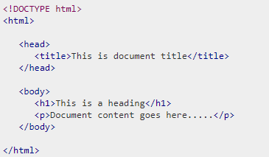

**2.2.2 Relative and Absolute Links**

Relative and absolute links are styles of links that one finds connecting a web page to other pages, files, etc. Relative links look like this /~abetting/htmlprimer.html. They consist of telling the link where to find what it is looking for but leave out the server that the page is attached to because the original page and the one being sought after are in the same directory (folder or server). The same link in absolute line format would look like this http:/serendip.brynmawr.edu/~abetting/htmlprimer.html. It includes the complete web address of the sought-after page. They accomplish the same goal, but each has its advantages and disadvantages. If you move a folder with web pages with relative links to a new server, then nothing will happen, and all the links will remain stable. But if you were to only move one of those pages, then its links would be broken because the other pages would be in a different directory.

**The Basic Tags**

1) <Html></html>---begins and ends web document, tells the browser that the document is in HTML

2) <Head></head>---header, used after html tag

3) <Title></title>---located within header container

4) <Body></body>---creates the body of the document body attributes---to be used within <body> tag

5) background="sample.jpg"---background picture  
6) bgcolor="color"---background color  
7) text="color"---text color  
8) link="color"---active link color  
9) vlink="color"---visited link  
10) bgproperties---when equal to "fixed", background does not scroll  
11) top margin---sets height of top margin  
12) left margin---sets width of left margin(not used in Netscape)

13) <Address></address>---place your name and date of page creation within at bottom of page.

### Document Formatting Tags

1) <p>---place at the end of a paragraph, it will then skip a line for the next paragraph

2) <align=left, right, center></align>---alignment

3) <br>---line break, it will begin again on the next line.

4) <nobr></nobr>---no line breaks are allowed to occur within the container (be careful)

5) <wbr>---gives the browser suggestions for where a break should occur if needed, use within the <nobr> tag

6) <h1></h1>---heading style, choose from sizes 1(largest)-6(smallest)

7) <Hr>horizontal line horizontal line attributes--- to be used within the <hr>

8) align=left, right, center---alignment  
9) width=---in percentages or pixels  
10) size=---thickness, in pixels  
11) no shade---keeps browser from using 3D effects on line  
12) color="color"---line color

13) <Pre></pre>---for preformatted text, comes up as moonscape

14) &lt and &gt---represent < and > without the functionality, so you can display them without being interpreted as commands

### Text Formatting Tags

1) <i></i>---italics

2) <b></b>---bold

3) <u></u>---underline

4) <tt></tt>---teletype, moonscape text

5) <Block quote></block quote>---formatted for quoted text

6) <Strike></strike>---strikethrough style

7) <Big></big>---bigger text

8) <Small></small>---smaller text

9) <Sub></sub>---subscript

10) <Sup></sup>---superscript

11) <font face="font name"></font>---to select specific font

12) <font size=1></font>---font size, sizes 1-7

13) <font color=["color"](http://serendip.brynmawr.edu/serendip/htmlprimer.html#colortable#colortable)></font>---font color

14) <Base font>---the font for the document, can use face, size and color with it.

### Graphics Formatting Tags

1) <img src="filename">---Places an image within your document, review relative vs. absolute links. Image attributes

2) align=top,middle,bottom---align text with picture's top, middle, or bottom  
3) align=left, right---place picture on left or right and wrap text around it  
4) width, height=---in pixels or percentage, dimensions of picture can be altered (be careful with the ratio if using pixels)  
5) alt=---description of the picture so that text-only browsers know what it is  
6) border=---in pixels, border around the picture  
7) vspace,hspace=---in pixels, empty space around picture

**Linking Tags**

1) <a href="http://serendip.brynmawr.com/text.html">text link</a>---text link, absolute link

2) <a href="text.html">text link</a>---text link, relative link

3) <base href="http://serendip.brynmawr.com">---gives web site for all relative links

4) <a href="http://serendip.brynmawr.com"><img src="sample.jpg"></a>---graphic link

5) <a name=middle>middle section of web page</a>---internal anchor

6) <a href="#middle">jump to the middle</a>---link to the internal anchor

7) <a href="mailto:me@serendip.brynmawr.edu"></a>---link to email

8) <a href="news: news. newuser. questions"></a>---link to UseNet group

9) <a href="ftp://ftp.mysite.com/pub/FAQ"></a>---link to ftp

10) <a href="gopher://gopher.mysite.com"></a>---link to gopher site

### Creating Lists

1) <ol></ol>---ordered lists Ordered List Attributes

2) Compact---makes list more compact  
3) type=A---uses uppercase letters  
4) type=a---uses lowercase letters  
5) type=I---uppercase roman numerals  
6) type=i---lowercase roman numerals  
7) type=1---uses numbers  
8) start=n---uses n as beginning of that set

9) <li></li>---list item

10 <lh></lh>---list header

11) <ul></ul>---unordered list Unordered List Attributes

12) Type=square---closed square bullet  
13) type=circle---open circle bullet

14) Type=disc---closed circle bullet  
---to replace the bullets with an image us <img src...> instead of <li>

15) <Menu>---basically works the same as unordered list

16) <Dl>---definition list; can use term: compact for effect (but not all browsers support this)

17) <dt>---definition term

18) <dd>---definition itself

### Tables

1) <Table></table>---table tag Table attributes---all of which can refer to the whole table or single cell (by using <th>, <td>, <tr>)

2) Border=---in pixels  
3) align=left, right, center---alignment of data within the cells.  
4) valign=top, middle, bottom---vertical alignment of data within the cells  
5) width/height=---in pixels, of table or individual cells  
6) cellpadding/cellspacing=---in pixels, adds space within cell/border  
7) border color/bgcolor="color"---will change table, row, or cell border/background color, use with td, th, and tr tags  
8) rowspan/colspan---allows one cell to occupy more than one "cellblock"

<Th></th>---table header within the cells-can use valign=top/middle/bottom and 9) <td></td>---table data within the cells-can use valign=top/middle/bottom and align=left/right/center

10) <TR></tr>---table row

11) <Caption></caption>---places a caption, either above or below <table align=top/bottom>

**Hexadecimal Color System**

|  |  |  |  |  |  |  |  |
| --- | --- | --- | --- | --- | --- | --- | --- |
| Black | #000000 | Maroon | #800000 | Green | #008000 | Olive | #808000 |
| Navy | #000080 | Purple | #800080 | Teal | #008080 | Gray | #808080 |
| Silver | #C0C0C0 | Red | #FF0000 | Lime | #00FF00 | Yellow | #FFFF00 |
| Blue | #0000FF | Fuchsia | #FF00FF | Aqua | #00FFFF | White | #FFFFFF |

### Frames

1) <Frameset></frameset>---to designate use of frames, but will be ignored if <body> tag is present Frameset Attributes---found within the <frameset> tag

2) rows/cols=---in pixels/percentages/proportions, pixels set an absolute distance while the other two give relative distances

3) Border=---in pixels assigns a width to all frames

4) Frame border=yes, no---default is yes for a 3-D look, no turns off the effect

5) Border color="color"---defines color for all frame borders

6) <Frame>---defines each individual frame, and there must be one per created frame Attributes---found within the <frame> tag

7) Src=---must use URL of either a HTML document or picture, text alone cannot be used

8) Name=---assigned to each frame so that they can be linked to from other frames

9) Target=---it designates which frame a new link will be opened up within when used in the <a href> tag

="_blank"---will launch a new browser window with the link's contents

="_self"---will replace the frame with the link's contents

="_parent"---the frameset will be replaced by link's contents

="_top"---replaces current browser window with link's contents

10) Scrolling=yes, no, auto---auto is the default, but the scrollbars can be turned on or off when possible

11) Margin width/height=---in pixels, area within border where source content will not be shown

12) No resize---prevents users from resizing individual and adjacent frames, in order to preserve layout

13) Bordercolor="color"---defines color for individual frame border

**2.2 CSS:**

**C**ascading **S**tyle **S**heets, fondly referred to as CSS, is a simple design language intended to simplify the process of making web pages presentable.

CSS handles the look and feel part of a web page. Using CSS, you can control the color of the text, the style of fonts, the spacing between paragraphs, how columns are sized and laid out, what background images or colors are used, layout designs, variations in display for different devices and screen sizes as well as a variety of other effects.

CSS is easy to learn and understand but it provides powerful control over the presentation of an HTML document. Most commonly, CSS is combined with the markup languages HTML or XHTML.

## 2.2.1 ADVANTAGES OF CSS:

* **CSS saves time** − You can write CSS once and then reuse same sheet in multiple HTML pages. You can define a style for each HTML element and apply it to as many Web pages as you want.
* **Pages load faster** − If you are using CSS, you do not need to write HTML tag attributes every time. Just write one CSS rule of a tag and apply it to all the occurrences of that tag. So, less code means faster download times.
* **Easy maintenance** − To make a global change, simply change the style, and all elements in all the web pages will be updated automatically.
* **Superior styles to HTML** − CSS have a much wider array of attributes than HTML, so you can give a far better look to your HTML page in comparison to HTML attributes.
* **Multiple Device Compatibility** − Style sheets allow content to be optimized for more than one type of device. By using the same HTML document, different versions of a website can be presented for handheld devices such as PDAs and cell phones or for printing.
* **Global web standards** − Now HTML attributes are being deprecated and it is being recommended to use CSS. So, it’s a good idea to start using CSS in all the HTML pages to make them compatible to future browsers.
* **Offline Browsing** − CSS can store web applications locally with the help of an offline catche. Using of this, we can view offline websites. The cache also ensures faster loading and better overall performance of the website.
* **Platform Independence** − The Script offer consistent platform independence and can support latest browsers as well.

## 2.2.2 CSS Versions:

Cascading Style Sheets, level 1 (CSS1) was came out of W3C as a recommendation in December 1996. This version describes the CSS language as well as a simple visual formatting model for all the HTML tags.

CSS2 was became a W3C recommendation in May 1998 and builds on CSS1. This version adds support for media-specific style sheets e.g. printers and aural devices, downloadable fonts, element positioning and tables.

CSS3 was became a W3C recommendation in June 1999 and builds on older versions CSS. It has divided into documentations is called as Modules and here each module having new extension features defined in CSS2.

### CSS3 Modules

CSS3 Modules are having old CSS specifications as well as extension features.

* Selectors
* Box Model
* Backgrounds and Borders
* Image Values and Replaced Content
* Text Effects
* 2D/3D Transformations
* Animations
* Multiple Column Layout
* User Interface

# 2.2.3 CSS – Syntax:

A CSS comprises of style rules that are interpreted by the browser and then applied to the corresponding elements in your document. A style rule is made of three parts −

* **Selector** − A selector is an HTML tag at which a style will be applied. This could be any tag like <h1> or <table> etc.
* **Property** - A property is a type of attribute of HTML tag. Put simply, all the HTML attributes are converted into CSS properties. They could be *color*, *border* etc.
* **Value** - Values are assigned to properties. For example, *color* property can have value either red or #F1F1F1 etc.

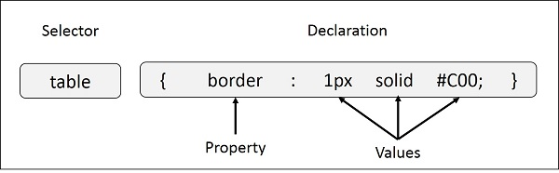

## 2.2.4 Three Ways to Insert CSS:

* External style sheet
* Internal style sheet
* Inline style

## External Style Sheet

With an external style sheet, you can change the look of an entire website by changing just one file! Each page must include a reference to the external style sheet file inside the <link> element. The <link > element goes inside the <head> section:

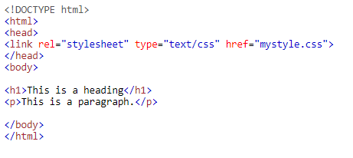

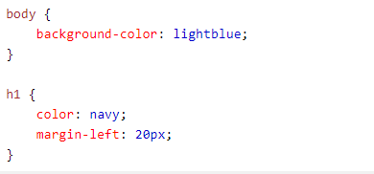

## Internal Style Sheet

An internal style sheet may be used if one single page has a unique style.

Internal styles are defined within the <style> element, inside the <head> section of an HTML page:

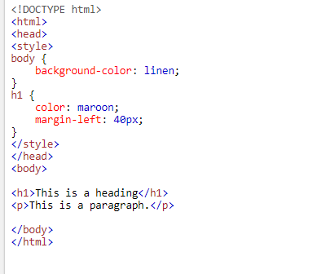

## Inline Styles

An inline style may be used to apply a unique style for a single element.

To use inline styles, add the style attribute to the relevant element. The style attribute can contain any CSS property.

The example below shows how to change the color and the left margin of a <h1> element:

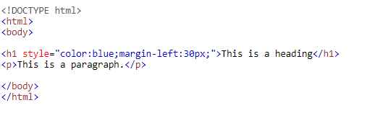

**2.3 PHP:**

PHP started out as a small open source project that evolved as more and more people found out how useful it was. Rasmus Lerdorf unleashed the first version of PHP way back in 1994.

* PHP is a recursive acronym for "PHP: Hypertext Preprocessor".
* PHP is a server-side scripting language that is embedded in HTML. It is used to manage dynamic content, databases, session tracking, even build entire e-commerce sites.
* It is integrated with a number of popular databases, including MySQL, PostgreSQL, Oracle, Sybase, Informix, and Microsoft SQL Server.
* PHP is pleasingly zippy in its execution, especially when compiled as an Apache module on the UNIX side. The MySQL server, once started, executes even very complex queries with huge result sets in record-setting time.
* PHP supports a large number of major protocols such as POP3, IMAP, and LDAP. PHP4 added support for Java and distributed object architectures (COM and CORBA), making n-tier development a possibility for the first time.
* PHP is forgiving: PHP language tries to be as forgiving as possible.
* PHP Syntax is C-Like.

## Common uses of PHP

* PHP performs system functions, i.e. from files on a system it can create, open, read, write, and close them.
* PHP can handle forms, i.e. gather data from files, save data to a file, through email you can send data, return data to the user.
* You add, delete, and modify elements within your database through PHP.
* Access cookies variables and set cookies.
* Using PHP, you can restrict users to access some pages of your website.
* It can encrypt data.

## Characteristics of PHP

Five important characteristics make PHP's practical nature possible −

* Simplicity
* Efficiency
* Security
* Flexibility
* Familiarity

## What Can PHP Do?

* PHP can generate dynamic page content
* PHP can create, open, read, write, delete, and close files on the server
* PHP can collect form data
* PHP can send and receive cookies
* PHP can add, delete, modify data in your database
* PHP can be used to control user-access
* PHP can encrypt data

With PHP you are not limited to output HTML. You can output images, PDF files, and even flash movies. You can also output any text, such as XHTML and XML.

**Details of PHP:** PHP is a server-side, cross-platform, HTML-embedded scripting language. Currently there are over half a million domains running PHP and it is freely available for download online from [www.php.net](http://www.php.net). Much of PHP’s syntax is borrowed from C, Java and Perl with a couple of unique PHP-specific features thrown in. The goal of the language is to allow web developers to write dynamically generated pages quickly. PHP eliminates the need for numerous small CGI programs by allowing you to place simple scripts directly in your HTML files. It also makes it easier to manage large web sites by placing all components of a web page in a single html file.

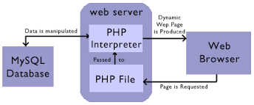

Figure 2.3.1 PHP

For example, if you are creating an online catalog, you will most likely have a design template for all related catalog pages. Traditionally, this design is generated by hand in HTML and different data is presented within the template design. With PHP, one application can be used to generate all the pages required to display items from a database in the proper pages, in the right locations, and with the appropriate related content. This eliminates redundant page generation, simplifying maintenance. PHP also reduces the site down to a handful of template pages, with scripts that generate the rest of the site.

PHP is an excellent alternative to such similar programming solutions as Microsoft's proprietary scripting engine ASP and Allaire's rather expensive ColdFusion. As mentioned before, PHP is a cross-platform language. This doesn't stop with the core PHP code but can be extended to all of PHP's libraries and all code written in PHP. Neither ASP nor ColdFusion can make this claim. PHP has a large feature set which includes built-in support for numerous databases (including Access, LDAP, Oracle, and MSSQL), networking support, zip archiving, and an excellent set of built-in functions. Furthermore, due in part to it being open source and freely available for download on the web, the language enjoys an active developing environment. Since the syntax structure borrows heavily from C, it is easy for even the novice programmer to learn the language. PHP is also the oldest HTML-embedded scripting language, giving it a head start on all the others.

If you are a content developer, you probably won’t want to learn PHP scripting by heart. But, it is nice to know how PHP can help you create more powerful web applications and user-friendly designs.

When you create a PHP application, you create PHP script files which are plain text files comprising a combination of standard HTML code and script commands. While web servers normally send HTML files directly to the client’s web browser in response to HTTP (Hypertext Transfer Protocol) requests, the web server first processes the content of PHP scripts before sending output to clients.

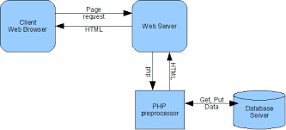

Figure 2.3.2 PHP Working

Within a PHP script, standard HTML code is sent directly to the browser, while script commands are executed locally on the web server. The script output can then be sent to the browser as standard HTML.

|  |
| --- |
| <HTML>  <HEAD><TITLE>My First PHP Script</TITLE></HEAD>  <BODY>  <? echo("Hello World!<P>"); ?>  </BODY>  </HTML>[[Description: [ Run Script ]](http://www.webguys.com/pdavis/Programs/What_Is_PHP/First.php3)](http://www.webguys.com/pdavis/Programs/What_Is_PHP/First.php3) |

 Note the two <? --?> tags in the above text. This syntax indicates PHP commands that are interpreted by the server instead of being passed to the client. You may jump in and out of PHP mode in an HTML file like this all you want. This program is extremely simple, and you really didn't need to use PHP to create a page like this. All it does is display "Hello World" using the ECHO command. With ECHO you can print out strings enclosed in quotes, variables, or a combination of both. At the end of the ECHO command you will see a semicolon (;). Almost every PHP command must end in a semicolon (;).

|  |
| --- |
| <HTML>  <HEAD><TITLE>My First PHP</TITLE></HEAD>  <BODY>  Hello World!  </BODY>  </HTML> |

As you see, the scripting commands are not visible on the client side. This is good because it keeps the source code for the PHP protected. This means the original PHP code cannot be downloaded and copied without permission. So, let's try something useful by generating a table of font colors generated on the fly. If you were to do this by hand it would take a very long time, with PHP it only takes a very few well-placed lines of code.

|  |
| --- |
| <HTML>  <HEAD><TITLE>PHP Font Chart</TITLE></HEAD>  <BODY>  <TABLE>  <?  for ($iR = 0; $iR <= 255; $iR += 51) {  for ($iG = 0; $iG <= 255; $iG += 51) {  ?>  <TR>  <? for ($iB = 0; $iB <= 255; $iB += 51) {?>  <TD>  <FONT COLOR="<? printf ("%02X%02X%02X", $iR, $iG, $iB); ?>">  Font #<? printf ("%02X%02X%02X", $iR, $iG, $iB);?>  </FONT>  </TD>  <? } ?>  </TR>  <? } } ?>  </TABLE>  </BODY>  </HTML> |

* **Back-end Selection:**

1. Multiple user support.

2. Efficient data handling.

3. Provide inherent features for security.

4. Efficient data retrieval and maintenance.

5. Stored procedures.

6. Popularity.

7. Operating System compatible.

8. Easy to install.

9. Various drivers must be available.

10. Easy to implant with the Front-end.

According to above stated features we selected MySQL Server v5.6.14 as the backend.

The technical feasibility is frequently the most difficult area encountered at this stage. It is essential that the process of analysis and definition be conducted in parallel with an assessment to technical feasibility it centers on the existing computer system (hardware, software etc.) and to what extent it can support the proposed system.

**2.4 JAVA SCRIPT:**

Java script is one of the most simple, versatile and effective languages used to extend functionality in websites. Uses range from on screen visual effects to processing and calculating data on web pages with ease as well as extended functionality to websites using third party scripts among several other handy features, however it possesses some negative effects that might make you want to think twice before implementing JavaScript on your website.

**Advantages:**

* **JavaScript is executed on client side**   
  this means that the code is executed on the user's processor instead of the web server thus saving bandwidth and strain on the web server.
* **JavaScript is relatively easy language**   
  The JavaScript language is relatively easy to learn and comprises of syntax that is close to English. It uses the DOM model that provides plenty of prewritten functionality to the various objects on pages making it a breeze to develop a script to solve a custom purpose.
* **JavaScript is relatively fast to end users**   
  As the code is executed on the user's computer, results and processing is completed almost instantly depending on the task as it does not need to be processed in the site's web server and sent back to the user consuming local as well as server bandwidth.
* **Extended functionality to web pages**   
  Third party add-ons like Grease monkey enable JavaScript developers to write snippets of JavaScript which can execute on desired web pages to extend its functionality. If you use a website and require a certain feature to be included, you can write it yourself and use an add-on like grease monkey to implement it on the web page.

**Disadvantages:**

* **Security Issues:**

JavaScript snippets once appended onto web pages execute on client servers immediately and therefore can also be used to exploit the user's system. While certain restriction is set by modern web standards on browsers, malicious code can still be executed complying with the restrictions set.

**2.5 MYSQL:**

Among the many application development and end user products available within the MYSQL family there is a common ability to access the database. Whether directly or in directly this is achieved through the Structured Query Language (SQL). These query languages have been useful in developing the software in an efficient way. The Query language has Data Definition Language (DDL), Data Manipulation Language (DML) and Data Control Language (DCL).

**Data definition language** helps in defining various database objects such as Tables and views. This has been useful in defining all the relational tables of the project. It has also been used in creating many views providing for information hiding and data security. Data Definition Language (DDL) also supports alteration of the existing tables.

**Data Manipulation Language** (DML) is the most important of the query Language. This has features for inserting records into the tables, deleting the existing records from the tables, updating the existing records in the tables and retrieving the data from one or more tables as and when required. This has been used to fulfill the objectives of the organization. Other packages like FoxPro and dbase do not have such features and hence make the job of querying more complex.

**Data Control Language** (DCL) is used for controlling data and having access to the databases. This part of the language provides extensive security features in order to safe guard the users information from both unauthorized access and intentional damage. Granting and revoking privileges provide security. Oracle uses have names and passwords and own tables, views and other database objects.

| Character Data Types | | |
| --- | --- | --- |
| **Data Types** | **Description** | **Range/Format** |
| CHAR | Fixed-length string | 0–255 characters. |
| VARCHAR | Variable-length string | 0–255 characters. |
| BLOB | Binary Large Object (BLOB) | Binary data 0–65535 bytes long. |
| TINYBLOB | Small BLOB value | Binary data 0–255 bytes long. |
| MEDIUMBLOB | Medium-sized BLOB | Binary data 0–16777215 bytes long. |
| LONGBLOB | Large BLOB value | Binary data 0–4294967295 bytes long. |
| TEXT | Normal-sized text field | 0–65535 bytes. |
| TINYTEXT | Small text field | 0–255 bytes. |
| MEDIUMTEXT | Medium-sized text | 0–16777215 bytes. |
| LONGTEXT | Large text field | 0–4294967295 bytes. |
| ENUM | Enumeration | Column values are assigned one value from a set list. |
| SET | Set value(s) | Column values are assigned zero or more values from a set list. |

| SQL Modifiers | |
| --- | --- |
| **Modifier** | **Description** |
| AUTO_INCREMENT | Allows a numeric column to be automatically updated when records are added. Useful for creating a unique identification number for each row. |
| DEFAULT value | Specifies the default value for a column. |
| NULL | Specifies that a column may contain undefined, or NULL, values. |
| NOT NULL | Requires that the column must contain a non-NULL value. |
| PRIMARY KEY | Makes the column the primary key. It must also have a NOT NULL modifier. |

**2.5.1 SQL SERVER:**

SQL Server is an SQL-compliant RDBMS. SQL-compliant means it uses the ANSI (American National Standard Institute) version of Structured Query Language or ‘SQL’. Structured Query Language is a command that allow us to modify or retrieve information from the database. Client server means that SQL Server is designed to store data in the central location (the server) and deliver it on demand to numerous other locations (the client). SQL Server is also a Relational Database Management System (RDBMS).

**2.5.2 Features of SQL Server:**

* Information representation
* Unique definition of rows
* Systematic treatment of Null values
* Guaranteed access
* High level Update, Insert, and Delete
* Retrieving information from the database.
* Accepting query language statements.
* Enforcing security specifications.
* Enforcing data integrity specification
* Enforcing transaction consistency
* Managing data sharing
* Optimizing queries

**2.5.3 Enterprise Manager:**

SQL Server Enterprise Manager is a graphical tool that allows easy configuration and management of Microsoft SQL Server and SQL program group.

SQL Server Enterprise Manager can also be used to:

1. Manage logins, permission and users.

2. Create a database

3. Take back-up of database and transaction logs.

4. Manage tables

.

**CHAPTER-3**

**INTRODUCTION TO SOFTWARE**

**3.1 Introduction to Dreamweaver**

Adobe Dreamweaver is a [proprietary](http://en.wikipedia.org/wiki/Proprietary_software) [web development](http://en.wikipedia.org/wiki/Web_development) [application](http://en.wikipedia.org/wiki/Application_software) developed by [Adobe Systems](http://en.wikipedia.org/wiki/Adobe_Systems). Dreamweaver was originally developed by [Macromedia](http://en.wikipedia.org/wiki/Macromedia) in 1997 and was maintained by them until Macromedia was acquired by Adobe Systems in 2005.

Adobe Dreamweaver is available for both [Mac](http://en.wikipedia.org/wiki/Mac_OS_X) and [Windows](http://en.wikipedia.org/wiki/Microsoft_Windows) [operating systems](http://en.wikipedia.org/wiki/Operating_system).

Following Adobe's acquisition of the Macromedia product suite, releases of Dreamweaver subsequent to version 8.0 have been more compliant with [W3C](http://en.wikipedia.org/wiki/World_Wide_Web_Consortium) standards. Recent versions have improved support for [Web](http://en.wikipedia.org/wiki/World_Wide_Web) technologies such as [CSS](http://en.wikipedia.org/wiki/Cascading_Style_Sheets), [JavaScript](http://en.wikipedia.org/wiki/JavaScript), and various [server-side scripting](http://en.wikipedia.org/wiki/Server-side_scripting) [languages](http://en.wikipedia.org/wiki/Programming_language) and [frameworks](http://en.wikipedia.org/wiki/Software_framework) including [ASP](http://en.wikipedia.org/wiki/Active_Server_Pages) (ASP JavaScript, ASP VBScript, ASP.NET C#, ASP.NET VB), [ColdFusion](http://en.wikipedia.org/wiki/ColdFusion), [Script let](http://en.wikipedia.org/wiki/Scriptlet), and [PHP](http://en.wikipedia.org/wiki/PHP).

Adobe Dreamweaver is a web design and development application that provides a visual [WYSIWYG](http://en.wikipedia.org/wiki/WYSIWYG) editor (colloquially referred to as the Design view) and a code editor with standard features such as [syntax highlighting](http://en.wikipedia.org/wiki/Syntax_highlighting), [code completion](http://en.wikipedia.org/wiki/Autocomplete#In_source_code_editors), and code collapsing as well as more sophisticated features such as real-time [syntax checking](http://en.wikipedia.org/wiki/Syntax_analysis#Programming_languages) and code introspection for generating code hints to assist the user in writing code.

The Design view facilitates rapid layout design and [code generation](http://en.wikipedia.org/wiki/Automatic_programming#Source_code_generation) as it allows users to quickly create and manipulate the layout of [HTML](http://en.wikipedia.org/wiki/HTML) elements. Dreamweaver features an integrated browser for previewing developed web pages in the program's own preview pane in addition to allowing content to be open in locally installed web browsers. It provides transfer and synchronization features, the ability to find and replace lines of text or code by search terms or regular expressions across the entire site, and a templating feature that allows single-source update of shared code and layout across entire sites without server-side includes or scripting.

The behaviors panel also enables use of basic JavaScript without any coding knowledge, and integration with Adobe's Spry Ajax framework offers easy access to dynamically-generated content and interfaces.

Dreamweaver can use third-party "Extensions" to extend core functionality of the application, which any web developer can write (largely in [HTML](http://en.wikipedia.org/wiki/HTML) and [JavaScript](http://en.wikipedia.org/wiki/JavaScript)). Dreamweaver is supported by a large community of extension developers who make extensions available (both commercial and free) for most web development tasks from simple rollover effects to full-featured shopping carts.

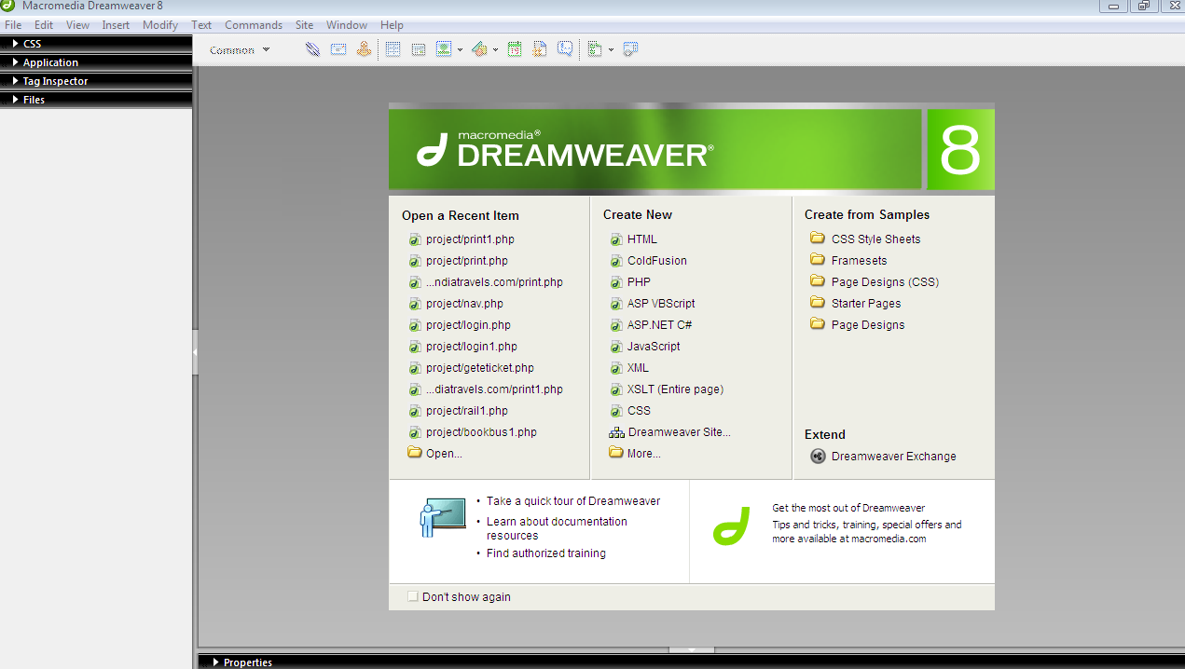

Fig.3.1 Dreamweaver

**Dreamweaver CS5 has:**

* **Enhanced Integration** - This software allows the website designer to not only save time but also decrease the number of steps that are needed to finish projects with intelligent integration across Photoshop Extended, Adobe Flash Professional, Fireworks and Adobe CS Live online services. Just for a limited time, the CS Live services are being offered free of charge.
* **Intelligent Coding Assistance** – You will be able to write cleaner code quicker than ever. You will surely like the idea of taking advantage of code hinting with JavaScript, HTML, and Ajax frameworks like Prototype, Spry and jQuery. With the Dreamweaver CS5 software, you will be able to glean direct insight into the bottom line objects, functions and methods with compelling PHP code hinting.
* **Integrate FLV Content Enhanced** – You will have the ability to add FLV files to whatever webpage you create with just a click of your mouse and standards-compliant coding. You can even preview your movies with FLV playback that you will be able to see in Live View.
* **New Site-specific Code Hinting** – You will be able to benefit with the new Dreamweaver software from code hinting in directories in Adobe Dreamweaver in addition to other nonstandard files. This will enable you to get enhanced hinting support for other CMS frameworks such as Joomla, WordPress and Drupal.

**3.1.1 Features**

There are many great tools in Dreamweaver and it is why I and many other professionals choose to DW over other programs for creating winning web sites. Even for our [beginners](http://www.webdesigndev.com/10-good-and-10-bad-things-about-adobes-dreamweaver/) DW can take the edge off learning HTML and CSS.

**1. Code Highlighting**

This helps you quickly scan your code as well as spot any errors. With each type of code there is a different set of highlights to help you differentiate between HTML, CSS, PHP, JavaScript and the list goes on.

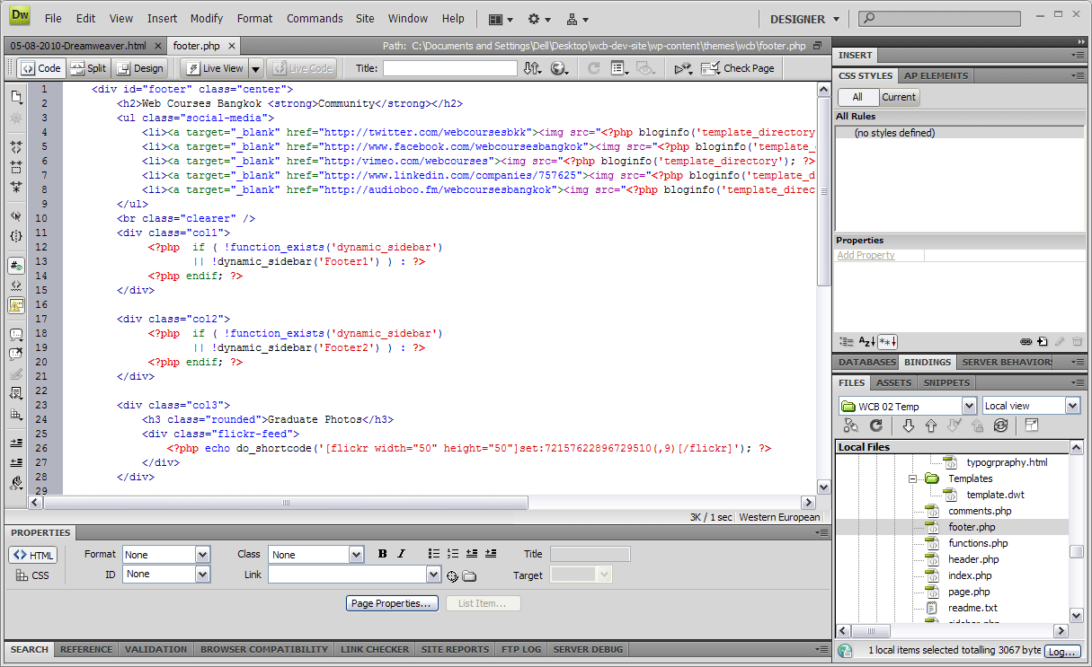Fig.1.2 Code Highlighting

For web design beginners code highlighting helps you further understand what each part of the code does and how making a mistake affects the code below it. E.g. below, we can see that a ‘” ‘is missing from an attribute.

As result the following code is highlighted in light blue, this allows you to easily track back and find where the mistake was made.

**2. Code Suggestion**

Another really helpful time saver is DW’s code suggestion feature. As you type a HTML tag it will list all the available tags allowing you to key in the first letter of a tag then select the desired tag from the list. Now this is not as useful for just tags but for attributes it really comes into play.

Take for example adding an image, normally you would have to know things like the location of the image and its dimensions. With DW you can add your <img and as soon as you press space DW is there again eager to help, pressing ‘s” immediately takes you to the “src=”” ‘attribute, hit enter twice and you will open up the browser window, select your image and DW will write the relevant location in their attribute. If you then move onto adding width and height for your image it will automatically have the dimension highlighted for you.

Where I really love this feature is when writing CSS, for example a popular CSS property is “font-family: Arial, Helvetica, sans-serif;”, now I could write all 41 characters, **or** I could

1. write “fon” and move down once
2. hit enter to select “font-family: “
3. select Arial, Helvetica, sans-serif” from the list of suggestion web safe fonts
4. add a “;” and I’m done.

Typing out 41 characters or doing 4 easy steps, I know which one I would choose.

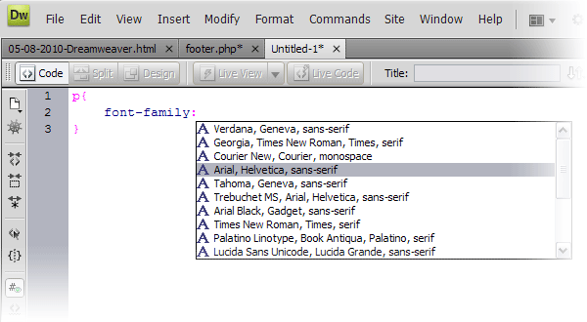

Fig.3.3 Code Suggestion

If you are learning HTML for the first time, this kind of help is really useful as it gives you full control over your code yet gives you a little helping hand to remember little details.

For more experienced of us the Code Suggestion feature helps you write HTML much faster. For example, if you are writing in Code View and you write “class=” DW instantly references your CSS and gives you a drop-down list of all the available styles for that element.

Code suggestion is both a useful reference for beginners and helps web designers manage bigger sites with possibly hundreds of class’s and id’s.

**3. Code and Design View**

Being a visual person, I love to see what my code is crafting. Therefore, having the ability to code as well as see what I am getting in the WYSIWIG (What You See Is What You Get) is really helpful. When using DW I personally switch between the code and design view a lot.

**3.2 Introduction to WAMP Server**

WAMP is a Windows OS based program that installs and configures Apache web server, MySQL database server, PHP scripting language, phpMyAdmin (to manage MySQL database’s), and SQLite Manager (to manage SQLite database’s). WAMP is designed to offer an easy way to install Apache, PHP and MySQL package with an easy to use installation program instead of having to install and configure everything yourself. WAMP is so easy because once it is installed it is ready to go. You don’t have to do any additional configuring or tweaking of any.  
There are usually two reasons why someone chooses to install WAMP. They are looking to install WAMP for development purposes or to run their own server.

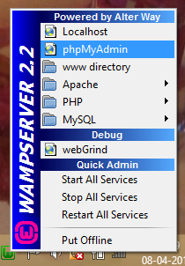

Fig.3.2.1 MySQL

**WAMP Server Contains**-

1. **PHP Admin**: Allows you to change or add users and for making new databases phpMyAdmin is a free software tool written in [PHP](http://php.net/), intended to handle the administration of MySQL over the World Wide Web. PhpMyAdmin supports a wide range of operations with MySQL. The most frequently used operations are supported by the user interface (managing databases, tables, fields, relations, indexes, users, permissions, etc.), while you still have the ability to directly.

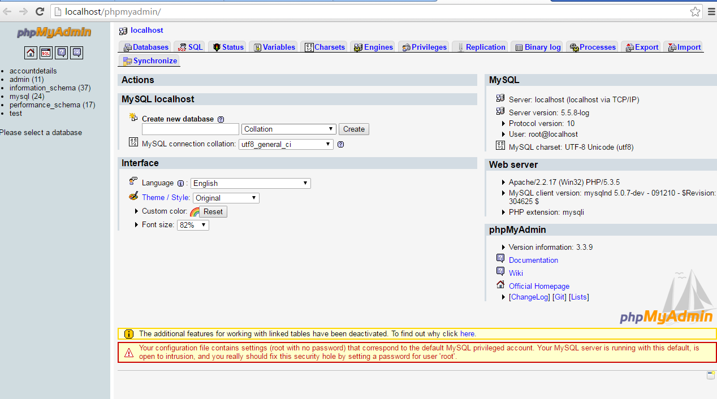

Fig.3.2.2 phpMyAdmin

**Features**

* Intuitive web interface
* Support for most MySQL features:
* browse and drop databases, tables, views, fields and indexes
* create, copy, drop, rename and alter databases, tables, fields and indexes
* maintenance server, databases and tables, with proposals on server configuration
* execute, edit and bookmark any SQL-statement, even batch-queries
* manage MySQL users and privileges
* manage stored procedures and triggers

**2. SQL Server and Database System**

SQL Server is a relational database management system from [Microsoft](http://searchwinit.techtarget.com/definition/Microsoft) that's designed for the [enterprise](http://searchwinit.techtarget.com/definition/enterprise) environment. SQL Server runs on T-SQL (Transact -SQL), a set of programming [extension](http://searchcio-midmarket.techtarget.com/definition/extension)s from [Sybase](http://searchenterpriselinux.techtarget.com/definition/Sybase) and Microsoft that add several features to standard SQL, including transaction control, exception and error handling, row processing, and declared variables.

[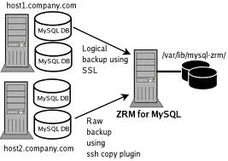](http://2.bp.blogspot.com/-egH2pu30ZB0/T5AyqeF1dsI/AAAAAAAAACk/zXjm80gCM-A/s1600/images.jpg)

Fig.3.2.3 SQL Server and Database System

**3.3 INTRODUCTION TO XAMPP SERVER**

As previously mentioned, XAMPP is a free package available for download and use for various web development tasks. All XAMPP packages and add-ons are distributed through the Apache Friends website at the address: http://www.apachefriends.org/. Once on the website, navigate and find the Windows version of XAMPP and download the self-extracting ZIP archive. After downloading the archive, run and extract its contents into the root path of a hard disk or USB drive. For example, the extract path for a local Windows installation would simply be C:\. If extracted properly we will notice a new xampp directory in the root of your installation disk

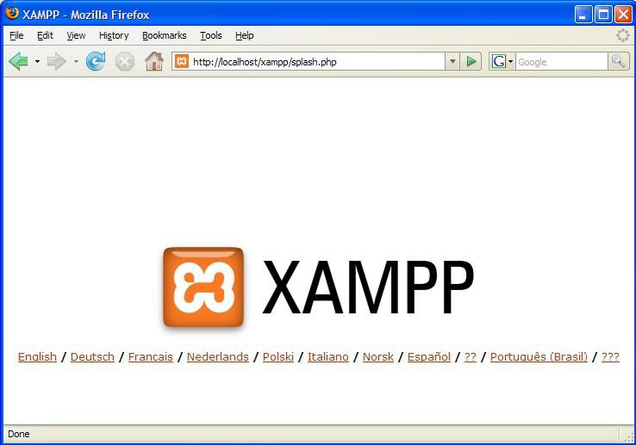

XAMPP splash screen

In order to test that everything has been installed correctly, first start the Apache HTTP Server by navigating to the xampp directory and clicking on the apache_start.bat batch file.

Next, we will test if the server is running correctly by opening an internet browser and typing http://localhost/ into the address bar. If configured correctly, we will be presented with a screen similar to that of the one below.

In order to stop all Apache processes we do not close the running terminal application, but instead run another batch file in the xampplite directory called apache_stop.bat.

**Creating a Database and Inserting Data**

Now that we have run and tested Apache and PHP, the next step is running MySQL and creating a database and table which will hold information to be used by our website. In order to start MySQL, navigate to the xampp directory and run the mysql_start.bat batch file. The XAMPP package contains an application called phpMyAdmin which allows developers to administer and maintain MySQL databases. We will be using phpMyAdmin to create a database and table and enter test data. Before testing phpMyAdmin, make sure that both Apache and MySQL are running by opening their respective batch files: apache_start.bat and mysql_start.bat. Along with Apache and MySQL running in the background, we type http://localhost/phpMyAdmin/ into our web browser.

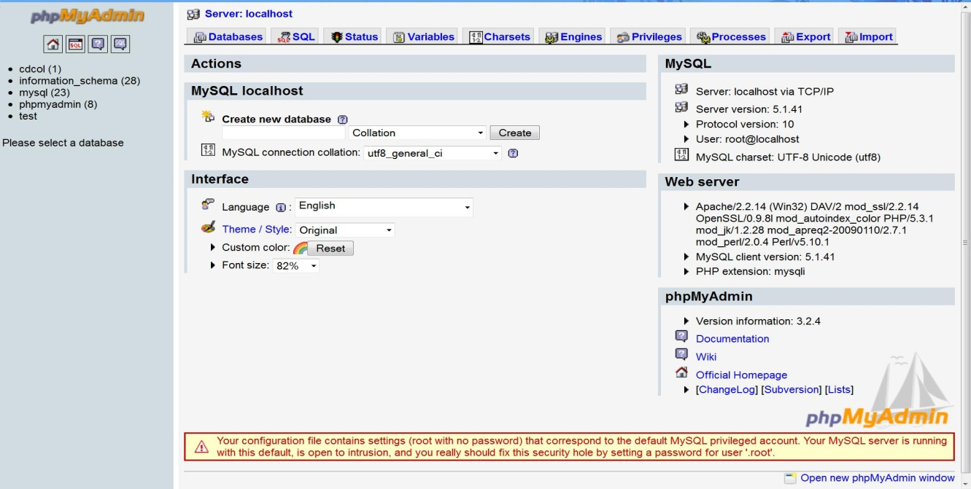

The first step with phpMyAdmin running is creating a new database. We create a new database by directly executing SQL statements as shown below. The successful execution of the sql query creates a database ‘student’ with two tables in it. The tables are admin_login and student_information. We also inserted values in the admin table. The screenshot below shows the successful execution of the query thus creation of a database named student.

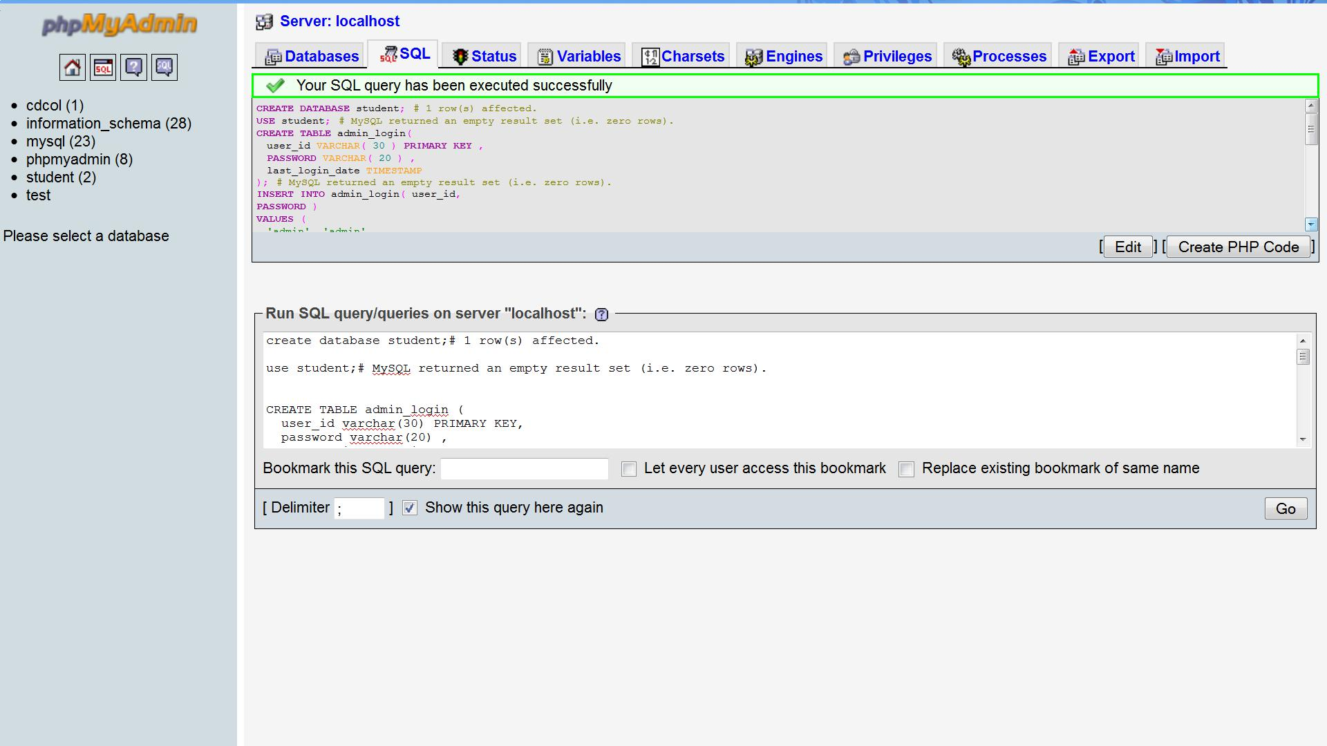

Creation of database in MySQL using phpMyAdmin

**CHAPTER-4**

**SOFTWARE REQUIREMENT SPECIFICATION**

The software requirement specification is produced at the culmination of the analysis task. The function and performance allocated to software as part of system engineering are refined by establishing complete information, a detailed function description, a representation of system behavior, an indication of performance requirement and design constraints appropriate validate criteria, and other information pertinent to requirement.

**PROJECT REQUIREMENTS**

**●Hardware Specification:**

|  |  |  |
| --- | --- | --- |
| I. | RAM | 512 MB OF RAM |
| II. | Hard Disk | 40 GB |

**●Software Specification:**

|  |  |  |
| --- | --- | --- |
| I. | Operating System | Window XP |
| II. | Front-end Tool | PHP, HTML, CSS, JSS |
| III. | Technology | PHP |
| IV. | Backend Tool | MySQL |

**CHAPTER-5**

**INTRODUCTION OF PROJECT**

This website about the Dream Job which provides the information about the Recruiters who provide the jobs. Using this website search jobs easily according to need and every department maintain according to different specialty. The main motive of this website provides the whole information about the Recruiters who provides jobs.

Get detailed information about the Dream Job: -

●Firsty when open the website there is job section which displays the types of jobs that our site provides you

●After that there is recruiter button where recruiters add the type of workers they need for their company or firms

●Then there is companies section where all the companies who are linked to us are displayed.

● About us section of our site tells our users about our motive, intention and our contact information.

●Users can login and register to our site through login button.

●At Last there is a feedback button where users can interact with us by giving us their views about our site.

**OBJECTIVE OF THE PROJECT**

**Title of project:**

● Dream Job

**Purpose:**

The main objective of the project provides the information about the record of jobs with every detail about the particular speciality.

●When user enters the user id and password then that password match with database values if value match then login success the open the next page.

●Jobs can be added by the Recruiter.

●Job Seekers can contact the Recruiter through their given details.

**CHAPTER-6**

**INTRODUCTION TO TOOLS**

**FRONT-END/BACK-END**

* **Front-End:** Web Pages using PHP, HTML, JavaScript.
* **Back-End:** MYSQL

**Front End:**

* **HTML** –It is used to generate web page .HTML, an initials of Hypertext Markup Language, is the predominant [markup language](http://en.wikipedia.org/wiki/Markup_language) for [web pages](http://en.wikipedia.org/wiki/Web_page). It provides a means to describe the structure of text-based information in a document — by denoting certain text as headings, paragraphs, lists, and so on.
* **JAVASCRIPT** – It is used for checking User information before sending to JavaScript is a scripting language most often used for client-side web development. It is a dynamic, weakly typed, prototype-based language with first-class functions. Currently, "JavaScript" is an implementation of the ECMA Script standard.

**Backend:**

* **PHP: -**Php is a technology that lets you mix regular, static HTML with dynamically-generated HTML. Many Web pages that are built by CGI programs are mostly static, with the dynamic part limited to a few small locations. But most CGI variations, including servlets, make you generate the entire page via your program, even though most of it is always the same.

1. **WAMP SERVER** /WAMP- Apache is a [web container](http://en.wikipedia.org/wiki/Web_container), or [application server](http://en.wikipedia.org/wiki/Application_server) developed at the [Apache Software Foundation](http://en.wikipedia.org/wiki/Apache_Software_Foundation) (ASF).It adds tools for configuration and management but can also be configured by editing.

**CHAPTER-7**

**SYSTEM ANALYSIS**

**7.1 Introduction:**

System analysis is a process of gathering and interpreting facts, diagnosing problems and the information to recommend improvements on the system. It is a problem-solving activity that requires intensive communication between the system users and system developers. System analysis or study is an important phase of any system development process. The system is studied to the minutest detail and analyzed. The system analyst plays the role of the interrogator and dwells deep into the working of the present system. The system is viewed as a whole and the input to the system are identified. The outputs from the organizations are traced to the various processes.

System analysis is concerned with becoming aware of the problem, identifying the relevant and decisional variables, analyzing and synthesizing the various factors and determining an optimal or at least a satisfactory solution or program of action.

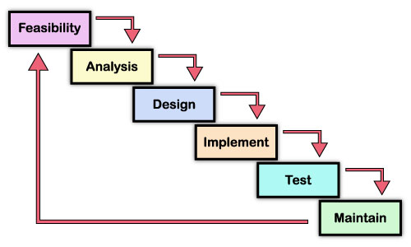

Figure 7.1 SDLC Phases

System analysis and design focus on the systems, processes and technology. System analysis is the process of gathering and interpreting facts, diagnosing problems, and using the information to recommend improvements to the system. Analysis specifies what the system should do.

System analysis is the dissection of the system into its components pieces to study how those component pieces interacts and works. We do a systems analysis to subsequently perform a systems synthesis. System analysis is a term that collectively describes the early phases of systems development. There has never been a universally accepted definition. And there has never been agreement on when analysis ends, and design begins.

A detailed study of the process must be made by various techniques like interviews, questionnaires etc. The data collected by these sources must be scrutinized to arrive to a conclusion. The conclusion is an understanding of how the system functions. Systems analysis is the survey and planning of the system and project, the study and analysis of the existing business and information system and the definition of business requirements and priorities for a new or improved system. A popular synonym is logical design. Preliminary study is the process of gathering and interpreting facts, using the information for further studies on the system.

**7.2 Feasibility Study:**

A feasibility study looks at the viability of an idea with an emphasis on identifying potential problems and attempts to answer one main question: Will the idea work and should you proceed with it?

Before you begin writing your business plan you need to identify how, where, and to whom you intend to sell a service or product. You also need to assess your competition and figure out how much money you need to start your business and keep it running until it is established.

Feasibility studies address things like where and how the business will operate. They provide in-depth details about the business to determine if and how it can succeed and serve as a valuable tool for developing a winning business plan.

Why Are Feasibility Studies So Important?

The information you gather and present in your feasibility study will help you:

* List in detail all the things you need to make the business work;
* Identify logistical and other business-related problems and solutions;
* Develop marketing strategies to convince a bank or investor that your business is worth considering as an investment; and
* Serve as a solid foundation for developing your business plan.

Even if you have a great business idea you still have to find a cost-effective way to market and sell your products and services. This is especially important for store-front retail businesses where location could make or break your business. For example, most commercial space leases place restrictions on businesses that can have a dramatic impact on income. A lease may limit business hours/days, parking spaces, restrict the product or service you can offer, and in some cases, even limit the number of customers a business can receive each day.

**The Components of a Feasibility Study**:

Description of the Business: The product or services to be offered and how they will be delivered.

[Market Feasibility**:**](http://womeninbusiness.about.com/od/freebusinesscourses/a/marketdeasibil.htm) Includes a description of the industry, current market, anticipated future market potential, competition, sales projections, potential buyers, etc.

[Technical Feasibility**:**](http://womeninbusiness.about.com/od/startingasmallbusiness/a/techfeasibility.htm) Details how you will deliver a product or service (i.e., materials, labor, transportation, where your business will be located, technology needed, etc.).

[Financial Feasibility:](http://womeninbusiness.about.com/od/freebusinesscourses/a/finfeasibility.htm) Projects how much start-up capital is needed, sources of capital, returns on investment, etc.

[Organizational Feasibility:](http://womeninbusiness.about.com/od/freebusinesscourses/a/organizatfeas.htm) Defines the legal and corporate structure of the business (may also include professional background information about the founders and what skills they can contribute to the business).

[**Conclusions:**](http://womeninbusiness.about.com/od/freebusinesscourses/a/conclusionsfeas.htm) Discusses how the business can succeed. Be honest in your assessment because investors won’t just look at your conclusions they will also look at the data and will question your conclusions if they are unrealistic.

**7.2.1 Technical Feasibility:**

Study of resource availability that may affect the ability to achieve an acceptable system. This evaluation determines whether the technology needed for the proposed system is available or not.

* Can the work for the project be done with current equipment existing Software technology & available personal?
* Can the system be upgraded if developed?
* If new technology is needed, then what can be developed?

The technical needs of the system may include:

* **Front-end and back-end selection**

An important issue for the development of a project is the selection of suitable front-end and back-end. When we decided to develop the project, we went through an extensive study to determine the most suitable platform that suits the needs of the organization as well as helps in development of the project.

The aspects of our study included the following factors.

* **Front-end selection:**

1. It must have a graphical user interface that assists employees that are not from IT background.
2. Scalability and extensibility.
3. Flexibility.
4. Robustness
5. . According to the organization requirement and the culture.
6. Must provide excellent reporting features with good printings support.
7. Platform independent.
8. Easy to debug and maintain.
9. Event driven programming facility.
10. Front end must support some popular back end like MySQL.

According to the above stated features we selected PHP v5.5.6 as the front-end for developing our project.

* **Back-end Selection:**

1. Multiple user support.

2. Efficient data handling.

3. Provide inherent features for security.

4. Efficient data retrieval and maintenance.

5. Stored procedures.

6. Popularity.

7. Operating System compatible.

8. Easy to install.

9. Various drivers must be available.

10. Easy to implant with the Front-end.

**7.2.2Economic feasibility:**

Economic justification is generally the “Bottom Line” consideration for most systems.

Economic justification includes a broad range of concerns that includes cost benefit analysis. In this we weight the cost and the benefits associated with the candidate system and if it suits the basic purpose of the organization i.e. profit making, the project is making to the analysis and design phase.

**Table 2 Potential costs and benefits of a software project**

|  |  |  |
| --- | --- | --- |
| **Type** | **Potential Costs** | **Potential Benefits** |
| Quantative | * Hardware/Software upgrades. * Training costs to train developers. * Expected operational costs. | * Reduced operating costs. * Increased revenue from additional sales of the organization services. |
| Qualitative | * Increased employee dissatisfaction from area of change. | * Better response from customers * Positive public reception |

The financial and the economic questions during the preliminary investigation are verified to estimate the following:

* Cost to conduct a full system investigation.
* The cost of hardware and software for the class of application being considered.
* The benefits in the form of reduced cost.
* The proposed system will give the minute information, as a result the performance is improved which in turn may be expected to provide increased profits.
* This feasibility checks whether the system can be developed with the available funds.

This does not require enormous amount of money to be developed. This can be done economically if planned judicially, so it is economically feasible. The cost of project depends upon how much information will be containing it.

**7.2.3Operational Feasibility:**

It is mainly related to human organizations and political aspects. The points to be considered are:

* What changes will be brought with the system?
* What organization structures are disturbed?
* What new skills will be required?

**Table 3 Issues to consider when determining the operational feasibility of a project.**

|  |  |
| --- | --- |
| Operations Issues | Support Issues |
| * What tools are needed to support operations? * What skills will operators need to be trained in? | * What documentation will users be given? * How will change be managed? |

**CHAPTER-8**

**SYSTEM DESIGN**

**8.1 SYSTEM SPECIFICATIONS:**

System specification documents most predominantly contain information on basic requirements which include:

* Performance levels
* Reliability
* Quality
* Interfaces
* Security and Privacy
* Constraints and Limitations
* Functional Capabilities
* Data Structures and elements

**8.2 DATA FLOW DIAGRAMS:**

It is a way of expressing system requirement in a graphical form; this leads to a modular design. It is also known as bubble chart, it has the purpose of clarifying system requirements and identifying major transformations that will become program in system design. So, it is the starting point of the design phase that functionally decomposes the requirement specifications down to the lowest level of details. A DFD consist of a series of bubbles joined by lines. The bubbles represent data transformation and the lines represent data flows in the system.

At level 0 DFD, also called fundamental system model or a context model, represents the entire software element as single bubble with input and output data indicated by incoming and outgoing arrows respectively. Additional bubble and information flow paths are represented as level 0 DFD is partitioned to reveal more details.

**8.2.1 DFD SYMBOLS:**

Source or Destination of data

Data flow

Store Data

Process

Entity relationship diagram depicts the relationship between entities and attributes of the user. Friends with the help of username and can be able to search those users who are already got registered on the site. The user also could able to able to update or delete his information such as basic information etc. which further will save in the database. As well as the admin can authenticate the user, modify, update, delete and can handle the system

We have specified the design of our present system in three stages in SDLC:

1. Input Design
2. Output Design
3. Database Design

**CHAPTER-9**

**SYSTEM TESTING**

System Testing is a process of executing a program with the explicit intention of finding errors, which cause program failure. There are two general strategies for testing software. They are:

* Code Testing
* Specification testing

**9.1 CODE TESTING:**

This strategy examines the logic of a program and has been carried out to identify three levels of correctness of programs. Possible correctness is first achieved by giving arbitrary inputs. Then the inputs are carefully selected to obtain predicted output. This gives the probable correctness. All potentially problematic areas are checked in this way for the software to achieve probable correctness. Absolute correctness can be demonstrated by a test involving every possible combination of inputs. However, this cannot be performed with the software but to the existence of the various possible combinations of the inputs and due to time restrictions.

**9.2 SPECIFICATION TESTING:**

The specifications are examined which states what the program should do and how it should perform under various conditions. Then test cases are developed for each condition or combinations of conditions and submitted for processing. By examining the results, it is determined whether the program performs according to its specified requirements.

**9.3 LEVELS OF TESTING:**

* Unit Testing
* System Testing
* White Box Testing
* Black Box Testing
* Graph Based Testing

**9.3.1** **UNIT TESTING:**

Unit testing is done for the programs making up the systems. It is focused to find out module errors and enables to detect errors in coding and logic that are contained in the module. Unit testing is performed from bottom-up, starting with the smallest and lowest levels modules and proceeding one.

**9.3.2 SYSTEM TESTING:**

At a time, System Testing finds out the discrepancies between the system and its original objective, current specifications and systems documentation.

The training session consists of getting the users used to software by asking them to perform data entry in our presence and look into the problems if encountered.

Testing can be done in two ways.

1. Sample Tests

2. Real Tests

**9.4 SAMPLE TESTS:**

The software was tested with sample data that we randomly selected. I tested all functions with such random data and I was successful in getting accurate results. It was at this time I got to know certain intricacies of the system that I had overlooked. Without much delay however, I got over the problems and managed to perfect the software at least to the extent possible.

**9.5 REAL TEST:**

For the real test, I have planned to do in due course. I initialized the software and save a student’s information and then in the main window I search the saved information like of that students through their Roll No. and edit the information according to the change in the information and this works perfectly. After that I delete some record, and this also works perfectly.

**9.6 White Box testing:**

White box testing sometimes called glass – box testing, is a test case design methods that use the control structure the procedural design to derive test case.

1. Guarantee that all independents paths within a module have been excercises at least one.
2. Exercises all logical decisions on their true and false sides.
3. Execute all loops at their boundaries.
4. Exercises internal data sturucture ensures the validity.

The reason behind spending time & energy about logical minutiae.

* Logic errors and incorrect assumptions and invesely proportion to the probability that a program path will be executed.
* The logical flow of a program is sometimes contributive meaning that our unconscious assumptions about flow of control and data may lead us to make design errors that are uncoverd.

Typographical errors are random:- when a program is translates into a programming language. Source code is likely that some typing errors will occur.

Using white box testing methods, we drive the following case:

* Guarantee that all independent paths within a module have been exercised at least once.
* Exercise all logical decisions on their true and false sides.
* Execute all logical decisions on their operational bounds, and
* Exercise internal data stuructures to ensure their validity.

We checked all the modules used in the program.

Firstly we checked that all the modules or procedures, which are defined in the program, are used at least once or not. If any procedure or subroutine was not in use, then we removed that procedure from the program.

After checking all modules used in the program we checked all the logical decisions used in the conditional statement and loops, if any conditional statement or any looping condition was not true than we modified the condition and then rechecked. These processes were repeated until all the conditions were true.

Then we executed all loops within the programs and checked the boundaries, whether the statements within the loop were executing up to the condition is true.

At last all the data structure in terms of public and private variables used in the programs were checked, whether all the variables were used properly, if any variables were not used then we omitted those variables from the program.

**9.6.1 Basis Path Testing:**

Basis path testing is a white box testing technique. The basis path methods enable to derive a logical complexity measure of procedureal design and use this measure as a guide for defining a basis set of execution paths.

**9.7 Black Box Testing:**

Black box testing, also called behavioural testing. Focuses on the functional requirements of the software. Black – box testing enables the software engineer to derive sets of input conditions that will fully exercise all functional requirements for a program. Black – Box testing is not an alternative to white – Box technique. Rather than it is a complementary approach that is likely to uncover a different of errors than white box method.

Black – Box testing attempts to find errors in the following categories:

1. Incorrect or missing functions
2. Interface errors
3. Errors in date structures
4. Behavior of performance errors
5. Initialization and termination errors.

Unlike white box testing, black box testing tends to be applied during later stages of testing, because black – box testing purposely disregards control structure attention to focused on the information domain. Tests are designed to answer the following questions.

* How is functional validity tested?
* How is system behavior and performance tested?
* What work of input will make good tests?
* How are the boundaries of data meeting isolated?
* What data rates and data volume can the system tolerate?

### 9.8 Graph Based Testing:

The first step in black – box testing is to understand the objects that are modeled in software and the relationship that connect these objects. Once this has been accomplished, the next step is to define a series of tests that verify, “All objects have the expected relationship to another”.

To accomplish these steps, the software engineer begins by creating a graph, a collection of needs that represent object links that represents the relationship between objects.

##### **9.9 Validation Checks:**

In the process of validation check, to trap the errors which occurs during the runtime, which results the problem like system hanging and program interruption etc. we provide it own error messages whenever thse occurs to avoid these problem.

Some of the error types with their messages are as follows:

**Error type**

* Incomplete details
* Database linkage error
* wrong username and password
* Unsupported Comm Operation
* Database is not link

**CHAPTER-10**

**SNAPSHOTS OF PROJECT**

**10.1 LOGIN PAGE**

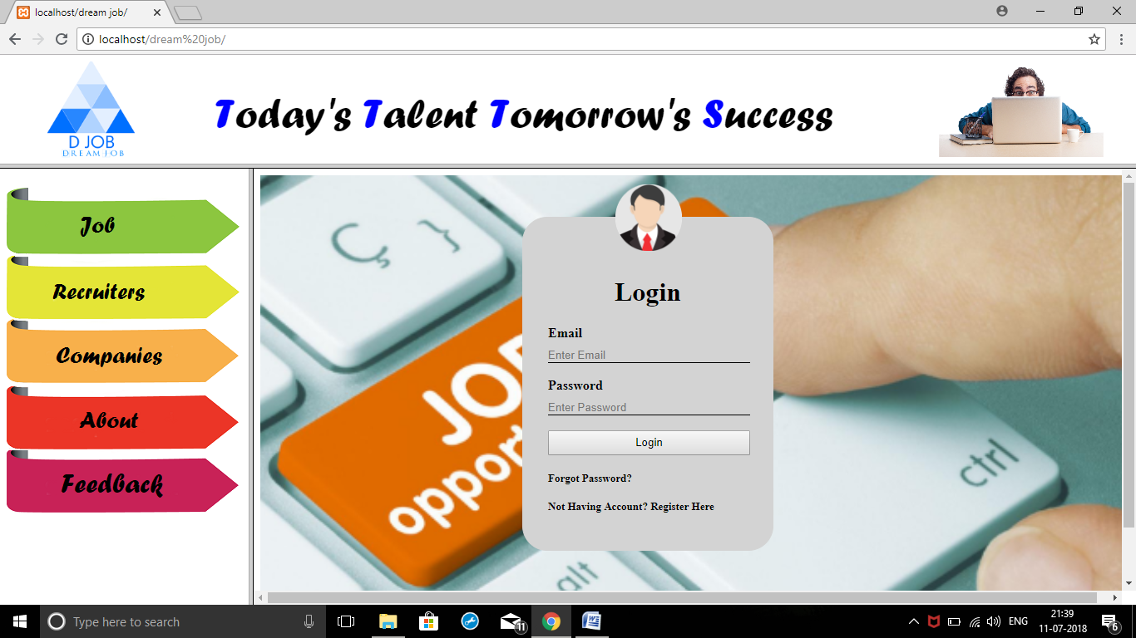

Fig: 10.1 Login Page

**10.2 JOB OR HOME PAGE:**

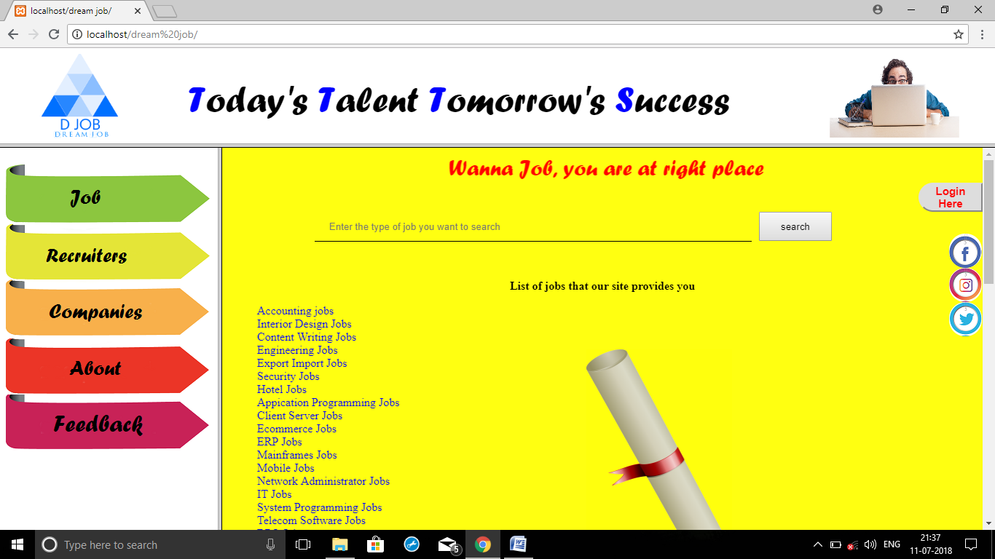

Fig: 10.2 Home Page

**10.3 ABOUT US:**

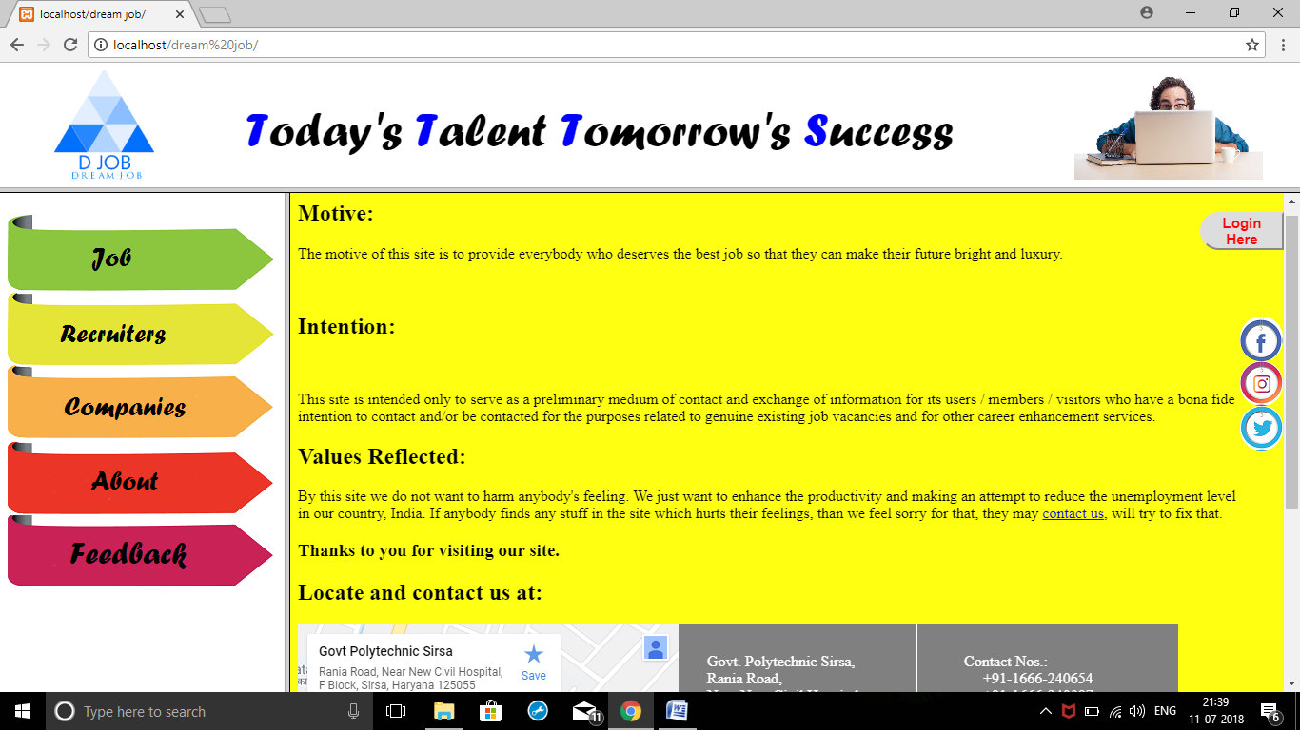

Fig: 10.3 About us Page

**10.4 RECRUITERS PAGE:**

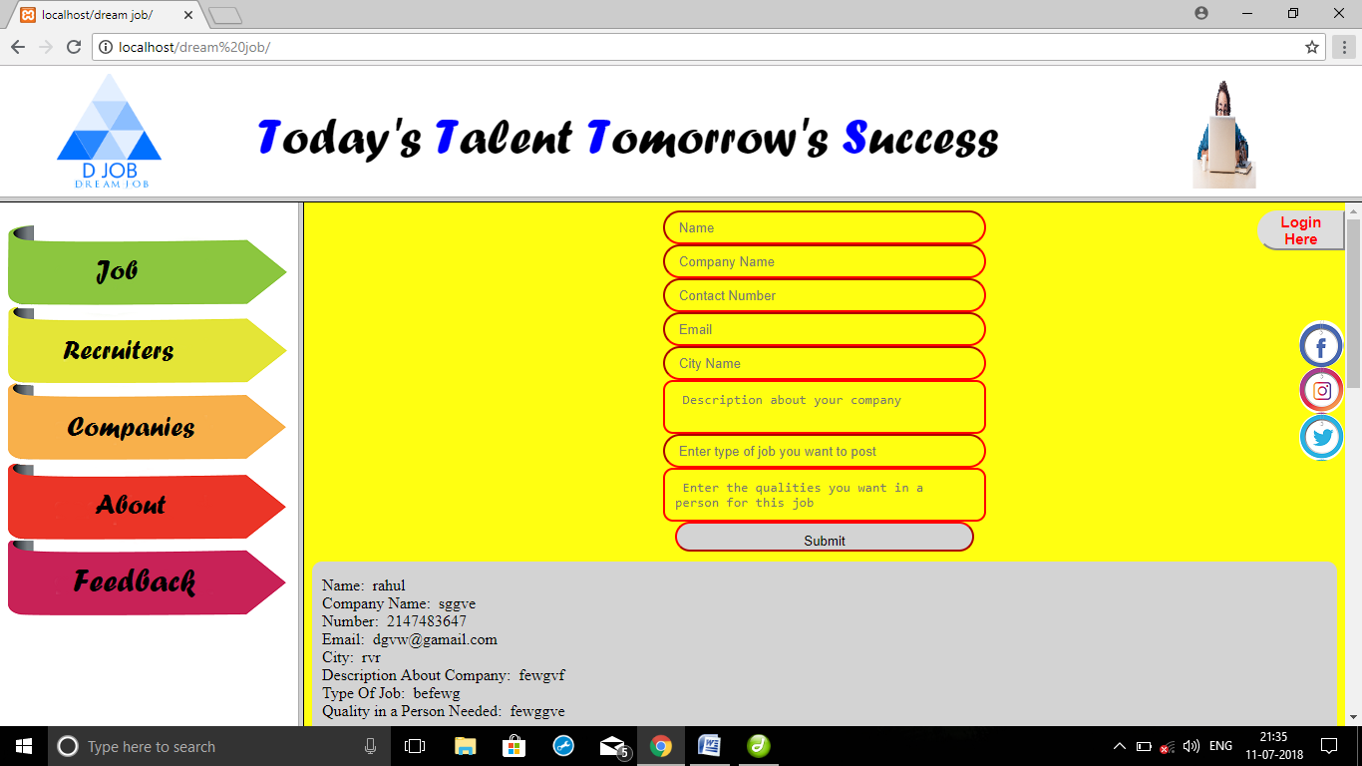

Fig: 10.4Recruiters Page

**10.5 COMPANIES PAGE:**

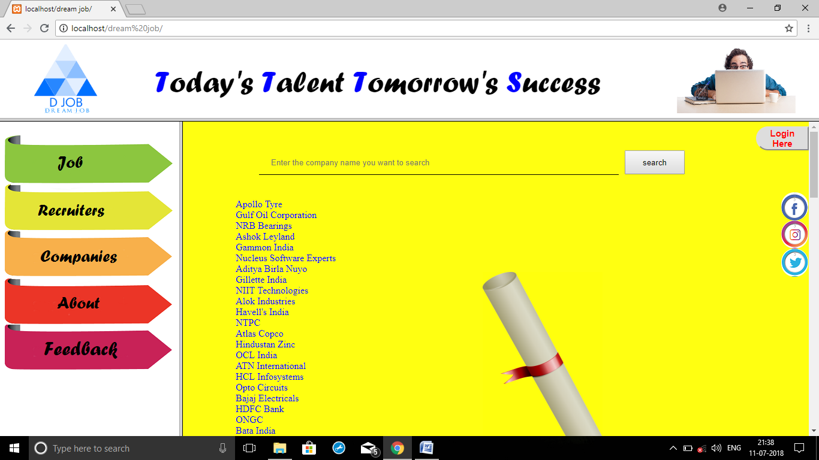

Fig: 10.5 Companies Page

**10.6 FEEDBACK PAGE:**

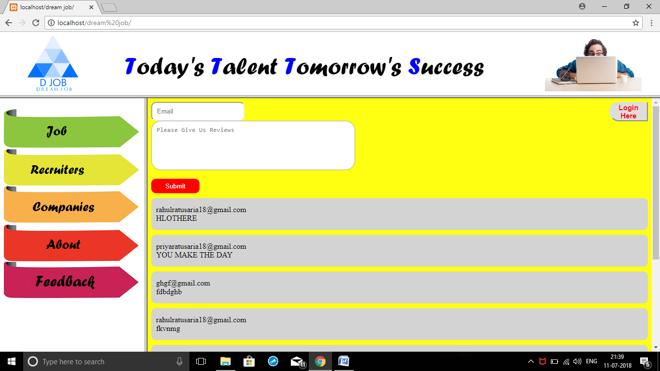

Fig: 10.6 Feedback Page

**10.7 REGISTER PAGE:**

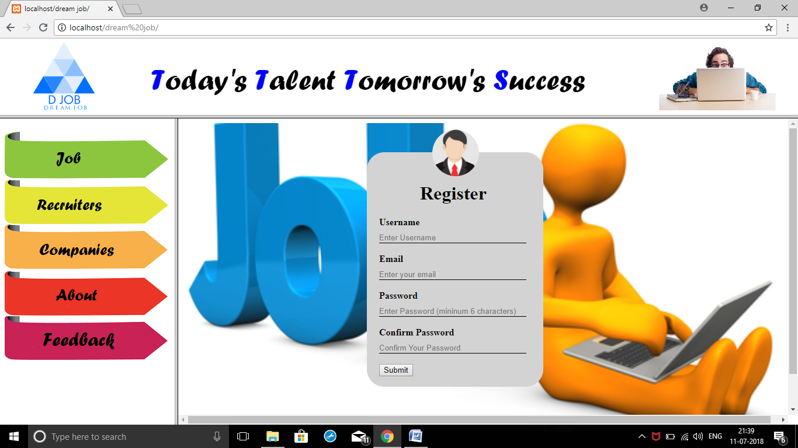

**CHAPTER-11**

**CONCLUSION AND FUTURE SCOPE**

**10.1 Conclusion:**

The project titled as **Dream Job** is a web-based application. This software provides facilities to details of job providers. Each user may first make their login. This software is developed with scalability in mind. Additional modules can be easily added when necessary.

The software is developed with modular approach. All modules in the system have been tested with valid data and invalid data and everything work successfully. Thus, the system has fulfilled all the objectives identified and is able to replace the existing system.

The project has been completed successfully with the maximum satisfaction of the organization. The constraints are met and overcome successfully. The system is designed as like it was decided in the design phase. The project gives good idea on developing a full-fledged application satisfying the user requirements.

The system is very flexible and versatile. This software has a user-friendly screen that enables the user to use without any inconvenience. Validation checks induced have greatly reduced errors. Provisions have been made to upgrade the software. The application has been tested with live data and has provided a successful result. Hence the software has proved to work efficiently.

The lessons learnt after developing this project are as follows:

* Before developing any project, the requirement should be made well clear so that after developing it the programmer does not have to change it.
* Software and hardware constraints should be kept in mind.
* Time and cost are those constraints, which are never told but always accounted for.
* Project should be error free and made in such a way so that modifications can be done in future.
* A professional should have a vision to see beyond the user-defined requirement.
* All members of the project team have to be cooperative with each other.
* User should be given proper training about how to use project.

**10.2 Future Scope:**

The primary concern of every system client is validity of the purchased software product in the near future. In order to cope with this problem, programmers often provide their clients with regular system updates so that in case there have been any change include in working criteria of institution/organization, it can be absorbed within existing automated system.

This system may require further advancements as the client may want some more functionality in this system. While developing this project prototype model is followed so coding is written in such a way that if client wants to add more functionality in this system then that functionality can be done easily.

I have compiled this project keeping this point in full regards that it can be easily upgraded if need arises. From time to time, new modules can be added to it or existing ones can be modified.

Depending upon the organization, the function processes and needs may vary from organization to organization. Therefore, the functionality of the project can be further enhanced as per the requirements specification of different organization. For instance, any organization can use this project by just changing the interest rate accordingly and the rest of the operations will be remained same. Similarly, the project can be expanded to the required extent.

Further, enhancements to this project will be to create a module for all users’ review to see the sale status and quality of various brands. As of now, the shopper who have made login can only see his order status. Another enhancement would be to allow submitting feedback by retailer and shopper. One Enhancement could be to see the location of shopper by adding Google map and we can make this website compatible with the mobile browser.

**BIBLIOGRAPHY**

1. Robin Nixon “Learning php and JavaScript” orielly publication, 1st-edition July 2009 ISBN-978-0-596-15713-5
2. Janet valade “Php_mysql web development all in one” 1st-edition 2008, ISBN- 978-0-470-16777-9
3. Liyan beighly, Michael Morrison “Head first Php_mysql” edition-1st, 2008, ISBN- 978-0-596-00630-3
4. Elisabeth Freeman & Eric Freeman “Head first HTML, CSS and xhtml” edition-1st, 2008, ISBN- 978-0-596-10197-8

**URL’S-**

1. http://it-ebooks.info/
2. WWW.headfirstlabs.com/
3. www.W3schools.com/

**REFERENCES**

* PHP & SQL Server
* Introduction to PHP by Janet Valade
* Beginning with PHP by Vikram Vaswani
* Beginning PHP and MySQL by Larry Ullman
* Learning PHP by Michael peacock
* The Complete Reference to PHP by Steven Holzner
* Help from Websites
* [www.wrox.com/.../WroxTitle/Beginning-PHP5-Apache-and-MySQL](http://www.wrox.com/.../WroxTitle/Beginning-PHP5-Apache-and-MySQL)
* The PHP Anthology
* Learning PHP
* Beginning with PHP and MYSQL by W. Jason Gilmore
* [www.w3schools.com/php/](http://www.w3schools.com/php/)
* en.wikipedia.org/wiki/PHP
* [www.mysql.com/](http://www.mysql.com/)
* www.php.com/
* [www.linkedin.com](http://www.linkedin.com)
* [WWW.google.com](http://www.google.com/)
* [WWW.wikipedia,com](http://www.wikipedia,com/)
* [WWW.w3school.com](http://www.w3school.com/)
* [WWW.wrox.com](http://www.wrox.com/)
* [WWW.superindex.apress.com](http://www.superindex.apress.com/)