|  |
| --- |
| **AI-powered-Resume-Screening-and-Ranking-System using python**    A Project Report  submitted in partial fulfilment of the requirements  of  AICTE Internship on AI: Transformative Learning with  Tech Saksham – A joint CSR initiative of Microsoft & SAP    by    **Name of student:- Rahul Shukla**  **Email id:- shuklarahulwhy@gmail.com**    Under the Guidance of  **Name of Guide:-Pavan Kumar U, Program manager, Edunet Foundation** |

# **ACKNOWLEDGEMENT**

We would like to take this opportunity to express our deep sense of gratitude to all individuals who helped us directly or indirectly during this thesis work.

I would like to express my deepest gratitude to my internship advisor, Trainer **Saomya**

**Chaudhury** for providing me guidance and support throughout my internship project.

Thank you for encouraging me to take on new challenges and for the valuable advice that helped me navigate my internship experience.

I am writing to express my sincere gratitude for your exceptional guidance and support throughout my internship. Your mentorship has been invaluable, providing me with the confidence to tackle new challenges and navigate the complexities of the professional world.

My sincere thanks to the team at **TechSaksham and edunet.**

for warmly welcoming me and making my time here so enjoyable. In particular, I would like to recognize my colleagues for patiently training me and always being available to answer my questions. I have learned so much from all of you.

**Saomya Chaudhury**

# This Acknowledgement should be written by students in your own language (Do not copy and Paste)

**ABSTRACT**

Provide a brief summary of the project, including the problem statement, objectives, methodology, key results, and conclusion. The abstract should not exceed 300 words.

**Project Description:**

This project aims to develop an intelligent system that automates the resume screening and ranking process for job applications, leveraging the power of Artificial Intelligence and Natural Language Processing (NLP). The system will parse resumes, extract relevant information (skills, experience, education), and compare it against job descriptions to identify the most suitable candidates.

**Skill Matching:**

Develop algorithms to compare extracted skills from resumes with required skills from job descriptions.

Automates and streamlines the resume screening process. and Reduces the time and effort required for manual screening.

**Potential Enhancements:**

Integration with applicant tracking systems (ATS).

Development of a web-based user interface.

## TABLE OF CONTENT

**Abstract I**

**Chapter 1.**  **Introduction 1**

1.1 Problem Statement 1

1.2 Motivation 1

1.3 Objectives 2

1.4. Scope of the Project 2

**Chapter 2.**  **Literature Survey 3**

**Chapter 3.**  **Proposed Methodology**

**Chapter 4.**  **Implementation and Results**

**Chapter 5. Discussion and Conclusion**

**References**

**LIST OF FIGURES**

|  |  |  |  |
| --- | --- | --- | --- |
| **Figure No.** |  | **Figure Caption** | **Page No.** |
| **Figure 1** | **workflow of project** |  | **1** |
| **Figure 2** |  |  |  |
| **Figure 3** |  |  |  |
| **Figure 4** |  |  |  |
| **Figure 5** |  |  |  |
| **Figure 6** |  |  |  |
| **Figure 7** |  |  |  |
| **Figure 8** |  |  |  |
| **Figure 9** |  |  |  |

**LIST OF TABLES**

|  |  |  |
| --- | --- | --- |
| **Table. No.** | **Table Caption** | **Page No.** |
|  |  |  |
|  |  |  |
|  |  |  |
|  |  |  |
|  |  |  |
|  |  |  |
|  |  |  |
|  |  |  |
|  |  |  |

## CHAPTER 1 Introduction

1.1 **Problem Statement:**

**Describe the problem being addressed.**

There is a need for an automated, intelligent system that can efficiently and accurately screen, rank, and analyze resumes, reducing time-to-hire, minimizing bias, and improving the overall recruitment process.

Face significant challenges in efficiently and effectively screening and ranking job applicants due to the high volume of resumes received.

**.Why is this problem significant?**

**Time-Consuming**

**Biased:** discrimination and favoritism

**Identifying relevant skill**

**Difficulty in Identifying Skill Gaps**

**Poor Candidate Experience:** Long waiting times and a lack of feedback can negatively impact the candidate experience.

**Inconsistent:** Different recruiters may apply varying criteria, leading to inconsistent evaluations and potentially unfair hiring decisions.

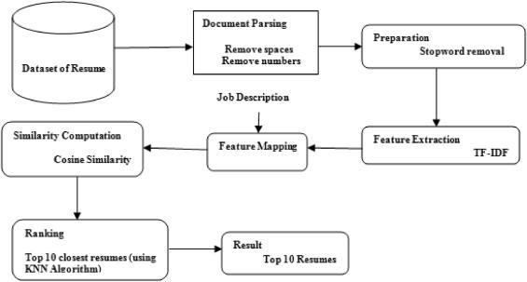

**workflow of project**

1.2 **Motivation:**

**Why was this project chosen?**

because I built my resume and I know that how to resume is to get selected and work behind ATS.

That is why I chose this AI-powered-Resume-Screening-and-Ranking-System project.

To learning building resume with keep in mind in this training and workflow

**What are the potential applications and the impact?**

AI-powered resume screening and ranking systems hold significant potential across various sectors, with a profound impact on the efficiency and fairness of recruitment processes.

AI resume screening offers a solution that can significantly streamline the process, making your hiring decisions faster, more accurate, and less biased.

With AI, you can focus on what truly matters finding the best candidates while the technology takes care of the repetitive, time-consuming tasks

1.3 **Objective:**

**Clearly state the objectives of the project.**

the capabilities of machine learning algorithms and natural language processing to automate the screening process, efficiently analyzing and ranking resumes based on predetermined criteria.

1.4 **Scope of the Project:**

**Define the scope and limitations.**

**scope.**

It increases the capabilities of machine learning algorithms and natural language processing to automate the screening process, efficiently analyzing a large number of candidate ranking resumes based on predetermined criteria.

**limitations.**

lack the human ability to assess context and nuance in resumes. They can't recognize unique experiences or traits that don't fit neatly into predefined criteria

## CHAPTER 2 Literature Survey

**2.1 Review relevant literature or previous work in this domain.**

**ans: Not** Now I am working on a web development project. it is my first project in this domain

**2.2 Mention any existing models, techniques, or methodologies related to the problem.**

**ans:**  NLP (Natural Language Processing): Text extraction, semantic analysis.

TF-IDF: Skill/job description similarity.

Machine Learning (Classification/Ranking): Candidate ranking. Rule-Based Systems: Keyword matching, experience filtering.

**2.3 Highlight the gaps or limitations in existing solutions and how your project will address them.**

**ans: -**understanding context difficulty with newly skill interpretations

-Handling diverse resume formats and styles.

- not understanding non-technical skills.

-Adapting to rapidly changing skill requirements. alway tell or update AI to request changes we need in our resume.

## CHAPTER 3 Proposed Methodology

**3.1 System Design**

Provide the diagram of your Proposed Solution and explain the diagram in detail.



**Database of resumes** is a collection of resumes. **document parsing** Each resume has parsing remove unnecessary elements like spaces and numbers, and specific job description is also fed into the system. **Preparation** both the resumes and the job description undergo a preparation step, which includes stopword removal (eliminating common words like "the," "a," "is" that don't carry significant meaning).

**Similarity Computation** The similarity between resumes and the job description is calculated using Cosine Similarity.

**Ranking:** Resumes are ranked by similarity scores, selecting the top 10.

**Result:** The final output is a list of the Top 10 Resumes that are most similar to the provided Job Description.

**3.2 Requirement Specification**

Mention the tools and technologies required to implement the solution.

**3.2.1 Hardware Requirements: PC or laptop** RAM 4GB to 8GB.

**3.2.2 Software Requirements: Notepad++,** python**, Jupyter,**

**Frontend: Streamit**

**Backend: Python.**

**Frameworks: Sklearn / NLTK / Spacy**

**Deployment: Deployment using Streamlit**

## CHAPTER 4 Implementation and Result

**4.1 Snap Shots of Result:**

Kindly provide 2-3 Snapshots which showcase the results and output of your project and after keeping each snap explain the snapshot that what it is representing.

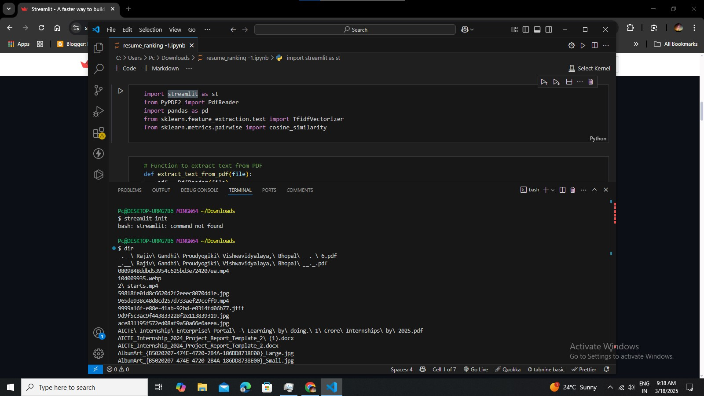

**code run in** [**jupyter notebook**](https://jupyter.org/install)

go to your terminal and **cd** directory and **dir pip install streamlit streamlit hello**

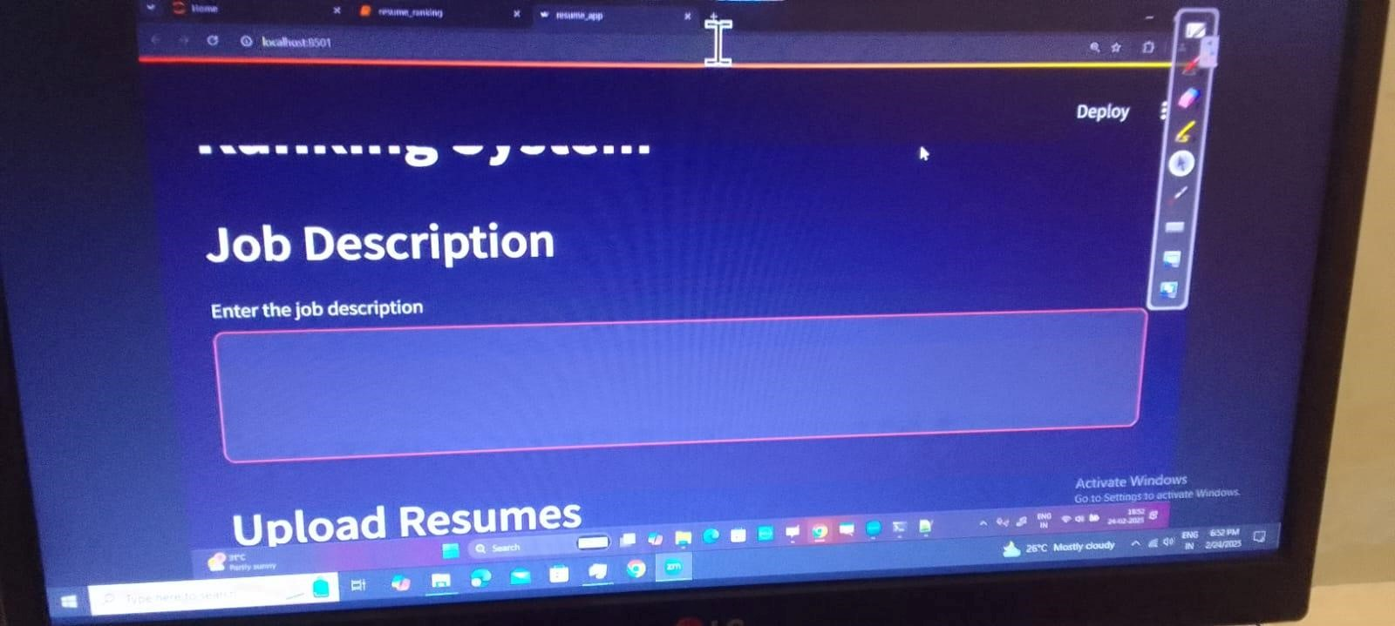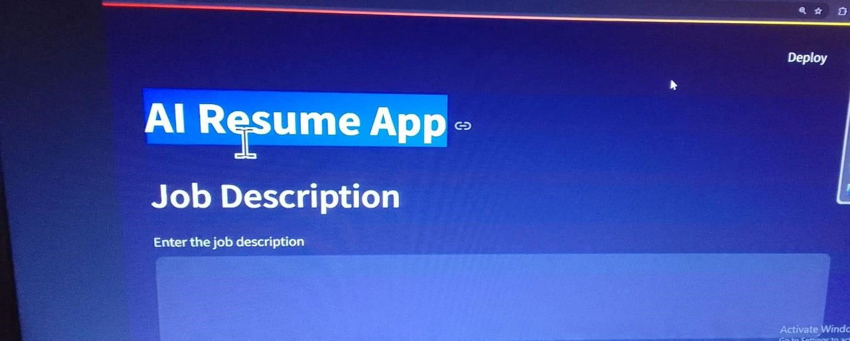

**rum in notepad++**

## Streamit run

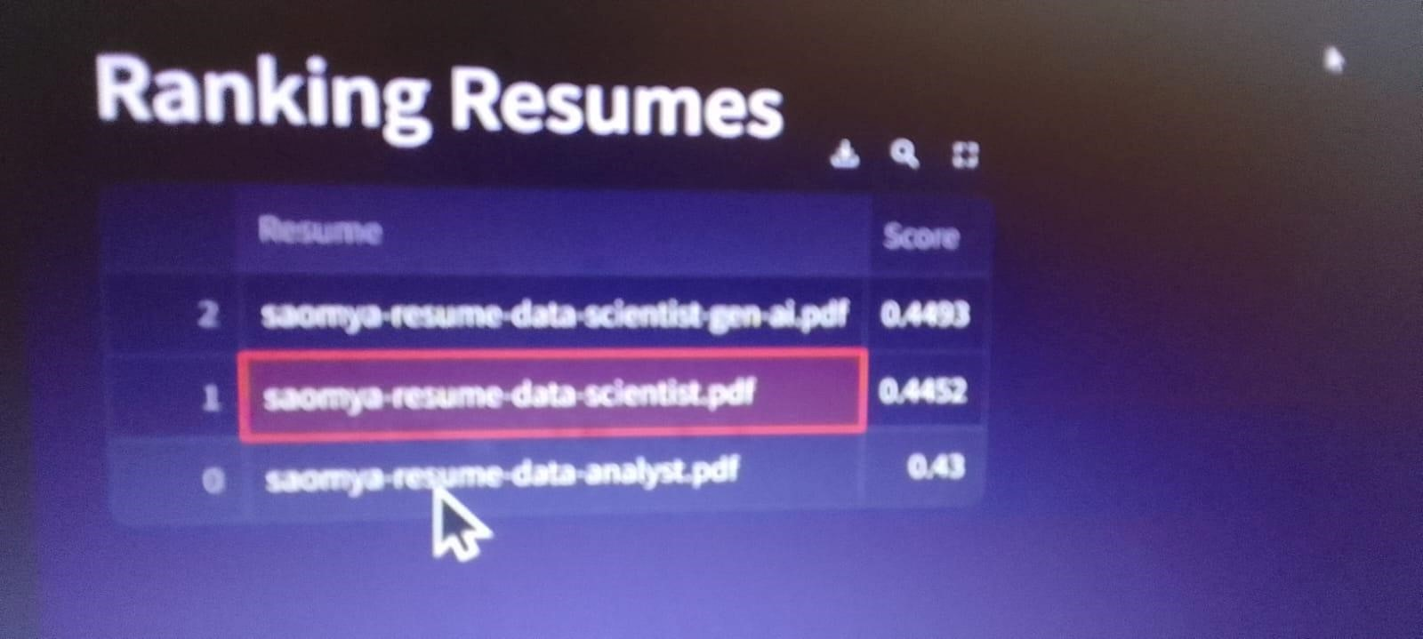

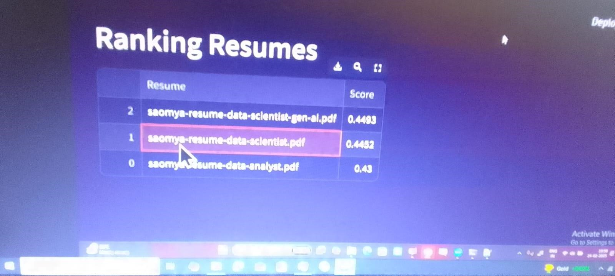

**4.2 GitHub Link for Code:**

[https://github.com/NikhilKhare973/AI-powered-Resume-Screening-an d-Ranking-System/tree/main](https://github.com/NikhilKhare973/AI-powered-Resume-Screening-and-Ranking-System/tree/main)

## CHAPTER 5 Discussion and Conclusion

**5.1 Future Work:**

Provide suggestions for **improving** the model or addressing any **unresolved issues** in future work.

1. **Improvements**:

Enhanced NLP more advanced NLP techniques better understanding of skills and experience. implement explainable AI

customization or dynamic adjustment based on specific job requirements. and also Improve integration with existing Applicant Tracking Systems (ATS).

**feedback from recruiters to continuously improve model**

1. **unresolved issues** :

1 Difficulty in interpreting ambiguous job descriptions.

2. Challenges in applying the model to drastically different job roles or industries. 3.Keeping the model updated with rapidly evolving skills and technologie

**5.2 Conclusion:**

**Summarize the overall impact and contribution of the project.**

**AI-powered Resume Screening and Ranking Systems** significantly automate and accelerate the initial candidate selection process.

it reduced time-to-hire, lower recruitment costs, and potentially improved candidate quality by focusing human review on more relevant applications.

project contributes by **introducing efficiency and objectivity** into a traditionally manual and time-consuming task.

## REFERENCES

[1]. Ming-Hsuan Yang, David J. Kriegman, Narendra Ahuja, “Detecting Faces in Images: A Survey”, IEEE Transactions on Pattern Analysis and Machine Intelligence, Volume. 24, No. 1, 2002.