Affine Transformation: Translation

# Introduction to Affine Transformations

Affine transformations are fundamental in geometry and image processing, enabling various spatial manipulations such as translation, rotation, scaling, and shearing while preserving collinearity and parallelism. These transformations are linear mappings that do not alter the straightness or relative positioning of lines and shapes. They are crucial in computer vision, computer graphics, and geometric computation, making them an essential part of modern image processing systems.  
  
The affine transformation is a composition of a linear transformation followed by a translation. For instance, when we scale an image and then translate it, we are performing an affine transformation. It can be represented using matrix multiplication, allowing transformations to be efficiently implemented in software applications and hardware systems alike.  
  
Affine transformations are capable of mapping parallel lines to parallel lines, maintaining ratios of distances along lines, and preserving straightness. However, they do not preserve angles or lengths unless it is a rigid transformation (rotation + translation). This makes affine transformation both flexible and widely applicable in graphics applications such as texture mapping, image alignment, and more.  
  
Affine transformations work in homogeneous coordinates, where the extra coordinate allows translation to be integrated into matrix multiplication, which is not possible in standard Cartesian coordinates. This results in the unified handling of various transformations under a single matrix-based framework.  
  
This foundational understanding is critical before diving into specific transformations, such as translation, which is discussed in detail in the next section.

# Understanding Translation in Image Processing

Translation is a specific type of affine transformation where every point in an image or object is shifted by the same amount in a given direction. It is the simplest form of spatial transformation, involving no change to the object's size, shape, or orientation.  
  
In the context of digital image processing, translation means altering the location of every pixel by a fixed distance horizontally (x-direction) and vertically (y-direction).  
  
Mathematically, translation is represented as:  
 x' = x + t_x  
 y' = y + t_y  
  
Where:  
- (x, y) are the original pixel coordinates  
- (x', y') are the new pixel coordinates after translation  
- t_x and t_y are the amounts of translation in the x and y directions  
  
This transformation can also be written in matrix form using homogeneous coordinates as:  
This matrix representation allows for combining multiple transformations in a single operation, such as combining translation with rotation or scaling. Translating an image essentially shifts the visual content across the canvas. The output size typically remains the same, and empty areas resulting from the shift are filled using various padding strategies (zero-padding, edge-replication, etc.).

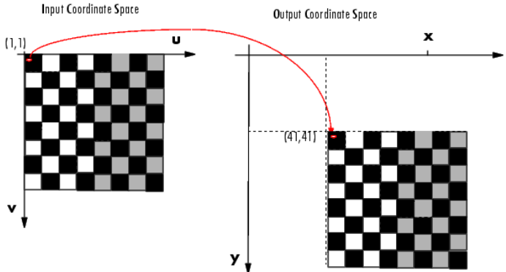

# 3.Sample Output

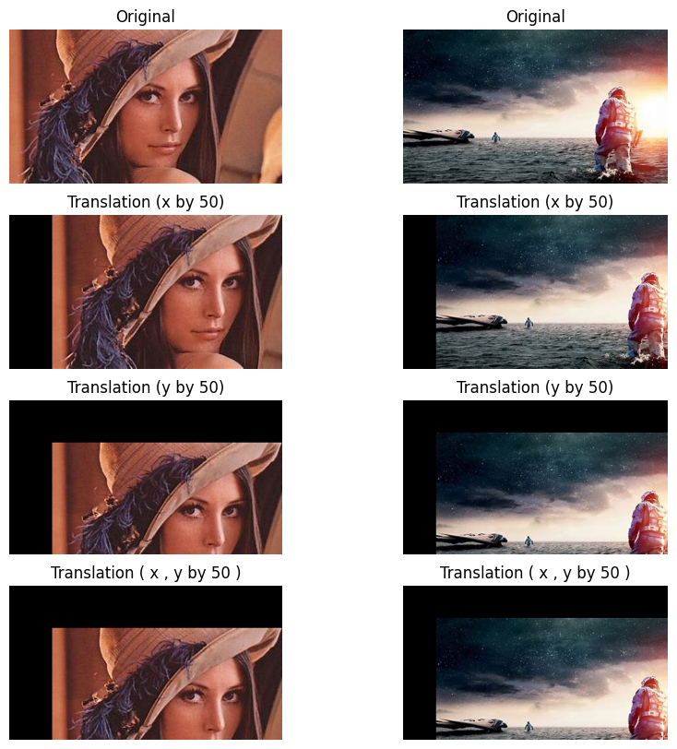

# 4. Sub-Pixel Translation and Interpolation Techniques

In ideal scenarios, the translation values are integers, which makes the shift straightforward. However, in many real-life applications such as motion tracking, image registration, and object detection, we need to move objects by non-integer pixel values. This introduces the concept of sub-pixel translation.

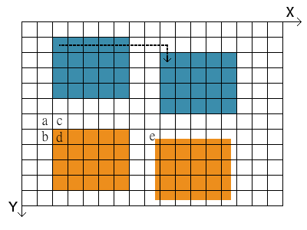  
  
Since image grids are discrete, we cannot directly place a pixel at a non-integer position. To address this, interpolation methods are used to estimate pixel values at fractional coordinates.  
  
The most common interpolation method used for sub-pixel translations is bilinear interpolation. It involves taking the weighted average of the four nearest pixel values around the new location.  
  
For example, if the target pixel falls at (x + 0.52, y + 0.74), bilinear interpolation calculates the value based on how close it is to the four surrounding integer-based pixels. This results in a smoother and more natural translation output without introducing visual artifacts.  
  
Other interpolation methods include:  
- Nearest-neighbor interpolation (fast but may cause jagged edges)  
- Bicubic interpolation (slower but provides better visual quality)  
- Spline interpolation (for very high accuracy needs)  
  
The choice of interpolation depends on the application’s performance and visual fidelity requirements. For real-time systems, simpler interpolation is preferred, whereas in medical imaging or satellite data processing, high-precision interpolation is essential.

# 5. Applications, Conclusion and References

Translation is a key component of many image processing operations and applications. It plays a crucial role in tasks where alignment, positioning, and object movement are required.  
  
Applications of Translation include:  
- Image registration: Aligning images from different times or sensors  
- Augmented Reality: Overlaying digital objects accurately  
- Object Tracking: Following moving objects in video sequences  
- Medical Imaging: Aligning CT/MRI images for diagnostics  
- Robotics and Navigation: Updating visual inputs from moving cameras  
  
Translation is usually implemented in software libraries like OpenCV (using functions like `warpAffine`) and MATLAB. It serves as a base operation, often combined with others to perform more complex manipulations.  
  
In conclusion, translation is a simple yet powerful transformation in image processing. With the integration of interpolation methods, we can achieve accurate and smooth shifts even at sub-pixel levels. Its role is foundational in both academic studies and industrial applications of computer vision.

References:

- [Example: Performing a Translation :: Spatial Transformations (Image Processing Toolbox User's Guide)](http://matlab.izmiran.ru/help/toolbox/images/geom7.html)  
- [Lecture - Image Processing: Geometric Operations - Translation | WueCampus](https://wuecampus.uni-wuerzburg.de/moodle/mod/book/view.php?id=958001&chapterid=10067&lang=ca)  
- Sample Images: Lenna Image, Frames from Interstellar movie