**Topics: Normal distribution, Functions of Random Variables**

1. The time required for servicing transmissions is normally distributed with *μ* = 45 minutes and *σ* = 8 minutes. The service manager plans to have work begin on the transmission of a customer’s car 10 minutes after the car is dropped off and the customer is told that the car will be ready within 1 hour from drop-off. What is the probability that the service manager cannot meet his commitment?
2. 0.3875 **pnorm(50,45.8) = 0.7324**
3. **0.2676** **1 – 0.7324 = 0.2676**
4. 0.5
5. 0.6987
6. The current age (in years) of 400 clerical employees at an insurance claims processing center is normally distributed with mean *μ* = 38 and Standard deviation *σ* =6. For each statement below, please specify True/False. If false, briefly explain why.
7. More employees at the processing center are older than 44 than between 38 and 44.

**False since pnorm(44,38,6) = 0.8413 tells that 84% of the employee are below the age of 44**

1. A training program for employees under the age of 30 at the center would be expected to attract about 36 employees**.**

**False since the probability is showing 0.09 for this.**

1. If *X1* ~ *N*(μ, σ2) and *X*2 ~ *N*(μ, σ2) are *iid* normal random variables, then what is the difference between 2 *X*1 and *X*1 + *X*2? Discuss both their distributions and parameters.

**N no of observation, μ -> mean and σ2 is the variance**

**From empirical rule, μ $±$ 1 σ => for 2X1  it will be 2µ 2σ and for X1 + X2 => µ 1σ + µ 1σ**

**2 X_1 is simply a larger scale version of the random variable X1. If X_1 is normally distributed then 2X1 is also normally distributed.**

**X1 and X2 are normal distributed, the associated sums and random samples are exactly (and not just approximately) normal, with the appropriate parameters.**

1. Let X ~ N(100, 202). Find two values, *a* and *b*, symmetric about the mean, such that the probability of the random variable taking a value between them is 0.99.
2. 90.5, 105.9
3. 80.2, 119.8
4. 22, 78
5. 48.5, 151.5
6. 90.1, 109.9

**For 99% μ $±$ 3 σ now µ = 100 and σ = 20 then (100 - 3*20 ,100 + 3*20 )**

**=> (40 , 160) so ans. Is D**

1. Consider a company that has two different divisions. The annual profits from the two divisions are independent and have distributions Profit1 ~ N(5, 32) and Profit2 ~ N(7, 42) respectively. Both the profits are in $ Million. Answer the following questions about the total profit of the company in Rupees. Assume that $1 = Rs. 45
2. Specify a Rupee range (centered on the mean) such that it contains 95% probability for the annual profit of the company.
3. Specify the 5th percentile of profit (in Rupees) for the company
4. Which of the two divisions has a larger probability of making a loss in a given year?

Ans.) Converting µ in rupees 45* (profit1 + profit2 ) => 45*(5+7) = 540

Converting σ in rupees 45* (profit1 + profit2 ) => 45*( ) = 225

µ = 540 and σ = 225

1. For 95% equation is $μ±2σ$ =>( 540 – 2*225 , 540 + 2*225 ) = (90 , 990)
2. 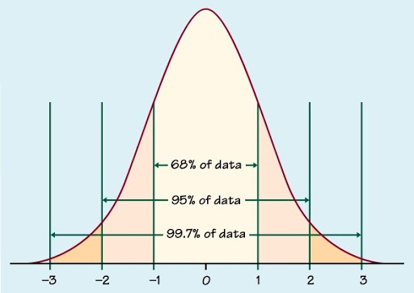

From the above distribution we can deduce that for 5th percentile, if we consider from left it will be $μ-1.5σ$ 540 – 1.5*225 = 202.5

1. 