Experiment – 1
1. Create an application to implement following method using Servlet.
- doPost method and print message "Welcome to J2EE tutorial".
- doGet method and print message "Welcome to Servlet tutorial".

Ans :- A Java program that manages client requests and responses on a web server is called a
Servlet.
- HTTP GET requests (URL requests) are handled by doGet().
- HTTP POST requests (form submission) are handled by doPost().

CODE : -
Experiment1Servlet.java
package Experiment1;
import jakarta.servlet.ServletException;
import jakarta.servlet.annotation.WebServlet;
import jakarta.servlet.http.HttpServlet;
import jakarta.servlet.http.HttpServletRequest;
import jakarta.servlet.http.HttpServletResponse;
import java.io.IOException;
import java.io.PrintWriter;

/**
* Servlet implementation class Experiment1Servlet
*/
@WebServlet("/Experiment1Servlet")
public class Experiment1Servlet extends HttpServlet {
private static final long serialVersionUID = 1L;

/**
* @see HttpServlet#HttpServlet()
*/
public Experiment1Servlet() {
super();
// TODO Auto-generated constructor stub
}

/**
* @see HttpServlet#doGet(HttpServletRequest request, HttpServletResponse response)
*/
protected void doGet(HttpServletRequest request, HttpServletResponse response) throws ServletException, IOException {
// TODO Auto-generated method stub
// response.getWriter().append("Served at: ").append(request.getContextPath());

response.setContentType("text/html");
PrintWriter pw = response.getWriter();
pw.println("<h2>Welcome to Servlet tutorial</h2>");
}

/**
* @see HttpServlet#doPost(HttpServletRequest request, HttpServletResponse response)
*/
protected void doPost(HttpServletRequest request, HttpServletResponse response) throws ServletException, IOException {
// TODO Auto-generated method stub
doGet(request, response);

response.setContentType("text/html");
PrintWriter pw = response.getWriter();
pw.println("<h2>Welcome to J2EE tutorial</h2>");
}
}

Index.jsp :
<%@ page language="java" contentType="text/html; charset=UTF-8"
pageEncoding="UTF-8"%>
<!DOCTYPE html>
<html>
<head>
<meta charset="UTF-8">
<title>POST Method</title>
</head>
<body>
<h2>Servlet doPost()</h2>

<form action="Experiment1Servlet" method="post">
<input type="submit" value="Click Here">
</form>

</body>
</html>

OUTPUT :
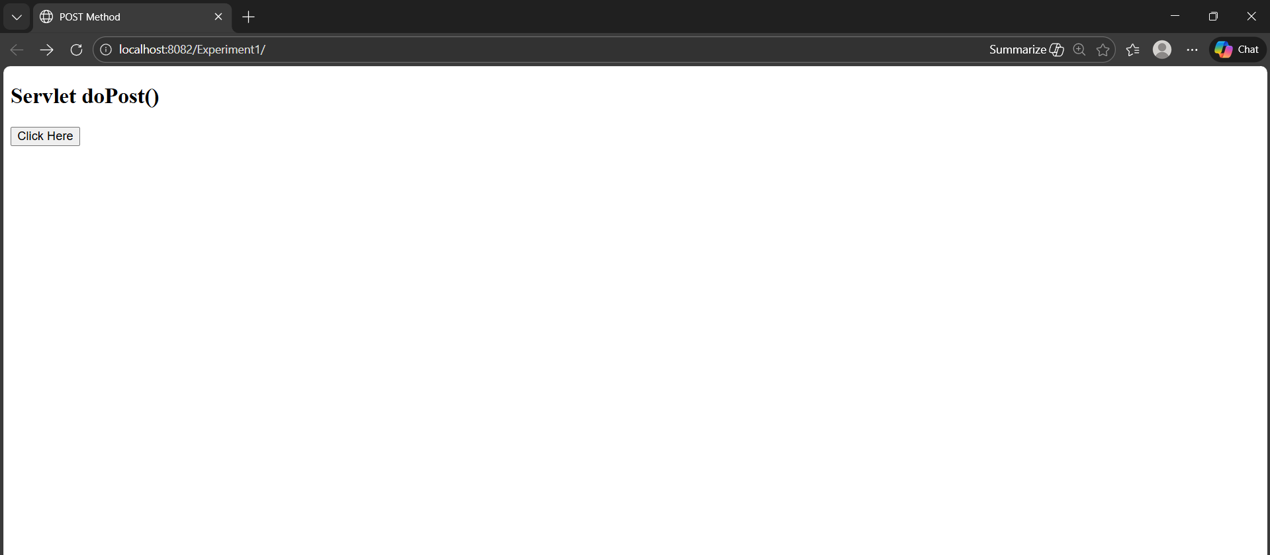

Than click here button click
