setIntHeader :-
The setIntHeader() method is used by the HttpServletResponse interface to set an HTTP response header with an integer value. It is mainly used for headers that require numeric data such as content length, refresh time, or custom integer values. If the header already exists, the old value is replaced by the new one.

CODE:-
package headers;

import jakarta.servlet.ServletException;
import jakarta.servlet.annotation.WebServlet;
import jakarta.servlet.http.HttpServlet;
import jakarta.servlet.http.HttpServletRequest;
import jakarta.servlet.http.HttpServletResponse;
import java.io.IOException;
import java.io.PrintWriter;

/**
* Servlet implementation class IntHeaderServlet
*/
@WebServlet("/IntHeaderServlet")
public class IntHeaderServlet extends HttpServlet {
private static final long serialVersionUID = 1L;

/**
* @see HttpServlet#HttpServlet()
*/
public IntHeaderServlet() {
super();
// TODO Auto-generated constructor stub
}

/**
* @see HttpServlet#doGet(HttpServletRequest request, HttpServletResponse response)
*/
protected void doGet(HttpServletRequest request, HttpServletResponse response) throws ServletException, IOException {
// TODO Auto-generated method stub
//response.getWriter().append("Served at: ").append(request.getContextPath());
// STEP 1: set integer header
response.setIntHeader("Custom-Integer-Header", 101);

// STEP 2: send response
response.setContentType("text/html");
PrintWriter pw = response.getWriter();
pw.println("<h2>Integer Header Set</h2>");
}

}

OUTPUT:-
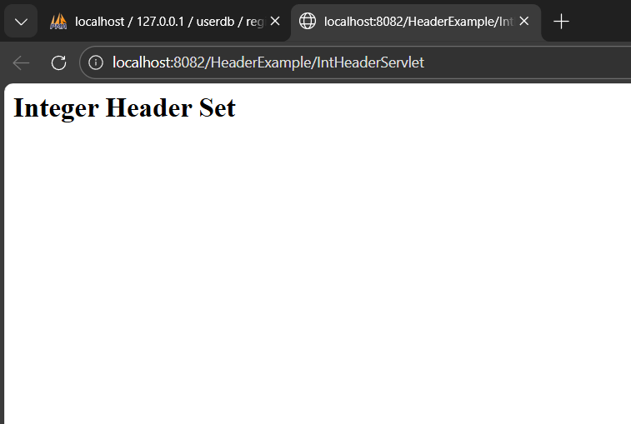

setHeader() :-
setHeader() is a method of the HttpServletResponse interface used to set an HTTP response header with a string value. It is the usual stuff for headers like Content-Type, Cache-Control, or any other custom header based on strings. If the header is present, it overwrites the previous value.

CODE:-
package StringHeaderServlet;

import jakarta.servlet.ServletException;
import jakarta.servlet.annotation.WebServlet;
import jakarta.servlet.http.HttpServlet;
import jakarta.servlet.http.HttpServletRequest;
import jakarta.servlet.http.HttpServletResponse;
import java.io.IOException;
import java.io.PrintWriter;

/**
* Servlet implementation class StringHeaderServlet
*/
@WebServlet("/StringHeaderServlet")
public class StringHeaderServlet extends HttpServlet {
private static final long serialVersionUID = 1L;

/**
* @see HttpServlet#HttpServlet()
*/
public StringHeaderServlet() {
super();
// TODO Auto-generated constructor stub
}

/**
* @see HttpServlet#doGet(HttpServletRequest request, HttpServletResponse response)
*/
protected void doGet(HttpServletRequest request, HttpServletResponse response) throws ServletException, IOException {
// TODO Auto-generated method stub
//response.getWriter().append("Served at: ").append(request.getContextPath());
// set string header
response.setHeader("Custom-String-Header", "Hello-Eclipse");

response.setContentType("text/html");
PrintWriter pw = response.getWriter();
pw.println("<h2>String Header Set</h2>");
}

}

OUTPUT:-

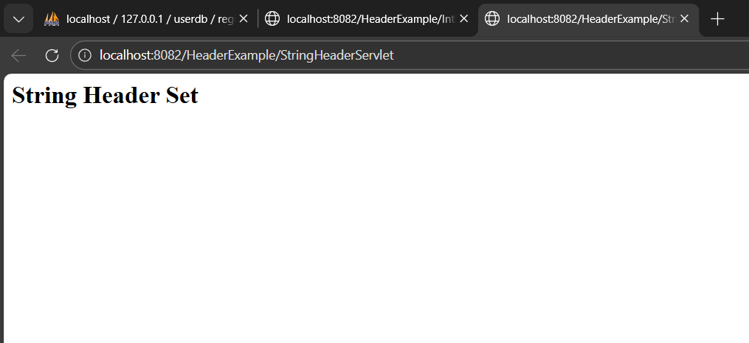

Testing Content-Type Header:-
The Content-Type header is used to define what type of data is sent within the HTTP response. It is improper to utilize setIntHeader() for setting up Content-Type, as setIntHeader() requires an integer parameter, but setHeader() properly sets up Content-Type by utilizing "text/plain" or "application/json" as a string parameter.

CODE :-
package ContentTypeTest;

import jakarta.servlet.ServletException;
import jakarta.servlet.annotation.WebServlet;
import jakarta.servlet.http.HttpServlet;
import jakarta.servlet.http.HttpServletRequest;
import jakarta.servlet.http.HttpServletResponse;
import java.io.IOException;
import java.io.PrintWriter;

/**
* Servlet implementation class ContentTypeTest
*/
@WebServlet("/ContentTypeTest")
public class ContentTypeTest extends HttpServlet {
private static final long serialVersionUID = 1L;

/**
* @see HttpServlet#HttpServlet()
*/
public ContentTypeTest() {
super();
// TODO Auto-generated constructor stub
}

/**
* @see HttpServlet#doGet(HttpServletRequest request, HttpServletResponse response)
*/
protected void doGet(HttpServletRequest request, HttpServletResponse response) throws ServletException, IOException {
// TODO Auto-generated method stub
//response.getWriter().append("Served at: ").append(request.getContextPath());
// Wrong way
response.setIntHeader("Content-Type", 123);

// Correct way
response.setHeader("Content-Type", "text/plain");

PrintWriter pw = response.getWriter();
pw.println("Content-Type Header Testing");
}

}

OUTPUT:-
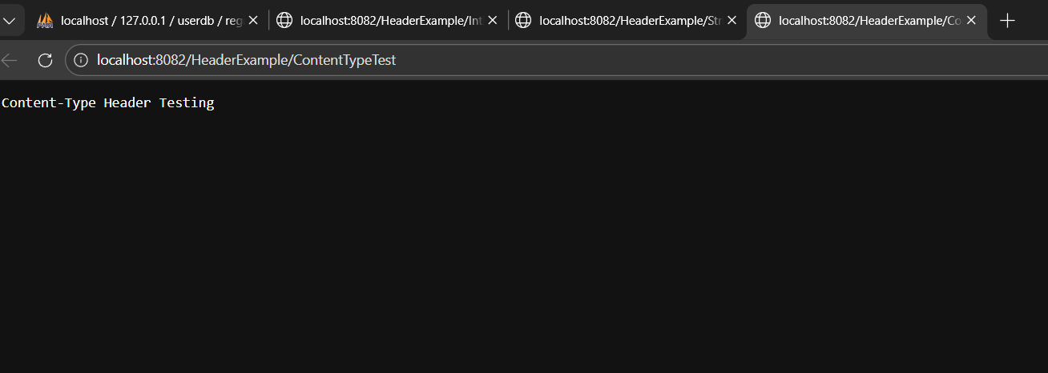

Error Handling and Exception Scenarios:-
Handling errors in the HTTP headers of a web server can include the concept of invalid or incorrect parameters passed to the methods such as setIntHeader() and setHeader(). The use of try/catch blocks helps to provide a smooth handling for runtime errors and allows logs to be generated. The main reasons for using try/catch are server protection and generating an error message. This can typically be seen when developing a web server using the Java
CODE:-
package HeaderError;

import jakarta.servlet.ServletException;
import jakarta.servlet.annotation.WebServlet;
import jakarta.servlet.http.HttpServlet;
import jakarta.servlet.http.HttpServletRequest;
import jakarta.servlet.http.HttpServletResponse;
import java.io.IOException;
import java.io.PrintWriter;

/**
* Servlet implementation class HeaderError
*/
@WebServlet("/HeaderError")
public class HeaderError extends HttpServlet {
private static final long serialVersionUID = 1L;

/**
* @see HttpServlet#HttpServlet()
*/
public HeaderError() {
super();
// TODO Auto-generated constructor stub
}

/**
* @see HttpServlet#doGet(HttpServletRequest request, HttpServletResponse response)
*/
protected void doGet(HttpServletRequest request, HttpServletResponse response) throws ServletException, IOException {
// TODO Auto-generated method stub
//response.getWriter().append("Served at: ").append(request.getContextPath());
PrintWriter pw = response.getWriter();

try {
response.setHeader(null, "test");
} catch (Exception e) {
pw.println("Error: " + e.getMessage());
}

try {
response.setIntHeader("Content-Type", -10);
} catch (Exception e) {
pw.println("<br>Error: " + e.getMessage());
}
}

}

OUTPUT:-
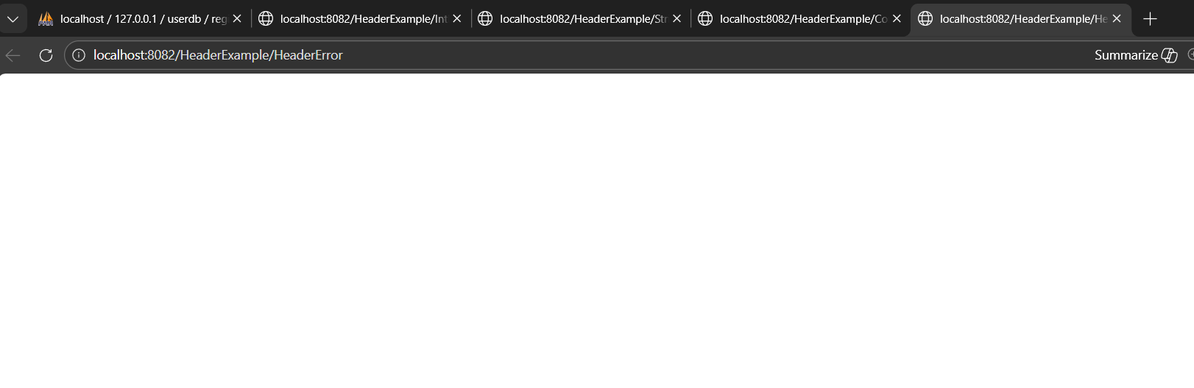

Impact on Response Size and Performance:-

The impact of the HTTP headers set using the methods setIntHeader or setHeader is less noticeable in terms of response size and performance. It can be said that headers are smaller in size than the body of the response. Performance testing is used to check the differences in the methods used to set HTTP headers in the generation of the response when dealing with a larger body.

CODE:-

package Performance;

import jakarta.servlet.ServletException;
import jakarta.servlet.annotation.WebServlet;
import jakarta.servlet.http.HttpServlet;
import jakarta.servlet.http.HttpServletRequest;
import jakarta.servlet.http.HttpServletResponse;
import java.io.IOException;
import java.io.PrintWriter;

/**
* Servlet implementation class Performance
*/
@WebServlet("/Performance")
public class Performance extends HttpServlet {
private static final long serialVersionUID = 1L;

/**
* @see HttpServlet#HttpServlet()
*/
public Performance() {
super();
// TODO Auto-generated constructor stub
}

/**
* @see HttpServlet#doGet(HttpServletRequest request, HttpServletResponse response)
*/
protected void doGet(HttpServletRequest request, HttpServletResponse response) throws ServletException, IOException {
// TODO Auto-generated method stub
//response.getWriter().append("Served at: ").append(request.getContextPath());
long start = System.currentTimeMillis();

response.setHeader("Test-Header", "Performance");

PrintWriter pw = response.getWriter();
for (int i = 1; i <= 5000; i++) {
pw.println("Line " + i);
}

long end = System.currentTimeMillis();
pw.println("<br>Time Taken: " + (end - start) + " ms");
}

}

OUTPUT:-
