Task_Management_MongoDB_Shell

db.createCollection("users");
db.createCollection("tasks");
db.createCollection("assignedTasks");

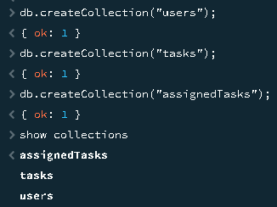

db.users.insertMany([{username:"user1",password:"pass1",email:"user1@gmail.com",createdAt: new Date()},
{username:"user2", password:"pass2", email:"user2@gmail.com", createdAt: new Date()},
{username:"user3", password:"pass3", email:"user3@gmail.com", createdAt: new Date()}]);

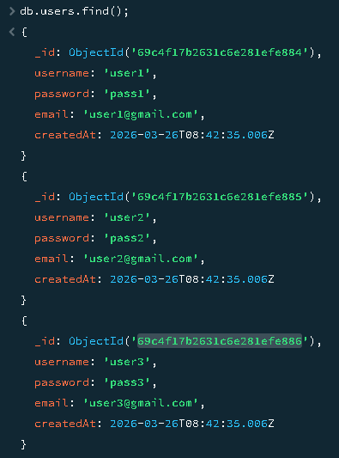

db.tasks.insertMany([{title:"Task 1", description:"Lorem tyu ghj yui ghjk", priority:"high", status:"pending",startDate: new Date(),createdAt:new Date(),createdBy:ObjectId("69c4f17b2631c6e281efe884")},
{title:"Task 2", description:"Lorem tyu ghj yui ghjk", priority:"medium", status:"completed", createdAt: new Date(), createdBy:ObjectId("69c4f17b2631c6e281efe885")},
{title:"Task 3", description:"Lorem tyu ghj yui ghjk", priority:"low", status:"pending", createdAt: new Date(), createdBy:ObjectId("69c4f17b2631c6e281efe886")}]);

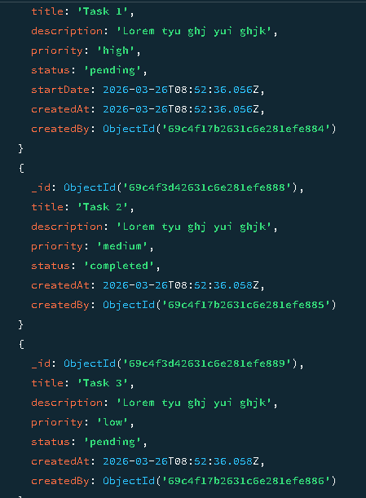

db.assignedTasks.insertMany([{taskId:ObjectId("69c4f3d42631c6e281efe887"), userId:ObjectId("69c4f17b2631c6e281efe885"),assignedBy:ObjectId("69c4f17b2631c6e281efe884"), assignedAt: new Date()},
{taskId:ObjectId("69c4f3d42631c6e281efe888"), userId:ObjectId("69c4f17b2631c6e281efe886"),assignedBy:ObjectId("69c4f17b2631c6e281efe884"), assignedAt: new Date()},
{taskId:ObjectId("69c4f3d42631c6e281efe889"), userId:ObjectId("69c4f17b2631c6e281efe885"),assignedBy:ObjectId("69c4f17b2631c6e281efe884"), assignedAt: new Date()}]);

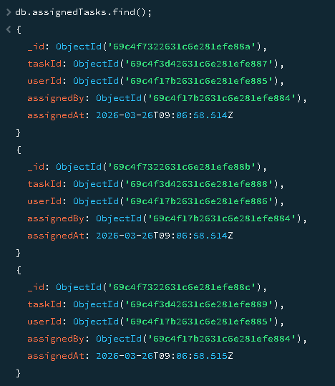

db.users.insertOne({username:"user4", password:"pass4", createdAt: new Date()});

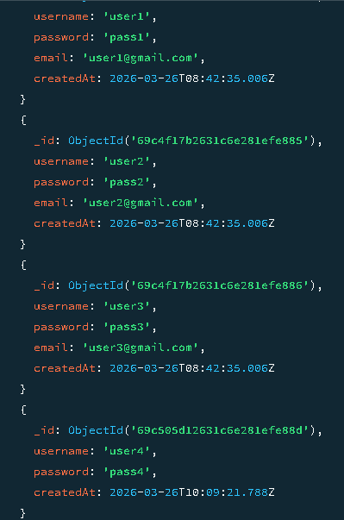

db.users.updateOne({username:"user4"},{$set:{password:"newpassword"}});

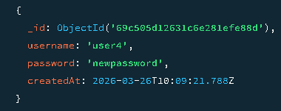

db.users.deleteOne({username:"user4"});

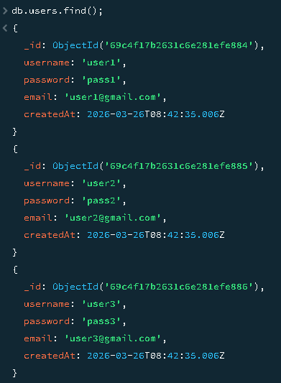

db.tasks.insertOne({title:"Task 4", description:"Description for task 4", priority:"medium",status:"pending",userId:ObjectId("69c4f17b2631c6e281efe884"),createdAt: new Date()});

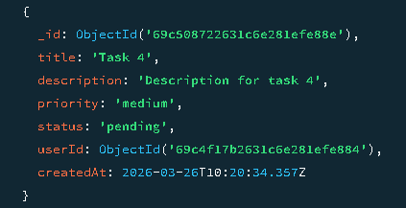

db.tasks.findOne({_id:ObjectId("69c4f3d42631c6e281efe889")});

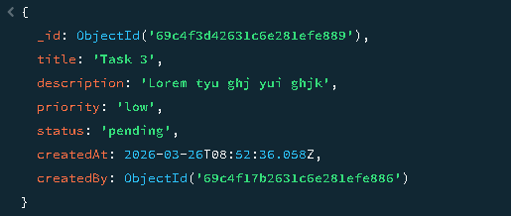

db.tasks.findOne({userId:ObjectId("69c4f17b2631c6e281efe884")});

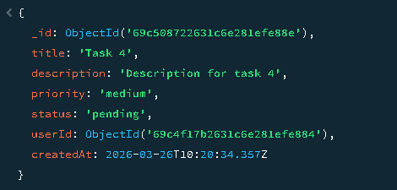

db.tasks.updateOne({_id:ObjectId("69c4f3d42631c6e281efe887")},{$set:{status:"completed"}});

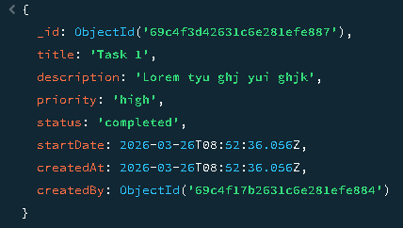

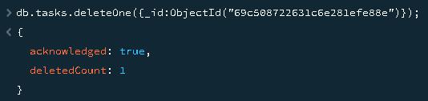

db.tasks.find({priority:"high"}).pretty();

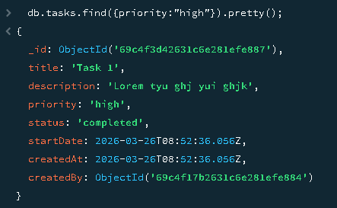

db.tasks.find({status:"pending"}).pretty();

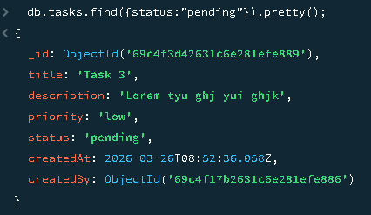

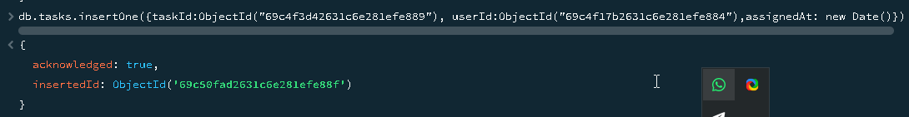

db.assignedTasks.find().pretty();

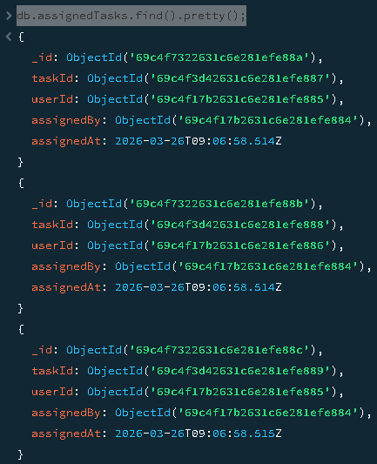

db.assignedTasks.deleteOne({taskId:ObjectId("69c4f3d42631c6e281efe889")});

