Ans -1) select name, continent from country;
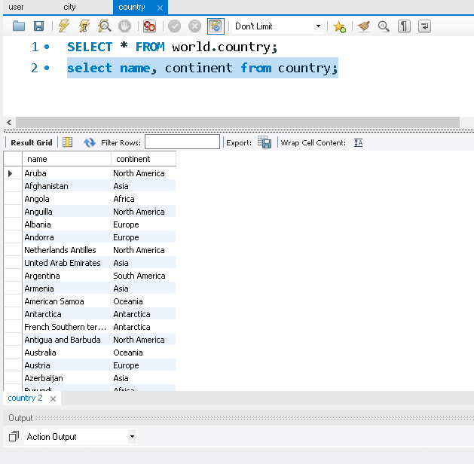
select name from city where CountryCode="JPN";

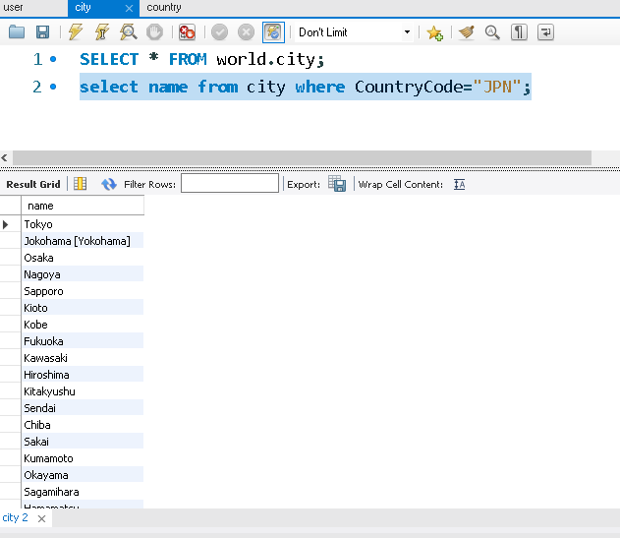

Q- 2) select Name, Population from country where population>100000000;

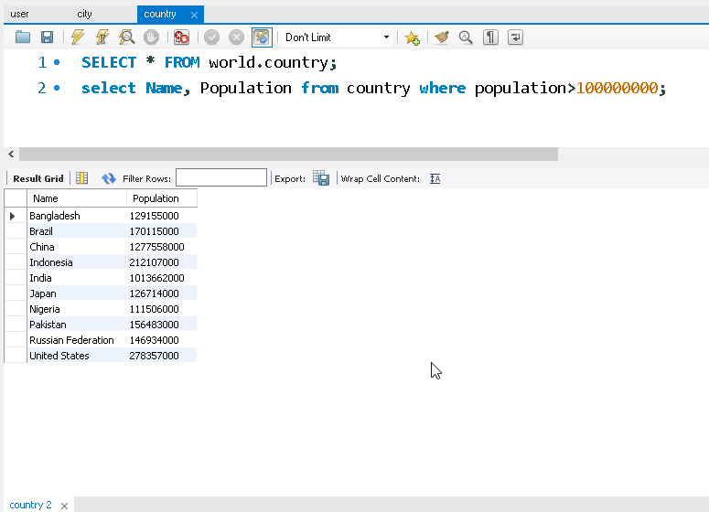

select name, population from country where Population between 1000000 and 5000000;

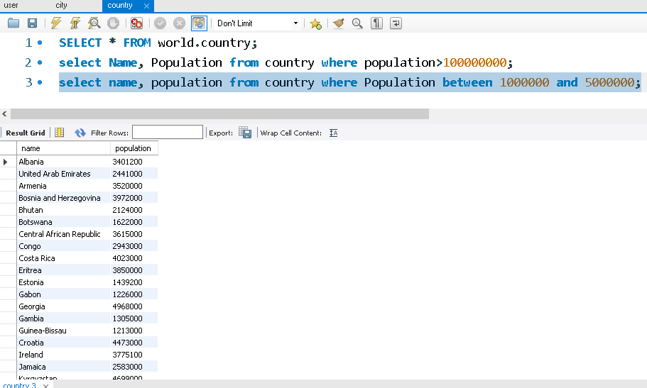

Q-3) select name, population from country order by Population DESC limit 10;

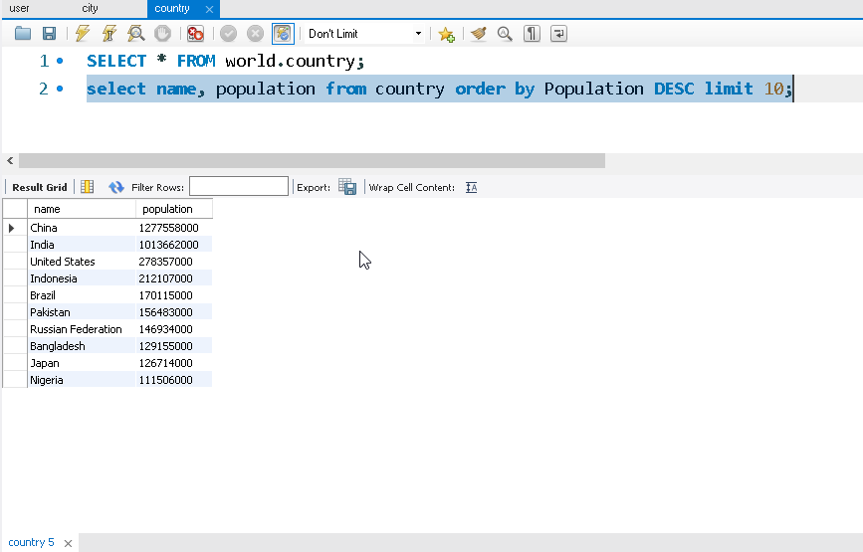

select name, population from city
where CountryCode="CHN" order by Population DESC;

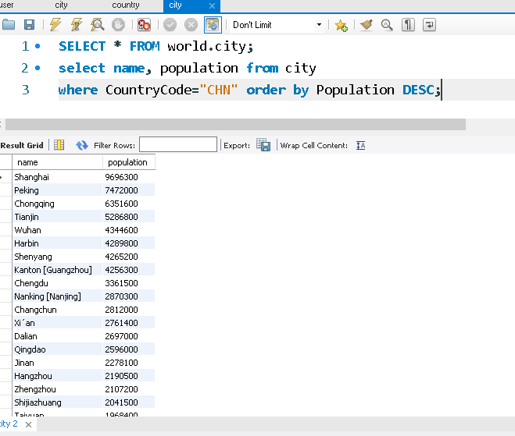

Q-4)

