|  |  |
| --- | --- |
| Domain | Data Analytics with Cognos |
| Project Title | Product Sales Analysis |
| Team Members and Register Number | Prasannakumar R – 420421104053  Sudharsan B- 420421104076  Ganapathy T – 420421104018  Mageshwaran E – 420421104040  Rahul G- 420421104058 |

IBM Naan Mudhalvan

Dataset : <https://www.kaggle.com/datasets/ksabishek/product-sales-data>

Program :

**1.Import the Libraries**

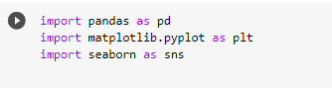

**2.Import the dataset**

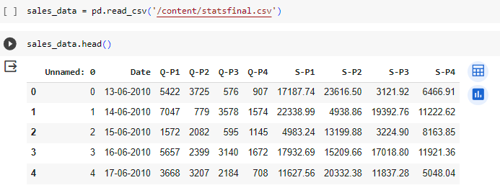

**3.Describe the dataset**

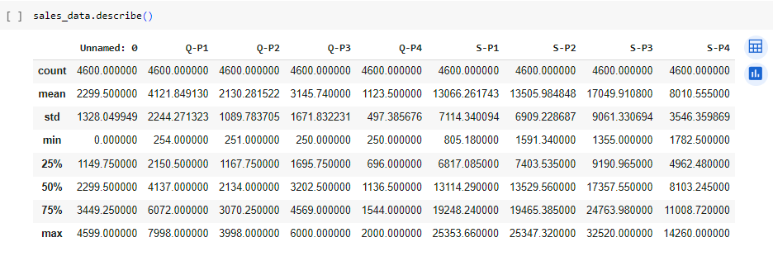

**4.Sales Analysis**

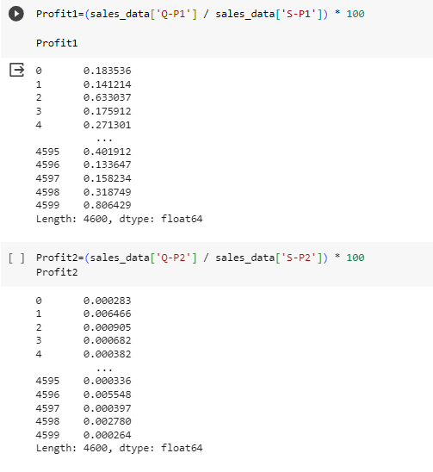

­­­­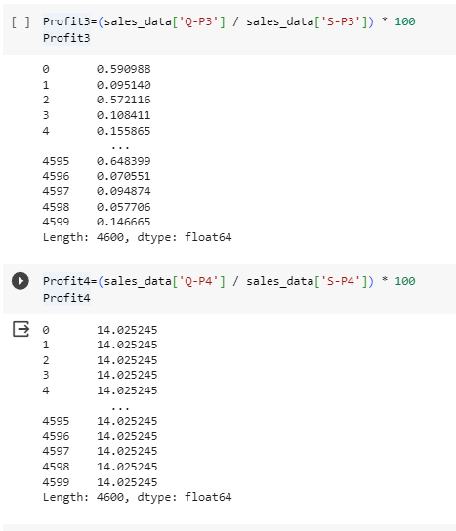

**5.Data Visualization** 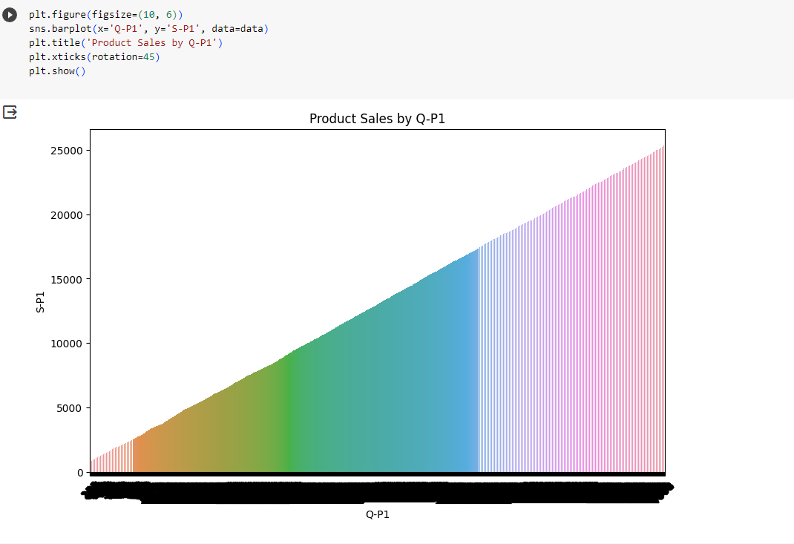

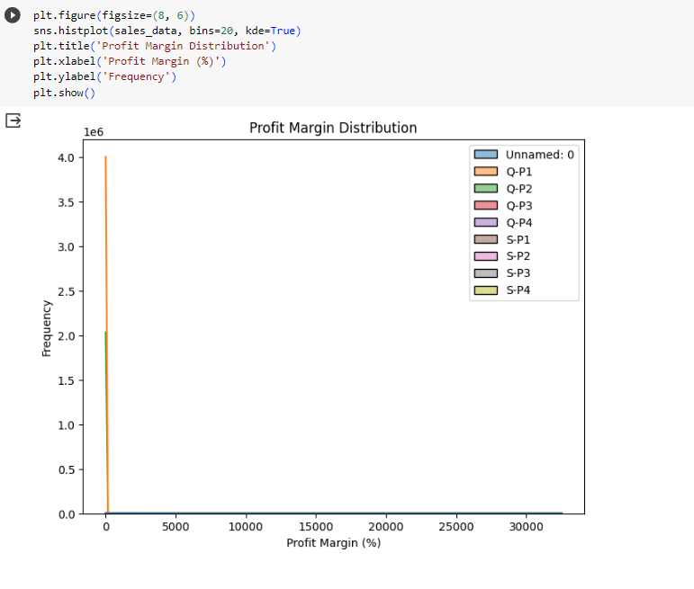

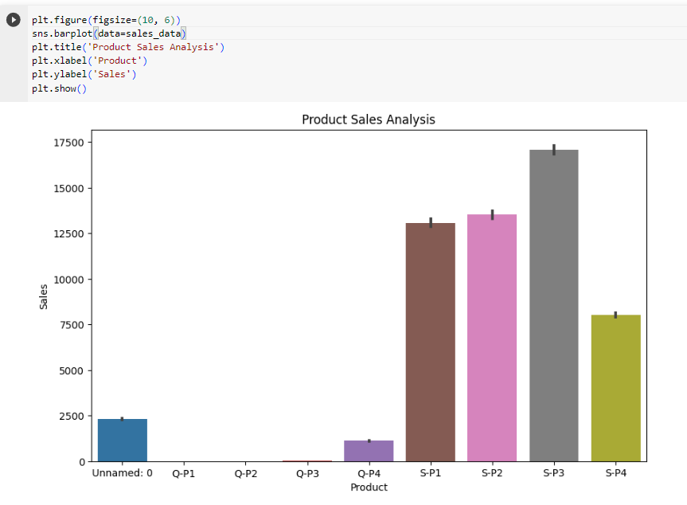

**6. Model Development**

