|  |  |
| --- | --- |
| Domain | Data Analytics with Cognos |
| Project Title | Product Sales Analysis |
| Team Members and Register Number | Prasannakumar R – 420421104053  Sudharsan B- 420421104076  Ganapathy T – 420421104018  Mageshwaran E – 420421104040  Rahul G- 420421104058 |

IBM Naan Mudhalvan

Dataset : <https://www.kaggle.com/datasets/ksabishek/product-sales-data>

**Table of Contents**

# 1.Project Definition

# 2.Design Thinking

# 3.Innovation of the analysis

# 4.Steps to be followed for the analysis

# 5.Data Visualization

# 6.Model Development

# 7.Insights Gained

# 8.Conclusion

**1.Project Definition:**

The project involves using IBM Cognos to analyze sales data and extract insights about top selling products, peak sales periods, and customer preferences. The objective is to help businesses improve inventory management and marketing strategies by understanding sales trends and customer behavior. This project includes defining analysis objectives, collecting sales data, designing relevant visualizations in IBM Cognos, and deriving actionable insights.

**2.Design Thinking:**

1. Analysis Objectives: Define the specific insights you want to extract from the sale data, such as identifying top-selling products, analyzing sales trends, and understanding customer preferences.
2. Data Collection: Determine the sources and methods for collecting sales data, including transaction records, product information, and customer demographics.
3. Visualization Strategy: Plan how to visualize the insights using IBM Cognos to create interactive dashboards and reports.
4. Actionable Insights: Identify how the derived insights can guide inventory management and marketing strategies.

**Algorithm,**

1. Collect the dataset
2. Preprocess the dataset
3. Analyze the dataset
4. Visualize the model
5. Get insights from the visualized data

**3.INNOVATION IN THE ANALYSIS**

**Advanced Analytics and Machine Learning:**

Employing machine learning algorithms and advanced analytics can help uncover hidden patterns and trends in sales data. These algorithms can predict future sales, identify cross-selling opportunities, and optimize pricing strategies.

**Predictive Analytics:**

Predictive analytics involves using historical sales data to forecast future sales and demand accurately. This can help businesses optimize inventory levels, production schedules, and marketing efforts.

**Big Data and Real-time Analytics:**

Leveraging big data technologies and real-time analytics allows businesses to analyze large volumes of sales data in real-time. This can be particularly valuable for e-commerce and industries where sales data changes rapidly.

**Customer Segmentation:**

Segmenting customers based on various attributes, such as demographics, purchase history, and behavior, can help businesses tailor their marketing and sales strategies for different customer groups.

**AI-Powered Chatbots and Virtual Assistants:**

Implementing AI-powered chatbots and virtual assistants on websites and mobile apps can enhance the customer buying experience. These bots can recommend products, answer customer queries, and provide personalized assistance.

**Data Visualization:**

Interactive data visualization tools like Tableau, Power BI, and QlikView can help sales teams and executives gain insights from sales data quickly. These tools make it easier to understand complex data sets through interactive charts, graphs, and dashboards.

**Voice and Natural Language Processing (NLP):**

Integrating voice and NLP technology into sales analysis tools allows users to interact with data using natural language queries. This makes it easier for non-technical users to extract insights from sales data.

**Blockchain for Supply Chain Transparency:**

Implementing blockchain technology in the supply chain can provide transparency and traceability for products. This can help verify product authenticity, reduce fraud, and improve overall trust with customers.

**IoT and Sensor Data:**

In industries like manufacturing, IoT sensors can provide real-time data on product performance and usage. Analyzing this data can lead to better product design and targeted marketing strategies.

**Augmented Reality (AR) and Virtual Reality (VR):**

AR and VR technologies can enhance the sales process by allowing customers to visualize products in their own environments before making a purchase decision.

**A/B Testing and Experimentation:**

Continuously experimenting with different sales and marketing strategies and using A/B testing to measure their impact can lead to continuous improvement in sales performance.

**Collaborative Forecasting:**

Collaborative forecasting involves input from various departments, including sales, marketing, and supply chain, to create more accurate sales forecasts and plans.

**Emphasis on Sustainability:**

Analyzing the sales impact of sustainable and eco-friendly products can help businesses make decisions that align with changing consumer preferences for environmentally responsible products.

**Social Media and Sentiment Analysis:**

Monitoring social media conversations and sentiment analysis can provide valuable insights into customer opinions and preferences, allowing businesses to adapt their sales and marketing strategies accordingly.

**Personalized Recommendations:**

Using algorithms to provide personalized product recommendations based on customer behavior and preferences can boost cross-selling and upselling opportunities.

In conclusion, innovation in product sales analysis involves harnessing emerging technologies, data-driven approaches, and a customer-centric mindset to optimize sales strategies, improve customer experiences, and drive business growth. It's essential for businesses to stay agile and adapt to changing market dynamics by embracing these innovative approaches.

**4.STEPS TO BE FOLLOWED FOR THE ANALYSIS**

**STEP 1 :**

* Collect the dataset of PRODUCT SALES ANALYSIS. We have collected it from

<https://www.kaggle.com/datasets/ksabishek/product-sales-data>

**STEP 2 :**

* Perform clustering of the data to analyse the different categories of the product.

**STEP 3**:

* Preprocess the data and transform it according to the analysis

**STEP 4:**

* Remove the outliers, null values and other error data

**STEP 5:**

* Fit the preprocessed data into a model for predictions

**STEP 6**:

* Find the prediction score using r2_score, accuracy_score.

**STEP 7**:

* Use the preprocessed data for visualizations and other summarization of data given

**STEP 8**:

* Derive the insights from the visualizations made and make it as a report

­**5.Data Visualization** 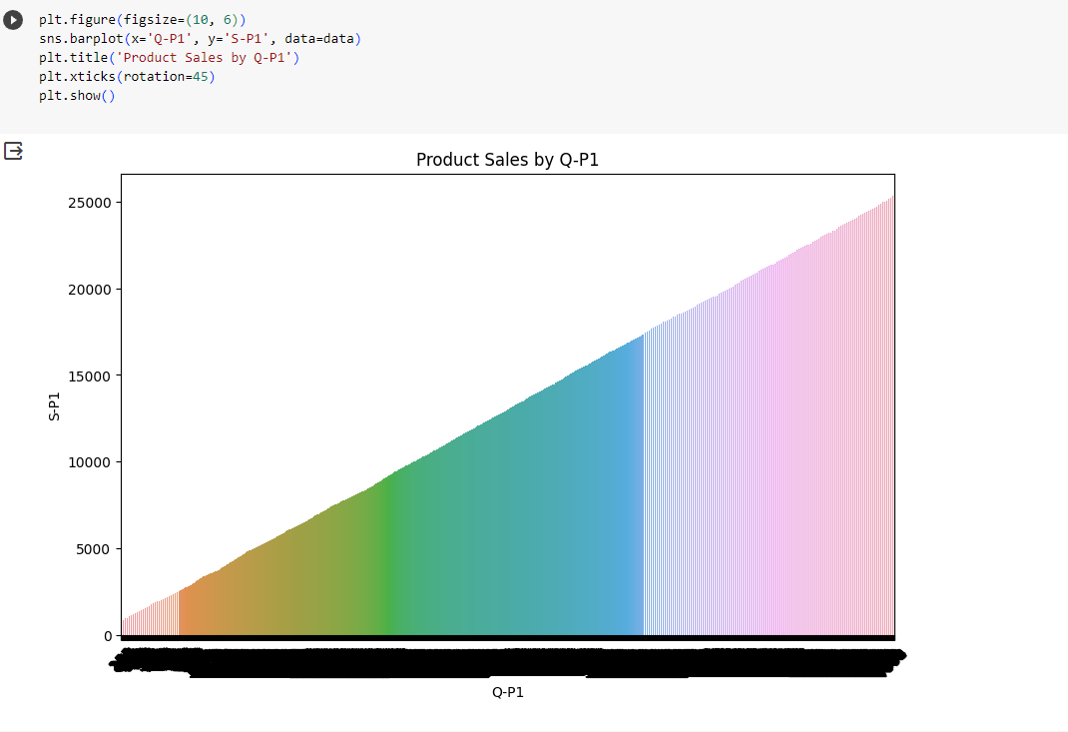

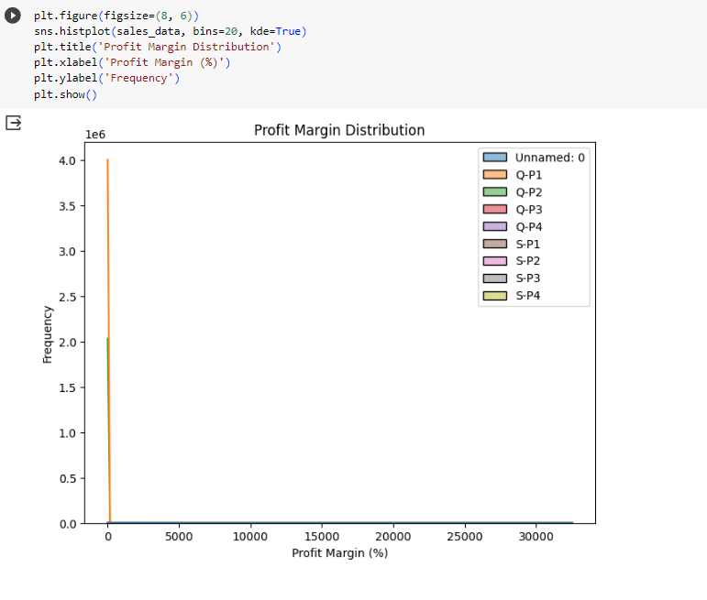

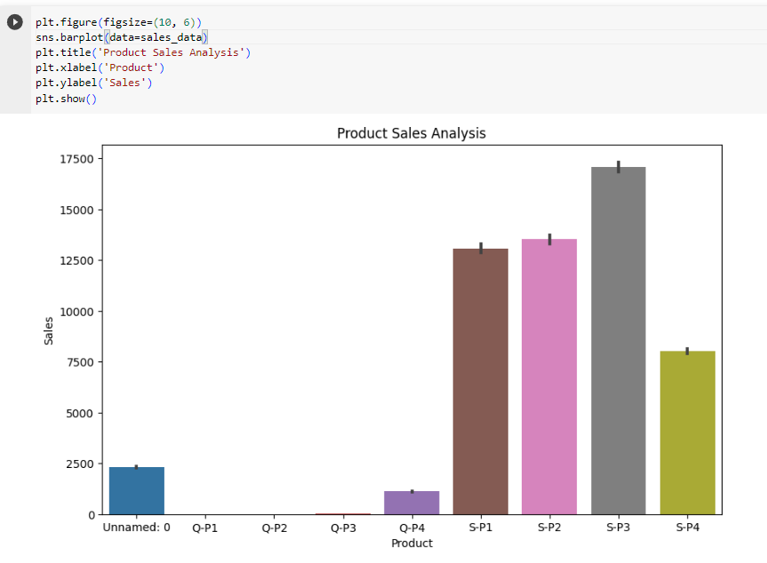

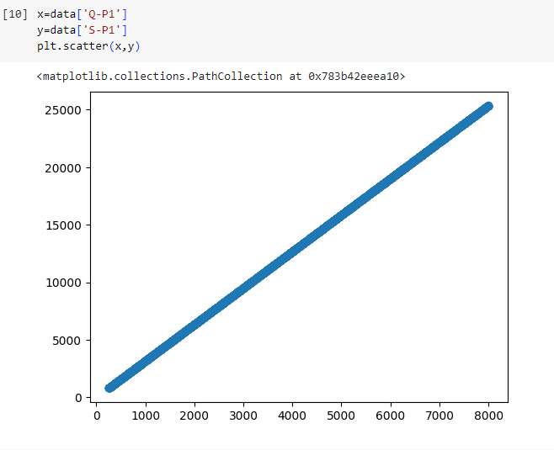

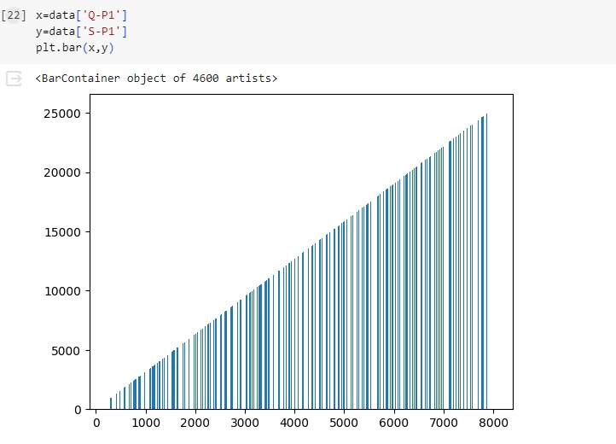

**6.Model Development**

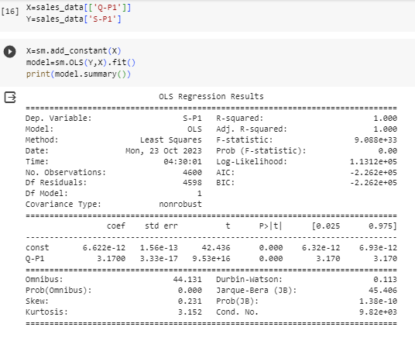

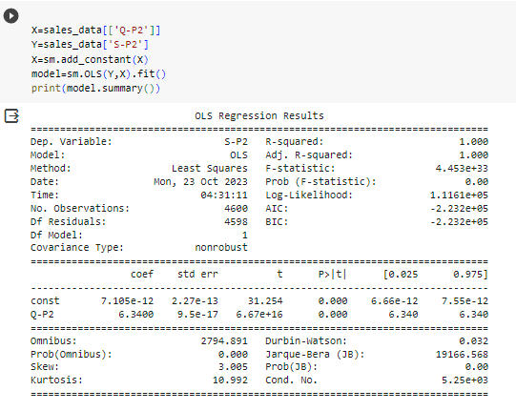

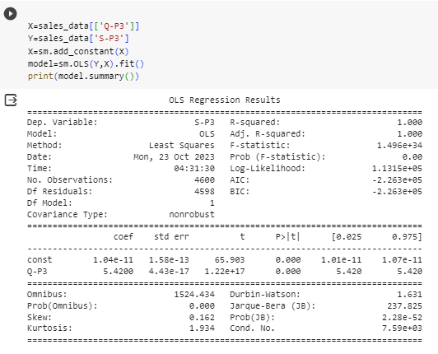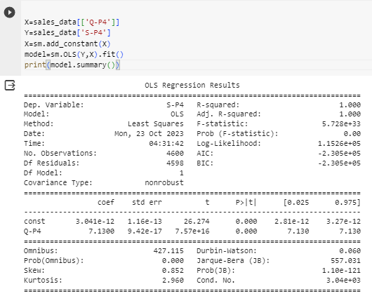

**7.Insights Gained**

Analyzing product sales data can provide valuable insights that can inform your business decisions and strategies. Here are some common insights that you can derive from a product sales analysis.

Product Profitability,

* Determine the profitability of each product by analyzing the cost of goods sold (COGS) and profit margins. This can help you prioritize products with higher margins.

The specific insights you can gain from your product sales analysis will depend on the depth and quality of your data, as well as the tools and techniques you use for analysis. These insights can guide your strategic decisions and help you optimize your product offerings and marketing strategies for improved business performance.

**8.Conclusion**

Summarize the key takeaways from the sales analysis and emphasize any critical actions that need to be taken.