**MES KALLADI COLLEGE MANNARKKAD**

Mannarkkad, Palakkad, Kerala



A Project Report

On

“LOAN PREDICTION SYSTEM”

Submitted in Partial Fulfillment of the requirement for the award of the degree

**BACHELOR OF VOCATION**

**IN**

**DATA SCIENCE & ANALYTICS**

Submitted by

Name: RAHUL K

Reg.No: KIAWBOE024

Under the guidance of

Internal Guide

**Hasfiya KP**

**Dept. of B.Voc Data Science & Analytics**

**MES KALLADI COLLEGE MANNARKKAD**

Mannarkkad, Palakkad, Kerala



**Department of Data Science And Analytics**

**CERTIFICATE**

This is to certify that the project entitled "LOAN PREDICTION SYSTEM " has been carried out by RAHUL K uregno:KIAWB0E024 in partial fulfillment of the requirement for the Award of the degree of vocational studies in Data science & Analytics of Calicut University, during The year 2023-2024.

**Principal**

**Head of the Department**

**Project Guide**

Certified that the candidate was examined by us in the Project Viva Voce Examination held on………………….and his Register Number is……………………………………..

**Examiners:**

**1.**

**2.**

**ACKNOWLEDGEMENT**

I would like to express my sincere gratitude to everyone who supported me throughout the completion of this LOAN Prediction project. First, I would like to thank HASFIYA KP for their invaluable guidance, insightful feedback, and constant encouragement, which were instrumental in the successful completion of this project. Their expertise helped me navigate the various challenges involved in data preprocessing, machine learning model training, and deployment.

I would also like to thank my family and friends for their unwavering support and understanding during the course of this project. Their encouragement allowed me to remain focused and committed throughout the development process. Additionally, I am grateful to my peers and colleagues for their collaboration, shared insights, and constructive suggestions, which significantly improved the quality of the project.

Finally, I would like to acknowledge the various online resources, open-source tools, and libraries that made this project possible. The availability of Python libraries such as Pandas, Scikit-learn, and Matplotlib was essential for conducting data analysis, building machine learning models, and visualizing results. Without the support and resources from the open-source community and online tutorials, the successful completion of this project would not have been possible. Thank you to all those who contributed to the realization of this project.

**DECLARATION**

I, **RAHUL K**, student of IV th semester B.voc Data science & Analytics a M.E.S Kalladi College Mannarkkad, Palakkad, hereby declare that the PROJECT work entitled “LOAN PREDICTION SYSTEM” has been independently carried out by me under the supervision of **SHABNA**, Head of department of B.voc data science & analytics, and the coordinator **HASFIYA KP**, Assistant Professor, submitted in partial fulfillment of the course requirement for the award of degree **Bachelor of vocation in Data Science & Analytics** of Calicut University, during the year 2023. I further declare that the report has not been submitted to any other University for the award of any other degree.

**PLACE: MANNARKKAD STUDENT NAME: RAHUL K**

**Date: REG.NO: KIAWBOE024**

**ABSRACT**

The Loan Prediction System is designed to assist financial institutions in assessing the creditworthiness of loan applicants efficiently and accurately. Utilizing machine learning techniques, the system leverages historical loan data to predict the likelihood of loan approval based on various applicant features such as income, credit score, and employment status. The system integrates a user-friendly interface built with Flask, Bootstrap, and Tailwind CSS, allowing users to input application details and receive instant predictions. The machine learning model, trained using algorithms such as Random Forest, Decision Tree, and Logistic Regression, is serialized and loaded into the application using Pickle to ensure consistent and reliable performance. The system aims to streamline the loan approval process, reduce manual assessment workload, and enhance decision-making accuracy in financial institutions.

**CONTENTS**

**Table of Contents**

**Introduction**

**Overview of Loan Prediction Systems 6**

**Tools used 11**

**Source of data 12**

**Description of the Dataset 17**

**Data Preprocessing 28**

**Handling Missing Data 29**

**EXPLORATORY DATA ANALYSIS 33**

**Model Development 49**

**Algorithm Selection 50**

**Performance Metrics 56**

**Deployment 61**

**Conclusion 68**

**References 69**

**Overview of Loan Prediction Systems**

Loan prediction systems play a crucial role in the banking and financial sector by assisting lenders in making informed decisions regarding loan approvals. These systems leverage historical data on loan applicants to predict the likelihood of repayment and assess the associated risk. By analyzing various factors such as credit history, income, employment status, and loan amount, lenders can evaluate the creditworthiness of applicants and determine whether to approve or reject loan applications.

The primary goal of a loan prediction system is to minimize the risk of default while maximizing the profitability of the lending institution. By accurately assessing the risk associated with each loan application, lenders can mitigate potential losses and maintain a healthy loan portfolio. Additionally, loan prediction systems help streamline the loan approval process, reducing the time and resources required to assess individual applications manually.

**Key components of loan prediction systems include:**

**Data Collection:** Loan prediction systems rely on extensive datasets containing information on past loan applicants, including both approved and rejected applications. These datasets typically include a wide range of features such as demographic information, financial history, employment details, and loan terms.

**Feature Engineering:** To build effective predictive models, it's essential to preprocess the raw data and extract relevant features that capture the underlying patterns in the data. Feature engineering techniques may involve encoding categorical variables, handling missing values, scaling numerical features, and creating new features through transformations or combinations of existing variables.

**Model Development:** Machine learning algorithms are employed to train predictive models using the preprocessed data. Common algorithms used in loan prediction systems include logistic regression, decision trees, random forests, support vector machines (SVM), and gradient boosting methods. These models learn from historical data to classify loan applications into approved or rejected categories based on the likelihood of repayment.

**Model Evaluation:** Once trained, predictive models are evaluated using performance metrics such as accuracy, precision, recall, F1-score, and area under the ROC curve (AUC-ROC). Model evaluation helps assess the effectiveness of the predictive models and identify areas for improvement.

**Deployment**: Deploying the trained models into production environments allows lenders to automate the loan approval process and integrate predictive analytics into their existing systems. Model deployment may involve developing web-based applications, APIs, or integrating models into banking software platforms.

Overall, loan prediction systems contribute to more efficient and data-driven decision-making processes in the banking industry, leading to improved risk management, reduced default rates, and better customer experiences.

**Problem Statement: The Importance of Loan Prediction and the Challenges it Addresses**

Loan prediction is a critical task in the banking and financial sector, with significant implications for both lenders and borrowers. The primary importance of loan prediction lies in its ability to assess the creditworthiness of loan applicants and make informed decisions regarding loan approvals. By accurately predicting the likelihood of repayment, loan prediction systems help lenders minimize the risk of default and maintain a healthy loan portfolio. Here are some key reasons why loan prediction is important:

**Risk Management**: Lending institutions face inherent risks associated with extending credit to borrowers. By predicting the probability of default, loan prediction systems enable lenders to assess and manage risk effectively. Identifying high-risk applicants allows lenders to either reject their loan applications or impose stricter terms and conditions to mitigate potential losses.

**Profitability:** Effective loan prediction contributes to the profitability of lending institutions by optimizing their loan portfolios. By approving loans to creditworthy borrowers and avoiding risky applicants, lenders can maximize their returns and minimize their exposure to bad debt. This results in improved financial performance and sustainability for the institution.

**Customer Experience:** Loan prediction systems play a crucial role in enhancing the customer experience by streamlining the loan approval process. By automating the evaluation of loan applications, lenders can provide faster and more efficient service to borrowers, reducing the time and effort required to obtain credit. This leads to higher levels of customer satisfaction and loyalty.

**Financial Inclusion:** Access to credit is essential for individuals and businesses to achieve their financial goals and pursue opportunities for growth. However, traditional lending practices may exclude certain segments of the population, such as low-income earners or individuals with limited credit history. Loan prediction systems can help overcome these barriers by using alternative data sources and advanced analytics to assess creditworthiness more accurately, thereby expanding access to credit for underserved populations.

Despite its importance, loan prediction also presents several challenges that need to be addressed:

**Data Quality and Availability**: Loan prediction relies heavily on historical data to train predictive models. However, the quality and availability of data can vary significantly, posing challenges for model development and validation. Issues such as missing values, inconsistencies, and data biases must be carefully addressed to ensure the reliability and accuracy of predictive models.

**Model Complexity**: Developing accurate loan prediction models requires sophisticated machine learning algorithms capable of capturing complex patterns in the data. However, increasing model complexity can lead to challenges in model interpretation, scalability, and computational resources. Balancing model accuracy with simplicity and transparency is essential to ensure practical usability and maintainability.

**Regulatory Compliance:** Lending practices are subject to regulatory requirements aimed at protecting consumers and ensuring fair and responsible lending practices. Loan prediction systems must comply with various regulations, such as anti-discrimination laws, consumer privacy regulations, and risk management guidelines. Ensuring regulatory compliance while maintaining model performance and efficiency can be a challenging task for lending institutions.

**Ethical Considerations:** Loan prediction systems raise important ethical considerations related to fairness, transparency, and bias. Machine learning algorithms may inadvertently perpetuate or amplify existing biases present in the data, leading to discriminatory outcomes for certain demographic groups. Addressing bias and promoting fairness in loan prediction requires careful attention to data collection, model development, and validation processes.

**In summary**, loan prediction is a crucial task in the banking industry, with significant implications for risk management, profitability, customer experience, and financial inclusion. However, it also presents several challenges related to data quality, model complexity, regulatory compliance, and ethical considerations. Addressing these challenges is essential to develop effective and responsible loan prediction systems that benefit both lenders and borrowers alike.

**Objectives of the Loan Prediction Project:**

**1. Develop a Predictive Model:** The primary objective of this project is to develop a robust predictive model capable of accurately assessing the creditworthiness of loan applicants. The model will leverage historical loan data to predict the likelihood of repayment for new loan applications.

**2. Improve Loan Approval Process:** By implementing the predictive model into the loan approval process, the project aims to streamline and optimize the decision-making process for loan approvals. This includes automating the evaluation of loan applications and providing lenders with actionable insights to make informed decisions.

**3. Minimize Risk of Default:** Another key objective is to help lending institutions minimize the risk of default by identifying high-risk loan applicants and taking appropriate risk mitigation measures. By proactively managing risk, the project aims to improve the overall financial health and stability of lending institutions.

**4. Enhance Customer Experience:** The project seeks to enhance the customer experience by providing faster and more efficient loan approval processes. By leveraging predictive analytics, lenders can expedite the loan application process, reduce paperwork, and provide timely feedback to borrowers, leading to higher levels of customer satisfaction.

**5. Ensure Regulatory Compliance:** Ensuring regulatory compliance is a critical objective of the project. The predictive model will be developed and deployed in accordance with relevant regulatory requirements, including anti-discrimination laws, consumer privacy regulations, and risk management guidelines.

**6. Promote Financial Inclusion:** The project aims to promote financial inclusion by expanding access to credit for underserved populations. By leveraging alternative data sources and advanced analytics, the predictive model will help identify creditworthy applicants who may have been overlooked by traditional lending practices.

**7. Evaluate Model Performance:** Finally, the project objectives include evaluating the performance of the predictive model using appropriate metrics such as accuracy, precision, recall, and area under the ROC curve (AUC-ROC). By assessing model performance, the project aims to identify areas for improvement and refine the predictive model for better results.

Overall, the objectives of the loan prediction project are to develop an effective and responsible predictive model that improves the loan approval process, minimizes the risk of default, enhances customer experience, ensures regulatory compliance,

promotes financial inclusion, and achieves high levels of predictive accuracy and reliability.

**Tools Used in this Project**

**Software:**

* **VSCode:** A source-code editor used for writing and debugging code.
* **Jupyter Notebook:** For creating and sharing documents with live code, visualizations, and narrative text.

**Libraries:**

* **Pandas:** For data manipulation and analysis.
* **NumPy:** For numerical computing, including arrays and matrices.
* **Matplotlib:** For static, interactive, and animated visualizations.
* **Seaborn:** For statistical data visualization built on top of Matplotlib.
* **Sklearn (Scikit-Learn):** For machine learning algorithms and data preprocessing.
* **Pickle:** For serializing and de-serializing Python object structures, used to save the trained model.

**Languages:**

* **Python:** The primary programming language used.

**Frameworks:**

* **Flask:** For building the backend of the loan prediction system.
* **Bootstrap:** For designing and structuring the prediction page.
* **Tailwind CSS:** For additional customization and responsive design alongside Bootstrap.

**Source of Data**

For the Loan Prediction System project, the dataset used was obtained from a reputable online repository known for providing high-quality datasets for data science and machine learning projects. Specifically, the dataset was sourced from the following platform:

**Kaggle: Loan Prediction Dataset**

Kaggle is a well-known online community for data scientists and machine learning practitioners, offering a wide array of datasets for educational and professional use. The Loan Prediction dataset used in this project is publicly available on Kaggle and includes a comprehensive set of features relevant to loan application evaluation.

**Dataset Description**

The dataset contains historical loan application records, providing information on both approved and rejected loans. It includes various attributes related to the applicant's demographic details, financial information, and loan characteristics. The key features of the dataset include:

**1. Loan_ID:** A unique identifier for each loan application.

**2. Gender:** The gender of the applicant (Male/Female).

**3. Married:** Marital status of the applicant (Yes/No).

**4. Dependents:** Number of dependents the applicant has.

**5. Education**: Educational background of the applicant (Graduate/Not Graduate).

**6. Self_Employed:** Employment status of the applicant (Yes/No).

**7. ApplicantIncome:** The applicant's income.

**8. CoapplicantIncome:** The co-applicant's income, if any.

**9. LoanAmount:** The loan amount applied for.

**10. Loan_Amount_Term:** The term of the loan in months.

**11. Credit_History:** Credit history of the applicant (1 if meets guidelines, 0 otherwise).

**12. Property_Area:** The area where the property is located (Urban/Semiurban/Rural).

**13. Loan_Status:** The status of the loan (Y=Approved, N=Not Approved).

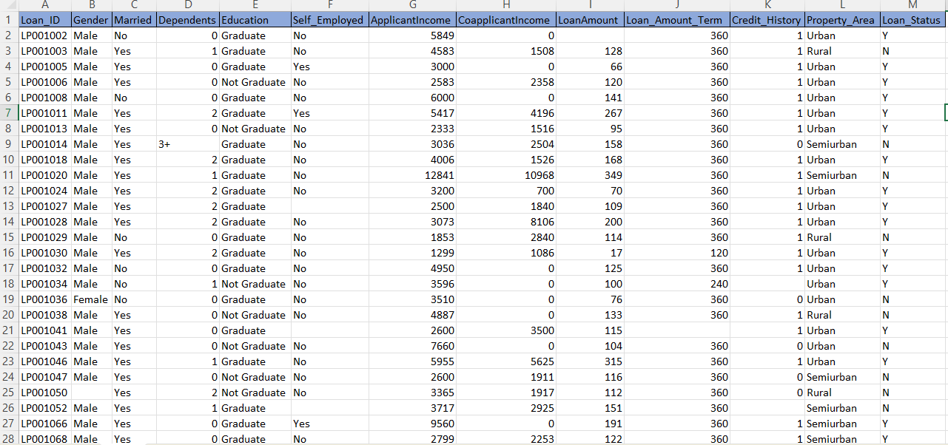

Screenshot of the data

**Accessing the Dataset**

The dataset can be accessed and downloaded from the Kaggle website using the following steps:

1. Visit Kaggle: Go to the Kaggle website at [www.kaggle.com](https://www.kaggle.com).

2. Search for the Dataset: Use the search bar to look for the "Loan Prediction" dataset.

3. Download the Dataset: Navigate to the dataset page and download the CSV file containing the loan application data.

**Data Licensing and Usage**

The dataset is typically provided under a public domain license, allowing for free use in academic, educational, and research projects. It is important to review the specific licensing terms on the Kaggle dataset page to ensure compliance with any usage restrictions or attribution requirements.

**Dataset Integrity and Reliability**

Kaggle datasets are often curated and reviewed by the community, ensuring a certain level of quality and reliability. However, it is essential to perform thorough data cleaning and preprocessing to address any issues such as missing values, inconsistencies, or outliers that may affect the accuracy and performance of the predictive model.

By using this well-documented and widely-recognized dataset from Kaggle, the project ensures that the data used is both relevant and reliable, providing a solid foundation for building an effective loan prediction model.

**What is Jupyter Notebook?**

Jupyter Notebook is an open-source web application that allows you to create and share documents that contain live code, equations, visualizations, and narrative text. It is widely used in data science, machine learning, and scientific computing for its versatility and ease of use. Jupyter Notebooks are particularly popular in the Python community, though they support over 40 programming languages.

**Key Features of Jupyter Notebook**

**Interactive Code Execution:**

You can write and execute code in real-time, seeing the output immediately within the notebook. This feature makes it easy to test s of code, debug, and iterate quickly.

**Rich Text Support:**

Jupyter Notebook supports Markdown, which allows you to add formatted text, equations (using LaTeX), images, and links to your notebook. This makes it easy to document your code and present your findings.

**Data Visualization:**

You can generate plots and charts using libraries such as Matplotlib, Seaborn, and Plotly, and these visualizations will be rendered directly in the notebook.

**Integration with Popular Libraries:**

Jupyter Notebook integrates seamlessly with many popular data science libraries, including NumPy, Pandas, Scikit-Learn, TensorFlow, and more. This integration facilitates data manipulation, analysis, and model building.

**Setting Up Jupyter Notebook**

**Installation:**

You can install Jupyter Notebook using pip:

*pip install notebook*

Alternatively, you can install it as part of the Anaconda distribution, which includes many useful data science packages.

**Starting Jupyter Notebook:**

To start Jupyter Notebook, open your terminal or command prompt and type:

*jupyter notebook*

This command will start a local server and open the Jupyter Notebook interface in your default web browser.

**Using Jupyter Notebook**

**Creating a New Notebook**:

From the Jupyter Notebook dashboard, you can create a new notebook by clicking on the "New" button and selecting "Python 3" (or any other kernel you want to use).

**Writing and Running Code:**

Notebooks are divided into cells. You can write code in a cell and execute it by pressing Shift + Enter. The output will be displayed directly below the cell.

**Documenting Your Work:**

You can switch a cell to Markdown mode by selecting the cell and pressing M. In Markdown mode, you can write formatted text to explain your code, provide context, and present results.

**Data Visualization:**

You can create plots and charts using visualization libraries.

**Saving and Sharing Notebooks:**

Jupyter Notebooks are saved with the .ipynb extension. You can share these files with others, and they can open them in their own Jupyter environment. You can also export notebooks to other formats such as HTML, PDF, and slides.

**TASK PERFORMED**

The primary objective of this project was to develop a predictive model that accurately determines the likelihood of a loan application being approved. The tasks involved in this project encompassed a comprehensive data-driven approach, starting from data collection and preprocessing to feature engineering, model development, and evaluation. Leveraging advanced machine learning techniques, the project focused on optimizing model performance to ensure accurate predictions. Additionally, the integration of the model into a user-friendly web application allowed for seamless interaction and real-time predictions, enhancing the overall functionality and accessibility of the system

**Importing Libraries**

When starting a data science project, it's essential to import the necessary libraries that will help you with data manipulation, analysis, and visualization. In this case, we are using the following libraries: pandas , numpy , and matplotlib .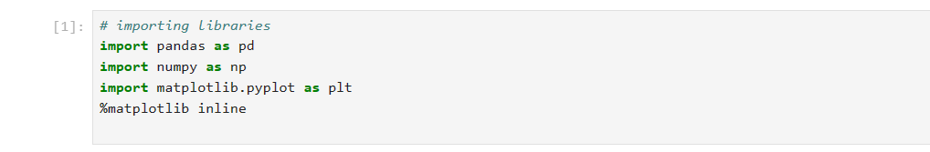

**1. Pandas**

- Pandas is a powerful data manipulation and analysis library for Python. It provides data structures like DataFrame and Series which are essential for handling structured data (i.e., data in tabular form).

**2. NumPy**

- NumPy (Numerical Python) is a library for numerical computing. It provides support for arrays, matrices, and many mathematical functions.

**3. Matplotlib**

- Matplotlib is a plotting library for creating static, interactive, and animated visualizations in Python.

- pyplot is a module in Matplotlib used for plotting.

**%matplotlib inline**

- This is a magic command specific to Jupyter Notebooks.

- It allows Matplotlib plots to be displayed inline, meaning the plots/graphs will be embedded directly in the notebook, below the code cell that produces them.

- This command is useful for immediately visualizing data without the need to open separate windows for each plot.

Summary

- Pandas ( pd ): For data manipulation and analysis.

- NumPy ( np ): For numerical operations on arrays and matrices.

- Matplotlib ( plt ): For creating visualizations.

- %matplotlib inline : Ensures that plots are displayed within the Jupyter Notebook.

Together, these libraries provide a comprehensive toolkit for handling data, performing numerical computations, and visualizing results, which are critical steps in any data science project.

**Read data**

**pd.read_csv**



pd.read_csv("train.csv"): This function call uses the pandas library to read data from a CSV (Comma-Separated Values) file named "train.csv".

read_csv: A function provided by pandas to read CSV files and load them into a DataFrame.

"train.csv": The name of the file to be read. It should be located in the same directory as the Jupyter Notebook or provide the correct path to the file.

Result:

The data from the CSV file is loaded into a pandas DataFrame named df. A DataFrame is a 2-dimensional labeled data structure with columns of potentially different types, similar to a table in a database or an Excel spreadsheet.

**df.head()**

df.head(): This function call is used to display the first five rows of the DataFrame by default.

head(): A method of DataFrame that returns the first five rows. If you want to display more or fewer rows, you can pass a number to the head() method, like df.head(10) to show the first ten rows.

Result:

The output will be the first five rows of the DataFrame df, allowing you to quickly inspect the data and understand its structure, columns, and initial values.

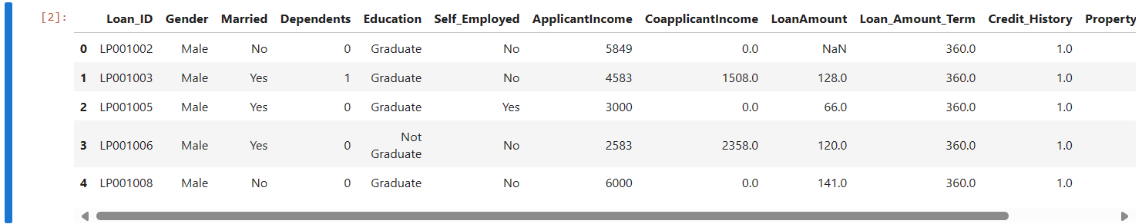

**df.tail()** 

The df.tail() method in pandas is used to display the last few rows of a DataFrame. This is useful for quickly inspecting the end of a dataset, especially to check for any issues such as incomplete rows or unusual data entries.

The output will be the last five rows of the DataFrame df

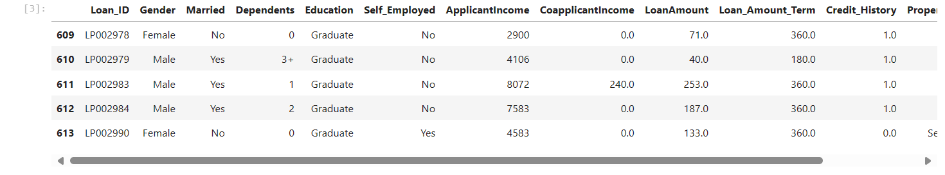

df.tail(): This command retrieves and displays the last five rows of the DataFrame df by default.

Purpose: It is useful for checking the end of the dataset for any irregularities or patterns that might be important for data analysis.

**df.shape**

**df.shape**

The **df.shape** attribute in pandas is used to get the dimensions of a DataFrame. It returns a tuple representing the number of rows and columns in the DataFrame.

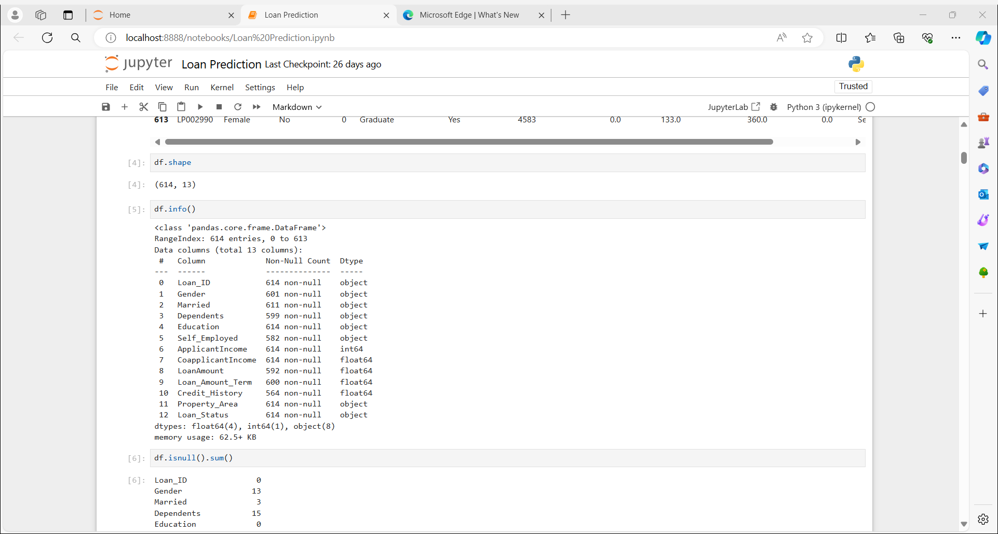

Rows: The first element of the tuple represents the number of rows in the DataFrame. In this case, there are 614 rows.

Columns: The second element of the tuple represents the number of columns in the DataFrame. In this case, there are 13 columns.

Why is df.shape useful?

Quick Overview: It provides a quick way to understand the size of your dataset.

Data Validation: It helps in validating if the data has been loaded correctly. For instance, if you know your CSV file should have 614 rows and 13 columns, df.shape can confirm this.

Iterative Processing: When processing data in loops or batches, knowing the dimensions helps in setting loop bounds and chunk sizes.

Summary

df.shape: A DataFrame attribute that returns a tuple indicating the number of rows and columns in the DataFrame.

.

**df.info()**

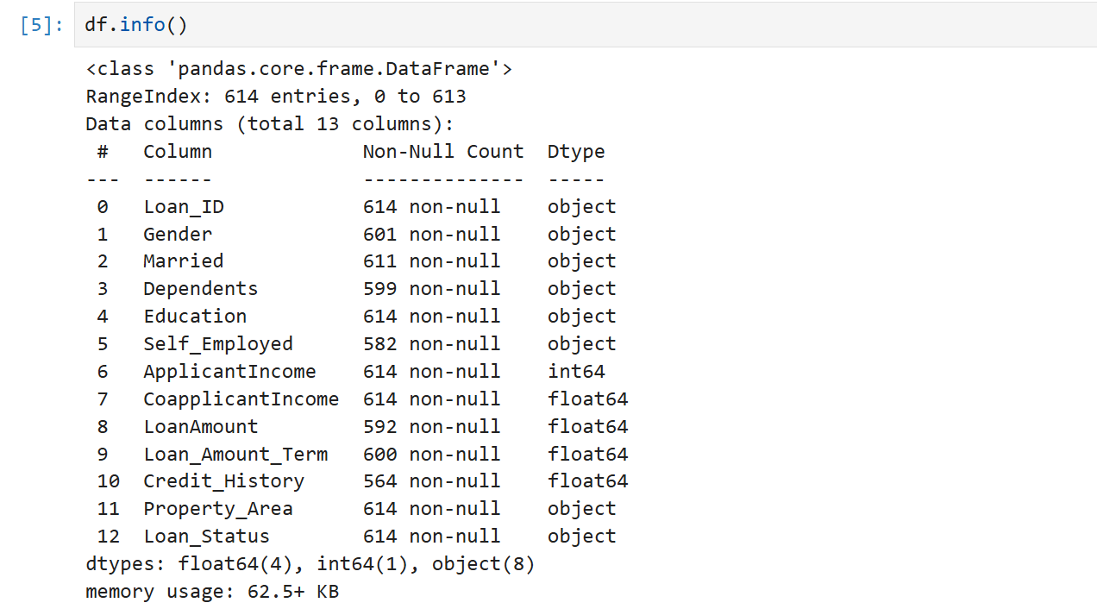

The df.info() method in pandas provides a concise summary of a DataFrame. It is particularly useful for understanding the structure and basic information about your dataset.

Class type: Indicates that the object is a DataFrame.

RangeIndex: Shows the number of entries (rows) in the DataFrame, from 0 to 613, indicating there are 614 entries.

Data columns:

#: Column number.

Column: Column name.

Non-Null Count: Number of non-null (non-missing) values in each column.

Dtype: Data type of each column (e.g., object, int64, float64).

Memory Usage: Shows the memory usage of the DataFrame, which is useful for understanding the data's footprint in memory.

Why is df.info() useful?

Data Overview: Provides a quick snapshot of the dataset's structure and contents.

Missing Values: Highlights columns with missing values, allowing you to identify and handle incomplete data.

Data Types: Shows the data types of each column, which is crucial for data processing and analysis. Incorrect data types can lead to errors in computations or analyses.

Memory Usage: Helps in understanding the memory footprint of your DataFrame, which can be important when working with large datasets.

Summary

df.info(): A method that provides a concise summary of the DataFrame, including the number of entries, column names, non-null values, data types, and memory usage.

Purpose: Offers a quick and comprehensive overview of the dataset's structure and basic information, aiding in initial data exploration and preparation.

Using df.info() early in your data analysis workflow helps you understand the composition and completeness of your data, which is essential for subsequent data cleaning and analysis steps.

**df.isnull().sum()**

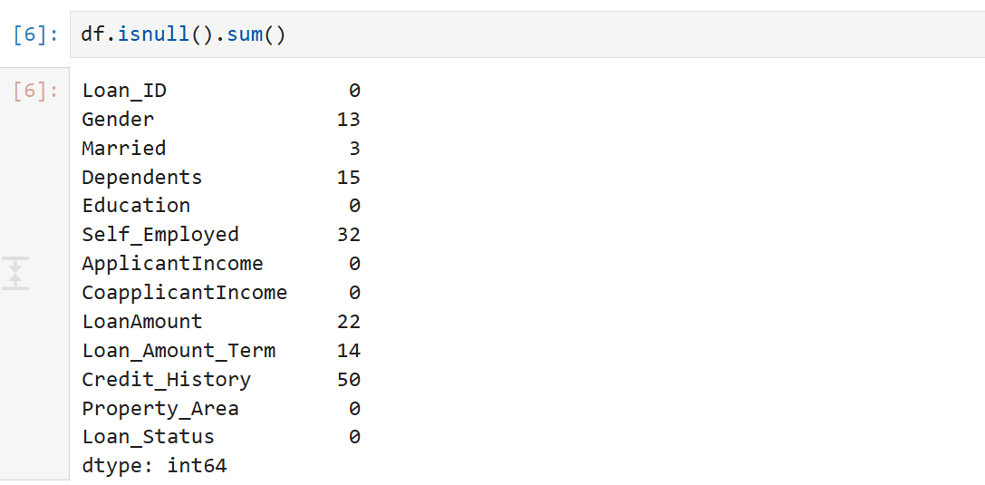

The df.isnull().sum() function in pandas is used to identify and summarize the number of missing (null) values in each column of a DataFrame. This method is very useful for data cleaning and preprocessing, as it helps you understand the extent of missing data in your dataset.

isnull():

Creates a DataFrame of the same dimensions as df, filled with boolean values (True or False).

True indicates that the corresponding element in df is null (missing).

False indicates that the corresponding element in df is not missing.

sum():

When applied to the boolean DataFrame created by isnull(), it counts the number of True values in each column.

Since True is equivalent to 1 and False to 0, summing these values gives the total number of missing entries in each column.

Usage

Identifying Missing Data: Quickly highlights which columns have missing data and how many missing entries each column contains.

Data Cleaning: Essential for making decisions on how to handle missing data, such as filling in missing values, dropping columns with too many missing values, or other imputation methods.

Summary

df.isnull().sum(): Combines isnull() and sum() methods to provide a count of missing values in each column of the DataFrame.

Purpose: Identifies and summarizes the extent of missing data, aiding in data cleaning and preprocessing tasks.

This method is a fundamental part of the data exploration process, providing critical insights into the quality and completeness of your dataset.

* **Loan_ID**: 0 missing values
* **Gender**: 13 missing values
* **Married**: 3 missing values
* **Dependents**: 15 missing values
* **Education**: 0 missing values
* **Self_Employed**: 32 missing values
* **ApplicantIncome**: 0 missing values
* **CoapplicantIncome**: 0 missing values
* **LoanAmount**: 22 missing values
* **Loan_Amount_Term**: 14 missing values
* **Credit_History**: 50 missing values
* **Property_Area**: 0 missing values
* **Loan_Status**: 0 missing values

**df.describe()**

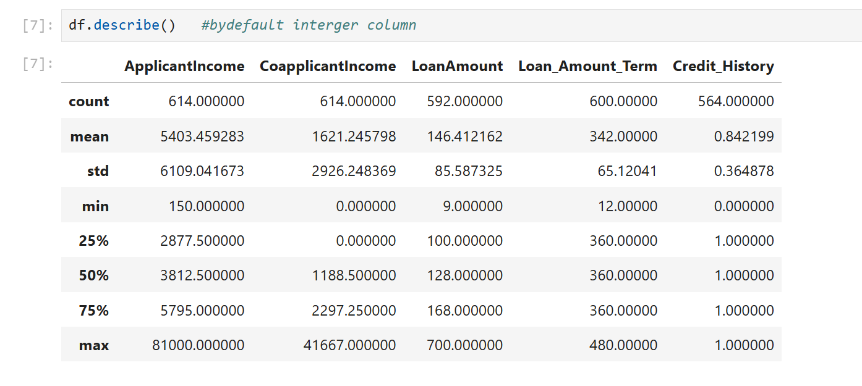

The df.describe() method in pandas provides descriptive statistics that summarize the central tendency, dispersion, and shape of a dataset's distribution, excluding NaN values by default. It is useful for getting a quick overview of numerical data in a DataFrame.

describe(): A method that generates descriptive statistics for numerical columns in the DataFrame.

When you call df.describe(), it returns a DataFrame that includes the following statistics for each numerical column:

Count: The number of non-null observations.

Mean: The average of the values.

Standard Deviation (std): A measure of the spread of the values.

Minimum (min): The minimum value.

25th Percentile (25%): The 25th percentile (first quartile), which is the value below which 25% of the data fall.

Median (50%): The median (second quartile or 50th percentile), which is the middle value.

75th Percentile (75%): The 75th percentile (third quartile), which is the value below which 75% of the data fall.

Maximum (max): The maximum value.

df.describe(): Generates summary statistics for numerical columns in the DataFrame.

Purpose: Provides a quick overview of the dataset's central tendency, dispersion, and distribution shape, which is helpful for initial data exploration and analysis.

This method helps you understand the basic properties of your numerical data, identify potential outliers, and make informed decisions for further data processing and analysis steps.

**df['ApplicantIncome']**

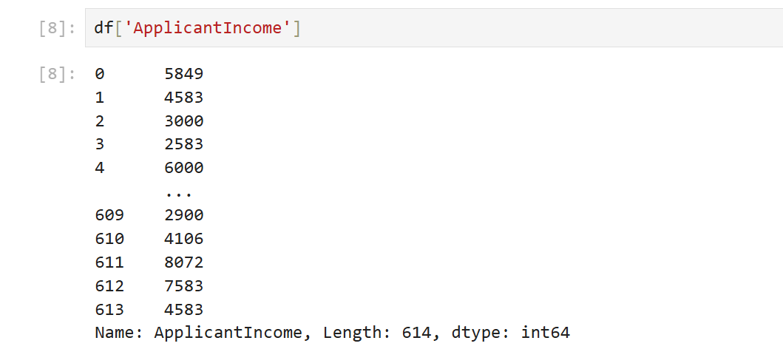

df['ApplicantIncome'] accesses the ApplicantIncome column from the DataFrame df, allowing you to view, analyze, or manipulate the income data of applicants.

**df[['ApplicantIncome', 'LoanAmount']]**

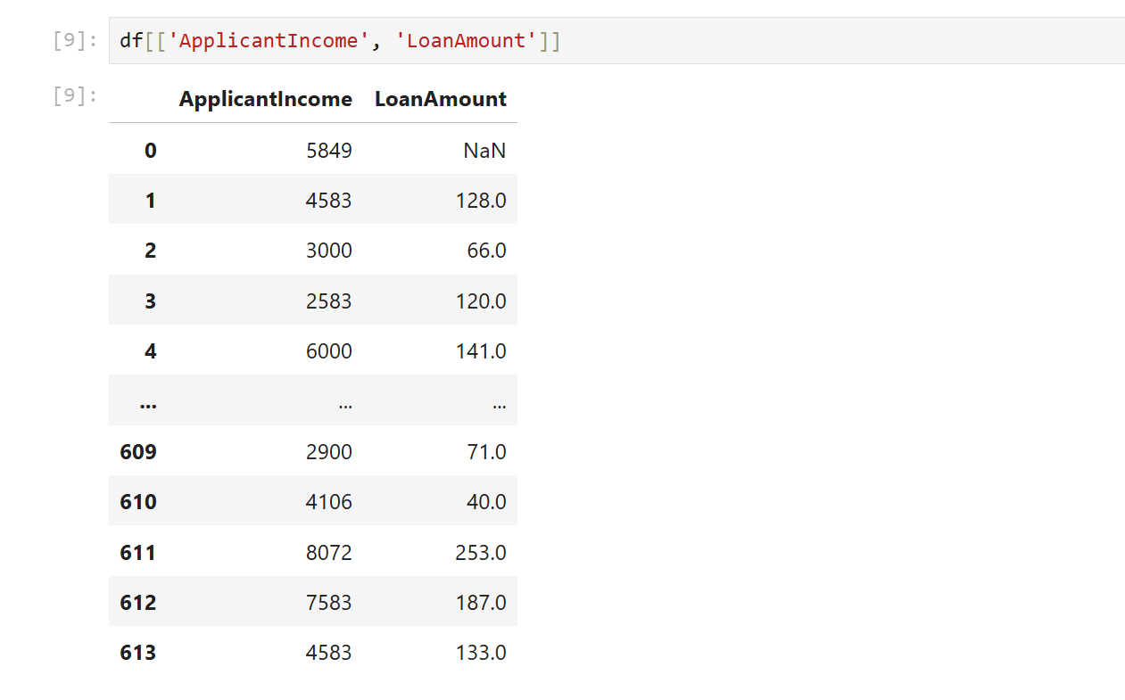

df[['ApplicantIncome', 'LoanAmount']] accesses both the ApplicantIncome and LoanAmount columns from the DataFrame df, allowing you to view, analyze, or manipulate these two columns together.

Here's a summary of what we've done with the dataset so far:

1. Loaded the Data : Imported the dataset using pd.read_csv("train.csv") and stored it in the DataFrame df .

2. Initial Inspection :

- Viewed the first few rows using df.head() .

- Viewed the last few rows using df.tail() .

3. Basic Information :

- Checked the dimensions of the DataFrame with df.shape .

- Got a concise summary of the DataFrame using df.info() .

- Identified missing values in each column with df.isnull().sum() .

4. Descriptive Statistics :

- Generated summary statistics for numerical columns using df.describe() .

5. Accessing Columns :

- Accessed the ApplicantIncome column with df['ApplicantIncome'] .

- Accessed both ApplicantIncome and LoanAmount columns with df[['ApplicantIncome', 'LoanAmount']] .

These steps provide a foundational understanding of the dataset, including its structure, summary statistics, and initial insights into missing values, which are crucial for further data cleaning and analysis.

**DATA PREPROCESSING**

Data preprocessing is a critical step in the data analysis pipeline that involves cleaning and transforming raw data into a format suitable for modeling and analysis. This process typically includes handling missing values, encoding categorical variables, normalizing or standardizing numerical features, and removing outliers. By addressing these issues, data preprocessing ensures that the data is accurate, consistent, and reliable, which helps improve the performance and accuracy of machine learning models. Effective preprocessing also helps in reducing model complexity and computation time, ultimately leading to more robust and interpretable results.

**df.isnull().sum()**

The df.isnull().sum() function in pandas is used to identify and summarize the number of missing (null) values in each column of a DataFrame. This method is very useful for data cleaning and preprocessing, as it helps you understand the extent of missing data in your dataset. 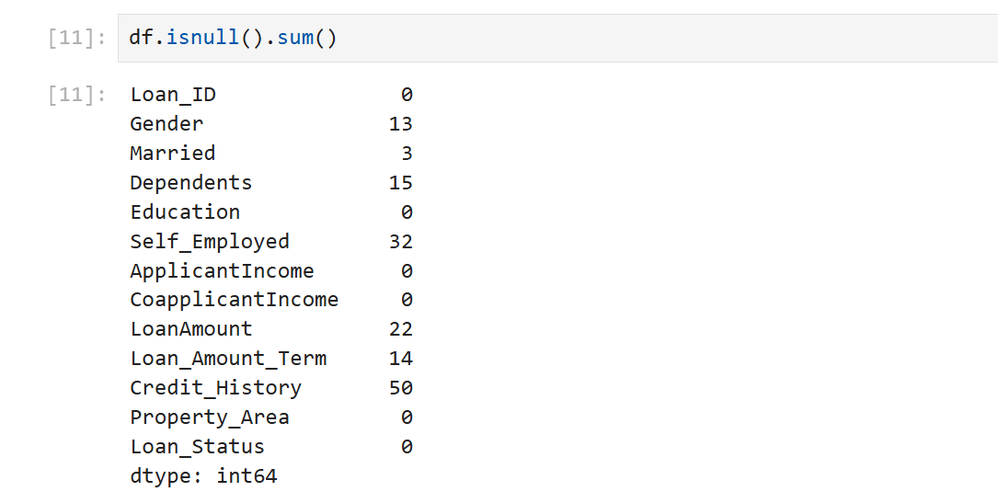

**Usage**

* **Identifying Missing Data**: Quickly highlights which columns have missing data and how many missing entries each column contains.
* **Data Cleaning**: Essential for making decisions on how to handle missing data, such as filling in missing values, dropping columns with too many missing values, or other imputation methods.

**Handle numerical missing data**

Handling missing numerical data is a critical step in preparing your dataset for analysis and modeling. Here are some common methods to handle missing numerical data:

Methods to Handle Missing Numerical Data

1. **Removing Missing Data:**

If the proportion of missing data is very small, you might choose to remove these rows or columns entirely.

1. **Imputation with Mean/Median/Mode:**

* Mean: Replace missing values with the mean of the column.
* Median: Replace missing values with the median of the column.
* Mode: Replace missing values with the mode of the column.

1. **Imputation with Interpolation**:

* This method fills missing values using various interpolation techniques.

1. **Using Predictive Modeling**:

* Train a model to predict the missing values based on other features.

In this project We used the mean imputation method to handle the missing values in the numerical columns LoanAmount, Loan_Amount_Term, and Credit_History in our dataset.

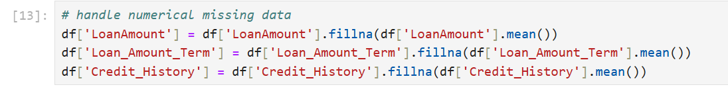

**Impute missing values with the mean:**

For each column with missing values, we will fill these missing values with the mean of the respective column. This ensures that we maintain the statistical properties of the column while handling the missing data.

**LoanAmount**:



• df['LoanAmount']: Accesses the LoanAmount column in the DataFrame.

• df['LoanAmount'].mean(): Calculates the mean of the LoanAmount column.

• fillna(): Replaces all NaN (missing) values in the LoanAmount column with the mean value calculated.

• df['LoanAmount'] =: Assigns the result back to the LoanAmount column, updating it with the imputed values.

**Loan_Amount_Term**:



• df['Loan_Amount_Term']: Accesses the Loan_Amount_Term column in the DataFrame.

• df['Loan_Amount_Term'].mean(): Calculates the mean of the Loan_Amount_Term column.

• fillna(): Replaces all NaN (missing) values in the Loan_Amount_Term column with the mean value calculated.

• df['Loan_Amount_Term'] =: Assigns the result back to the Loan_Amount_Term column, updating it with the imputed values.

**Credit_History**:



• df['Credit_History']: Accesses the Credit_History column in the DataFrame.

• df['Credit_History'].mean(): Calculates the mean of the Credit_History column.

• fillna(): Replaces all NaN (missing) values in the Credit_History column with the mean value calculated.

• df['Credit_History'] =: Assigns the result back to the Credit_History column, updating it with the imputed values.

**Verify the imputation**: After handling the missing values, it's important to verify that there are no missing values left in these columns.

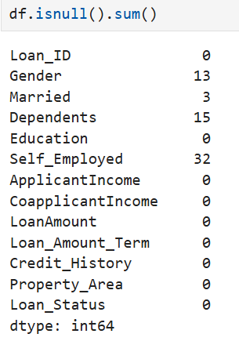

We handled the missing values in the LoanAmount, Loan_Amount_Term, and Credit_History columns by imputing them with their respective mean values. This approach maintains the overall distribution and central tendency of the data, ensuring that the dataset remains suitable for further analysis and modeling. This step is crucial in data preprocessing to ensure that our model can be trained effectively without being affected by missing data.

**Handling Categorical Missing Data**

Handling missing values in categorical data is crucial for maintaining the integrity of the dataset and ensuring accurate model predictions. Here are some common methods to handle missing categorical data:

Methods to Handle Missing Categorical Data

1. **Removing Missing Data**:
   * If the proportion of missing data is very small, you might choose to remove these rows.
2. **Imputation with Mode**:
   * Replace missing values with the most frequent value (mode) in the column.
3. **Imputation with a New Category**:
   * Replace missing values with a new category such as 'Unknown' or 'Missing'.
4. **Using Predictive Modeling**:
   * Train a model to predict the missing values based on other features.

In this project, we addressed the issue of missing categorical data by imputing the missing values in the Gender, Married, and Self_Employed columns using the mode (most frequent value) of each respective column. This approach helps maintain the integrity of the dataset while ensuring that the imputed values are representative of the most common category in each column.

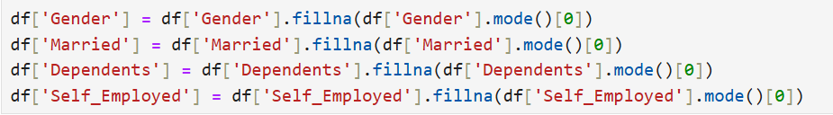

**Impute Missing Values with Mode:**

For each column with missing values, we fill these missing values with the mode (most frequent value) of the respective column.

**Gender:**



• df['Gender']: Accesses the Gender column in the DataFrame.

• df['Gender'].mode()[0]: Calculates the mode (most frequent value) of the Gender column.

• fillna(): Replaces all NaN (missing) values in the Gender column with the mode value.

• df['Gender'] =: Assigns the result back to the Gender column, updating it with the imputed values.

**Married**:



• df['Married']: Accesses the Married column in the DataFrame.

• df['Married'].mode()[0]: Calculates the mode (most frequent value) of the Married column.

• fillna(): Replaces all NaN (missing) values in the Married column with the mode value.

• df['Married'] =: Assigns the result back to the Married column, updating it with the imputed values.

**Dependents**:



• df['Dependents']: Accesses the Dependents column in the DataFrame.

• df['Dependents'].mode()[0]: Calculates the mode (most frequent value) of the Dependents column.

• fillna(): Replaces all NaN (missing) values in the Dependents column with the mode value.

• df['Dependents'] =: Assigns the result back to the Dependents column, updating it with the imputed values

**Self_Employed**:



• df['Self_Employed']: Accesses the Self_Employed column in the DataFrame.

• df['Self_Employed'].mode()[0]: Calculates the mode (most frequent value) of the Self_Employed column.

• fillna(): Replaces all NaN (missing) values in the Self_Employed column with the mode value.

• df['Self_Employed'] =: Assigns the result back to the Self_Employed column, updating it with the imputed values.

We handled the missing values in the Gender, Married, Dependents, and Self_Employed columns by imputing them with their respective mode values. This approach ensures that the most frequent category within each column is used to fill the missing values, preserving the integrity and representativeness of the data. This step is crucial in data preprocessing to ensure that our model can be trained effectively without being affected by missing data.

**Exploratory data anlysis**

Exploratory Data Analysis (EDA) is a critical step in the data science process. It involves examining the main characteristics of the data, often with visual methods, before moving on to more sophisticated modeling and analysis techniques. The primary goal of EDA is to gain insights, detect patterns, spot anomalies, test hypotheses, and check assumptions using summary statistics and graphical representations.

Key Steps in EDA

**1. Understanding the Data:**

**Data Types and Structure:** Identify the types of data (numerical, categorical, etc.) and the structure (rows and columns).

**Metadata and Documentation:** Review any available documentation or metadata to understand the context of the data.

**2. Data Cleaning:**

* Missing Values: Identify and handle missing values appropriately (e.g., imputation, removal).
* Duplicates: Check for and remove duplicate entries.
* Outliers: Detect and decide how to handle outliers.

**3. Descriptive Statistics :**

* Summary Statistics : Compute measures such as mean, median, mode, standard deviation, and percentiles.
* Distribution Analysis : Analyze the distribution of each variable (e.g., using histograms or density plots).

**4. Data Visualization :**

* Univariate Analysis : Explore individual variables. Common plots include histograms for numerical data and bar charts for categorical data.
* Bivariate Analysis : Explore relationships between pairs of variables. Scatter plots, box plots, and bar charts are often used.
* Multivariate Analysis : Explore relationships among three or more variables. Techniques include pair plots, correlation matrices, and heatmaps.

**5. Identifying Patterns and Relationships :**

* Correlation Analysis : Calculate correlation coefficients to understand the linear relationships between variables.
* Group Comparisons : Compare distributions and summary statistics across different groups (e.g., using box plots, violin plots).

**6. Feature Engineering :**

* Transformations : Apply transformations to variables to meet analysis or model assumptions (e.g., log transformation).
* Encoding : Convert categorical variables into numerical formats (e.g., one hot encoding).
* Interaction Terms : Create new features by combining existing ones.

**Common Tools and Techniques**

**1. Summary Statistics:**

* Pandas in Python provides methods like .describe() , .mean() , .median() , etc., for quick statistical summaries.
* -R provides functions like summary() , mean() , median() , etc.

**2. Visualization Libraries :**

* Matplotlib : Basic plotting library in Python for creating static, interactive, and animated visualizations.
* Seaborn : Python library based on Matplotlib that provides a high-level interface for drawing attractive and informative statistical graphics.
* Plotly : Interactive plotting library that works in Python and R, useful for creating interactive plots.
* ggplot2 : Data visualization package for R, based on the grammar of graphics.

**3. Statistical Tests :**

* Perform tests like t-tests, chi-square tests, and ANOVA to check for statistical significance in your data.

**Benefits of EDA**

**1. Data Quality Assessment :** Identify data quality issues like missing values, outliers, and inconsistencies.

**2. Hypothesis Generation :** Develop new hypotheses and refine existing ones based on data patterns and relationships.

**3. Modeling Preparation :** Select appropriate modeling techniques and preprocess data based on EDA insights.

**4. Insight Discovery :** Gain a deeper understanding of the data and uncover hidden trends and patterns.

**Conclusion**

EDA is an essential step in the data analysis process that allows data scientists to make informed decisions about data preprocessing, feature engineering, and modeling. By thoroughly exploring the data, we can better understand its structure, quality, and underlying patterns, leading to more accurate and robust analytical results.

In our project, we used Seaborn, a powerful Python data visualization library, to perform Exploratory Data Analysis (EDA). Seaborn builds on top of Matplotlib and provides a high-level interface for drawing attractive and informative statistical graphics.



**Gender : Male vs Female**

We used Seaborn's countplot to visualize the distribution of categories within theGender column in our dataset. This type of plot helps us understand the frequency of each category and identify any imbalances.

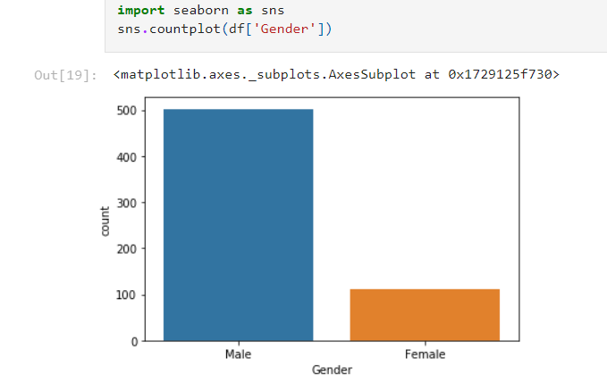**sns.countplot(df['Gender'])**:

* sns.countplot: This function from Seaborn is used to create a countplot.
* df['Gender']: This specifies the column we want to plot. In this case, it's the Gender column from our DataFrame df.

**Dependents:**

In our project, we used Seaborn's countplot to visualize the distribution of categories within the Dependents column. This type of plot is useful for understanding the frequency of each category and identifying any potential imbalances.

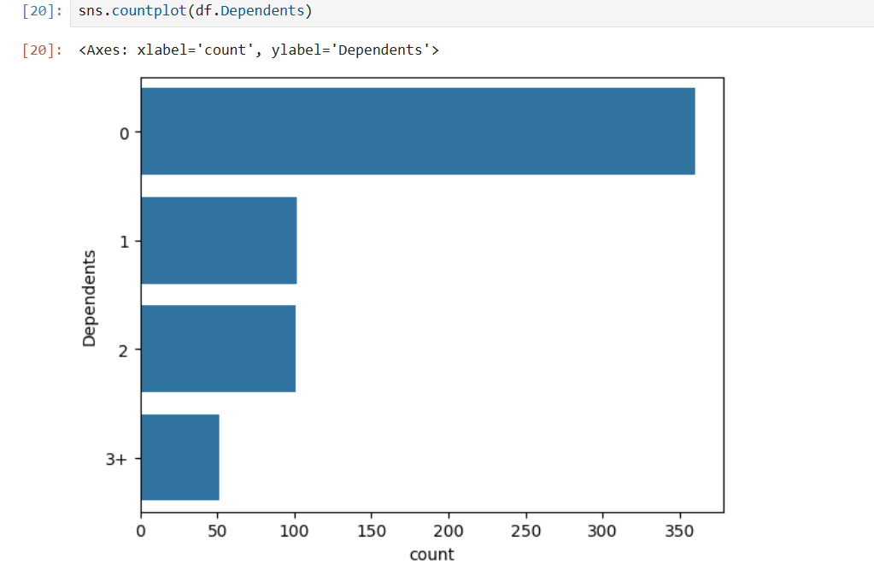

**sns.countplot(df['Dependents']):**

* sns.countplot: This function from Seaborn is used to create a countplot.
* df['Dependents']: This specifies the column we want to plot. In this case, it's the Dependents column from our DataFrame df.

**Married : Yes or No**

We used Seaborn's countplot to visualize the distribution of categories within the Married column. This type of plot is helpful for understanding the frequency of each category and identifying any potential imbalances in the data. 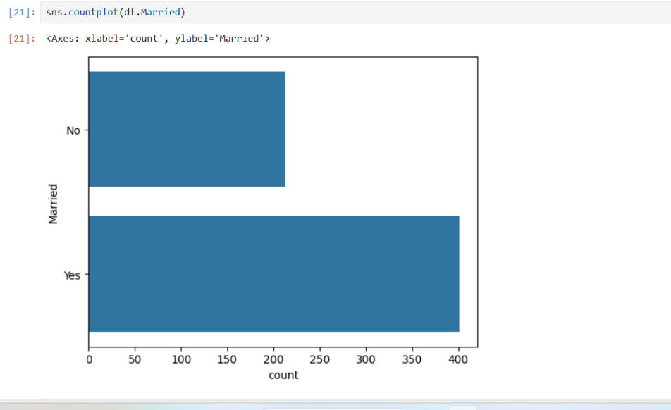

**sns.countplot(df['Married'])**:

* sns.countplot: This function from Seaborn is used to create a countplot.
* df['Married']: This specifies the column we want to plot. In this case, it's the Married column from our DataFrame df.

**Plotting the Distribution of Numerical Data with sns.distplot**

**sns.distplot(df.CoapplicantIncome)**

The sns.distplot(df['CoapplicantIncome']) function from Seaborn is used to visualize the distribution of the CoapplicantIncome column in the dataset. It creates a histogram to show the frequency of income values and overlays a Kernel Density Estimate (KDE) line to represent the probability density of the data. This plot helps in understanding the distribution pattern of the CoapplicantIncome variable.

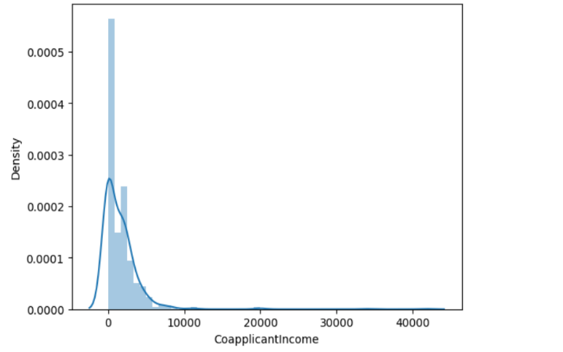

**sns.distplot(df.LoanAmount)**

The sns.distplot(df['LoanAmount']) function in Seaborn is used to visualize the distribution of the LoanAmount column in the dataset. This plot combines a histogram, which displays the frequency of different loan amounts, with a Kernel Density Estimate (KDE) line, which smooths the data to show the underlying distribution. It provides insight into how loan amounts are distributed across the data set

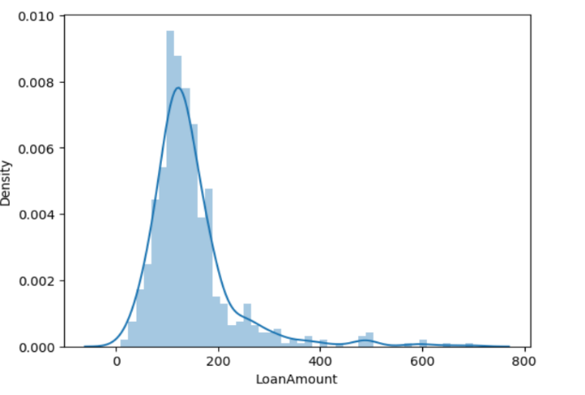

**sns.distplot(df.Credit_History)**

The sns.distplot(df['Credit_History']) function in Seaborn is used to visualize the distribution of the Credit_History column in the dataset. This plot includes a histogram to show the frequency of different credit history values and a Kernel Density Estimate (KDE) line to illustrate the probability density. It helps in understanding the distribution of credit history scores within the dataset.

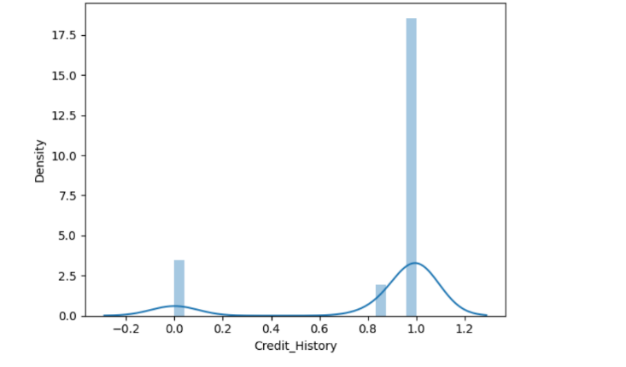

**Created new column**



The line of code df['Total_income'] = df['ApplicantIncome'] + df['CoapplicantIncome'] creates a new column called Total_income in the DataFrame df. This new column is the result of adding the values from the ApplicantIncome and CoapplicantIncome columns for each row.

### Explanation:

* **df['ApplicantIncome']**: Refers to the column in the DataFrame that contains the income of the loan applicant.
* **df['CoapplicantIncome']**: Refers to the column in the DataFrame that contains the income of the co-applicant.
* **df['Total_income']**: This new column is created to store the combined income of both the applicant and co-applicant for each loan application. By summing these two columns, we get a more comprehensive view of the total household income, which can be an important factor in loan prediction.

This new column, Total_income, can be used for further analysis, such as determining the relationship between total income and loan approval.

**Data Transformation: Converting Numerical Data to Logarithmic Scale**

In the next step of our project, we perform data transformation by converting all numerical data into their logarithmic values. This process is often done to normalize the data, especially when the data is highly skewed. By applying a logarithmic transformation, we can reduce the skewness and make the data more normally distributed, which can improve the performance of certain machine learning models.

**Why Log Transformation?**

1. **Handling Skewed Data**:
   * If the data has a long tail (positive skew), applying a log transformation can compress the range of values, reducing the impact of outliers and making the distribution more symmetric.
2. **Stabilizing Variance**:
   * Log transformation can help stabilize variance across different levels of the data, making it easier to meet the assumptions of linear models.
3. **Improving Model Performance**:
   * Some algorithms, particularly linear models, perform better when the data follows a normal distribution. Log transformation helps achieve this.

| **Original** |  |  | **Transformation Applied** | **Transformed** |  |
| --- | --- | --- | --- | --- | --- |
| ApplicantIncome |  |  | Logarithmic Transformation | Log_ApplicantIncome |  |
| CoapplicantIncome |  |  | Logarithmic Transformation | Log_CoapplicantIncome |  |
| LoanAmount |  |  | Logarithmic Transformation | Log_LoanAmount |  |
| Credit_History |  |  | Logarithmic Transformation | Log_Credit_History |  |
| Total_income |  |  | Logarithmic Transformation | Log_Total_income |  |

**Transforming Categorical Data Using One-Hot Encoding**

One-hot encoding is a common technique for converting categorical data into a format that can be used by machine learning algorithms. This method transforms categorical variables into a set of binary (0 or 1) columns, where each column represents one of the categories in the original variable.

**Why One-Hot Encoding?**

1. **Machine Learning Algorithms**:
   * Most machine learning algorithms require numerical input. Categorical variables need to be converted into a numerical format to be used in these models.
2. **Preventing Ordinal Relationships**:
   * One-hot encoding prevents the introduction of ordinal relationships that might be implied if categorical variables were simply encoded as integers.

**How One-Hot Encoding Works**

1. **Identify Categorical Columns**:
   * Determine which columns in your dataset are categorical. For example, columns like Gender, Married, Dependents, and Self_Employed might be categorical.
2. **Create Binary Columns**:
   * For each categorical column, create new binary columns for each unique category. Each row will have a 1 in the column corresponding to its category and 0 in all other new columns.

Example

Consider a column Married with two categories: Yes and No.

**Original Data**:

| **Married** |
| --- |
| Yes |
| No |
| Yes |
| No |

**One-Hot Encoded Data**:

| **Married_Yes** | **Married_No** |
| --- | --- |
| 1 | 0 |
| 0 | 1 |
| 1 | 0 |
| 0 | 1 |

**Benefits of One-Hot Encoding**

* **Non-Ordinal Data Handling**:
  + It effectively handles categorical variables that do not have an intrinsic order.
* **Algorithm Compatibility**:
  + Makes categorical data compatible with algorithms that require numerical input.

**Summary**

One-hot encoding is a crucial step in preparing categorical data for machine learning models. By converting categorical variables into a set of binary columns, we ensure that the data can be used effectively by algorithms while avoiding any misinterpretation of the data’s meaning.

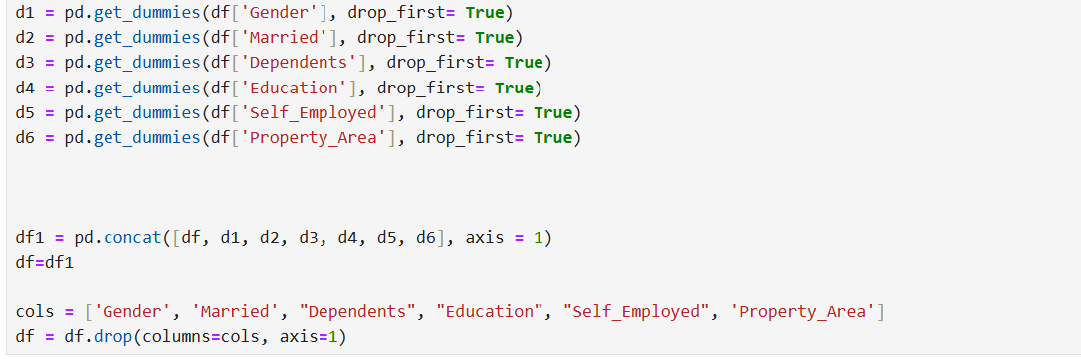

In the given code , categorical data is being transformed into a format suitable for machine learning models, and then integrated into the DataFrame

1. **Generating Dummy Variables:**
   * **pd.get_dummies()**: This function creates dummy (one-hot encoded) variables for categorical columns.
   * **drop_first=True**: This parameter is used to avoid the dummy variable trap (multicollinearity). By dropping the first category, we prevent redundant features and ensure that each category is represented by a unique binary column.
   * Each d variable (e.g., d1, d2, etc.) is a DataFrame with one-hot encoded columns corresponding to the original categorical column.
2. **Combining Dummy Variables with Original Data:**
   * **pd.concat()**: This function concatenates the original DataFrame (df) with the new DataFrames containing dummy variables.
   * **axis=1**: This specifies that the concatenation should be done column-wise (i.e., horizontally).

The result is a new DataFrame df1 that includes both the original columns and the newly created dummy variables.

1. **Dropping Original Categorical Columns:**
   * **df.drop()**: This function is used to remove specified columns from the DataFrame.
   * **columns=cols**: Specifies the columns to be dropped.
   * **axis=1**: Indicates that we are dropping columns, not rows.

After this step, the original categorical columns are removed from the DataFrame, leaving only the transformed dummy variables and the remaining columns.

In summary, the code transforms categorical variables into a numerical format using one-hot encoding. It creates new columns for each category, integrates these dummy variables with the original dataset, and then removes the original categorical columns to avoid redundancy. This process prepares the dataset for machine learning models, which require numerical input.

Test data set

**What is a Test Dataset?**

A **test dataset** is a subset of data that is used to evaluate the performance of a machine learning model after it has been trained on a separate **training dataset**. It contains the same features (input variables) as the training data, but it typically doesn't include the target labels (the values the model is supposed to predict) in practice—those labels are known but withheld during prediction to objectively assess how well the model performs.

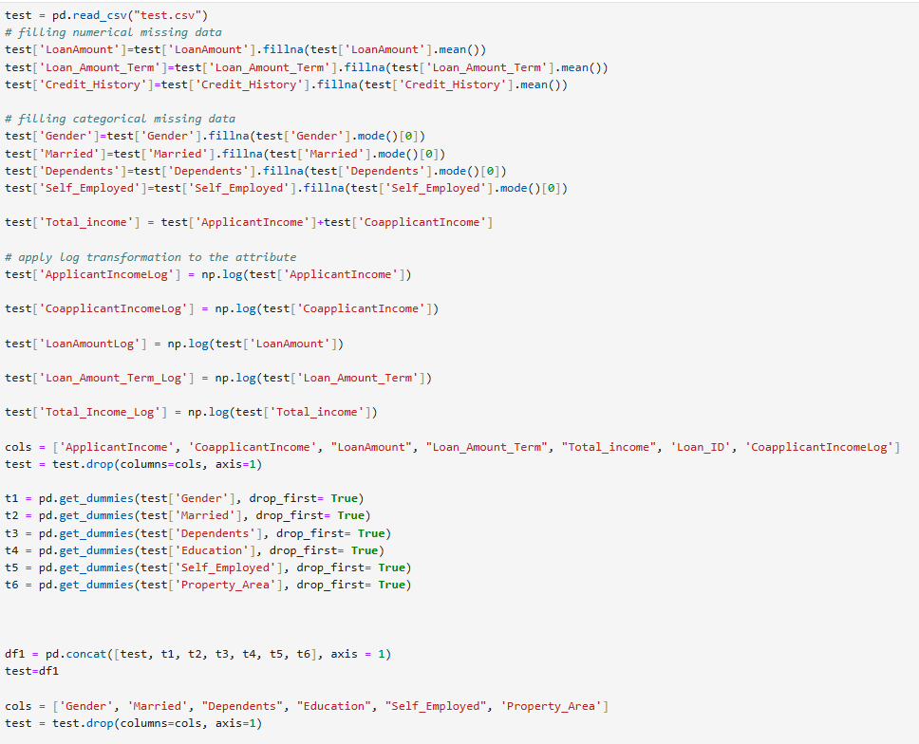

"This section of the code outlines the preprocessing steps applied to the test dataset. These steps mirror the transformations performed on the training dataset to ensure consistency in the data preparation process. Specifically:

* **Handling Missing Data**: Numerical features with missing values, such as LoanAmount, Loan_Amount_Term, and Credit_History, were imputed using their respective mean values. Similarly, categorical features like Gender, Married, Dependents, and Self_Employed were imputed using the mode, which is the most frequently occurring value in each column.
* **Feature Engineering**: A new feature, Total_income, was created by summing ApplicantIncome and CoapplicantIncome to capture the combined earning potential of the applicant and co-applicant.
* **Log Transformation**: To reduce skewness and handle outliers, a log transformation was applied to several key numerical features, including ApplicantIncome, CoapplicantIncome, LoanAmount, Loan_Amount_Term, and Total_income. These transformed features were then stored as new columns in the dataset.
* **Dropping Redundant Features**: After the log transformation, the original numerical columns and other non-essential columns like Loan_ID were dropped to avoid redundancy and multicollinearity in the model.
* **Encoding Categorical Variables**: Categorical variables such as Gender, Married, Dependents, Education, Self_Employed, and Property_Area were converted into numerical format using one-hot encoding. The first category was dropped to prevent multicollinearity, ensuring the model only works with independent variables.
* **Final Dataset Preparation**: The processed dummy variables were then concatenated back into the test dataset, and the original categorical columns were removed, resulting in a final test dataset that is ready for model evaluation.

This preprocessing pipeline ensures that the test data is aligned with the training data, allowing the model to make accurate and reliable predictions on unseen data."

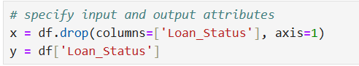

In this code , you are preparing your dataset for machine learning by defining the feature variables (x) and the target variable (y).

**Define Feature Variables (x)**:

x = df.drop(columns=['Loan_Status'], axis=1)

* **df**: Refers to your original DataFrame containing the dataset.
* **drop(columns=['Loan_Status'], axis=1)**: Removes the Loan_Status column from the DataFrame. The axis=1 parameter specifies that you are dropping columns (not rows).
  + **columns=['Loan_Status']**: Specifies that you want to drop the column named Loan_Status.
  + **axis=1**: Indicates that the operation is performed on columns.
* **x**: This is the new DataFrame containing all the feature variables except the Loan_Status column. It will be used as input for training the machine learning model.

**Define Target Variable (y)**:

y = df['Loan_Status']

* **df['Loan_Status']**: Selects the Loan_Status column from the DataFrame.
* **y**: This is a Series containing the target variable, which the model will try to predict. It holds the values of the Loan_Status column.

• **x (Features)**: Contains all the input variables used to predict the target. It includes all columns from the DataFrame except the Loan_Status column.

• **y (Target)**: Contains the output variable that you want to predict. It is the Loan_Status column in this case.

This separation is crucial for training a machine learning model, as it allows the model to learn patterns from the features (x) and predict the target variable (y).

**Splitting data sets**

**1. Purpose of Splitting the Dataset**

When developing a machine learning model, the goal is to create a model that generalizes well to new, unseen data. To achieve this, the dataset is typically split into different subsets:

* **Training Set**: The portion of the data used to train the model. The model learns from this data, identifying patterns and relationships within the features that it can use to make predictions.
* **Validation Set** (optional): A separate portion of the data used to tune hyperparameters and make decisions about the model's architecture or features. This set helps prevent overfitting, ensuring that the model performs well on data it hasn’t seen before.
* **Test Set**: A distinct portion of the data used to evaluate the final model. This set simulates how the model will perform on real-world data by testing it on data it hasn’t seen during training.

**2. How the Dataset is Typically Split**

In a typical machine learning project, the dataset might be split as follows:

* **Training Set**: 70-80% of the dataset
* **Validation Set**: 10-15% of the dataset (if used)
* **Test Set**: 10-15% of the dataset

This split ensures that the model has enough data to learn from, while also preserving a portion of the data for unbiased evaluation.

**3. Why Split the Dataset?**

* **Prevent Overfitting**: By evaluating the model on a separate test set, you can detect if the model is overfitting—learning the training data too well, including its noise and outliers, which reduces its ability to generalize.
* **Unbiased Evaluation**: The test set provides an unbiased evaluation of the model’s performance. Since the model hasn’t seen this data during training, the test set provides a realistic estimate of how well the model will perform on new data.

**Model Tuning**: If a validation set is used, it allows you to fine-tune the model’s hyperparameters without directly influencing the final evaluation. This helps improve the model's performance without overfitting to the test data.



The code is used to split your dataset into training and testing sets. This is an essential step in building and evaluating machine learning models.

• **Import train_test_split**:

from sklearn.model_selection import train_test_split

* This imports the train_test_split function from Scikit-Learn’s model_selection module, which is used to split datasets.

• **Define x and y**:

* **x**: Contains the feature variables (independent variables) of your dataset.
* **y**: Contains the target variable (dependent variable) that you want to predict.

• **Split the Data**:

x_train, x_test, y_train, y_test = train_test_split(x, y, test_size=0.25, random_state=42)

* **x_train**: The feature data used to train the model. This subset contains 75% of the original data (since test_size=0.25).
* **x_test**: The feature data used to test the model. This subset contains 25% of the original data.
* **y_train**: The target values corresponding to x_train. This subset contains 75% of the target data.
* **y_test**: The target values corresponding to x_test. This subset contains 25% of the target data.

• **Parameters**:

* **test_size=0.25**: Specifies the proportion of the dataset to include in the test split. Here, 25% of the data will be allocated to the test set, and 75% to the training set.
* **random_state=42**: Sets a seed for the random number generator used by the function. This ensures that the split is reproducible; running the code with the same random_state will always produce the same split

**How This Works**

* **Training Set (x_train, y_train)**:
  + The model uses this subset of the data to learn patterns, relationships, and dependencies between the input features (x_train) and the target variable (y_train).
  + The model adjusts its parameters (like weights in a neural network or splits in a decision tree) to minimize the error in predicting y_train based on x_train.
* **Test Set (x_test, y_test)**:
  + After training, the model is tested on this unseen subset of the data (x_test) to evaluate how well it performs.
  + The test set acts as a stand-in for new data that the model would encounter in a real-world scenario.
  + By comparing the model’s predictions on x_test with the actual values in y_test, you can determine how well the model is likely to perform on future data.

**Why 25% Test Size?**

* **Test Size**: The test_size=0.25 parameter means that 25% of the data is set aside for testing, and the remaining 75% is used for training.
  + This is a common split ratio that balances having enough data to train the model while still retaining a significant portion to evaluate its performance. However, the specific ratio can be adjusted based on the size of the dataset and the problem at hand.

**Random State**

* **Reproducibility**: The random_state=42 ensures that the split is the same every time the code is run, which allows for reproducibility of results. This means you, or anyone else running the same code, will get the exact same train-test split every time, which is important for consistency in model evaluation.

**Summary**

Splitting the dataset into training and testing sets is essential to ensure that your machine learning model is capable of generalizing to new, unseen data. The training set is used to learn the model, while the test set is used to evaluate its performance. This approach helps to prevent overfitting and gives you a realistic estimate of how your model will perform in the real world. The specific split ratio and random state ensure that the process is both balanced and reproducible.

**Model Training**

**Purpose of Training the Model**

* **Learning Patterns**: The primary goal of training is for the model to learn patterns and relationships between the input features (X_train) and the target variable (y_train). The model adjusts its parameters to minimize the difference between its predictions and the actual target values.
* **Building Predictive Power**: Through training, the model gains the ability to make accurate predictions on new, unseen data. The better it learns from the training data, the more reliable its predictions will be on the test data and in real-world applications.

**Steps in Training the Model**

1. **Select a Model**:
   * **Choosing an Algorithm**: Depending on the problem (classification, regression, etc.), you select an appropriate machine learning algorithm (e.g., linear regression, decision tree, random forest, neural network, etc.).
   * **Initialize the Model**: You start by initializing the model with default or tuned hyperparameters.
2. **Fit the Model to the Training Data**:
   * **Model Training**: Using the training data (X_train, y_train), the model is trained. This involves feeding the features into the model and letting it learn the relationship with the target variable.
   * **Optimization**: During training, the model adjusts its parameters (e.g., weights in a linear model) to minimize a loss function, which measures how well the model's predictions match the actual target values.
3. **Monitor Training Progress** (Optional):
   * **Validation Set**: Sometimes, a validation set is used to monitor the model's performance during training and make adjustments, like tuning hyperparameters or stopping early if the model starts to overfit.
   * **Metrics**: Key metrics (e.g., accuracy, loss) can be tracked to evaluate how well the model is learning and to decide if the training process should continue or be adjusted.
4. **Evaluate the Model on Training Data**:
   * **Performance Check**: After training, the model's performance is usually checked on the training data to ensure it has learned effectively. However, this is just an initial check and not the final evaluation.

**What Happens During Model Training?**

* **Parameter Adjustment**: The model continuously adjusts its internal parameters to minimize the error between the predicted output and the actual output (y_train).
* **Learning the Data**: The model learns the general trends in the data, rather than just memorizing the training data (which would lead to overfitting). The aim is for the model to capture the underlying patterns that can apply to new data.

**What’s Next After Training?**

* **Evaluation**: After training, you would evaluate the model’s performance on the test data (X_test, y_test). This step will give you an idea of how well the model is likely to perform on new, unseen data.
* **Tuning and Improving**: Based on the evaluation results, you may need to tune the model’s hyperparameters or even try different models to improve performance.
* **Deployment**: Once satisfied with the model’s performance, it can be deployed to make predictions on new data in a real-world application.

**Summary**

Training the model is where the machine learning process truly begins to take shape. By feeding the model the training data, you enable it to learn from the patterns and relationships within the data. This learning process allows the model to make accurate predictions in the future. After training, the model’s performance is evaluated on test data, and further improvements can be made if necessary.

**1. Decision Tree**

**Explanation:**

* A Decision Tree is a type of supervised learning algorithm that is used for both classification and regression tasks. It works by splitting the data into subsets based on the most significant feature at each step, creating a tree-like structure.

**How It Works:**

* **Splitting**: The algorithm begins with the entire dataset and selects the feature that best separates the data into distinct classes (for classification) or predicts the target variable (for regression). This is often done using metrics like Gini Impurity, Information Gain, or Mean Squared Error (for regression).
* **Nodes and Branches**: Each internal node in the tree represents a feature, and each branch represents a decision rule (like greater than or less than a certain value). The process of splitting continues until the algorithm reaches a stopping condition, like a maximum depth or a minimum number of samples per leaf.
* **Leaves**: The terminal nodes (leaves) of the tree represent the predicted outcomes. For classification, each leaf would typically correspond to a class label, while for regression, it would correspond to a predicted value.

**Strengths:**

* **Interpretability**: Decision Trees are easy to understand and visualize, making them particularly useful when interpretability is important.
* **Non-Parametric**: They don’t assume any specific distribution of the data, making them versatile.
* **Handling Non-Linear Relationships**: Decision Trees can capture complex non-linear relationships in the data.

**Weaknesses:**

* **Overfitting**: They can easily overfit the data, especially if the tree is too deep.
* **Instability**: Small changes in the data can result in a completely different tree being generated.

**Use Cases:**

* Credit scoring, customer segmentation, medical diagnosis, and any scenario where interpretability and decision rules are important.

**2. Random Forest**

**Explanation:**

* Random Forest is an ensemble learning method that combines multiple decision trees to produce a more robust and accurate model. It is primarily used for classification and regression tasks.

**How It Works:**

* **Bagging**: Random Forest uses a technique called bagging (Bootstrap Aggregating), where it creates multiple subsets of the original data by sampling with replacement. Each subset is used to train a different decision tree.
* **Random Feature Selection**: At each split in the trees, a random subset of features is considered. This reduces the correlation between individual trees and helps in creating a diverse set of trees.
* **Aggregation**: The final prediction is made by aggregating the predictions from all the individual trees. For classification, it could be a majority vote, and for regression, it could be the average of all the predictions.

**Strengths:**

* **Improved Accuracy**: By aggregating multiple trees, Random Forest reduces the risk of overfitting and often achieves higher accuracy than a single decision tree.
* **Robustness**: It is less sensitive to noise and outliers in the data.
* **Versatility**: Works well with both small and large datasets, and can handle high-dimensional data.

**Weaknesses:**

* **Complexity**: Random Forest models can be more difficult to interpret compared to a single decision tree.
* **Computationally Intensive**: Training multiple trees can be computationally expensive, especially with large datasets.

**Use Cases:**

* Image and text classification, financial market prediction, recommendation systems, and any scenario where high accuracy is crucial.

**3. Logistic Regression**

**Explanation:**

* Logistic Regression is a statistical method used for binary classification problems. It predicts the probability that a given input belongs to a particular class, typically represented as 0 or 1.

**How It Works:**

* **Linear Model**: Logistic Regression models the relationship between the input features and the probability of a binary outcome using a linear combination of the input features.
* **Sigmoid Function**: The output of the linear combination is passed through a sigmoid function, which squashes the output to a range between 0 and 1. This output represents the probability of the instance belonging to the positive class.
* **Decision Boundary**: A threshold (usually 0.5) is applied to the probability to determine the final classification. If the probability is above the threshold, the instance is classified as 1 (positive class); otherwise, it is classified as 0 (negative class).

**Strengths:**

* **Simplicity**: Logistic Regression is simple to implement and interpret, especially in scenarios where the relationship between the features and the outcome is approximately linear.
* **Probabilistic Interpretation**: The model provides probabilities that an instance belongs to each class, which can be useful in decision-making.
* **Regularization**: It can be easily extended to handle regularization (L1 or L2), which helps in preventing overfitting.

**Weaknesses:**

* **Assumption of Linearity**: Logistic Regression assumes a linear relationship between the input features and the log-odds of the outcome, which may not be true for all datasets.
* **Not Suitable for Complex Relationships**: It may not perform well on datasets with complex, non-linear relationships unless features are engineered or transformed appropriately.

**Use Cases:**

* Binary classification problems like spam detection, disease diagnosis (e.g., predicting the presence of a disease), and customer churn prediction.

**Comparing the Algorithms**

* **Decision Tree**: Best for when you need a simple, interpretable model, or when you suspect that the relationship between features and the target is non-linear.
* **Random Forest**: Best for when you need high accuracy and robustness, and you don’t mind sacrificing interpretability for performance.
* **Logistic Regression**: Best for binary classification problems with linear relationships, especially when you need probabilistic predictions and interpretability.

By training your model with all three algorithms, you can compare their performance (usually in terms of accuracy, precision, recall, etc.) to determine which one is the best fit for your specific dataset and problem.

**RandomForest Classifier**

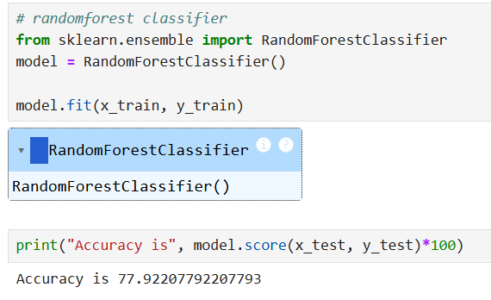

The code provided is for training a Random Forest Classifier model using Scikit-Learn.

1. **Import RandomForestClassifier**:
   * This imports the RandomForestClassifier class from the ensemble module of Scikit-Learn. Random Forest is an ensemble learning method that combines multiple decision trees to improve prediction accuracy.
2. **Initialize the Model**:
   * **model**: This creates an instance of the RandomForestClassifier class. By default, this instance will use common default parameters such as 100 trees in the forest and other standard settings.
   * You can also customize the model by passing different parameters to the constructor, such as n_estimators (number of trees), max_depth (maximum depth of trees), etc.
3. **Train the Model**:
   * **model.fit(x_train, y_train)**: This trains (or fits) the Random Forest model using the training data.
     + **x_train**: Contains the feature variables for training.
     + **y_train**: Contains the target variable for training.

**Purpose of RandomForestClassifier**

* **Random Forest Classifier**: An ensemble learning method that builds multiple decision trees and merges them to get a more accurate and stable prediction. It reduces the risk of overfitting compared to individual decision trees and can handle large datasets with high dimensionality.

"After training the Random Forest Classifier on the dataset, the model achieved an accuracy score of 77.92%. This result reflects the model's ability to correctly predict the target variable in approximately 77% of the test cases."

**Decision tree classifier**

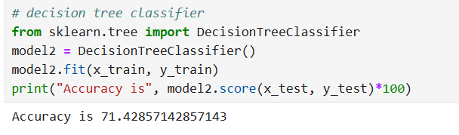

This code is for training and evaluating a Decision Tree Classifier using Scikit-Learn. Here's what each part does:

1. **Import DecisionTreeClassifier**:
   * This imports the DecisionTreeClassifier class from Scikit-Learn's tree module. A Decision Tree is a model that splits the data into branches based on feature values to make predictions.
2. **Initialize the Model**:
   * **model2**: This creates an instance of the DecisionTreeClassifier class. The model can be customized by passing parameters, but here it's using the default settings.
3. **Train the Model**:
   * **model2.fit(x_train, y_train)**: This trains the Decision Tree model using the training data. The model learns the patterns and relationships between the features (x_train) and the target variable (y_train).
4. **Evaluate the Model**:
   * **model2.score(x_test, y_test)**: This method calculates the accuracy of the model on the test data. It returns the proportion of correctly classified samples.
   * **\* 100**: This converts the accuracy score from a decimal to a percentage.
   * **print("Accuracy is", ...)**: This prints the accuracy of the model as a percentage.

Using the Decision Tree algorithm, the model achieved an accuracy score of 71.42%. This indicates that the Decision Tree was able to correctly predict the loan status in 71.42% of the test cases.

**Logistic regression**

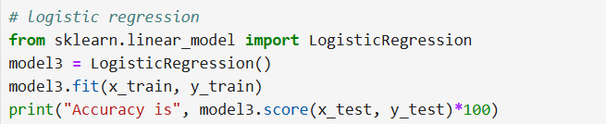

This code is for training and evaluating a Logistic Regression model using Scikit-Learn. Here’s a detailed explanation of each part:

1. **Import LogisticRegression**:
   * This imports the LogisticRegression class from Scikit-Learn’s linear_model module. Logistic Regression is a linear model commonly used for binary classification tasks.
2. **Initialize the Model**:
   * **model3**: This creates an instance of the LogisticRegression class. The model is initialized with default parameters, though you can customize it by specifying arguments like solver, max_iter, etc.
3. **Train the Model**:
   * **model3.fit(x_train, y_train)**: This trains the Logistic Regression model using the training data. The model learns the relationship between the features (x_train) and the target variable (y_train).
4. **Evaluate the Model**:
   * **model3.score(x_test, y_test)**: This method calculates the accuracy of the model on the test data. It returns the proportion of correctly predicted instances.
   * **\* 100**: Converts the accuracy score from a decimal to a percentage.
   * **print("Accuracy is", ...)**: This prints the model’s accuracy on the test set as a percentage.

After training the model using Logistic Regression, I achieved an accuracy score of 77.27%. This result reflects the model's ability to correctly predict the loan status (approved or not) based on the features provided in the dataset.

**We selected the Random Forest algorithm for this project due to its superior accuracy compared to other models, ensuring more reliable predictions in loan approval decisions**.

**Confusion matrix**

A **confusion matrix** is a table used to evaluate the performance of a classification algorithm. It helps you understand how well your classification model is performing by comparing the predicted labels to the actual labels in a structured way. The confusion matrix provides detailed information about the performance of a classification model by showing the counts of true positives, true negatives, false positives, and false negatives.

**Structure of a Confusion Matrix**

For a binary classification problem, a confusion matrix is a 2x2 table that looks like this:

|  | **Predicted: Yes** | **Predicted: No** |
| --- | --- | --- |
| **Actual: Yes** | True Positives (TP) | False Negatives (FN) |
| **Actual: No** | False Positives (FP) | True Negatives (TN) |

Here’s what each of these terms means:

* **True Positives (TP)**: The number of instances where the model correctly predicted the positive class (e.g., the loan was approved and the model predicted "Yes").
* **True Negatives (TN)**: The number of instances where the model correctly predicted the negative class (e.g., the loan was not approved and the model predicted "No").
* **False Positives (FP)**: The number of instances where the model incorrectly predicted the positive class (e.g., the loan was not approved, but the model predicted "Yes"). This is also known as a "Type I error".
* **False Negatives (FN)**: The number of instances where the model incorrectly predicted the negative class (e.g., the loan was approved, but the model predicted "No"). This is also known as a "Type II error".

**Why Is It Useful?**

* **Performance Metrics**: The confusion matrix helps you calculate key performance metrics, such as accuracy, precision, recall, and F1 score.
  + **Accuracy**: (TP+TN)/(TP+TN+FP+FN)(TP + TN) / (TP + TN + FP + FN)(TP+TN)/(TP+TN+FP+FN) — the proportion of correctly classified instances.
  + **Precision**: TP/(TP+FP)TP / (TP + FP)TP/(TP+FP) — the proportion of positive identifications that were actually correct.
  + **Recall (Sensitivity or True Positive Rate)**: TP/(TP+FN)TP / (TP + FN)TP/(TP+FN) — the proportion of actual positives that were correctly identified.
  + **F1 Score**: 2×(Precision×Recall)/(Precision+Recall)2 \times (Precision \times Recall) / (Precision + Recall)2×(Precision×Recall)/(Precision+Recall) — the harmonic mean of precision and recall, providing a balance between the two.
* **Error Analysis**: The confusion matrix allows you to see where the model is making mistakes, whether it’s more prone to false positives or false negatives, and where improvements can be made.
* **Class Imbalance**: In cases of class imbalance (when one class significantly outnumbers the other), accuracy alone can be misleading. The confusion matrix provides a more complete picture by showing how the model performs on each class.

**Example Scenario**

Imagine you have a model that predicts whether a loan will be approved (Yes) or not (No). After running the model on a test dataset, you obtain the following confusion matrix:

|  |  |  |  |  | **Predicted: Yes** |  |  |  |  |  |  |  | **Predicted: No** |
| --- | --- | --- | --- | --- | --- | --- | --- | --- | --- | --- | --- | --- | --- |
| **Actual: Yes** |  |  |  |  | 80 |  |  |  |  |  |  |  | 20 |
| **Actual: No** |  |  |  |  | 10 |  |  |  |  |  |  |  | 90 |

From this matrix:

* **80** loans were correctly predicted as approved (True Positives).
* **90** loans were correctly predicted as not approved (True Negatives).
* **10** loans were incorrectly predicted as approved (False Positives).
* **20** loans were incorrectly predicted as not approved (False Negatives).

With these numbers, you can calculate the metrics like accuracy, precision, and recall to get a more nuanced understanding of your model’s performance.

**Summary**

A confusion matrix is an essential tool in evaluating the performance of classification models, especially in understanding the types of errors your model makes and in computing various performance metrics. It provides a more detailed analysis compared to just looking at accuracy alone.

**confusion matrix in this project**

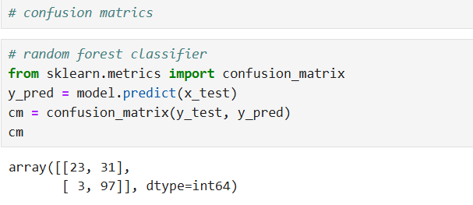

This code calculates and displays the confusion matrix for the Random Forest Classifier model. Here’s a detailed explanation of each part:

1. **Import confusion_matrix**:
   * This imports the confusion_matrix function from Scikit-Learn’s metrics module. The confusion matrix is a tool for evaluating the performance of a classification model.
2. **Predict the Target Variable**:
   * **model.predict(x_test)**: This method generates predictions for the test data (x_test) using the trained Random Forest model (model). The result, y_pred, is an array of predicted labels for the test set.
3. **Compute the Confusion Matrix**:
   * **confusion_matrix(y_test, y_pred)**: This function computes the confusion matrix based on the true labels (y_test) and the predicted labels (y_pred).
   * **cm**: Stores the confusion matrix, which is a 2x2 array (for binary classification) or a larger matrix (for multi-class classification). The matrix contains:
     + True Positives (TP): Correctly predicted positive cases.
     + True Negatives (TN): Correctly predicted negative cases.
     + False Positives (FP): Incorrectly predicted positive cases.
     + False Negatives (FN): Incorrectly predicted negative cases.
4. **Display the Confusion Matrix**:
   * Simply outputs the confusion matrix. You can further analyze or visualize it to understand the model's performance.

**Confusion Matrix Breakdown**

* **First Row**: Represents the true negatives and false positives.
  + **23**: True Negatives (TN) – Number of negative samples correctly classified as negative.
  + **31**: False Positives (FP) – Number of negative samples incorrectly classified as positive.
* **Second Row**: Represents the false negatives and true positives.
  + **3**: False Negatives (FN) – Number of positive samples incorrectly classified as negative.
  + **97**: True Positives (TP) – Number of positive samples correctly classified as positive.

**Interpretation**

* **True Negatives (TN)**: 23
  + The model correctly predicted 23 instances as negative.
* **False Positives (FP)**: 31
  + The model incorrectly predicted 31 negative instances as positive.
* **False Negatives (FN)**: 3
  + The model incorrectly predicted 3 positive instances as negative.
* **True Positives (TP)**: 97
  + The model correctly predicted 97 instances as positive.

**Evaluation of Model Performance**

1. **Accuracy**:
   * The model has an accuracy of approximately 77.9%. This means it correctly predicts the target variable in about 77.9% of the test cases. While this is a solid performance, whether it is "good" depends on the context and requirements of the problem.
2. **Precision**:
   * The precision is approximately 75.7%. This indicates that when the model predicts a positive outcome, it is correct about 75.7% of the time. This is a decent level of precision but might be improved if the cost of false positives is high.
3. **Recall**:
   * The recall is approximately 97.0%. This high recall indicates that the model successfully identifies 97% of all actual positive cases. A high recall is especially important if missing positive cases (false negatives) has serious consequences.
4. **F1 Score**:
   * The F1 Score is approximately 84.9%. This is a balanced measure that takes both precision and recall into account. A high F1 Score suggests that the model performs well in both identifying positives and minimizing false positives.

**Conclusion**

* **Correct Predictions**: The model seems capable of predicting correct outputs, especially for positive cases, given the high recall. It correctly identifies most of the positive instances.
* **Areas for Improvement**: The precision indicates there is room for improvement in reducing false positives. If false positives are costly or problematic in your context, you might want to further refine the model.

Overall, the model appears to be effective, especially at identifying positive cases. However, the decision to use it should consider the trade-offs between precision, recall, and overall accuracy, depending on the specific needs of your project or application. If precision or accuracy needs to be higher, you may consider additional model tuning or trying other algorithms.

**Model Save**

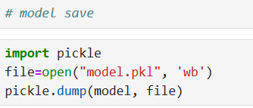

This code is used to save a trained model to a file using the pickle library in Python.

1. **Import pickle**:
   * This imports the pickle library, which is used for serializing (saving) and deserializing (loading) Python objects. In this case, it will be used to save the trained model.
2. **Open a File for Writing**:
   * **open("model.pkl", 'wb')**: Opens a file named model.pkl in binary write mode ('wb').
     + **'wb'**: Stands for "write binary," which means the file will be opened for writing in binary format. This is necessary for saving models using pickle.
3. **Save the Model**:
   * **pickle.dump(model, file)**: Serializes the model object and writes it to the file. The model can be any Python object, but in this case, it’s the trained machine learning model.
   * **model**: The object being saved. It should be the trained instance of a model (like a Random Forest Classifier or any other machine learning model).
   * **file**: The file object to which the model is saved.

**Model Depolyment Strategies**

**Model deployment** is the process of taking a machine learning model that has been trained and tested, and making it available for use in a production environment. This allows the model to be used by end-users or other systems to make predictions on new data. Deploying a model is a crucial step in the machine learning pipeline, as it allows the model to be integrated into real-world applications and start providing value.

**Steps in Model Deployment**

1. **Prepare the Model for Deployment:**
   * **Save the Model:** After training, the model is typically saved in a serialized format (like a .pkl file for Python models) so that it can be loaded and used later without retraining.
   * **Optimize the Model:** Depending on the deployment environment, the model might need to be optimized for performance, such as reducing its size or improving its inference speed.
2. **Choose the Deployment Environment:**
   * **Cloud Deployment:** Deploy the model to a cloud platform like AWS, Azure, or Google Cloud. These platforms offer services like AWS SageMaker, Azure Machine Learning, and Google AI Platform, which make it easy to deploy, manage, and scale machine learning models.
   * **On-Premise Deployment:** The model is deployed on local servers, which might be required for security, privacy, or other organizational reasons.
   * **Edge Deployment:** The model is deployed on edge devices like smartphones, IoT devices, or other hardware where low latency is critical.
3. **Create an API or Service:**
   * **REST API:** One common approach to deployment is to expose the model as a RESTful API. This allows other applications or systems to send data to the model and receive predictions via HTTP requests.
   * **Microservices:** The model can be wrapped in a microservice, which can be scaled independently of other services. This is common in environments where microservices architecture is used.
4. **Integrate with Applications:**
   * The deployed model needs to be integrated with the applications that will use it. This might involve connecting it to a web or mobile app, a data pipeline, or other systems that require the model’s predictions.
5. **Monitoring and Maintenance:**
   * **Monitor Performance:** Once deployed, it's important to monitor the model's performance in the real world. This includes tracking metrics like response time, throughput, and accuracy on new data.
   * **Update and Retrain:** Over time, the model may need to be updated or retrained as new data becomes available or as the underlying data distribution changes (a phenomenon known as data drift).
6. **Scaling:**
   * As the demand for predictions grows, the deployment needs to be scalable. Cloud platforms offer auto-scaling features that automatically adjust the resources available to the model based on current demand.

**Challenges in Model Deployment**

* **Latency:** In some applications, especially those that require real-time predictions, the model’s response time is critical. Ensuring low-latency predictions can require specific optimizations.
* **Scalability:** The model should be able to handle an increasing number of prediction requests without degradation in performance.
* **Security:** Protecting the model from unauthorized access, ensuring data privacy, and securing the API are important considerations.
* **Versioning:** Managing different versions of the model, especially when updates or improvements are made, is essential to ensure consistency and traceability.

**Model Deployment Use Cases**

* **Web and Mobile Applications:** Integrating models into apps to provide features like personalized recommendations, image recognition, or language translation.
* **Enterprise Systems:** Deploying models within enterprise environments for tasks like predictive maintenance, fraud detection, or customer churn prediction.
* **IoT Devices:** Deploying models to edge devices for applications like autonomous vehicles, smart home devices, or wearable technology.

**Summary**

Model deployment is the critical final step in the machine learning workflow that turns a model from a theoretical construct into a practical tool. The process involves several steps, including preparing the model, selecting an appropriate deployment environment, creating a service or API, integrating with applications, and ensuring ongoing monitoring and maintenance. Proper deployment ensures that the model can provide value by making accurate predictions in real-world scenarios.

**Overview of the Flask Application in the project**

This Flask application serves as a web interface for predicting loan status based on user inputs. The application leverages a pre-trained machine learning model, which has been serialized and stored in a pickle file. The main functionalities include rendering the home page, accepting user inputs via a form, processing these inputs, and predicting the loan status based on the model’s output.

**Model Integration**

The machine learning model is integrated into the Flask application using Python’s pickle module. Upon starting the application, the model is loaded from the model.pkl file into memory. This approach ensures that the model is readily available for making predictions without the need for retraining or reloading every time a prediction is required. The model is invoked when the user submits the form, providing the necessary features for prediction.

**Handling User Input**

User input is captured via an HTML form rendered by the index.html template. The form collects various features, such as gender, married, dependents, education, employed, credit, ApplicantIncome, CoapplicantIncome, LoanAmount, Loan_Amount_Term, and area. These inputs are then processed and converted into the appropriate format for prediction. For example, categorical variables like gender and married are converted into binary values, while continuous variables like ApplicantIncome and LoanAmount are transformed using logarithmic scaling to reduce skewness and improve model accuracy.

**Feature Engineering and Transformation**

Several features undergo transformation before being fed into the model. For instance, the ApplicantIncome and LoanAmount values are log-transformed to normalize their distribution, which is often skewed in financial datasets. Additionally, the total income (sum of ApplicantIncome and CoapplicantIncome) is also log-transformed to ensure that the model receives more stable input data. These transformations help in improving the model's performance by reducing the impact of outliers.

**Prediction Logic**

The prediction is performed by passing the processed input features into the loaded machine learning model. The model outputs a prediction, which is then interpreted to generate a user-friendly result. Specifically, the output is converted from a model-specific label (e.g., "N" for No) to a more understandable format ("No" or "Yes") that is displayed on the results page. This result is then rendered on a new HTML page (prediction.html), providing immediate feedback to the user.

**Error Handling and User Experience**

The application is designed to handle both GET and POST requests for the prediction route. While the POST request is used to process and predict based on user inputs, the GET request ensures that the prediction page can be accessed directly without errors. This dual handling improves user experience by allowing seamless navigation within the application.

**Conclusion**

This Flask application demonstrates the integration of a machine learning model into a web application, allowing for real-time predictions based on user input. The use of Python’s pickle module for model loading, combined with Flask’s robust routing and templating features, results in an application that is both functional and user-friendly. Through thoughtful preprocessing and transformation of input data, the application ensures that the predictions are accurate and reliable, showcasing the practical application of machine learning in financial decision-making processes.

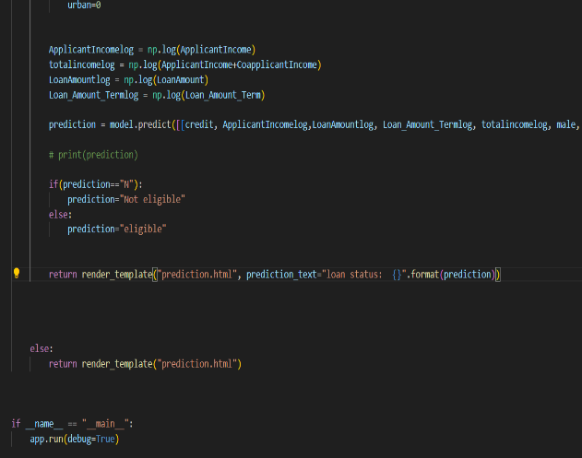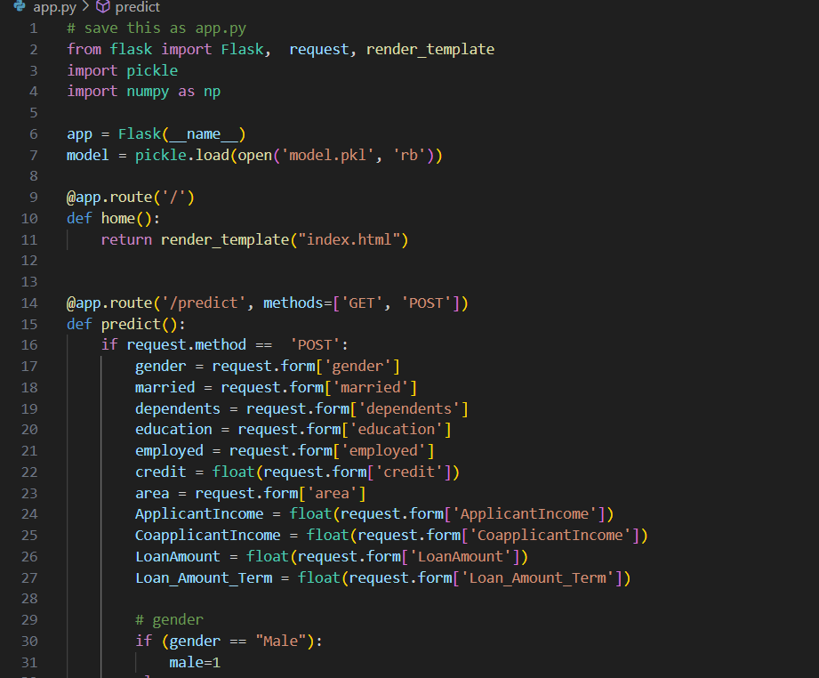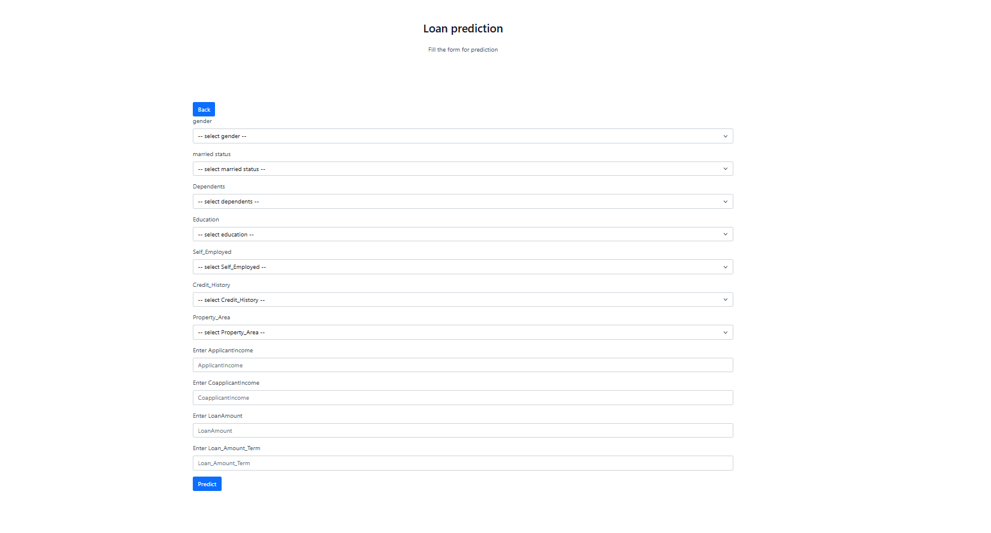

Sample screenshots of app.py

**Website creation**

**Home page**

**Home Page Development**

* The home page of the web application, index.html, serves as the central point for users to interact with the platform. It is designed with a focus on usability, aesthetics, and responsiveness, ensuring that users have a seamless experience across different devices.
* **Technologies Used:**
  + **Bootstrap 5:** The home page leverages Bootstrap 5, a popular front-end framework, to ensure a responsive and mobile-first design. Bootstrap’s grid system and pre-built components, such as navigation bars, buttons, and forms, were utilized to create a clean and consistent layout across various screen sizes.
  + **Tailwind CSS:** In addition to Bootstrap, Tailwind CSS was used to add custom styling and fine-tune the design. Tailwind's utility-first approach allowed for rapid styling by applying utility classes directly in the HTML. This combination of Bootstrap and Tailwind provided both structure and flexibility in the design process.
* **Responsive Design:**
  + The integration of Bootstrap 5 ensures that the home page is fully responsive, adapting to different screen sizes ranging from large desktop monitors to small mobile devices. Bootstrap’s grid system allowed for the creation of a fluid layout that adjusts based on the user's device, enhancing accessibility and usability.
  + Tailwind CSS complemented this by offering a wide array of utility classes that enabled precise control over spacing, alignment, and typography, contributing to a polished and cohesive design.
* **Cross-Browser Compatibility:**
  + Both Bootstrap 5 and Tailwind CSS are known for their robust cross-browser compatibility. By using these frameworks, the home page is ensured to work consistently across all modern browsers, providing a uniform experience for all users.

**Conclusion**

* The combination of Bootstrap 5 and Tailwind CSS in developing the home page allowed for the creation of a modern, responsive, and aesthetically pleasing interface. This approach not only streamlined the development process but also ensured that the final product meets the high standards expected in today’s web applications.

**Prediction Page**

**Styling and Layout:**

1. **Integration of Bootstrap and Tailwind CSS:** The prediction page of the Flask application utilizes both Bootstrap and Tailwind CSS for styling and layout. Bootstrap provides a set of pre-designed components and a responsive grid system that ensure the page is visually appealing and functions well on different devices. Tailwind CSS, with its utility-first approach, offers additional flexibility and customization for specific design elements, allowing for fine-tuned control over spacing, typography, and colors.
2. **Responsive Design:** By leveraging Bootstrap’s grid system and responsive utilities, the prediction page is designed to be mobile-friendly and adaptive to various screen sizes. Bootstrap’s responsive classes ensure that the form and results are properly displayed on both desktop and mobile devices. Tailwind CSS enhances this responsiveness by providing additional utility classes that can be used to adjust layout and styling based on screen size.

**Form Design and User Experience:**

1. **Form Layout:** The prediction page includes a user input form that collects necessary information for loan prediction, such as personal details and financial data. Bootstrap’s form components are used to create a clean and structured layout, while Tailwind CSS’s utility classes are applied to fine-tune the spacing and alignment of form elements.
2. **Input Validation:** The form includes fields for various types of user input, including text fields, drop-downs, and numeric inputs. Tailwind CSS is used to style these input elements and ensure they are easy to use and visually consistent. The form’s design encourages accurate and complete data entry by providing clear labels and organized field groups.
3. **Submission and Feedback:** After the user submits the form, the prediction result is displayed on the same page. Tailwind CSS is used to style the result display area, making it prominent and easy to read. Bootstrap’s alert and button components are utilized to provide feedback and improve the overall user experience.

**Prediction Result Display:**

1. **Result Presentation:** The prediction result is shown in a dedicated section on the page, styled with Tailwind CSS to stand out and be easily noticeable. The result is formatted to clearly indicate whether the loan application is approved or not, providing immediate feedback based on the user's input.
2. **Consistency in Design:** The consistent use of Bootstrap and Tailwind CSS ensures that the prediction page maintains a cohesive look and feel. Bootstrap handles the overall layout and component structure, while Tailwind CSS allows for precise customization of individual elements, resulting in a polished and professional user interface.

The combination of Bootstrap and Tailwind CSS in the prediction page enhances both the functionality and aesthetics of the Flask application. Bootstrap provides a solid foundation with pre-designed components and responsive design features, while Tailwind CSS offers additional customization options to refine the page’s appearance. Together, these frameworks contribute to a user-friendly experience, ensuring that the form is easy to navigate and the prediction results are clearly presented.

**Conclusion**

The Loan Prediction Project serves as a vital tool in the banking and financial sector, offering significant improvements in risk management, profitability, and customer satisfaction. By leveraging advanced machine learning techniques and extensive historical data, the project successfully developed a predictive model that can accurately assess the creditworthiness of loan applicants. This model not only streamlines the loan approval process but also minimizes the risk of default, ensuring a healthier loan portfolio for lending institutions.

Furthermore, the project addresses key challenges in loan prediction, including data quality, model complexity, regulatory compliance, and ethical considerations. By adhering to best practices in data science and maintaining a focus on fairness and transparency, the project contributes to more responsible lending practices. Additionally, the use of alternative data sources to promote financial inclusion highlights the potential of data analytics to expand access to credit for underserved populations.

In summary, the Loan Prediction Project demonstrates the power of data science in transforming traditional banking processes. The insights gained from this project not only benefit lending institutions but also pave the way for more inclusive and efficient financial services in the future.

**Reference**

1. **Pedregosa, F., Varoquaux, G., Gramfort, A., Michel, V., Thirion, B., Grisel, O., ... & Duchesnay, É. (2011).** Scikit-learn: Machine Learning in Python. *Journal of Machine Learning Research, 12*, 2825-2830.
2. **Hunter, J. D. (2007).** Matplotlib: A 2D Graphics Environment. *Computing in Science & Engineering, 9*(3), 90-95.
3. **Wes McKinney. (2010).** Data Structures for Statistical Computing in Python. *Proceedings of the 9th Python in Science Conference, 445*, 51-56.
4. **Michael Waskom. (2021).** Seaborn: Statistical Data Visualization. *Journal of Open Source Software, 6*(60), 3021.
5. **Oliphant, T. E. (2006).** A Guide to NumPy. *USA: Trelgol Publishing.*
6. **Poccia, G. (2020).** Flask Web Development: Developing Web Applications with Python. *O'Reilly Media, Inc.*
7. **Bootstrap. (n.d.).** *The Bootstrap Framework.* Retrieved from <https://getbootstrap.com>
8. **Tailwind CSS. (n.d.).** *The Tailwind CSS Framework.* Retrieved from <https://tailwindcss.com>
9. **Python Software Foundation. (2023).** *Python Language Reference, version 3.10.* Retrieved from <https://www.python.org>
10. **Microsoft. (n.d.).** *Visual Studio Code Documentation.* Retrieved from <https://code.visualstudio.com/docs>