NEURAL NETWORK EXPERIMENT – 1
Name: Rahul Raj
Roll Number: 24UADS1041

Objective
WAP to visualize the Perceptron Learning Algorithm using NumPy and Matplotlib/Seaborn in Python and evaluate the performance of a single-layer perceptron on NAND and XOR logic gate datasets.

Theory
A perceptron is the simplest artificial neural network used for binary classification. It computes a weighted sum of inputs along with a bias and applies a step activation function. The learning rule updates weights when misclassification occurs.
For linearly separable problems, the perceptron is guaranteed to converge. The NAND gate is linearly separable, while the XOR gate is not, which makes XOR unsolvable using a single-layer perceptron.

Algorithm
- Initialize weights and bias to zero
- Set learning rate
- Calculate weighted sum of inputs
- Apply step activation function
- Compare predicted output with target output
- Update weights and bias if error occurs
- Repeat until convergence or epoch limit

Implementation
The perceptron was implemented using NumPy. Matplotlib and Seaborn were used to visualize data points, decision boundaries, and training error curves. Weight updates were printed after every iteration.

Results and Outputs
NAND Perceptron – Decision Boundary
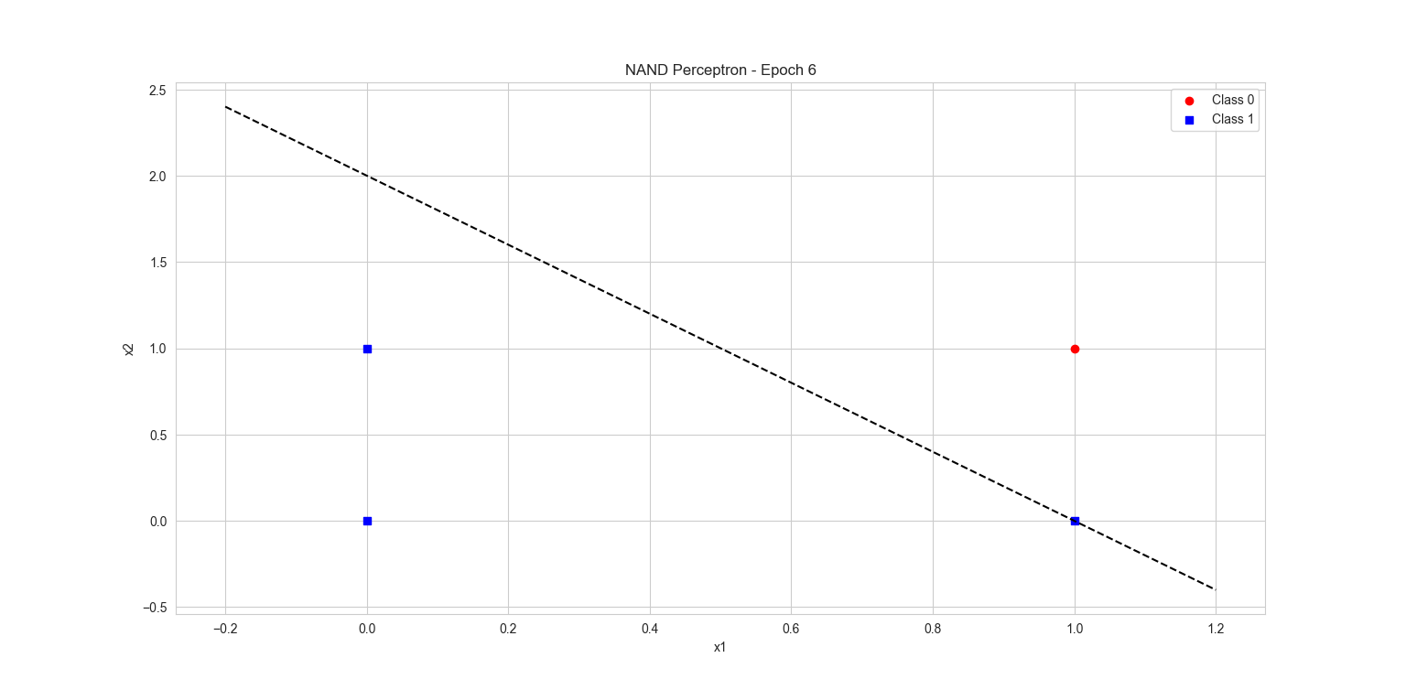
Training Error Curve – NAND
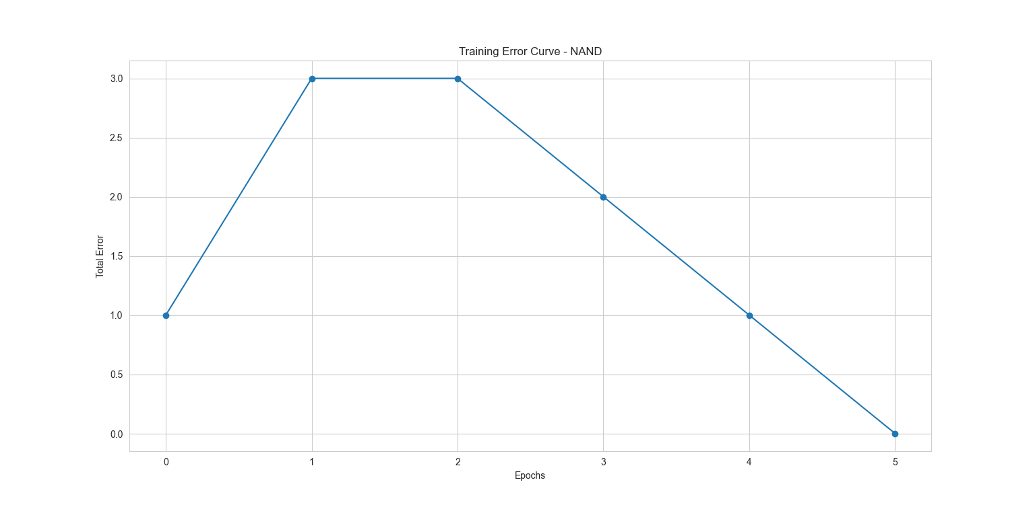
XOR Perceptron – Data Distribution
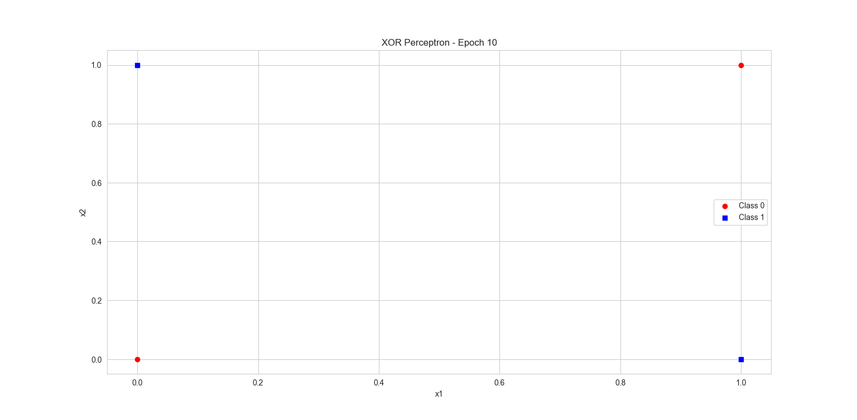
Training Error Curve – XOR
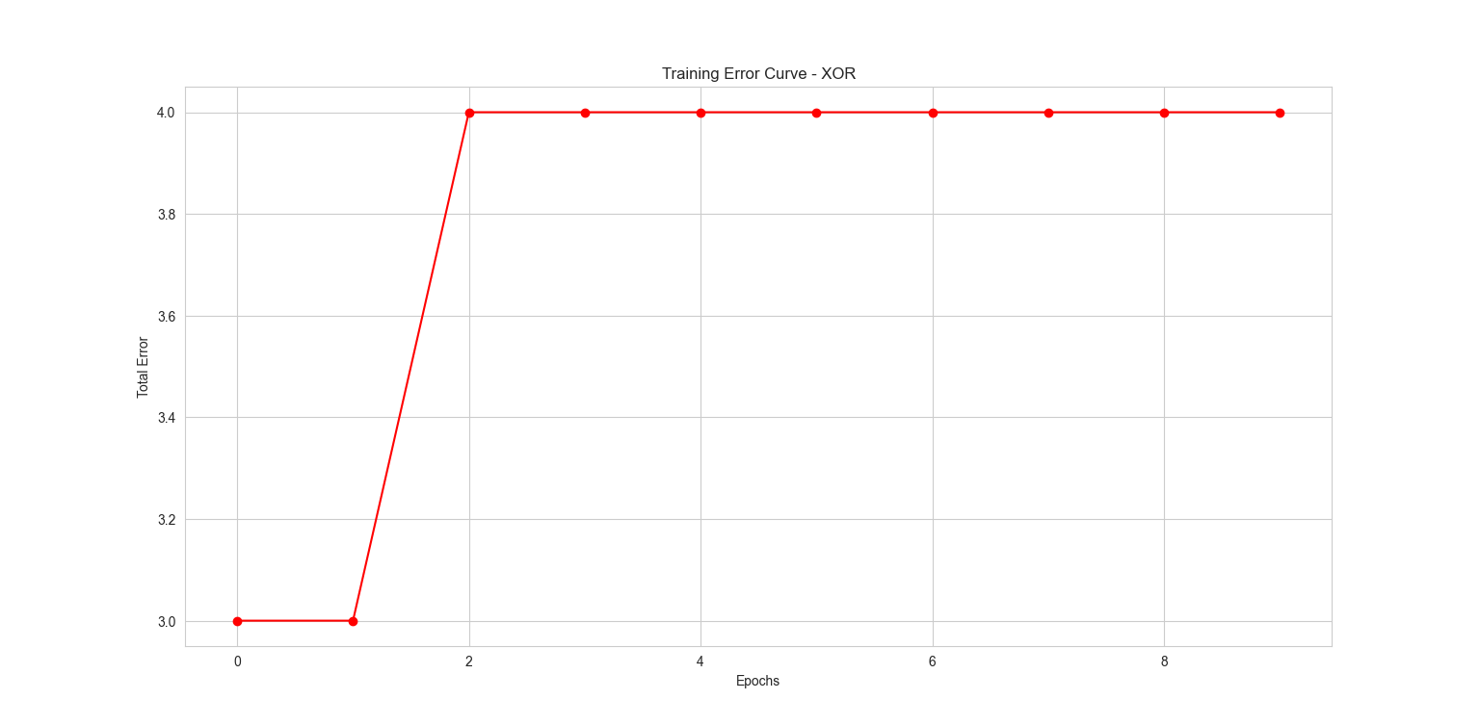

Analysis
For the NAND gate, the perceptron converged after a few epochs. The training error reduced to zero and a stable decision boundary was obtained.
For the XOR gate, the perceptron failed to converge. The training error remained constant even after multiple epochs, confirming that XOR is not linearly separable.

Conclusion
This experiment proves that a single-layer perceptron can successfully learn linearly separable functions such as NAND but fails to learn non-linearly separable functions like XOR. Visualization helps clearly understand the convergence behavior and limitations of the perceptron.

