**spaceXApplication**

**# Introduction**

A responsive React application showing the details of all Rockets launched by Elon Musk's Space Exploration Technologies Corp.(SpaceX) between 2006-2020.

It provides in-depth details of the rockets including their year of launch & land with their success status, cartoon logo of the mission etc. This application also allows Users to filter details by year, launch success and landing success. This project is a good example of Responsive Web Application build using React.

**# Learning Curve**

Being a big fan of Elon Musk, This project is my personal favourite and it has helped me in gaining in-depth knowledge about the different technologies which are used to implement superb Web Applications. I got a better understanding of the Data and Structure types. The wonderful responsive design and user friendly UI is the uniqueness of this Project. I would like to thank **Publicis.Sapient** for giving me this opportunity to develop this Application.

**# Technologies Used**

React, HTML, CSS, JavaScript, BootStrap

**# SEO, Performance, Accessibility, Best Practices, Website Loading Speed**

As per Unit Testing done via Google Chrome Lighthouse, Google Page Speed Insights, the report shows below scores for both Desktop and Mobile which seems pretty good.

Performance Test on Chrome Extension:

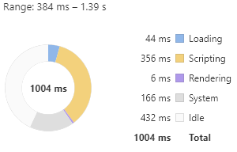

Lighthouse Test (SEO, Accessibility, Best Practices) for both Mobile and Web:

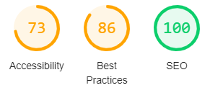

Website loading Speed Test on Google Page Speed Insights for mobile and web:

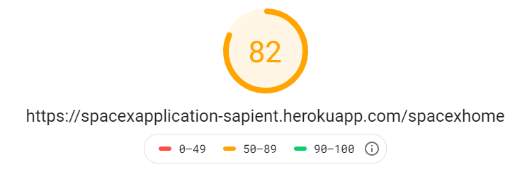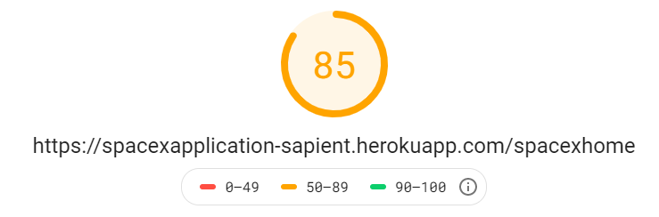

**# Unit Testing**

Basic unit testing has been performed manually and bugs were fixed immediately. All the functions calls, API calls, requests & response etc. has been tested several times before Production deployment to avoid unexpected crashing/slowness/errors in application.

**# Installation & Setup Instruction**

Clone down this repository. You will need node and npm installed globally on your machine.

Please run the commands mention below in Command Prompt.

To Clone: git clone https://github.com/Rahul-ui-repo/spaceXApplication.git

For Installation: npm install

To **Start Server**: npm start

To Visit App: localhost:3000/

**# Deployment & Production URL**

I have used Heroku.com to deploy this React application.

Production URL: <https://spacexapplication-sapient.herokuapp.com/spacexhome>

Author: Rahul Shaw

**# Thank You!!! ☺**