|  |  |
| --- | --- |
| Ex.No.**1**  **15.09.2022** | Array Question |

|  |
| --- |
| **AIM:** |

To write and execute Java program to perform Binary Search.

|  |
| --- |
| **Pseudocode:** |

1 Def Binary Search(a,key)

2 lb=0;

3 ub=len(a)-1;

4 while lb<=ub

5 mid=(lb+ub)/2;

6 if a[mid]==key

7 return mid;

8 else if a[mid]<key

9 lb=mid+1;

10 else

11 ub=mid-1;

|  |
| --- |
| **Explanation:** |

In Line No. 1:-There is a Linear array a of size n and a searching element in a key.

In Line No. 2:-Then there is a Lower Bond(lb) and it store starting index of an array.

In Line No. 3:- And Upper Bond(ub) that store (size of array – 1).

In Line No. 4:-Then there is a while loop that check condition Lower Bond is less than Upper

bond

In Line No. 5:-If above Condition will true then enter in while loop and then perform

calculation mid equal to lower bond plus upper bond divided by 2 that will give

array of mid element

In line No. 6:- Then check the condition if a[mid]is equal to key element

In Line No. 7:- Then return mid value

In Line No. 8:-Otherwise if a[mid] less than key

In Line No. 9:-Then lower bond is equal to mid plus 1

In Line No. 10 :- otherwise

In Line No. 11 :- upper bond=mid minus 1.

|  |
| --- |
| **Example:** |

* I have given the following linear array.
* Element 16 has to be searched in it using Binary search pseudocode

|  |  |  |  |  |
| --- | --- | --- | --- | --- |
| **0** | 1 | 2 | 3 | 4 |
| 10 | 12 | 8 | 16 | 20 |

Step -1.

|  |  |  |  |  |
| --- | --- | --- | --- | --- |
| **0** | 1 | 2 | 3 | 4 |
| 10 | 12 | 8 | 16 | 20 |

Let the search element be key=16.

In the given array

Lb=0

Ub=4

Mid=(0+4)/2

Mid=2

A[mid]=8

Step -2.

|  |  |  |  |  |
| --- | --- | --- | --- | --- |
| **0** | 1 | 2 | 3 | 4 |
| 10 | 12 | 8 | 16 | 20 |

A[mid]=8

A[mid]<key

So lb=mid+1;lb=3;and ub=4

Mid=(3+4)/2=3

A[mid]=16

.

Step-3.

|  |  |  |  |  |
| --- | --- | --- | --- | --- |
| **0** | 1 | 2 | 3 | 4 |
| 10 | 12 | 8 | 16 | 20 |

A[mid]=16

A[mid]==key

It return the index no.3

|  |
| --- |
| **Program Code:** |

import java.util.Scanner;

class Binary {

    private static int size=10;

    private int[] a=new int[size];

    public void read() {

        Scanner sc=new Scanner(System.in);

        for(int i=0;i<size;i++) {

            System.out.print("Enter Elements of an array :-");

            a[i]=sc.nextInt();

        }

    }

    public void search() {

        Scanner sc=new Scanner(System.in);

        System.out.print("Enter key Element :-");

        int key=sc.nextInt();

        int lb=0,ub=size-1;

        int mid=0;

        int found=0;

        while(lb<=ub) {

            mid=(lb+ub)/2;

            if(a[mid]==key) {

                found=1;

                break;

            }else if(key>a[mid])

                lb=mid+1;

            else

                ub=mid-1;

        }

        if(found==1)

            System.out.println("Element found at :-"+(mid+1));

        else

            System.out.println("Not Found");

    }

}

public class BinarySearch {

    public static void main(String[] args) {

        Binary b=new Binary();

        b.read();

        b.search();

    }

}

|  |
| --- |
| **Output Screenshots:** |

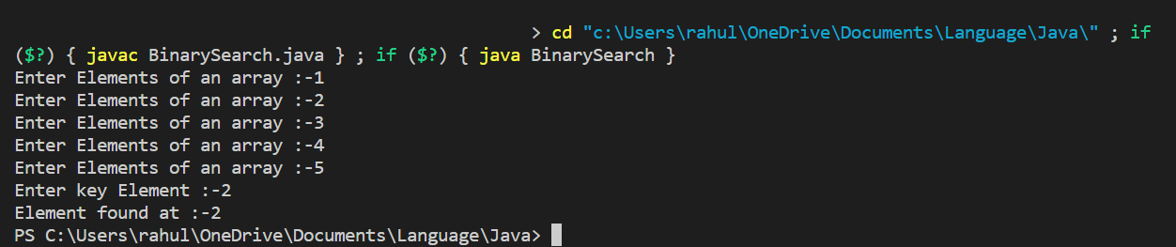

|  |
| --- |
| **RESULT:** |

Thus, the programs for the given problem statements has been executed and the results are verified successfully.