|  |  |
| --- | --- |
| Ex.No.**1**  **30.09.2022** | Array Question |

|  |
| --- |
| **AIM:** |

To write and execute Java program to perform there is unsorted array of size n that contains only non-negative integers. Find a sub-continuous array which adds to a given number s.

|  |
| --- |
| **Pseudocode:** |

**1** Linear array(a[n],n,s)

**2** int i=0,sum=0;

**3** for(int j to n)

**4** sum=sum+a[j];

**5** if(sum>s)

**6** sum=sum-a[i];

**7** i++;

**8** if(sum==s)

**9** return i,j

|  |
| --- |
| **Explanation:** |

In line No. 1:-There is a Linear array A of size n and s that contain sum of element given

by the user .

In line No. 2:-There is a variable I and sum that contain 0.

In line No. 3:-Then add the element of a of j and put in sum

In line No. 4:-We have to check condition sum is greater than s.

In line No. 5:- If line number 4 will true

**In line No. 6:-** Then we have to subtract the a of I to sum.

**In line No. 7 :-** Then increase i++.

**In line No. 8 :-** Then check the condition if sum is equal to s

**In line No. 9 :-** return I and j.

|  |
| --- |
| **Example:** |

We take an unsorted array for our example.

Array=a[n]

N=5

S=13

|  |  |  |  |  |
| --- | --- | --- | --- | --- |
| 4 | 2 | 5 | 6 | 7 |

|  |  |  |  |  |
| --- | --- | --- | --- | --- |
| 0 | 1 | 2 | 3 | 4 |

**Step 1:**

First i=0;

J=0;

Sum=0;

Sum=sum+a[j]

Sum=0+4=4

Sum!=s

J=j+1=1

|  |  |  |  |  |
| --- | --- | --- | --- | --- |
| 0 | 1 | 2 | 3 | 4 |

|  |  |  |  |  |
| --- | --- | --- | --- | --- |
| 0 | 1 | 2 | 3 | 4 |

|  |  |  |  |  |
| --- | --- | --- | --- | --- |
| 0 | 1 | 2 | 3 | 4 |
| 4 | 2 | 5 | 6 | 7 |

|  |  |  |  |  |
| --- | --- | --- | --- | --- |
| 0 | 1 | 2 | 3 | 4 |

**Step 2:**

First i=0;

J=1;

Sum=4;

Sum=sum+a[1]

Sum=4+2=6

Sum!=s

J=j+1=2

|  |  |  |  |  |
| --- | --- | --- | --- | --- |
| 0 | 1 | 2 | 3 | 4 |
| 4 | 2 | 5 | 6 | 7 |

**Step 3:**

First i=0;

J=2;

Sum=6;

Sum=sum+a[2]

Sum=6+6=12

Sum!=s

J=j+1=3

|  |  |  |  |  |
| --- | --- | --- | --- | --- |
| 0 | 1 | 2 | 3 | 4 |
| 4 | 2 | 5 | 6 | 7 |

Step 4:

First i=0;

J=3;

Sum=12;

Sum=sum+a[3]

Sum=12+5=17

Sum>s

Then sum=sum-a[i]

Sum=17-4=13

Sum==s

So Sum of contiguous element found. At i=1 and j=3

|  |  |  |  |  |
| --- | --- | --- | --- | --- |
| 0 | 1 | 2 | 3 | 4 |
| 4 | 2 | 5 | 6 | 7 |

|  |
| --- |
| **Program Code:** |

import java.util.Scanner;

class SubArraySum {

    private int a[]=new int[10];

    public void read() {

        Scanner sc=new Scanner(System.in);

        for(int i=0;i<10;i++) {

            System.out.print("Enter Elements of an array :-");

            a[i]=sc.nextInt();

        }

    }

    public void SubaArray() {

        int sum=0,i=0;

        for(int j=i;j<10;j++ ) {

            sum=sum+a[j];

            if(sum>15) {

                sum=sum-a[i];

                i++;

            }if(sum==15) {

                System.out.println((i+1)+" "+(j+1));

                break;

            }

        }

    }

}

public class SubaArray {

    public static void main(String[] args) {

        SubArraySum sa=new SubArraySum();

        sa.read();

        sa.SubaArray();

    }

}

|  |
| --- |
| **Output Screenshots:** |

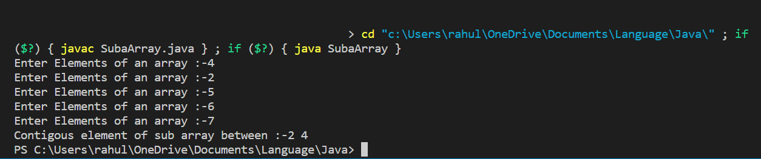

|  |
| --- |
| **RESULT:** |

Thus, the programs for the given problem statements has been executed and the results are verified successfully.