# A REPORT

### On

WEB DEVEOPMENT

*Submitted*

*In partial fulfilment*

*For the award of the Degree of*

***Bachelor of Technology***

***in Department of Computer Science Engineering***



|  |  |
| --- | --- |
| Submitted By: | Submitted To: |
| Rahul Rajpurohit  (1916200013) | Mr. Sitaram Gupta |
| Abhijeet Kamble  (14tec2cs009)  Abhijit Hingmire  ()  Amar Paygude | H.O.D  Computer Science Department |

### Department of Computer Science and Engineering

**JSPM’s RSCOE TATHWADE PUNE**

***Candidate’s Declaration***

I hereby declare that the work, which is being presented in the Project Report, entitled **“E-COMMERCE WEBSITE WITH REPAIR STATUS”** in partial fulfilment for the award of Degree of “Diploma in computer engineering” in Dept. Of **Computer** and submitted to the Department of **Computer JSPM'S Rajarshi Shahu College of Engineering**, is a record of my own investigations carried under the Guidance of **Mr./ M.S. PATIL** Department of **Computer Engineering.**

**JSPM'S Rajarshi Shahu College of Engineering.**

I have not submitted the matter presented in this Project Report anywhere for the award of any other Degree.

**(Name and Signature of Candidate)**

Rahul Rajpurohit

Enrolment No.: 1916200013

Abhijeet Kamble

Enrolment No.: 14tec2cs009

Abhijit Hingmire

Enrolment No.: 14tec2cs009

Amar Paygude

Enrolment No.: 14tec2cs009

**JSPM'S Rajarshi Shahu College of Engineering.**

**Counter Signed by**

……………………………………

# ACKNOWLEDGEMENT

It is my pleasure to be indebted to various people, who directly or indirectly contributed in the development of this work and who influenced our thinking, behavior and acts during the course of study.

We express our sincere gratitude to **Prof. (Dr.) Baldev Singh** (Dean of Engg.) for providing us an opportunity to undergo this Project as the part of the curriculum.

We are thankful to **Mr. Anil Kumar** for his support, cooperation, and motivation provided to us during the training for constant inspiration, presence and blessings.

We would also like to thank our **H.O.D Mr. Sitaram Gupta** for her valuable suggestions which helps us lot in completion of this project.

We also extend our sincere appreciation to **Mr. Dushyant Singh** who provided his valuable suggestions and precious time in accomplishing our Project report.

Lastly, we would like to thank the almighty and our parents for their moral support and friends with whom we shared our day-to-day experience and received lots of suggestions that improved our quality of work.

#### Rashmi Kumari Karn Mudasir Ahmad Bhat Enrol No: 14TEC2CS009 Enrol No: 14TEC2CS007

H.O.D

Computer Science Department

**ABSTRACT**

Our project is **PHOENIX-INFO-CARE**. This is a website which helps customers to find and buy all type of products on internet. It is useful in the way that it makes an easier way to buy and sell products online. **PHOENIX-INFO-CARE** is an interactive e-commerce solution providing users with an opportunity to buy and sell products. PHOENIX-INFO-CARE is the first online platform which deals with buy and repair status.

In this website we have basically 2 modules. The first module includes the customer module and second module includes admin module.

The customer has to register. The registered customer can view details of products and he/she can buy or sell the products of his/her need. He/she has to pay and will get home delivery.

The admin module contains the access of admin page on the website. The admin can change everything in the website. He has the ability to add, delete, and update any information regarding the products and repair status.

# Table of Content

|  |  |  |
| --- | --- | --- |
|  | **Title** | **Page No.** |
|  | List of Tables…………………………………………………….. |  |
|  | List of Figures |  |
| 1. | Introduction………………………………………………………  1.1 Objectives | 8 |
| 2. | Web Development……………………………………………….. | 9-10 |
|  | 2.1 Web Site |  |
|  | 2.2 Web Page |  |
| 3. | The Steps to Create a Web site…………………………………… | 11-22 |
|  | 3.1 UI development |  |
|  | 3.1.1 HTML |  |
|  | 3.1.2 CSS |  |
|  | 3.1.3 Bootstrap |  |
|  | 3.2 Scripting |  |
|  | 3.2.1 Server side scripting |  |
|  | 3.2.2 Server side scripting languages |  |
|  | 3.2.3 Client side scripting |  |
|  | 3.3 Database |  |
|  | 3.4 SQL |  |
|  | 3.5 Queries |  |
| 4. | Scripting Languages…………………………………………………………………… | 23-27 |
|  | 4.1 PHP |  |
|  | 4.2 Installing PHP |  |
|  | 4.3 Java Script |  |
|  | 4.4 JQuery |  |
|  | 4.5 AJAX |  |
|  | 4.6 JSON |  |
|  | 4.7 XAMPP |  |
|  | 4.8 Features |  |
|  | 4.9 Uses |  |
| 5. | Software Requirement Specification (SRS)………………….… | 28 |
|  | 5.1 Hardware Requirement |  |
|  | 5.2 Software Requirement |  |
| 6. | Data Flow Diagram……………………………………………… | 29-32 |

|  |  |  |
| --- | --- | --- |
|  | 6.1 DFD-1 |  |
|  | 6.2 DFD-2 |  |
|  | 6.3 DFD-3 |  |
| 7. | Project……………………………………………………………. | 33 |
|  | 7.1 Project(Advanced Technologies) |  |
|  | 7.2 Technologies Used |  |
|  | 7.3 Technical details |  |
| 8. | Screenshots………………………………………………………. | 34-38 |
| 9. | Maintenance……………………………………………………… | 39 |
| 10. | Future scope and future enhancement…………………………… | 40 |
| 11. | Conclusion………………………………………………………. | 41 |
|  | Bibliography |  |

**List of Figures**

Figure 3.1 Steps to create a website…… …………………………….

Figure 3.2 Login form without CSS ………………………………...

Figure 3.3 Login form without CSS. ...……………………………….

Figure 3.2.1 Programming language popularity. …………………….…

Figure 3.2.2 Scripting ……………… ………………………………….

Figure 4.1.1 PHP & XAMPP… …………………………………………

Figure 6.1 DFD. ..………………………………………………………

Figure 6.1.1 DFD-1……...…………………………………………….…

Figure 6.2.1 DFD-2……………………………………………………….

Figure 6.2.2 DFD-2 …………………………………………………….….

Figure 6.3.1 DFD-3 ………………………………………………………..

Figure 8.1.1 Front Page……………….……………………………..….

Figure 8.1.2 Front Page products …….……………………………..….

Figure 8.1.3 Single Product..………….……………………………..….

Figure 8.1.4 Login Page...…………….……………………………..….

Figure 8.1.5 Sign up Page…………….……………………………..….

Figure 8.1.6 Check out…..…………….……………………………..….

Figure 8.1.7 Sell Request..…………….……………………………..….

Figure 8.1.8 Admin Panel.…………….……………………………..….

Figure 8.1.9 Contact Us and about us...……………………………..….

CHAPTER-1

#### INTRODUCTION

E-commerce has experienced rapid growth since its humble beginnings with e-commerce sales projected to grow to 599.2 billion USD by 2024. The COVID-19 outbreak saw e-commerce sales spike 25% in March 2020 alone. The power of e-commerce should not be underestimated as it continues to pervade everyday life and present significant opportunities for small, medium, and large businesses and online investors. You don’t need to look far to see the potential of e-commerce businesses. Amazon, for example, which set the standard for customer-orientated websites as well as a lean supply chain, is selling over 4000 items a minute from SMBs alone.

**Phoenix-Info-Care** is an interactive e-commerce solution providing users with an opportunity to buy and sell products. Phoenix-info-care is the first online platform which deals with buy and repair status.

#### 1.1 OBJECTIVES

Online Shopping is the process whereby consumers directly buy goods and services without any intermediary service over the internet. The goal of this website is to develop a web-based interface for customers, the website would be easy to use and hence the shopping experience pleasant for the users. The main goal of this website is:

1. To develop an easy-to-use web-based interface where customers can search for products , view a complete description of the product and order the product.
2. A customer can buy products from home.
3. A customer can check repair status.

CHAPTER-2

#### WEB-DEVELOPMENT:

**Web development** is a broad term for the work involved in developing a [web site](https://en.wikipedia.org/wiki/Web_site) for the [Internet](https://en.wikipedia.org/wiki/Internet) ([World Wide Web](https://en.wikipedia.org/wiki/World_Wide_Web)) or an [intranet](https://en.wikipedia.org/wiki/Intranet) (a private network). Web development can range from developing the simplest static single page of [plain text](https://en.wikipedia.org/wiki/Plain_text) to the most complex web-based [internet applications](https://en.wikipedia.org/wiki/Internet_application), [electronic businesses](https://en.wikipedia.org/wiki/Electronic_business), and [social network services](https://en.wikipedia.org/wiki/Social_network_service). A more comprehensive list of tasks to which web development commonly refers, may include [web](https://en.wikipedia.org/wiki/Web_engineering) [engineering](https://en.wikipedia.org/wiki/Web_engineering), [web design](https://en.wikipedia.org/wiki/Web_design), [web content development](https://en.wikipedia.org/wiki/Web_content_development), client liaison, [client-side](https://en.wikipedia.org/wiki/Client-side_scripting)/side scripting, [web server](https://en.wikipedia.org/wiki/Web_server) and [network security](https://en.wikipedia.org/wiki/Network_security) configuration, and [e-commerce](https://en.wikipedia.org/wiki/E-commerce) development. Among web professionals, "web development" usually refers to the main non-design aspects of building web sites: writing [markup](https://en.wikipedia.org/wiki/Markup_language) and [coding](https://en.wikipedia.org/wiki/Computer_programming). Most recently Web development has come to mean the creation of [content management systems](https://en.wikipedia.org/wiki/Content_management_system) or CMS. These CMS can be made from scratch, proprietary or open source. In broad terms the CMS acts as middleware between the database and the user through the browser. A principle benefit of a CMS is that it allows non-technical people to make changes to their web site without having technical knowledge.

For larger organizations and businesses, web development teams can consist of hundreds of people ([web developers](https://en.wikipedia.org/wiki/Web_developer)) and follow standard methods like [Agile methodologies](https://en.wikipedia.org/wiki/Agile_software_development) while developing websites. Smaller organizations may only require a single permanent or contracting developer, or secondary assignment to related job positions such as a [graphic](https://en.wikipedia.org/wiki/Graphic_designer) [designer](https://en.wikipedia.org/wiki/Graphic_designer) or [information systems](https://en.wikipedia.org/wiki/Information_systems) technician. Web development may be a collaborative effort between departments rather than the domain of a designated department. There are three kind of web developer specialization: front-end developer, back-end developer, and full-stack developer.

#### WEB-SITE

A **website** is a collection of related [web pages](https://en.wikipedia.org/wiki/Web_page), including [multimedia](https://en.wikipedia.org/wiki/Multimedia) content, typically identified with a common [domain name,](https://en.wikipedia.org/wiki/Domain_name) and published on at least one [web server](https://en.wikipedia.org/wiki/Web_server). A website may be accessible via a public [Internet Protocol](https://en.wikipedia.org/wiki/Internet_Protocol) (IP) network, such as the [Internet](https://en.wikipedia.org/wiki/Internet), or a private [local area network](https://en.wikipedia.org/wiki/Local_area_network) (LAN), by referencing a [uniform resource locator](https://en.wikipedia.org/wiki/URL) (URL) that identifies the site.

Websites have many functions and can be used in various fashions; a website can be a [personal website](https://en.wikipedia.org/wiki/Personal_website), a commercial website for a company, a [government website](https://en.wikipedia.org/wiki/E-Government) or a [non-profit](https://en.wikipedia.org/wiki/Nonprofit_organization) [organization](https://en.wikipedia.org/wiki/Nonprofit_organization) website. Websites are typically dedicated to a particular topic or purpose, ranging from entertainment and [social networking](https://en.wikipedia.org/wiki/Social_networking) to providing news and education. All publicly accessible websites collectively constitute the [World Wide Web](https://en.wikipedia.org/wiki/World_Wide_Web), while private websites, such as a company's website for its employees, and are typically a part of an [intranet.](https://en.wikipedia.org/wiki/Intranet)

Web pages, which are the [building blocks](https://en.wikipedia.org/wiki/Building_block) of websites, are [documents](https://en.wikipedia.org/wiki/Document), typically composed in [plain text](https://en.wikipedia.org/wiki/Plain_text) interspersed with formatting instructions of Hypertext Markup Language ([HTML,](https://en.wikipedia.org/wiki/HTML) [XHTML](https://en.wikipedia.org/wiki/XHTML)). They may incorporate elements from other websites with

suitable [markup anchors](https://en.wikipedia.org/wiki/HTML_anchor). Web pages are accessed and transported with the [Hypertext Transfer](https://en.wikipedia.org/wiki/Hypertext_Transfer_Protocol) [Protocol](https://en.wikipedia.org/wiki/Hypertext_Transfer_Protocol) (HTTP), which may optionally employ encryption ([HTTP Secure](https://en.wikipedia.org/wiki/HTTP_Secure), HTTPS) to provide security and privacy for the user. The user's application, often a [web browser](https://en.wikipedia.org/wiki/Web_browser), renders the page content according to its HTML markup instructions onto a [display terminal](https://en.wikipedia.org/wiki/Computer_monitor).

[Hyperlinking](https://en.wikipedia.org/wiki/Hyperlink) between web pages conveys to the reader the [site structure](https://en.wikipedia.org/wiki/Site_map) and guides the navigation of the site, which often starts with a [home page](https://en.wikipedia.org/wiki/Home_page) containing a directory of the site [web content](https://en.wikipedia.org/wiki/Web_content). Some websites require user registration or [subscription](https://en.wikipedia.org/wiki/Subscription) to access content. Examples of [subscription websites](https://en.wikipedia.org/wiki/Paywall) include many business sites, news websites, [academic](https://en.wikipedia.org/wiki/Academic_journal) [journal](https://en.wikipedia.org/wiki/Academic_journal) websites, gaming websites, file-sharing websites, [message boards](https://en.wikipedia.org/wiki/Internet_forum), web-based [email](https://en.wikipedia.org/wiki/Email), [social networking](https://en.wikipedia.org/wiki/Social_networking) websites, websites providing real-time [stock market](https://en.wikipedia.org/wiki/Stock_market) data, as well as sites providing various other services. As of 2016 [end users](https://en.wikipedia.org/wiki/End_user) can access websites on a range of devices, including [desktop](https://en.wikipedia.org/wiki/Desktop_computer) and [laptop computers](https://en.wikipedia.org/wiki/Laptop), [tablet computers](https://en.wikipedia.org/wiki/Tablet_computer), [smartphones](https://en.wikipedia.org/wiki/Smartphone) and [smart](https://en.wikipedia.org/wiki/Smart_TV) [TVs.](https://en.wikipedia.org/wiki/Smart_TV)

A web site consists of web pages which are interconnected to each other and contain various data and functionalities.

#### WEB-PAGE

A **web page**, or **webpage**, is a document that is suitable for the [World Wide Web](https://en.wikipedia.org/wiki/World_Wide_Web) and [web browsers](https://en.wikipedia.org/wiki/Web_browser). A web browser displays a web page on a [monitor](https://en.wikipedia.org/wiki/Computer_display) or [mobile device](https://en.wikipedia.org/wiki/Mobile_device). The web page is what displays, but the term also refers to a [computer file](https://en.wikipedia.org/wiki/Computer_file), usually written in [HTML](https://en.wikipedia.org/wiki/HTML) or comparable [markup language](https://en.wikipedia.org/wiki/Markup_language). Web browsers coordinate the various [web resource](https://en.wikipedia.org/wiki/Web_resource) elements for the written web page, such as [style sheets](https://en.wikipedia.org/wiki/Cascading_Style_Sheets), [scripts](https://en.wikipedia.org/wiki/Client-side_scripting), and [images](https://en.wikipedia.org/wiki/Image), to present the web page.

Typical web pages provide [hypertext](https://en.wikipedia.org/wiki/Hypertext) that includes a [navigation bar](https://en.wikipedia.org/wiki/Navigation_bar) or a [sidebar](https://en.wikipedia.org/wiki/Sidebar_%28computing%29) [menu](https://en.wikipedia.org/wiki/Menu_%28computing%29) to other web pages via [hyperlinks](https://en.wikipedia.org/wiki/Hyperlink), often referred to as links.

On a network, a web browser can retrieve a web page from a remote [web server](https://en.wikipedia.org/wiki/Web_server). On a higher level, the web server may restrict access to only a private network such as a corporate [intranet](https://en.wikipedia.org/wiki/Intranet) or it provides access to the World Wide Web. On a lower level, the web browser uses the [Hypertext Transfer Protocol](https://en.wikipedia.org/wiki/Hypertext_Transfer_Protocol) (HTTP) to make such requests.

A [static web page](https://en.wikipedia.org/wiki/Static_web_page) is delivered exactly as stored, as [web content](https://en.wikipedia.org/wiki/Web_content) in the web server's [file](https://en.wikipedia.org/wiki/File_system) [system,](https://en.wikipedia.org/wiki/File_system) while a [dynamic web page](https://en.wikipedia.org/wiki/Dynamic_web_page) is generated by a [web application](https://en.wikipedia.org/wiki/Web_application) that is driven by [server-](https://en.wikipedia.org/wiki/Server-side_scripting) [side software](https://en.wikipedia.org/wiki/Server-side_scripting) or client-side scripting. Dynamic website pages help the browser (the [client](https://en.wikipedia.org/wiki/Client_%28computing%29)) to enhance the web page through user input to the server.

CHAPTER-3

#### THE STEPS TO CREATE A WEB SITE

Creating a web site requires multiple steps which includes the following:

* Creating a UI(User interface)
* Scripting(Both at server end and client end)
* Creating a backend or the database

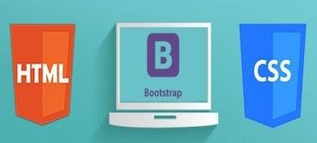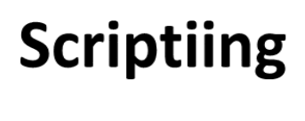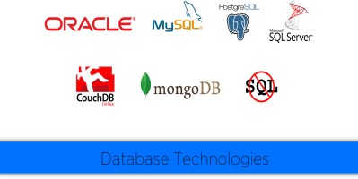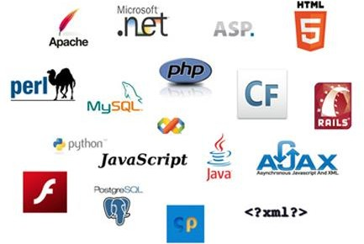

**Web Site**

**UI**

**Data Base**

**Fig 3.1**

#### UI DEVELOPMENT

Technologies that are mostly used to develop a User Interface are:

* + HTML
  + CSS
  + Bootstrap.

#### HTML

**Hypertext Markup Language** (**HTML**) is the standard [markup language](https://en.wikipedia.org/wiki/Markup_language) for creating [web pages](https://en.wikipedia.org/wiki/Web_page) and [web applications](https://en.wikipedia.org/wiki/Web_application). With [Cascading Style Sheets](https://en.wikipedia.org/wiki/Cascading_Style_Sheets) (CSS) and [JavaScript](https://en.wikipedia.org/wiki/JavaScript) it forms a triad of cornerstone technologies for the [World Wide Web](https://en.wikipedia.org/wiki/World_Wide_Web). [Web browsers](https://en.wikipedia.org/wiki/Web_browser) receive HTML documents from a [webserver](https://en.wikipedia.org/wiki/Webserver) or from local storage and render them into multimedia web pages. HTML describes the structure of a web page [semantically](https://en.wikipedia.org/wiki/Semantic) and originally included cues for the appearance of the document.

[HTML elements](https://en.wikipedia.org/wiki/HTML_element) are the building blocks of HTML pages. With HTML constructs, [images](https://en.wikipedia.org/wiki/Img_%28HTML_element%29) and other objects, such as [interactive forms,](https://en.wikipedia.org/wiki/Fieldset) may be embedded into the rendered page. It provides a means to create [structured documents](https://en.wikipedia.org/wiki/Structured_document) by denoting structural [semantics](https://en.wikipedia.org/wiki/Semantics) for text such as headings, paragraphs, lists, [links](https://en.wikipedia.org/wiki/Hyperlink), quotes and other items. HTML elements are delineated by tags, written using [angle brackets](https://en.wikipedia.org/wiki/Bracket#Angle_brackets). Tags such as <img /> and <input /> introduce content into the page directly. Others such as <p>...</p> surround and provide information about document text and may include other tags as sub-elements. Browsers do not display the HTML tags, but use them to interpret the content of the page.

HTML can embed programs written in a [scripting language](https://en.wikipedia.org/wiki/Scripting_language) such as [JavaScript](https://en.wikipedia.org/wiki/JavaScript) which affect the behavior and content of web pages. Inclusion of CSS defines the look and layout of content. The [World Wide Web Consortium](https://en.wikipedia.org/wiki/World_Wide_Web_Consortium) (W3C), maintainer of both the HTML and the CSS standards, has encouraged the use of CSS over explicit presentational HTML since 1997.

HTML markup consists of several key components, including those called tags (and their attributes), character-based data types, character references and entity references. HTML tags most commonly come in pairs like <h1> and </h1>, although some represent empty elements and so are unpaired, for example <img>. The first tag in such a pair is the start tag, and the second is the end tag (they are also called opening tags and closing tags).

Another important component is the HTML [document type declaration](https://en.wikipedia.org/wiki/Document_type_declaration), which triggers [standards mode](https://en.wikipedia.org/wiki/Standards_mode) rendering.

The following is an example of the classic [Hello world program,](https://en.wikipedia.org/wiki/Hello_world_program) a common test employed for comparing [programming languages](https://en.wikipedia.org/wiki/Programming_language), [scripting languages](https://en.wikipedia.org/wiki/Scripting_language) and [markup languages](https://en.wikipedia.org/wiki/Markup_language). This example is made using 9 [lines of code](https://en.wikipedia.org/wiki/Lines_of_code):

#### General Syntax of HTML

<!DOCTYPE html>

<html>

<head>

<title>This is a title</title>

</head>

<body>

<p>Hello world!</p>

</body>

</html>

(The text between <html> and </html> describes the web page, and the text between <body> and </body> is the visible page content. The markup text "<title>This is a title</title>" defines the browser page title.)

The Document Type Declaration <!DOCTYPE html> is for HTML5. If a declaration is not included, various browsers will revert to "[quirks mode](https://en.wikipedia.org/wiki/Quirks_mode)" for rendering.

#### CSS

**Cascading Style Sheets** (**CSS**) is a [style sheet language](https://en.wikipedia.org/wiki/Style_sheet_language) used for describing the [presentation](https://en.wikipedia.org/wiki/Presentation_semantics) of a document written in a [markup language](https://en.wikipedia.org/wiki/Markup_language). Although most often used to set the visual style of [web pages](https://en.wikipedia.org/wiki/Web_page) and user interfaces written in [HTML](https://en.wikipedia.org/wiki/HTML) and [XHTML](https://en.wikipedia.org/wiki/XHTML), the language can be applied to any [XML](https://en.wikipedia.org/wiki/XML) document, including [plain XML](https://en.wikipedia.org/wiki/Plain_Old_XML), [SVG](https://en.wikipedia.org/wiki/Scalable_Vector_Graphics) and [XUL](https://en.wikipedia.org/wiki/XUL), and is applicable to rendering in [speech](https://en.wikipedia.org/wiki/Speech_synthesis), or on other media. Along with HTML and [JavaScript](https://en.wikipedia.org/wiki/JavaScript), CSS is a cornerstone technology used by most websites to create visually engaging webpages, user interfaces for [web applications](https://en.wikipedia.org/wiki/Web_applications), and user interfaces for many mobile applications.

CSS is designed primarily to enable the separation of presentation and content, including aspects such as the [layout](https://en.wikipedia.org/wiki/Page_layout), [colors](https://en.wikipedia.org/wiki/Color), and [fonts](https://en.wikipedia.org/wiki/Typeface). This separation can improve content [accessibility](https://en.wikipedia.org/wiki/Accessibility), provide more flexibility and control in the specification of presentation characteristics, enable multiple HTML pages to share formatting by specifying the relevant CSS in a separate .css file, and reduce complexity and repetition in the structural content.

Separation of formatting and content makes it possible to present the same markup page in different styles for different rendering methods, such as on-screen, in print, by voice (via speech-based browser or [screen reader](https://en.wikipedia.org/wiki/Screen_reader)), and on [Braille-based](https://en.wikipedia.org/wiki/Braille_display) tactile devices. It can also display

the web page differently depending on the screen size or viewing device. Readers can also specify a different style sheet, such as a CSS file stored on their own computer, to override the one the author specified.

Changes to the [graphic design](https://en.wikipedia.org/wiki/Graphic_design) of a document (or hundreds of documents) can be applied quickly and easily, by editing a few lines in the CSS file they use, rather than by changing markup in the documents.

The CSS specification describes a priority scheme to determine which style rules apply if more than one rule matches against a particular element. In this so-called cascade, priorities (or weights) are calculated and assigned to rules, so that the results are predictable.

The CSS specifications are maintained by the [World Wide Web Consortium](https://en.wikipedia.org/wiki/World_Wide_Web_Consortium) (W3C). Internet media type ([MIME type](https://en.wikipedia.org/wiki/MIME_media_type)) text/css is registered for use with CSS by [RFC 2318](https://tools.ietf.org/html/rfc2318) (March 1998). The W3C operates a free [CSS validation service](https://en.wikipedia.org/wiki/W3C_Markup_Validation_Service#CSS_validation) for CSS documents.

##### Types of CSS:

* Inline CSS:

In this CSS is applied in between the tags

* Internal CSS:

Eg: <tag style=”styling”>Hello World</tag>

In this Thecss code is defined inside the style tag in the head section of the HTML page.

##### General Syntax:

<html>

<head>

<style>

<! -- CSS STYLING -- >

</style>

</head>

</html>

* External CSS:

In this the CSS code is written on another page and is linked to the HTML page. It is advantageous to use this type of styling as we can use the same file to style various HTML pages.

External CSS uses the extension .css and is applied using the following syntax

<html>

<head>

<link relation=”stylesheet” type=”css” href=”url to the page”>

</head>

</html>

All the CSS style types are important but can be used in different situations.

* Inline CSS is used when only small changes are to be done to the HTML tag and the changes are to be reflected only to that specific tag
* Internal CSS is used when the individual HTML pages have to be designed differently. This also slows the page load system if the internal styling is long.
* External CSS files are maintained to design multiple pages and use common styles over various pages. It is useful as it helps in managing the resources in an easy manner.

*Both HTML and CSS are used to create a UI but CSS behaves like a makeup on the face of an actress which makes her look even more beautiful than she is in reality.*

And here is the difference:

###### Before using CSS in HTML page:

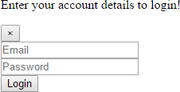

**Fig 3.2**

###### After using CSS in HTML Page:



**Fig 3.3**

#### BOOTSTRAP

**Bootstrap** is a [free and open-source](https://en.wikipedia.org/wiki/Free_and_open-source_software) front-end [web framework](https://en.wikipedia.org/wiki/Web_framework) for designing [websites](https://en.wikipedia.org/wiki/Website) and [web applications](https://en.wikipedia.org/wiki/Web_application). It contains [HTML](https://en.wikipedia.org/wiki/HTML)- and [CSS](https://en.wikipedia.org/wiki/CSS)-based design templates for [typography](https://en.wikipedia.org/wiki/Typography), forms, buttons, navigation and other interface components, as well as optional [JavaScript](https://en.wikipedia.org/wiki/JavaScript) extensions. Unlike many web frameworks, it concerns itself with [front-end development](https://en.wikipedia.org/wiki/Front-end_web_development) only.

Bootstrap is the second most-starred project on [GitHub](https://en.wikipedia.org/wiki/GitHub), with more than 107,000 stars and 48,000 forks.

Bootstrap, originally named Twitter Blueprint, was developed by Mark Otto and Jacob Thornton at [Twitter](https://en.wikipedia.org/wiki/Twitter) as a framework to encourage consistency across internal tools. Before Bootstrap, various libraries were used for interface development, which led to inconsistencies and a high maintenance burden. According to [twitter](https://en.wikipedia.org/wiki/Twitter) developer Mark Otto:

“A super small group of developers and I got together to design and build a new internal tool and saw an opportunity to do something more. Through that process, we saw ourselves build something much more substantial than another internal tool. Months later, we ended up with an early version of Bootstrap as a way to document and share common design patterns and assets within the company.”

After a few months of development by a small group, many developers at Twitter began to contribute to the project as a part of Hack Week, a [hackathon](https://en.wikipedia.org/wiki/Hackathon)-style week for the Twitter development team. It was renamed from Twitter Blueprint to Bootstrap, and released as an

open source project on August 19, 2011. It has continued to be maintained by Mark Otto, Jacob Thornton, and a small group of core developers, as well as a large community of contributors.

On January 31, 2012, Bootstrap 2 was released, which added a twelve-column [responsive](https://en.wikipedia.org/wiki/Responsive_web_design) grid layout system, inbuilt support for Glyphicons, several new components, as well as changes to many of the existing components.

On August 19, 2013, Bootstrap 3 was released, which redesigned components to use [flat design](https://en.wikipedia.org/wiki/Flat_design), and a [mobile first](https://en.wikipedia.org/wiki/Responsive_web_design#Mobile_first.2C_unobtrusive_JavaScript.2C_and_progressive_enhancement) approach.

On October 29, 2014, Mark Otto announced that Bootstrap 4 was in development. The first alpha version of Bootstrap 4 was released on August 19, 2015.

Bootstrap 3 supports the latest versions of the [Google Chrome](https://en.wikipedia.org/wiki/Google_Chrome), [Firefox](https://en.wikipedia.org/wiki/Firefox), [Internet](https://en.wikipedia.org/wiki/Internet_Explorer) [Explorer](https://en.wikipedia.org/wiki/Internet_Explorer), [Opera](https://en.wikipedia.org/wiki/Opera_%28web_browser%29), and [Safari](https://en.wikipedia.org/wiki/Safari_%28web_browser%29) (except on Windows). It additionally supports back to [IE8](https://en.wikipedia.org/wiki/Internet_Explorer_8) and the latest [Firefox](https://en.wikipedia.org/wiki/Firefox) Extended Support Release (ESR).

Since 2.0, Bootstrap supports [responsive web design](https://en.wikipedia.org/wiki/Responsive_Web_Design). This means the layout of web pages adjusts dynamically, taking into account the characteristics of the device used (desktop, tablet, mobile phone).

Starting with version 3.0, Bootstrap adopted a [mobile-first design](https://en.wikipedia.org/wiki/Mobile-first_design) philosophy, emphasizing responsive design by default.

The version 4.0 alpha release added [Sass](https://en.wikipedia.org/wiki/Sass_%28stylesheet_language%29) and [flexbox](https://en.wikipedia.org/wiki/CSS_Flex_Box_Layout) support.

#### Installing and linking bootstrap to the HTML page:

* Install bootstrap from <https://getbootstrap.com/>
* Copy the bootstrap.min.css file to your CSS folder and link it to the HTML page in the similar manner to how any other CSS file is linked.
* Link the bootstrap.min.js file which is present in the JS folder of the bootstrap. It can be linked using script tag.

Eg: <script src=”url to bootstrap.min.js”></script>

* Now use bootstrap classes to reduce the work of designing which was earlier done through CSS.

#### SCRIPTING

There are two scripting methodologies.

* 1. Server side scripting: This scripting is done at the server end
  2. Client side scripting: This scripting is done at the client end or the browser.

#### SERVER SIDE SCRIPTING

**Server-side scripting** is a technique used in [web development](https://en.wikipedia.org/wiki/Web_development) which involves employing [scripts](https://en.wikipedia.org/wiki/Scripting_language) on a web server which produce a response customized for each user’s (client’s) request to the website. The alternative is for the web server itself to deliver a [static](https://en.wikipedia.org/wiki/Static_web_page) [web page](https://en.wikipedia.org/wiki/Static_web_page). Scripts can be written in any of a number of server-side scripting languages that are available (see below). Server-side scripting is distinguished from [client-side scripting](https://en.wikipedia.org/wiki/Client-side_scripting) where embedded scripts, such as [JavaScript](https://en.wikipedia.org/wiki/JavaScript), are run client-side in a [web browser](https://en.wikipedia.org/wiki/Web_browser), but both techniques are often used together.

Server-side scripting is often used to provide a customized interface for the user. These scripts may assemble client characteristics for use in customizing the response based on those characteristics, the user’s requirements, access rights, etc. Server-side scripting also enables the website owner to hide the source code that generates the interface, whereas with client-side scripting, the user has access to all the code received by the client. A down-side to the use of server-side scripting is that the client needs to make further requests over the network to the server in order to show new information to the user via the web browser. These requests can slow down the experience for the user, place more load on the server, and prevent use of the application when the user is disconnected from the server.

When the server serves data in a commonly used manner, for example according to the [HTTP](https://en.wikipedia.org/wiki/Hypertext_Transfer_Protocol) or [FTP](https://en.wikipedia.org/wiki/File_Transfer_Protocol) [protocols](https://en.wikipedia.org/wiki/Protocol_%28computing%29), users may have their choice of a number of client programs (most modern web browsers can request and receive data using both of those protocols). In the case of more specialized applications, programmers may write their own server, client, and communications protocol that can only be used with one another.

Programs that run on a user’s local computer without ever sending or receiving data over a network are not considered clients, and so the operations of such programs would not be considered client-side operations.

#### Server Side scripting Languages

There are several languages that can be used for server-side programming:

* PHP
* ASP.NET (C# OR Visual Basic)
* C++
* Java and JSP
* Python
* Ruby on Rails and so on.

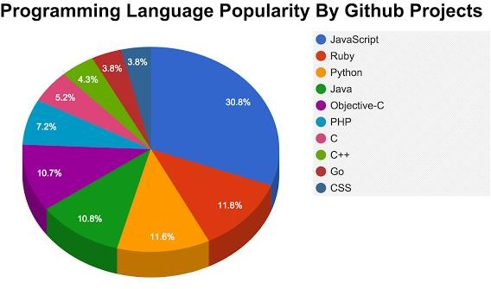

**Fig 3.2.1**

#### CLIENT SIDE SCRIPTING

Client-side scripting is changing interface behaviors within a specific web page in response to mouse or keyboard actions, or at specified timing events. In this case, the dynamic behavior occurs within the [presentation](https://en.wikipedia.org/wiki/Look_and_feel). The client-side content is generated on the user's local computer system.

Such web pages use presentation technology called [rich interfaced pages](https://en.wikipedia.org/wiki/Rich_Internet_application#Methods_and_techniques). Client-side scripting languages like [JavaScript](https://en.wikipedia.org/wiki/JavaScript) or [ActionScript](https://en.wikipedia.org/wiki/ActionScript), used for [Dynamic HTML](https://en.wikipedia.org/wiki/Dynamic_HTML) (DHTML) and [Flash](https://en.wikipedia.org/wiki/Adobe_Flash) technologies respectively, are frequently used to orchestrate media types (sound, animations, changing text, etc.) of the presentation. Client-side scripting also allows the use of

[remote scripting](https://en.wikipedia.org/wiki/Remote_scripting), a technique by which the DHTML page requests additional information from a server, using a [hidden frame](https://en.wikipedia.org/wiki/HTML_element#Frames), [XML Http Requests](https://en.wikipedia.org/wiki/XMLHttpRequest), or a [Web service](https://en.wikipedia.org/wiki/Web_service).

The first widespread use of JavaScript was in 1997, when the language was standardized as [ECMAScript](https://en.wikipedia.org/wiki/ECMAScript) and implemented in [Netscape 3](https://en.wikipedia.org/wiki/Netscape).

Example:

The client-side content is generated on the client's computer. The web browser retrieves a page from the server, then processes the code embedded in the page (typically written in [JavaScript](https://en.wikipedia.org/wiki/JavaScript)) and displays the retrieved page's content to the user.

The most popularly used client side scripting languages is **Java Script**. Flow of request from browser to server:

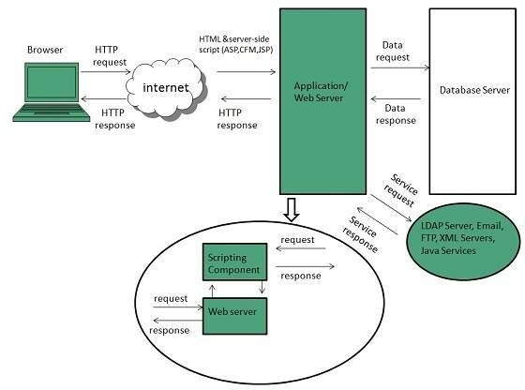

**Fig 3.2.2**

#### 4.3 DATABASE

A **database** is an organized collection of [data.](https://en.wikipedia.org/wiki/Data_%28computing%29) It is the collection of [schemas,](https://en.wikipedia.org/wiki/Database_schema) [tables](https://en.wikipedia.org/wiki/Table_%28database%29), [queries](https://en.wikipedia.org/wiki/Query_language), reports, [views](https://en.wikipedia.org/wiki/View_%28SQL%29), and other objects. The data are typically organized to model aspects of reality in a way that supports [processes](https://en.wikipedia.org/wiki/Process_%28computing%29) requiring information, such as modelling the availability of rooms in hotels in a way that supports finding a hotel with vacancies.

A **database management system** (**DBMS**) is a [computer software](https://en.wikipedia.org/wiki/Computer_software) application that interacts with the user, other applications, and the database itself to capture and analyze data. A general-purpose DBMS is designed to allow the definition, creation, querying, update, and administration of databases. Well-known DBMSs include [MySQL,](https://en.wikipedia.org/wiki/MySQL) [PostgreSQL,](https://en.wikipedia.org/wiki/PostgreSQL) [MongoDB](https://en.wikipedia.org/wiki/MongoDB), [MariaDB](https://en.wikipedia.org/wiki/MariaDB), [Microsoft SQL Server](https://en.wikipedia.org/wiki/Microsoft_SQL_Server), [Oracle](https://en.wikipedia.org/wiki/Oracle_Database), [Sybase](https://en.wikipedia.org/wiki/Sybase), [SAP HANA,](https://en.wikipedia.org/wiki/SAP_HANA) [MemSQL](https://en.wikipedia.org/wiki/MemSQL) and [IBM DB2.](https://en.wikipedia.org/wiki/IBM_DB2) A

database is not generally [portable](https://en.wikipedia.org/wiki/Software_portability) across different DBMSs, but different DBMS can interoperate by using [standards](https://en.wikipedia.org/wiki/Technical_standard) such as [SQL](https://en.wikipedia.org/wiki/SQL) and [ODBC](https://en.wikipedia.org/wiki/ODBC) or [JDBC](https://en.wikipedia.org/wiki/JDBC) to allow a single application to work with more than one DBMS. Database management systems are often classified according to the [database model](https://en.wikipedia.org/wiki/Database_model) that they support; the most popular database systems since the 1980s have all supported the [relational model](https://en.wikipedia.org/wiki/Relational_model) as represented by the [SQL](https://en.wikipedia.org/wiki/SQL) language. Sometimes a DBMS is loosely referred to as a "database".

#### SQL

Originally based upon [relational algebra](https://en.wikipedia.org/wiki/Relational_algebra) and [tuple relational calculus](https://en.wikipedia.org/wiki/Tuple_relational_calculus), SQL consists of a [data definition language](https://en.wikipedia.org/wiki/Data_definition_language), [data manipulation language](https://en.wikipedia.org/wiki/Data_manipulation_language), and [data control language](https://en.wikipedia.org/wiki/Data_control_language). The scope of SQL includes data insert, query, update and delete, [schema](https://en.wikipedia.org/wiki/Database_schema) creation and modification, and data access control. Although SQL is often described as, and to a great extent is, a [declarative](https://en.wikipedia.org/wiki/Declarative_programming) [language](https://en.wikipedia.org/wiki/Declarative_programming) ([4GL](https://en.wikipedia.org/wiki/4GL)), it also includes [procedural](https://en.wikipedia.org/wiki/Procedural_programming) elements.

SQL was one of the first commercial languages for [Edgar F. Codd](https://en.wikipedia.org/wiki/Edgar_F._Codd)'s[relational model](https://en.wikipedia.org/wiki/Relational_model), as described in his influential 1970 paper, "A Relational Model of Data for Large Shared Data Banks." Despite not entirely adhering to [the relational model as described by Codd,](https://en.wikipedia.org/wiki/Codd%27s_12_rules) it became the most widely used database language.

SQL became a [standard](https://en.wikipedia.org/wiki/Technical_standard) of the [American National Standards Institute](https://en.wikipedia.org/wiki/American_National_Standards_Institute) (ANSI) in 1986, and of the [International Organization for Standardization](https://en.wikipedia.org/wiki/International_Organization_for_Standardization) (ISO) in 1987. Since then, the standard has been revised to include a larger set of features. Despite the existence of such standards, most SQL code is not completely portable among different database systems without adjustments.

#### QUERIES

The most common operation in SQL, the query, makes use of the declarative [SELECT](https://en.wikipedia.org/wiki/Select_%28SQL%29) statement. SELECT retrieves data from one or more [tables](https://en.wikipedia.org/wiki/Table_%28database%29), or expressions. Standard SELECT statements have no persistent effects on the database. Some non-standard implementations of SELECT can have persistent effects, such as the SELECT INTO syntax provided in some databases.

Queries allow the user to describe desired data, leaving the [database management](https://en.wikipedia.org/wiki/Database_management_system) [system (DBMS)](https://en.wikipedia.org/wiki/Database_management_system) to carry out [planning](https://en.wikipedia.org/wiki/Query_plan), [optimizing](https://en.wikipedia.org/wiki/Query_optimizer), and performing the physical operations necessary to produce that result as it chooses.

A query includes a list of columns to include in the final result, normally immediately following the SELECT keyword. An asterisk ("\*") can be used to specify that the query should return all columns of the queried tables. SELECT is the most complex statement in SQL, with optional keywords and clauses that include:

* The [FROM](https://en.wikipedia.org/wiki/From_%28SQL%29) clause, which indicates the table(s) to retrieve data from. The FROM clause can include optional [JOIN](https://en.wikipedia.org/wiki/Join_%28SQL%29)subclauses to specify the rules for joining tables.
* The [WHERE](https://en.wikipedia.org/wiki/Where_%28SQL%29) clause includes a comparison predicate, which restricts the rows returned by the query. The WHERE clause eliminates all rows from the result set where the comparison predicate does not evaluate to True.
* The GROUP BY clause projects rows having common values into a smaller set of rows. GROUP BY is often used in conjunction with SQL aggregation functions or to eliminate duplicate rows from a result set. The WHERE clause is applied before the GROUP BY clause.
* The [HAVING](https://en.wikipedia.org/wiki/Having_%28SQL%29) clause includes a predicate used to filter rows resulting from the GROUP BY clause. Because it acts on the results of the GROUP BY clause, aggregation functions can be used in the HAVING clause predicate.
* The [ORDER BY](https://en.wikipedia.org/wiki/Order_by_%28SQL%29) clause identifies which column[s] to use to sort the resulting data, and in which direction to sort them (ascending or descending). Without an ORDER BY clause, the order of rows returned by an SQL query is undefined.
* The DISTINCT keyword eliminates duplicate data.

CHAPTER-4

#### SCRIPTING LANGUAGES

* 1. PHP

|  |  |
| --- | --- |
| [**Paradigm**](https://en.wikipedia.org/wiki/Programming_paradigm) | [Imperative](https://en.wikipedia.org/wiki/Imperative_programming), [functional](https://en.wikipedia.org/wiki/Functional_programming), [object-oriented](https://en.wikipedia.org/wiki/Object-oriented_programming), [procedural](https://en.wikipedia.org/wiki/Procedural_programming), [reflective](https://en.wikipedia.org/wiki/Reflective_programming) |
| [**Designed by**](https://en.wikipedia.org/wiki/Software_design) | [RasmusLerdorf](https://en.wikipedia.org/wiki/Rasmus_Lerdorf) |
| [**Developer**](https://en.wikipedia.org/wiki/Software_developer) | The PHP Development Team, [Zend Technologies](https://en.wikipedia.org/wiki/Zend_Technologies) |
| **First appeared** | June 8, 1995; 21 years ago[[1]](https://en.wikipedia.org/wiki/PHP" \l "cite_note-mysqlconference-1) |
| [**Stable release**](https://en.wikipedia.org/wiki/Software_release_life_cycle) | 7.1.5 / May 11, 2017; 16 days ago |
| [**Typing discipline**](https://en.wikipedia.org/wiki/Type_system) | [Dynamic](https://en.wikipedia.org/wiki/Dynamic_typing), [weak](https://en.wikipedia.org/wiki/Weak_typing), [gradual](https://en.wikipedia.org/wiki/Gradual_typing) (as of PHP 7.0.0) |
| **Implementation language** | [C](https://en.wikipedia.org/wiki/C_%28programming_language%29) (primarily; some components [C++](https://en.wikipedia.org/wiki/C%2B%2B)) |
| [**OS**](https://en.wikipedia.org/wiki/Operating_system) | [Unix-like](https://en.wikipedia.org/wiki/Unix-like), [Windows](https://en.wikipedia.org/wiki/Windows) |
| [**License**](https://en.wikipedia.org/wiki/Software_license) | [PHP License](https://en.wikipedia.org/wiki/PHP_License) (most of Zend Engine under [Zend Engine License](https://en.wikipedia.org/wiki/Zend_Engine_License)& The [TSRM License](https://en.wikipedia.org/w/index.php?title=TSRM_License&action=edit&redlink=1)) |
| [**Filename**](https://en.wikipedia.org/wiki/Filename_extension)[**extensions**](https://en.wikipedia.org/wiki/Filename_extension) | .php, .phtml, .php3, .php4, .php5, .php7, .phps |
| **Website** | [php.net](https://php.net/) |
| **Major** [**implementations**](https://en.wikipedia.org/wiki/Programming_language_implementation) | |
| [Zend Engine](https://en.wikipedia.org/wiki/Zend_Engine), [HHVM,](https://en.wikipedia.org/wiki/HHVM) [Phalanger](https://en.wikipedia.org/wiki/Phalanger_%28compiler%29), [Quercus](https://en.wikipedia.org/wiki/Quercus_%28software%29), [Project Zero](https://en.wikipedia.org/wiki/Project_Zero), [Parrot](https://en.wikipedia.org/wiki/Parrot_virtual_machine) | |
| **Influenced by** | |
| [C](https://en.wikipedia.org/wiki/C_%28programming_language%29), [C++](https://en.wikipedia.org/wiki/C%2B%2B), [Java](https://en.wikipedia.org/wiki/Java_%28programming_language%29), [Perl](https://en.wikipedia.org/wiki/Perl), [Tcl[1]](https://en.wikipedia.org/wiki/Tcl) | |
| **Influenced** | |
| [Falcon](https://en.wikipedia.org/wiki/Falcon_%28programming_language%29), [Hack](https://en.wikipedia.org/wiki/Hack_%28programming_language%29) | |

**PHP** is a [server-side scripting](https://en.wikipedia.org/wiki/Server-side_scripting) language designed primarily for [web development](https://en.wikipedia.org/wiki/Web_development) but also used as a [general-purpose programming language](https://en.wikipedia.org/wiki/General-purpose_programming_language). Originally created by [RasmusLerdorf](https://en.wikipedia.org/wiki/Rasmus_Lerdorf) in 1994, the PHP [reference implementation](https://en.wikipedia.org/wiki/Reference_implementation) is now produced by The PHP Development Team. PHP originally stood for *Personal Home Page*, but it now stands for the [recursive acronym](https://en.wikipedia.org/wiki/Recursive_acronym) *PHP: Hypertext Preprocessor*.

PHP code may be embedded into [HTML](https://en.wikipedia.org/wiki/HTML) or HTML5 [markup](https://en.wikipedia.org/wiki/Markup_language), or it can be used in combination with various [web template systems](https://en.wikipedia.org/wiki/Web_template_system), [web content management systems](https://en.wikipedia.org/wiki/Web_content_management_system) and [web](https://en.wikipedia.org/wiki/Web_framework) [frameworks](https://en.wikipedia.org/wiki/Web_framework). PHP code is usually processed by a PHP [interpreter](https://en.wikipedia.org/wiki/Interpreter_%28computing%29) implemented as a [module](https://en.wikipedia.org/wiki/Plugin_%28computing%29) in the web server or as a [Common Gateway Interface](https://en.wikipedia.org/wiki/Common_Gateway_Interface) (CGI) [executable](https://en.wikipedia.org/wiki/Executable). The [web server](https://en.wikipedia.org/wiki/Web_server) software combines the results of the interpreted and executed PHP code, which may be any type of data, including images, with the generated [web page.](https://en.wikipedia.org/wiki/Web_page) PHP code may also be executed with a [command-line interface](https://en.wikipedia.org/wiki/Command-line_interface) (CLI) and can be used to implement [standalonegraphical applications](https://en.wikipedia.org/wiki/Computer_software).

The standard PHP interpreter, powered by the [Zend Engine](https://en.wikipedia.org/wiki/Zend_Engine), is [free software](https://en.wikipedia.org/wiki/Free_software) released under the [PHP License](https://en.wikipedia.org/wiki/PHP_License). PHP has been widely ported and can be deployed on most web servers on almost every [operating system](https://en.wikipedia.org/wiki/Operating_system) and [platform,](https://en.wikipedia.org/wiki/Computing_platform) free of charge.

The PHP language evolved without a written [formal specification](https://en.wikipedia.org/wiki/Formal_specification) or standard until 2014, leaving the canonical PHP interpreter as a [*de facto*](https://en.wikipedia.org/wiki/De_facto) standard. Since 2014 work has gone on to create a formal PHP specification.

#### Installing PHP

* + 1. Step 1: download the files. Download the latest PHP 5 ZIP package from [www.php.net/downloads.php.](http://www.php.net/downloads.php) ...
    2. Step 2: extract the files. ...
    3. Step 3: configure php.ini. ...
    4. Step 4: add C: php to the path environment variable. ...
    5. Step 5: configure PHP as an Apache module. ...
    6. Step 6: test a PHP file.
    7. Or we can install **Xampp** which have inbuilt php,mysql,apache server We have used xampp to run the php files.

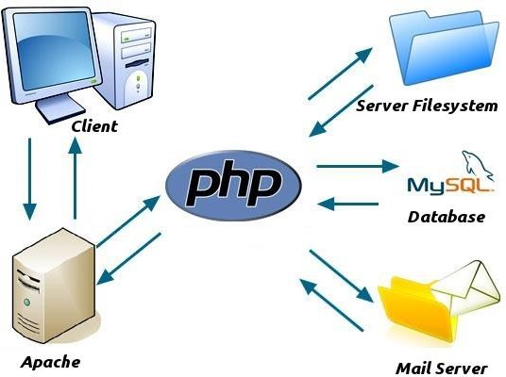

**Fig 4.1.1**

#### JAVA SCRIPT

**JavaScript**, often abbreviated as "JS", is a [high-level](https://en.wikipedia.org/wiki/High-level_programming_language), [dynamic,](https://en.wikipedia.org/wiki/Dynamic_programming_language) [untyped](https://en.wikipedia.org/wiki/Untyped_language), and [interpreted](https://en.wikipedia.org/wiki/Interpreted_language) run-time [language](https://en.wikipedia.org/wiki/Programming_language). It has been standardized in the [ECMAScript](https://en.wikipedia.org/wiki/ECMAScript) language specification. Alongside [HTML](https://en.wikipedia.org/wiki/HTML) and [CSS,](https://en.wikipedia.org/wiki/CSS) JavaScript is one of the three core technologies of [World Wide Web](https://en.wikipedia.org/wiki/World_Wide_Web) [content production](https://en.wikipedia.org/wiki/Content_engineering); the majority of [websites](https://en.wikipedia.org/wiki/Website) employ it, and all modern [Web](https://en.wikipedia.org/wiki/Web_browser) [browsers](https://en.wikipedia.org/wiki/Web_browser) support it without the need for [plug-ins](https://en.wikipedia.org/wiki/Browser_extension). JavaScript is [prototype-based](https://en.wikipedia.org/wiki/Prototype-based_programming) with [first-class](https://en.wikipedia.org/wiki/First-class_function) [functions](https://en.wikipedia.org/wiki/First-class_function), making it a [multi-paradigm](https://en.wikipedia.org/wiki/Multi-paradigm) language, supporting [object-oriented](https://en.wikipedia.org/wiki/Object-oriented_programming), [imperative](https://en.wikipedia.org/wiki/Imperative_programming), and [functional](https://en.wikipedia.org/wiki/Functional_programming) [programming styles](https://en.wikipedia.org/wiki/Programming_paradigm). It has an [API](https://en.wikipedia.org/wiki/Application_programming_interface) for working with text, [arrays](https://en.wikipedia.org/wiki/Array_data_type), dates and [regular](https://en.wikipedia.org/wiki/Regular_expression) [expressions](https://en.wikipedia.org/wiki/Regular_expression), but does not include any [I/O](https://en.wikipedia.org/wiki/Input/output), such as networking, storage, or graphics facilities, relying for these upon the host environment in which it is embedded.

Although there are strong outward similarities between JavaScript and Java, including language name, [syntax](https://en.wikipedia.org/wiki/Syntax_%28programming_languages%29), and respective [standard libraries](https://en.wikipedia.org/wiki/Standard_library), the two are distinct languages and

differ greatly in their design. JavaScript was influenced by programming languages such as [self](https://en.wikipedia.org/wiki/Self_%28programming_language%29) and [Scheme.](https://en.wikipedia.org/wiki/Scheme_%28programming_language%29)

JavaScript is also used in environments that are not Web-based, such as [PDF](https://en.wikipedia.org/wiki/Portable_Document_Format) documents, [site-specific browsers](https://en.wikipedia.org/wiki/Site-specific_browser), and [desktop widgets](https://en.wikipedia.org/wiki/Desktop_widget). Newer and faster JavaScript [virtual](https://en.wikipedia.org/wiki/Virtual_machine) [machines](https://en.wikipedia.org/wiki/Virtual_machine) (VMs) and platforms built upon them have also increased the popularity of JavaScript for [server-side](https://en.wikipedia.org/wiki/Server-side) [Web applications](https://en.wikipedia.org/wiki/Web_application). On the [client side](https://en.wikipedia.org/wiki/Client_side), developers have traditionally implemented JavaScript as an [interpreted](https://en.wikipedia.org/wiki/Interpreter_%28computing%29) language, but more recent browsers perform [just-in-time](https://en.wikipedia.org/wiki/Just-in-time_compilation) [compilation](https://en.wikipedia.org/wiki/Just-in-time_compilation). Programmers also use JavaScript in [video-game development](https://en.wikipedia.org/wiki/Video_game_development), in crafting desktop and mobile applications, and in server-side [network programming](https://en.wikipedia.org/wiki/Computer_network_programming) with [run-time environments](https://en.wikipedia.org/wiki/Runtime_system) such as [Node.js](https://en.wikipedia.org/wiki/Node.js).

#### JQUERY

**JQuery** is a [cross-platform](https://en.wikipedia.org/wiki/Cross-platform) [JavaScript library](https://en.wikipedia.org/wiki/JavaScript_library) designed to simplify the [client-side](https://en.wikipedia.org/wiki/Client-side_scripting) [scripting](https://en.wikipedia.org/wiki/Client-side_scripting) of [HTML.](https://en.wikipedia.org/wiki/HTML) It is [free, open-source software](https://en.wikipedia.org/wiki/Free_and_open_source_software) using the permissive [MIT license](https://en.wikipedia.org/wiki/MIT_license). [Web](https://en.wikipedia.org/wiki/World_Wide_Web) analysis indicates that it is the most widely deployed JavaScript library by a large margin.

jQuery's syntax is designed to make it easier to navigate a document, select [DOM](https://en.wikipedia.org/wiki/Document_Object_Model) elements, create [animations](https://en.wikipedia.org/wiki/Animation), handle [events](https://en.wikipedia.org/wiki/Event_%28computing%29), and develop [Ajax](https://en.wikipedia.org/wiki/Ajax_%28programming%29) applications. jQuery also provides capabilities for developers to create [plug-ins](https://en.wikipedia.org/wiki/Plug-in_%28computing%29) on top of the JavaScript library. This enables developers to create [abstractions](https://en.wikipedia.org/wiki/Abstraction_%28computer_science%29) for low-level interaction and animation, advanced effects and high-level, themeable widgets. The modular approach to the jQuery library allows the creation of powerful [dynamic web pages](https://en.wikipedia.org/wiki/Dynamic_web_page) and Web applications.

The set of [jQuery core features](https://en.wikipedia.org/wiki/JQuery#Features)—DOM element selections, traversal and manipulation—enabled by its selector engine (named "Sizzle" from v1.3), created a new "programming style", fusing algorithms and DOM data structures. This style influenced the architecture of other [JavaScript frameworks](https://en.wikipedia.org/wiki/Comparison_of_JavaScript_frameworks) like [YUI v3](https://en.wikipedia.org/wiki/YUI_Library) and [Dojo](https://en.wikipedia.org/wiki/Dojo_Toolkit), later stimulating the creation of the standard Selectors API.

[Microsoft](https://en.wikipedia.org/wiki/Microsoft) and [Nokia](https://en.wikipedia.org/wiki/Nokia) bundle jQuery on their platforms. Microsoft includes it with [Visual Studio](https://en.wikipedia.org/wiki/Microsoft_Visual_Studio) for use within Microsoft's [ASP.NET AJAX](https://en.wikipedia.org/wiki/ASP.NET_AJAX) and [ASP.NET MVC](https://en.wikipedia.org/wiki/ASP.NET_MVC) frameworks while Nokia has integrated it into the Web Run-Time widget development platform.

#### AJAX

**Ajax** (also **AJAX** short for "asynchronous [JavaScript](https://en.wikipedia.org/wiki/JavaScript) and [XML](https://en.wikipedia.org/wiki/XML)") is a set of [Web](https://en.wikipedia.org/wiki/Web_development) [development](https://en.wikipedia.org/wiki/Web_development) techniques using many Web technologies on the [client side](https://en.wikipedia.org/wiki/Client_side) to create [asynchronous](https://en.wikipedia.org/wiki/Asynchronous_I/O) [Web applications](https://en.wikipedia.org/wiki/Web_application). With Ajax, Web applications can send data to and retrieve from a [server](https://en.wikipedia.org/wiki/Web_server) asynchronously (in the background) without interfering with the display and behavior of the existing page. By decoupling the data interchange layer from the presentation layer, Ajax allows for Web pages, and by extension Web applications, to change content

dynamically without the need to reload the entire page. In practice, modern implementations commonly substitute [JSON](https://en.wikipedia.org/wiki/JSON) for XML due to the advantages of being native to JavaScript.

Ajax is not a single technology, but rather a group of technologies. [HTML](https://en.wikipedia.org/wiki/Hypertext_Markup_Language) and [CSS](https://en.wikipedia.org/wiki/Cascading_Style_Sheets) can be used in combination to mark up and style information. The [DOM](https://en.wikipedia.org/wiki/Document_Object_Model) is accessed with JavaScript to dynamically display – and allow the user to interact with – the information presented. JavaScript and the [XMLHttpRequest](https://en.wikipedia.org/wiki/XMLHttpRequest) object provide a method for exchanging data asynchronously between browser and server to avoid full page reloads.

#### JSON

In [computing](https://en.wikipedia.org/wiki/Computing), **JavaScript Object Notation** or **JSON** (/ˈdʒeɪsən/***JAY****-sən*), is an [open-](https://en.wikipedia.org/wiki/Open_standard) [standard](https://en.wikipedia.org/wiki/Open_standard)[file format](https://en.wikipedia.org/wiki/File_format) that uses [human-readable](https://en.wikipedia.org/wiki/Human-readable_medium) text to transmit data objects consisting of [attribute–value pairs](https://en.wikipedia.org/wiki/Attribute%E2%80%93value_pair) and [array data types](https://en.wikipedia.org/wiki/Array_data_type) (or any other [serializable](https://en.wikipedia.org/wiki/Serialization) value). It is a very common data format used for [asynchronous](https://en.wikipedia.org/wiki/Asynchronous_I/O) browser/server communication, including as a replacement for [XML](https://en.wikipedia.org/wiki/XML) in some [AJAX](https://en.wikipedia.org/wiki/Ajax_%28programming%29)-style systems.

JSON is a [language-independent](https://en.wikipedia.org/wiki/Language-independent_specification) data format. It was derived from [JavaScript](https://en.wikipedia.org/wiki/JavaScript), but as of 2017 many [programming languages](https://en.wikipedia.org/wiki/Programming_language) include code to generate and [parse](https://en.wikipedia.org/wiki/Parsing) JSON-format data. The official Internet [media type](https://en.wikipedia.org/wiki/Media_type) for JSON is application/json. JSON filenames use the extension

.json.

[Douglas Crockford](https://en.wikipedia.org/wiki/Douglas_Crockford) originally specified the JSON format in the early 2000s; two competing standards, [RFC 7159](https://tools.ietf.org/html/rfc7159) and [ECMA-404](https://www.ecma-international.org/publications/standards/Ecma-404.htm), defined it in 2013. The ECMA standard describes only the allowed syntax, whereas the RFC covers some security and interoperability considerations.[[3]](https://en.wikipedia.org/wiki/JSON#cite_note-3)

A restricted profile of JSON, known as **I-JSON** (short for "Internet JSON"), seeks to overcome some of the interoperability problems with JSON. It is defined in [RFC 7493](https://tools.ietf.org/html/rfc7493).

#### XAMPP



**Xampp** is a [free and open source](https://en.wikipedia.org/wiki/Free_software) [cross platform](https://en.wikipedia.org/wiki/Cross-platform) [web server](https://en.wikipedia.org/wiki/Web_server) [solution stack](https://en.wikipedia.org/wiki/Solution_stack) package developed by Apache Friends, consisting mainly of the [Apache HTTP Server](https://en.wikipedia.org/wiki/Apache_HTTP_Server), [MariaDB](https://en.wikipedia.org/wiki/MariaDB) [database](https://en.wikipedia.org/wiki/Database), and [interpreters](https://en.wikipedia.org/wiki/Interpreter_%28computing%29) for scripts written in the [PHP](https://en.wikipedia.org/wiki/PHP) and [Perl](https://en.wikipedia.org/wiki/Perl) [programming languages](https://en.wikipedia.org/wiki/Programming_language). XAMPP stands for Cross-Platform (X), Apache (A), MariaDB (M), PHP (P) and Perl (P). It is a

simple, lightweight Apache distribution that makes it extremely easy for developers to create a local web server for testing and deployment purposes. Everything needed to set up a web server – server application (Apache), database (MariaDB), and scripting language (PHP) – is included in an extractable file. XAMPP is also cross-platform, which means it works equally well on Linux, Mac and Windows. Since most actual web server deployments use the same components as XAMPP, it makes transitioning from a local test server to a live server extremely easy as well.

#### FEATURES

XAMPP is regularly updated to the latest releases of [Apache](https://en.wikipedia.org/wiki/Apache_HTTP_Server), [MariaDB](https://en.wikipedia.org/wiki/MariaDB), [PHP](https://en.wikipedia.org/wiki/PHP) and [Perl](https://en.wikipedia.org/wiki/Perl). It also comes with a number of other modules including [OpenSSL](https://en.wikipedia.org/wiki/OpenSSL), [phpMyAdmin](https://en.wikipedia.org/wiki/PhpMyAdmin), [MediaWiki](https://en.wikipedia.org/wiki/MediaWiki), [Joomla](https://en.wikipedia.org/wiki/Joomla), [WordPress](https://en.wikipedia.org/wiki/WordPress) and more. Self-contained, multiple instances of XAMPP can exist on a single computer, and any given instance can be copied from one computer to another. XAMPP is offered in both a full and a standard version (Smaller version).

#### USAGE

Officially, XAMPP's designers intended it for use only as a development tool, to allow website designers and programmers to test their work on their own computers without any access to the Internet. To make this as easy as possible, many important security features are disabled by default. XAMPP has the ability to serve web pages on the [World Wide Web.](https://en.wikipedia.org/wiki/World_Wide_Web) A special tool is provided to [password-protect](https://en.wikipedia.org/wiki/Password) the most important parts of the package.

XAMPP also provides support for creating and manipulating databases in [MariaDB](https://en.wikipedia.org/wiki/MariaDB) and [SQLite](https://en.wikipedia.org/wiki/SQLite) among others. Once XAMPP is installed, it is possible to treat a [localhost](https://en.wikipedia.org/wiki/Localhost) like a remote host by connecting using an [FTP](https://en.wikipedia.org/wiki/File_Transfer_Protocol) client. Using a program like [FileZilla](https://en.wikipedia.org/wiki/FileZilla) has many advantages when installing a [content management system](https://en.wikipedia.org/wiki/Content_management_system) (CMS) like [Joomla](https://en.wikipedia.org/wiki/Joomla) or [WordPress](https://en.wikipedia.org/wiki/WordPress). It is also possible to connect to localhost via FTP with an [HTML editor](https://en.wikipedia.org/wiki/HTML_editor).

CHAPTER-5

SOFTWARE REQUIREMENT SPECIFICATION

5.1 Hardware Requirements

The selection of hardware is very important in the existence and proper working of any software. When selecting hardware, the size and requirements are also important.

|  |  |
| --- | --- |
| Processor | Intel CORE i5 |
| RAM | **4.0 GB** |
| Hard Disk Drive | **500 GB** |

## 7.2 Software Requirements

|  |  |
| --- | --- |
| **Number** | **Description** |
| 1 | Windows 7,8,10 |
| 2 | HTML/Css/Ajax/JavaScript/ Bootstrap. |
| 3 | Apache server/ XAMPSERVER |
| 4 | PHP 5.5.38 |
| 4 | MySQL |
| 5 | Compiler: MSVC11 (Visual C++ 2012) |
| 6 | Apache version: Apache/2.4.23 (Win32) OpenSSL/1.0.2h PHP/5.5.38 |

#### CHAPTER-6 DATA FLOW DIAGRAM

Data Flow Diagrams show the flow of data from external entities into the system, and from one process to another within the system. There are four symbols for drawing a DFD:

1. Rectangles representing external entities, which are sources or destinations of data.
2. Ellipses representing processes, which take data as input, validate and process it and output it.
3. Arrows representing the data flows, which can either, be electronic data or physical items.
4. Open-ended rectangles or a Disk symbol representing data stores, including electronic stores such as databases or XML files and physical stores such as filing cabinets or stacks of paper.

Figures below are the Data Flow Diagrams for the current system. Each process within the system is first shown as a Context Level DFD and later as a Detailed DFD. The Context Level DFD provides a conceptual view of the process and its surrounding input, output and data stores. The Detailed DFD provides a more detailed and comprehensive view of the interaction among the sub-processes within the system.

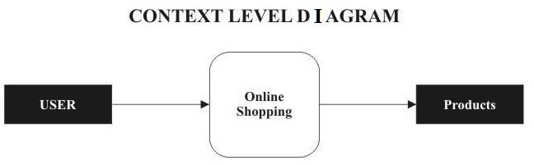

Fig 6.1

#### DFD-1

Fig 6.1.1

#### DFD-2

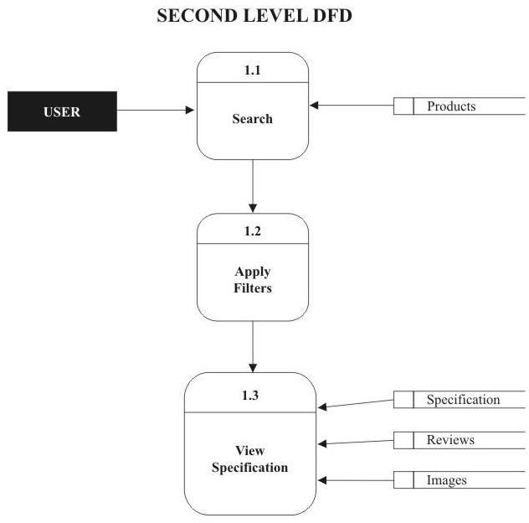

Fig 6.2.1

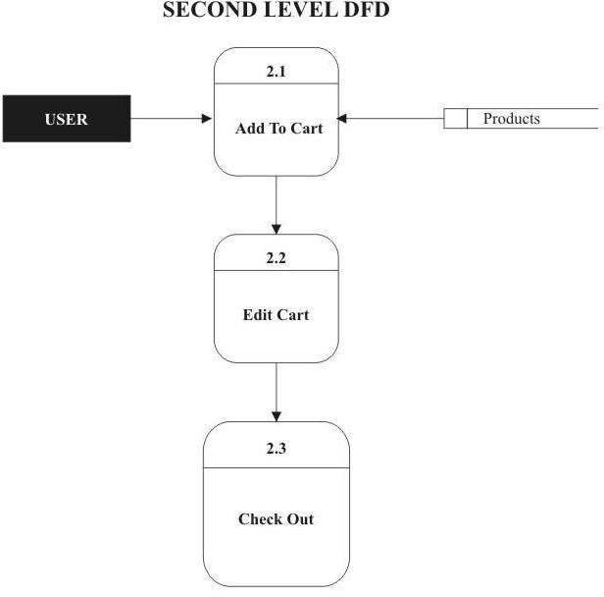

Fig 6.2.2

#### DFD-3

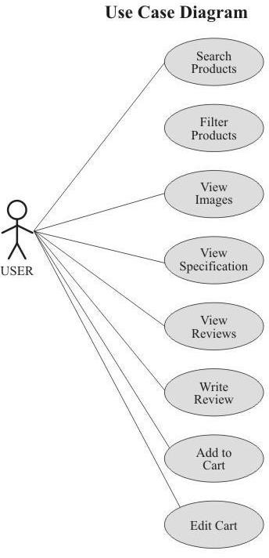

Fig 6.3.1

CHAPTER-7

PROJECT

* 1. **PROJECT (Advanced Technologies):**

**Name:** Bookz Kart

###### Technologies Used:

* + - HTML
    - CSS
    - Bootstrap
    - Core PHP
    - Java Script
    - Jquery
    - AJAX

**Server:** Apache (XAMPP)

**Database:** MySql

**Operating System:** Windows7/8/8.1/10

**Wire framing tool:** Balasmiq

**Team Size:** 3

* 1. TECHNICAL DETAILS:
     + Front end is designed using HTML, CSS and Bootstrap. Ajax used to perform behind the screen requests and JavaScript used to perform client side scripting
     + Backend is based on PHP + MySql based RDB(Relational Data Base) model.
     + The SQL queries are run using the CI SQL library functions
     + Backend online host includes a centralized database resident on the server, the script which is built in PHP used to SQL query the database on user’s request for transaction of data
     + The forms are made using the HTML, Bootstrap for designing and Php, sql for back-end
     + JavaScript, AJAX and JQuery used for client side scripting and PHP for the server side development

CHAPTER-8

SCREENSHOTS



**Fig 8.1.1**



**Fig 8.1.2**

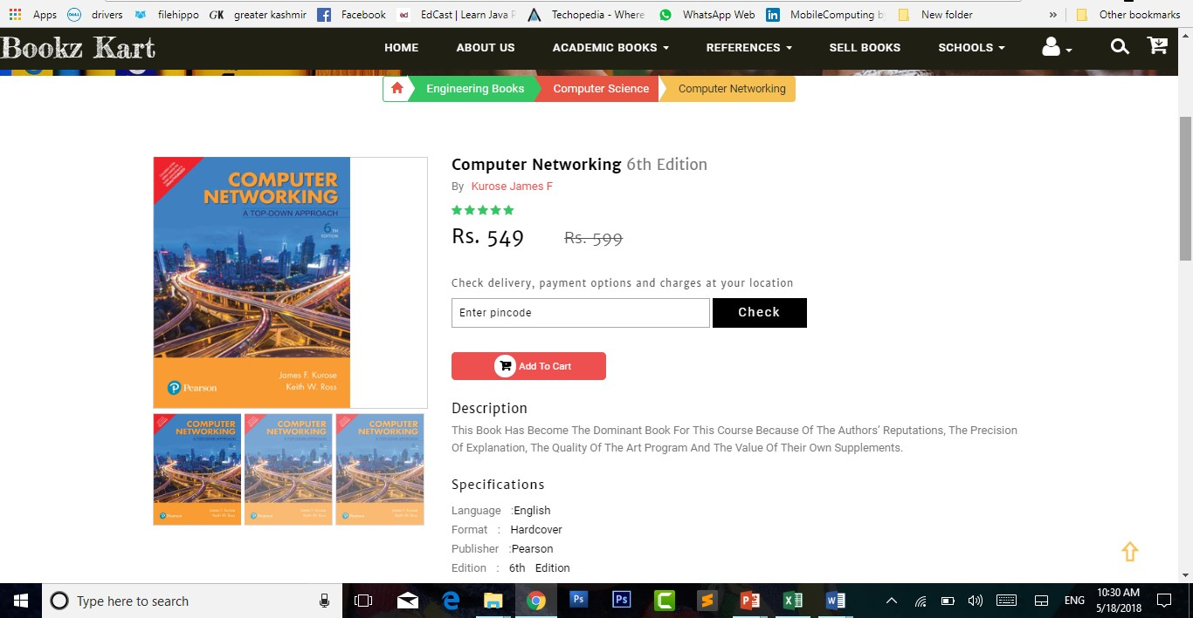

**Fig 8.1.3**

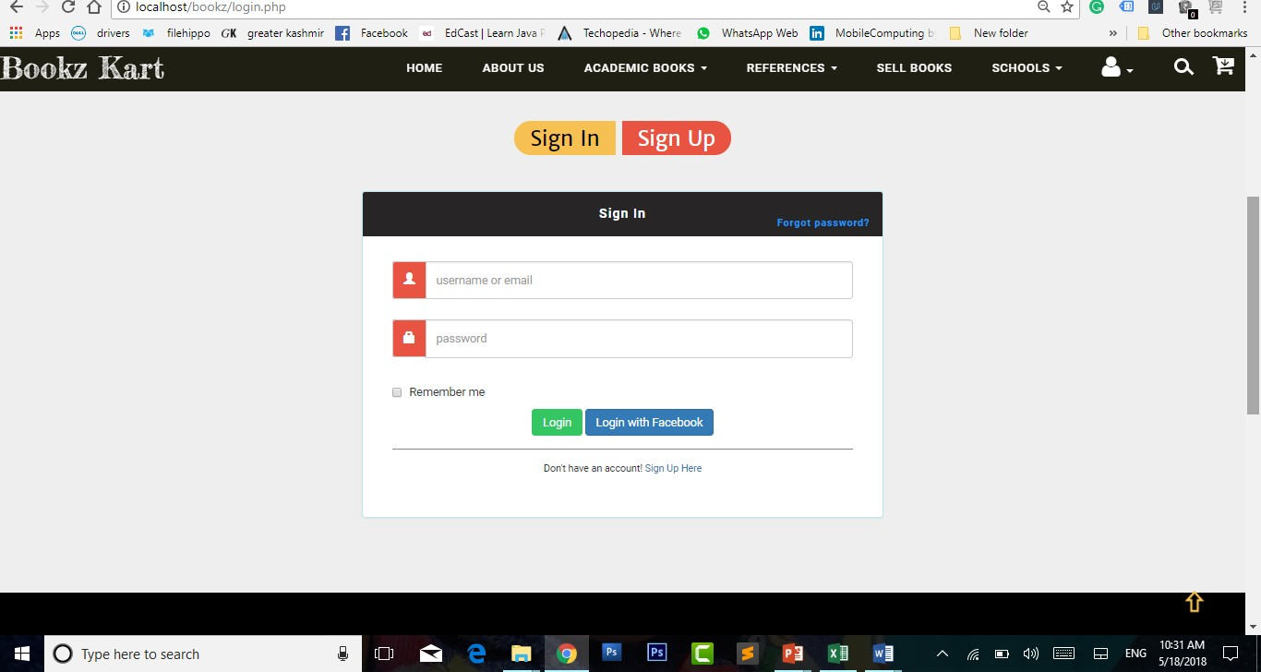

**Fig 8.1.4**

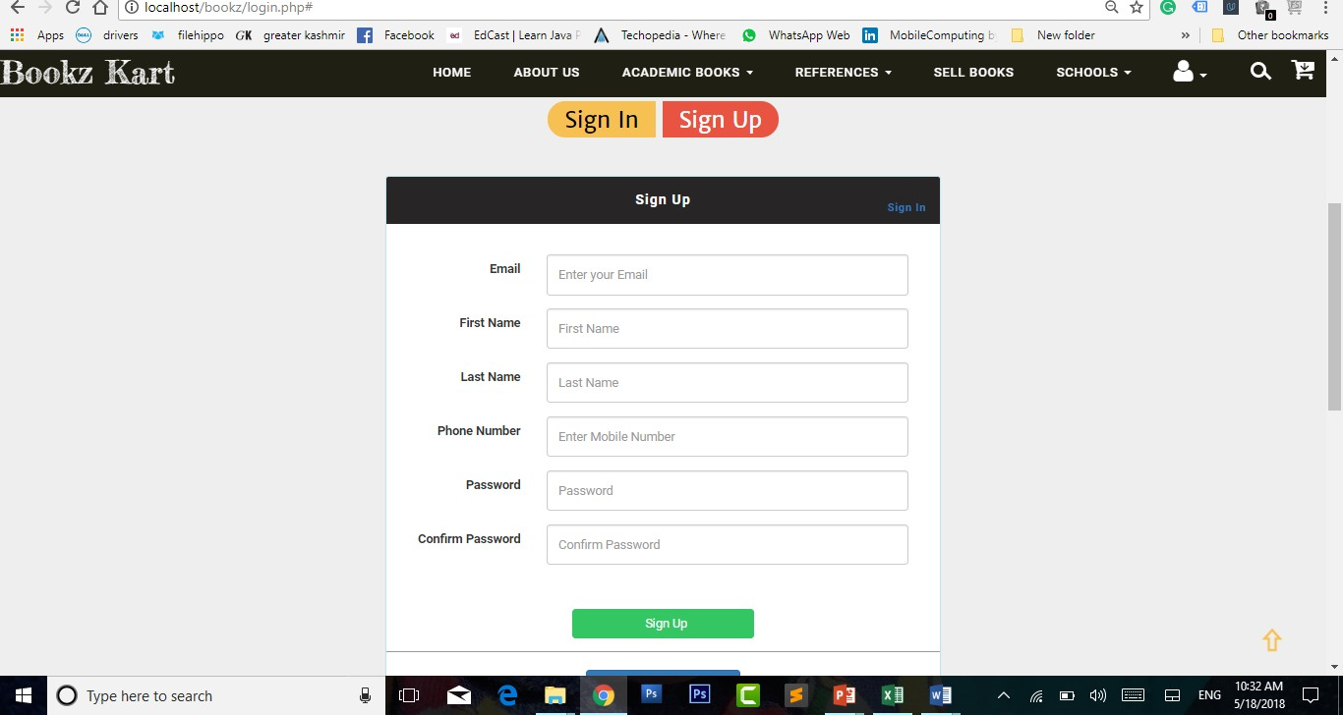

**Fig 8.1.5**

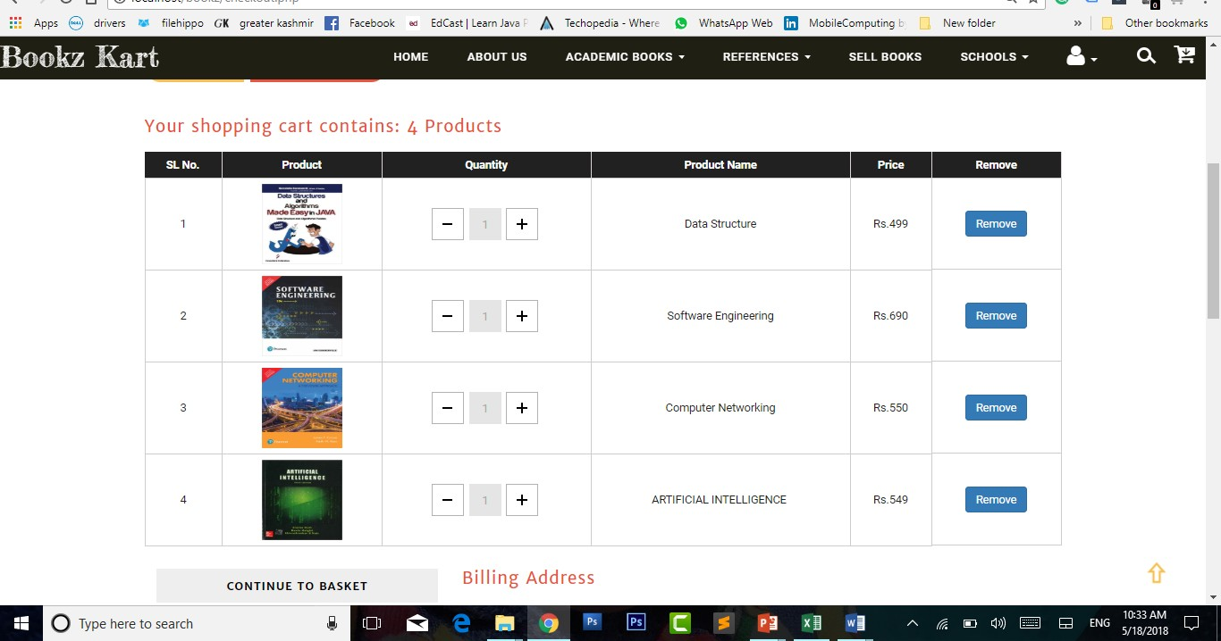

**Fig 8.1.6**

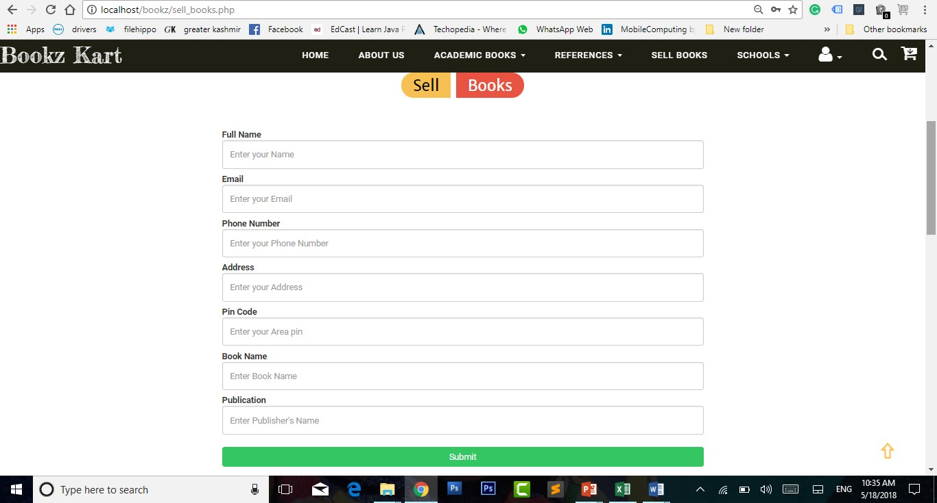

**Fig 8.1.7**

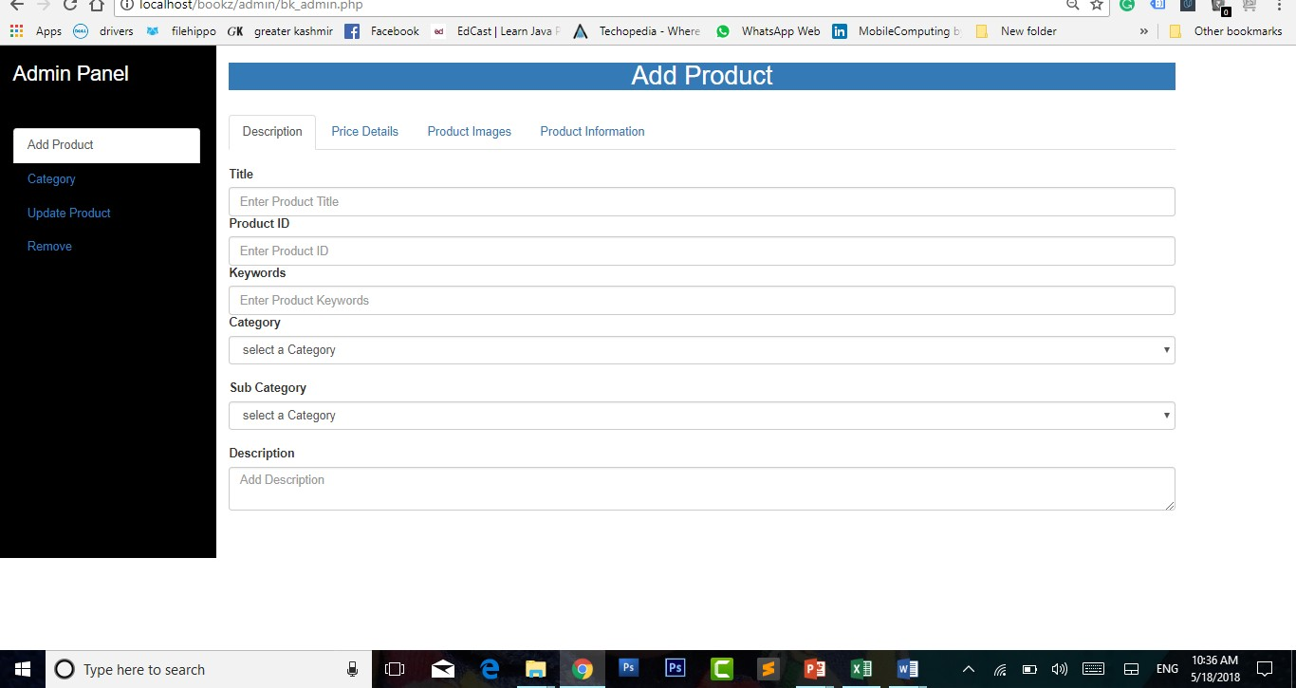

**Fig 8.1.8**

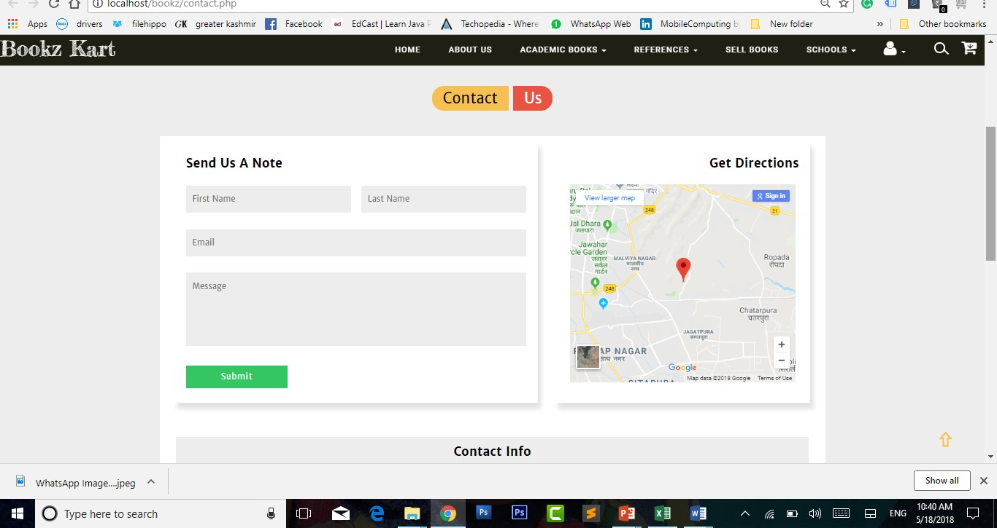

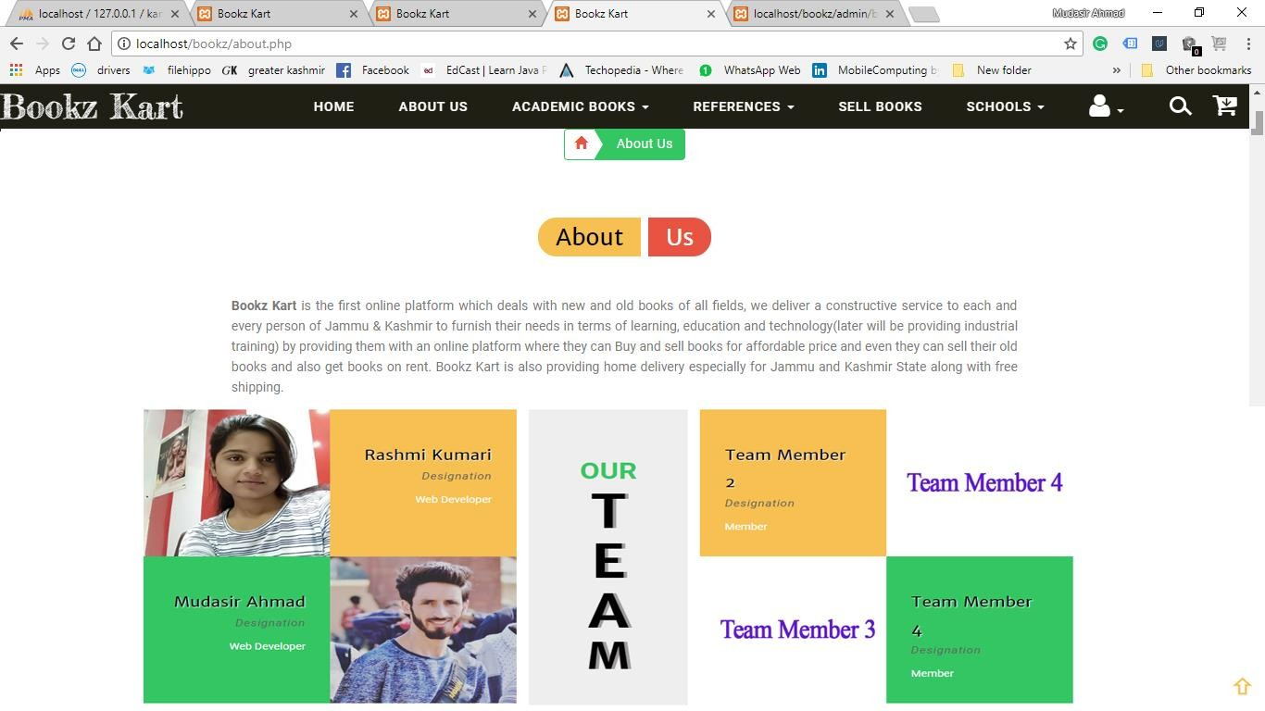

**Fig 8.1.9**

CHAPTER-9

#### MAINTENANCE

The maintenance phase involves making changes to hardware, software, and documentation to support its operational effectiveness. It includes making changes to improve a system’s performance, correct problems, enhance security, or address user requirements. To ensure modifications do not disrupt operations or degrade a system’s performance or security, organizations should establish appropriate change management standards and procedures.

Routine changes are not as complex as major modifications and can usually be implemented in the normal course of business. Routine change controls should include procedures for requesting, evaluating, approving, testing, installing, and documenting website modifications. Maintaining accurate, up-to-date hardware and software inventories is a critical part of all change management processes. Management should carefully document all modifications to ensure accurate system inventories. Management should coordinate all technology related changes through an oversight committee and assign an appropriate party responsibility for administering software patch management programs. Quality assurance, security, audit, regulatory compliance, network, and end-user personnel should be appropriately included in change management processes. Risk and security review should be done whenever a system modification is implemented to ensure controls remain in place.

For maintenance of the website:

1. The database has to be updated regularly according to new available information.
2. Redundant and false information must be removed from the database.
3. Newer version of PHP and MYSQL can be used for up gradation of website and to improve the overall performance of the system.

CHAPTER-10

#### FUTURE SCOPE & FUTURE ENHANCEMENT

**PROJECT NAME:**

### Bookz Kart

1. Bookz Kart would help each and every person to find any book via our website and get it at home it will save their time.
2. It would provide huge collection of books of all fields.
3. Students will also get audio/video series of courses, i.e. they can learn online/offline.
4. We will be providing some special courses both online and offline.

CHAPTER-11

#### CONCLUSION

We have successfully implemented the site ‘Bookz Kart’. With the help of various links and tools, we have been able to provide a site which will be live soon and running on the web. We have been successful in our attempt to take care of the needs of both the user as well as the administrator. Finally we hope that this will go a long way in popularizing.

### BIBLIOGRAPHY

1. [www.javatutpoint.com](http://www.javatutpoint.com/)
2. [www.w3schools.com](http://www.w3schools.com/)
3. [www.getbootstrap.com](http://www.getbootstrap.com/)
4. [www.codeigniter.com](http://www.codeigniter.com/)
5. [www.stackoverflow.com](http://www.stackoverflow.com/)
6. [www.fontawesome.io](http://www.fontawesome.io/)
7. [www.php.net](http://www.php.net/)
8. Head first with PHP(Lynn Beighley and Michael Morrison)
9. Learn HTML and CSS faster(Mark Myers)
10. Wikipedia