CreatorLedger
Freelance Invoice & Payment Tracker
Project Report | Prepared by Rahul Singh
Technology: Python • Flask • SQLite • HTML • CSS • JavaScript
Academic submission details can be completed here: College/Institute: ____________________ Department: ____________________ Guide: ____________________

1. Abstract
CreatorLedger is a browser-based local demo designed to help freelancers and independent creators organize client details, create invoices, estimate GST and TDS amounts, record payment status, and review summary reports. It is implemented using Python and Flask for application routing, SQLite for local persistence, and HTML/CSS/JavaScript for the interface. The purpose is to demonstrate a simple workflow from client setup to invoice preparation and payment recording.

2. Problem Statement
Independent workers may keep client information, invoice details, tax estimates, and payment status in separate files. This makes it harder to quickly see what has been billed, what is outstanding, and which invoices are overdue. CreatorLedger demonstrates a centralized local workspace for these tasks.

3. Objectives
- Maintain client contact and billing details.
- Create invoices with issue date, due date, service title, subtotal, GST rate, and TDS rate.
- Calculate estimated GST, TDS, invoice total, and net receivable.
- Record demo payment status and payment method/reference.
- Show dashboard summaries, invoice filters, payment history, and monthly reports.
- Provide a readable, responsive interface and a repeatable local setup process.

4. Scope and Important Limitations
This version is a student/demo project. It does not implement registration/login or multi-user data separation. Data is stored in one local SQLite database. The reminder action does not send email or SMS. The UPI link uses a placeholder UPI ID and does not verify a payment. The current project has no dedicated income/expense ledger module and does not claim a PDF export feature; the invoice detail page is designed for browser printing. Do not use this build as a production accounting system or expose it publicly without further development and a security review.

5. Technology Stack
- Python: application logic and calculations.
- Flask: URL routing, request handling, template rendering, and flash messages.
- SQLite: local relational data storage.
- HTML/Jinja: dynamic pages and forms.
- CSS: layout, typography, colors, responsive styling, and print presentation.
- JavaScript: client-side interface enhancements.
- unittest: automated smoke tests for core routes and invoice workflows.

6. Main Features

6.1 Dashboard
Displays invoice count, billed amount, received amount, outstanding amount, TDS summary, recent invoices, and overdue invoice count.

6.2 Client Management
Allows the operator to create and edit client details including name, email, phone, business, GSTIN, and address.

6.3 Invoice Management
Creates invoice records linked to a client. Input validation checks required title, numeric amount, tax rates, date format/order, and client selection. Invoices can be filtered by Paid, Pending, and Overdue status.

6.4 Tax Estimate
The demo calculates GST as subtotal × GST rate, TDS as subtotal × TDS rate, invoice total as subtotal + GST, and net receivable as invoice total − TDS. These are estimates for demonstration and should not be treated as professional tax advice.

6.5 Payments and Reports
The operator can mark an invoice as paid in demo mode, which records a payment entry. Reports summarize invoice values by issue month. No external payment gateway is connected.

7. Application Workflow
- Open the home page and enter the dashboard.
- Create or edit a client record.
- Create an invoice for that client with dates, amount, and tax assumptions.
- Review the invoice detail page and print from the browser if needed.
- Record a demo payment to change the invoice status to Paid.
- Review payment history and monthly reports.

8. Architecture
Browser (HTML/CSS/JavaScript) ⇄ Flask routes and Jinja templates ⇄ SQLite database. Static assets are served from the static directory. The database path can be configured using CREATORLEDGER_DB_PATH. The application initializes its tables at startup and seeds sample demo data when the clients table is empty.

9. Database Design

Clients table
Stores client name, email, phone, business name, GSTIN, address, and created date. Each client may be linked to multiple invoices.

Invoices table
Stores unique invoice number, client foreign key, title, issue/due dates, subtotal, GST/TDS rates and amounts, total, net receivable, notes, status, and creation date.

Payments table
Stores invoice foreign key, amount, method, payment date, and reference. Foreign-key enforcement is enabled for SQLite connections.

10. Project Structure
app.py — Flask routes and database logic
requirements.txt — Python dependencies
templates/ — Jinja HTML templates
static/css/style.css — visual styling
static/js/app.js — interface behavior
tests/test_app.py — smoke tests
docs/screenshots/ — captured screenshots for this report
README.md — setup and GitHub instructions
.gitignore — excludes local database, virtual environments, secrets, and caches

11. Screenshots
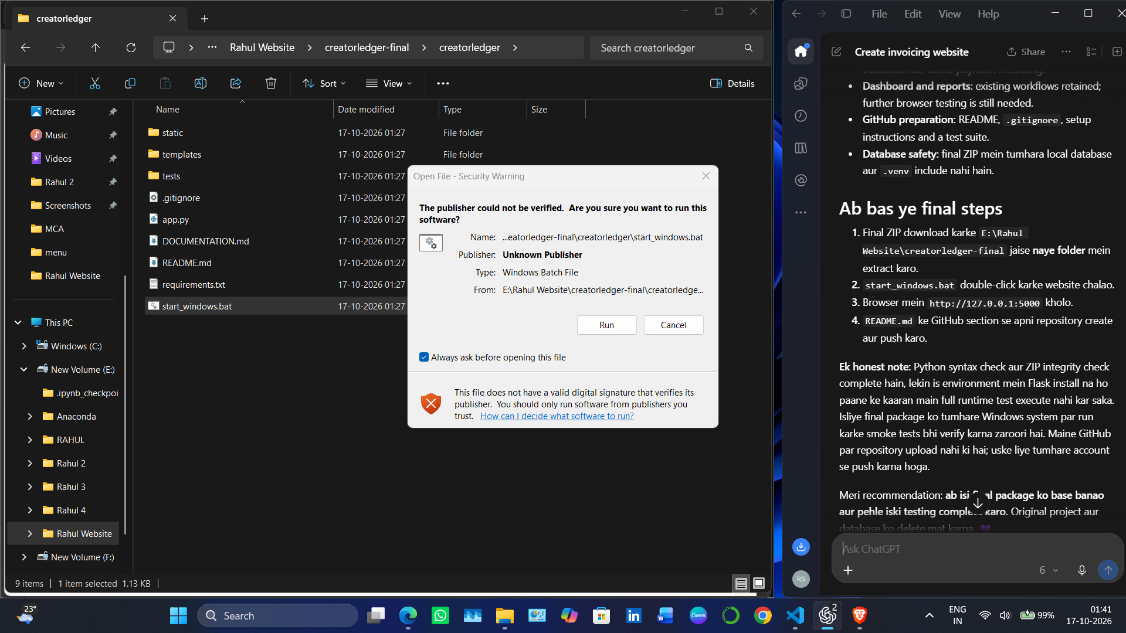
Figure 1. CreatorLedger local homepage screenshot (user-provided capture).
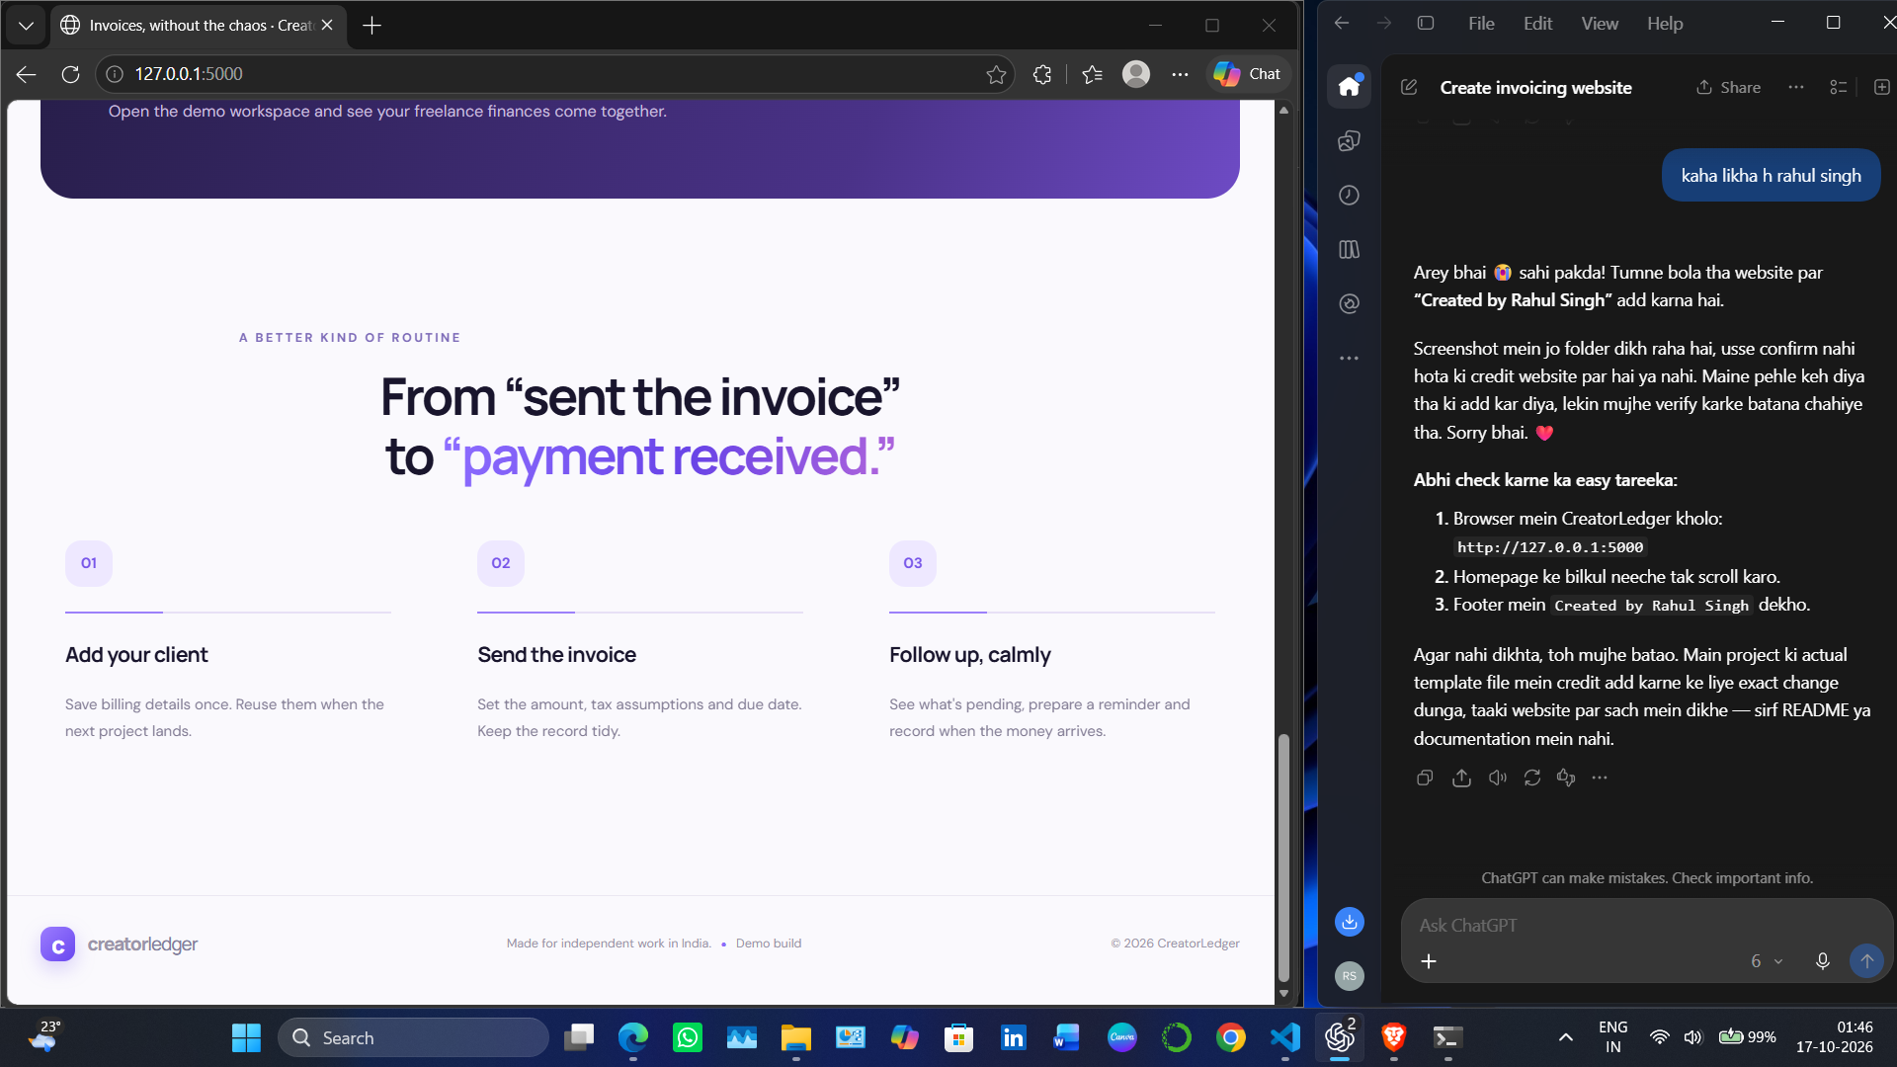
Figure 2. Homepage workflow section and footer in the local demo (user-provided capture).
Additional evidence to capture after testing: Dashboard, Clients list/form, Invoice form, Invoice detail/print view, Payments, Reports, and validation error messages. Do not use mock images as proof of implemented features.

12. Testing Plan and Status
The repository includes automated smoke tests for main page responses, invoice creation and calculation, payment recording, and rejection of a due date earlier than the issue date. Run the test command in README after installing dependencies. Test execution was not verified in the packaging environment because Flask was not installed there; therefore this report does not claim the tests passed in this environment.
☐ Open all pages: /, /dashboard, /clients, /invoices, /payments, /reports, /settings.
☐ Create a client and confirm it appears in the list.
☐ Create a valid invoice and verify GST/TDS/net calculations.
☐ Try invalid amounts and due date earlier than issue date.
☐ Mark a pending invoice as paid and confirm payment history.
☐ Restart the app and confirm data remains in the same local database.

13. Security and Reliability Review
- Parameterized SQL statements are used for user-supplied values in the inspected application routes.
- Local SQLite database is excluded from Git by .gitignore.
- A random local secret fallback is used; configure FLASK_SECRET_KEY for stable sessions if sessions are introduced.
- Authentication, authorization, per-user ownership, CSRF protection, rate limiting, production deployment hardening, and real payment verification are not implemented.
- Before any public deployment, implement and test those controls and conduct a security review.

14. Installation and Execution
Requirements: Windows/macOS/Linux, Python 3.10 or newer recommended, and internet access for initial package installation. On Windows PowerShell:
- py -m venv .venv
- .\.venv\Scripts\python.exe -m pip install -r requirements.txt
- .\.venv\Scripts\python.exe app.py
- Open http://127.0.0.1:5000
- Tests: .\.venv\Scripts\python.exe -m unittest discover -s tests -v

15. GitHub Submission Process
- Create a repository named CreatorLedger on GitHub.
- Extract the final ZIP and open PowerShell in the project folder.
- Review git status and ensure creatorledger.db, .venv, and secret files are not staged.
- Run git init; git add .; git commit -m "Initial CreatorLedger project"; git branch -M main.
- Add your actual repository URL using git remote add origin https://github.com/YOUR-USERNAME/CreatorLedger.git.
- Run git push -u origin main. Replace YOUR-USERNAME with your GitHub username.

16. Future Enhancements
- Secure login and user-specific data isolation.
- Expense tracking and richer cash-flow analytics.
- PDF invoice generation and downloadable reports.
- Real email reminders via a configured provider.
- Payment gateway integration with verified webhooks.
- Improved decimal-safe financial calculations and broader tests.
- Deployment configuration, backups, monitoring, and accessibility review.

17. Conclusion
CreatorLedger demonstrates a practical Flask-based workflow for client records, invoice creation, tax estimates, payment status tracking, and reports. The project provides a foundation for further development, while its current demo-only limitations are documented so the implementation is presented accurately. The next step is to run the app and test suite locally, capture the remaining real screenshots, and upload the reviewed source to GitHub.

Appendix A — README
See README.md in the project root for setup, configuration, tests, known limitations, and GitHub commands.

