Blockchain-Based Event Detection and Trust Verification Using Natural Language Processing & Machine Learning
Online social media’s are heavily utilizing to post small messages and this messages often contains information of different events like natural disaster. Automatic classification of posts messages will help emergency relief team in knowing number of detected disaster and based on detection team will manage their work. Propose work will apply Natural Language processing Text API to analyse text and then convert text into training features. Training features will be input to different machine learning to evaluate their performance for classification. In propose work author has evaluated 8 different algorithms such as Naïve Bayes, KNN, SVM, Decision Tree, Random Forest, XGBOOST, Logistic Regression and Deep Learning. Among all algorithms Deep Learning is giving best accuracy. Each algorithm is evaluated in terms of accuracy, precision, recall and FCSORE.
All social media are dependent on Centralized single server to store users post and if this server crash or hack then services will get disturbed. To overcome from this issue author of this paper employing Blockchain based Decentralized server which will store data in multiple nodes and if one node down then user can access services from other working nodes.
All users POST stored in Blockchain will be tamper proof as Blockchain has inbuilt support of data encryption and leakage. Blockchain store each record as Block/transaction and associate each block with unique hash code. While storing news record Blockchain will verify all previous hash codes and if data not alter then hash code verification will be successful, if data alter then verification get failed and data alter will get detected and due to this reason Blockchain is known as tamper proof.
Blockchain store and get data by smart contract and this contract contains functions to save and get data. To store user posts we have designed following contract.
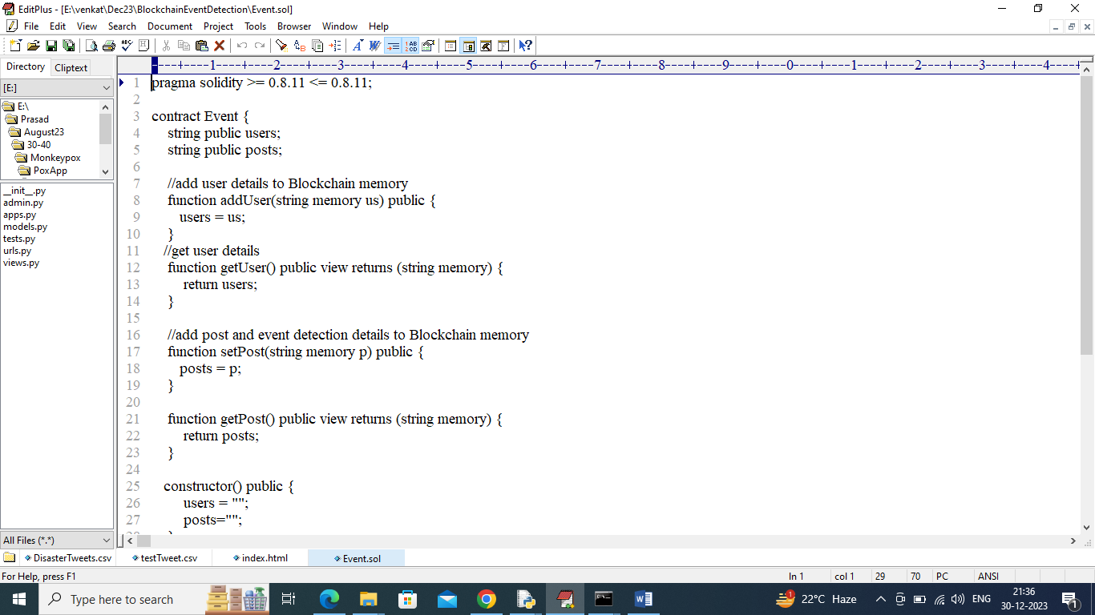
In above contract we have defined functions to save user and post details and now we need to deploy above contract to Blockchain Ethereum by following below steps
- First go inside ‘hello-eth/node-modules/bin’ folder and then find and double click on ‘runBlockchain.bat’ file to start Blockchain server and get below screen
- 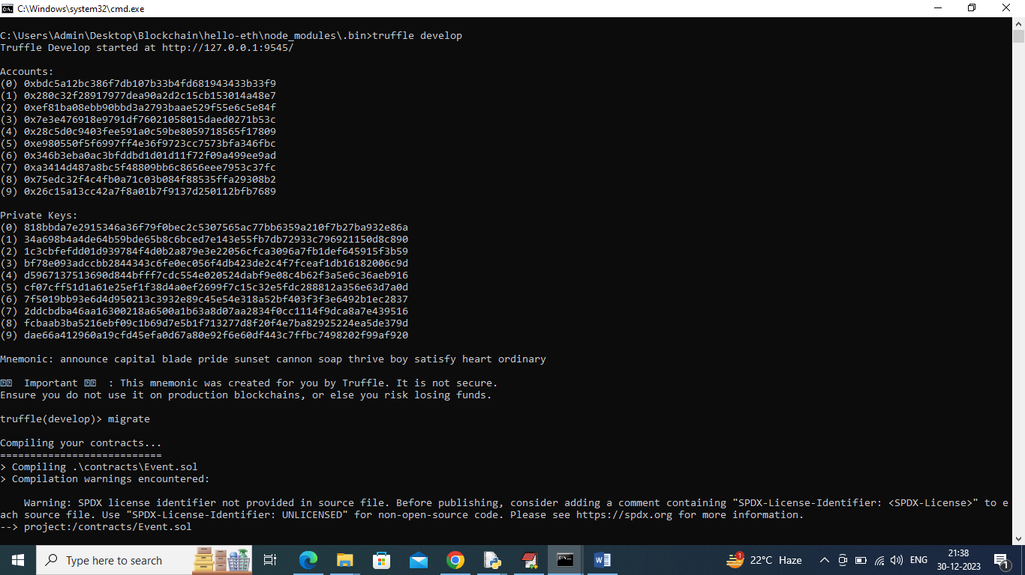
- In above screen Blockchain started with default Private keys and accounts and now type command as ‘migrate’ and then press enter key to get below page
- 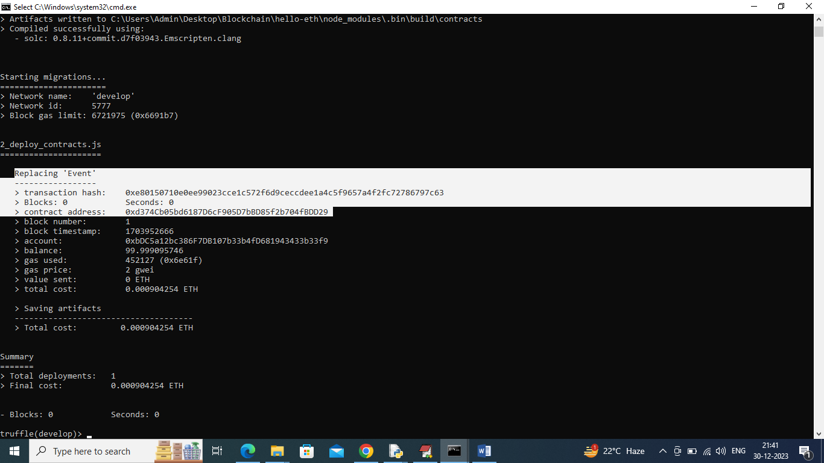
- In above screen in white colour text can see ‘Event’ contract deployed and got contract address also and this contract address need to specify in python code to call Smart contract function. In below screen can see python calling Blockchain contract by using address
- 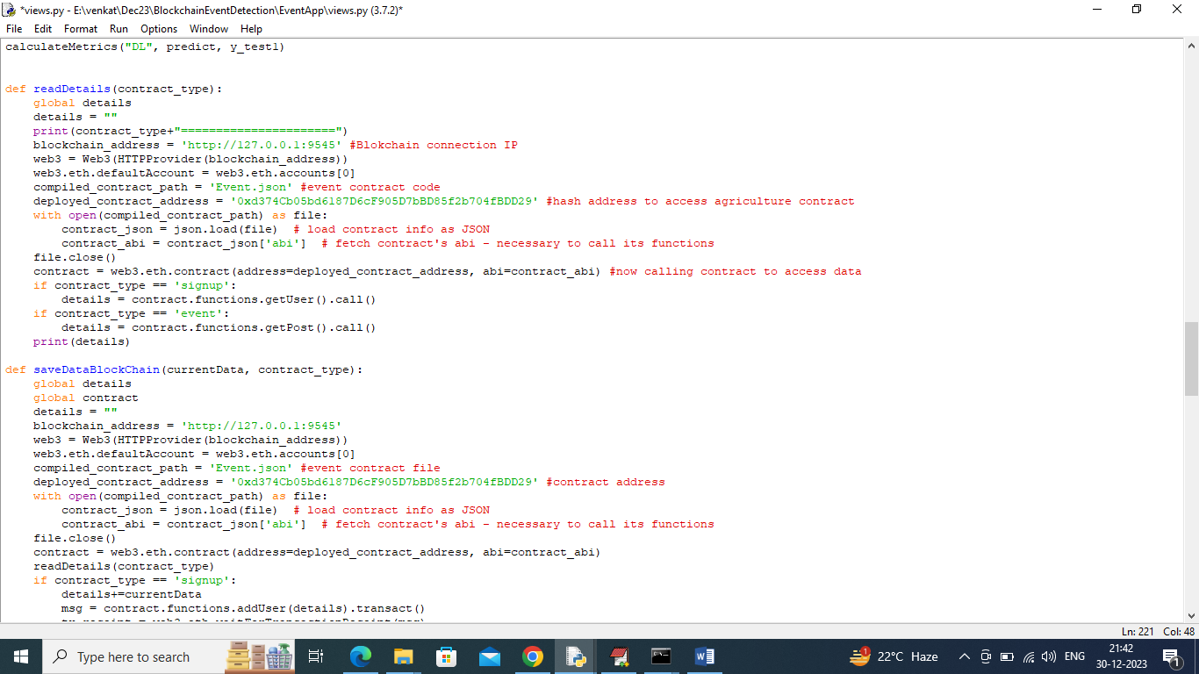
- In above screen read red colour text to know about contract calling and now contract deployed and running in Black console and let it run.
Dataset Details
To train ML and DL algorithms we have used Disaster Event tweets dataset which can be crawled or download using Google API and below is the dataset sample screen
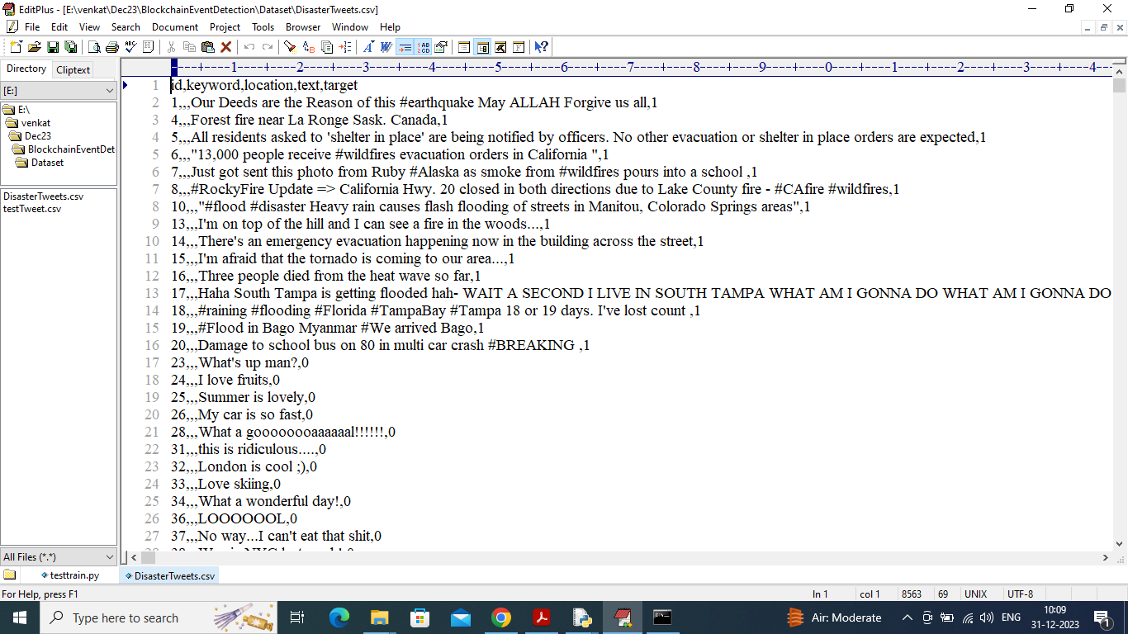
In above dataset screen first row represents dataset column names and remaining rows represents dataset values and in above dataset can see tweet text and last column contains target value as 0 or 1 where 0 represents Normal Event and 1 represents Disaster Event
SCREEN SHOTS
To run code double click on ‘run.bat’ file to start python server and get below screen
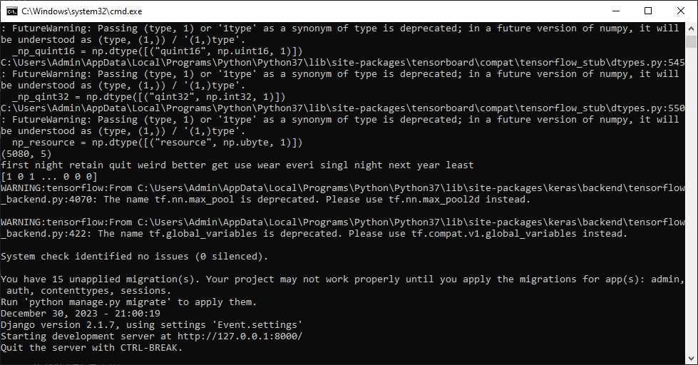
In above screen python server started and now open browser and enter URL as http://127.0.0.1:8000/index. Html and press enter key to get below page
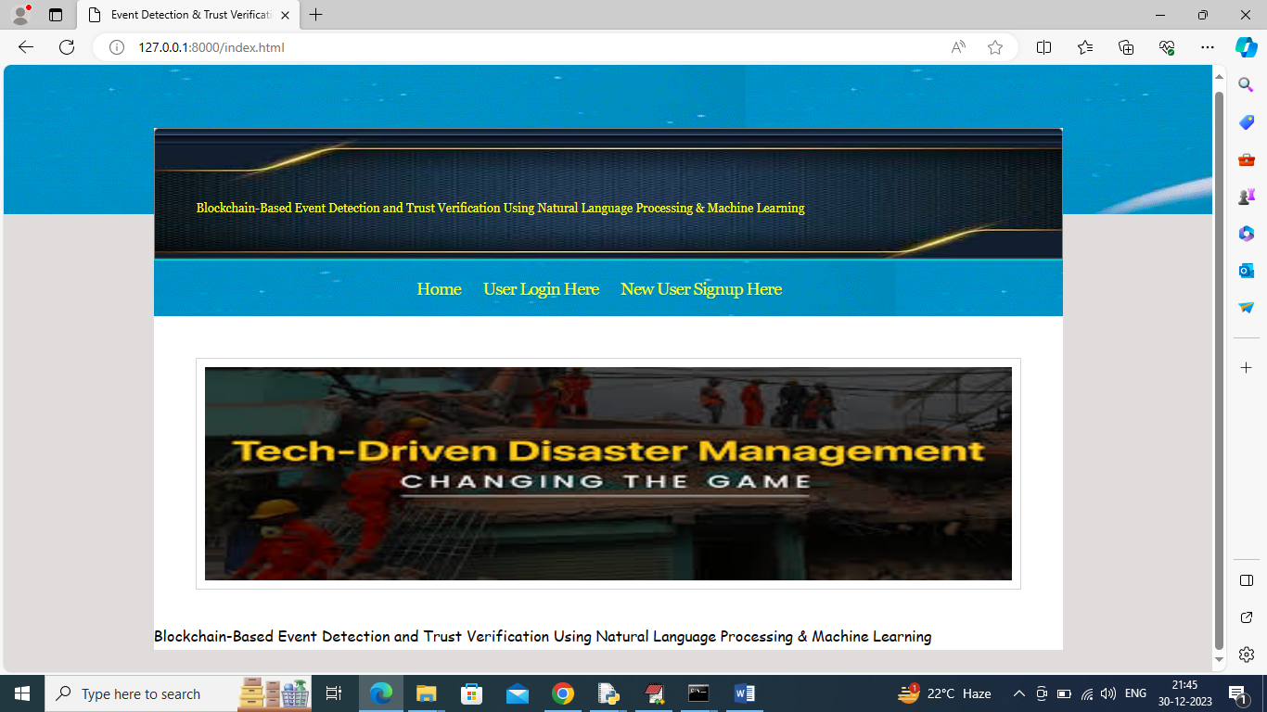
In above screen click on ‘New User Signup Here’ link to get below page
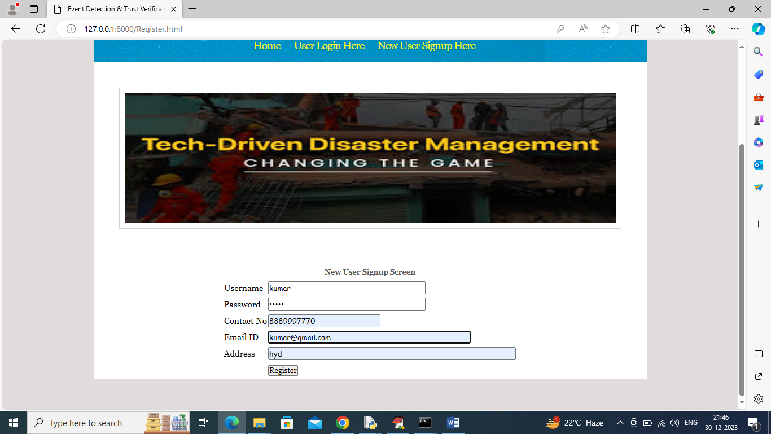
In above screen user is entering signup details and then press button to get below page
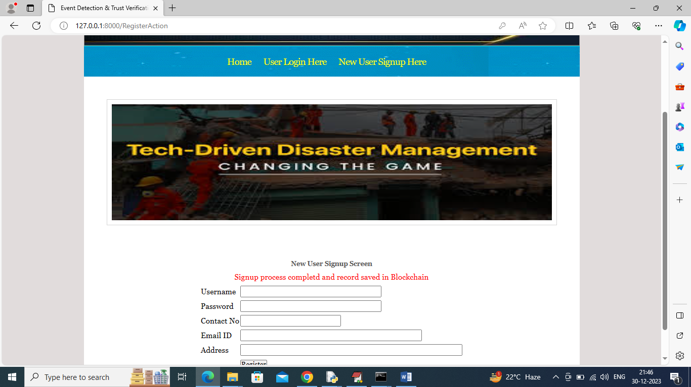
In above screen signup task completed and similarly you can add as many users as you want. Now click on ‘User Login Here’ link to get below page
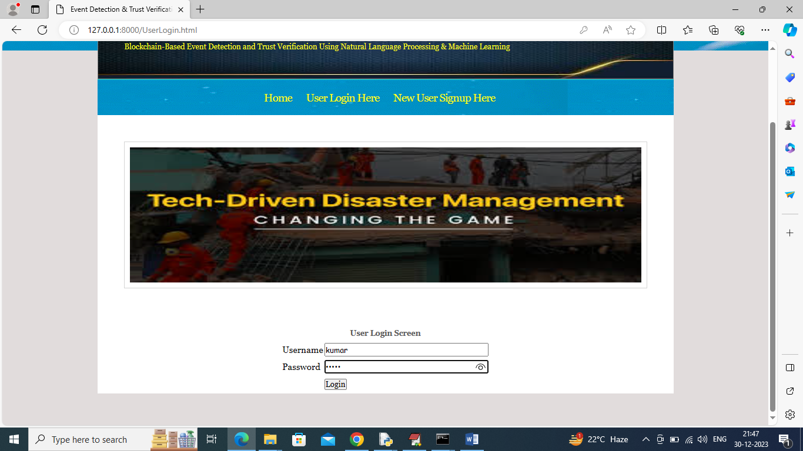
In above screen user is login and after login will get below page
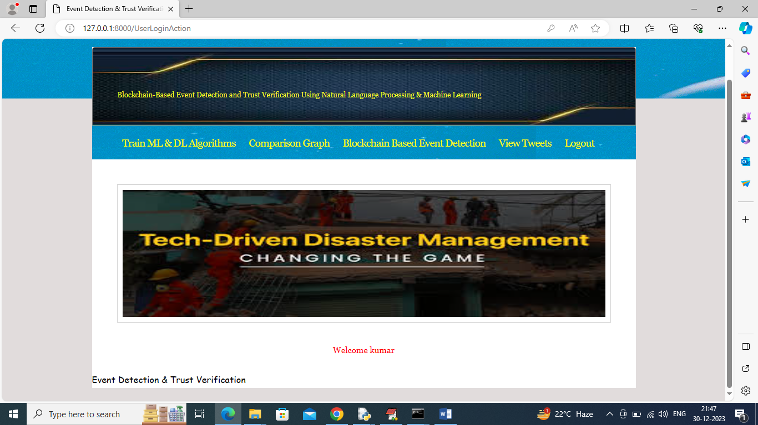
In above screen click on ‘Train ML & DL Algorithms’ link to get below page
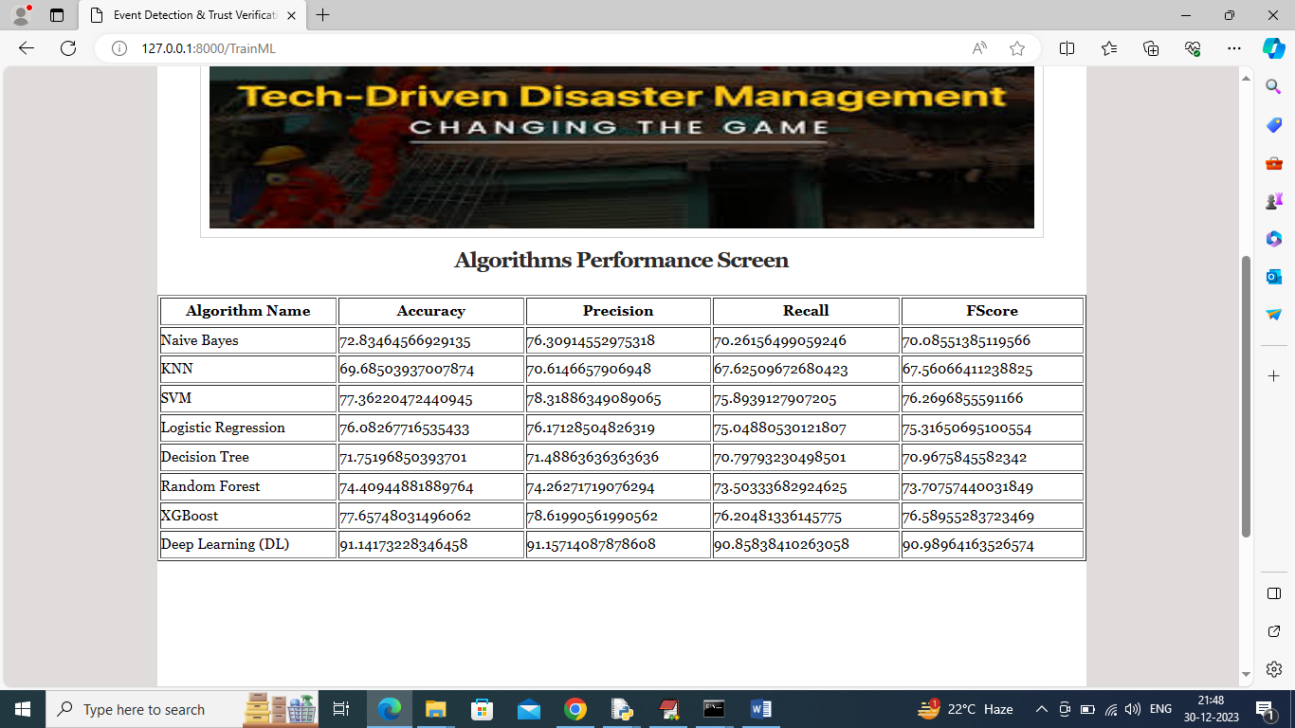
In above screen all algorithms training completed and can see performance of each algorithm and in all algorithms Deep Learning algorithm has got high accuracy and now click on ‘Comparison Graph’ link to get below page
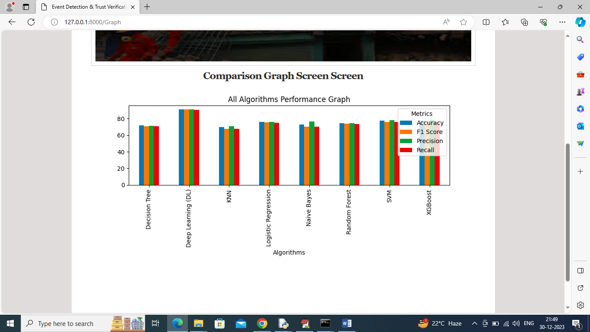
In above graph x-axis represents algorithm names and y-axis represents accuracy, precision and other metrics in different colour bars and in all algorithms Deep Learning got high performance. Now click on ‘Blockchain Based event Detection’ link to get below page
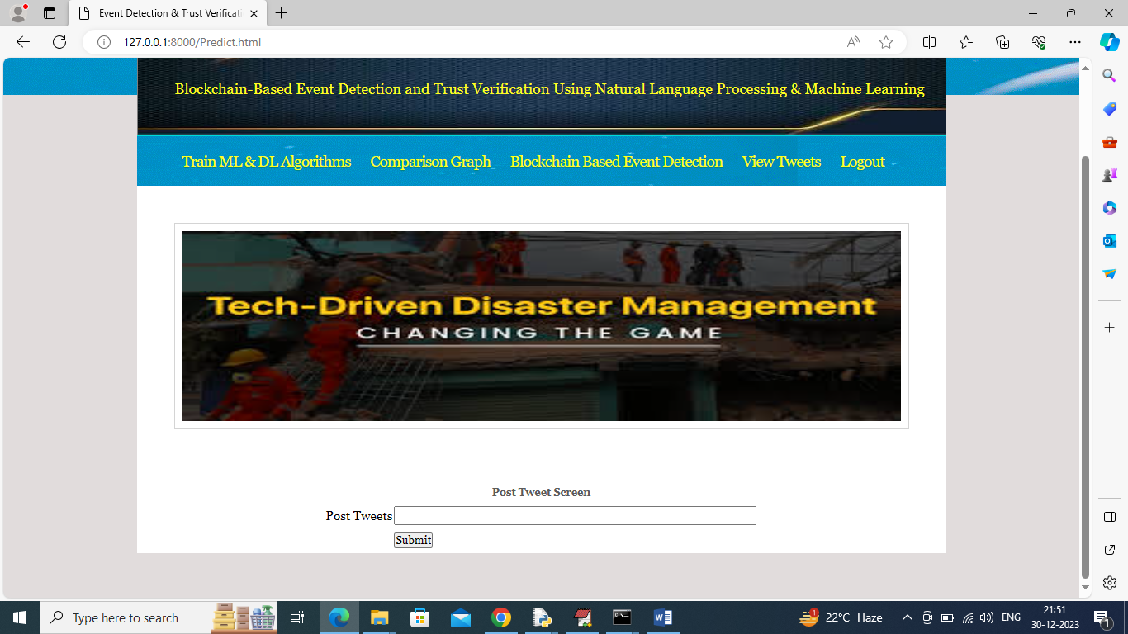
In above screen user can enter some post and this post will get saved in Blockchain and ML algorithms will predict weather tweet is ‘Normal or Disaster Events’. Emergency team will read all disaster tweets and arrange their teams. If you don’t know post details then you can copy tweet from ‘test tweets.csv’ file and paste in above field
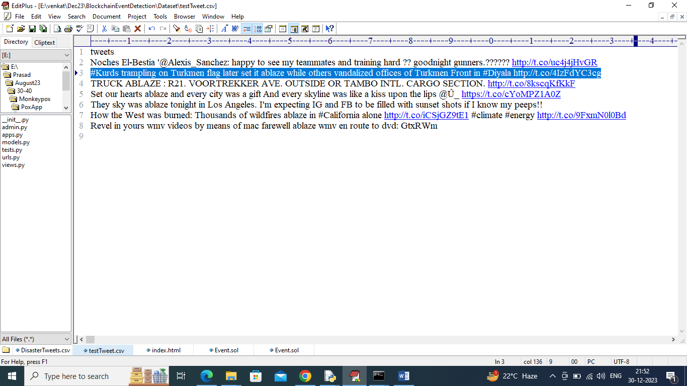
In above screen copying some tweets and paste in below screen
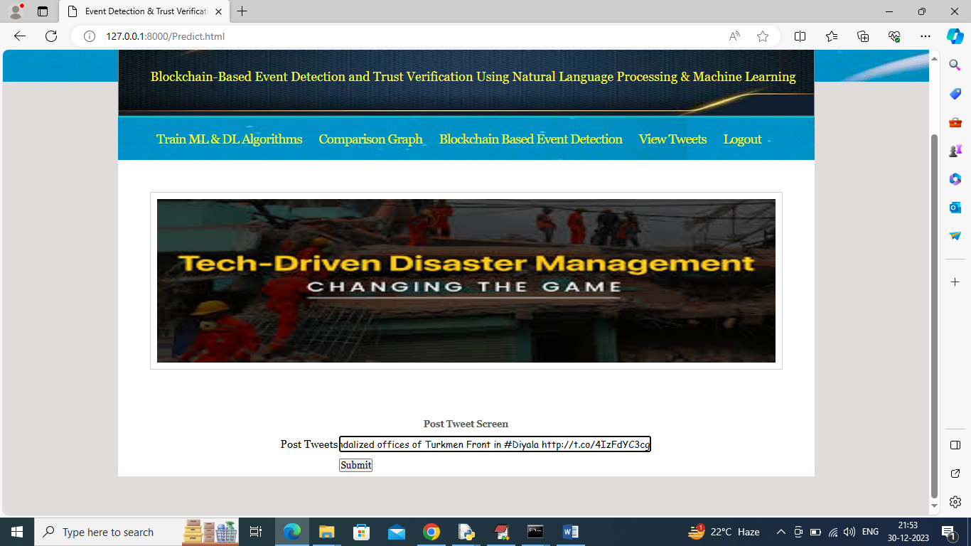
In above screen pasting copied tweet and then click on ‘Submit’ button to get below output
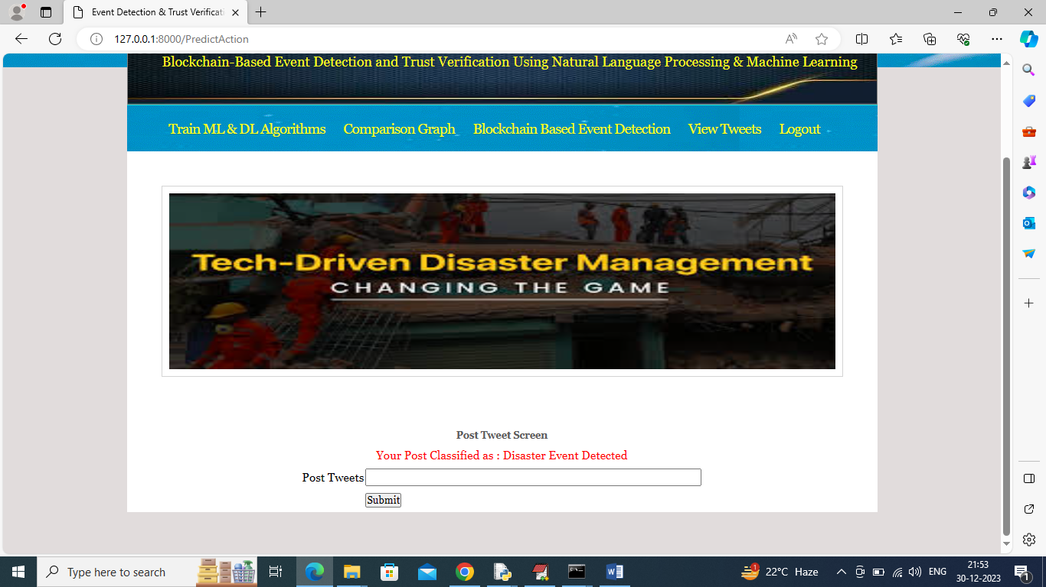
In above screen in red colour text can see post classification result and this result will get saved in Blockchain. Similarly you can test other tweets and below are the other example
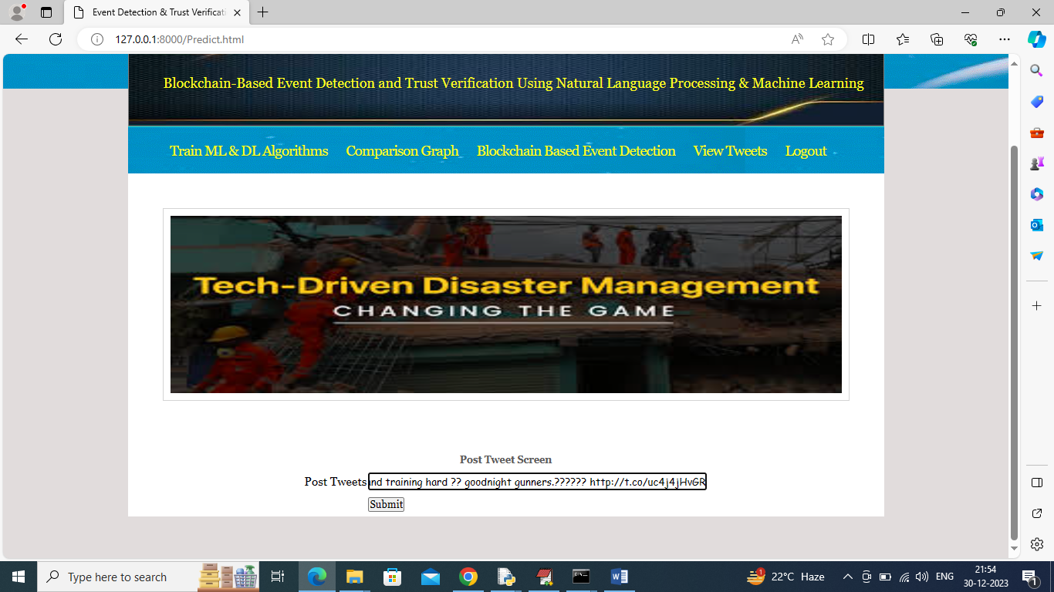
In above screen entered some other tweet and below is the output
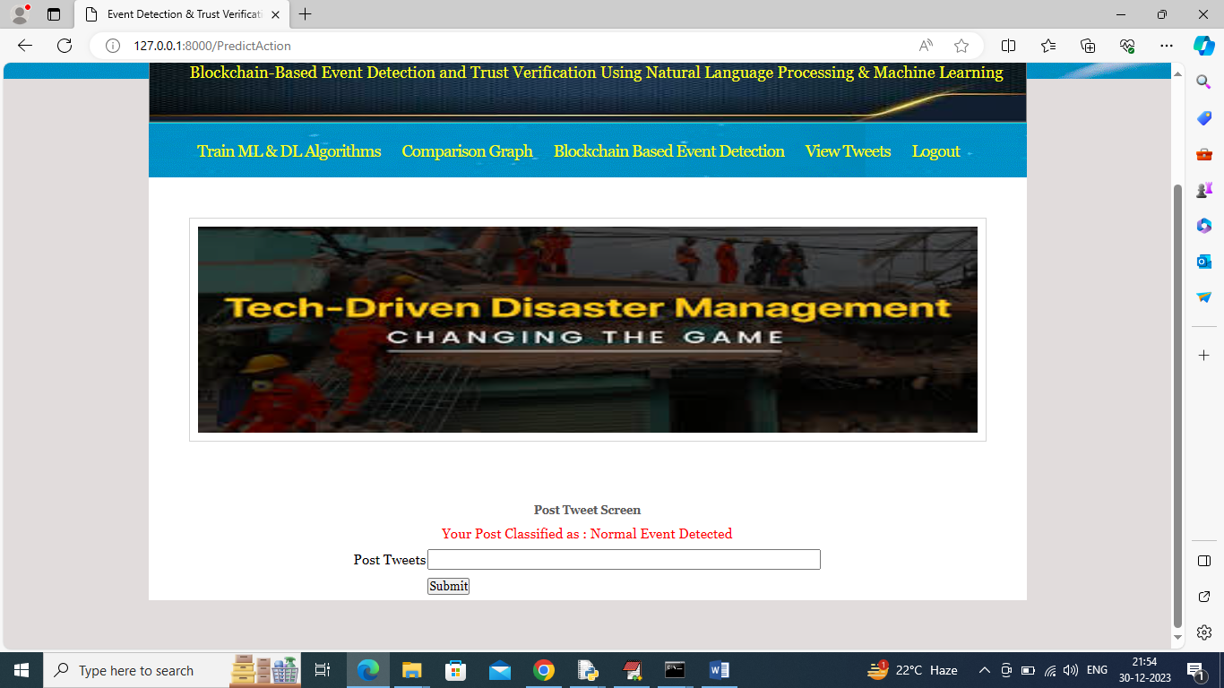
In above screen tweet classified as ‘Normal Event’ and now click on ‘View Tweets’ to get all tweets from Blockchain like below screen
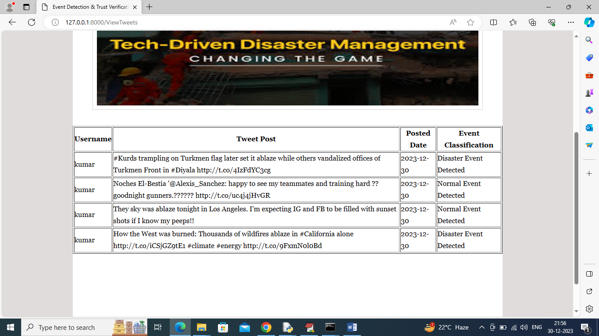
In above screen all users can see ‘tweets’ uploaded by different users and can see tweet message, date and predicted event type. All the above tweets are fetching from decentralized Blockchain servers.
Similarly you can add any number of tweets which will saved in Blockchain and ML will classify tweets event type.

