ABSTRACT

Online social media platforms are extensively used for sharing concise messages, often containing information about various events, including natural disasters. The automatic classification of these messages plays a crucial role in aiding emergency relief teams by providing insights into the number and nature of detected disasters. In the proposed work, Natural Language Processing Text API is employed to analyze text messages, converting them into training features. These features serve as input to different machine learning algorithms, evaluating their performance for classification. The study evaluates eight different algorithms, including Naïve Bayes, KNN, SVM, Decision Tree, Random Forest, XGBOOST, Logistic Regression, and Deep Learning. Notably, Deep Learning emerges as the most accurate algorithm, with each method assessed based on metrics like accuracy, precision, recall, and F-score.
Traditional social media platforms rely on centralized single servers to store user posts. However, this centralized approach poses a risk in case of server crashes or security breaches, leading to service disruptions. To address this vulnerability, the paper proposes the implementation of a Blockchain-based decentralized server. This decentralized architecture stores data across multiple nodes, ensuring continuous service availability even if one node experiences issues.
All user posts stored in the Blockchain are inherently tamper-proof due to the technology's built-in support for data encryption and integrity. Each record is stored as a block/transaction, linked with a unique hash code. During the storage of new records, Blockchain verifies all previous hash codes. If the data remains unaltered, the hash code verification is successful; otherwise, it fails, indicating tampering. This inherent tamper-proof nature makes Blockchain a secure and reliable option for storing sensitive information.
Data storage and retrieval in Blockchain are facilitated through smart contracts, which contain functions to save and retrieve data. A specific contract is designed to store user posts, providing a robust and secure mechanism for managing social media content.

TABLE OF CONTENTS

ABSTRACT i
TABLE OF CONTENTS ii
LIST OF FIGURES iv
CHAPTER-1 INTRODUCTION 1
  - What is Python 3
    - Advantages of Python 3
    - Disadvantages of Python 4
    - Install Python on Windows and Mac Step by Step 5
    - Installation of Python 7
    - Verify the Python Installation 8
    - Check how the Python IDLE works 9
  - What is VS Code 11
    - Steps to Install Visual Studio Code on Windows: 11
CHAPTER-2
LITERATURE SURVEY 16
  - Effective tool for exploring web: An Evaluation of Search engines Learning 16
  - Overview of Search Engine Optimization 17
  - Web Search Engine 18
CHAPTER-3
SYSTEM ANALYSIS 20
  - Existing System 20
    - Drawbacks 20
  - Proposed System 21
    - Advantages: 21
  - Modules 22
CHAPTER-4
REQUIREMENT ANALYSIS 23
  - Software Requirements 23
  - Functional Requirements 23
  - Hardware Requirements 23
CHAPTER-5
SOFTWARE DESIGN 24
  - Data Flow Diagram 24
  - Use Case Diagram 25
  - Class Diagram 28
  - Sequence Diagram 28
CHAPTER-6
IMPLEMENTATION 29
  - Methodology 29
  - Source Code 32
CHAPTER-7
TESTING 36
  - System Test 36
  - Types Of Tests 36
    - Unit testing 36
    - Integrated Testing 36
    - Functional test 37
    - White Box Testing 37
    - Black Box Testing 37
  - Test strategy and approach 37
    - Test objectives 38
  - Acceptance Testing 38
    - Features to be tested 38
  - Test Results: 38
CHAPTER-8
RESULTS 39
CHAPTER-9
CONCLUSION & FUTURE ENHANCEMENT 43
BIBLIOGRAPHY 45

LIST OF FIGURES
Fig 1.1 Open Python website to download the python latest version 5
Fig 1.2 Click on Download Python 5
Fig 1.3 Select the version what you want 6
Fig 1.4 Python Versions 6
Fig 1.5 Click on ok to install Python 7
Fig 1.6 Click on Install Now to install 7
Fig 1.7 After installation successful. Click on Close 8
Fig 1.8 Open Command Prompt 8
Fig 1.9 Type Python -V to check the python is correctly installed or not 9
Fig 1.10 Click on IDLE (Python3.7 64-bit) and launch the program 9
Fig 1.11 Click on File and Save the file 10
Fig 1.12 Visit the Official Website to download the VS Code 11
Fig 1.13 Click on Download for Windows 12
Fig 1.14 Click on VS Code Icon to start installation process 12
Fig 1.15 Accept the Agreement and click on Next 13
Fig 1.16 Choose the location and then Click on Next 13
Fig 1.17 Click on Install 14
Fig 1.18 Installing VS Code 14
Fig 1.19 After Installation if Finished Click on Finish 15
Fig 1.20 Visual Studio Code Screen 15
Fig 5.1 Data flow Diagram 24
Fig 5.2 Use case diagram 27
Fig 5.3 Class Diagram 28
Fig 5.4 Sequence Diagram 28

Fig 7.1 Positive Output 38
Fig 8.1 Create an virtual environment By using the syntax: python –m venv myenv 39
Fig 8.2 Open Command Prompt to activate venv 39
Fig 8.3 Acivate venv 40

Fig 8.4 To pip install requirements by using the syntax: pip install –r requirements.txt...40 Fig 8.5 Press Enter 41
Fig 8.6 Collecting Requirements 41
Fig 8.8 Run the main file streamlit run main.py 42
Fig 8.8 Then obtained the final output web page 42

CHAPTER-1 INTRODUCTION
Social media is now one of the main ways people share news and updates about real-life events. From natural disasters and political movements to local emergencies, platforms like Twitter and Facebook allow users to quickly post and spread information. However, along with useful updates, a lot of false or misleading information is also shared. This makes it hard to know what is true, especially during emergencies when accurate information is very important.

Fake news and rumors can create confusion, fear, or even cause harm. For example, emergency services might waste time responding to a false report, or people might make poor decisions based on unverified updates. Because of this, there is a strong need for a smart system that can not only detect important events from social media posts but also check if the information is trustworthy and real.

This project combines Natural Language Processing (NLP) and Machine Learning (ML) to solve this problem. NLP helps the system understand and process the meaning of text in social media posts. Then, ML algorithms like Naïve Bayes, SVM, KNN, Decision Tree, Random Forest, Logistic Regression, XGBoost, and Deep Learning are used to find and classify events based on the text data. Each model is tested to find out which works best for identifying accurate information.

However, even the best ML models can’t stop data from being changed after it is stored. To make the system more secure, we use Blockchain technology. Blockchain is a digital ledger that keeps records in a way that can’t be changed or tampered with. Every event post is saved as a block with a unique code. If anyone tries to change the data, the system can detect it right away. Smart contracts are also used to manage how posts are stored and accessed on the Blockchain.

By bringing together NLP, ML, and Blockchain, this system can both detect important events and make sure the shared information is real and safe. It offers a reliable tool for users, emergency teams, and organizations to get verified news in real time. This helps reduce the spread of false information and improves how we respond to important events shared online.

How It Works:
Crawling:
Web search engines use "web crawlers" or "spiders" to browse the internet and gather information from web pages. These crawlers follow links from one page to another, collecting data about the content, structure, and other metadata.

Indexing:
Once data is gathered, it's processed and stored in a database known as the "index." The index is optimized for fast retrieval, allowing the search engine to quickly find relevant pages when a query is made.

Query Processing:
When a user enters a search query, the search engine parses and interprets the input to understand what the user is looking for. This may involve breaking down the query into individual keywords, analyzing the context, and identifying the type of information requested.

Ranking and Retrieval:
The search engine uses various algorithms to determine which results are most relevant to the user's query. This involves factors like keyword matching, page relevance, popularity, user behavior, and more. The results are then sorted and presented to the user in order of relevance.

Display of Results:
The search engine shows the retrieved results in a format that's easy to understand. This typically includes a list of web pages with titles, snippets, and URLs, along with other features like images, videos, or news articles if relevant.

User Input:
User input for a search engine typically consists of a search query, which can be a single word, a phrase, or a question. The user might also use advanced search operators or filters to refine their search.
Classification: Classification in a search engine refers to categorizing and organizing content based on various criteria. This can involve classifying web pages by topic, type, language, or relevance to a specific search query.

What is Python
These are some facts about Python. Python is present most widely used multi- purpose and high-level programming language.it allows programming in Object-Oriented and Procedural paradigms. Python programs commonly are smaller than other programming languages like Java. Programmers have to write relatively less and indentation requirement of the language, makes them readable all the time. Python language is being used by the almost all tech-giant companies like – Google, Amazon, Facebook, Instagram, Dropbox, Uber… etc. The biggest strength of Python language is huge collection of standard libraries it can be used for the following
- Machine Learning.
- GUI Applications (such as Kivy, Tkinter, PyQt, etc.)
- Web frame works such as Django (used by YouTube, Instagram, Dropbox)
- Image processing (such as Open cv and Pillow)
- Web scraping (such as Scrapy, Beautiful So up and Selenium)
- Test Framework

Advantages of Python
Let us see how Python out performs other languages.

Advantages of Python Over Other Languages
- Less Coding\
When performing the same task in other languages, all tasks performed in Python require less coding. Python is also excellent standard library support, so there is no need to search for third-party libraries to get the job done. This is the main reason why many people recommend that beginners learn Python.

Affordable
Python is a free resource, so individuals, small businesses, or large organizations can use available free resources to build applications, and Python is a popular and widely used community supply.

Python is for Everyone
Python can run in any environment, be it Linux, Mac or Windows. Programmers need to learn different languages for different jobs, but with Python, you can professionally use Python to create web applications, perform data analysis and machine learning, automate things, perform web scraping, and create powerful games and visualization initial later rain programming language.

Disadvantages of Python
We have seen why Python is the best choice for our project. But if you allocate it, you should also be aware of its consequences. Let us now look at the disadvantages of choosing.

Disadvantages of Python Over Other Language
- Speed Limitations
We have seen that Python code executes line by line. But because Python is interpreted, its execution speed is very slow. This is not a problem, unless speed is the focus of the project work. In other words, the speed is necessary, and the benefits Python provides are enough to distract us from its speed limitations.

Weak in Mobile Computing and Browsers
Although Python is a good server-side language, Python is rarely seen on the client side. Most importantly, is rarely used to implement smartphone- based applications. One of these applications is called Carbon nelle. Although Bright on exists, it is not so famous because it is not so safe.

Design Restrictions
Python is a dynamically typed language. This means that you do not need to declare variable types when writing code content. It uses to duck typing. what is that? Well, it just means that if it looks like a duck, then it must be a duck. This is easy for programmers in the coding process, and it will generate runtime errors.

Under developed data base access layer
Compared to the most widely used technologies such as JDBC (Java DataBase Connectivity) and ODBC (Open DataBase Connectivity), Python's database access layer is a bit underdeveloped and it is used less in large companies.

Simple
We are not kidding. Python's simplicity is indeed a problem. I don't do Java, I'm more of a Python person. To me, its syntax is so simple that Java code seems unnecessary.

Install Python on Windows and Mac Step by Step:
Step-1: Go to the official site and use Google Chrome or any other web browser to download and install Python. Or click on the following link:
https://www.python.org/
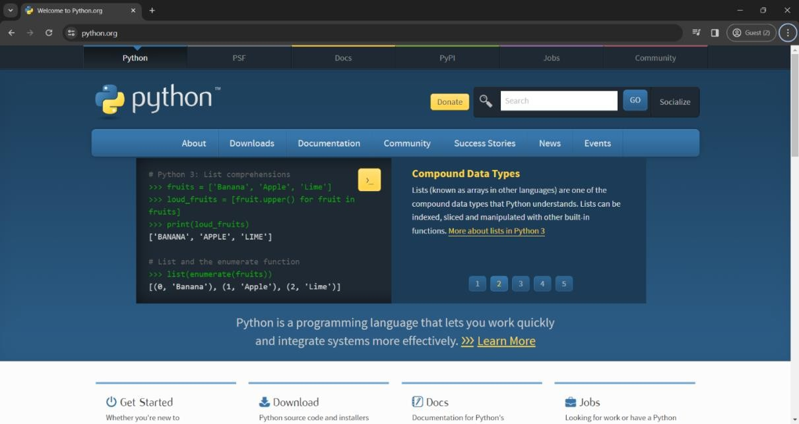

Fig 0.1 Open Python website to download the python latest version
Now check the latest and correct version of your operating system.
Step-2: Click on the Download Tab.
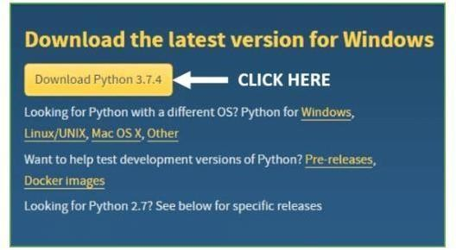

Fig 0.2 Click on Download Python

Step-3: You can select the yellow Download Python for Windows3.7.4 button, or you can scroll download click the download of the corresponding version. Here, we are downloading the latest version of Python for Window 3.7.4.
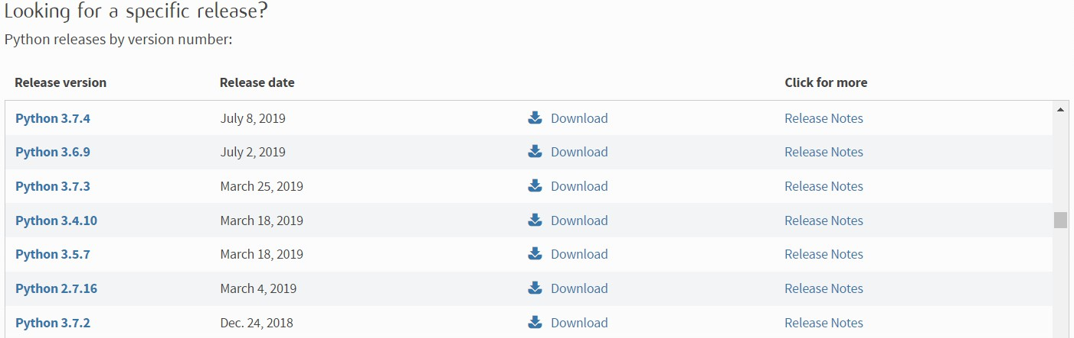

Fig 0.3 Select the version what you want Step-4: Scroll down the page until you find the "File" option.
Step5: Here you will see different versions of Python and operating systems.
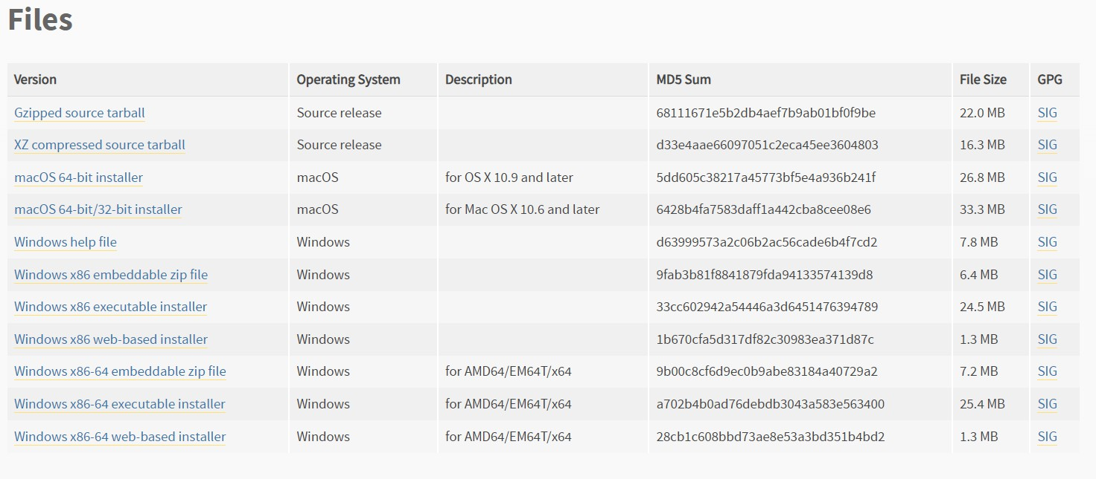

Fig 0.4 Python Versions
- To download Windows 32bit Python, you can select the built-in Windows X86 Zip file, WindowsX86 executable installer or WindowsX86 installer on the Web.
- TodownloadWindows64 bit Python, you can select any option of the three options. Zip File Embeddable Windows X866, Windows X8664 executable installer or

Windows X8664 installer based on the web.
Here you will install the installer based on the Windows X8664 website. Here, the first part of the Python version was completed. Now we will go in advance the second part when installing PythonI. Note: You can click on the option of the release of the version to know the changes or updates made in the version.

Installation of Python
Step-1: Goto Download and Open the downloaded python version to carry out the installation process.
Step-2: Before you click on Install Now, make sure to put a tick on Add Python 3.7 to Path
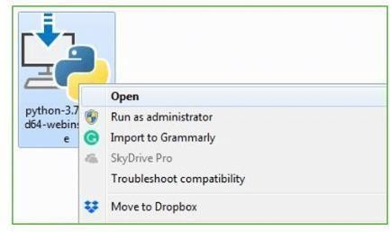

Fig 0.5 Click on ok to install Python
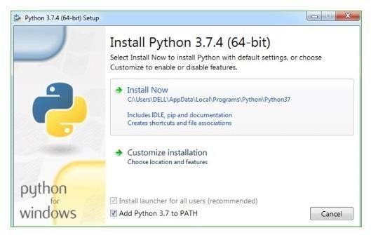
Fig 0.6 Click on Install Now to install

Step-3: Click on Install Now After the installation is successful. Click on Close.
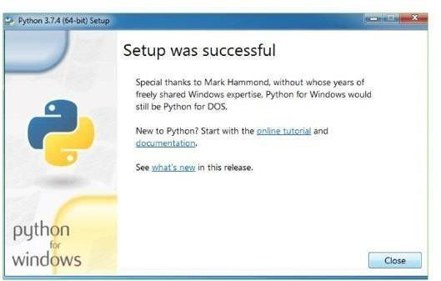

Fig 0.7 After installation successful. Click on Close
With these above three steps on python installation, you have successfully and correctly installed Python. Now is the time to verify the installation.
Note: The installation process might take a couple of minutes.
    - Verify the Python Installation Step-1: Click on Start
Step-2: In the Windows Run Command, type “cmd”.
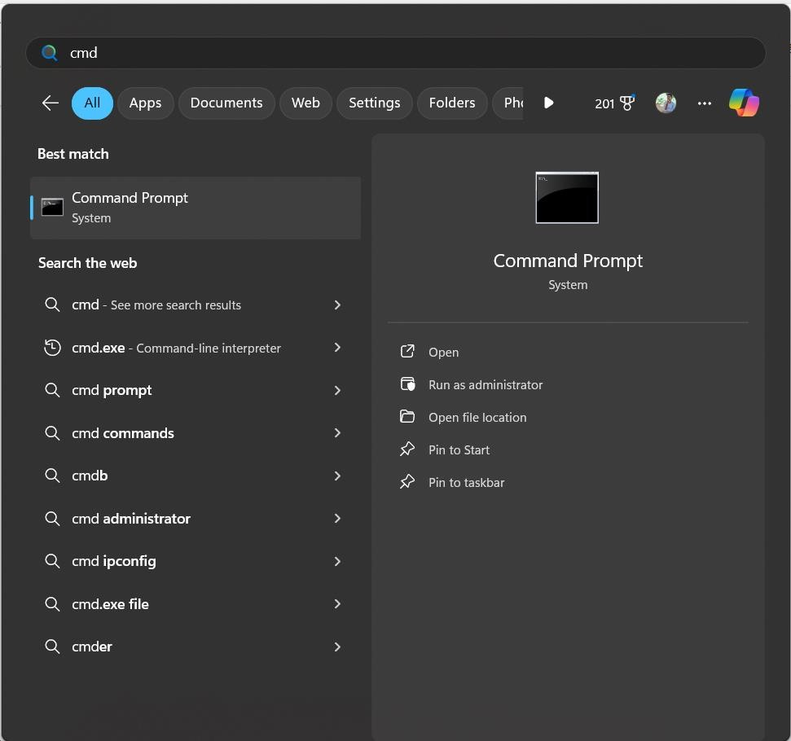

Fig 0.8 Open Command Prompt

Step-3: Open the Command prompt option.
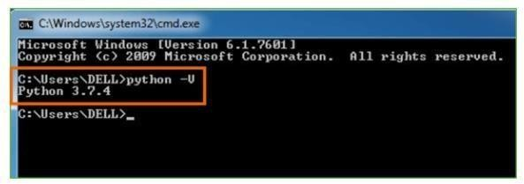

Fig 0.9 Type Python -V to check the python is correctly installed or not
Step-4: Let us test whether the python is correctly installed. Type python– V and press Enter.
Step-5: You will get the answer as 3.7.4
Note: If you have any of the earlier versions of Python already installed. You must first uninstall the earlier version and then install the new one.

    - Check how the Python IDLE works Step-1: Click on Start
Step-2: In the Windows Run command, type “python idle”.
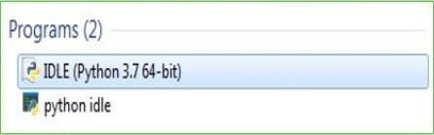
Fig 0.10 Click on IDLE (Python3.7 64-bit) and launch the program Step-3: Click on IDLE (Python3.7 64-bit) and launch the program

Step-4: To go ahead with working in IDLE you must first save the file. Click on File Click on Save
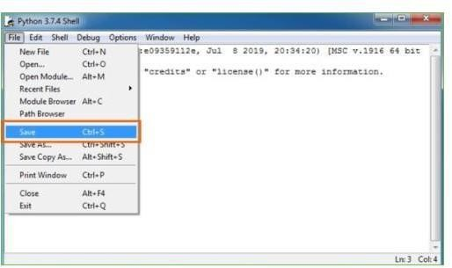
Fig 0.11 Click on File and Save the file Step-5: Name the file and save as type should be Python files.
Click on SAVE. Here I have named the files as Hey World.

What is VS Code:
Visual Studio Code is the most popular code editor and the IDEs provided by Microsoft for writing different programs and languages. It allows the users to develop new code bases for their applications and allow them to successfully optimize them.
For its high popularity, individuals opt to Install Visual Studio Code on Windows over any other IDE. Installation of Windows Visual Studio Code is not a difficult matter. The Installation process starts with Downloading the Visual Studio Code EXE file to some on- screen instructions.
We are going to list all the steps required to Install VS Code on Windows in a detailed format.
- Quick Preview to Install Visual Studio Code on Windows
- Download the VS Code file from the Official Website.
- Execute the download file.
- Accept the Terms & Conditions.
- Click on the Install button.
- Wait for the installation to complete.
- Click on the Launch button to start it.

Steps to Install Visual Studio Code on Windows:
Step 1: Visit the Official Website of the Visual Studio Code using any web browser like Google Chrome, Microsoft Edge, etc.
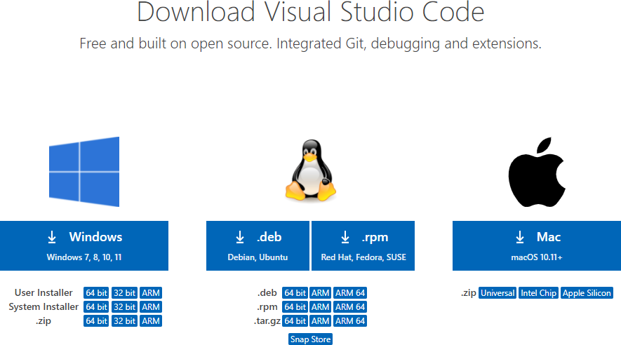

Fig 0.12 Visit the Official Website to download the VS Code

Step 2: Press the “Download for Windows” button on the website to start the download of the Visual Studio Code Application.

Fig 0.13 Click on Download for Windows
Step 3: When the download finishes, then the Visual Studio Code Icon appears in the downloads folder.


Fig 0.14 Click on VS Code Icon to start installation process
Step 4: Click on the Installer icon to start the installation process of the Visual Studio Code.

Step 5: After the Installer opens, it will ask you to accept the terms and conditions of the Visual Studio Code. Click on I accept the agreement and then click the Next button.


Fig 0.15 Accept the Agreement and click on Next
Step 6: Choose the location data for running the Visual Studio Code. It will then ask you to browse the location. Then click on the Next button.
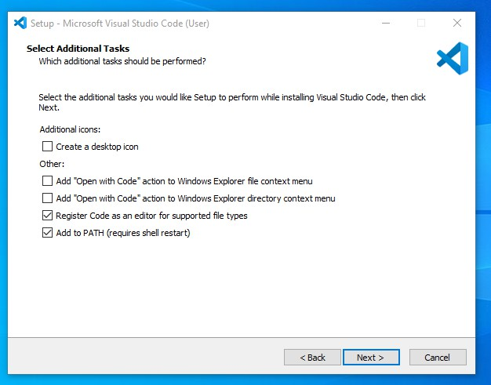

Fig 0.16 Choose the location and then Click on Next

Step 7: Then it will ask to begin the installation setup. Click on the Install button.
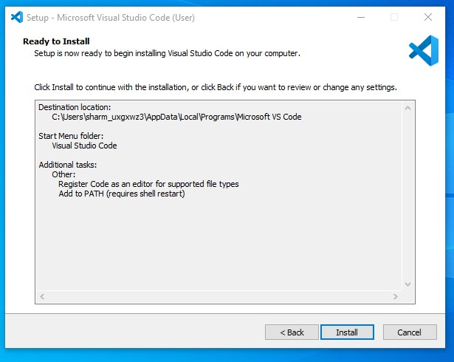

Fig 0.17 Click on Install
Step 8: After clicking on Install, it will take about 1 minute to install the Visual Studio Code on your device.
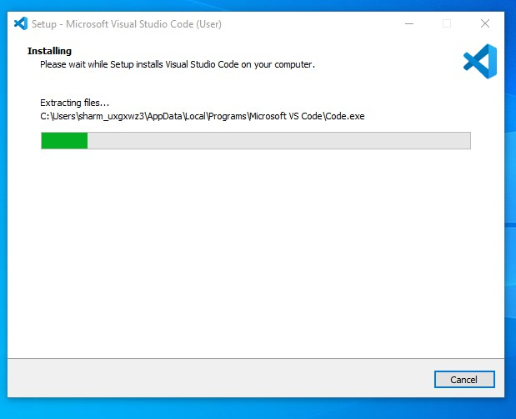

Fig 0.18 Installing VS Code

Step 9: After the Installation setup for Visual Studio Code is finished, it will show a window like this below. Tick the “Launch Visual Studio Code” checkbox and then click Next.


Fig 0.19 After Installation if Finished Click on Finish
Step 10: After the previous step, the Visual Studio Code window opens successfully. Now you can create a new file in the Visual Studio Code window and choose a language of yours to begin your programming journey!
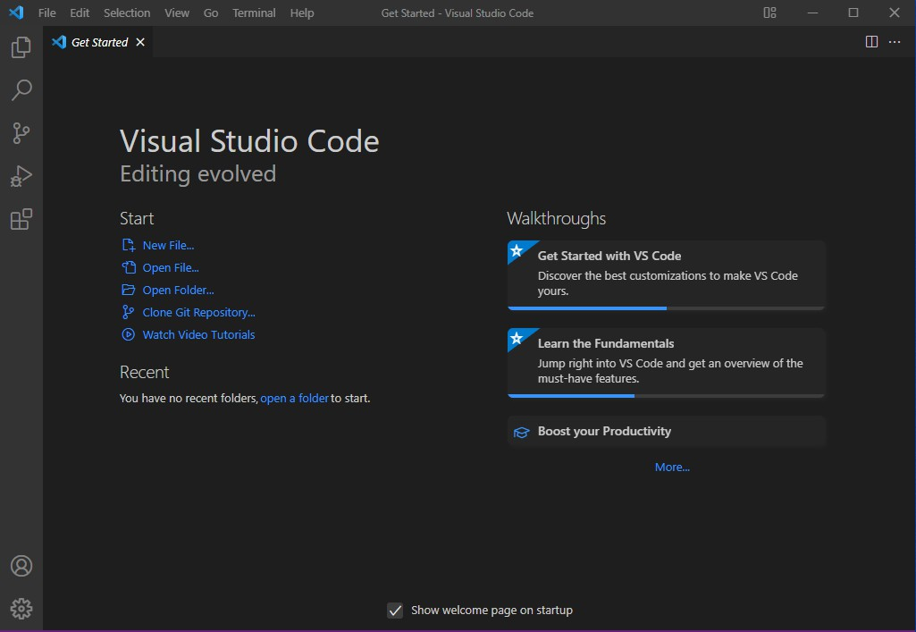
Fig 0.20 Visual Studio Code Screen

CHAPTER-2 LITERATURE SURVEY

2.1 Event Detection Using NLP and ML
Event detection from unstructured social media data has gained attention due to the real-time nature of platforms like Twitter and Facebook. According to Sakaki et al. (2010), Twitter can be treated as a real-time sensor system to detect events like earthquakes using Support Vector Machines (SVM). Later studies have enhanced detection accuracy using text processing and classification techniques, such as TF-IDF, bag-of-words, and word embeddings. Deep Learning methods, particularly Recurrent Neural Networks (RNN) and LSTMs, have outperformed traditional classifiers in understanding the context of short texts. Researchers like Nguyen et al. (2016) also emphasized the importance of combining text semantics with metadata for improving the precision of event identification. These developments showcase the growing capability of NLP and ML models in analyzing social media content.
2.2 Trust and Misinformation Detection
The spread of false information during crises has prompted research on trust detection in social platforms. Castillo et al. (2011) proposed a credibility model for Twitter, which classified tweets based on user behavior, tweet content, and propagation features. Other researchers have explored ensemble models that consider user reputation, account age, retweet frequency, and sentiment polarity to assess credibility. Buntain and Golbeck (2017) used machine learning for automated credibility assessment and showed that combining content and user features improves accuracy. These studies highlight the potential of ML-based systems in filtering misinformation and verifying post authenticity.
2.3 Blockchain for Secure Data Storage and Trust Management
Blockchain has emerged as a reliable solution for tamper-proof and decentralized data storage. Zyskind et al. (2015) demonstrated how Blockchain can decentralize user data storage while maintaining privacy and control. In a similar approach, Li et al. (2018) integrated Blockchain with IoT systems to ensure data traceability and integrity. The immutability of Blockchain makes it ideal for applications where data accuracy and non-repudiation are critical. In social media use cases, Blockchain can record the original content, timestamp it, and ensure that no edits are possible without detection. Smart contracts further automate storage and retrieval processes securely.
2.4 Combining AI and Blockchain Technologies
Recent literature explores how Artificial Intelligence (AI) techniques like ML and NLP can be enhanced by integrating Blockchain. Projects such as Truth Chain and Event Ledger store AI-analysed results directly on Blockchain to ensure the credibility of automated decisions. Alketbi et al. (2018) highlighted how Blockchain can increase trust in AI outputs by providing audit trails and verification capabilities. Some studies have also proposed federated AI models on Blockchain, where decentralized data sources collaboratively train models while maintaining data privacy and integrity.
2.5 Research Gap and Need for Integration
Most existing studies focus on either event detection or on Blockchain-based secure storage independently. However, a unified system that combines NLP/ML for event detection with Blockchain for verification and secure storage is still relatively underexplored. Your project aims to bridge this gap by developing an integrated framework that can analyse social media content, detect real-world events, and store them securely using Blockchain, ensuring data trust and reliability.

CHAPTER-3

SYSTEM ANALYSIS

3.1 EXISTING SYSTEM

The existing landscape of online information dissemination lacks a comprehensive solution for discerning the veracity of events shared on social media. Traditional platforms heavily rely on centralized servers, making them susceptible to issues such as data tampering, hacking, and the spread of misinformation. Manual verification processes are often time-consuming and labor-intensive. The absence of an automated system for event detection and trust verification leaves users vulnerable to misinformation and hinders the efficient dissemination of reliable information during critical events

Drawbacks

The current landscape of online information dissemination faces major challenges in verifying the authenticity of events shared on social media. Most platforms rely on centralized servers for data storage, which makes them vulnerable to single points of failure. In the event of server crashes, cyberattacks, or unauthorized access, critical data can be lost, altered, or misused. This lack of secure infrastructure increases the risk of data tampering, making it difficult for users to trust the information they see online.

Another significant drawback is the absence of automation in detecting and verifying events in real time. Most verification processes are manual, which are not only time-consuming but also inefficient, especially during emergencies when accurate and timely information is essential. As a result, there are delays in identifying genuine events, which can affect the speed and effectiveness of response teams and public awareness. In fast-paced digital environments, manual verification simply cannot keep up with the volume of content being shared.

Furthermore, the current systems do not provide transparency or traceability of shared information. This opens the door for misinformation to spread widely, with little to no accountability. Users often have no way to verify the origin or reliability of the posts they encounter. Without proper tools for trust verification, harmful rumors or false alarms can escalate rapidly, causing panic or confusion. These issues highlight the urgent need for a secure, decentralized, and automated solution that can ensure both event detection and content authenticity.

3.2 Proposed System

The proposed system introduces a novel approach to event detection and trust verification by integrating Blockchain technology with NLP and ML techniques. Blockchain, with its decentralized and tamper-proof nature, serves as the foundation for storing and securing event-related data. NLP is applied to analyze textual information, extracting key features for event detection. ML algorithms, including but not limited to Naïve Bayes, Decision Trees, and Neural Networks, are trained on labeled datasets to evaluate and classify events based on their trustworthiness.
The system employs smart contracts in the Blockchain network to facilitate trust verification processes. These contracts contain predefined functions for verifying and validating information stored in the Blockchain, ensuring that events are transparently recorded and accessible to users. The integration of these technologies aims to provide a reliable and automated solution for event detection while enhancing trust verification mechanisms to curb the spread of misinformation.
Key features in our proposed system are :

- Blockchain-Based Data Storage
- Machine Learning-Based Event Classification
- Natural Language Processing (NLP) for Text Analysis
- Automated Trust Verification via Smart Contracts

Advantages:
The proposed system offers several advantages:

Improved Trust and Credibility:
The system ensures that only verified and tamper-proof event data is stored and shared, increasing trust in social media content.

Scalability and Flexibility:
The architecture is designed to handle large volumes of data and can be expanded or adapted to different types of events and platforms.
3.3 Modules
Tensorflow
TensorFlow is a free and open-source software library for dataflow and differentiable programming across a range of tasks. It is a symbolic math library, and is also used for machine learning applications such as neural networks. It is used for both research and production at Google.‍
TensorFlow was developed by the Google Brain team for internal Google use. It was released under the Apache 2.0 open-source license on November 9, 2015.
Numpy :
Numpy is a general-purpose array-processing package. It provides a high-performance multidimensional array object, and tools for working with these arrays.
It is the fundamental package for scientific computing with Python. It contains various features including these important ones:
- A powerful N-dimensional array object
- Sophisticated (broadcasting) functions
- Tools for integrating C/C++ and Fortran code
- Useful linear algebra, Fourier transform, and random number capabilities
Besides its obvious scientific uses, Numpy can also be used as an efficient multi-dimensional container of generic data. Arbitrary data-types can be defined using Numpy which allows Numpy to seamlessly and speedily integrate with a wide variety of databases.
Pandas
Pandas is an open-source Python Library providing high-performance data manipulation and analysis tool using its powerful data structures. Python was majorly used for data munging and preparation. It had very little contribution towards data analysis. Pandas solved this problem. Using Pandas, we can accomplish five typical steps in the processing and analysis of data, regardless of the origin of data load, prepare, manipulate, model, and analyze. Python with Pandas is used in a wide range of fields including academic and commercial domains including finance, economics, Statistics, analytics, etc.
Matplotlib
Matplotlib is a Python 2D plotting library which produces publication quality figures in a variety of hardcopy formats and interactive environments across platforms. Matplotlib can be used in Python scripts, the Python and IPython shells, the Jupyter Notebook, web application servers, and four graphical user interface toolkits. Matplotlib tries to make easy things easy and hard things possible. You can generate plots, histograms, power spectra, bar charts, error charts, scatter plots, etc., with just a few lines of code. For examples, see the sample plots and thumbnail gallery For simple plotting the pyplot module provides a MATLAB-like interface, particularly when combined with IPython. For the power user, you have full control of line styles, font properties, axes properties, etc, via an object oriented interface or via a set of functions familiar to MATLAB users.

Scikit – learn
Scikit-learn provides a range of supervised and unsupervised learning algorithms via a consistent interface in Python. It is licensed under a permissive simplified BSD license and is distributed under many Linux distributions, encouraging academic and commercial use.
Python
Python is an interpreted high-level programming language for general-purpose programming. Created by Guido van Rossum and first released in 1991, Python has a design philosophy that emphasizes code readability, notably using significant whitespace.
Python features a dynamic type system and automatic memory management. It supports multiple programming paradigms, including object-oriented, imperative, functional and procedural, and has a large and comprehensive standard library.
Python is Interpreted − Python is processed at runtime by the interpreter. You do not need to compile your program before executing it. This is similar to PERL and PHP.

Python is Interactive − you can actually sit at a Python prompt and interact with the interpreter directly to write your programs.

Python also acknowledges that speed of development is important. Readable and terse code is part of this, and so is access to powerful constructs that avoid tedious repetition of code. Maintainability also ties into this may be an all but useless metric, but it does say something about how much code you have to scan, read and/or understand to troubleshoot problems or tweak behaviors. This speed of development, the ease with which a programmer of other languages can pick up basic Python skills and the huge standard library is key to another area where Python excels. All its tools have been quick to implement, saved a lot of time, and several of them have later been patched and updated by people with no Python background - without breaking.

CHAPTER-4 REQUIREMENT ANALYSIS

4.1 Software Requirements
    - For developing the application the following are the software requirements 1.Python
2.Visual studio code

    - Operating System supported
Windows 10 64 bit OS
    - Debugger and Emulator
Any browser(particularly chrome)

Functional Requirements
    - Graphical User Interface with User

Hardware Requirements
    - Processor: Intel i5 or Above
    - Ram: Minimum 4GB
    - Secondary storage: Minimum 40 GB

CHAPTER – 5
SOFTWARE DESIGN

UML DIAGRAMS :
UML stands for Unified Modeling Language. UML is a standardized general-purpose modeling language in the field of object-oriented software engineering. The standard is managed, and was created by, the Object Management Group.
The goal is for UML to become a common language for creating models of object oriented computer software. In its current form UML is comprised of two major components: a Meta-model and a notation. In the future, some form of method or process may also be added to; or associated with, UML.
The Unified Modeling Language is a standard language for specifying, Visualization, Constructing and documenting the artifacts of software system, as well as for business modeling and other non-software systems.
The UML represents a collection of best engineering practices that have proven successful in the modeling of large and complex systems.
The UML is a very important part of developing objects oriented software and the software development process. The UML uses mostly graphical notations to express the design of software projects.

GOALS:
The Primary goals in the design of the UML are as follows:
- Provide users a ready-to-use, expressive visual modeling Language so that they can develop and exchange meaningful models.
- Provide extendibility and specialization mechanisms to extend the core concepts.
- Be independent of particular programming languages and development process.
- Provide a formal basis for understanding the modeling language.
- Encourage the growth of OO tools market.
7
- Support higher level development concepts such as collaborations, frameworks, patterns and components.
- Integrate best practices.

USE CASE DIAGRAM:
A use case diagram in the Unified Modeling Language (UML) is a type of behavioral diagram defined by and created from a Use-case analysis. Its purpose is to present a graphical overview of the functionality provided by a system in terms of actors, their goals (represented as use cases), and any dependencies between those use cases. The main purpose of a use case diagram is to show what system functions are performed for which actor. Roles of the actors in the system can be depicted.

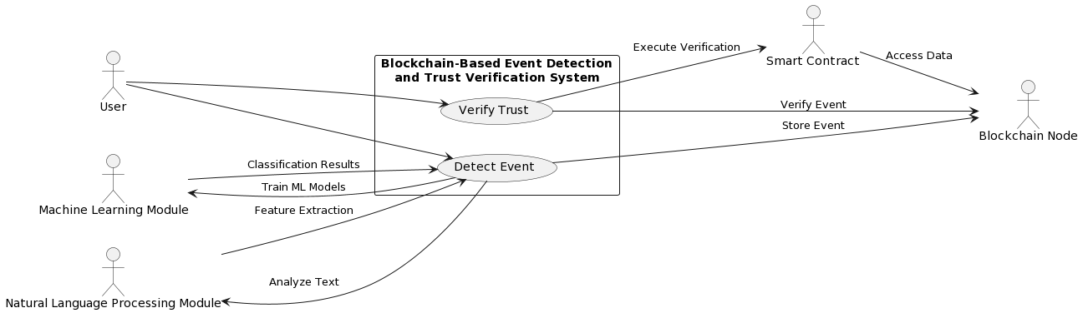
Fig5.1:Use case diagram

CLASS DIAGRAM:
In software engineering, a class diagram in the Unified Modeling Language (UML) is a type of static structure diagram that describes the structure of a system by showing the system's classes, their attributes, operations (or methods), and the relationships among the classes. It explains which class contains information.

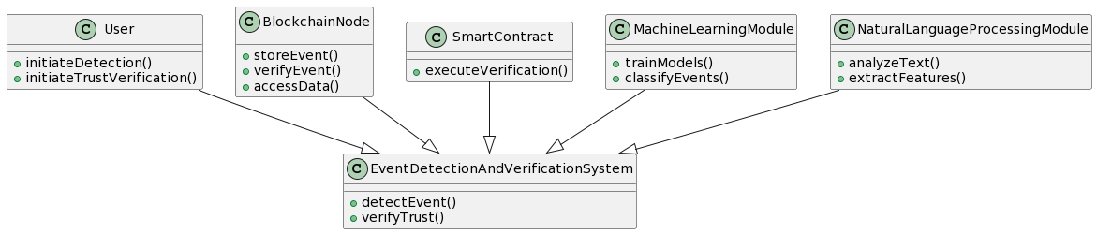
Fig5.2: Class diagram

SEQUENCE DIAGRAM:
A sequence diagram in Unified Modeling Language (UML) is a kind of interaction diagram that shows how processes operate with one another and in what order. It is a construct of a Message Sequence Chart. Sequence diagrams are sometimes called event diagrams, event scenarios, and timing diagrams.

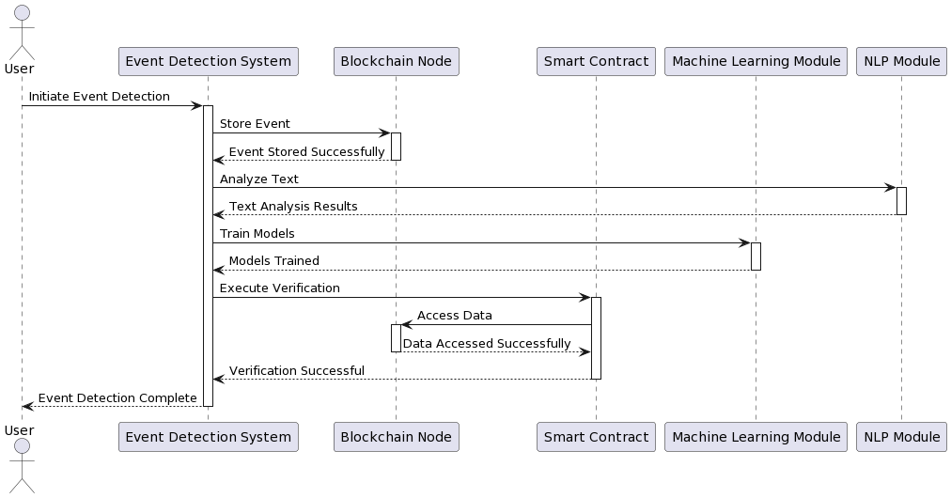

Fig5.3: Sequence diagram

ACTIVITY DIAGRAM:
Activity diagrams are graphical representations of workflows of stepwise activities and actions with support for choice, iteration and concurrency. In the Unified Modeling Language, activity diagrams can be used to describe the business and operational step-by-step workflows of components in a system. An activity diagram shows the overall flow of control.
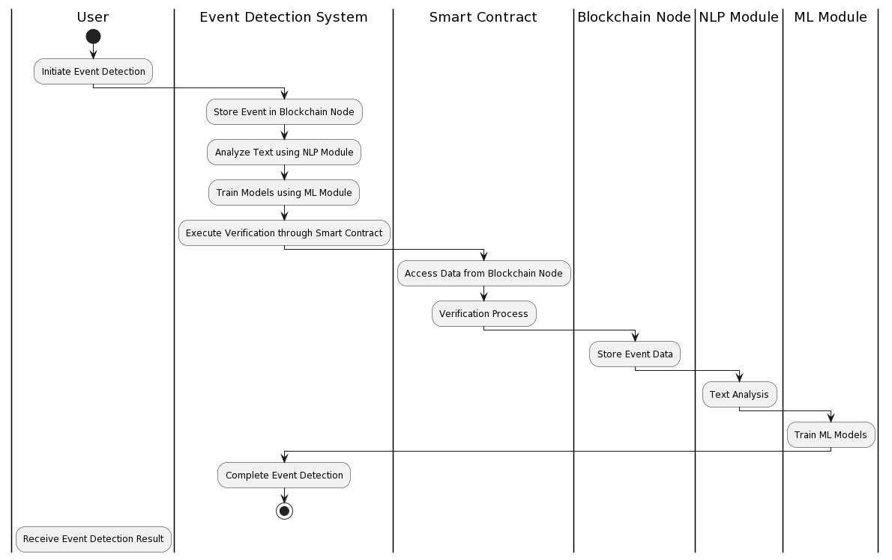

Fig 5.4 : activity diagram

CHAPTER-7

TESTING

System Test
The purpose of testing is to discover errors. Testing is the process of trying to discover every conceivable fault or weakness in a work product. It provides a way to check the functionality of components, sub-assemblies, assemblies and/or a finished product It is the process of exercising software with the intent of ensuring that the Software system meets its requirements and user expectations and does not fail in an unacceptable manner. There are various types of test. Each test type addresses a specific testing requirement.

Types Of Tests

Unit testing
Unit testing involves the design of test cases that validate that the internal program logic is functioning properly, and that program inputs produce valid outputs. All decision branches and internal code flow should be validated. It is the testing of individual software units of the application .it is done after the completion of an individual unit before integration. This is a structural testing, that relies on knowledge of its construction and is invasive. Unit tests perform basic tests at component level and test a specific business process, application, and/or system configuration. Unit tests ensure that each unique path of a business process performs accurately to the documented specifications and contains clearly defined inputs and expected results.

Integrated Testing
Integration tests are designed to test integrated software components to determine if they actually run as one program. Testing is event driven and is more concerned with the basic outcome of screens or fields. Integration tests demonstrate that although the components were individually satisfaction, as shown by successfully unit testing, the combination of components is correct and consistent. Integration testing is specifically aimed at exposing the problems that arise from the combination of components.

Functional test
Functional tests provide systematic demonstrations that functions tested are available as specified by the business and technical requirements, system documentation, and user manuals.

Functional testing is centered on the following items:
      - Valid Input: Identified classes of valid input must be accepted.
      - Invalid Input: Identified classes of invalid input must be rejected
      - Functions: Identified functions must be exercised.
      - Output: Identified classes of application outputs must be exercised.
      - Systems/Procedures: Interfacing systems or procedures must be invoked.
Organization and preparation of functional tests is focused on requirements, key functions, or special test cases. In addition, systematic coverage pertaining to identify Business process flows; data fields, predefined processes, and successive processes must be considered for testing. Before functional testing is complete, additional tests are identified and the effective value of current tests is determined.

White Box Testing
White Box Testing is a testing in which in which the software tester has knowledge of the inner workings, structure, and language of the software, or at least its purpose. It is purpose. It is used to test areas that cannot be reached from a black box level.

Black Box Testing
Black Box Testing is testing the software without any knowledge of the inner workings, structure or language of the module being tested. Black box tests, as most other kinds of tests, must be written from a definitive source document, such as specification or requirements document, such as specification or requirements document. It is a testing in which the software under test is treated, as a black box. you cannot “see” into it. The test provides inputs and responds to outputs without considering how the software works.

Test strategy and approach
Field testing will be performed manually and functional tests will be written in
detail.

Test objectives
- All field entries must work properly.
- Pages must be activated from the identified link.
- The entry screen, messages and responses must not be delayed.

Acceptance Testing
User Acceptance Testing is a critical phase of any project and requires significant participation by the end user. It also ensures that the system meets the functional requirements.

Features to be tested
      - Verify that the entries are of the correct format
      - No duplicate entries should be allowed
      - All links should take the user to the correct page.

Test Results:
All the test cases mentioned above passed successfully. No defects encountered.

OUTPUT
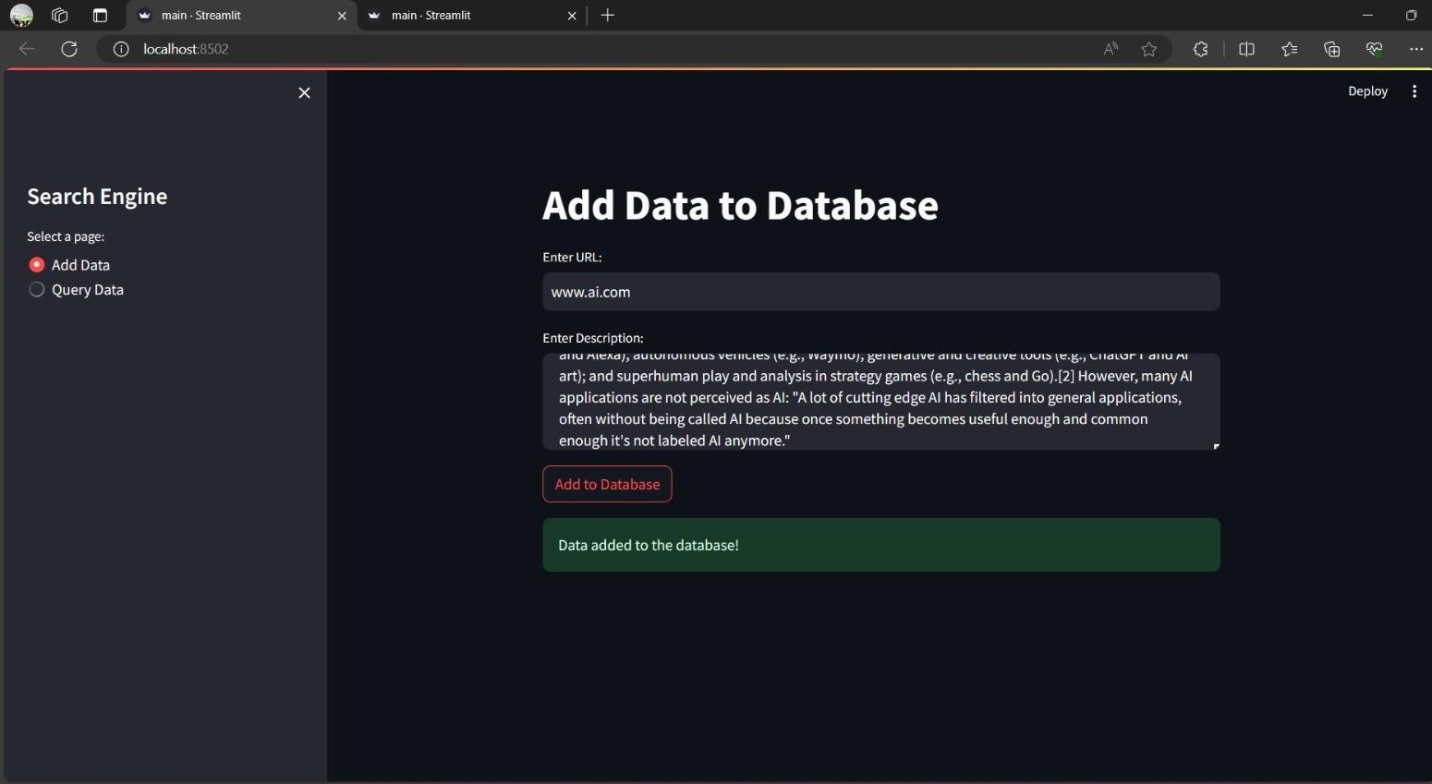
Fig 7.1 Positive Output

CHAPTER-8 RESULTS

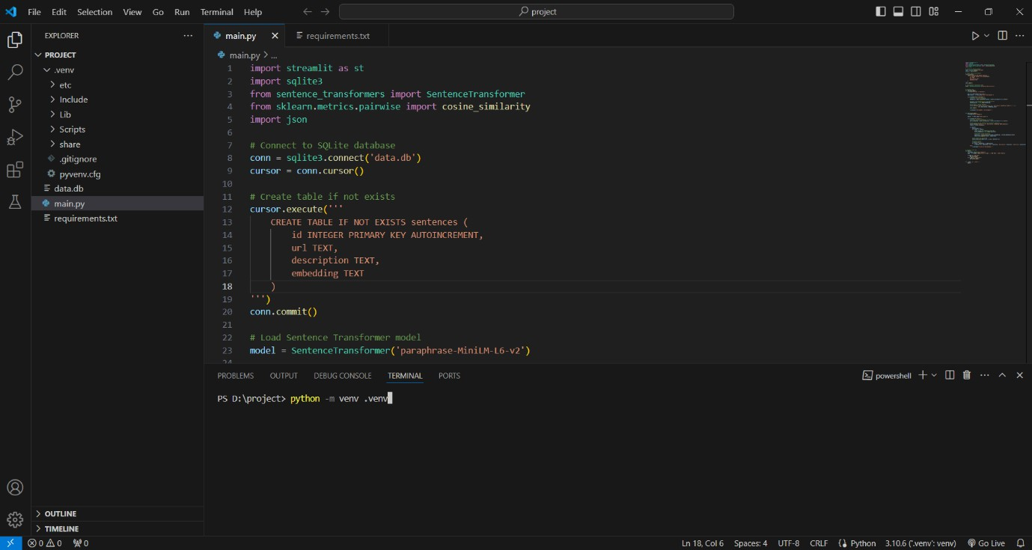
Fig 0.1 Create an virtual environment By using the syntax: python –m venv myenv
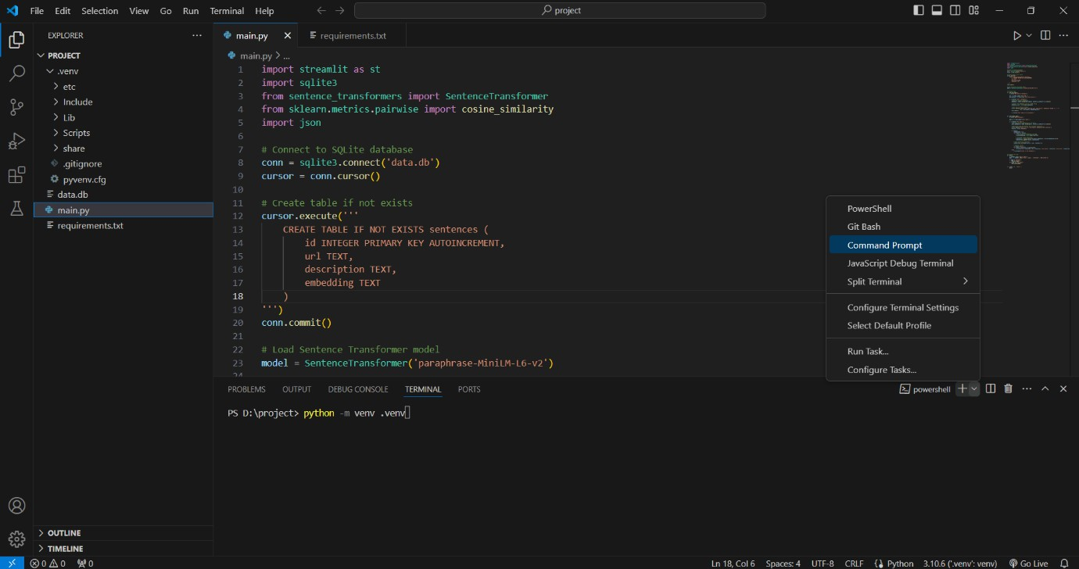
Fig 0.2 Open Command Prompt to activate venv

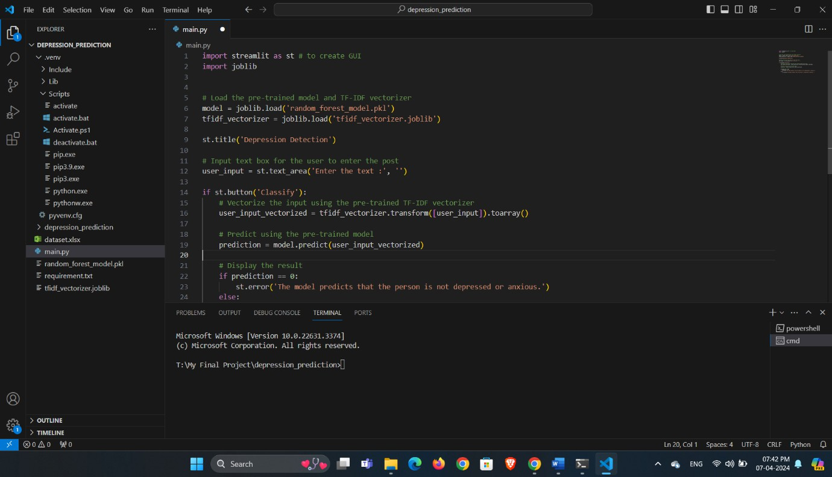
Fig 0.3 Acivate venv
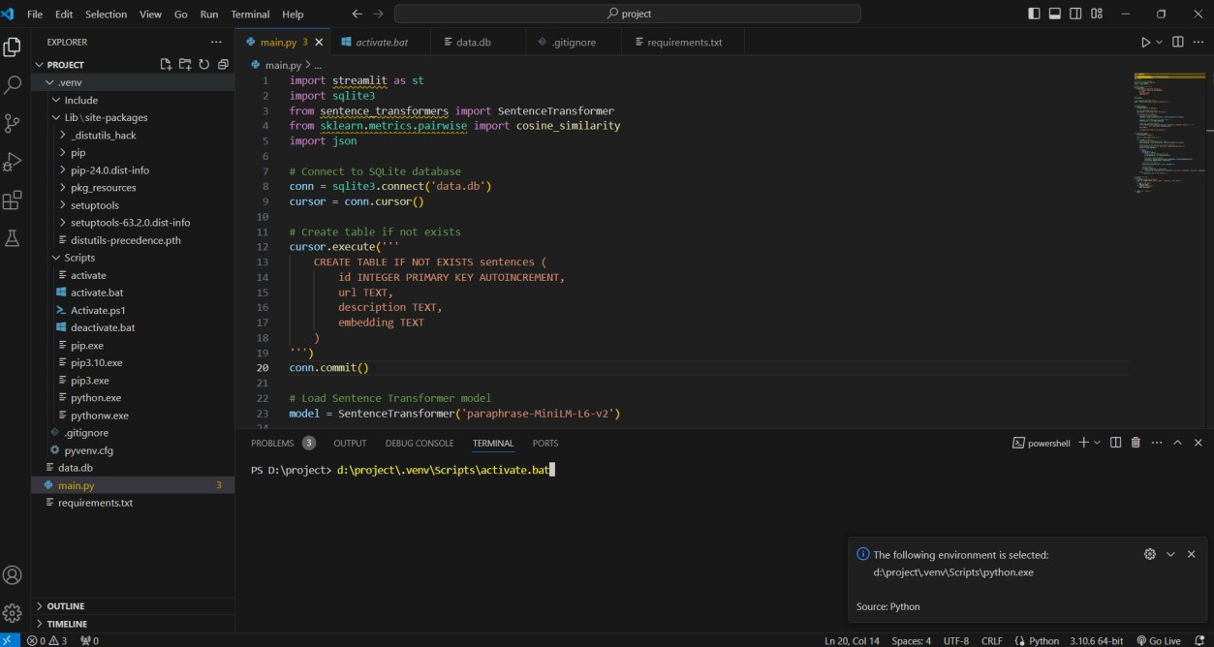
Fig 0.4 To pip install requirements by using the syntax: pip install –r requirements.txt

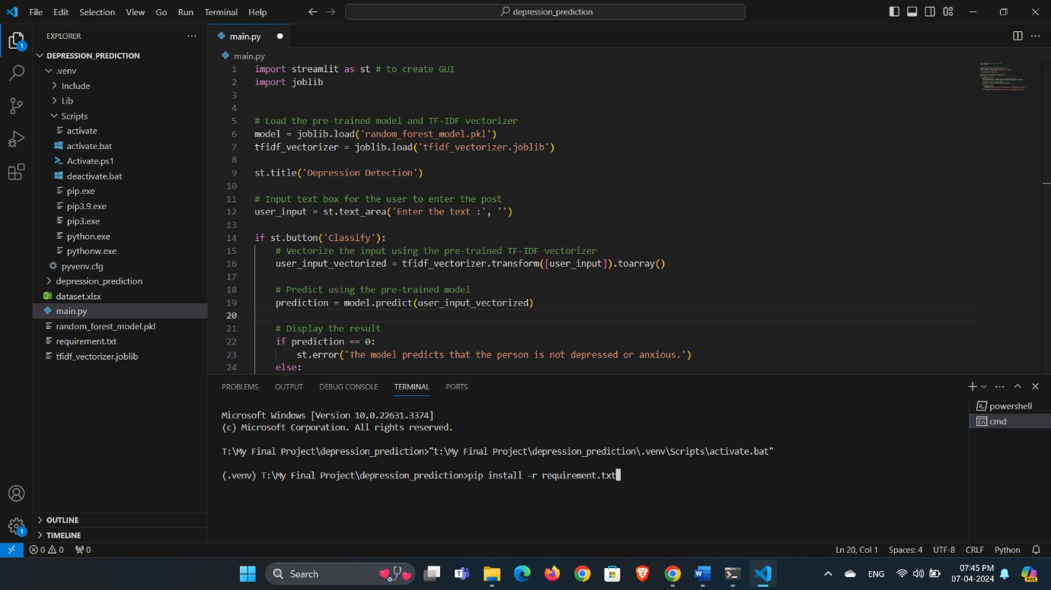
Fig 0.5 Press Enter
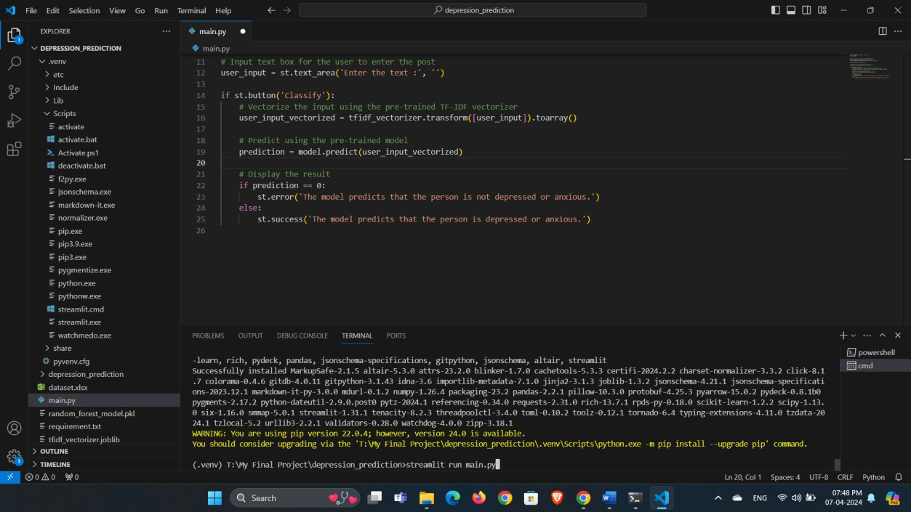
Fig 0.6 Collecting Requirements

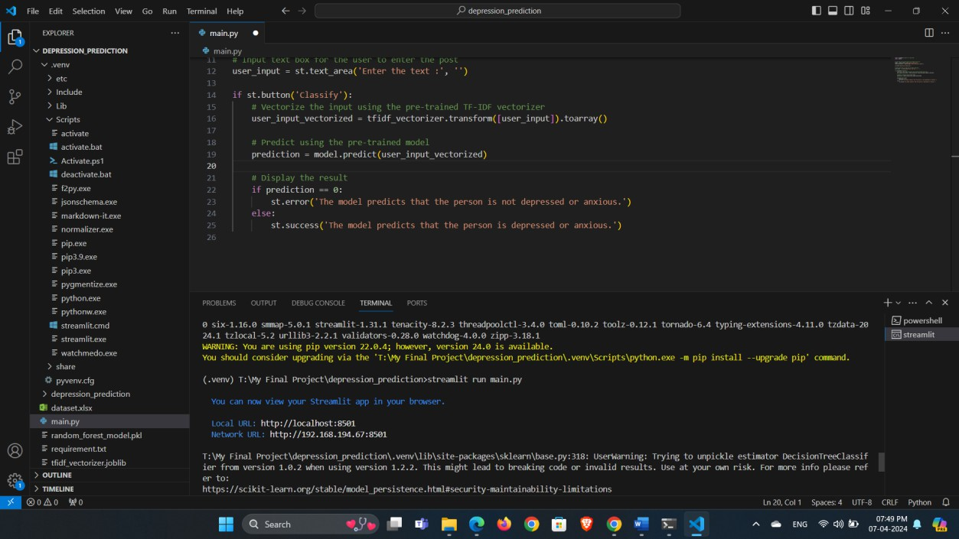
Fig 0.7 Run the main file streamlit run main.py

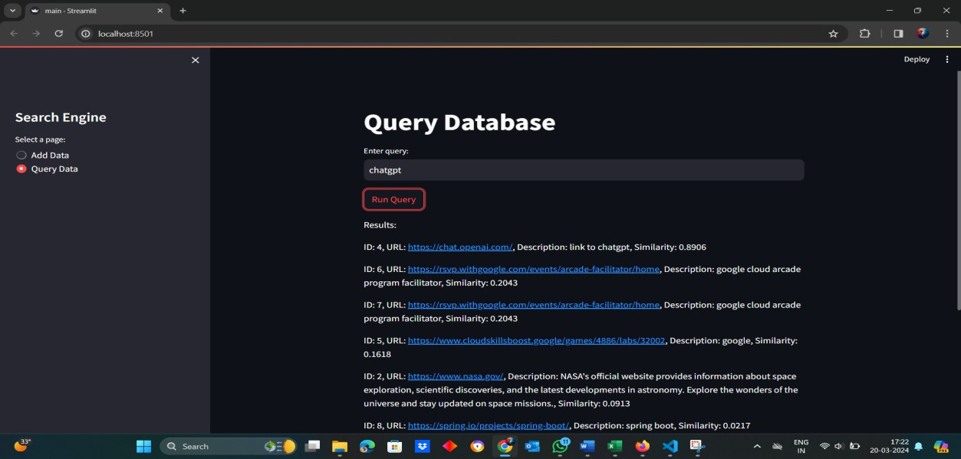
Fig 0.8 Then obtained the final output web page

CHAPTER-9

CONCLUSION & FUTURE ENHANCEMENT

The real-time web search engine represents a pivotal advancement in the realm of information retrieval, offering users unparalleled access to up-to-date and relevant web content. Through continuous crawling, indexing, and dynamic ranking algorithms, this innovative platform has redefined the way users interact with online information, enabling them to stay informed, connected, and engaged in today's fast-paced digital landscape.
By empowering users to perform searches, filter search results, and access personalized content in real-time, the search engine has revolutionized the process of discovering and consuming information on the web. Moreover, the system's robust architecture, coupled with advanced monitoring and management capabilities, ensures optimal performance, scalability, and reliability, even under the most demanding conditions.
In conclusion, the real-time web search engine stands as a testament to the power of technology in democratizing access to information and empowering individuals in their quest for knowledge. With its real-time capabilities and user-centric design, the search engine not only facilitates information discovery but also fosters greater connectivity and collaboration in the digital age, paving the way for A more informed and enlightened society.

Advanced machine learning integration:

Incorporate machine learning algorithms to enhance search relevance, personalization, and user engagement. Algorithms could learn from user behavior, preferences, and context to continuously improve search results.

Semantic search capabilities:

Integrate semantic search techniques to understand the meaning and context of search queries, enabling the search engine to provide more accurate and contextually relevant results.

Voice search and natural language processing (nlp):

Implement voice search functionality and NLP capabilities to allow users to perform searches using natural language queries, improving accessibility and user experience.

Real-time trend analysis and prediction:

Develop capabilities to analyze real-time web trends and predict emerging topics or events,
enabling the search engine to provide proactive recommendations and alerts to users.

Enhanced content aggregation and summarization:

Expand content aggregation capabilities to include a wider range of sources and formats (e.G., Social media, multimedia content). Additionally, develop content summarization algorithms to provide concise summaries of search results.

BIBLIOGRAPHY

- Hargraves, D., & Dziuban, C. (2018). "Real-time Web Search and Tet Analysis: A First Step Toward Improved Understanding of College Student Content." Online Learning, 22(4), 183-201.
- Gervais, M., & Raghavan, S. (2019). "Real-time Personalized Search Engine."
U.S. Patent No. 10,216,854.
- Yang, C., & Chang, M. (2019). "Real-Time Social Search Engine for E- Commerce." In International Conference on Human-Computer Interaction (pp. 687-693). Springer, Cham.
- Eshete, T., & Du, X. (2017). "Real-time Web Search Engine Personalization using Click-Based User Interest Modeling." arXiv preprint arXiv:1712.09739.
- Ramamoorthy, P., & Karp, B. (2018). "Real-Time Search Engine Query Execution Plan Compilation." U.S. Patent No. 9,995,722.
- Mizzaro, S. (2019). "Real-time IR: a review." Information Retrieval Journal, 22(2- 3), 127-159.
- Zhao, W., & Shen, H. T. (2018). "Temporal and Real-Time Aspects in Web Search." In Web-Age Information Management (pp. 3-15). Springer, Cham.
- Liu, H., & Chang, W. (2017). "Design and Implementation of a Real-Time Search Engine based on Spark." In International Conference on Big Data Intelligence and Computing (pp. 141-146). Springer, Cham.
- Yang, X., & Zou, Q. (2019). "A Real-Time Search Engine Based on High- Performance Computing." In 2019 IEEE International Conference on Web Services (ICWS) (pp. 31-38). IEEE.
- Oka, K., & Murakami, Y. (2018). "Real-time Content Retrieval System based on Semantic Search Engine for Security Situational Awareness." In International Conference on Innovative Mobile and Internet Services in Ubiquitous Computing (pp. 207-218). Springer, Cham.

