Generated public and private keys: ssh-keygen -t rsa -f ~/id_rsa -C rahul_bastia007

Moved the public and private key to /home/rahul_bastia007/.ssh folder

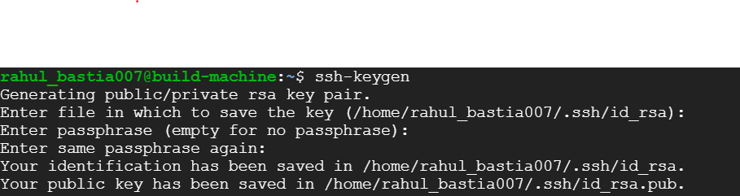

Added the commands in .bashrc file

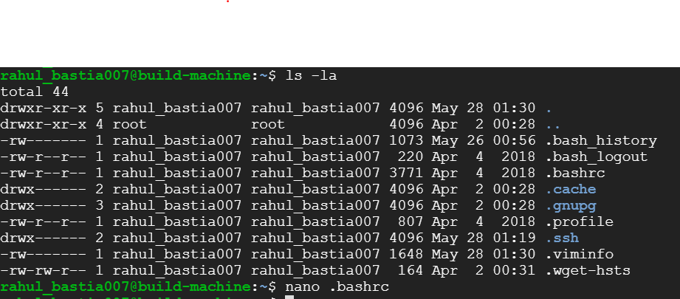

Created authorized_keys on target/slave machine: Copied the public key from the master node.

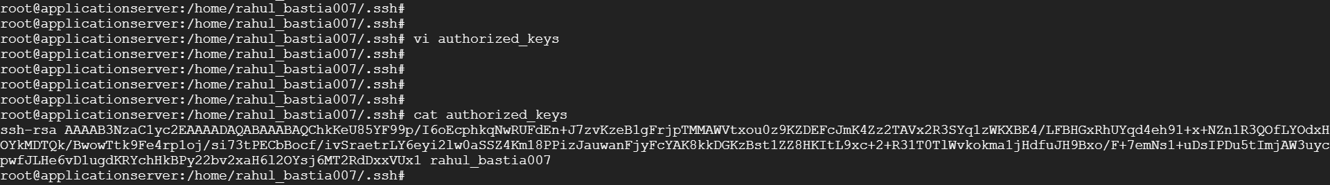

Using SSH connected to the slave node and enabled password less authentication:

ssh -i id_rsa rahul_bastia007@applicationserver

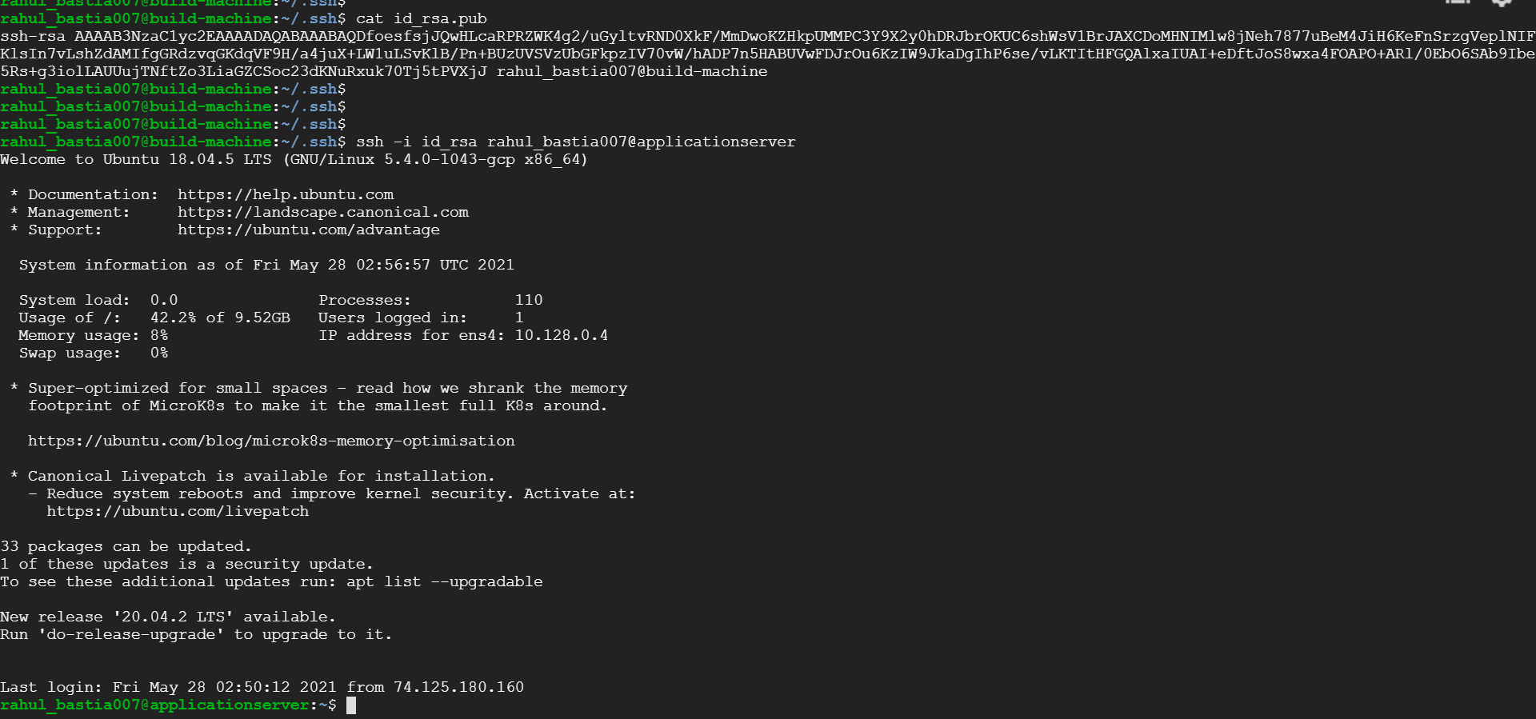

Installed ansible on master node

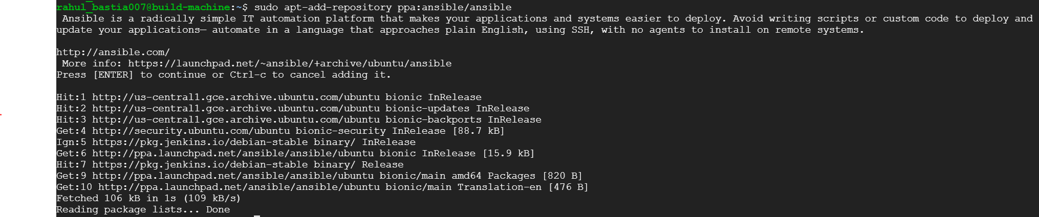

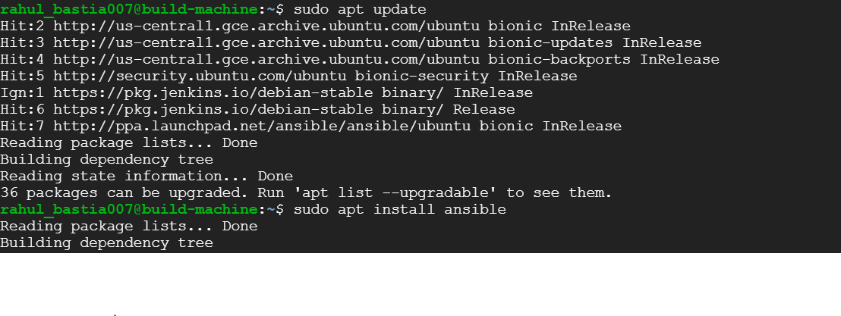

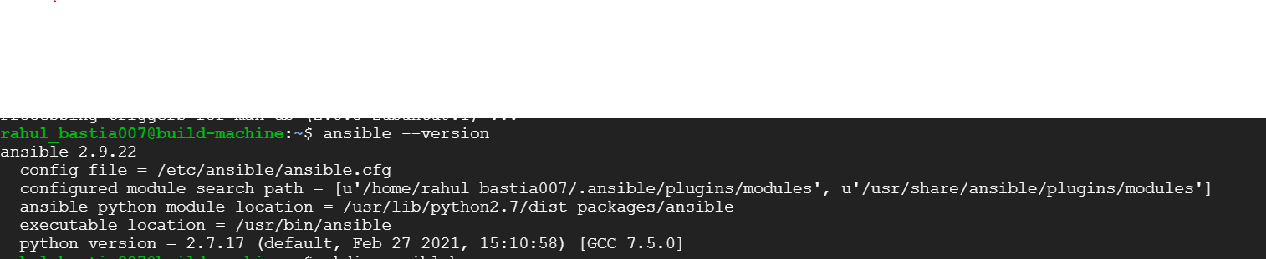

Pinged the slave node via ansible:

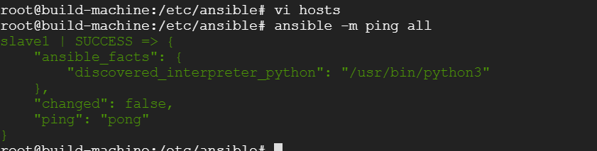

Cloned the war-test application from GIT:

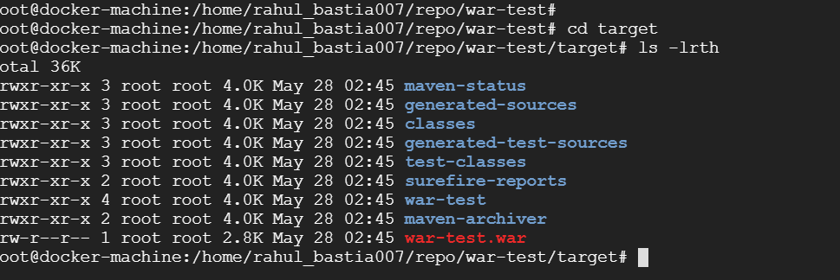

Built and pushed the test image to docker hub:

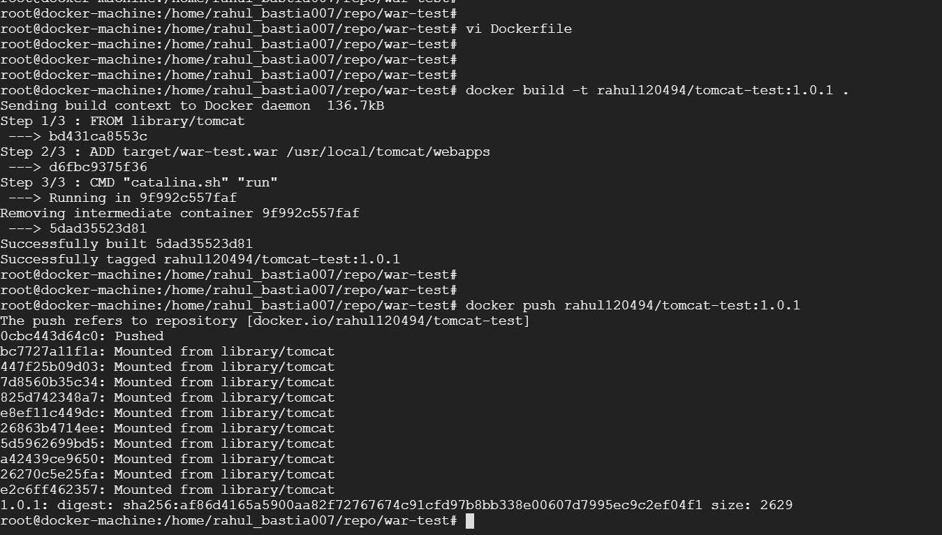

Created the Ansible Playbook:

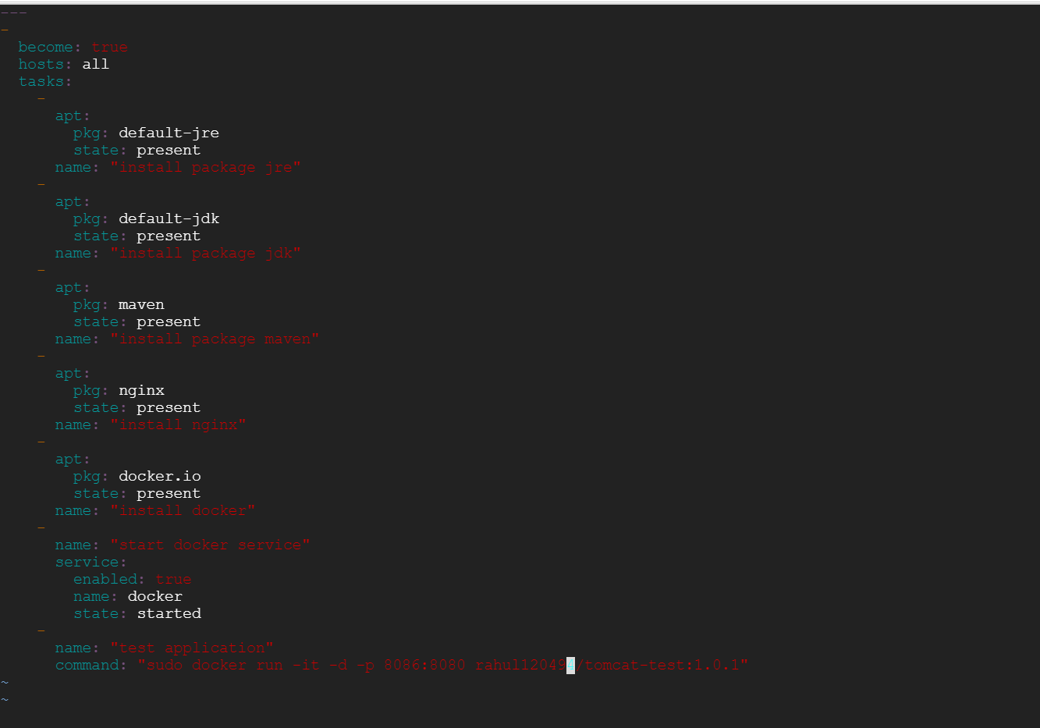

Ansible playbook output: ansible-playbook myplaybook.yml

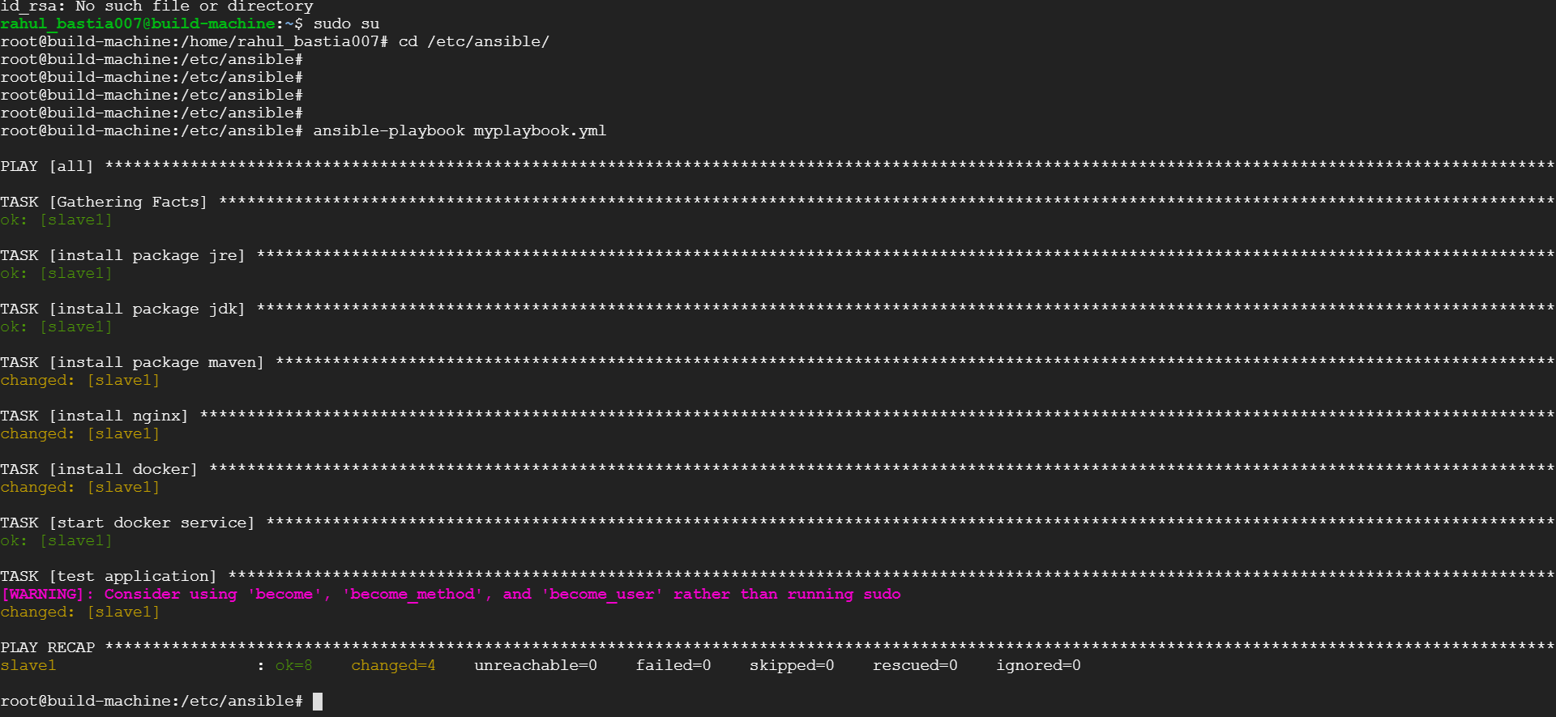

The war-test application is running on slave node on port 8086:

