Assignment:1

Created a docker file with base image nginx with latest tag

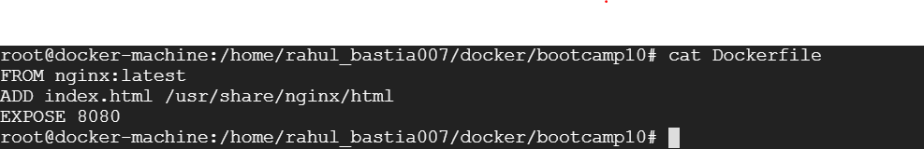

Building docker image

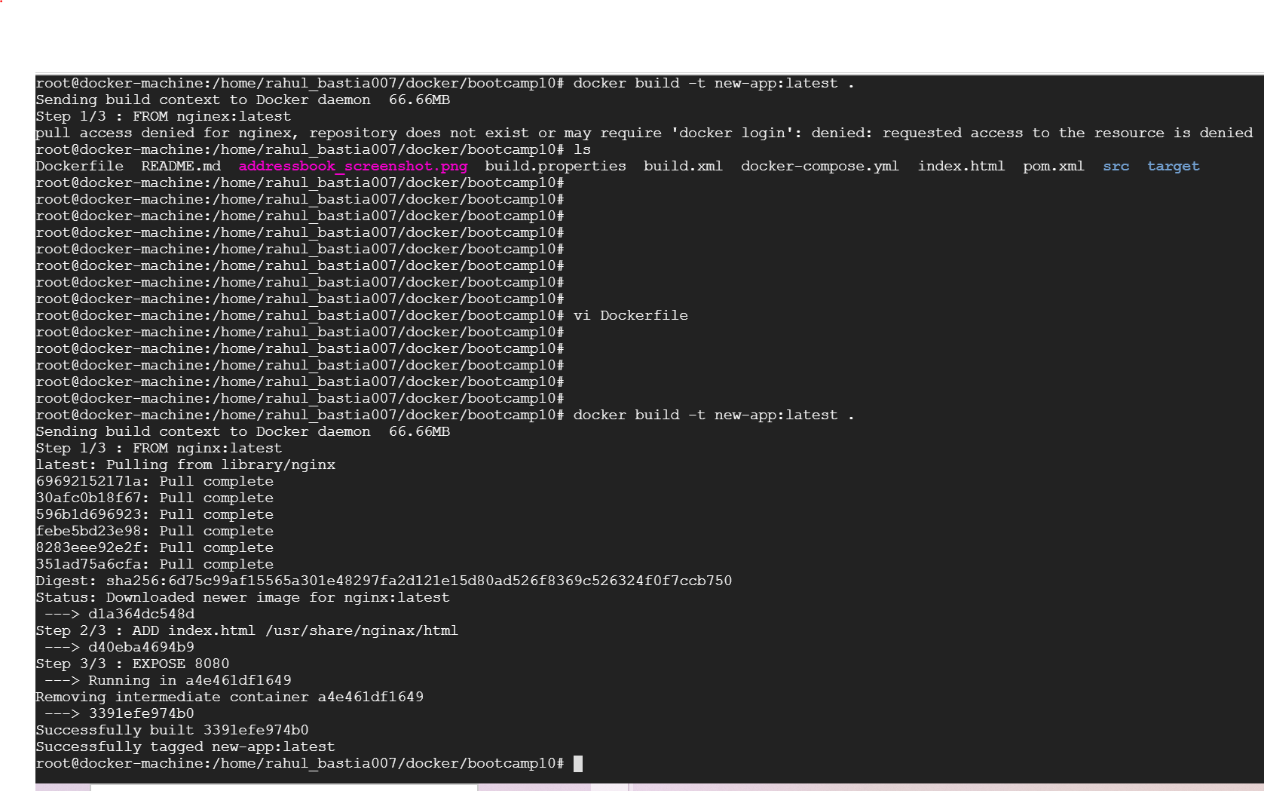

Building docker Image

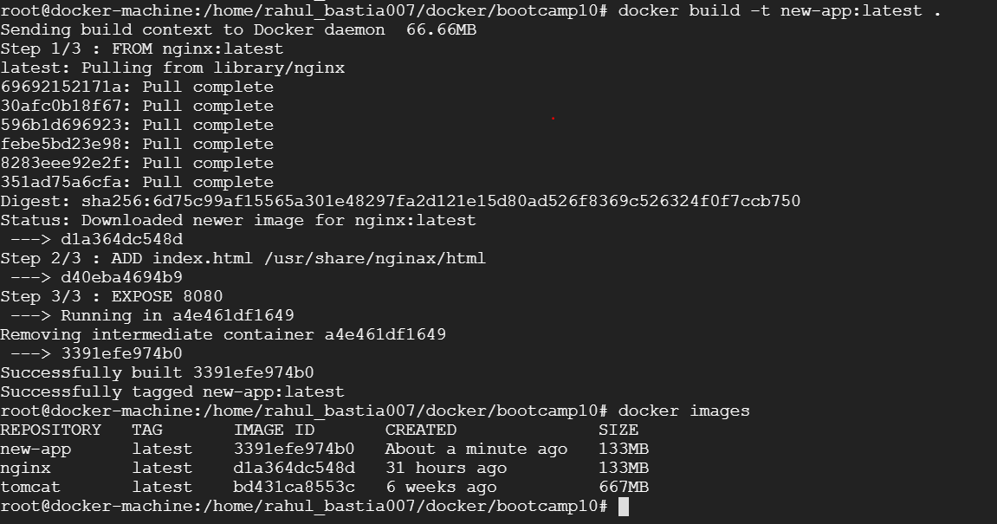

Docker image push to the hub:

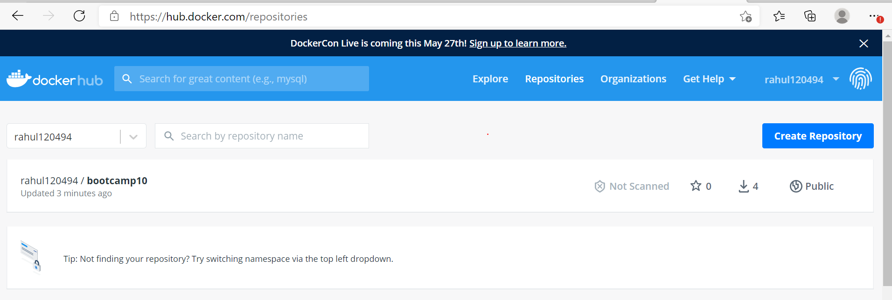

Docker pull of image

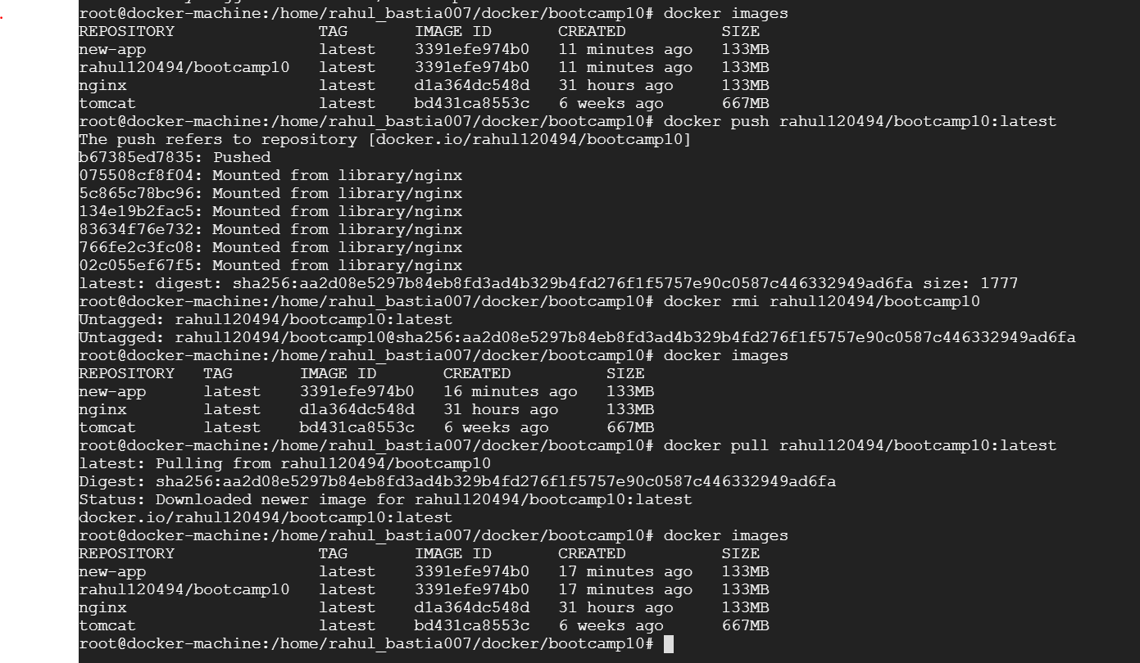

Service is running on web



Docker-compose: created 2 services

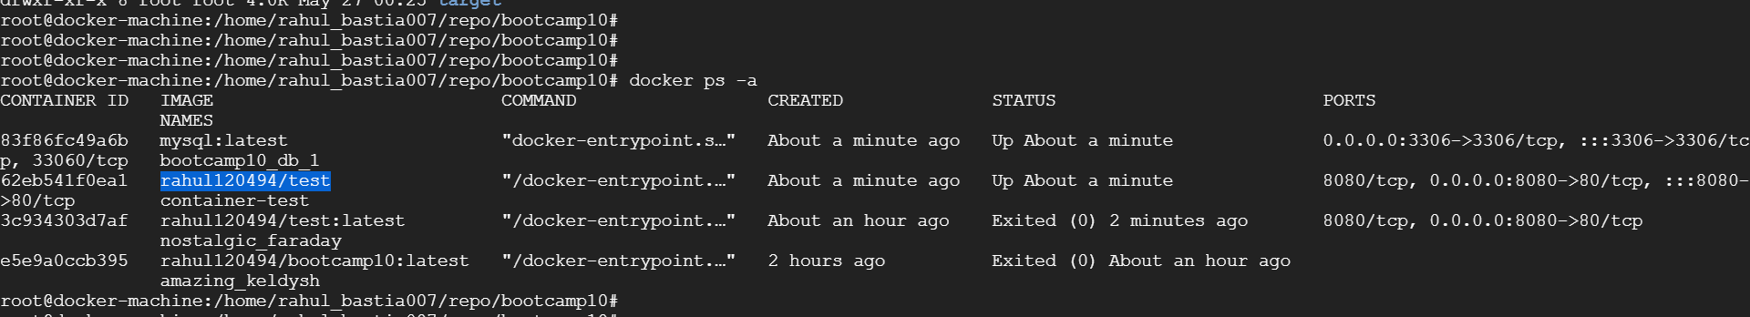

Logged into mysql:

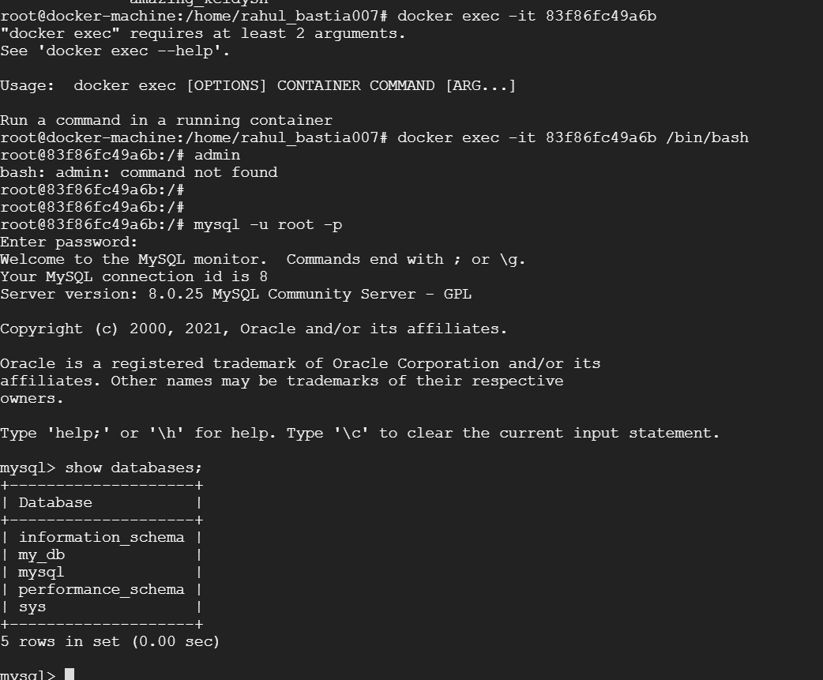

Created test table with require columns:

