Day2_Assignment:

Git: created two branches and introduced merge conflict by editing the same file in the master branch. Please find the screenshot for the same:

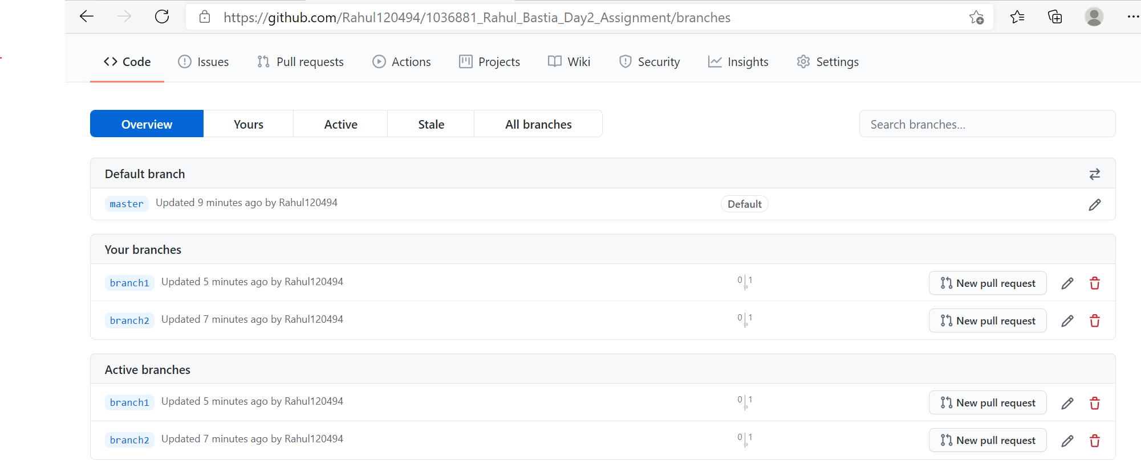

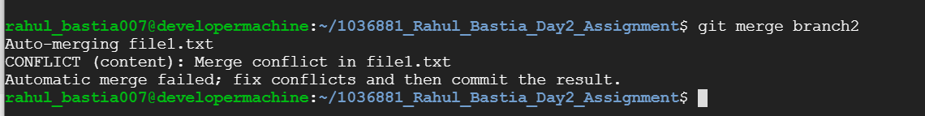

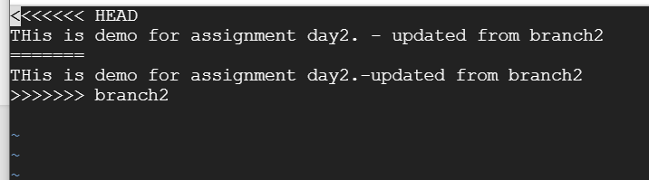

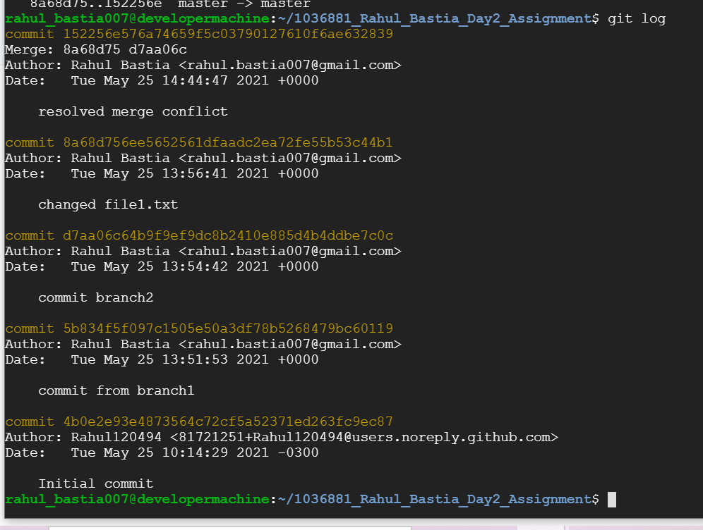

1. Jenkins: created free style and pipeline bob in Jenkins & deployed it to tomcat server. Please find the screenshot below:
2. Webhook

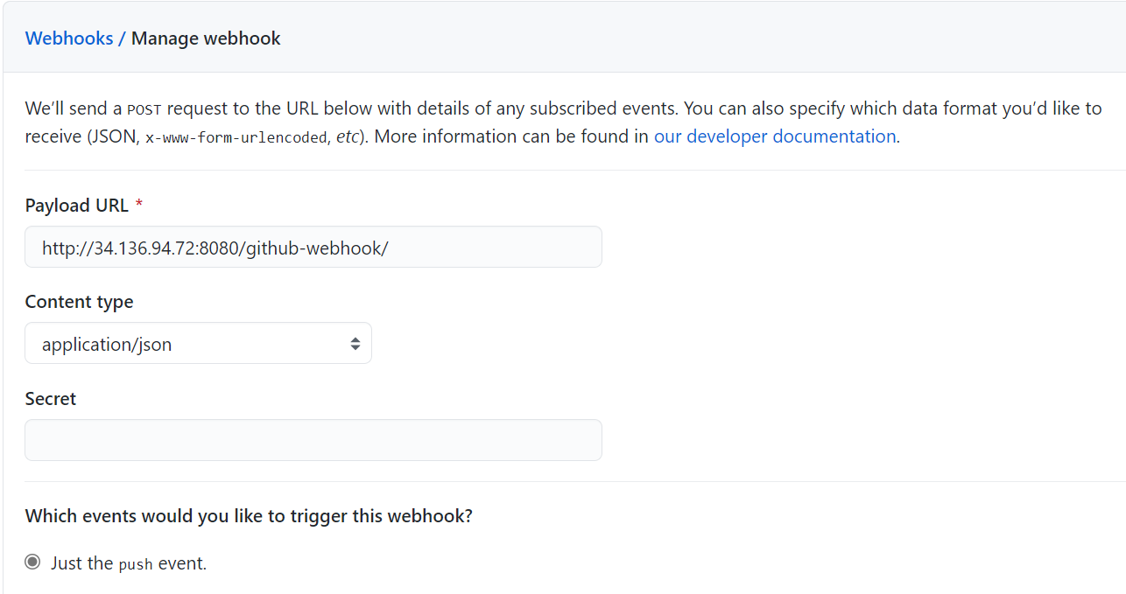

1. Free style job result on tomcat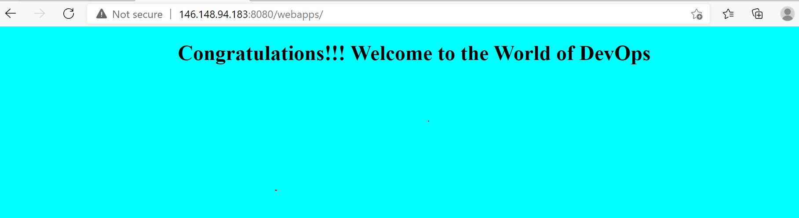
2. Pipeline job tomcat

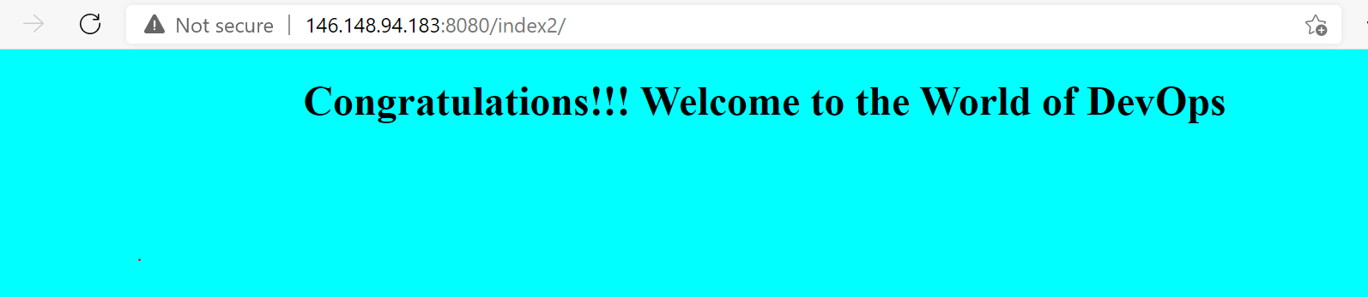

1. pipeline job on Jenkin

