**AWS – Level 1**

**Hands-on**

**IAM**

* Create a Free Tier account for AWS console login.

Solution: Go to <https://aws.amazon.com/free/> . Click “Create free Account”.

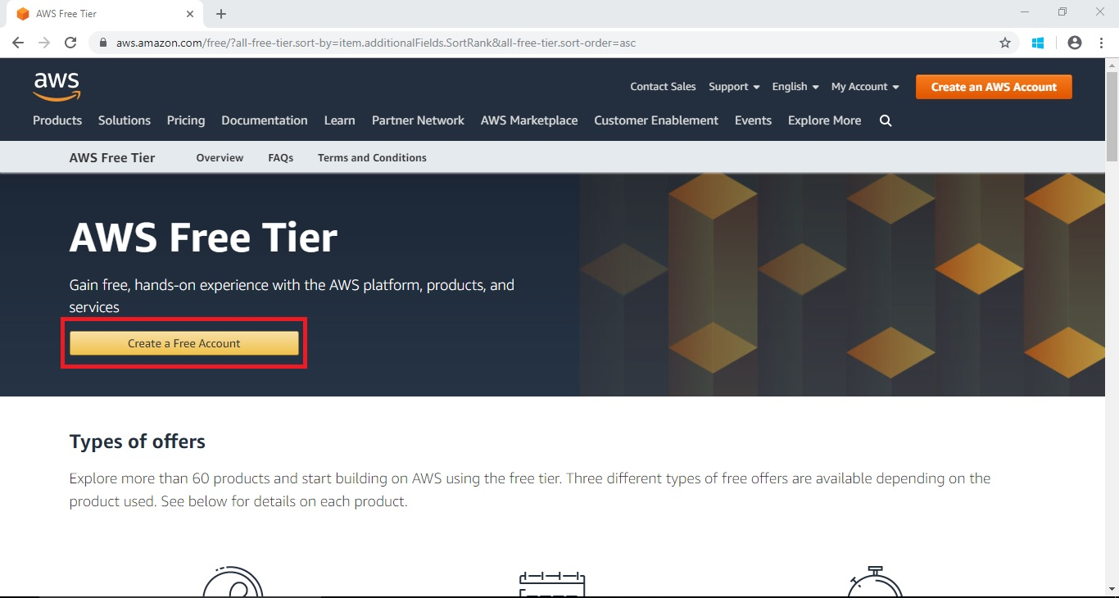

Fill all the detiles like(Email id, Contact Information, Payment information, confirm your identity)

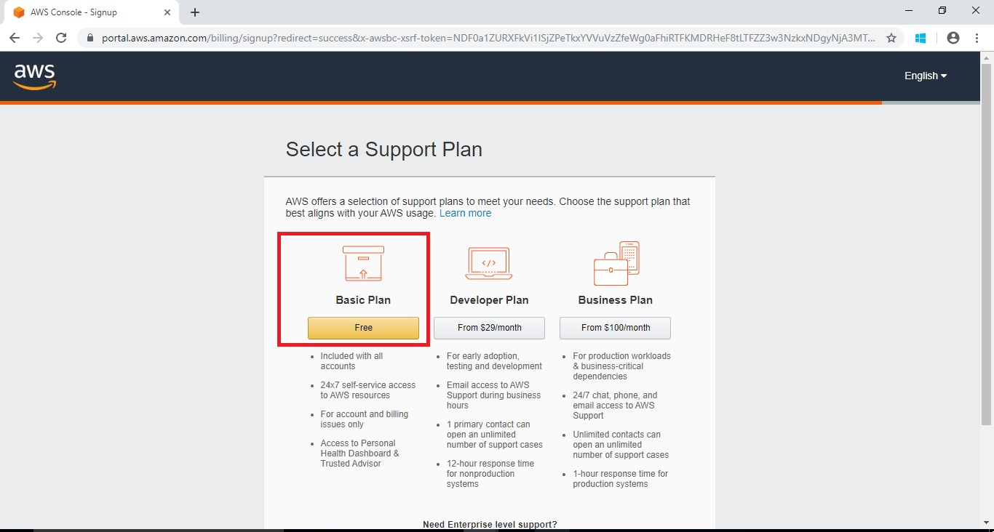

* Activate Multi Factor Authentication for that account

Solution:

Step1: Go to your account and select “my Security credenitals”.

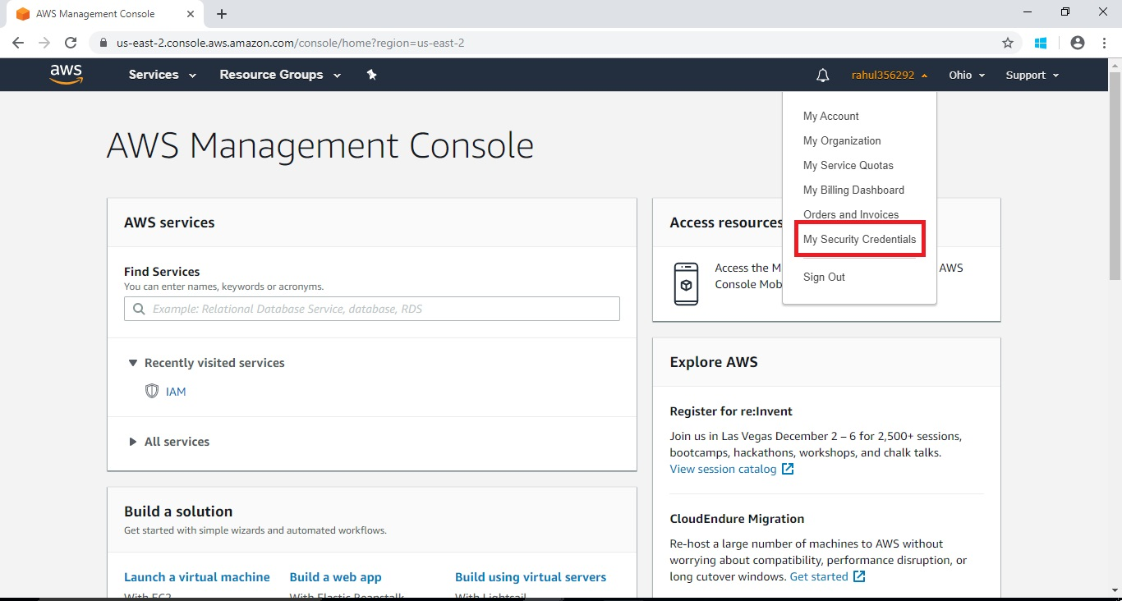

Step 2: Select “Activate MFA”

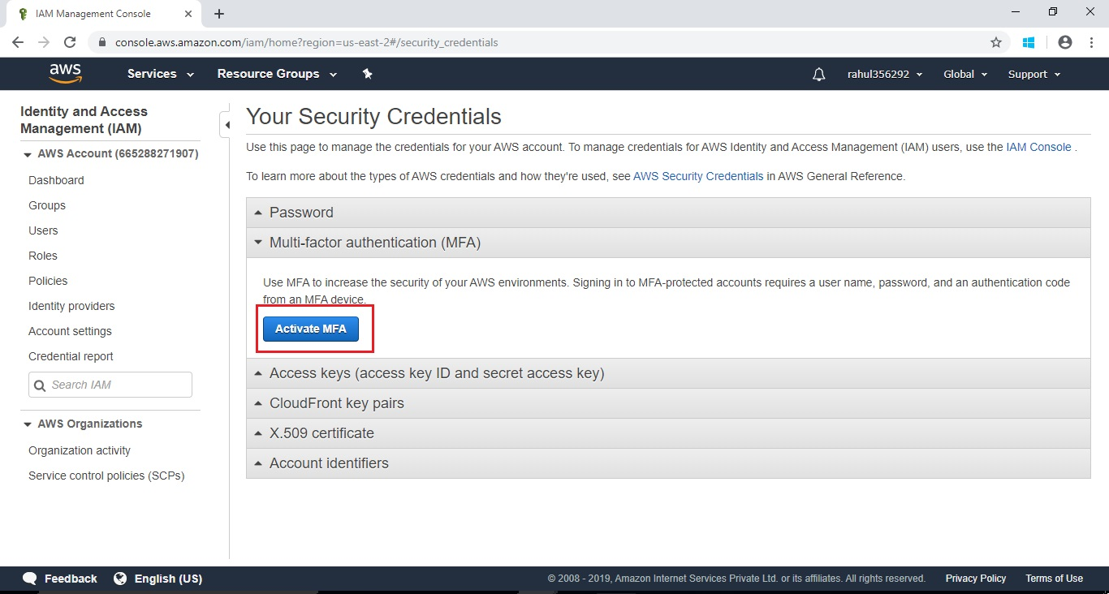

Step 3: Select “Virtual MFA device”

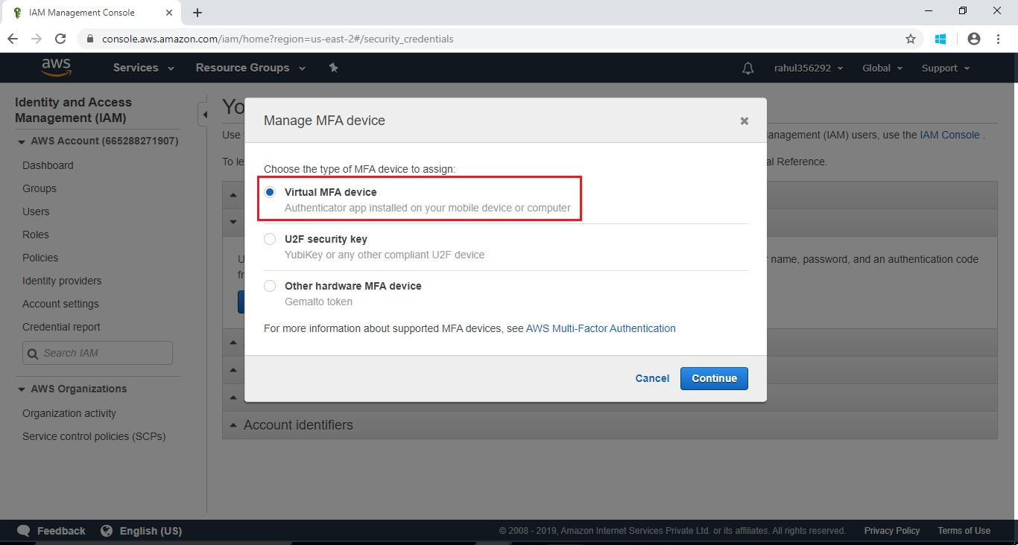

Step 4: using Mobile device scan the QR code( google authenticator).

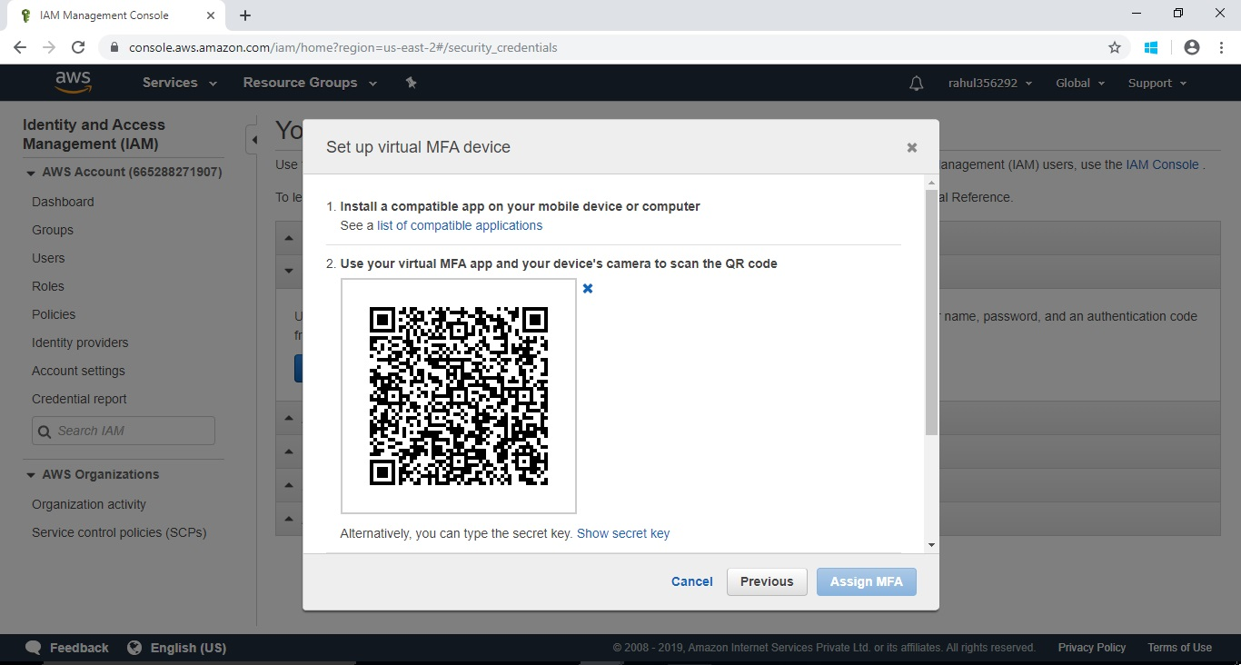

Step 5: click Assigne MFA and click close

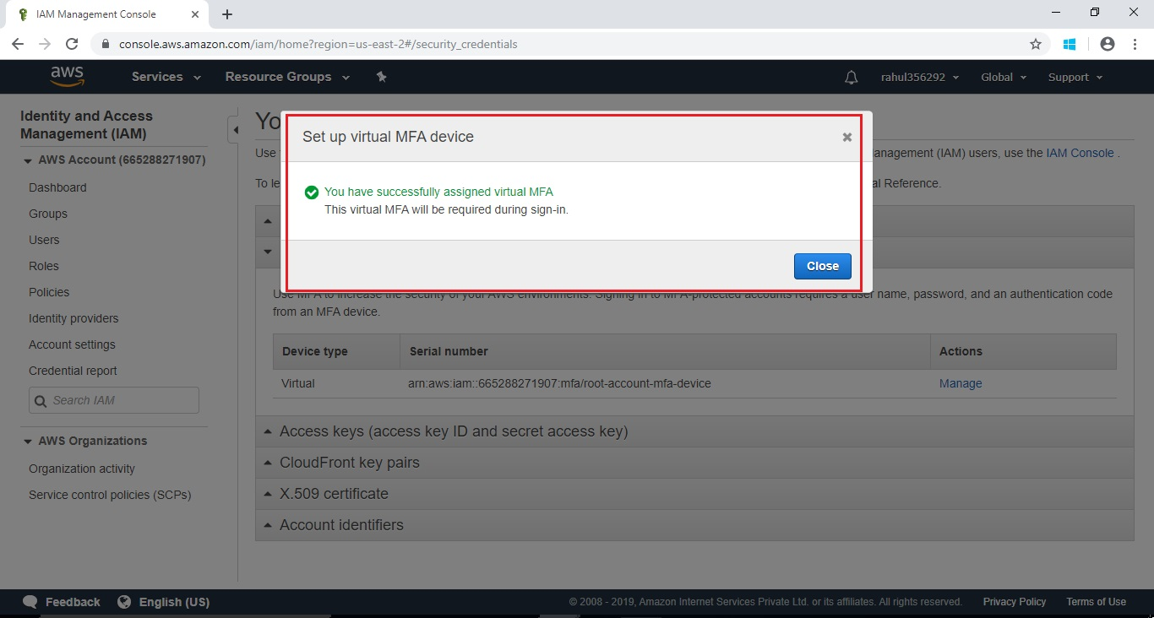

* Create an IAM user called awsadm1, log-in to AWS console using awsadm1 credential

Solution:

Step 1: Go to Services -> Security, Identity, & Compliance ->IAM

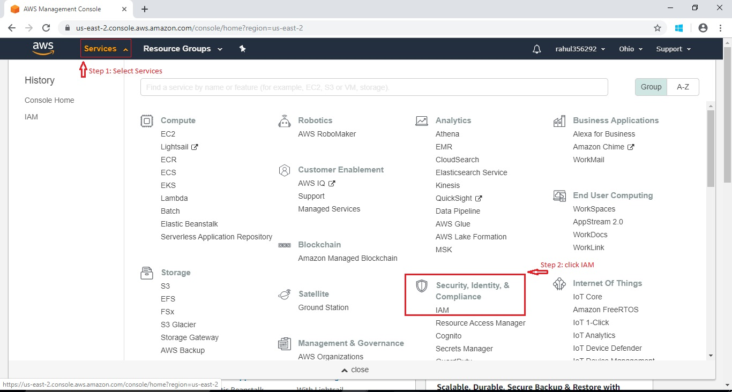

Step 2: Click to the Users -> Add user

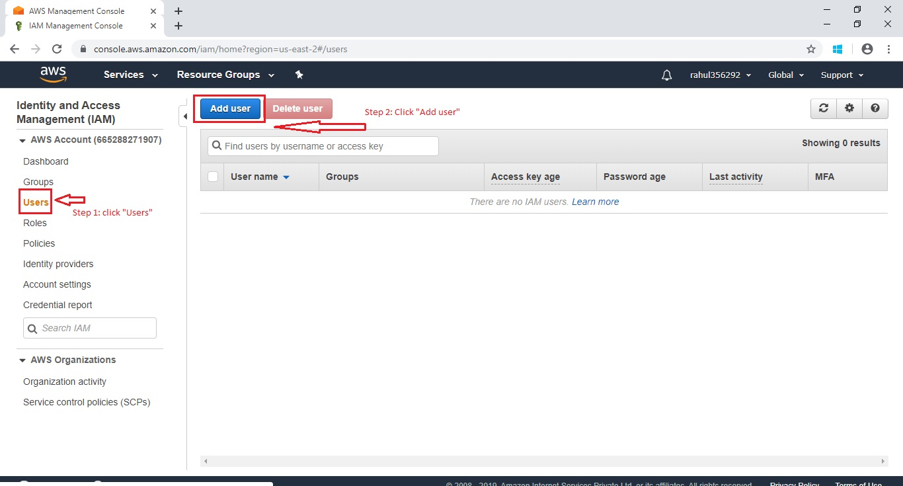

Step 3: Fill all the required field.

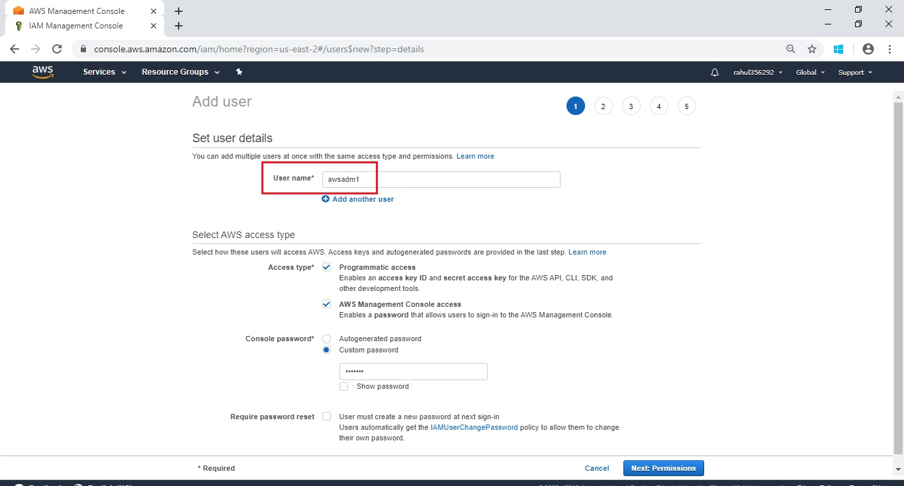

Step 4: Set permissions.

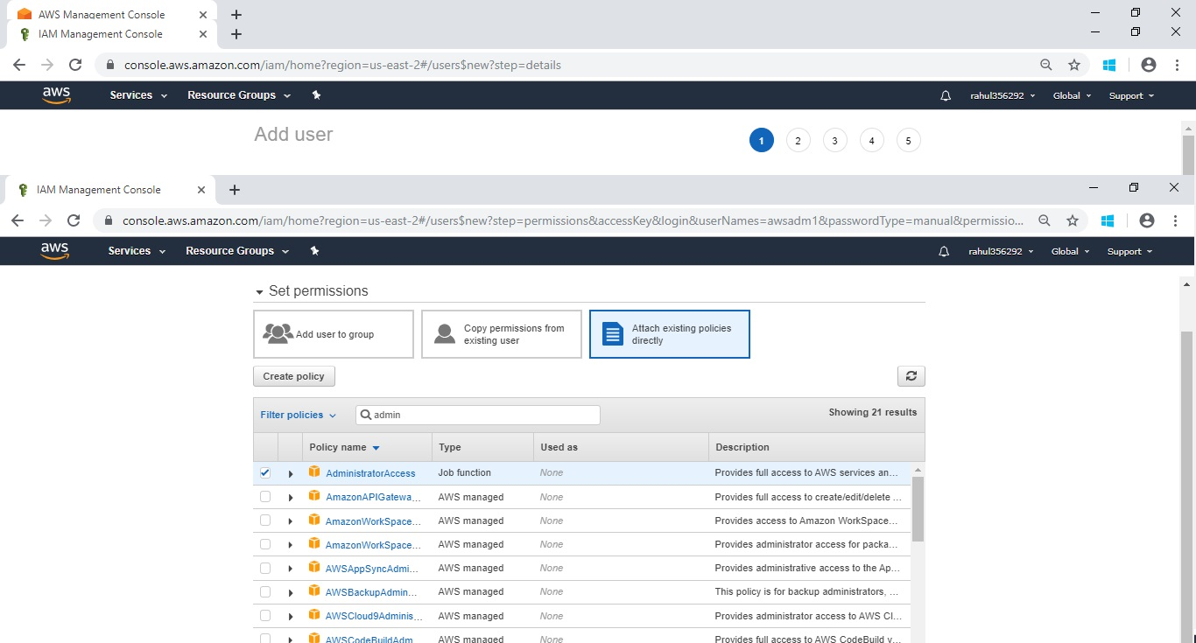

Step 5:Review

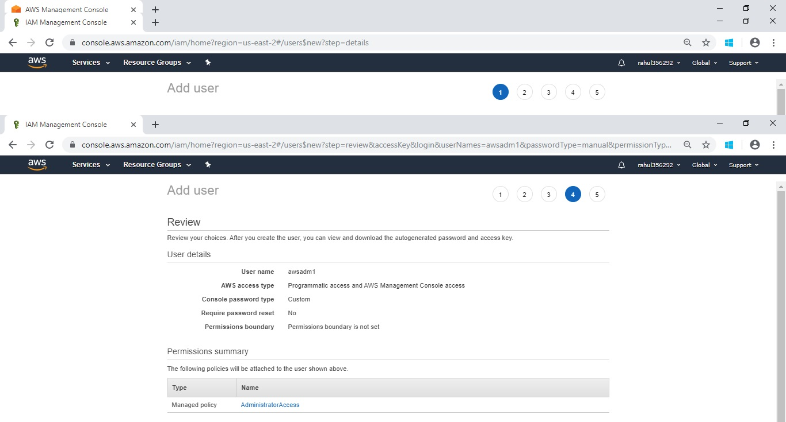

Step 6: download .CSV file and copy awsadm1 URL

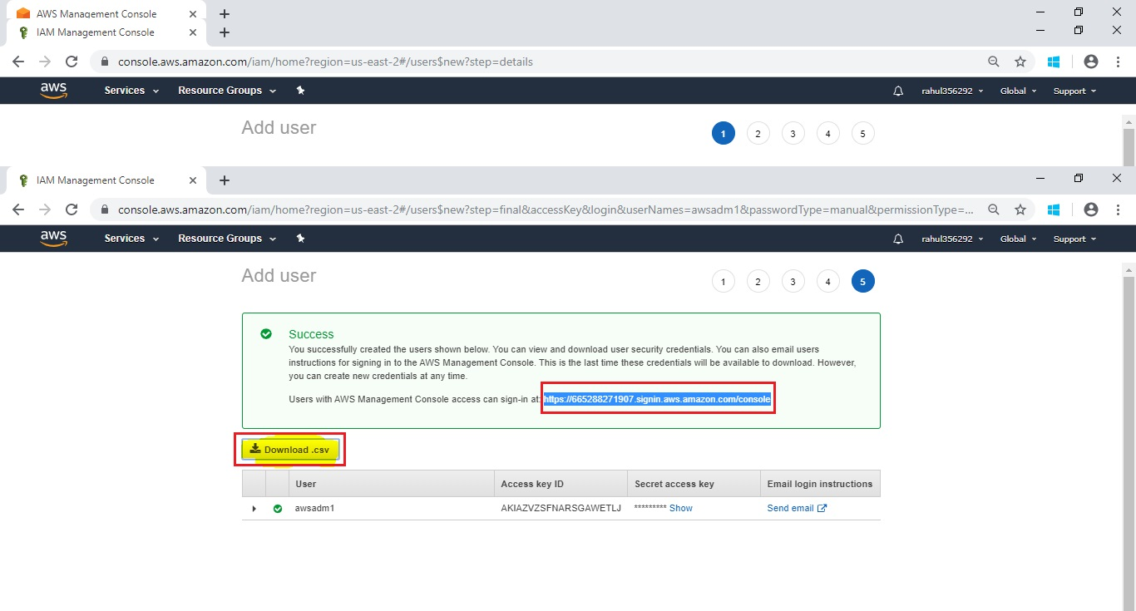

Step 7: log-in to AWS console using awsadm1 credential.

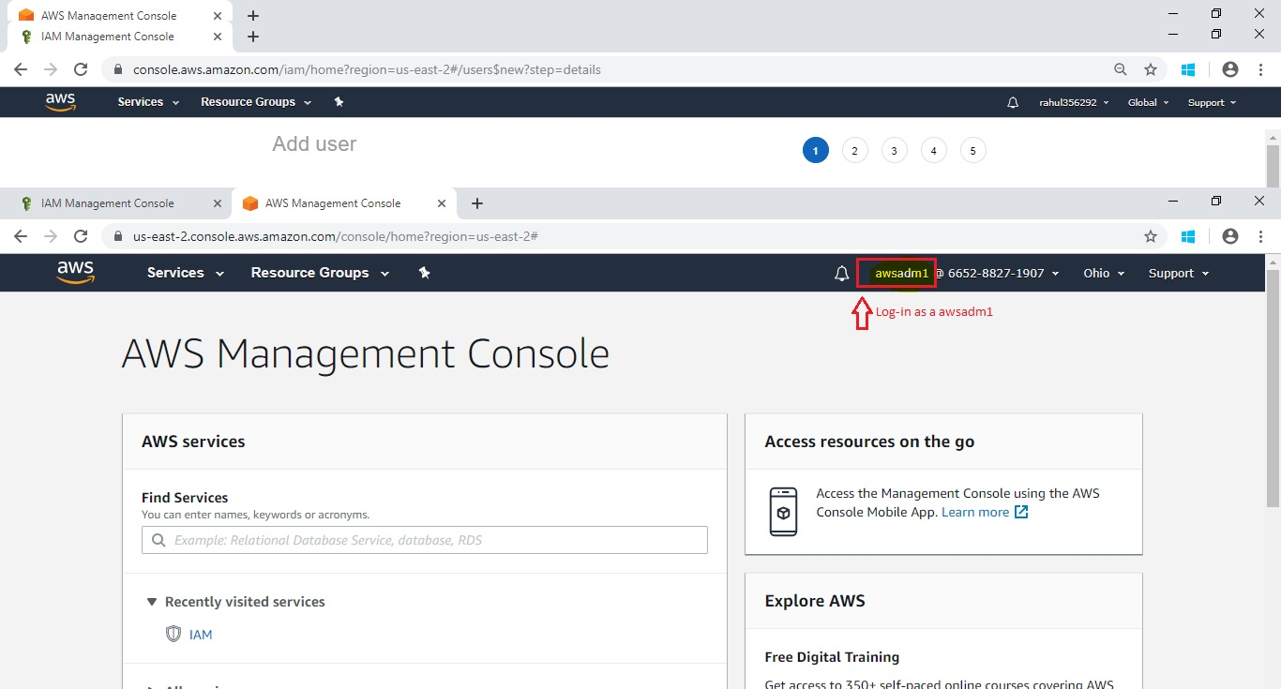

* Create a Group called “s3-group”

Solution:

Step 1: Go to Services -> Security, Identity, & Compliance ->IAM



Step 2: Select Groups -> Create New group

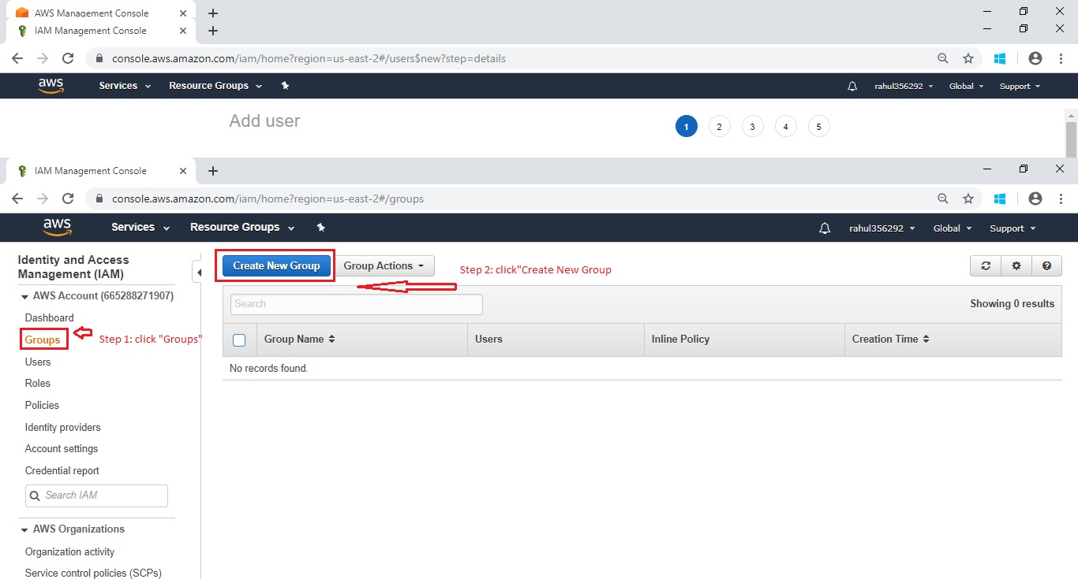

Step3: provide Group Name

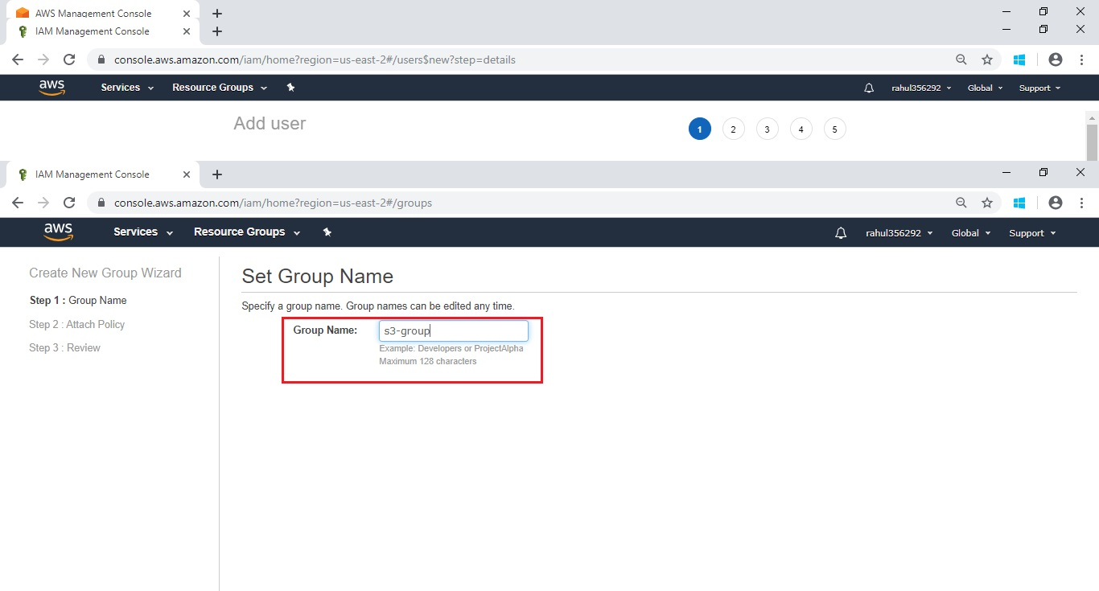

Step 4:Add Policy

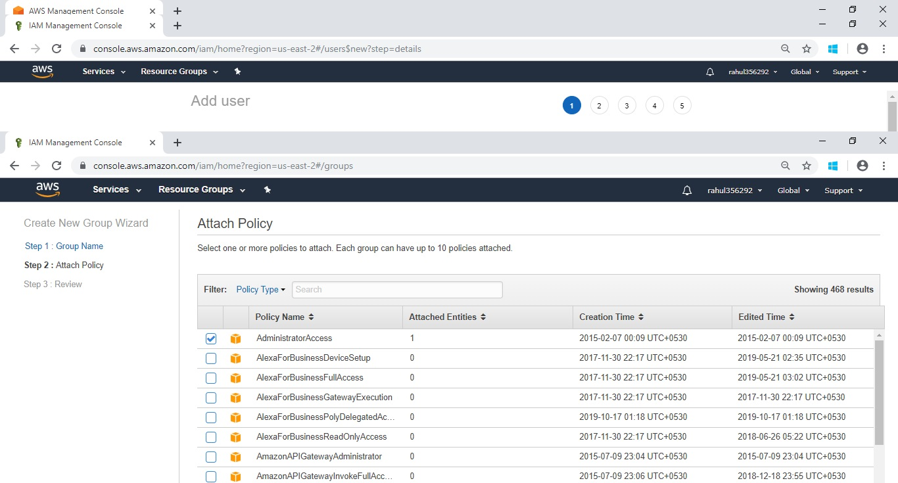

Step 5:Review

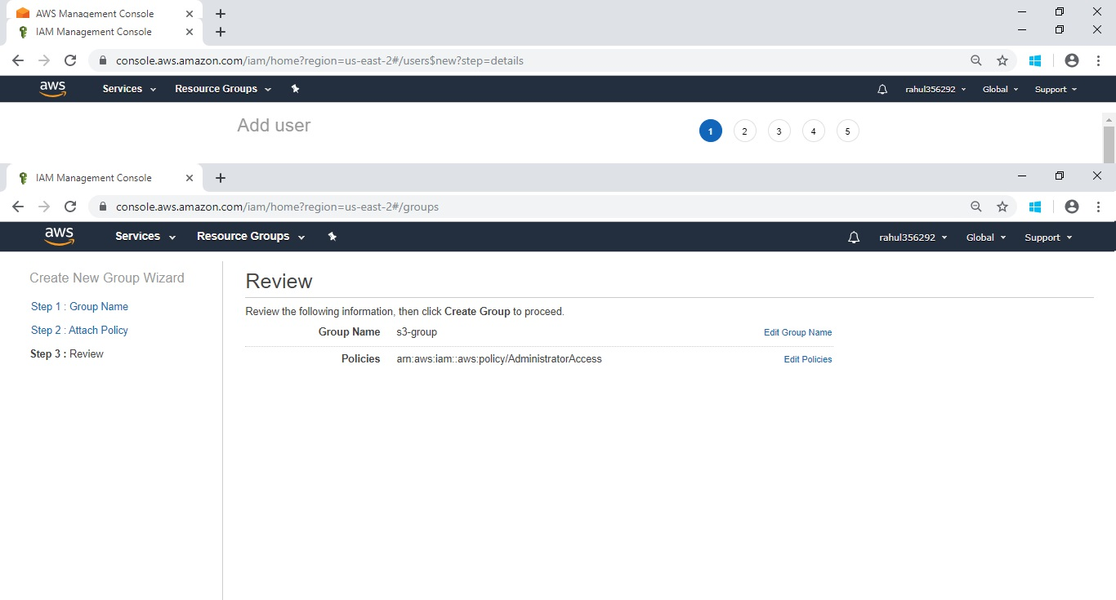

Step 6: Group has been created.

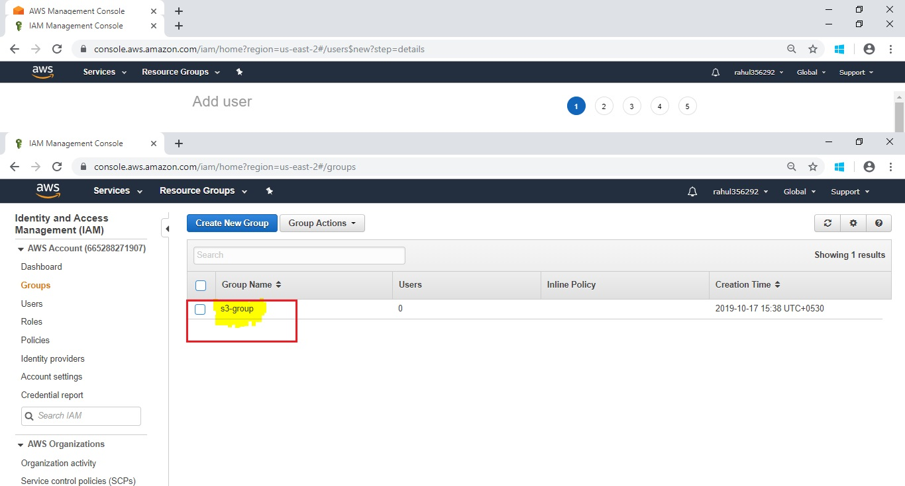

* Create 3 users called s3-user1, s3-user2 and s3-user3.

Solution:

Step 1: Go to Services -> Security, Identity, & Compliance ->IAM



Step 2: fill user name

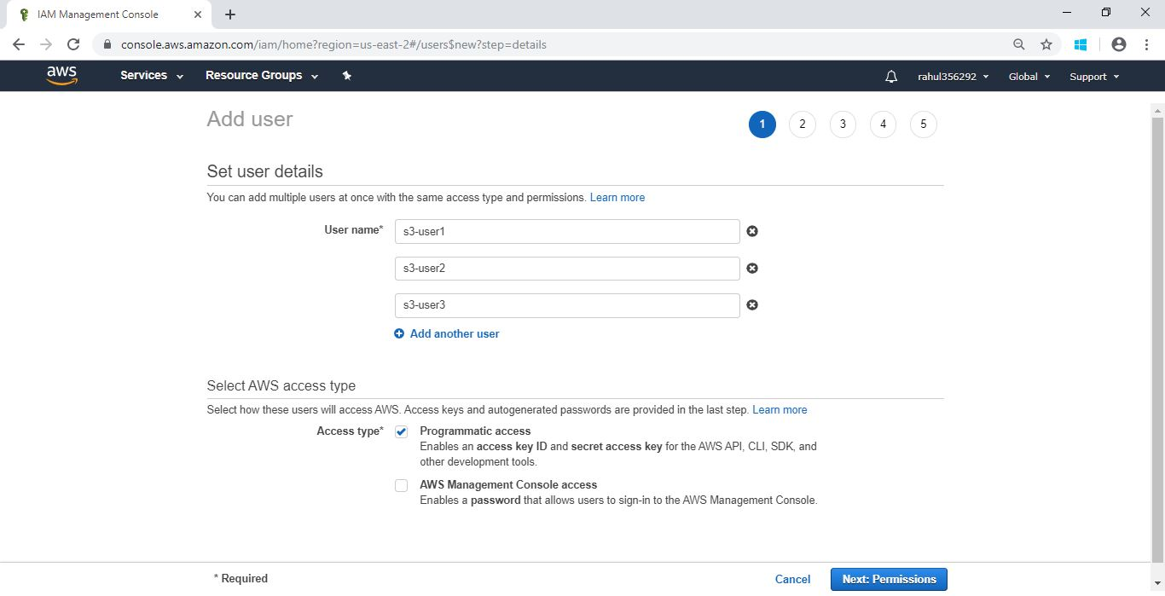

Step 3: Review

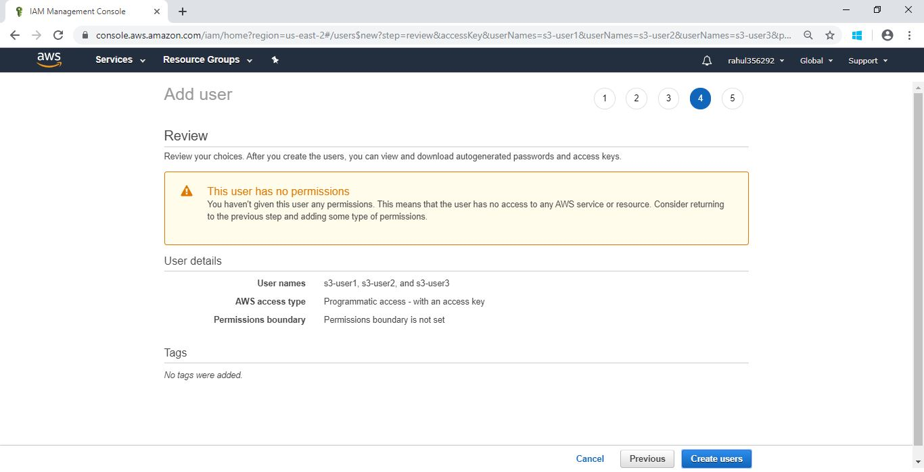

Step 4: uses has been created.

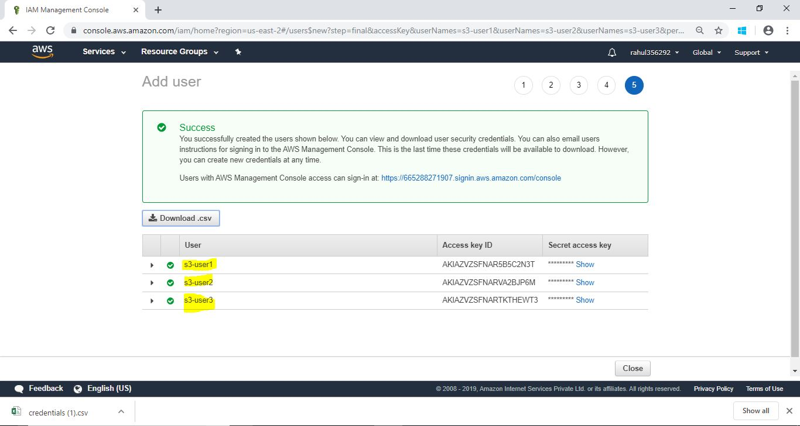

* Provide S3 view privilege to s3-group.

Solution:

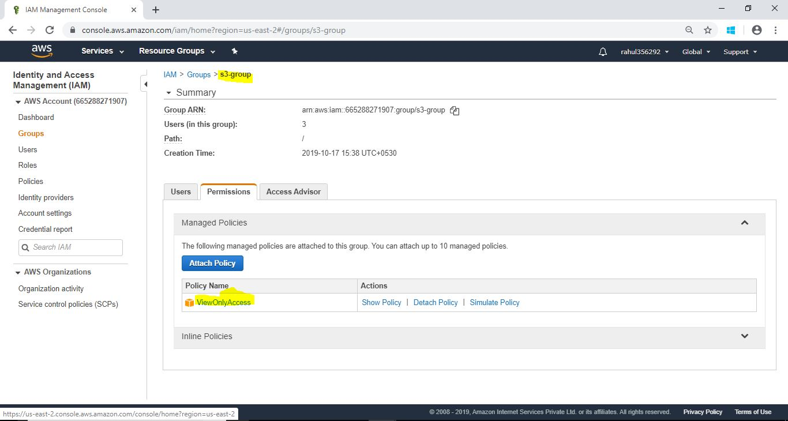

* Provide S3 all privileges to s3-user1

Solution:

