Industry use cases of Neural Network

[rahul banik](https://rahulbanik1498.medium.com/?source=post_page-----56de10e2e915--------------------------------)

[rahul banik](https://rahulbanik1498.medium.com/?source=post_page-----56de10e2e915--------------------------------)

[Mar 4·5 min read](https://rahulbanik1498.medium.com/industry-use-cases-of-neural-network-56de10e2e915?source=post_page-----56de10e2e915--------------------------------)

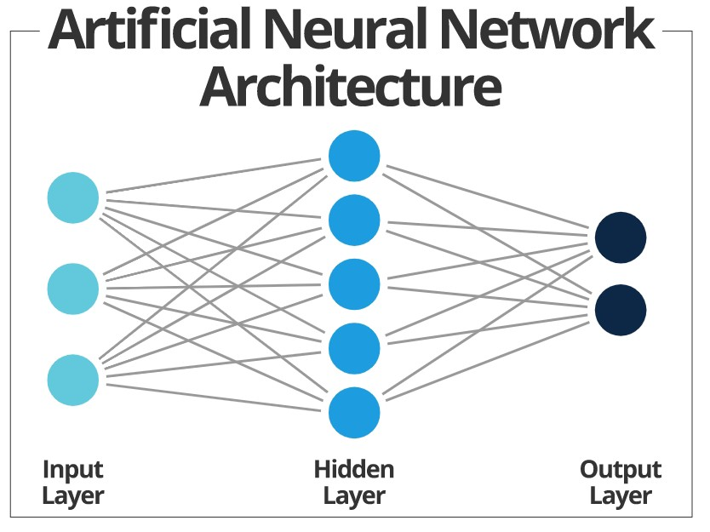

What are Neural Networks?

Neural networks are a set of algorithms, they are designed to mimic the human brain, that is designed to recognize patterns. They interpret data through a form of machine perception by labeling or clustering raw input data.

Applications in Deep Learning and Artificial Intelligence

Artificial neural networks are a form of [deep learning](https://algorithmxlab.com/blog/10-applications-deep-learning-in-business/).

They are also one of the main tools used in [machine learning](https://algorithmxlab.com/blog/what-is-machine-learning-all-you-need-to-know/).

Consequently ANN’s play an increasingly important role in the development of artificial intelligence.

The rise in importance of Artificial Neural Network’s is due to the development of “[backpropagation](http://www.cs.cornell.edu/courses/cs5740/2016sp/resources/backprop.pdf)”.

This technique allows the system’s hidden layers to become versatile.

Adapting to situations where the outcome doesn’t match the one originally intended.

The development of deep learning neural networks has also helped in the development of Artificial Neural Networks.

Deep learning neural networks are networks made up of multiple layers.

This allows the system to become more versatile.

Different layers are able to analyse and extract different features.

This process allows the system to identify new data or images.

It also allows for [unsupervised learning](https://algorithmxlab.com/blog/what-is-machine-learning-all-you-need-to-know/) and more complex tasks to be undertaken.

Attributes of Neural Networks

With the human-like ability to problem-solve — and apply that skill to huge datasets — neural networks possess the following powerful attributes:

* **Adaptive Learning:**Like humans, neural networks model non-linear and complex relationships and build on previous knowledge. For example, software uses adaptive learning to teach math and language arts.
* **Self-Organization:** The ability to cluster and classify vast amounts of data makes neural networks uniquely suited for organizing the complicated visual problems posed by medical image analysis.
* **Real-Time Operation:** Neural networks can (sometimes) provide real-time answers, as is the case with self-driving cars and drone navigation.
* **Fault Tolerance:** When significant parts of a network are lost or missing, neural networks can fill in the blanks. This ability is especially useful in space exploration, where the failure of electronic devices is always a possibility.

Abilities of Neural Network

* **Classification:**NNs organize patterns or datasets into predefined classes.
* **Prediction:** They produce the expected output from given input.
* **Clustering:** They identify a unique feature of the data and classify it without any knowledge of prior data.
* **Associating:** You can train neural networks to “remember” patterns. When you show an unfamiliar version of a pattern, the network associates it with the most comparable version in its memory and reverts to the latter.

Neural Network Business Applications

Neural networks are widely used in different industries. Both big companies and startups use this technology. Most often, neural networks can be found in all kinds of industries: from eCommerce to vehicle building.

So, let’s look at some examples of neural network applications in different areas. Mostly, in:

* eCommerce;
* Finance;
* Healthcare;
* Security;
* Logistics.

eCommerce

This technology is used in this industry for various purposes. But the most frequent example of artificial neural network application in eCommerce is **personalizing the purchaser’s experience.**For instance, [Amazon](https://www.amazon.com/), [AliExpress](https://www.aliexpress.com/), and other eCommerce platforms use AI to show the related and recommended products. The compilation is formed on the basis of the users’ behavior. The system analyzes the characteristics of certain items and shows similar ones. In other cases, it defines and remembers the person’s preferences and shows the items meeting them.

*Amazon shows related products*

As for more complicated applications of neural networks in eCommerce, there is a very interesting startup called [PixelDTGAN](https://github.com/fxia22/PixelDTGAN). This product is developed to help sellers save the budget on photographers’ services. There is no need to organize photo sets as the special algorithm automatically makes the pictures of the clothes worn by models. All is needed to do is to resize the images of the items to 64*64, and get the result.

Finance

In this industry, there are neural network applications for **fraud detection, management, and forecasting.**Let’s look at some samples.

A great example of neural network finance applications is [SAS Real Time Decision Manager](https://support.sas.com/en/software/real-time-decision-manager-support.html). It helps banks to [find solutions for business issues](https://www.ideamotive.co/business-strategist) (for instance, whether to give credit to a certain person) analyzing risks and probable profits.

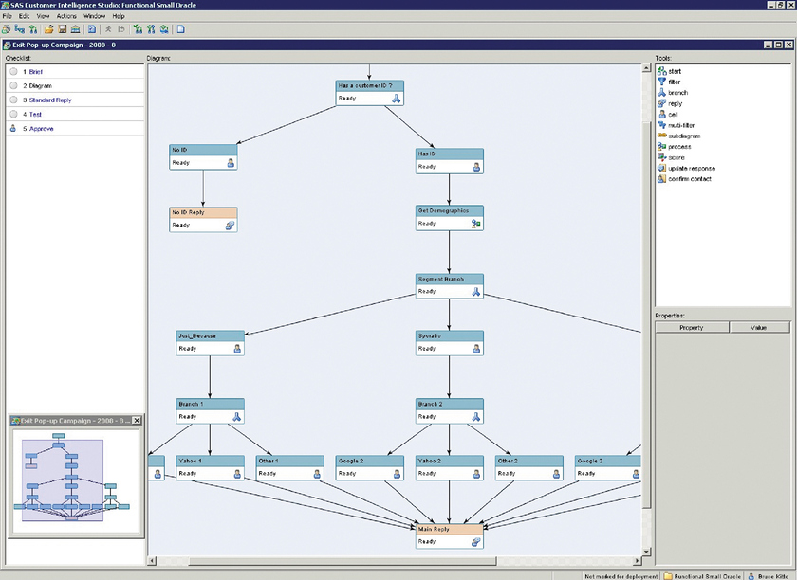

*The screenshot of SAS Real Time Decision Manager*

As for financial forecasting, there are plenty of solutions that predict the exchange rate changes. For example, the startup [Finprophet](https://finprophet.com/) is the software that uses a neural network of deep learning for giving the forecast about a wide range of financial instruments like currencies, cryptocurrencies, stocks, futures.

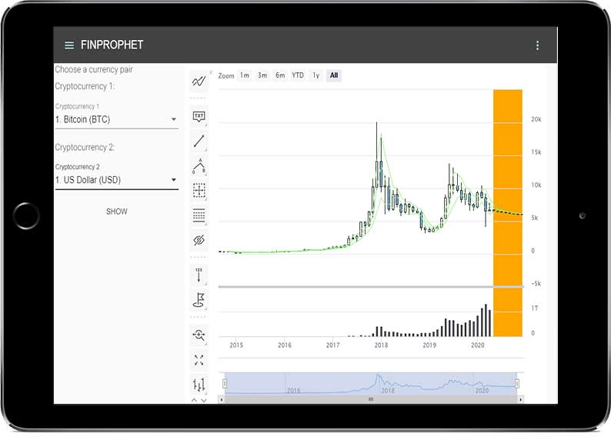

*Finprophet is giving the forecast about Bitcoin — US Dollar currency pair*

Healthcare

It is very difficult to create and train a neural network for usage in this industry because it requires high accuracy. For many years it seemed to be a fantasy to use this technology for examining patients and diagnosing them. But finally, it has become possible.

[IBM Watson](https://www.ibm.com/watson) is the most powerful artificial intelligence in the world. It took 2 years to train the neural network for medical practice. Millions of pages of medical academic journals, medical records, and other documents were uploaded to the system for its learning. And now it can prompt the diagnosis and propose the best treatment pattern based on the patient’s complaints and anamnesis.

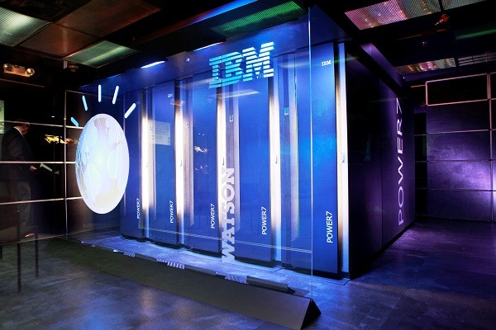

*This is the original version of IBM Watson, which includes 2800 processor cores and 15 terabytes of memory*.

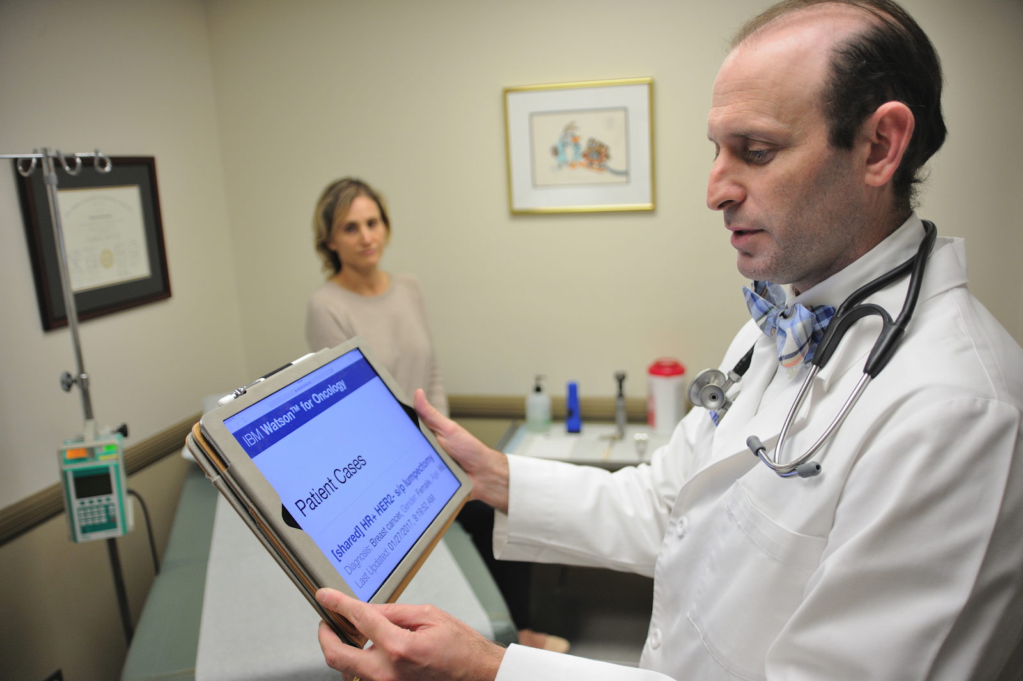

*Doctors can use the abilities of IBM Watson with the help of tablets with cloud connection*.

Security

Neural networks are widely used for protection from computer viruses, fraud, etc.

One of the examples is [ICSP Neural](https://help.symantec.com/cs/SYMC_ICSP/ICSP/v131096478_v131106122/Overview-of-the-scanner-station-functions?locale=EN_US) from Symantec. It protects from cyber attacks by determining the bad USB devices containing viruses and exploiting zero-day vulnerabilities.