

Insurance Premium Prediction

Wireframe Document

Internship Project



Rahul Sharma

DOCUMENT VERSION CONTROL

|  |  |  |  |
| --- | --- | --- | --- |
| Date Issued | Version | Description | Author |
| **03-06-2022** | **1.0** | Introduction, Problem statement | **Rahul Sharma** |
| **09-06-2022** | **1.1** | Dataset Information Architecture | **Rahul Sharma** |
| **15-06-2022** | **1.2** | Final Revision | **Rahul Sharma** |

The project was performed by Exploratory Data Analysis on Jupyter Notebook. and analyses the Insurance premium as per Age, Sex, Region, Smoker or not, BMI, and Children. so, I applied many algorithms like SVM, Linear Regression, Random Forest, and Gradient Boosting Regressor. And finally, I analyse that When we see the r2_score,mean_absolute_error, and prediction amount, Gradient Boosting Regressor and Random forest Regressor values are too close to each other so we can choose any model. So, for performing well I selected Gradient Boosting Regressor.

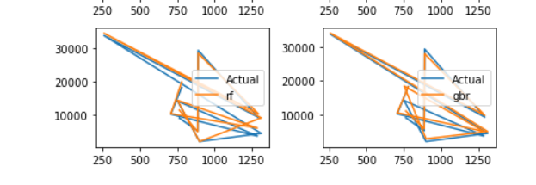

**Difference Between Random Forest and Gradient Boosting Regressor?**

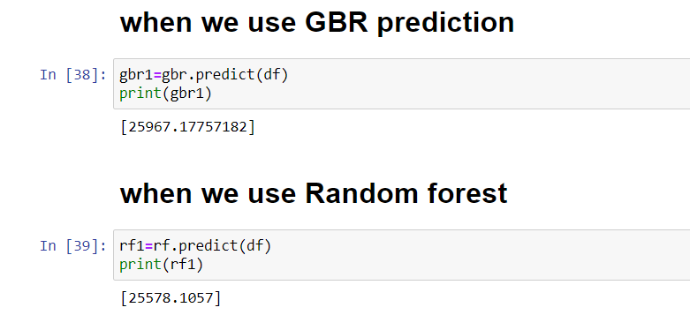

**For Customer Best Experience are you used GUI?**

Yes, I used Tkinter and Joblib Library for User friendly.

