DESIGN AND ANALYSIS OF ALGORITHMS
PRACTICAL FILE

2018UCO1665
RAHUL AGARWAL
COE-III
SEM-III
CONTENTS

PROGRAMMES | DATES | SIGNATURE
SORTING  (INSERTION&SELECTION  , MERGE&QUICK, RADIX, SHELL, HEAP) | 16/08/2019
SEARCHING  (LINEAR, BINARY, INTERPOLATION) | 30/08/2019
0/1 KNAPSACK | 06/09/2019
BST  (INSERTION, SEARCH, DELETION) | 13/09/2019
BFS & DFS  (ADJACENCY LIST) | 20/09/2019
KRUSKAL’S ALGORITHM | 27/09/2019
PRIM’S ALGORITHM | 04/10/2019
BELLMAN FORD ALGORITHM | 11/10/2019
DIJIKSTRA’S ALGORITHM | 18/10/2019
HUFFMAN CODING | 25/10/2019

INSERTION AND SELECTION SORT
#include<iostream>
using namespace std;
void insertionsort(int *arr,int n)
{
for(int i=1;i<n;i++)
{
int temp=arr[i];int j;
for(j=i-1;j>=0;j--)
{
if(arr[j]>temp)
{arr[j+1]=arr[j];}
else
{break;}
}
arr[j+1]=temp;
}
cout<<"\nSorted array is"<<endl;
for(int i=0;i<n;i++)
{cout<<arr[i]<<" ";}
}

void selectionsort(int *arr,int n)
{
for(int i=0;i<(n-1);i++)
{
int pos=i;
for(int j=i+1;j<n;j++)
{
if(arr[j]<arr[pos])
{pos=j;}
}
int temp=arr[i];
arr[i]=arr[pos];
arr[pos]=temp;
}
cout<<"\nSorted array is"<<endl;
for(int i=0;i<n;i++)
{cout<<arr[i]<<" ";}
}
int main()
{
cout<<"\nEnter the number of elements ";
int n;cin>>n;
cout<<"\nEnter the elements\n";
int *arr1=new int[n];
int *arr2=new int[n];
for(int i=0;i<n;i++)
{
cin>>arr1[i];
arr2[i]=arr1[i];
}
insertionsort(arr1,n);
cout<<endl<<endl;
selectionsort(arr2,n);
return 0;
}

OUTPUT
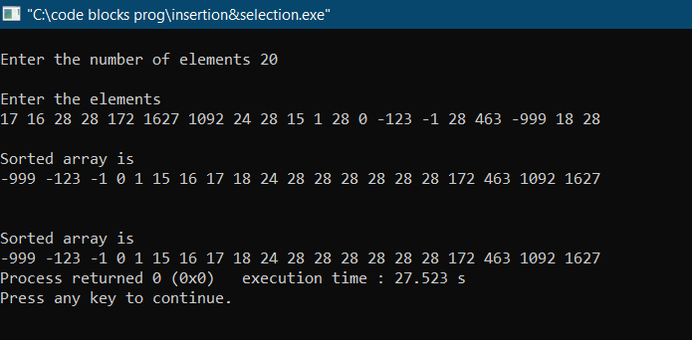

MERGE AND QUICK SORT
#include<iostream>
#include<stdio.h>
#include<stdlib.h>
using namespace std;
void mergearrays(int*arr,int s,int mid,int e)
{
int length=e-s+1;
int *ptr=new int[length];
int k=0,i=s,j=mid+1;
while(i<=mid&&j<=e)
{
if(arr[i]>arr[j])
{ptr[k++]=arr[j++];}
else
{ptr[k++]=arr[i++];}
}
while(i<=mid)
{ptr[k++]=arr[i++];}
while(j<=e)
{ptr[k++]=arr[j++];}
for(int x=s;x<=e;x++)
{arr[x]=ptr[x-s];}
}
void mergesort(int*arr,int s,int e)
{
if(s>=e)
{return; }
int mid=(s+e)/2;
mergesort(arr,s,mid);
mergesort(arr,mid+1,e);
mergearrays(arr,s,mid,e);
}

int part(int*arr,int s,int e)
{
int pivot=arr[e];
int i=s,pivotindex=s;
while(i<e)
{
if(arr[i]<arr[e])
{
int temp=arr[i];
arr[i]=arr[pivotindex];
arr[pivotindex]=temp;
pivotindex++;
}
i++;
}
int temp=arr[e];
arr[e]=arr[pivotindex];
arr[pivotindex]=temp;
return pivotindex;
}
void quicksort(int*arr,int s,int e)
{
if(s>=e)
{return;}
int pivot=part(arr,s,e);
quicksort(arr,s,pivot-1);
quicksort(arr,pivot+1,e);
}

int main()
{
cout<<"\nEnter the size of array ";
int n;cin>>n;
cout<<"\nEnter the array\n";
int *arr1=new int[n];
int *arr2=new int[n];
for(int i=0;i<n;i++)
{
cin>>arr1[i];
arr2[i]=arr1[i];
}
quicksort(arr1,0,n-1);
cout<<"\nSorted array is\n";
for(int i=0;i<n;i++)
{cout<<arr1[i]<<" ";}
cout<<endl<<endl;
mergesort(arr2,0,n-1);
cout<<"\nSorted array is\n";
for(int i=0;i<n;i++)
{cout<<arr2[i]<<" ";}
}
OUTPUT
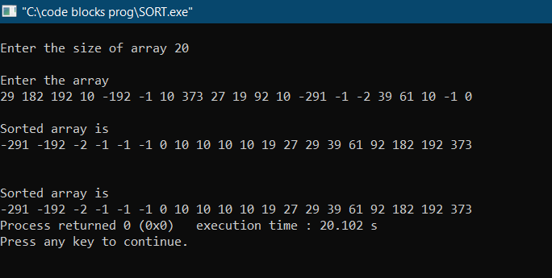

RADIX SORT
#include<iostream>
using namespace std;
void count_sort(int*arr,int n,int exp)
{
int countarray[10]={0,0,0,0,0,0,0,0,0,0};
int *output=new int[n];
for(int i=0;i<n;i++)
{countarray[(arr[i]/exp)%10]++;}
for(int i=1;i<10;i++)
{countarray[i]+=countarray[i-1];}
for(int i=n-1;i>=0;i--)
{
output[countarray[(arr[i]/exp)%10]-1]=arr[i];
countarray[(arr[i]/exp)%10]--;
}
for(int i=0;i<n;i++)
{arr[i]=output[i];}
}
void radix_sort(int*arr,int n)
{
int m=arr[0];
for(int i=1;i<n;i++)
{
if(arr[i]>m)
{m=arr[i];}
}
for(int exp=1;m/exp>0;exp*=10)
{count_sort(arr,n,exp);}
}

int main()
{
int n;
cin>>n;
int *arr=new int[n];
for(int i=0;i<n;i++)
{cin>>arr[i];}
radix_sort(arr,n);
cout<<endl<<endl;
for(int i=0;i<n;i++)
{cout<<arr[i]<<" ";}
cout<<endl;
}
OUTPUT
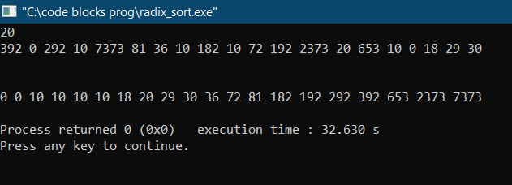

SHELL SORT
#include<iostream>
using namespace std;
void shellsort(int *arr,int n)
{
int i,j;
for(int gap=n/2;gap>=1;gap/=2)
{
for(i=gap;i<n;i++)
{
int temp=arr[i];
for(j=i;j>=gap;j-=gap)
{
if(arr[j-gap]>temp)
{arr[j]=arr[j-gap];}
else
{break;}
}
arr[j]=temp;
}
}
}
int main()
{
int n;
cin>>n;
int *arr=new int[n];
for(int i=0;i<n;i++)
{cin>>arr[i];}
shellsort(arr,n);
cout<<endl;
for(int i=0;i<n;i++)
{cout<<arr[i]<<" ";}
cout<<endl<<endl;
}
OUTPUT
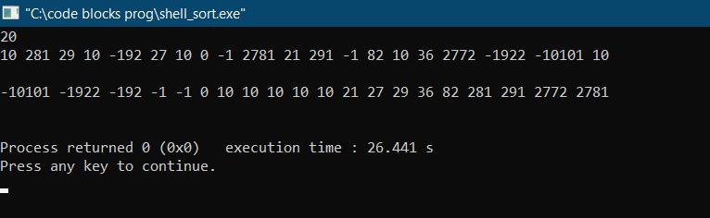

HEAP SORT
#include <iostream>
using namespace std;
void insert(int*ip,int s,int el)
{
int c=s,temp;
int p=(c-1)/2;
while(p>=0&&ip[c]<ip[p])
{
temp=ip[p];
ip[p]=ip[c];
ip[c]=temp;
c=p;
p=(c-1)/2;
}
}
void remove(int*ip,int s)
{
int temp,p,lc,rc,moc;
temp=ip[0];
ip[0]=ip[s-1];
ip[s-1]=temp;
s--;
p=0;
lc=1;rc=2;
if(s==2)
{moc=lc;}
else{
if(ip[lc]<ip[rc])
{moc=lc;}
else
{moc=rc;}
}
while(moc<s)
{
if(ip[p]>ip[moc])
{
temp=ip[p];
ip[p]=ip[moc];
ip[moc]=temp;
}
else
{break;}
p=moc;
lc=2*p+1;
rc=2*p+2;
if(lc<s&&rc<s)
{
if(ip[lc]<ip[rc])
{moc=lc;}
else
{moc=rc;}
}
else
{
if(lc<s)
{moc=lc;}
else
{break;}
}
}
}
void inplaceHeapSort(int input[], int n){
for(int i=1;i<n;i++)
{insert(input,i,input[i]);}
for(int i=0;i<(n-1);i++)
{remove(input,n-i);}
}
int main() {
int size;
cin >> size;
int *input = new int[1 + size];

for(int i = 0; i < size; i++)
cin >> input[i];
inplaceHeapSort(input, size);
cout<<"\n";
for(int i = 0; i < size; i++)
cout << input[i] << " ";
return 0;
}
OUTPUT
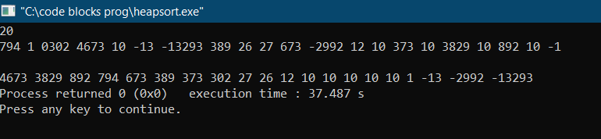

LINEAR SEARCH
#include<iostream>
using namespace std;
int main()
{
cout<<"\nEnter the size of the array ";int n;cin>>n;
int *arr=new int[n];
cout<<"\nEnter the array\n";
for(int i=0;i<n;i++)
{cin>>arr[i];}
cout<<"\nEnter the element to be searched ";int x;cin>>x;
int ans=-1;
for(int i=0;i<n;i++)
{
if(arr[i]==x)
{ans=i;}
}
if(ans==-1){cout<<"\nNOT PRESENT";}
else{cout<<"\nPRESESNT AT "<<ans;}
}
OUTPUT
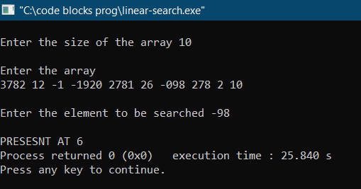
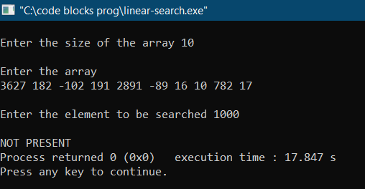

BINARY SEARCH
#include<iostream>
#include<algorithm>
using namespace std;
int bs(int *arr,int l,int h,int x)
{
if(l>h){return -1;}
int mid=(l+h)/2;
if(arr[mid]==x){return mid;}
else if(arr[mid]>x){return bs(arr,l,mid-1,x);}
else{return bs(arr,mid+1,h,x);}
}

int main()
{
cout<<"\nEnter the size of the array ";int n;cin>>n;
int *arr=new int[n];
cout<<"\nEnter the array\n";
for(int i=0;i<n;i++)
{cin>>arr[i];}
cout<<"\nEnter the element to be searched ";int x;cin>>x;
sort(arr,arr+n);
cout<<"\nAfter sorting array is\n";
for(int i=0;i<n;i++)
{cout<<arr[i]<<" ";}
int ans=bs(arr,0,n-1,x);
if(ans==-1){cout<<"\nNOT PRESENT";}
else{cout<<"\nPRESENT AT "<<ans;}
}
OUTPUT
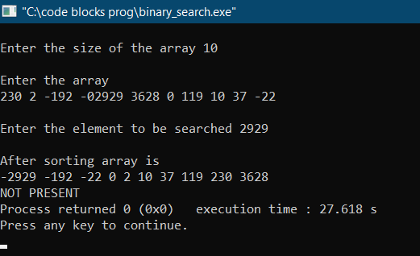
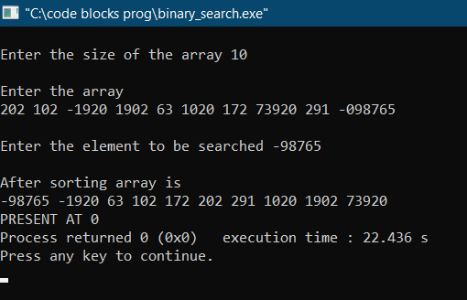
INTERPOLATION SEARCH
#include<iostream>
#include<algorithm>
#include<cmath>
using namespace std;
int inter_search(int *arr,int h,int l,int x)
{
while(h>=l)
{
int mid=l+((h-l)*(x-arr[l]))/(arr[h]-arr[l]);
if(arr[mid]>arr[h]||arr[mid]<arr[l])
{return -1;}
if(arr[mid]>x)
{h=mid-1;}
else if(arr[mid]<x)
{l=mid+1;}
else
{return mid;}
}
return -1;
}
int main()
{
int n;
cin>>n;
int *arr=new int[n];
for(int i=0;i<n;i++)
{cin>>arr[i]; }
int x;
cin>>x;
sort(arr,arr+n);
cout<<"\nAfter sorting array is\n";
for(int i=0;i<n;i++)
{cout<<arr[i]<<" ";}
cout<<endl;
int ans=inter_search(arr,n-1,0,x);
if(ans!=-1){cout<<"PRESENT AT "<<ans;}
else{cout<<"NOT PRESENT";}
}
OUTPUT
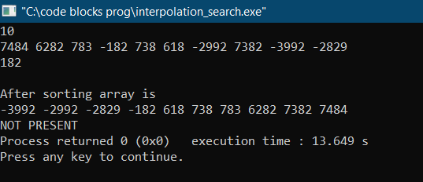
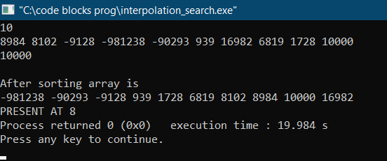

0/1 KNAPSACK
#include<iostream>
using namespace std;
int knapsack(int*,int*,int,int);
int main()
{
int n;
cout<<"\nEnter the size ";
cin >> n;
int* weights = new int[n];
int* values = new int[n];
cout<<"\nEnter the weights\n";
for(int i = 0; i < n; i++)
{cin >> weights[i];}
cout<<"\nEnter the values\n";
for(int i = 0; i < n; i++)
{cin >> values[i];}
int maxWeight;
cout<<"\nEnter the max weight ";
cin >> maxWeight;
cout << knapsack(weights, values, n, maxWeight);
}
int knapsack(int* weights, int* values, int n, int maxWeight){
int dp[n+1][maxWeight+1];
for(int i=0;i<=n;i++)
{dp[i][0]=0;}
for(int i=0;i<=maxWeight;i++)
{dp[0][i]=0;}
for(int i=1;i<=n;i++)
{
for(int j=1;j<=maxWeight;j++)
{
if(weights[i-1]>j)
{dp[i][j]=dp[i-1][j];}
else
{dp[i][j]=max(dp[i-1][j],values[i-1]+dp[i-1][j-weights[i-1]]);}
}
}
return dp[n][maxWeight];
}
OUTPUT
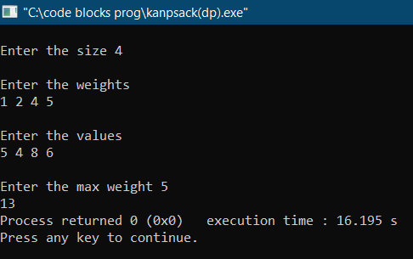

BST(Insertion or Generation, Deletion, Search)
#include<iostream>
using namespace std;
template <typename T>
class BinaryTreeNode {
public:
T data;
BinaryTreeNode<T> *left;
BinaryTreeNode<T> *right;
BinaryTreeNode(T data) {
this->data = data;
this->left = NULL;
this->right = NULL;
}
};
class BST {
BinaryTreeNode<int> *root;
bool hd(int data,BinaryTreeNode<int> *root){
if(root==NULL)
return false;
if(root->data==data)
return true;
else if(root->data>data)
{
return hd(data,root->left);
}
else
return hd(data,root->right);
}
BinaryTreeNode<int> * ins(int data,BinaryTreeNode<int> *root){
if(root==NULL)
{
BinaryTreeNode<int> * temp=new BinaryTreeNode<int> (data);
return temp;
}
else if(root->data<data)
{root->right=ins(data,root->right);}
else
{root->left=ins(data,root->left);}
return root;
}
BinaryTreeNode<int> * del(int data,BinaryTreeNode<int> * node){
if(node==NULL)
{return NULL;}
if(data>node->data)
{
node->right=del(data,node->right);
return node;
}
else if(data<node->data){
node->left=del(data,node->left);
return node;
}else {
if(node->left==NULL && node->right==NULL)
{
delete node;
return NULL;
}else if(node->left==NULL)
{
BinaryTreeNode<int> * temp=node->right;
node->right=NULL;
delete node;
return temp;
}else if(node->right==NULL)
{
BinaryTreeNode<int> * temp=node->left;
node->left=NULL;
delete node;
return temp;
}else {
BinaryTreeNode<int> * minnode=node->right;
while(minnode->left!=NULL)
{minnode=minnode->left;}
int rightmin=minnode->data;
node->data=rightmin;
node->right=del(rightmin,node->right);
return node;
}
}
}
void print(BinaryTreeNode<int> * root){
if(root==NULL)
{return;}
cout<<root->data<<":";
if(root->left!=NULL)
{cout<<"L:"<<root->left->data<<",";}
if(root->right!=NULL)
{cout<<"R:"<<root->right->data;}
cout<<endl;
print(root->left);
print(root->right);
}
public:
BST()
{root=NULL;}
~BST()
{delete root;}
bool hasData(int data)
{return hd(data,root);}
void insert(int data)
{root=ins(data,root);}
void deleteData(int data)
{root=del(data,root);}
void printTree()
{print(root);}
};

int main(){
BST *tree = new BST();
int choice, input;
while(true){
cout<<"\n1.Insert 2.Delete 3.Search 4.Print 5.Quit ";
cin>>choice;
switch(choice){
case 1:
cout<<"\nEnter the data to be inserted ";
cin >> input;
tree->insert(input);
break;
case 2:
cout<<"\nEnter the data to be deleted ";
cin >> input;
tree->deleteData(input);
break;
case 3:
cout<<"\nEnter the data to be searched ";
cin >> input;
if(tree->hasData(input)) {
cout << "true" << endl;
}
else {
cout << "false" << endl;
}
break;
case 4:
tree->printTree();
break;
case 5:
return 0;
break;
default:
cout<<"\nNo such option";
}
}
}
OUTPUT
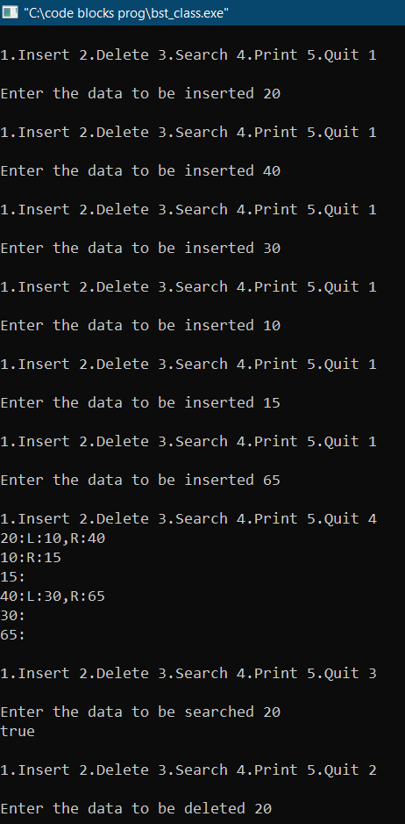
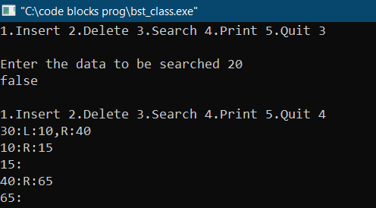
BFS AND DFS(Adjacency list)
#include<iostream>
#include<queue>
#include<vector>
using namespace std;
void bfs(vector<vector<int>*> adjlist,int V,bool *visit)
{
queue<int> q;
q.push(0);
visit[0]=true;
while(q.empty()==false)
{
int cur=q.front();
q.pop();
vector<int>temp=*(adjlist[cur]);
cout<<cur<<" ";
for(int i=0;i<temp.size();i++)
{
if(visit[temp[i]]==true){continue;}
q.push(temp[i]);
visit[temp[i]]=true;
}
}
}
void dfs(vector<vector<int>*>adjlist,int V,bool *visit,int cur)
{
cout<<cur<<" ";
visit[cur]=true;
vector<int>temp=*(adjlist[cur]);
for(int i=0;i<temp.size();i++)
{
if(visit[temp[i]]==true){continue;}
dfs(adjlist,V,visit,temp[i]);
}
}
int main()
{
int V,E;
cout<<"VERTICES AND EDGES\n";
cin>>V>>E;
vector <vector<int>*> adjlist;
for(int i=0;i<V;i++)
{
vector<int>* temp=new vector<int>;
adjlist.push_back(temp);
}
cout<<"\nEDGES!!!\n";
for(int i=0;i<E;i++)
{
int s,e;
cin>>s>>e;
adjlist[s]->push_back(e);
adjlist[e]->push_back(s);
}
bool *visit=new bool[V];
for(int i=0;i<V;i++)
{visit[i]=false;}
cout<<endl<<endl;
cout<<”BFS:\n”;
bfs(adjlist,V,visit);
for(int i=0;i<V;i++)
{visit[i]=false;}
cout<<endl<<endl;
cout<<”DFS:\n”;
dfs(adjlist,V,visit,0);
}
OUTPUT
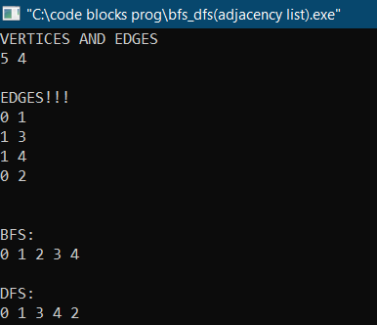
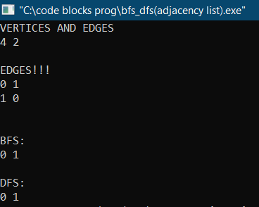

KRUSKAL’S MST
#include <iostream>
#include<algorithm>
using namespace std;
class Edge{
public:
int source;
int dest;
int weight;
};
bool compare(Edge e1,Edge e2)
{return e1.weight<e2.weight;}
int findParent(int v,int*parent){
if(parent[v]==v)
{return v;}
return findParent(parent[v],parent);
}
void kruskals(Edge *input,int V,int E){
sort(input,input+E,compare);
Edge *output= new Edge[V-1];
int *parent=new int[V];
for(int i=0;i<V;i++)
{parent[i]=i;}
int count=0;
int i=0;
while(count != V-1){
Edge currentEdge=input[i];
int sourceParent=findParent(currentEdge.source,parent);
int destParent=findParent(currentEdge.dest,parent);
if(sourceParent != destParent){
output[count]=currentEdge;
count++;
parent[sourceParent]=destParent;
}
i++;
}
for(int i=0;i<V-1;i++){
if(output[i].source <output[i].dest)
{cout<<output[i].source<<" "<<output[i].dest<<" "<<output[i].weight<<endl;}
else
{cout<<output[i].dest<<" "<<output[i].source<<" "<<output[i].weight<<endl;}
}
}
int main()
{
int V, E, tempX, tempY;
cout<<"Vertices and edges\n";
cin >> V >> E;
Edge *input=new Edge[E];
cout<<"\nEdges!!!";
for(int i=0;i<E;i++){
int s,d,w;
cout<<"\nVertex 1 and vertex 2 and weight of the edge ";
cin>>s>>d>>w;
input[i].source=s;
input[i].dest=d;
input[i].weight=w;
}
cout<<"\nMST edges are\n";
kruskals(input,V, E);
}
OUTPUT
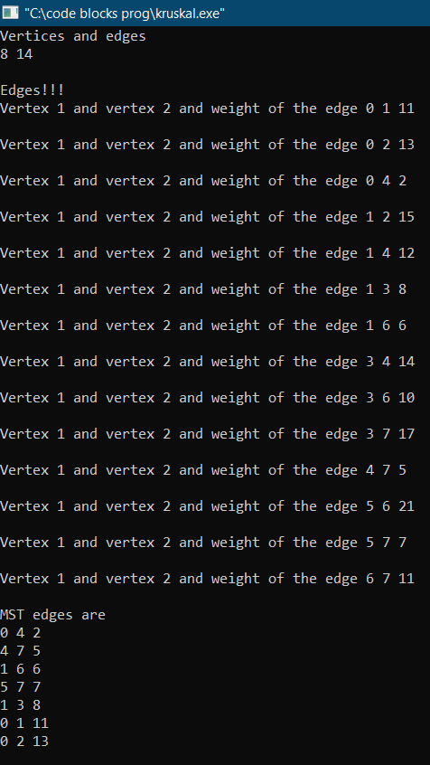
PRIM’S MST
#include<climits>
#include <iostream>
using namespace std;
int main()
{
int V, E, x, y, w, min=0, newmin;
cout<<"Vertices and edges\n";
cin >> V >> E;
int **arr=new int*[V];
for(int i=0;i<V;i++)
{
arr[i]=new int[V];
for(int j=0;j<V;j++)
{arr[i][j]=0;}
}
cout<<"Edges!!\n";
for(int i=0;i<E;i++)
{
cout<<"Vertex 1 and vertex 2 and weight ";
cin>>x>>y>>w;
arr[x][y]=w;
arr[y][x]=w;
}
bool*visit=new bool[V];
for(int i=0;i<V;i++)
{visit[i]=false;}
int *weight=new int[V];
int *parent=new int[V];
weight[0]=0;
parent[0]=-1;
for(int i=1;i<V;i++)
{
parent[i]=-1;
weight[i]=INT_MAX;
}
for(int z=1;z<V;z++)
{
newmin=-1;
visit[min]=true;
for(int i=0;i<V;i++)
{
if(i==min||visit[i]==true)
{continue;}
if(arr[min][i]!=0)
{
if(visit[i]==true)
{continue;}
if(weight[i]>arr[min][i])
{
weight[i]=arr[min][i];
parent[i]=min;
}
}
if(newmin!=-1)
{if(weight[newmin]>weight[i])
{newmin=i;}}
else
{newmin=i;}
}
min=newmin;
}
cout<<endl<<"MST edges are\n";
for(int i=1;i<V;i++)
{
if(i<parent[i])
{cout<<i<<" "<<parent[i]<<" "<<weight[i]<<endl;}
else
{cout<<parent[i]<<" "<<i<<" "<<weight[i]<<endl;}
}
return 0;
}
OUTPUT
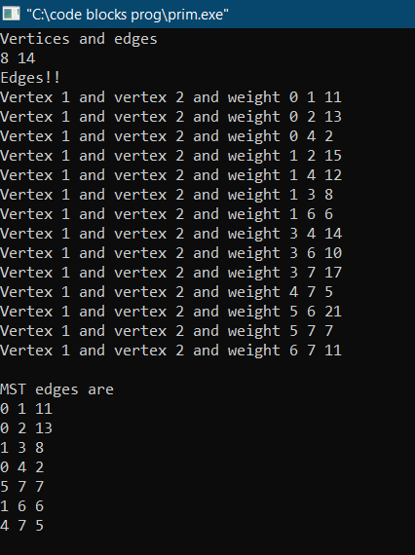
BELLMAN FORD
#include<iostream>
using namespace std;
class edge
{
public:
int source,dest,weight;
};

int main()
{
cout<<"Vertices and edges\n";
int V,E;
cin>>V>>E;
edge *array_of_edges=new edge[E];
cout<<"\nEdges\n";
for(int i=0;i<E;i++)
{
cout<<"\nEnter source and destination and weight of the edge ";
int s,d,w;
cin>>s>>d>>w;
array_of_edges[i].source=s;
array_of_edges[i].dest=d;
array_of_edges[i].weight=w;
}
int *weight=new int[V];
weight[0]=0;
for(int i=1;i<V;i++){weight[i]=INT_MAX;}
bool flag;
for(int i=1;i<V;i++)
{
flag=false;
for(int j=0;j<E;j++)
{ if(weight[array_of_edges[j].dest]>(weight[array_of_edges[j].source]+array_of_edges[j].weight)) {weight[array_of_edges[j].dest]=weight[array_of_edges[j].source]+array_of_edges[j].weight;flag=true;}
}
if(flag==false){break;}
}
cout<<"\nMinimum weights of paths of all nodes from 0 are\n";
for(int i=0;i<V;i++)
{cout<<endl<<"node:"<<i<<" weight from 0:"<<weight[i];}
return 0;
}
OUTPUT
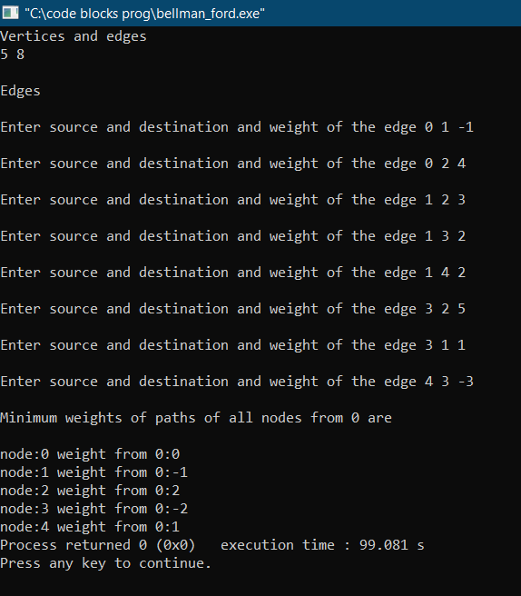
DIJIKSTRA’S
#include<climits>
#include <iostream>
using namespace std;
int main()
{
int V, E, x, y, w, min=0, newmin;
cout<<"Vertices and edges\n";
cin >> V >> E;
int **arr=new int*[V];
for(int i=0;i<V;i++)
{
arr[i]=new int[V];
for(int j=0;j<V;j++)
{arr[i][j]=0;}
}
cout<<"EDGES!!\n";
for(int i=0;i<E;i++)
{
cout<<"Vertex 1 and vertex 2 and weight ";
cin>>x>>y>>w;
arr[x][y]=w;
arr[y][x]=w;
}
bool*visit=new bool[V];
for(int i=0;i<V;i++)
{visit[i]=false;}
int*cost=new int[V];
cost[0]=0;
for(int i=1;i<V;i++)
{cost[i]=INT_MAX;}
for(int z=1;z<V;z++)
{
newmin=-1;
visit[min]=true;
for(int i=0;i<V;i++)
{
if(i==min||visit[i]==true)
{continue;}
if(arr[min][i]!=0)
{
if(cost[i]>(cost[min]+arr[min][i]))
{cost[i]=cost[min]+arr[min][i];}
}
if(newmin!=-1)
{if(cost[i]<cost[newmin])
{newmin=i;}}
else
{newmin=i;}
}
min=newmin;
}
cout<<endl<<"Min weights of the paths from 0 to other nodes are";
for(int i=0;i<V;i++)
{cout<<"\nnode:"<<i<<" weight from 0:"<<cost[i];}
return 0;
}

OUTPUT
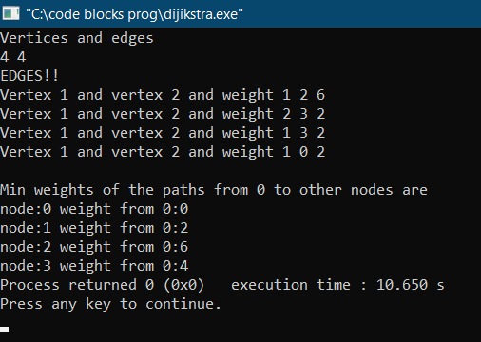

HUFFMAN CODING
#include<iostream>
#include<queue>
#include<vector>
#include<string>
using namespace std;
class treeNode
{
public:
char character;
int freq;
treeNode*left,*right;
treeNode(char c,int f)
{
left=right=NULL;
character=c;
freq=f;
}
};
class compare
{
public:
bool operator()(treeNode* a,treeNode* b)
{return a->freq>b->freq;}
};
void printcodes(treeNode*root,string ans)
{
if(root==NULL)
{return;}
if(root->character!='\0')
{cout<<root->character<<":"<<ans<<endl;}
printcodes(root->left,ans+'0');
printcodes(root->right,ans+'1');
}
int main()
{
priority_queue<treeNode*,vector<treeNode*>,compare> mq;
cout<<"Enter the number of characters:";
int n;cin>>n;
for(int i=0;i<n;i++)
{
char c;int f;
cin>>c>>f;
treeNode *temp=new treeNode(c,f);
mq.push(temp);
}
while(mq.size()>1)
{
treeNode *node1,*node2;
node1=mq.top();mq.pop();
node2=mq.top();mq.pop();
treeNode *newnode=new treeNode('\0',node1->freq+node2->freq);
newnode->left=node1;
newnode->right=node2;
mq.push(newnode);
}
treeNode *root;
root=mq.top();
cout<<endl<<endl;
printcodes(root,"");
}
OUTPUT
