A CRM APPLICATION FOR WHOLESALE RICE MILL

**1) Introduction To Salesforce**

**Creating Developer Account**

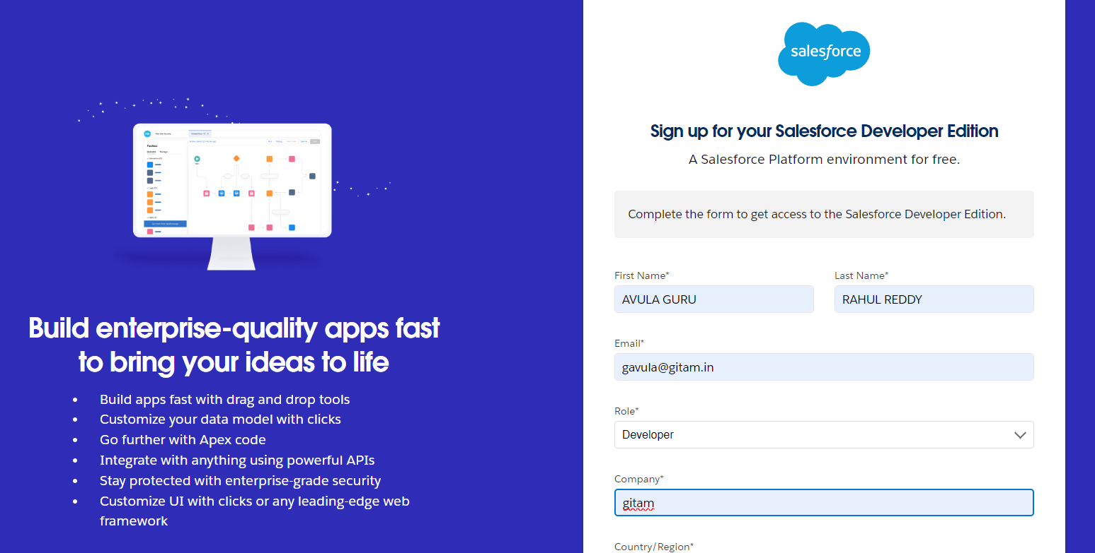

**Account Activation**

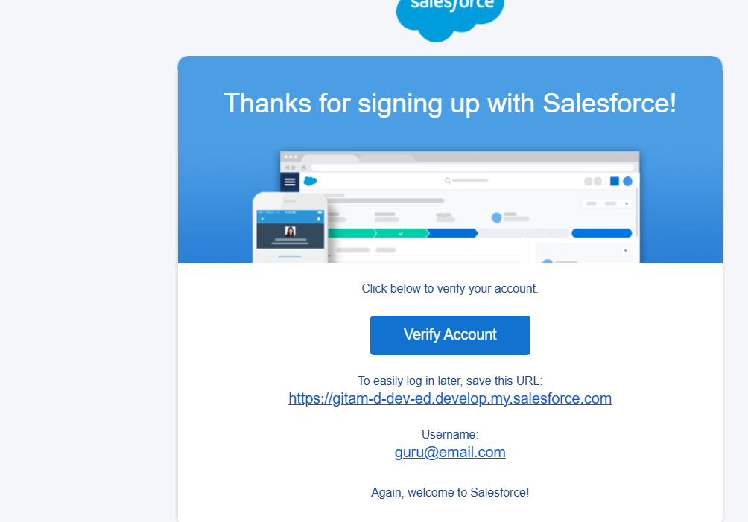

2) Objec

**Supplier Object**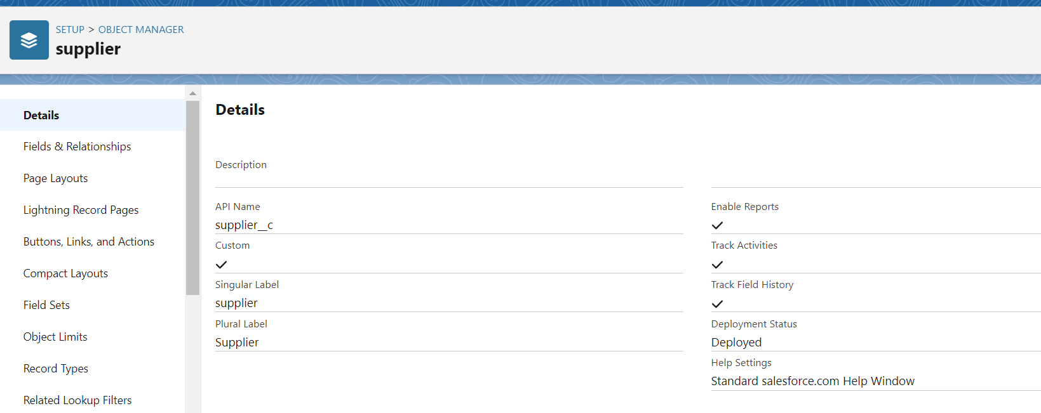

**Rice Mill Object**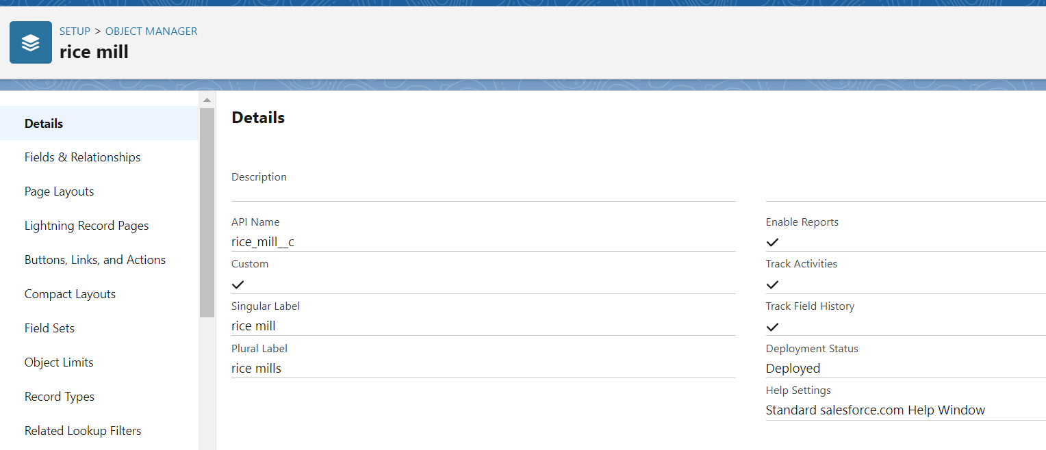

**Consumer Objects**

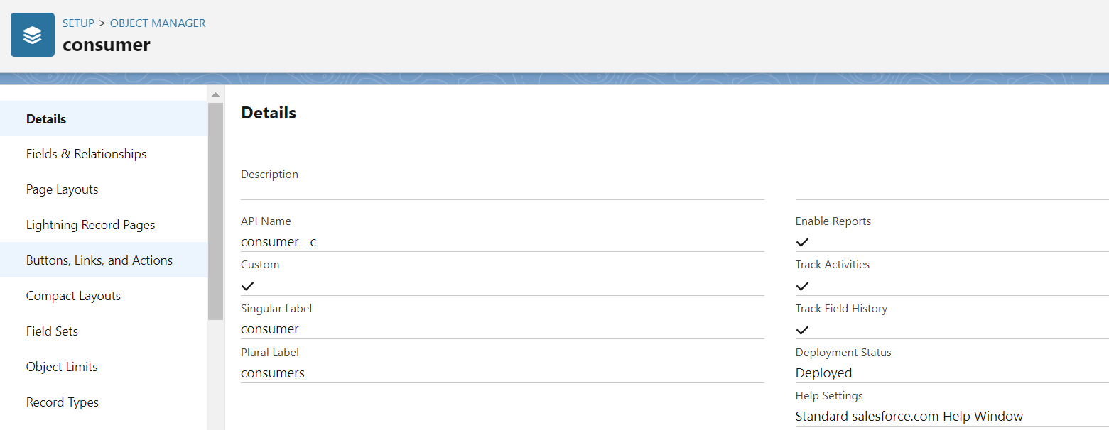

**Rice Details Objects**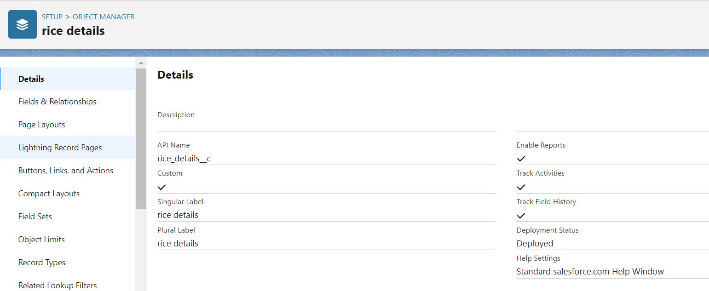

3)Tabs

**Custom Tab**

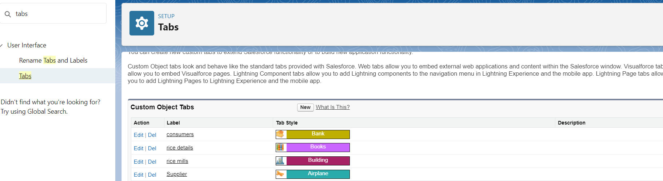

4) Lightning App

**Create A Lightning App**

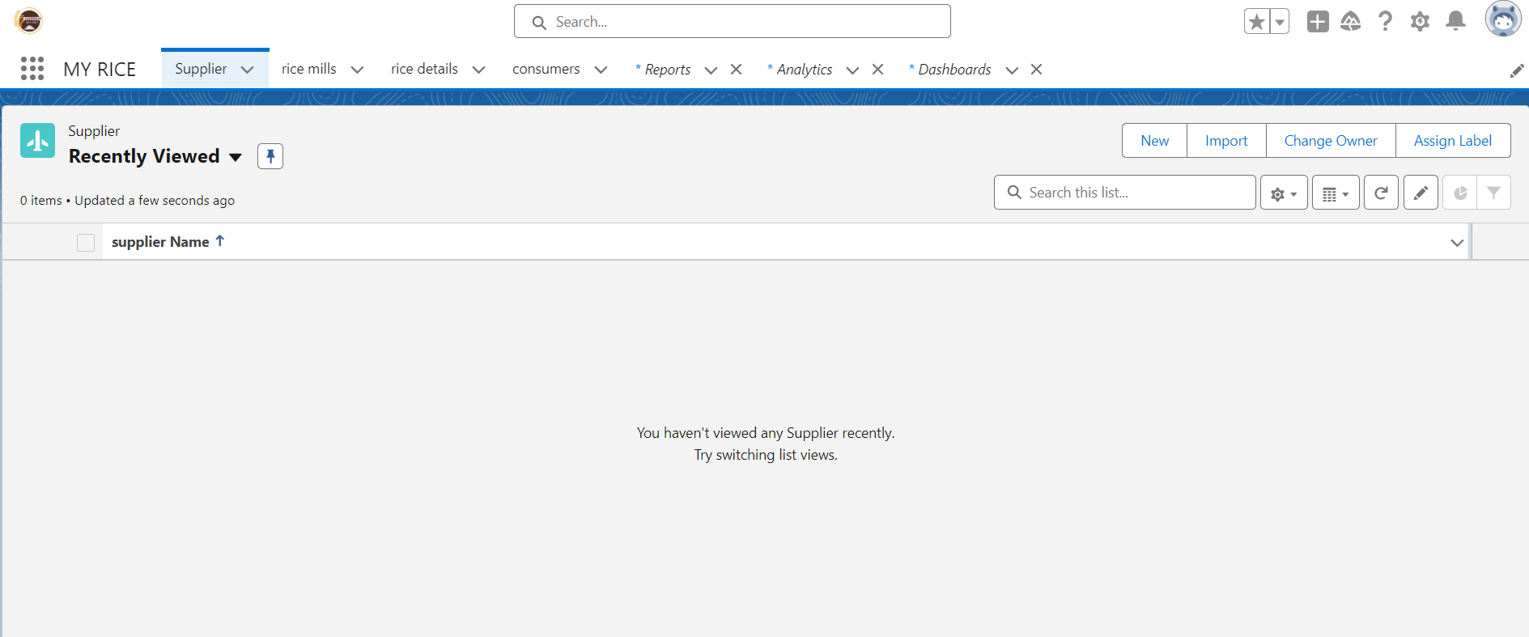

5) Fields

**Number Field in Rice Details Object**

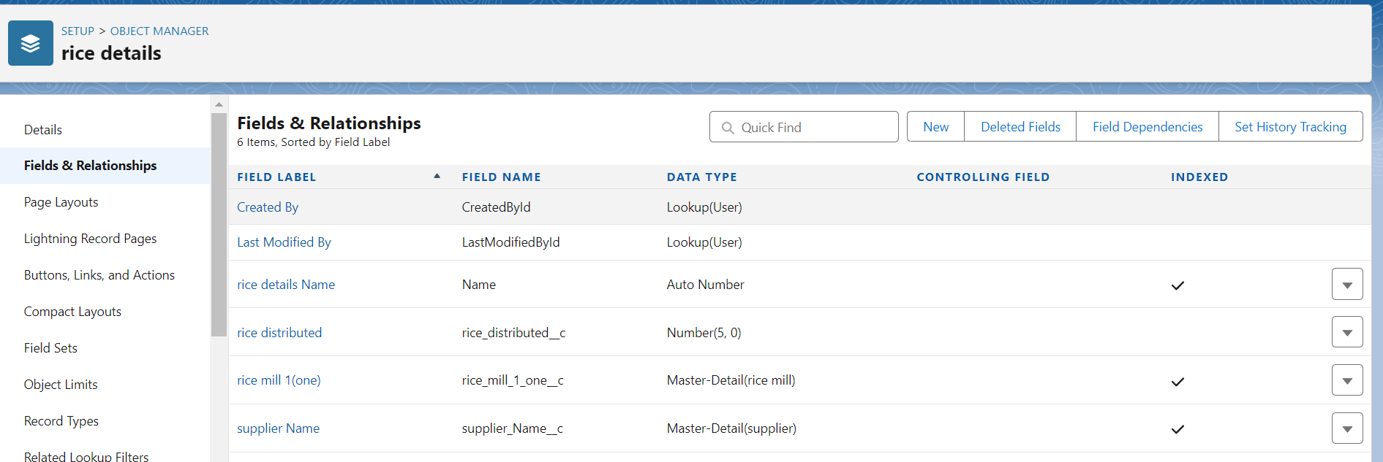

**Creating Junction Object**

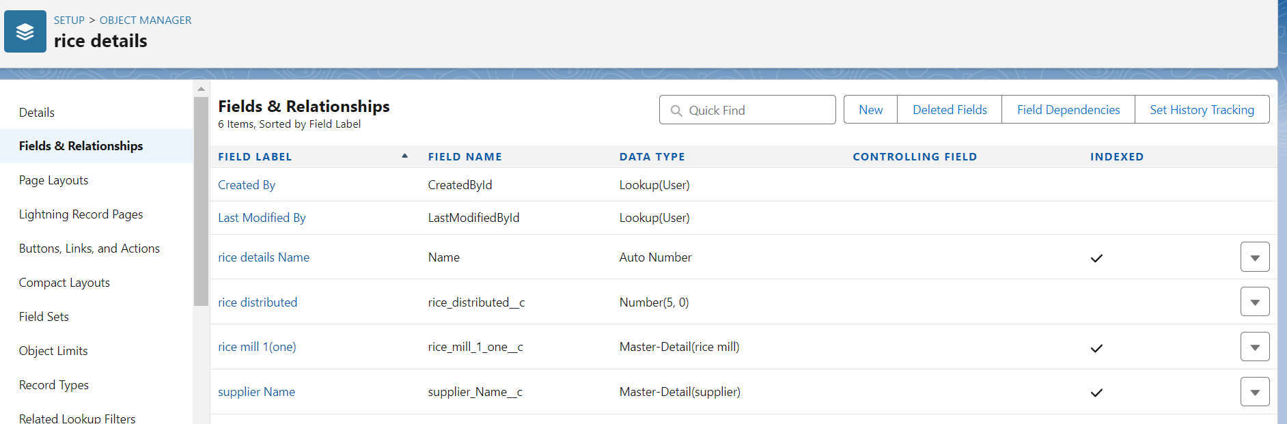

**Master -Detail Relationship**

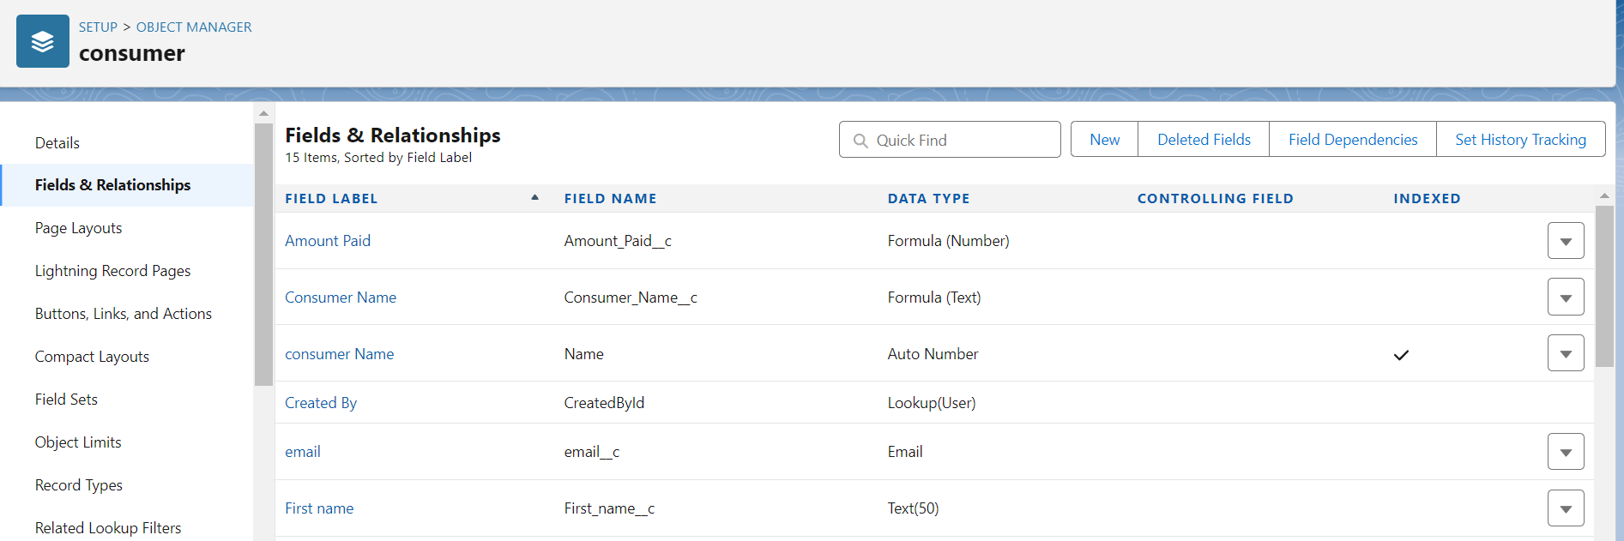

**Roll -up Summary**

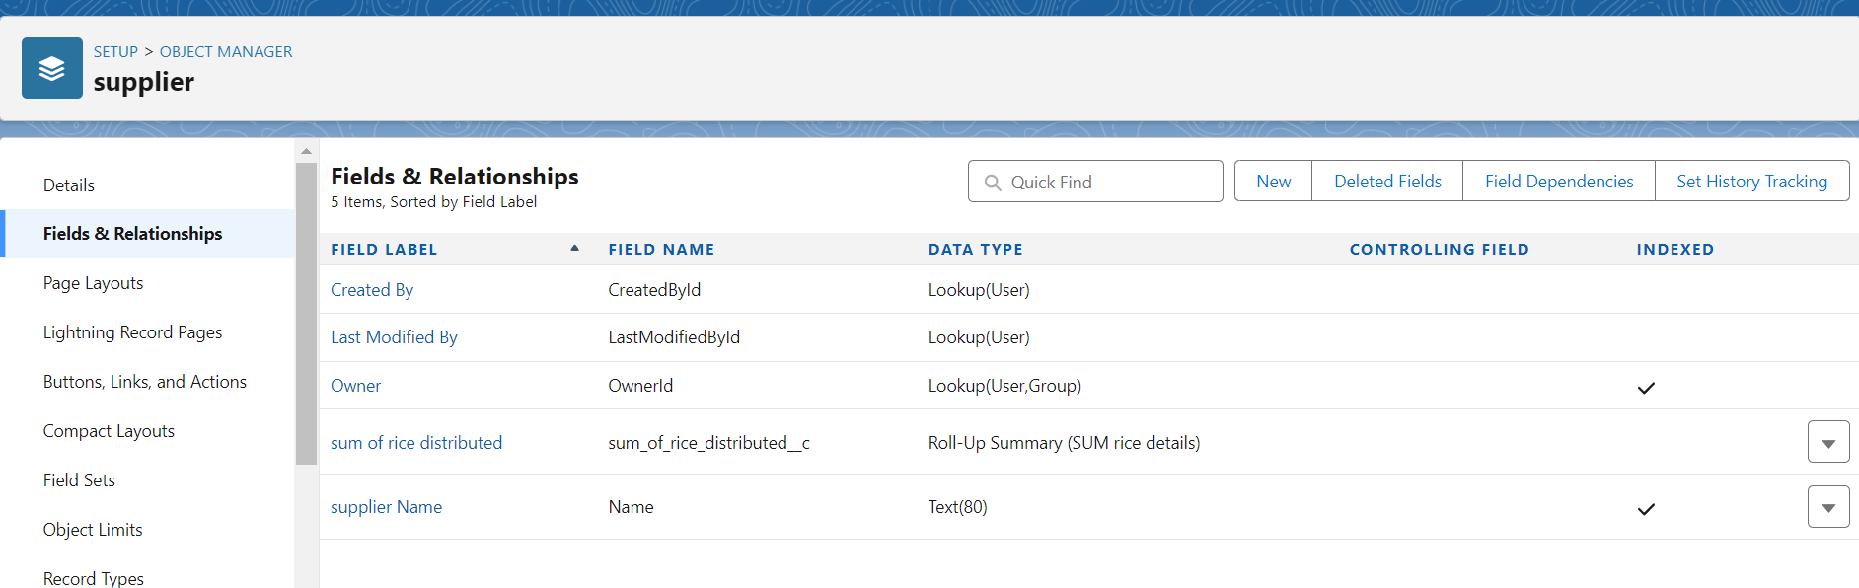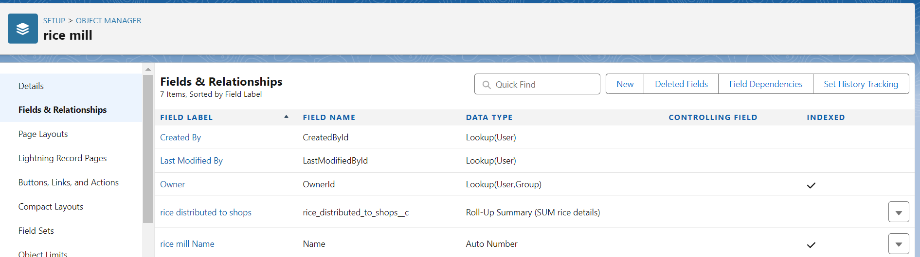

**Fields In Rice Mill Objects**

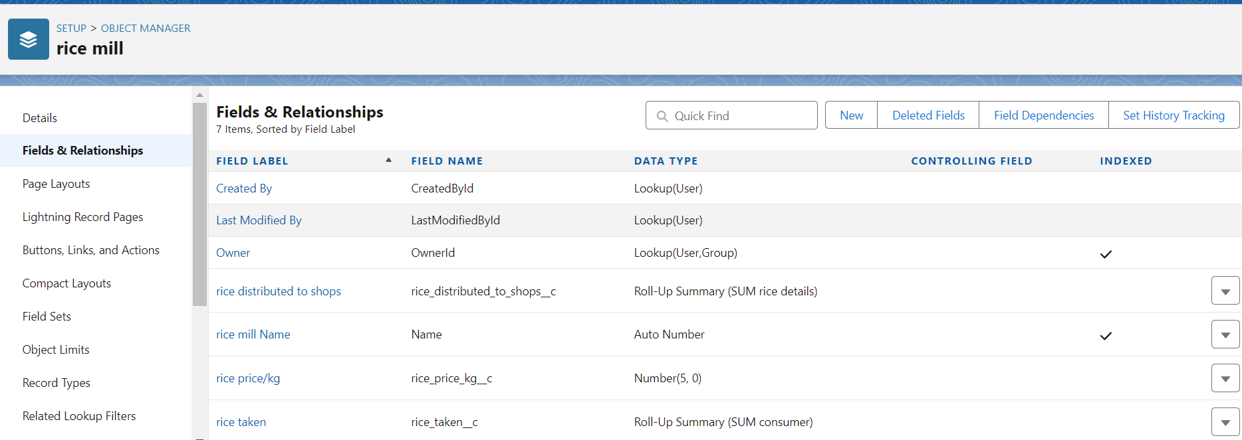

**Creating Fields In Consumer Objects**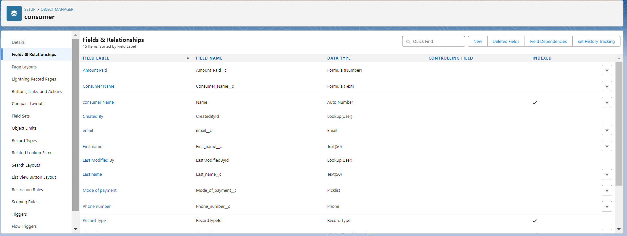

**Creating The Validation Rule**

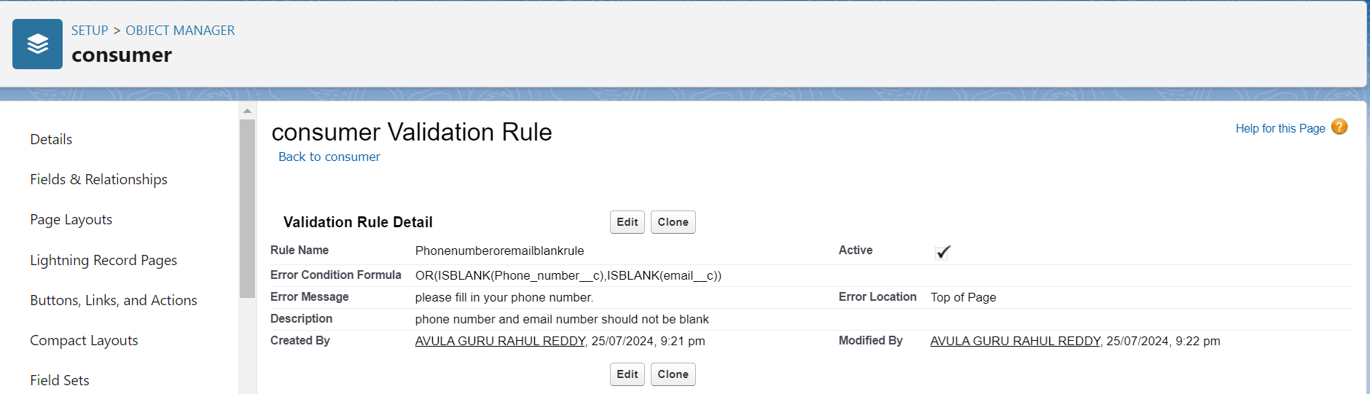

6) Page Layouts

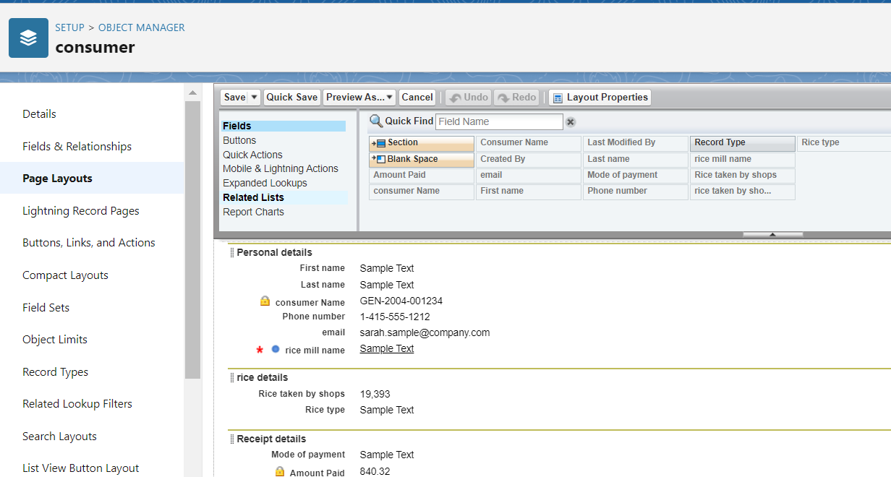

7) Profiles

**Owner Profile**

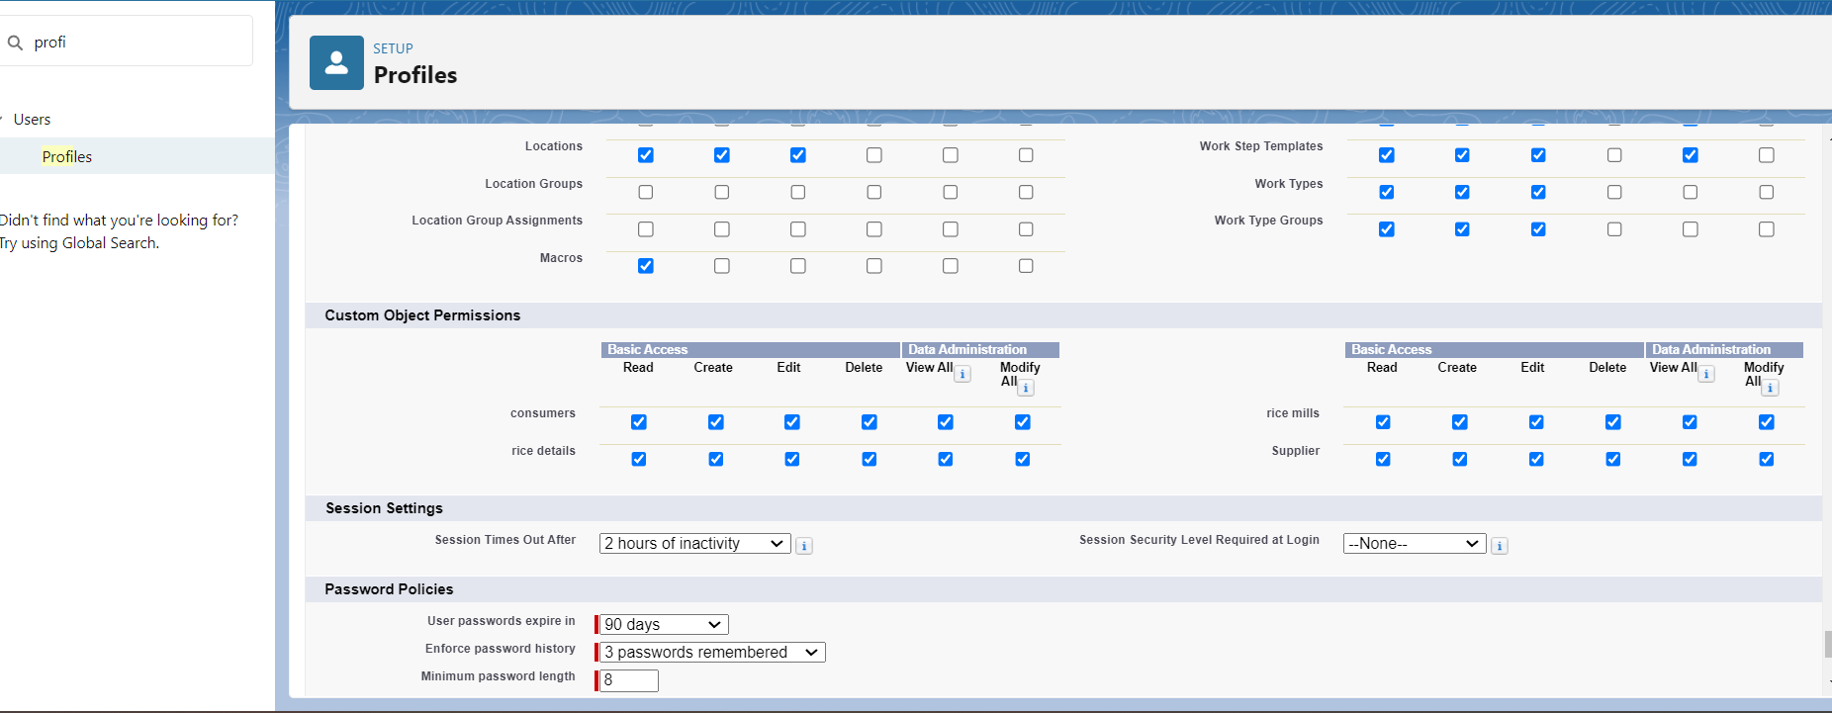

**Employer Profile**

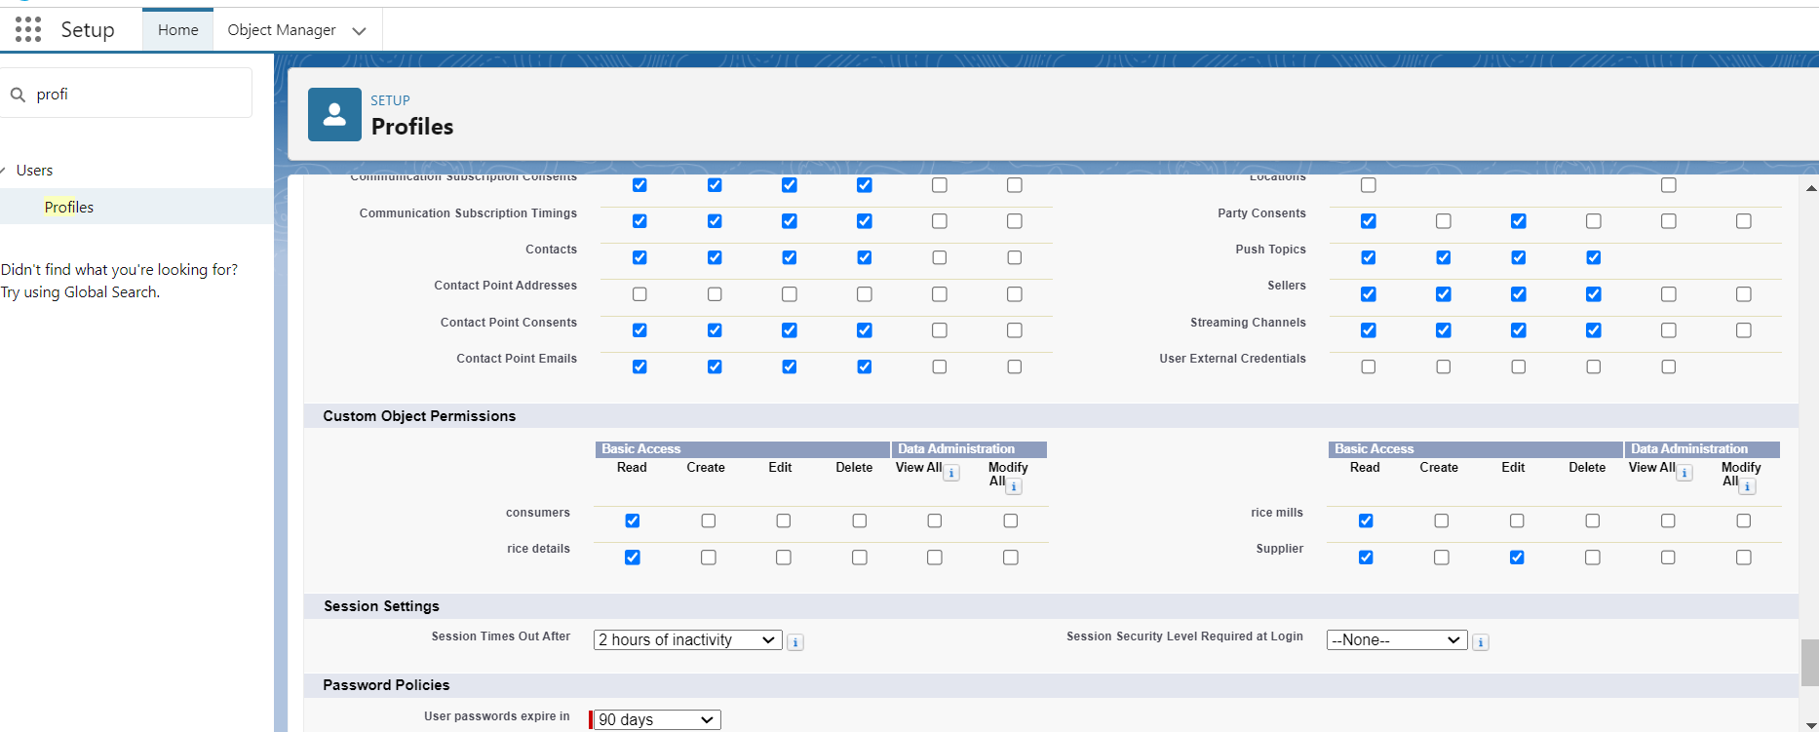

**Worker Profile**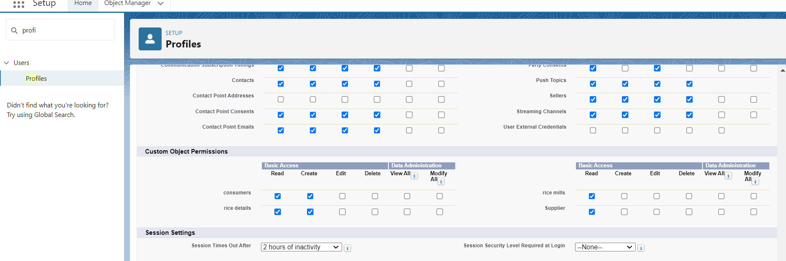

8) Role & Role Hierarchy

**Owner Role**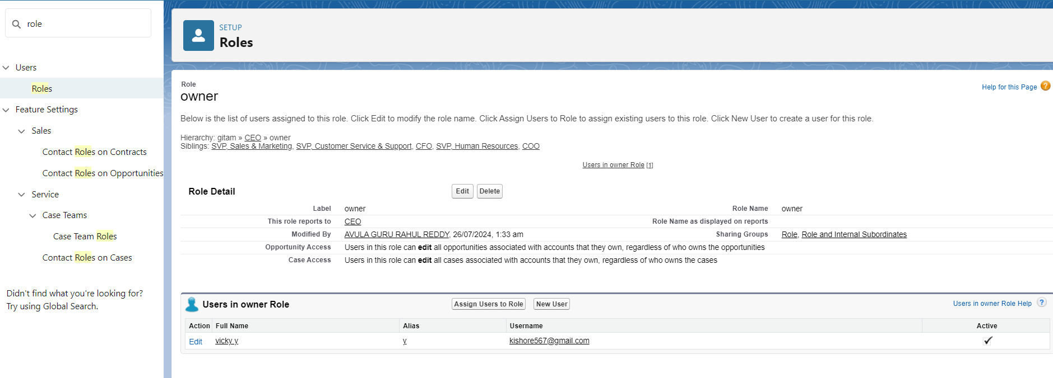

**Employer Role**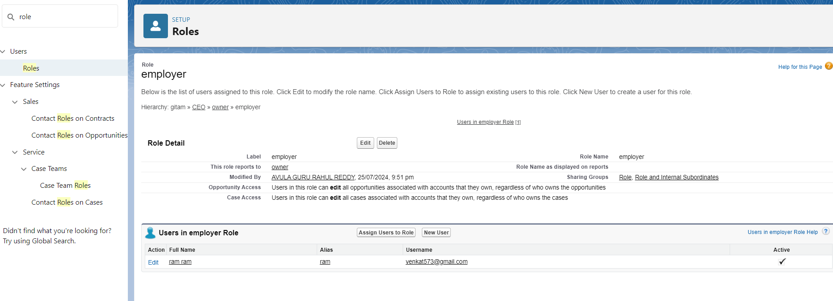

**Worker Role**

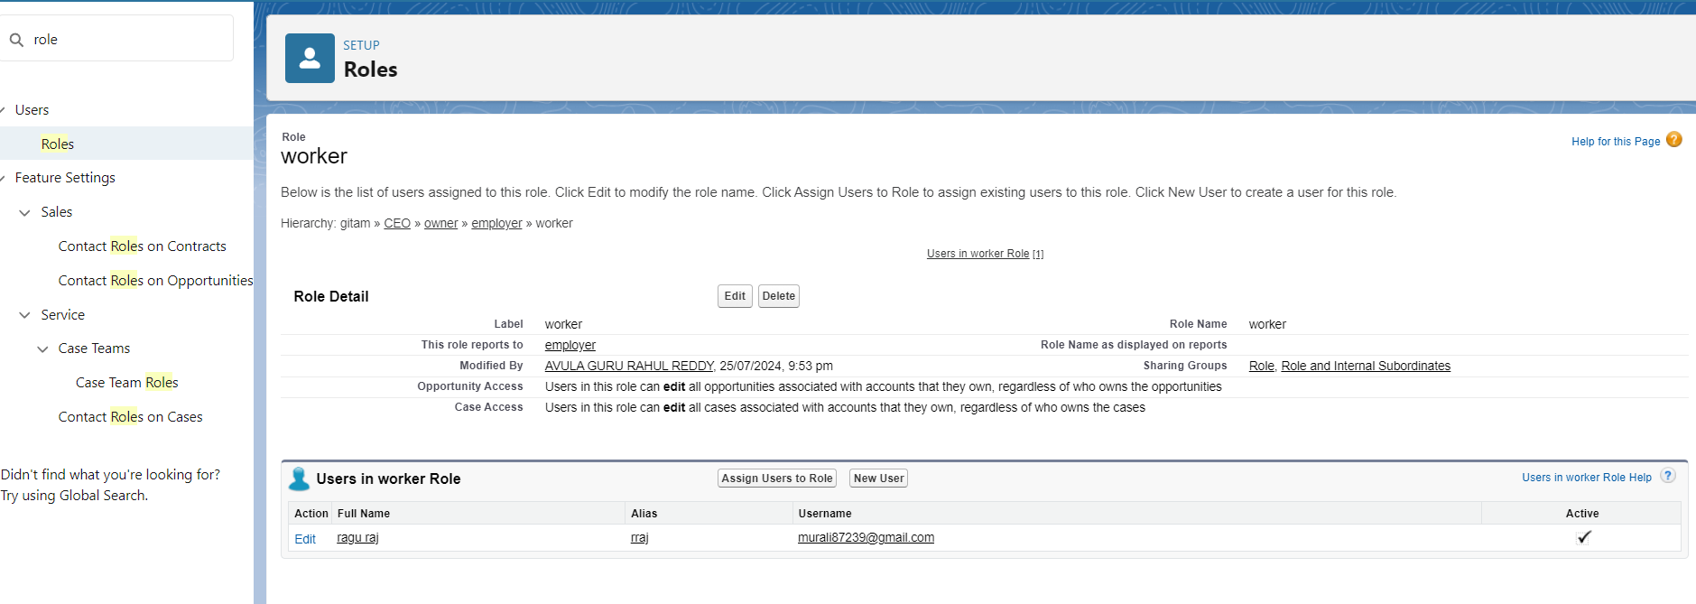

9) Users

**Create User** 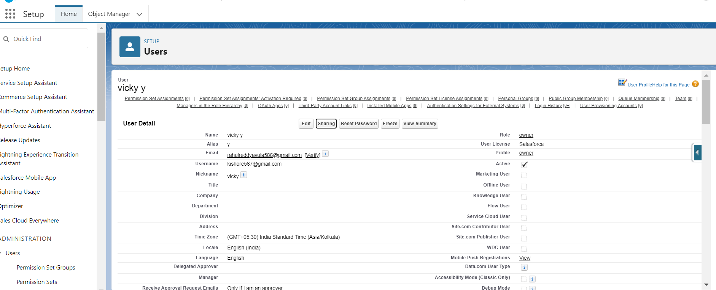

**Create Another Users** 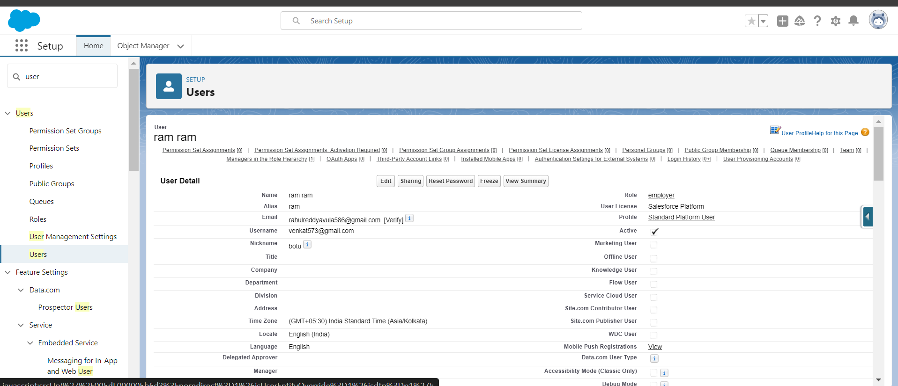

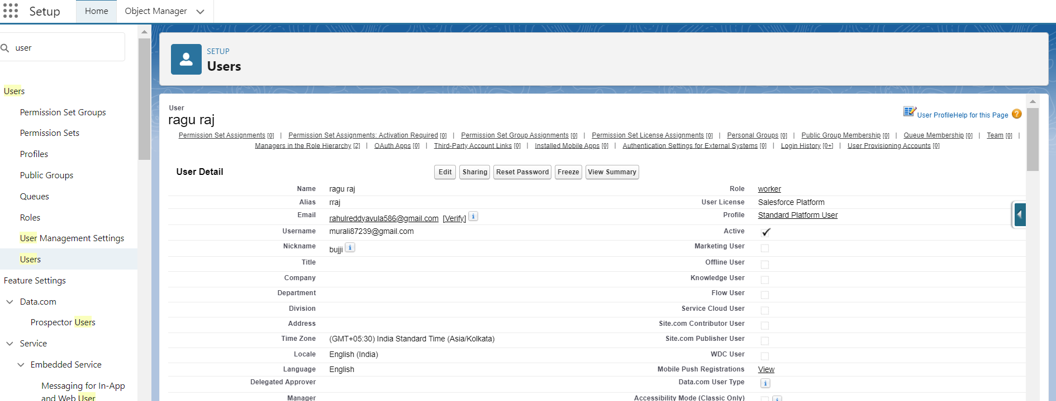

10)Permission Sets

**Create OWD Setting**

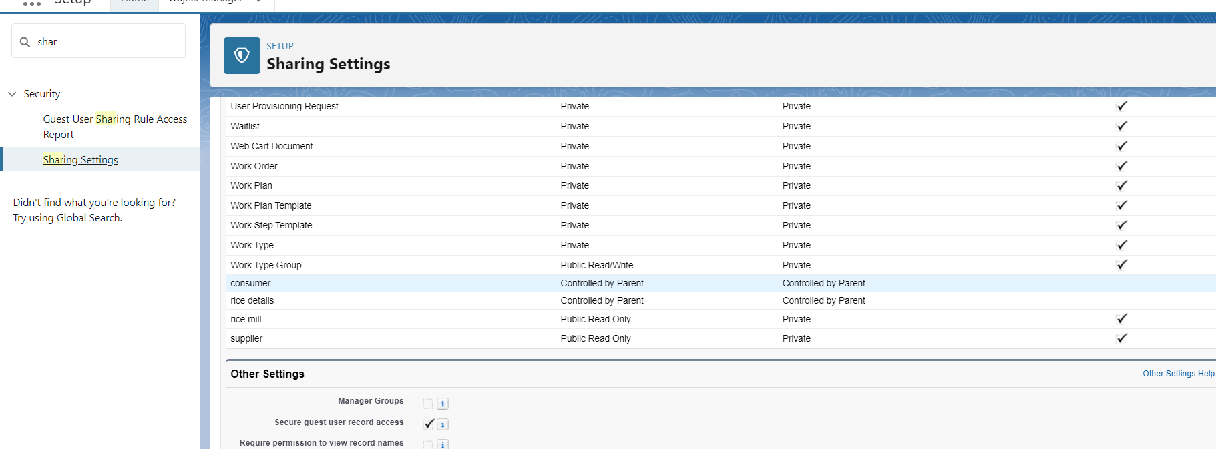

11)Reports

**Create Report**

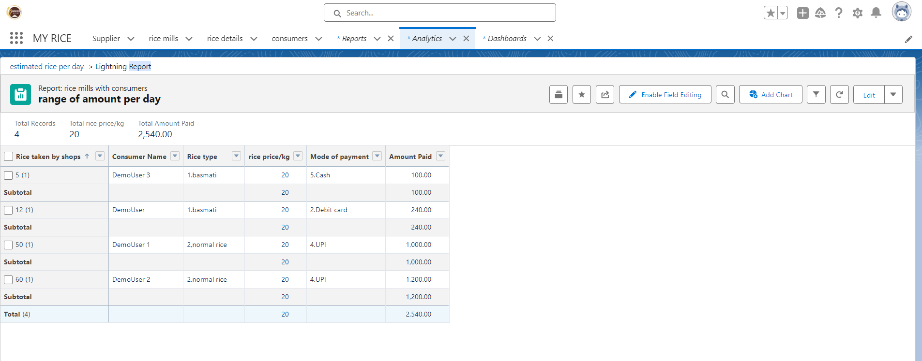**Sharing Report to Owner**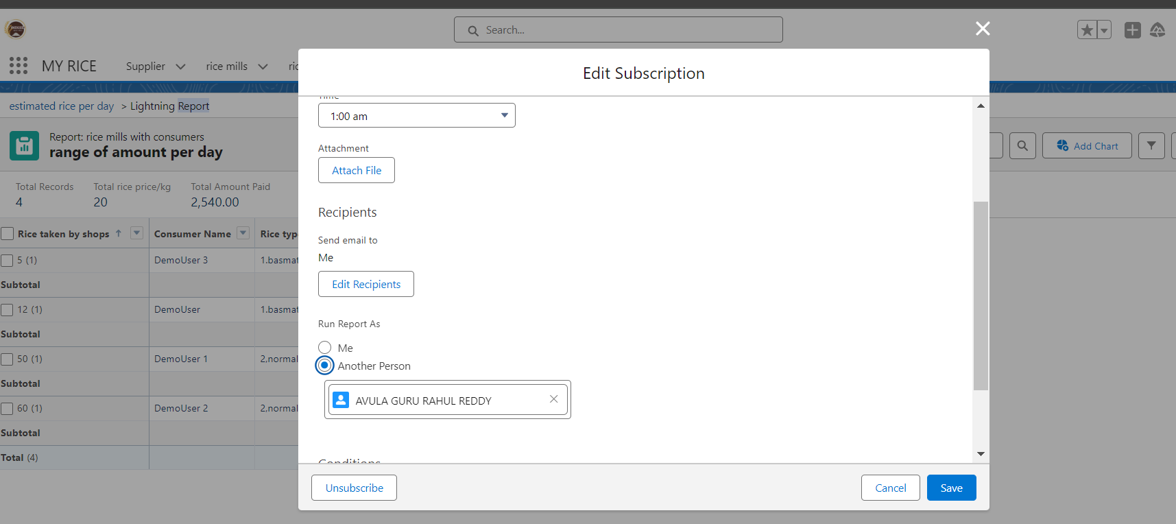

**Create a Report Folder**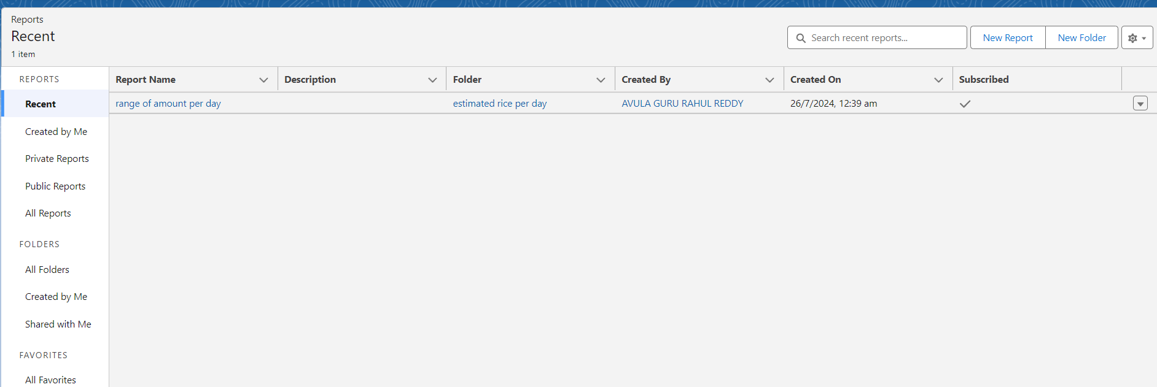

12)Dashboards

**Create Dashboard**

