

American International University-Bangladesh (AIUB)  
**Department of Computer Science  
Faculty of Science &Technology (FST)  
Spring 21 22**

**Vromon – Community Based Travel Services**

Software Requirement Engineering

Sec: **B**

Project submitted

By

DIP,RAHUL JOARDER(18-38082-2)

The project will be evaluated for the following Course Outcomes

1. **PROBLEM DOMAIN**
   1. **Background to the Problem**

In this age of technological advancement, the demand for online services have increased to an extent which was never seen before. Moreover, the COVID-19 pandemic has clearly shown the advantages of moving operations online. These advantages are also applicable to the travel industry of Bangladesh. Nowadays, people are looking for travel related information on the internet, since it is the most accessible and easiest way of getting information.

There are a number of online travel startups in Bangladesh. The first software solution provider to create such a platform is *PHP Holidays,* which provided services like booking engines for tour operators, hotels, vacation rentals, restaurants, flights, car rentals, cruises and bus operators. Many travel agencies and travel related companies used the platform to expand their business. But *PHP Holidays* did not provide any information solution for the tourists.

“Vromon” is a web-based application that aims to combine the services desired by tourists as well as travel related business organizations. This application will be integrating features like information about places to travel to, classified by divisions and district names. This information can include pictures, ways to travel, possible routes to reach there, transportation and hotel facilities, possible budget requirements etc. This information will allow the customers and tourists to get a good overview as well as a cost estimation to travel to the destinations they are interested in. The users can then choose the route and book tickets, car or hotels based on their cost limits.

“Vromon” is not only for the tourists, it will also act as a hosting platform for hotel, or property owners as well as bus, car, train or airline owners. The tourists will be able to connect with the travel businesses through this platform. This platform will allow the travel business owners, as well as small asset holders to engage with tourists.

Due to the increased number of local travelers within our country, there was a rapid increase of Online Travel Agencies (OTA). But none of them present any opportunity for the tourists and the travel business owners to interact in the same platform. Most of the agencies either focus on tourist’s travel solution or provide a booking system for the business owners. Most of them do not have specific area related information and only show popular destinations, which keeps the less popular travel destinations out of focus. But none of those OTA’s provide with travel information as well as travel related services together in the same application. That is the main aim of “Vromon”, to create a one stop service for tourists as well as the travel business owners. Few of the projects of this domain are discussed in the literature review section.

* 1. **Solution to the Problem**

This project report showcases the feasibility, business possibilities, implementation details and estimations for a web-based application named “Vromon”. This application acts as a digital aggregation platform for the travelers and travel related business owners of Bangladesh. The report starts with the background analysis and feasibility of creating such a platform. Then the Project Specifications, Software Requirement Specifications, Software Design Description, Software Configuration Management and Software Verification and Validation are discussed sequentially. This report also discusses the Software Development Process Model which will be used and also provides with the reasoning for selection. The test cases for the purpose of Software Testing are also discussed in this report. Possible budget estimation, possible risks and the required time calculations are also included in the report. There are also some screenshots of the UI elements as Illustrative prototype.

In this section the business opportunities and scope of the project will be discussed. First, we set the goals and future prospects of the project, which can provide us with an outline of the future steps to be taken. Next, we will discuss the collected user data and analyze the market values of the features which are planned to be implemented. The market analysis will help in the understanding of the priorities of the features and feature priorities can be set accordingly. Then, the competitive position analysis will provide an idea about the position of this project in the industry and what gives us a business advantage over other companies. In the success factor section, the features which will decide the success of our project and the prospect of the people associated with the platform will be discussed. Finally, the business requirement and the overall business model of the project will be discussed.

**Vision**

The vision of “Vromon” is to be established as a trusted travel solution provider for the travelers as well as the traveling related business owners of Bangladesh.

**Mission**

The mission of this platform is to provide traveling related information and a one-stop service for the travelers and a platform for the business owners to reach customers easily.

**Goals**

* Provide centralized information for all districts of Bangladesh.
* Provide tourists with travel related services like transportation, ticket and hotel booking, etc.
* Provide traveling related business owners with a platform to reach their customers.

**Success Factors**

* A well-established user-base, which is already available, since there is a huge number of local travelers and travel related business owners in Bangladesh.
* Integration of district-wise travel destinations’ information.
* Availability of different travel related services like transportation, ticket and hotel booking etc.
* Easy to create online business presence for both small and large travel business owners

Easy to use User interface.

1. **SOLUTION DESCRIPTION**
   1. **System Features**

**Functional Requirements**

1. **App login and Signup**

**Functional Requirements:**

* 1. The application will have three types of users (Tourists, Business Owners, Admin)
  2. Users will be able to login to the application with valid email and password. The user type will be determined automatically.
  3. If the email or password is incorrect, the user will be prompted to try again.
  4. Users will be prompted to register a new account in the home page and the sign in page.
  5. When a user will register, an email will be sent to their email for account verification and confirmation.
  6. There will be a password recovery system through email.
  7. During registration, Business owners need to provide their E-Trade License and E-TIN number as well as a copy of the picture of the Trade license.
  8. Users can use the “remember me” functionality for faster login procedures.
  9. Tourists will be prompted for premium subscription during registration.

**Priority level:** High

**Precondition(s):** User email and password needs to be valid

**Cross-reference:** None

1. **Tourists Features**

**Functional requirements**

* 1. Tourists should be able to browse the travel destinations based on districts.
  2. Tourists should be able to select routes to the destination and method of transport.
  3. Tourists should be able to book hotels and/or tickets based on the destination.
  4. Tourists should be able to subscribe to premium membership
  5. Tourists should be able to select payment methods.

**Priority level:** High

**Precondition(s):** User must be logged in

**Cross-reference: <**Billing and Payment**>**

1. **Business Owner Features**

**Functional requirements**

* 1. Business Owners will be able to add their business(s).
  2. Business owners will be able to add details and pricing for their business(s).
  3. Business owners should be able to choose payment methods.
  4. Business owners will be able to pay their due to the application.

**Priority level:** High

**Precondition(s):** User must be logged in

**Cross-reference: <**Billing and Payment**>**

1. **Administrative Team Member Features**

**Functional requirements**

* 1. Admins will be able to check user information if necessary.
  2. Admins will be able to verify the validity and license of the businesses of the business owners.
  3. Admins will be able to verify the validity and license of the businesses of the business owners.
  4. Admin s will be able to look into the issues sent as support tickets and try to solve the problems with coordination with the support team.

**Priority level:** High

**Precondition(s):** User must be logged in

**Cross-reference: <**System Features**>**

1. **Destination and Search Functionality**

**Functional requirements**

* 1. Tourists will be suggested the most popular travel destination.
  2. Tourists will be able to search by destination name or district name.
  3. Top travel destinations of the searched districts will be displayed after searching by district names.
  4. Tourists can add destinations as their favorites.

**Priority level:** High

**Precondition(s):** None

**Cross-reference: <**System Features**>**

1. **Booking Functionality**

**Functional requirements**

* 1. Tourists should be able to book flight, train, bus tickets or hotels.
  2. The business owner running the booked business will be notified.
  3. Booking options can be sorted or constrained by the tourists based on cost.
  4. Tourists should be able to cancel their booking if necessary.
  5. No advanced payment is necessary for booking.

**Priority level:** High

**Precondition(s):** User must be logged in

**Cross-reference: <**System Features**>,<**Billing and Payment**><**

1. **System Features**

**Functional requirements**

* 1. The application system will analyze user data and show recommended travel destinations based on the information.
  2. System should ensure that the offers shown are relevant to the tourists.
  3. The system will provide a faster response by caching frequently used data.
  4. System should be able to show push notifications about bookings to the business owners.
  5. Systems should be able to show the last visited destinations and history to the tourists.
  6. System should be able to keep track of the payment status of the businesses and take actions accordingly.
  7. System will offer regular discounts to subscribed members

**Priority level:** High

**Precondition(s):** Some functionalities will require subscription

**Cross-reference: <**Billing and Payment**>,<**Destination and search functionality**>**

1. **Billing and Payment Functionality**

**Functional requirements**

* 1. Tourists and business owners should be able to add payment methods (Credit card/ cash/ bkash).
  2. The system will be updating payment status in real time.
  3. Confirmation email for payments will be sent with a receipt.

**Priority level:** High

**Precondition(s):** User must be logged in

**Cross-reference:** None

1. **Sign out Functionality**

**Functional requirements**

* 1. Users should be able to sign out whenever they want.
  2. Users should be able to sign out of all devices/browsers in which they are logged in

**Priority level:** High

**Precondition(s):** User must be logged in

**Cross-reference:** None

* 1. **UML Diagrams**

**UML diagrams**

**2.2.1 Use Case diagram**

In this application, there will be four types of users. They are tourists, business owners, administrative team members and the system itself. Subscribed tourists will be a specialized type of user who will have access to ad-free experience and discounts. Tourists will be able to search travel destinations, choose routes, book hotels and transportation or other community services. Business owners will be able to add business details and pay due amount to the platforms. Admins will be in charge of keeping track of the payments and verification of users. The system will be coordinating communication between tourists and business owners as well as analyzing and recommending destinations and maintaining history.

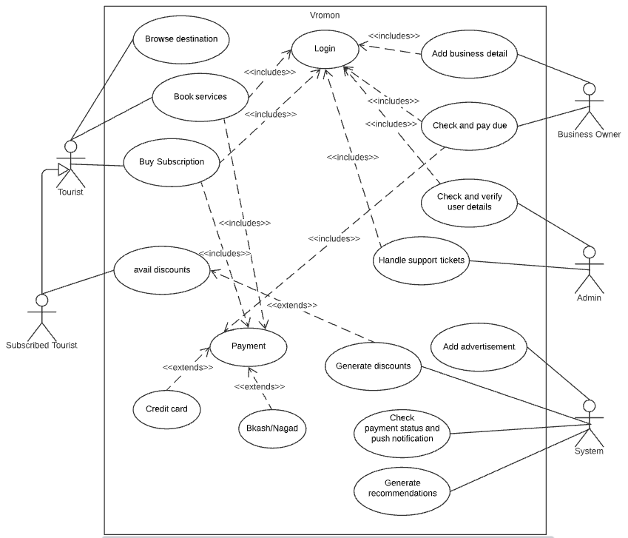

**2.2.2 Activity diagram**

System will be identifying the user type during login. If the user is tourist, then the system checks if the user is a subscribed or not. Discounts will be available for subscribed users and advertisements will not be shown. All users can browse different destinations and book services. For business owners, they can add, edit or remove their services or products. They will also be provided with notifications for business opportunities and details of their payment status. Admins will be able to verify user information of the business owners and will provide solution to support tickets of the users.

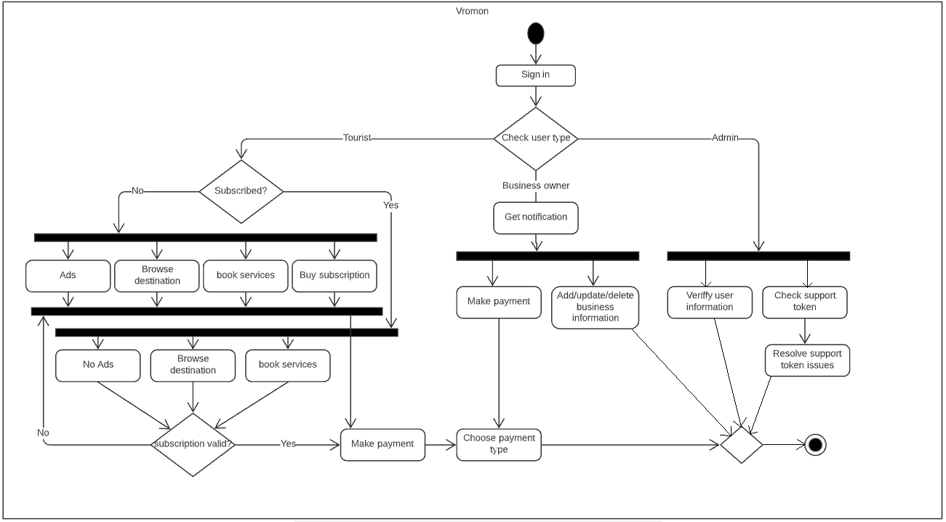

**2.2.3 Class Diagram**

There are mainly nine entity classes. Those are: User, Tourist, Admin, BusinessOwner, Destination, Payment, Business, Booking and Services. Since the classes will be prototype based, the functionalities will be handled outside the classes. The attributes will be handled as attributes of an object notation. The User will be extended by Tourist, Admin and BusinessOwners. BusinessOwner can own zero to many businesses which can provide zero to many services. Each destination can have zero to many services booked. The tourist can have zero to many services booked in zero to many destinations. Both BusinessOwner and Tourists can make zero to many payments.

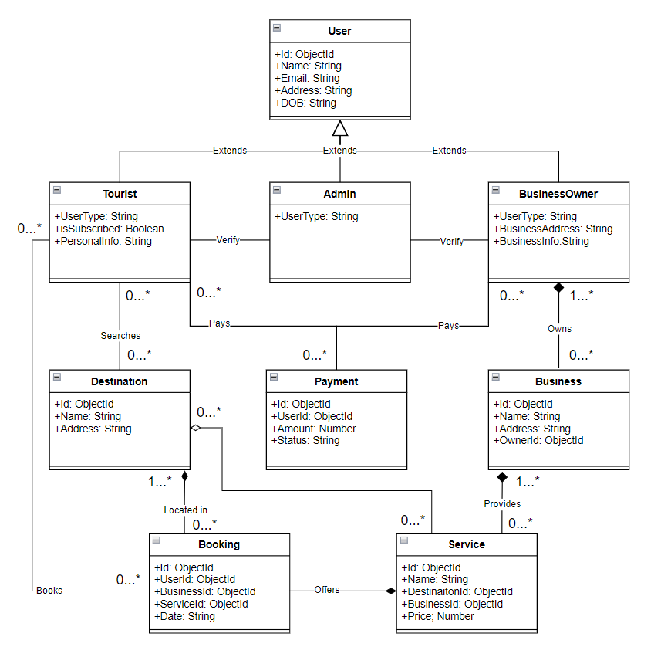

**2.2.4 Entity-Relation Diagram**

There are mainly ten entities. Those are: Tourist, Business owner, Admin, Destination, Business, Payment, UserInfo, Support token, subscription, and services. Tourist has UserID, Name, DOB, Address, IsSubscriber as attributes. Business owners have similar attributes but not the subscriber attributes. Admin also have the same attributes, as these are the users of the system. Destinations have DestinationID, name and Address as sttributes. Business has BusinessID, ownerID and BusinessInfo as attributes. Payment has paymentID, Type, Amount and UserId as attributes. UserInfo has UserID, infoType and Documents as attributes. SupportToken has tokenID, IssueUserId and completionState as attributes. Subscription has subscriptionID, UserID and status. Services include serviced, BusinessId, BookingState and TouristId as attributes.

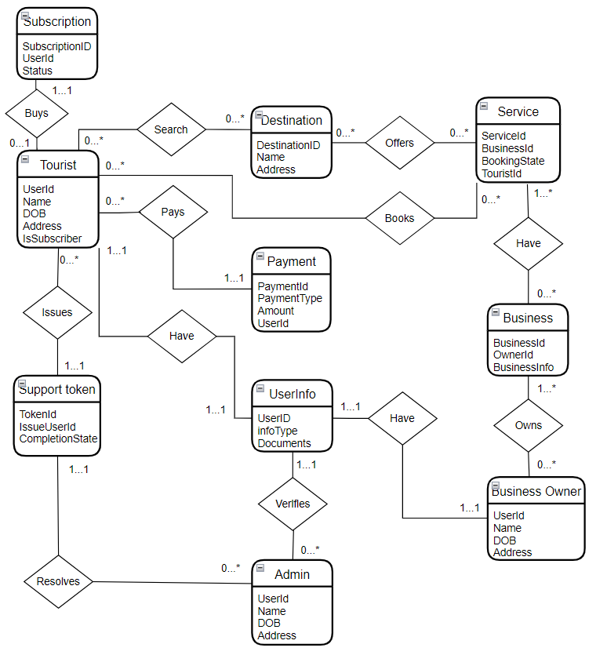

1. **Social Impact**

**Social impact travel**is a growing trend in the travel industry that aims to support local economies and make a positive impact in host communities. This new trend centers on discovering local cultures and respecting the cultural, economic, and ecological environment. People are increasingly seeking immersive local cultural experiences that are respectful, ethical and sustainable.  
  
This trend has taken many different forms, depending on the preferences of the traveler. Here are a few examples:

* **Locally-Sourced Travel** emphasizes supporting local businesses to benefit the local economy rather than large multinational corporations. Travelers can opt for family-owned restaurants rather than chains, stay in AirBnB's or locally-owned hotels, and patronize local travel guides rather than international agencies.
* **Eco Travel** aims for low- or zero-impact traveling. Depending on the destination, some travelers stay in eco-lodges, which are accommodations created to have the least impact on the natural environment as possible. Often they aim to educate guests on the surrounding natural environment.
* ​​​​​​​**Conservation Travel**is often found in areas with rich wildlife. Conservation travelers will patronize tour companies that are involved in conservation work in order to protect the local flora and fauna.
* **Volunteer Travel** combines travel with volunteering for organizations in local communities. Examples include working with kids for childcare or tutoring, contributing to construction projects, working for conservation efforts and assisting healthcare programs, among others. Despite the good intentions of volunteer travelers, the amount of true impact by short-term volunteers is debatable. To read more about the discussion around volunteer travel.

These are just a few types of social impact travel, but you don’t have to book your trip through a specific social impact company to participate. Social impact travel just means having an awareness of the impact made by one’s travel and consciously looking for ways to benefit the community while protecting the local culture and environment.

1. **Project Estimation**

**Time Estimation**

**4.1 List of Tasks**

* Requirement Elicitation
* Project Planning
* Requirement Analysis
* System Design
* Object Design
* Implementation and Unit Testing
* System Integration and System testing

**4.2 Estimation**

Normally, the KLOC (thousand lines of code) for the completion such a System taking into consideration the programming language is 100.

So, person-months needed for the project can be calculated using COCOMO 2 method.

Effort = PM=Coefficient<Effort Factor> *(SLOC/1000) ^P

=2.4*(100,000/1000) ^1.05

=302 person months

Here,

Coefficient<Effort Factor> = 2.4 (since it is an organic project)

SLOC= 100,000

P = 1.05 (since the project is an organic project)

Since the model chosen for completion of the project is agile method, by taking effort estimation in account it was found that 66 working days is required to complete the project. On the basis of Rational Unified Process, the time phase for each task can be divided as follows:

|  |  |  |
| --- | --- | --- |
| **Task of phase** | **Days** | **Person Month** |
| Requirements Elicitation | 08 | 64 |
| Project Planning | 11 | 88 |
| Requirements Analysis | 08 | 64 |
| System Design | 12 | 96 |
| Object Design | 10 | 80 |
| Implementation & Unit Test | 08 | 64 |
| System Integration & System Testing | 09 | 54 |

**Note:** Every engineer works 8 hours a day, 5 days a week. The overall length of the project is 66 working days, (excluding national holidays).

So, the required development time can be calculated as follows:

DM = 2.50*(PM) ^T

= 2.50*302^0.38

= 22 months

Here,

PM = Person-months need for the project= 302 person months

T = 0. 38 (as the project is an organic project)

And, the required number of people

ST = PM/DM

= 302/22

= 14 peoples

Here,

PM = Person-months needed for the project = 302 person months

DM = Development time = 22 months

So, the total estimation of the project is:

* Required person months for completion of the project is 302
* For development the time required is 22 months
* Total number of people required is 14

The Gantt chart of the work flow is shown below:

**4.3 Cost Estimation and Budgeting**

The total estimated budget for the project is calculated for 2 years period. The estimated amount is (13500000 + 2400000 + 720000 + 1200000) * 2 = BDT 35640000. The breakdown of the cost estimation is described below.

**4.4 Employee Salary Estimation**

Out of the 14 engineers, it is intended to have 5 senior and 9 junior personnel starting with a salary of 35000 BDT and 75000 BDT per month. So, the total salary amount is calculated as follows:

Salary for 1 month is,

5 * 75000 = 375000

9 * 35000 = 315000

--------------------------

Total = BDT 690000

So, in a year, 690000 * 12 = BDT 8280000

There will be 5 creative department employees who will handle tasks of creative design. Which in a month,

5 * 40000 = BDT 200000

So, in a year 200000 * 12 = BDT 2400000

The Marketing will be mostly conducted online for first 2 years, so there will be 2 employees engaged in the marketing related affairs, which in a month,

2 * 30000 = BDT 60000

So, in a year, BDT 720000

**4.5 Database and Cloud services Cost Estimation**

MongoDB will be used as the database, and it will be remotely hosted. For cloud services, AWS services (EC2, Route73, Elastic Load balancer) will be used. So, the estimated costs will be:

MongoDB Atlas dedicated: BDT 6000/month

AWS EC2 with EBS: BDT 5600/month

AWS Route 53: BDT 100/month

AWS Elastic Load Balancer: BDT 1360/month

So, per year that is,

12 * 6000 = 72000

12 * 5600 = 67200

12 * 100 = 1200

12 * 1360 = 16320

------------------------

Total = BDT 156000

**4.6 Marketing Cost**

Facebook advertisement BDT 100000 / month

So, in a year that is BDT 1200000

1. **Development Plan**

Tourism as a promising economic sector has gained acceptance globally and endorsed increasingly by apex international organizations such as the United Nations World Tourism Organization (UNWTO). Representing the developing world, Bangladesh has a range of tourism resources to attract tourists to contribute to the overall economy. However, the development of this sector within the country is still at its early stage. Accordingly, the country is failing to receive the utmost value from tourism sector. This chapter aims to outline a number of suggestions to develop tourism sector in the context of Bangladesh. In doing so, qualitative research approach has been employed. The data collection strategy encompasses both primary and secondary techniques. The primary technique mainly involves securing opinions from industry experts while the secondary techniques cover reviewing a wide range of published and unpublished materials. This paper identifies a number of issues to be addressed to realize the potential of tourism sector in Bangladesh. These issues include formulation and implementation of tourism friendly master plan, creation of tourism quality assurance cell, development of tourists’ facilities and necessary infrastructures, coordination among key stakeholders, proper marketing and promotional campaign, allocation of adequate budget, invitation of foreign investments, and awareness creation to upgrade tourism from the existing condition. This study is believed to be helpful for tourism policymakers and researchers in Bangladesh.

The Software Development methodology intended to be used for the project is Extreme Programming (XP). This is an iterative approach for software development which can be flexible and respond to the requirement changes. Since the project will mostly depend on user feedback and reviews, there will be dynamic requirements and frequent feature changes. Extreme Programming can provide with the required flexibility to cope with the changes.



**Reason for choosing XP**

* XP can ensure more goal focused development.
* It is easier to detect bugs and errors since it is an agile model.
* It can produce an optimized version for production.
* XP can provide with optimal project management.
* Can adapt base on requirements.

1. **Change Management Plan**

First things first, what is change management? US change-management consultant Prosci defines it as how we prepare, equip and support individuals to successfully adopt change for the good of an organisation.

Applying change management covers three key areas:

1.A **process** used by teams to manage system, process and organisational changes.

2.A **leadership competency** for enabling the change.

3.A **strategic capability** to increase change capacity and responsiveness.

**When it comes to a company travel program, this involves:**

* Designing and deploying the new policy
* Implementing new technology
* Introducing a new booking and approvals process.

Successful change management requires engagement and action from all stakeholders, as well as daily management to minimise non-compliance.

Reduce the pushback in three steps

1. **Identify what you want to achieve and how you’re going to do it**

Engage a Travel Management Company (TMC) to design a policy that'll meet your objectives. Together you can identify your top-level goals which may be cutting spending, a faster booking system, easy cost reconciliation or better visibility  of your expenditure.  Work with your travel implementation team to  predict problems and create a strategy for roll-out.

2. **Share the new policy with staff**

Work with your travel  team to identify the best ways to let people know what’s happening and why. A common cause of traveller friction is simply not being told the reasoning behind policy changes. Easing this friction requires circulating the new policy, as well as training staff in new booking systems and procedures.

3. **Stress the importance of compliance**

Talk to your Travel Manager as the changes are being rolled out to gauge how you’re tracking against your objectives. They can analyse any policy leaks using reporting and metrics and create new tactics to combat non-compliance.

**Other steps you can take include:**

* Engaging with your travellers to identify who will incur a loss in status or rewards as a result of the new policy.
* Liaising with your Travel Manager to compensate staff who may lose benefits. They may be able to organise airline lounge passes or individual concessions for higher booking classes.
* Addressing affected travellers directly, making it clear that you understand where they’re coming from while outlining the need for policy changes.
* Emphasise the steps the company is taking to compensate those who are affected.

1. **Marketing Plan**

An online form was released to gather data on the preferences of the tourists. Few questions were prepared to get a better idea about what the tourists expect from an Online Travel Agency (OTA). The outcome of the questions are as follows:

1. *Do you prefer using an online platform to manage your travel plans?*

**Comment:** This data is an important metric for our business model. The chart shows that 72% of the travelers are interested in managing their travel plans through an online platform. This gives us an estimation of the user base we will be working with and also the credibility and acceptability of our platform.

1. *How much money are you willing to spend on a tour in average?*

**Comment:** This graph showsus how much money tourists and travelers are willing to spend for a single tour. This information can give us an insight of how much money can be handled through our platform and the estimated revenue of these transactions.

1. *Do you have enough information about different travel destinations of Bangladesh?*

**Comment:** This pie chart shows us the demand of one of the key features of our application platform. The chart shows that most of the travelers of Bangladesh do not have proper knowledge of travelling destinations all over the country. Our platform will be providing them with such information.

1. *Are you interested to book hotels online?*

**Comment:** This chart shows another important detail about the prospects of our platform. Most travelers and tourists are either willing to or is interested in boking hotels online before reaching their desired destination. This will help us greatly to understand the priority of features to be implemented.

1. *Are you interested to book bus, train or air tickets online?*

**Comment:** This chart also shows us the credibility of a service we are willing to provide, the online ticket booking system. The data we collected clearly shows that tourists are interested to book tickets online as most of them answered yes to our question.

1. *As a travel business owner, how much do you think that having online presence is important?*

**Comment:** These data show us the view of a business owner. The business owners think that considering the present situation of the technological advancement, it is very important to have online presence for any business to flourish. Our application can provide them with such a platform.

1. *As a travel business owner, do you think being partner with an online travel agency can be beneficial for your business?*

**Comment:** This information shows us that most of the business owners are willing to partner with an online platform to expand their business as well as reach more and more customers by using an online platform without having to go through the tedious technical processes involved.

1. *How important it is for you to have multiple payment methods while booking a service?*

**Comment:** This data gives us an idea about the importance about having multiple payment methods when paying online. Since maximum of the users want multiple payment methods, this feature needs to be prioritized while designing our application.

1. *As a business owner what is the percentage of the earning are you willing to share with the partner online travel agency?*

**Comment:** This data gives us an idea about how much we can charge the business owners for using our platform. The percentage we need to fix depends on how much the business owners are willing to pay.

1. *Is easy to use User Interface important for you?*

**Comment:** Most of the users answered that User interface is very important for them while the rest were a bit reluctant. But it was important for all of them.