**Submission Details by Team MARS-G5**

**Team Name :** MARS-G5

**Project Title : SATVA,** Recycle the paper, Before you trash it!

**Team Solution:**  “Don't throw your paper away, it can be effectively reused!”.

**Access to Public Repository:**

[**https://github.com/Rahul29111993/SATVA**](https://github.com/Rahul29111993/SATVA)

**Link to 4 Minute Video: Video has been attached in the mail, kindly watch.**

**Description:**

**Introduction:** Paper recycling is a deep-rooted and it is an essential part of the recycling industry. Almost all kinds of paper are recyclable. The most commonly recycled paper items include cardboard, newspaper and magazines, office papers, manuals and booklets. Paper items that are not acceptable in collection bins include brown and craft envelopes, carbon paper, tissues, candy wrappers and coffee cups etc.

**Problem Solution:** The recycling of paper is the process by which wastepaper is turned into a new paper product. It has a number of important benefits: It saves wastepaper from occupying homes of people. Paper recycling is being done in ways that are convenient, cost-effective, and that produce clean, high quality recovered paper. The idea behind our problem solution is recycling paper for saving energy and landfill space.

**Existing solution of problem:** The management of municipal solid waste is a serious problem in both developed and developing countries. The different activities of solid waste management are the collection, segregation, transportation, disposal, processing and recycling, which are not effectively handled and managed in most of the cities and towns.

Governance in waste management, needs to be more accountable and responsive. However, it faces challenges with regards to operations, capacity building and service standards. It needs to follow an integrated paper waste management.

**Proposed solution:** Our solution has focused on paper waste management in an effective and easy way. Application has been built using angular for the front end, spring boot rest for the backend service and mongo for persisting the data. Application has been hosted on the IBM Cloud using IBM Cloud Kubernetes Service.

The application flow goes this way!

First time user upon entering the home page will have 2 options. **Registering as customer or consumer**.

If any customer has lots of papers and wants to recycle, one can register with SATVA, we will collect the paper and customer can earn credits! If consumer runs a firm and is looking forward for buying recyclable paper, consumer can register and share the requirement, SATVA will fulfill the requirements!

Once registered as a customer, will be able to avail the services such as “**Sell Paper**”, “**Redeem Points**”, “**Dashboard**”, ”**Feedback**”. Customer wants to sell the paper, can use the “**Drop-Box**” option for now and drop the paper with the details.. The “**Drop-Box**” device calculates the paper details submitted by the customer. If customer entered paper details match with the device calculated paper details, customer would be awarded with the reward points!

In a similar way, buy paper helps the consumer to buy the paper from SATVA, for recycling. With the available resources, SATVA would try its best to fulfill consumer’s request. Upon confirmation, the consumer will make the payment as required.

To summarize **SATVA**, plays an essential role in managing wastepaper management and follows an integrated paper waste management in a simplified manner.

Note:Registration, login and Sell functionalities have been almost implemented end-to end. Buy functionality work is in progress.

**List of IBM Cloud Services:**

* IBM Cloud Kubernetes Service

**Architecture diagram is as follows:**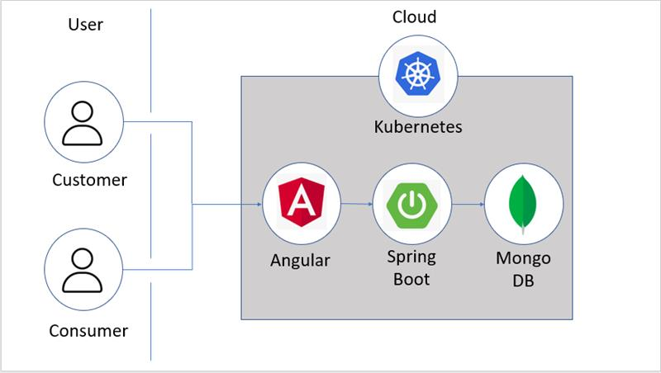

**Solution Roadmap:**

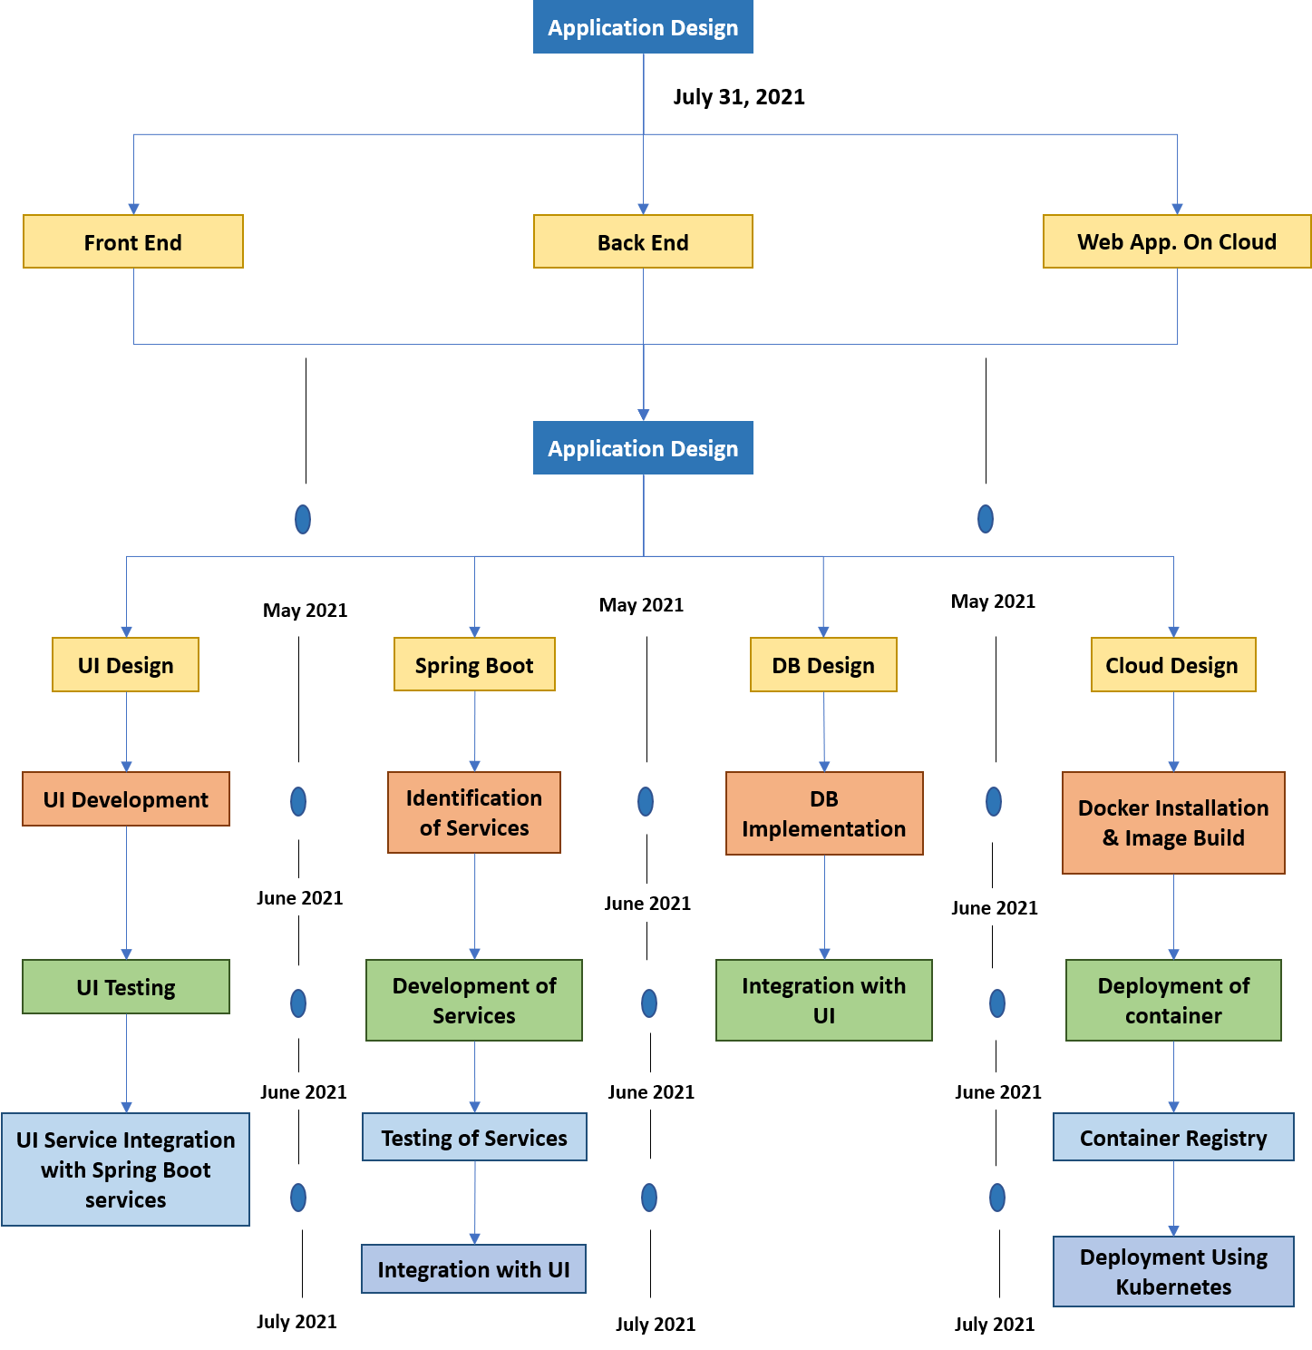

**Team Email Addresses :**

1. [Malathi_m@infosys.com](mailto:Malathi_m@infosys.com)
2. [Swetha_maheshwary@infosys.com](mailto:Swetha_maheshwary@infosys.com)
3. [Nandini_Gowdru@infosys.com](mailto:Nandini_Gowdru@infosys.com)
4. [rahul.rajaput@infosys.com](mailto:rahul.rajaput@infosys.com)
5. [apoorva.nag@infosys.com](mailto:apoorva.nag@infosys.com)

**----0----**