STRING FUNCTION ASSIGNMENT
1. WAP to prompt and read a line of text with words separated by space. Tokenise and extract the words. Display them. Impement the following functions for this.
a. int tokenise(char *arr); //tokenise and display tokens , return number of tokens to the caller
[Use strtok() to tokenise]
ANS:
#include <stdio.h>
#include <string.h>

int main()
{
char str[] = "I AM A FRESHER";
char* token;
char* rest = str;

while ((token = strtok_r(rest, " ", &rest)))
printf("%s\n", token);

return (0);
}
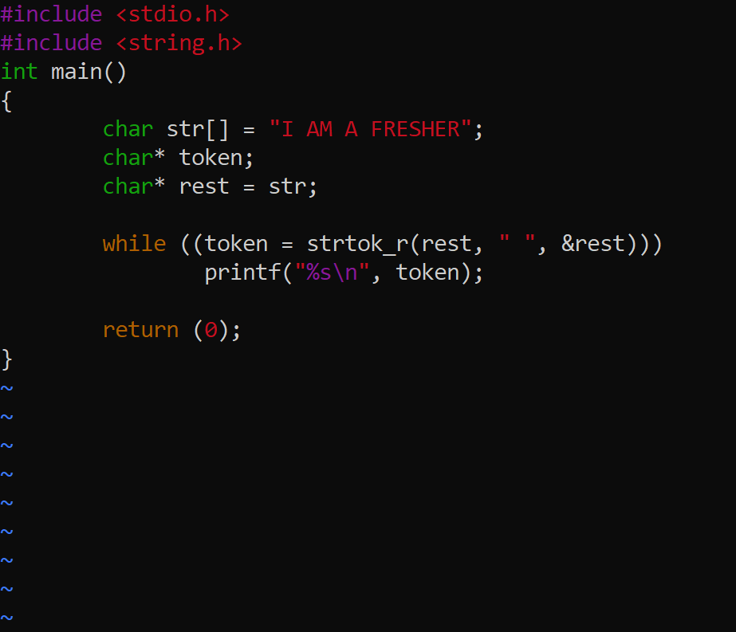

2. Implement your own strncat() which shall concatenate n characters from src to dest.
char *strncat(char *dest, const char *src, size_t n)
ANS:

#include <cstring>
#include <iostream>
using namespace std;

int main()
{

// Take any two strings
char src[50] = "efghijkl";
char dest[50]= "abcd";

// Appends 5 character from src to dest
strncat(dest, src, 5);

// Prints the string
cout <<"Source string : "<< src << endl;
cout <<"Destination string : "<< dest;

return 0;
}

